Examining The Flood Vulnerability of Urban Areas in the Municipality of Carmen, Davao del Norte

Mark Anthony J. Tajale
University of Southeastern Philippines
PHILIPPINES
mjtajale00322@usep.edu.ph

Abstract
The devastating effect of flooding in this modern day is different from past decades when climate change was not yet a big deal. Nowadays, even an hour-long heavy downpour of rain can trigger destructive floods. A flood has a variety of impacts on the communities and the environment. The study aimed to examine the flood susceptibility of the urban portions of the Municipality of Carmen in the province of Davao del Norte, through Geographic Information System (GIS) based investigation and mapping techniques supported by the collected data on flood susceptibility and hydrological activities maps from the National Mapping and Resource Information Authority (NAMRIA). Moreover, this study encourages researchers to the paramount use of Geographic Information Systems as a modern approach to support data analysis and to provide a comprehensive interpretation for better disaster risk mitigation and planning.

Keywords: Flood susceptibility; Municipality of Carmen; Inundation; GIS-based; NAMRIA; Topography; Urban areas
______________________________________________________________________
Introduction
In the last decades, foods have increased in frequency all over the world due to diverse
phenomena such as climate change, extended urbanization, land use, etc (Miranda & Ferreira, 2019). Floods are one of the disasters feared by people in society, because floods come with a high water discharge, inundate at a high level for a long time, and carry waste materials that interfere with activities in society (Sholihah, Kuncoro, Wahyuni, Suwandi, & Feditasari, 2019). Affecting daily activities, especially in low-lying urban areas where the central business districts are located. Urban areas face global challenges of flood risk not only due to climate change but also due to the continued densification of residential areas, infrastructure development, and urban sprawl (Berndtssona, et al., 2018). City resilience to natural disasters is critically undermined by urbanization and the implications of climate change, particularly in low-lying areas prone to flooding. Flooding is one of the several environmental problems and risks faced by urban areas that enhance population vulnerability and a threat to urban sustainability (Ferreira, Potočki, Kapović-Solomun, & Kalantari, 2021). An obvious case in point is the challenges of the Municipality of Carmen, Davao del Norte in the Philippines, highlighted by the increased frequency and intensity of metropolitan districts during the rainfed floods. Efficient disaster risk reduction requires comprehensive knowledge of the processes behind flood susceptibility.

Carmen’s susceptibility to flooding flows from its interconnectedness involving environmental, social, and infrastructural elements that are common to numerous fast urbanization. City areas, characterized by a low share of green cover, a rapidly growing density, and modified natural drainage systems, are especially at risk from flooding during heavy rainfalls. However, there is still an information gap concerning both the root reasons basics and flood risk characteristics over time. These urban areas under the jurisdiction of the Municipality of Carmen appear to get inundated every time there is a significant downpour. Flooding is a persistent issue in some barangays. Locals have been accustomed when weather-causing floods occurs and with limited pieces of information about the flood vulnerability of their municipality.

On January 16, 2024, a weather disturbance called the shear line made an impact affecting the province of Davao del Norte. Affecting lives, agriculture, and economic loss due to flooding. Recovering from the shear line after one week, on January 28, 2024, another weather disturbance occurred, a Northeast Monsoon and the Trough of the Low-Pressure Area affected eastern Mindanao. According to the International Federation of Red Cross (IFRC) DREF Operations Mindanao Floods report, the combined effects of three weather systems - the shear line, Northeast Monsoon, and trough of LPA caused widespread flooding and landslide incidents, making the people’s capabilities to cope up were limited (Reliefweb, 2024). Prolonged light to heavy downpours triggers flooding that results in declaring the municipality of Carmen in a state of calamity. Major economic activities of the municipality such as transportation, delivery of goods, and agricultural fields are greatly affected.

The research aims to identify flood-prone locations, study the hydrological processes that lead to floods, and encourage policymakers, urban planners, and local people in Carmen to make this study as useful insights to improve flood resilience and promote sustainable development by clarifying these complex relationships.

Methodology
The research data collection relevant to the investigation of flood susceptibility in urban areas of the Municipality of Carmen relied on a Geographic Information System (GIS) based investigation. Additional layers of information from the National Mapping and Resource Information Authority (NAMRIA) consist of topographical maps, flood susceptibility maps, and hydrological data that significantly support this study.

Results and Discussion
It has been easier to assess flood risk and prevention due to modern mapping technologies and techniques. Through the use of GIS mapping, understanding the problem of flooding in an area, including the planning to mitigate such types of disasters. The map data are GIS-based investigation with raster data collected from NAMRIA. The figures below shows the flood susceptibility of the Municipality of Carmen.

Municipal Boundary Map
The Municipality of Carmen is a 1st Class Municipality of the Davao Region (Region 11) under the jurisdiction of the province of Davao del Norte having a land area of approximately 16, 600 hectares (Norte, 2016). The figure below is the approximate municipal boundary of the Municipality of Carmen. The map has been delineated from the municipal and city boundaries of Davao del Norte based on the delineation of the National Mapping and Resource Information Authority (NAMRIA).

Figure 1
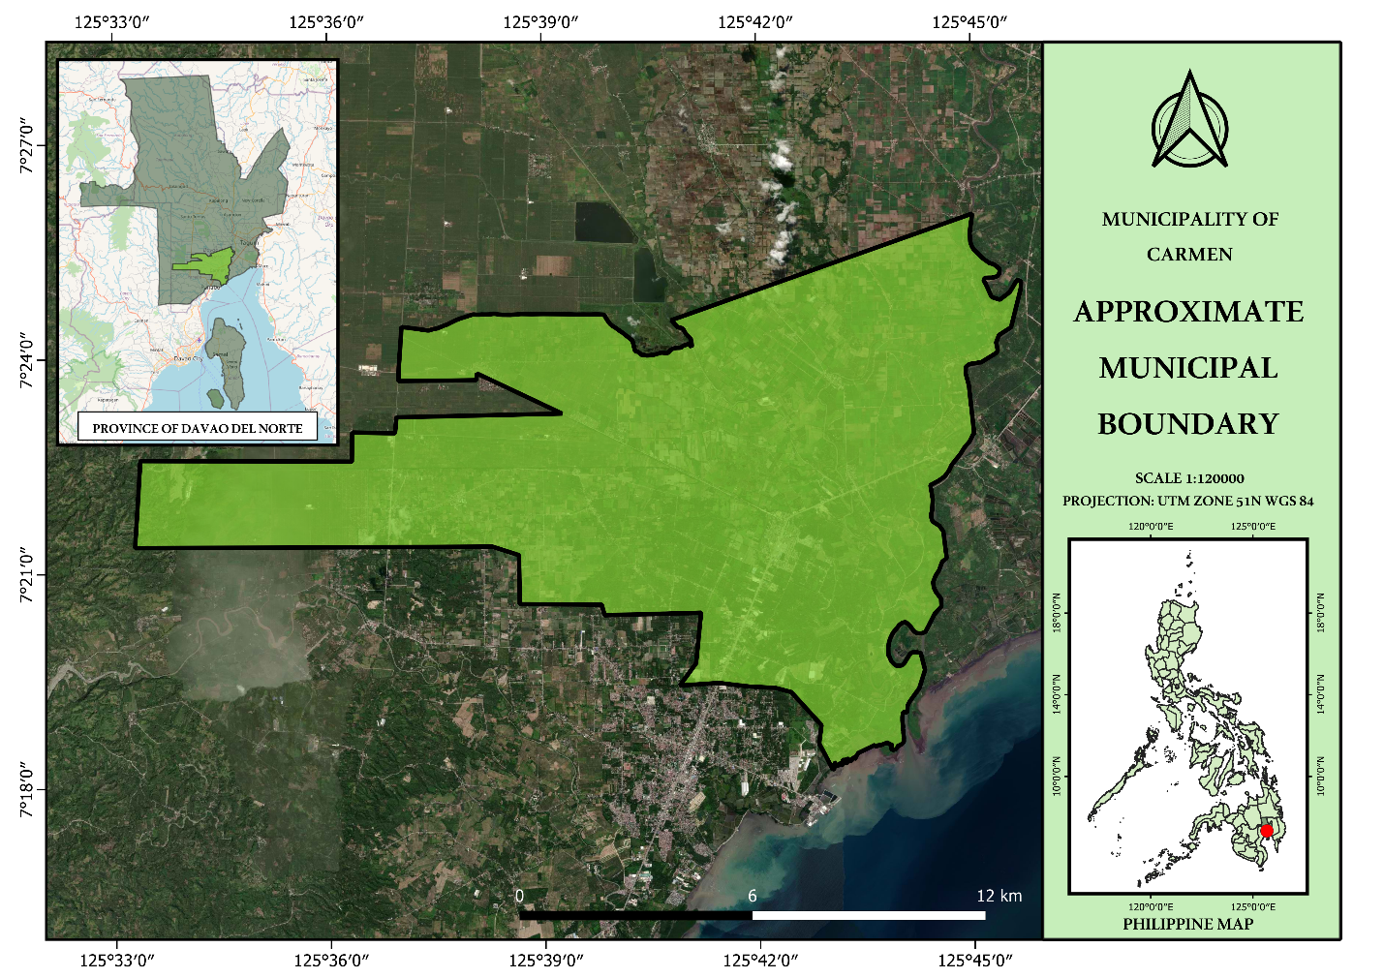Source: NAMRIA Municipal Boundaries of the Philippines; Google Earth satellite image

Rivers and Creeks Network
The figure below shows the network of rivers and creeks within the municipality. It is shown on the map that the municipality is the basin of waterways, creeks, and rivers that come from neighboring municipalities. It is observed that Ising River, Tibungol Creek, Sadpudon Creek, and Mangalcal Creek intersect at a certain point where the upper portion of the central district of the municipality is located.

There are four rivers and four creeks that enters the municipality of Carmen in Davao del Norte. Libuganon River is one of the major rivers in the province of Davao del Norte. Locutan River, Cabayangan Creek, and Salao River are tributaries of Tuganay River. Tibungol, Mangalcal, and Sadpudon Creek are tributaries of the Ising River. Waters from Tibungol and Mangalcal Creek juncture at a point where it splits into Sadpudon and Ising River however, the endpoint of Sadpudon Creek intersects at Ising River (figure 2.a).

Figure 2 (the delineation of rivers and creeks is based on the open street map basemap)
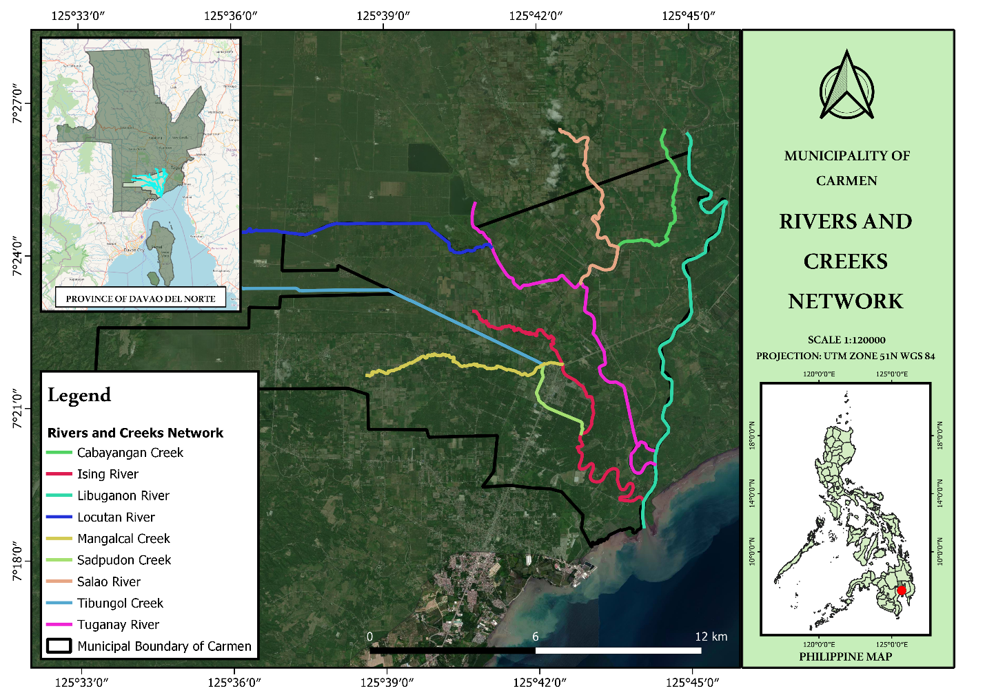
Source: Open Street map; Google Satellite Image

Figure 2.a
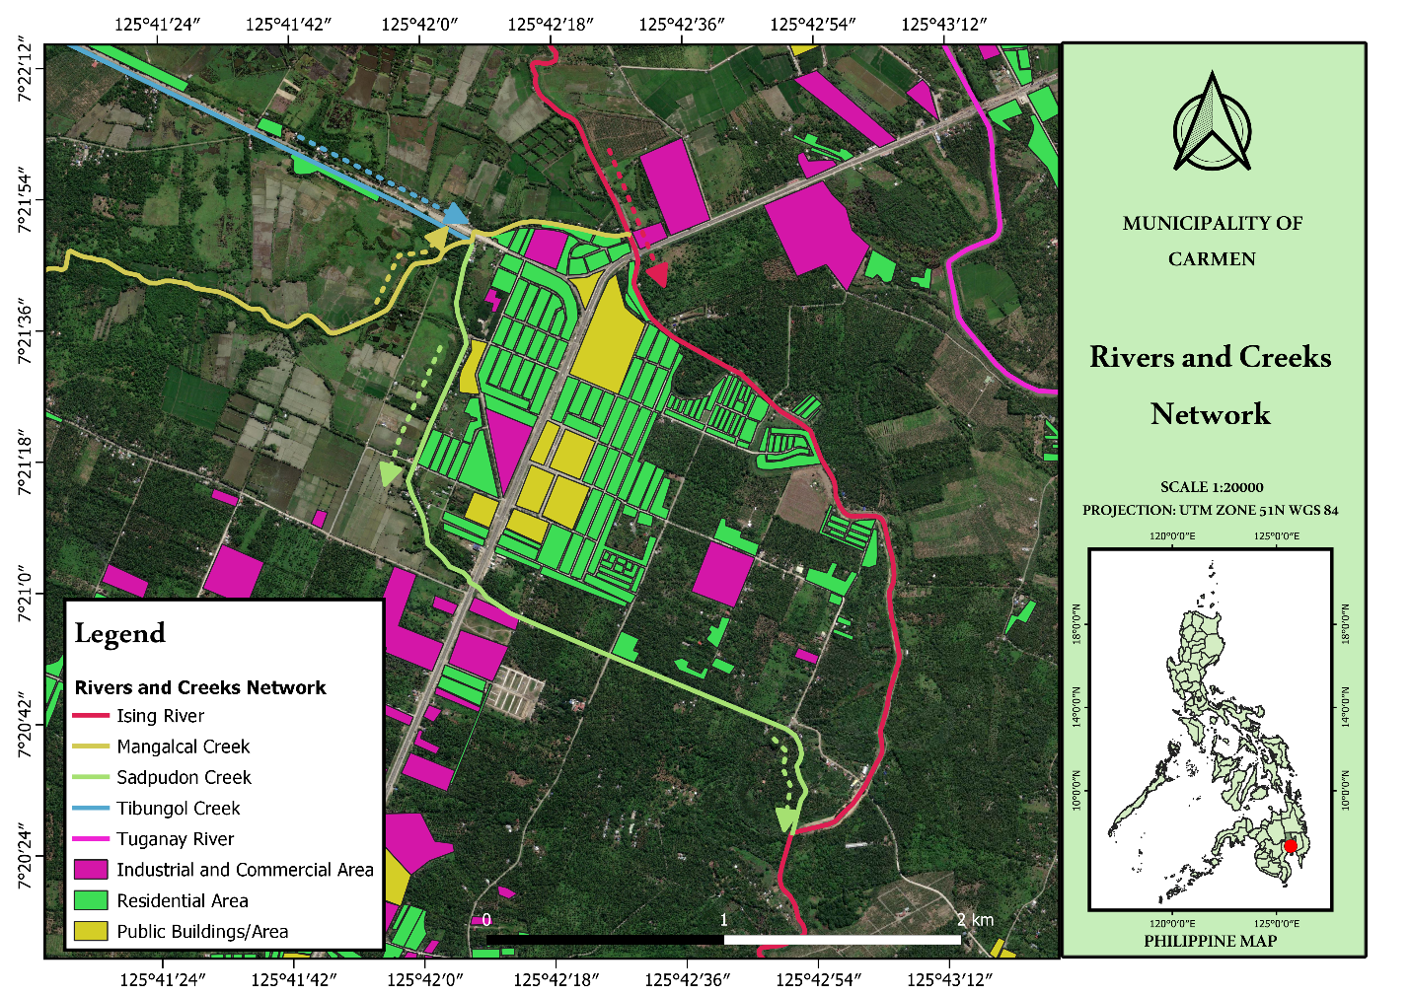
Source: Open Street map; Google Satellite Image

Flood Susceptibility
The map shown below is the flood susceptibility map, a flood susceptibility raster data from the National Mapping and Resource Information Authority (NAMRIA). It is shown on the map that most human activity in the central area of the municipality is at moderate to high susceptibility to flood. The central area of the municipality is mostly residential and commercial areas where daily human activities happen in this area. It is observed on the map that the portion with a moderate to high indicator of flood susceptibility is mostly residential areas. It is the portion where the Tibungol, Mangalcal, and Sadpudon Creek meet (Figure 3.a).

Figure 3: Table 1
Flood Susceptibility Indicator
Very High Susceptibility | High Susceptibility | Moderate Susceptibility | Low Susceptibility | None

Figure 3
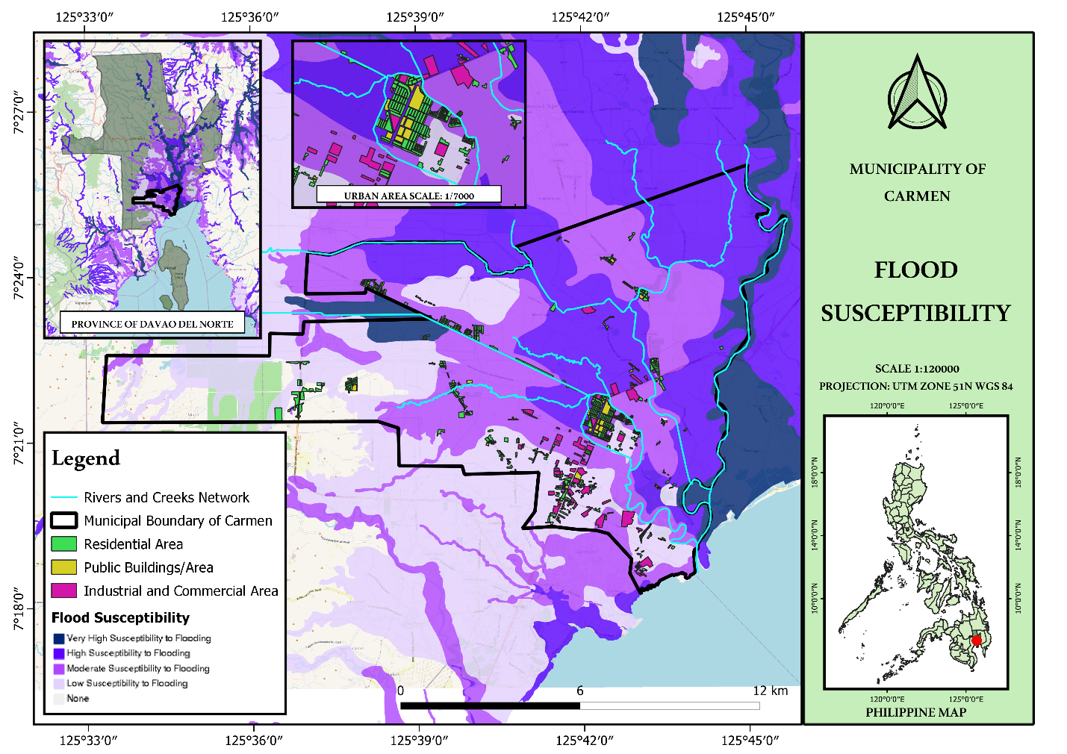
Source: NAMRIA Flood Susceptibility Scale 1:10000

Figure 3.a
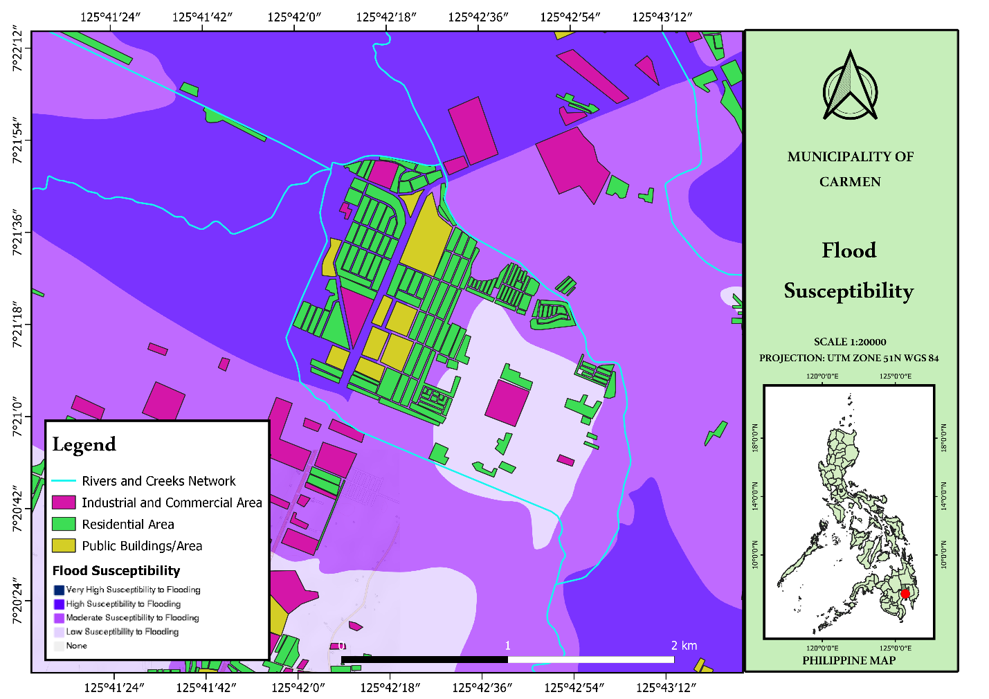
Source: NAMRIA Flood Susceptibility Scale 1:10000

Inundation of Sea Level Rise
Sea level rise is a contributing factor in flooding. Since the municipality is in the coastal area, the map below shows that a 0.5 meter sea level rise can reach the urban areas. An ankle-deep inundation, typically ranging from 0.1 to 0.25 meters in depth, which has the potential to penetrate into the central district, shows as a reasonable indication of the municipality's susceptibility to flooding, highlighting its low-lying topography and vulnerability to inundation events.

Figure 4: Table 1
Inundation Map at 0.5 Meter Sea Level Rise
Knee Deep (0.25-0.5m) | Ankle Deep (0.1-0.25m) | No flooding (0.0-0.1 m)

Figure 4
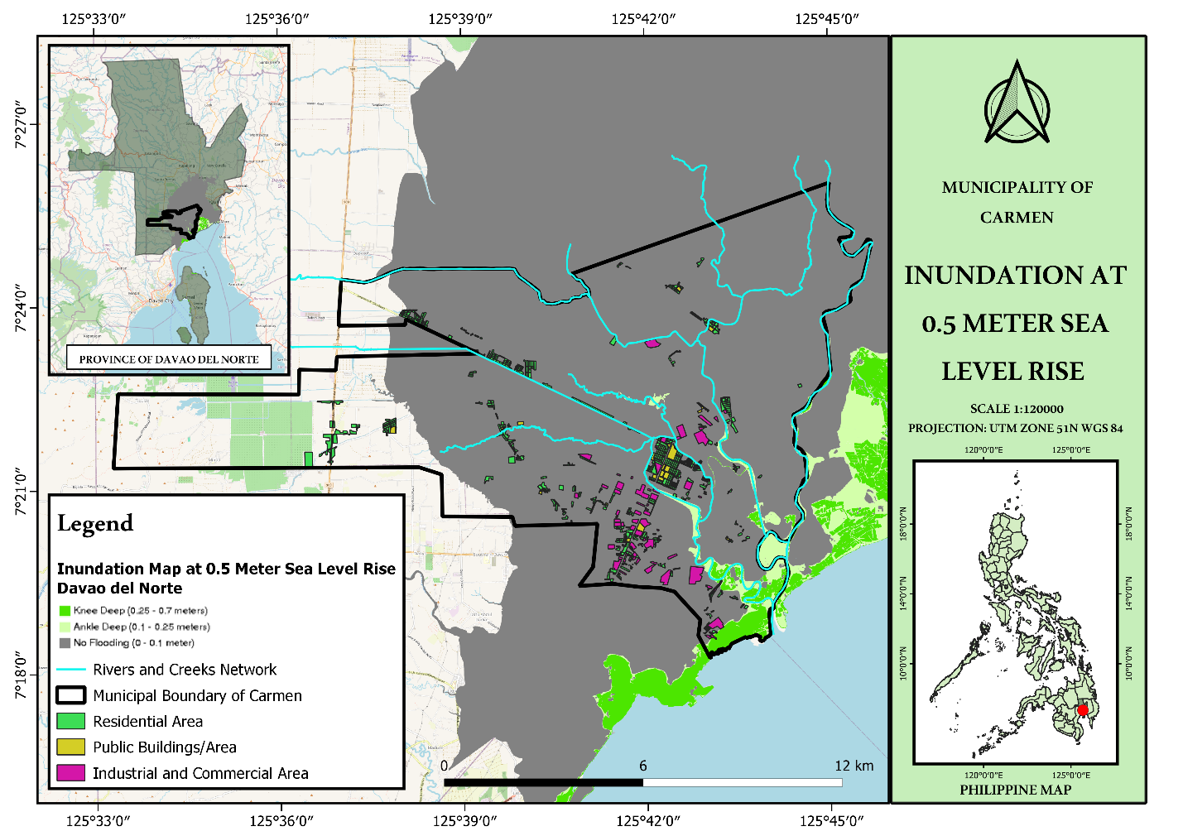
Source: NAMRIA Inundation Map at 0.5 Meter Sea Level Rise – Davao del Norte

Contour Map
Figure 5 represent the topographic map of the municipality. The researcher used the 1-meter contour interval to present precisely the topography of the municipality from the mean sea level. The enlarged scale map (Figure 5.a) that focuses on the central district of the municipality. It is observed and evidently that the contours represent the topography of the central district of the municipality showing that it is only 1 to 2 meters above mean sea level and reasonably depicts its susceptibility to flooding when heavy rains and sea level rise occur at the same time.

Figure 5
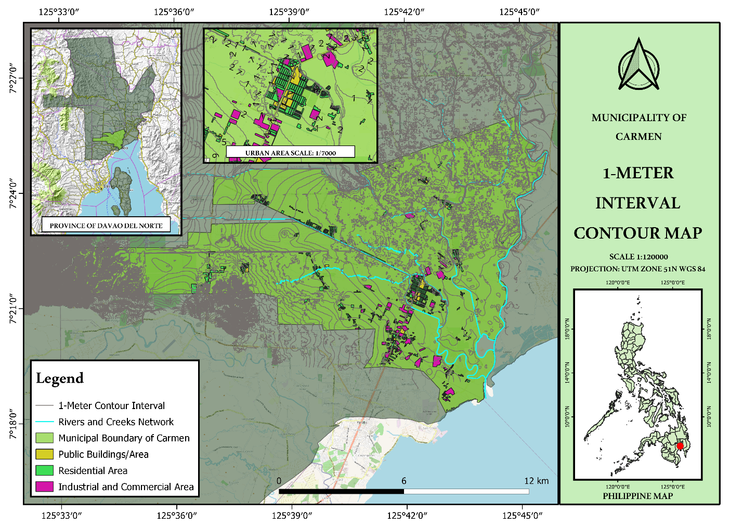
Source: National Irrigation Administration/Irrigation Management Office - Davao del Norte

Figure 5.a
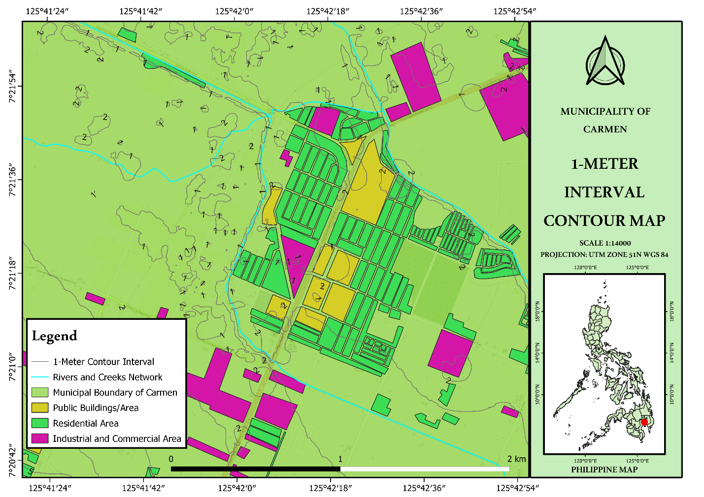

Conclusion
Based on the findings of the study, it is concluded that low-lying urban areas in Carmen, Davao del Norte are vulnerable to sea level rise inundation. By utilizing these maps and data, this study would be a great provider of disaster reduction plans. Mitigating the impacts of flooding on the economic, infrastructure, industrial, and agricultural sectors of the municipality. Proper and regular management of waterways and drainages. Installations of protective elements on river banks such as gabions or even construction of protection dikes. Regular declogging and de-siltation of waterways and rivers.

Through historical events of flooding in susceptible areas, a thorough land use analysis plan supported by ordinances and policies that these susceptible areas of flooding must reclassified accordingly. Enhancing flood-resilient infrastructures and facilities within these areas where residents, businesses, and industries are resilient in times when a disaster occurs. Reviewing the rivers and waterways networks through regular hydrological observations where necessary altering and bypassing the course of the waters to lessen the destructive impact of flooding.

References
Berndtssona, R., Becker, P., Persson, A., Aspegren, H., Haghighatafshar, S., Jönsson, K., . . . Tussupova, K. (2018). Drivers of changing urban flood risk: A framework for action. Journal of Environmental Management. doi:10.1016/j.jenvman.2019.03.094
Ferreira, C. S., Potočki, K., Kapović-Solomun, M., & Kalantari, Z. (2021). Nature-Based Solutions for Flood Mitigation and Resilience in Urban Areas. doi:https://doi.org/10.1007/698_2021_758
Miranda, F. N., & Ferreira, T. M. (2019). A simplifed approach for flood vulnerability assessment of historic sites. Natural Hazard. doi:https://doi.org/10.1007/s11069-018-03565-1
Norte, P. G. (2016). DAVAO DEL NORTE PROVINCIAL DEVELOPMENT AND PHYSICAL 2014-2022. Tagum City: Provincial Government of Davao del Norte.
Reliefweb. (2024, February 15). Retrieved from https://reliefweb.int/report/philippines/philippines-mindanao-floods-dref-operation-appeal-mdrph053: https://reliefweb.int/
Sholihah, Q., Kuncoro, W., Wahyuni, S., Suwandi, S. P., & Feditasari, E. D. (2019). The Analysis of The Causes Of Flood Disasters And Their Impacts In The Perspective Of Environmental Law. IOP Conference Series: Earth and Environmental Science. doi:10.1088/1755-1315/437/1/012056

