**EXAMINING THE ECOLOGICAL CONSEQUENCES OF SAND AND GRAVEL QUARRY IN LASANG RIS DAM AT MANAY, PANABO, DAVAO DEL NORTE**

Anne R. Jaron

University of Southeastern Philippines, College of Development Management, Graduate School Program, Mintal Campus, Davao City

______________________________________________________________________________

**ABSTRACT**

Dams play a crucial role in irrigation by controlling and conserving water supplies for agricultural usage. However, the quarrying activity near dam constructions poses considerable risks to their integrity and usability. This investigation examines the impact of quarrying on the dams utilized for irrigation in the Lasang River Irrigation System (RIS) in Davao Del Norte, Philippines, specifically. It aims to assess the ecological and infrastructure harm caused by sand and gravel extraction, evaluating variations in water quality, accumulation of sediment, and local biodiversity. Using records from the National Irrigation Administration (NIA) and on-location surveys, the research documents substantial harm to the Lasang RIS due to prohibited quarrying activities inside barred zones. The conclusions emphasize the adverse effects on river profiles, sedimentation patterns, and the structural health of the irrigation system. To minimize the detrimental effects on water resources and guarantee the long-term survival of irrigation infrastructure, this research highlights the necessity of strict regulatory enforcement, sustainable quarrying techniques, and thorough management plans.

**Keywords**: Dam impacts, Sand and gravel extraction

_____________________________________________________________________________________

**INTRODUCTION**

Dams are essential for agricultural irrigation because they store and manage water supplies. The possible dangers of quarrying operations close to dam structures may impact irrigation techniques. These risks might jeopardize the integrity and performance of the dams. To protect agricultural water resources, this research will investigate the impact of quarrying on dam structures meant for irrigation, assess the harm caused, and suggest ways to mitigate the consequences.

Infrastructure projects funded by the National Irrigation Administration (NIA) are at risk from sand and gravel quarry sites. These operate too close to irrigation systems and utilities, which results in the negative impacts of excessive quarrying activities, such as scoured riverbanks, deteriorated river beds, and exposed foundations of those structures.

Based on Section 79 of Department Administrative Order No. 2010-21, which states that; “ No extraction, removal, and disposition of materials shall be allowed within a distance of one (1) kilometer from the boundaries of reservoirs established for public water supply, archaeological and historical sites or any public or private works structures, unless the prior clearance of the Government agency(ices) concerned or owner is obtained. “(DENR ,2010)

In Davao Del Norte IMO, the Lasang River Irrigation System at Manay, Panabo Davao Del Norte experiences illegal quarrying approximately 650 meters downstream of the dam site, and the Lasang RIS is heavily damaged. The PENRO-LGU technical team inspected the site dated January 21, 2022, around 10:00 am; they made some observations and found the damaged dike adjacent to the NIA Dam facility and had approximated the length of the damage for about 40 meters in length and 15 meters high. The team also found quarry activity along the river and three (3) quarry activities along the river. (PENRO DDN REPORT ,2022)

To prevent the continuous damage of the NIA facilities, the PENRO-LGU requires the removal of all the quarry activities within the 1-kilometer no-go zone and shall seek PMRB's decision to cleanse the adjacent area to the river of all quarry applications. (PENRO DDN REPORT ,2022)

**OBJECTIVES OF THE STUDY**

The purpose of this study, includes the assessment of the current state of the ecological aspect of the location of the Lasang RIS Dam in connection with the impact of sand and gravel extraction on local biodiversity. The evaluation of changes in water quality and sedimentation of the dam due to extraction. The determination of how the activities at the site affect the nearby ecosystem and the changes in the habitat for local flora and fauna and the assessment of the consequences for local human communities and the implications for water availability and quality.

**METHODOLOGY**

Lasang RIS Dam at Manay, Panabo, Davao Del Norte, is well-chosen for the study regarding this ecological and environmental site as a concern for sand and gravel quarrying’s effects. The geographic location of the research, topographic characteristics, and biodiversity will be carefully examined to understand the initial ecological state. The data collection is secondary data from the National Irrigation Administration. This process will involve a comprehensive approach, including on-site topographic surveys with profile data, and the results will be used in AutoCAD to determine the profile elevation from 2020 to 2023 of the ogee to the downstream area. Images from Google earth and aerial photos from the National Irrigation Administration.  These methods will provide a holistic understanding of the changes in the apron flooring of the dam, which is continuously damaged because of quarrying activities. Using this research, we want to thoroughly understand the ecological effects of sand and gravel mining around the Lasang RIS Dam and workable options for sustainable resource management.

**RESULTS AND DISCUSSION**

**Figure 1: Lasang River Profile from year 2020 to 2023**

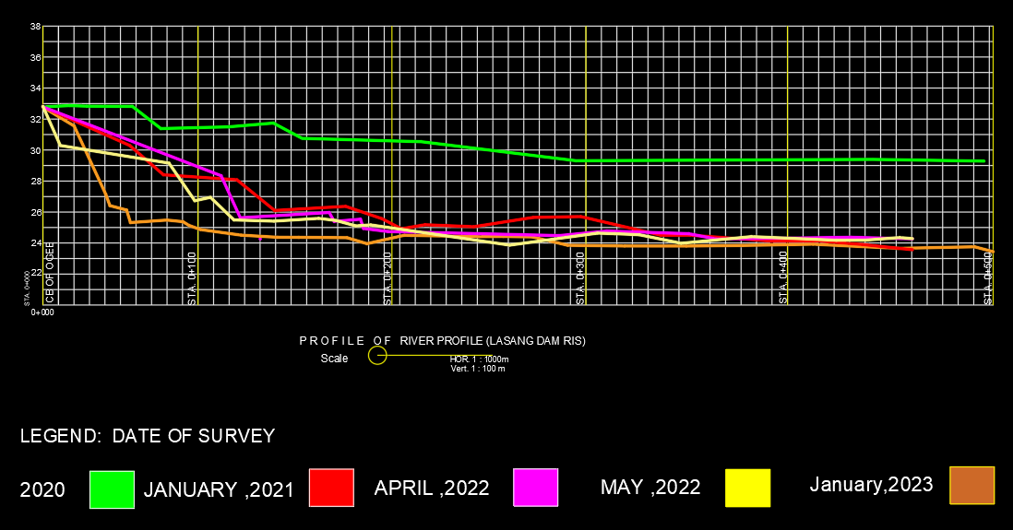

*(Source*: *NIA DAVAO DEL NORTE IMO REGION XI*)

**Noticeable changes in elevation during quarry operations**. Figure 1 illustrates how, through the span of three years, the elevation of Lasang River’s river bed has been lowered by almost five meters after a quarry has started its operation.

**2. Google Earth Satellite image year 2020** 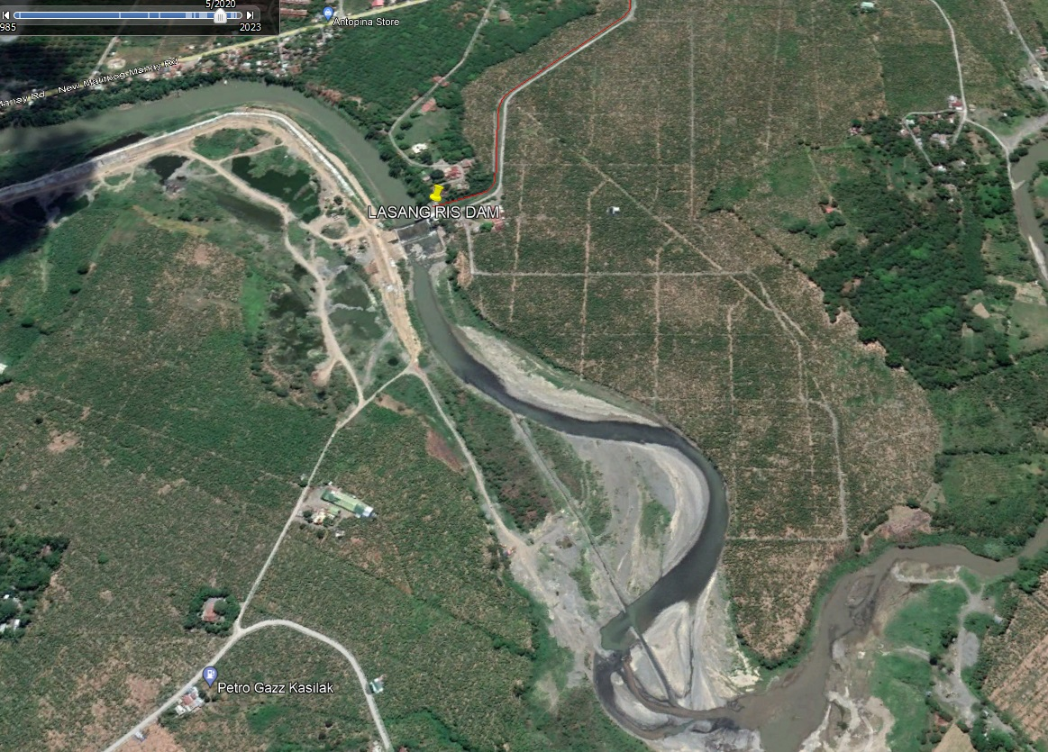

*(Source*: *Google Earth*)

**Lasang River year 2020**. Figure 2 shows how the river has followed its natural course before quarry activities.

**Figure 3. Google Earth Satellite image year 2021**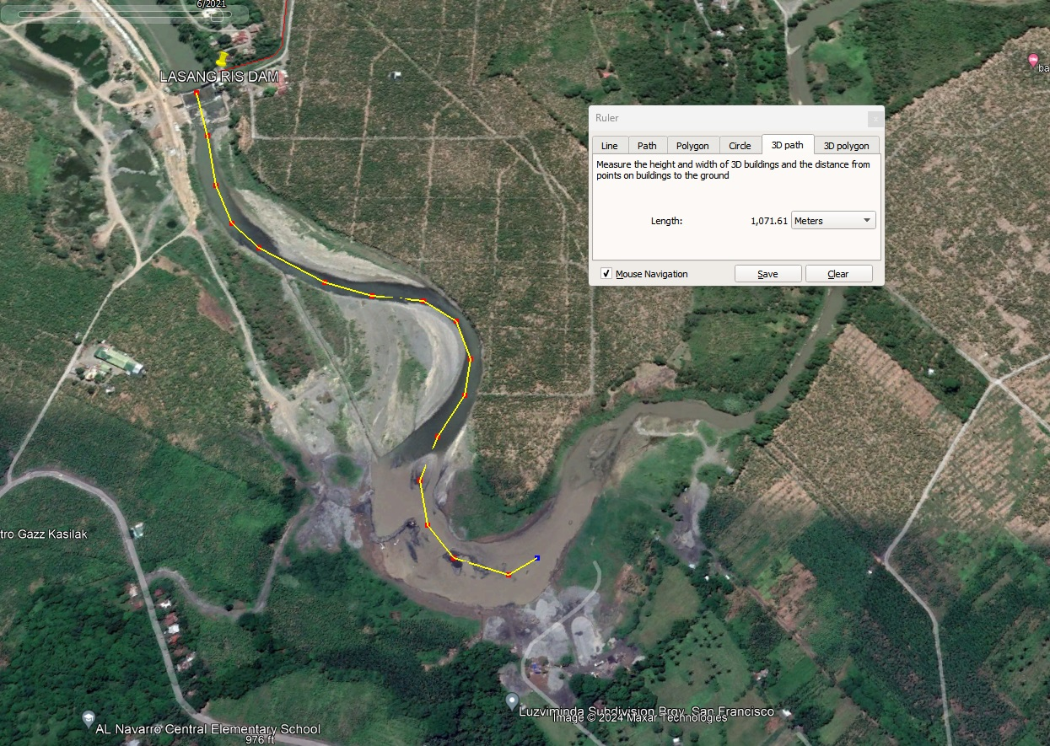

QUARRY SITE, 1.071 KM AWAY FROM DAM SITE STRUCTUR

*(Source*: *Google Earth*)

**Lasang River year 2021**. Figure 3 displays the early stages of the operation of the quarry.

**Figure 4. Google Earth Satellite image year 2022**

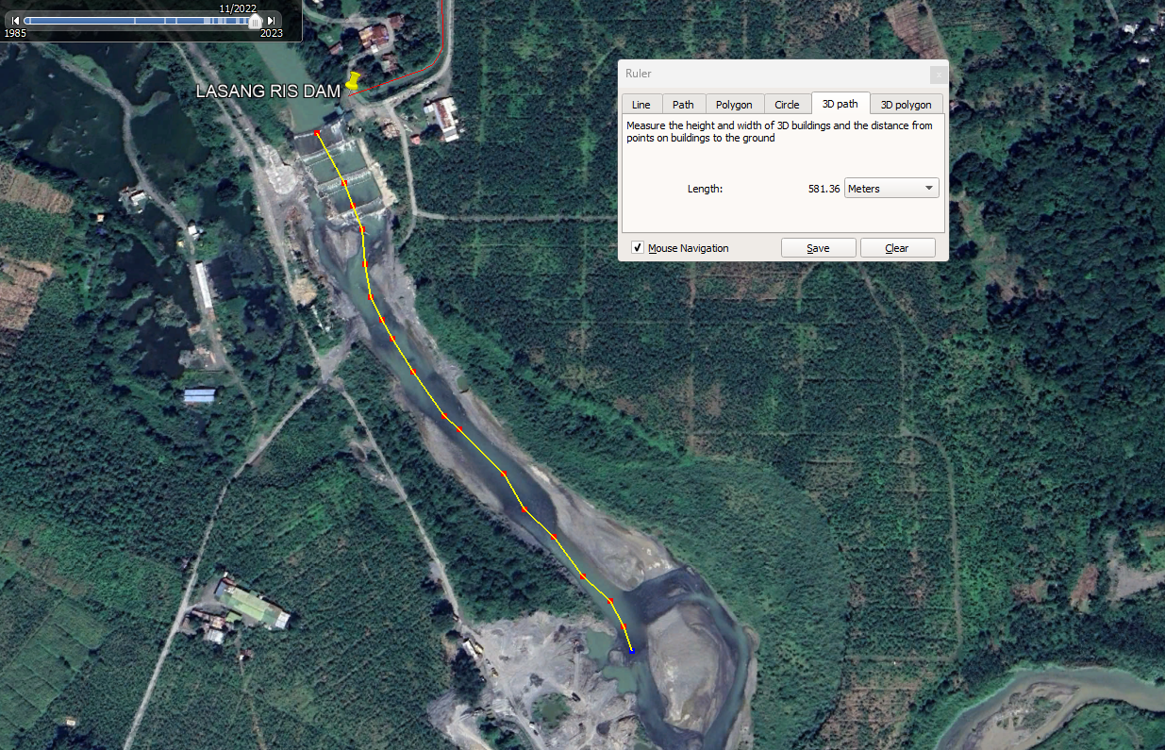

QUARRY ACTIVITIES, 581.36 METERS AWAY FROM DAMSITE

*(Source*: *Google Earth*)

**Lasang River year 2022**. Figure 3 illustrates another quarry operation site almost 600 meters away from the Lasang RIS Dam.

**Figure 4. Aerial photos of Lasang River Dam using drone equipment** 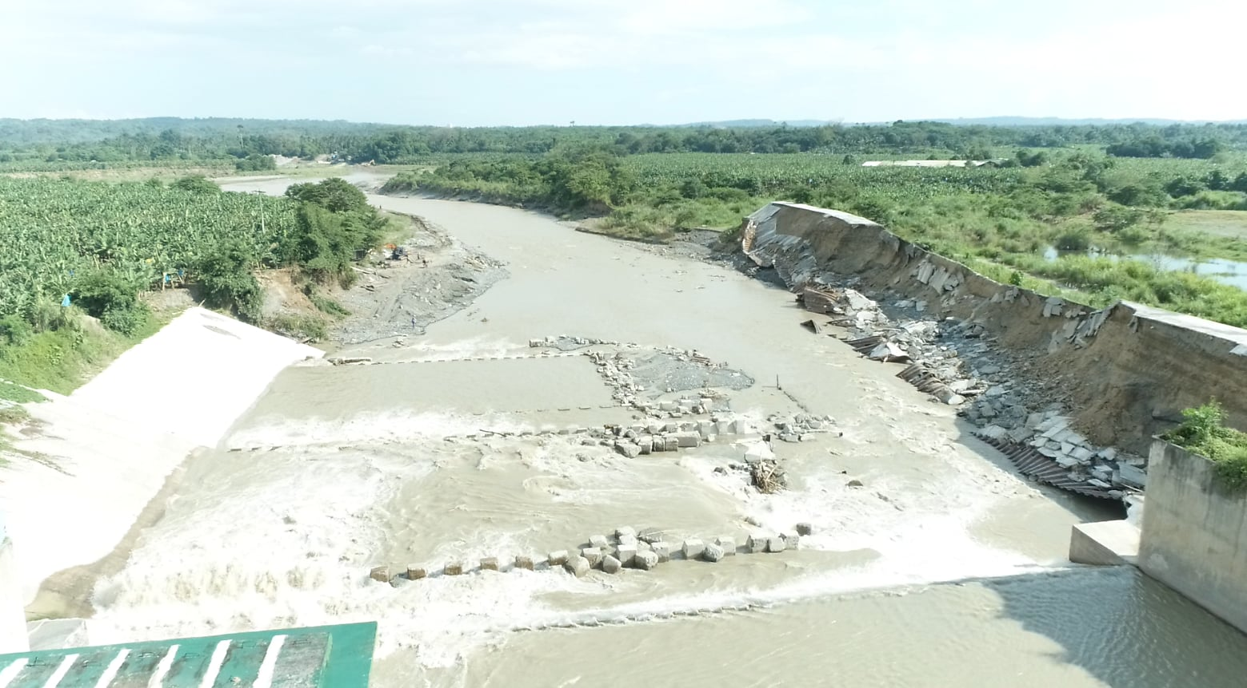

Quarry site (right side of the river)

*(Source*: *NIA DAVAO DEL NORTE IMO REGION XI*)

**Lasang RIS Dam**. Figure 4 displays the damage to the downstream apron of the dam on the right side, which results from a significant drop in river profile elevation brought about by extensive quarry excavations. (also coming from the river's right bank)

**Figure 5. Aerial photos of Quarry activities along Lasang River Dam Downstream using drone equipment**

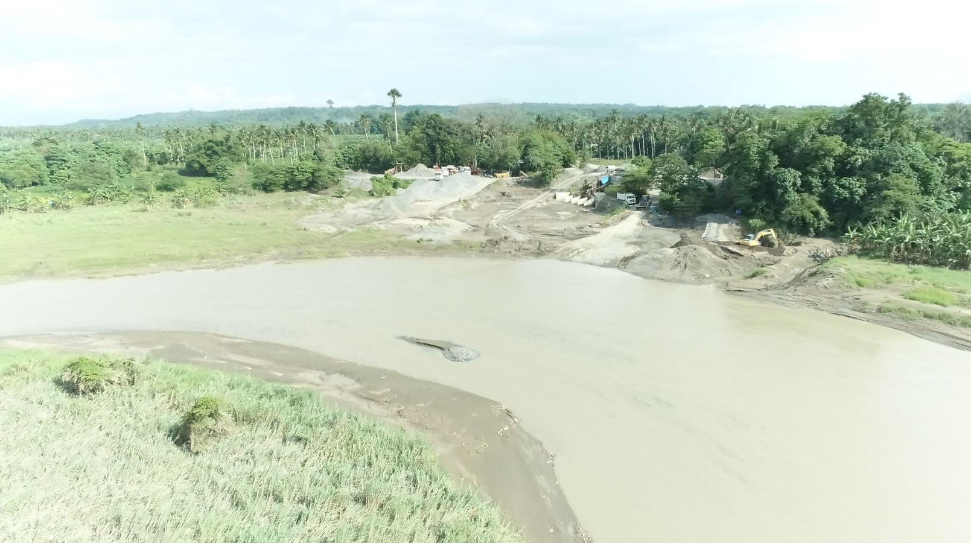

*(Source*: *NIA DAVAO DEL NORTE IMO REGION XI*)

**Quarry Site (Aerial Photo)**. Up-close photo of the quarry site.

**Figure 6. Google Earth Satellite image year 2023**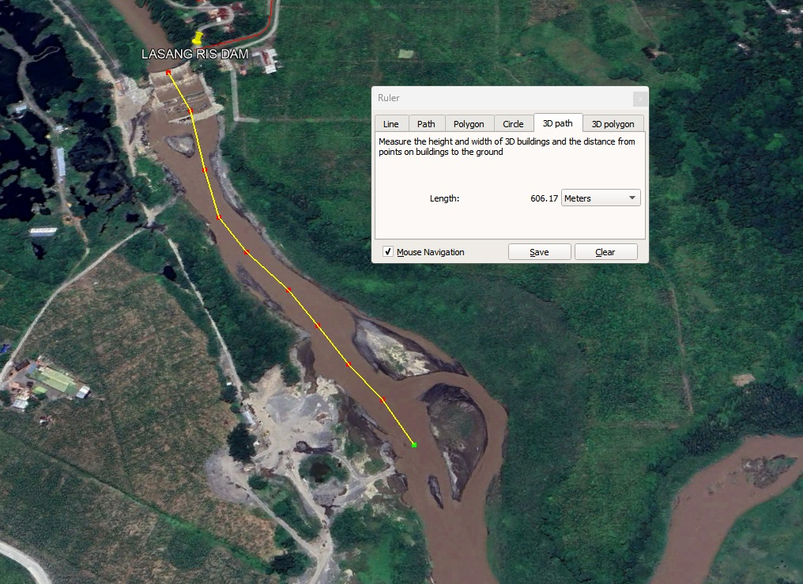

*(Source*: *Google Earth*)

**Lasang River year 2023**. Figure 6 show that the quarry still has been operational on 2023.

**Discussions**

This study's findings demonstrate how closely related quarrying operations and dam irrigations are, highlighting the substantial effects of quarrying on the efficiency and long-term viability of water management systems. One main issue surfacing was sedimentation, exacerbated by quarrying activities and accumulating in reservoirs. This sedimentation affects downstream water availability and quality by lowering dams' storage capacity and ability to control water flow successfully.

Adverse effects on irrigation projects across the country are caused by quarry operators excavating deeper than the 1-meter extraction-depth limit, excessive quarrying (including quarrying of river boulders that limit river flow speed and cause the river course to diverge and the river slope to become steeper, resulting in rapid erosion of riverbanks), and inadequately marking and delineating the quarrying area with high and conspicuous markers. (NIA, 2021)

These issues are made worse by the physical harm quarrying operations do to dam infrastructure, which calls for more funding for upkeep and rehabilitation projects to guarantee dams' structural soundness and safety.

Comprehensive management plans that combine sustainable development, resource conservation, and environmental protection are needed to address the effects of quarrying on dam irrigations. It is possible to lessen the adverse effects of quarrying on water resources and increase the resilience of dam irrigation systems in the face of shifting environmental challenges by implementing strategies including sediment control, land-use planning, and regulatory enforcement.

**CONCLUSION**

Studies on how quarrying affects dam irrigation systems show essential social, economic, and environmental repercussions. Quarrying close to dam locations can have an adverse environmental impact by increasing sedimentation and contaminating water bodies, which can lower the quality of the water and the storage capacity of the dams, eventually reducing the effectiveness of irrigation. Due to the decreasing quantity and quality of irrigation water, these quarrying operations may economically deteriorate agricultural land, resulting in lower agricultural production and higher expenses associated with soil remediation and water treatment. To mitigate these effects, it is essential to implement stringent regulatory measures, adopt sustainable quarrying practices, enhance monitoring and rehabilitation efforts to ensure that the benefits of quarrying are balanced with the protection of vital irrigation infrastructures and the well-being of affected communities and strengthen the laws and regulations enforced by the Department of Environment and Natural Resources that the “NIA technical recommended that the quarry area should be 2.8-5 km away of the diversion dam to allow for the river basin to return to its original elevation and protect the existing irrigation structures.” (Manila Bulletin.2021)

**REFERENCES**

1. Abbasov, Rovshan, and Vasif Yahyayev. "The impact of dams and sand-gravel extractions on the downstream channel deformations (in the example of the Goychay River)." *Sustainable Water Resources Management* 10.2 (2024): 1-13.
2. Devi, Maharabam Anjali, and Lunghim Rongmei. "Impacts of sand and gravel quarrying on the stream channel and surrounding environment." *Asia Pacific Journal of Energy and Environment* 4.1 (2017): 7-12.
3. https://earth.google.com/web/
4. Miraflor M.(2021) Manilla Bulletin. [*NIA seeks DENR, DILG action as quarry sites threaten irrigation projects (mb.com.ph)*](https://mb.com.ph/2021/08/19/nia-seeks-denr-dilg-action-as-quarry-sites-threaten-irrigation-projects/)
5. NIA Central Office .(August 19,2021). [*IRRIGATION PROJECTS THREATENED BY SAND AND GRAVEL QUARRY SITES | National Irrigation Administration (nia.gov.ph)*](https://www.nia.gov.ph/content/irrigation-projects-threatened-sand-and-gravel-quarry-sites)
6. Provincial Environment and Natural Resources Office Davao Del Norte.(2022), *Inspection Report*