REAL TIME SIGN LANGUAGE TRANSLATOR
Mohamed Fazal.V.A¹, Adharsh Reghu², Muhammed Naisam³, Ijas .P.R⁴, Vijith K.V⁴
^{1,2,3,4,5} Final Year Students, Department of Computer Engineering, Sree Rama Government Polytechnic College Triprayar, Thrissur ,Kerala, India

ABSTRACT
Sign language serves as a crucial medium of communication for the deaf and hard-of-hearing community, enabling them to express thoughts, emotions, and ideas through visual-gestural elements. However, the lack of widespread understanding of
sign language poses barriers to effective communication between the deaf and hearing individuals. This research focuses on developing a Sign Language Translation (SLT) system that leverages advancements in computer vision, machine learning, and natural language processing to facilitate seamless communication between sign language users and the broader population. The proposed SLT system employs real-time video analysis to capture and interpret sign language gestures, recognizing the intricacies of hand movements, facial expressions, and body language. A deep neural network architecture is trained on extensive sign language datasets to enhance the accuracy and robustness of gesture recognition. The system incorporates a natural language processing component to convert the interpreted signs into written or spoken language, ensuring comprehensive understanding and expression. Key features of the SLT system include adaptability to different sign language dialects, user-friendly interfaces, and the ability to learn and adapt to new signs over time. The research also explores the integration of wearable devices and mobile applications to make the SLT system accessible and portable for users in various settings.

- INTRODUCTION
Sign Language translation is an innovative project dedicated to creating an advanced Sign Language Recognition System, leveraging cutting-edge technologies such as computer vision, machine learning, and natural language processing. The primary objective is to enhance communication for individuals with hearing impairments by seamlessly translating sign language gestures into text and synthesizing speech in real-time. The project focuses on developing a robust gesture recognition model, capable of accurately detecting and tracking sign language gestures. The system aims to break down communication barriers by providing dynamic subtitles for those unfamiliar with sign language and incorporating text-to-speech synthesis to enable two-way communication between sign language users and non-signers. With an emphasis on inclusivity, Sign Language translation features an intuitive and accessible user interface designed to accommodate
users with varying levels of sign language proficiency. The methodology involves hands detection and tracking using the MediaPipe library, training a versatile machine learning model, and utilizing OpenCV for efficient real-time video processing. Key features include real-time interaction, inclusive communication through subtitles, and speech synthesis. Future enhancements include multi-language support, mobile application development, and wearable device integration. Sign Language translation aspires to revolutionize communication, contributing to a universally accessible and inclusive
platform that transcends boundaries, fostering understanding and connectivity in society..

- METHODOLOGY
Sign Language translation represents an innovative venture dedicated to the development of a cutting-edge Sign Language Recognition System. With a profound commitment to inclusivity and communication accessibility, this project integrates advanced technologies such as computer vision, machine learning, and natural language processing. The primary objective is to empower individuals with hearing impairments by creating a real-time system that can proficiently recognize and interpret sign language gestures. The project is driven by a set of well-defined objectives. Firstly, the focus is on realtime gesture recognition, employing computer vision techniques to accurately detect and track sign language movements. Subsequently, the system dynamically generates subtitles,
translating recognized gestures into text to facilitate communication for individuals unfamiliar with sign language. Furthermore, the integration of text-to-speech synthesis enhances the system’s capabilities, converting the recognized text into audible speech for effective two-way communication. The methodology encompasses hands detection and tracking using the MediaPipe library, training a robust machine learning model to recognize a diverse array of sign language gestures, and employing OpenCV for efficient real-time video processing. The system aims to deliver a user-friendly interface, ensuring accessibility for individuals with varying levels of sign language proficiency.
2.1 Front-end technologies
HTML, CSS, and JavaScript are the primary front-end technologies used to create a website’s user interface. HTML provides the structure of the web page, CSS is used to style the web page, and JavaScript adds interactivity to the web page.
2.2 Back-end technologies
The back-end of a web application is responsible for processing data and delivering it to the user interface. Technologies such as PHP, Python, Ruby, Java, and .NET are commonly used to develop the back-end of a web application.
2.3 Database technologies
Databases are used to store and retrieve data for web applications. Technologies like MySQL, PostgreSQL, MongoDB, and Oracle are commonly used to build and manage databases.
2.4 Google Maps API
Web servers like Apache, Nginx, and IIS are used to serve web content to users.They manage incoming requests, process data, and deliver web pages to the users’ browsers.

- LITERATURE SURVEY
Significant advancements in Sign Language Recognition Systems have emerged, combining computer vision, machine learning, and natural language processing. Early work by Starner et al. (1998) pioneered ASL gesture recognition with sensor-equipped gloves. The MediaPipe library, as highlighted by Cheng et al. (2020), revolutionizes hand tracking, providing accurate landmarks for real-time sign language recognition.
Deep learning, particularly CNNs (Pfister et al., 2015), shows promise in recognizing complex sign language gestures. Camgoz et al. (2017) contribute with a spatiotemporal neural network and a large-scale dataset, while transfer learning techniques (Pu et al., 2020) address data scarcity.
Integration of text-to-speech synthesis involves intricate natural language processing(Poria et al., 2017). User interfaces, per Huenerfauth et al. (2013), emphasize inclusive design for varying sign language proficiency levels.

- PROPOSED SYSTEM
The proposed Sign Language Recognition System, sign language translation, represents a ground-breaking solution designed to transform communication for individuals with hearing impairments. By seamlessly integrating advanced technologies such as real time gesture recognition using MediaPipe, dynamic subtitles, and text-to-speech synthesis, sign language translation offers a comprehensive communication experience. The system’s key components include a sophisticated gesture recognition model trained on diverse datasets, ensuring versatility across various sign languages. The user-friendly interface provides a seamless interaction with features like video feed, dynamic subtitles, and audible feedback. The methodology involves precise hands detection through MediaPipe, efficient video processing with OpenCV, and the translation of recognized gestures into real-time dynamic subtitles. The future roadmap envisions expanding recognition to multiple sign languages globally, adapting the system for mobile platforms, and exploring wearable device integration for hands-free communication. In essence, sign language translation is poised to empower individuals with hearing impairments, fostering inclusivity and connectivity in society.

- KEY CHALLENGES
• Real-time Gesture Recognition: Developing a system that can accurately and swiftly recognize sign language gestures in real-time to enable immediate and fluid communication.
• Inclusive Communication: Creating a solution that not only recognizes gestures but also provides dynamic subtitles and audible speech, ensuring inclusivity for individuals who do not understand sign language.
• Versatility and Adaptability: Designing a system capable of recognizing diverse sign language gestures, accommodating various sign languages and dialects to ensure broad applicability.
• User Interface Accessibility: Crafting an intuitive and accessible user interface that caters to users with varying levels of sign language proficiency, promoting a positive and user-friendly interaction.

- RESULTS AND DISCUSSION
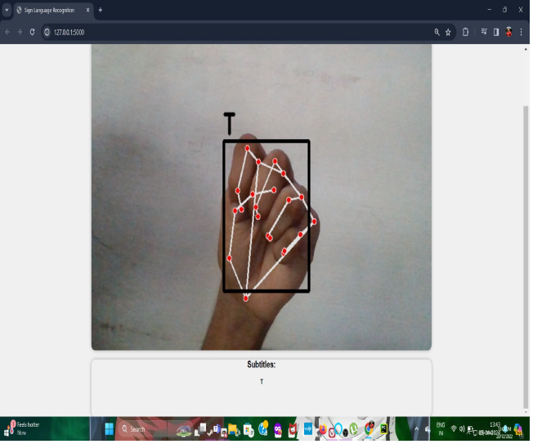 | 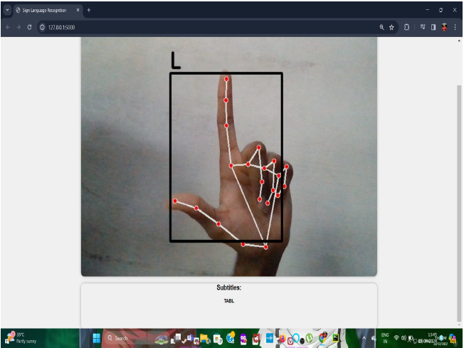
Fig 5.1Letter ’T’ gesture | Fig 5.2 Letter ’L’ gesture
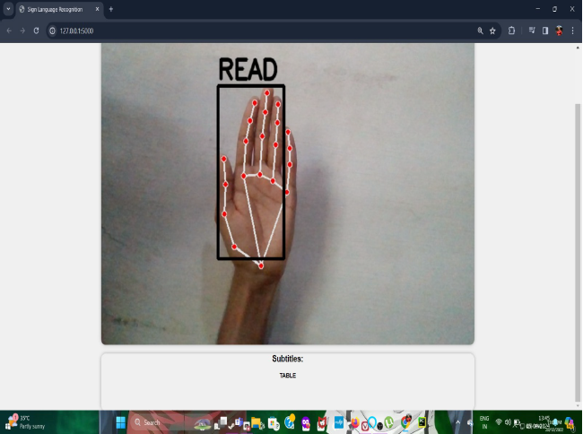 | 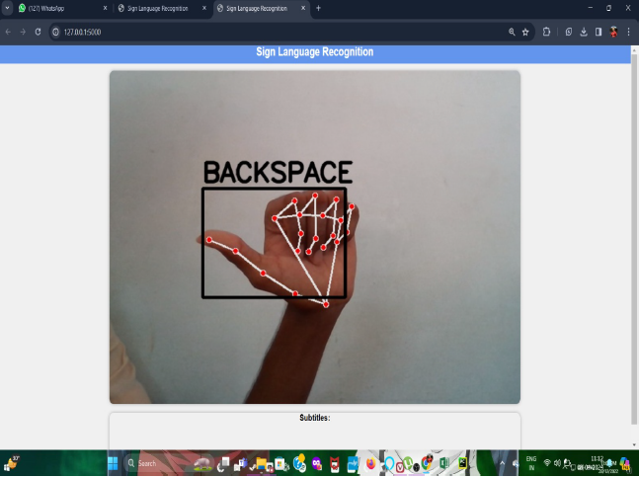
Fig 5.3’READ’ gesture | Fig 5.4’BACKSPACE’ gesture

- CONCLUSION
According to World Health Organization (WHO), more than 5% of the world’s population has hearing loss, i.e., 466 million people, 432 million adults, and 34 million children. Deaf people also need a way to communicate and have developed a language that is directly accessible and useful for them that is called sign language [2]. In the journey towards creating a more inclusive society, the advancement of sign language transaltion algorithms emerges as a beacon of progress. Through continuous refinement and innovation, we have witnessed remarkable strides in enhancing the accuracy and reliability of these algorithms, thereby enabling seamless communication and access to information for the deaf and hard of hearing community. The use of technology reduces isolation, increases independence, and offers social, economic, educational, and other opportunities to deaf/hard-of-hearing people. With dedication, collaboration, and unwavering determination, we can create a world where communication knows no bounds and where every voice is heard and valued.

- REFERENCES
[1] P. Dubey, “Sign language conversion flex sensor based on iot,” International Journal of Research in Engineering and Science (IJRES), vol. 9, no. 2, pp. 69–71, 2021.
[2] D. Sturman and D. Zeltzer, “A survey of glove-based input,” IEEE Computer Graphics and Applications, vol. 14, no. 1, pp. 30–39, 1994.
[3] Y. Wu and T. Huang, “Vision-based gesture recognition: A review. gesture-based communication in human-computer interaction,,” pp. 103– 115, 1999.
[4] T. Johnston and A. Schembri, Australian Sign Language (Auslan): an introduction to sign language linguistics. United Kingdom: Cambridge University Press, Jan. 2007.

