**FINGERPRINT BASED DOOR CONTROLLER**

**Darshan Jagtap, Mangesh, Nitin Pawar, Prof. Pushpendra Singh Chouhan**

Department of Electronic & Communication Engineering

Thakur ShivKumar Singh Memorial Engineering College, Burhanpur,

(Affiliated to RGPV Bhopal), India

**ABSTRACT**

This project presents a fingerprint-based access control system using an 8051 microcontroller, fingerprint reader, and servo motors to enhance security. Users can dynamically manage access permissions via dedicated buttons for adding or removing fingerprints. A buzzer provides auditory feedback for successful operations. This holistic solution ensures only authorized individuals gain entry, offering a reliable, user-friendly interface suitable for various security-sensitive environments.

**INTRODUCTION**

This concept of fingerprint lock is related to security issues in contemporary life. A copy of the physical key can be made at very low cost and the key can be lost or stolen somewhere. To solve these problems, we can use biometric data security equipment and try to further increase security because it is never stolen, never lost, it is very unlikely to be stolen and copied, thus compromising security. Security has always been a major issue for corporate homes and other places, and everyone is concerned about security these days. The solution to such problems may therefore lie in combining door locking with biometrics. A biological test is any method that uniquely identifies an individual by examining one or more biological variables. Its unique features include thumbs, geometric fingers, geometric ears, retina and iris patterns, sound waves, DNA and signatures. The fingerprint scanner captures the user's fingerprints and sends them to the microcontroller to match the fingerprint. If the output matches one of the microcontroller's fingerprint memories, the microcontroller will close or open the latch depending on the current state. If the thumbs don't match, nothing happens. The door lock will unlock and the user must try again. The system will reboot as soon as the record is determined. Here we will use fingerprint for biometric authentication because this is one of the unique things for each person and using thumb as key to lock doors is very important to our homes, shops, offices etc. It is so large that it is impossible to copy the key. In addition, when this system is used instead of traditional locks, it will not cause problems such as losing keys since we do not need to carry keys. Now, with the help of Arduino, we will try to implement things that will increase the system and security level.

Another important reason fingerprint scanners are used is, they provide a quick, easy, efficient, and secure measure through which, an individual with the proper access privileges can authenticate. The fingerprint of an employee for example, is stored in a database that the scanner queries every time it is used. There are two basic Boolean conditions the scanner then goes through when an individual’s print is scanned. First, the print is usually searched for in a database of fingerprints, once it is found it then looks at the print to see what access privileges are associated with the print and compares them to the access they are trying to gain. Fingerprint scanners are also very versatile in the function that they can serve. The most common use may be for access restriction; however, they have served as time clocks, personal data retrievers, and even to cut down on truancy in some schools. Since they have experienced so much success in these areas, businesses are expanding upon their use and they are getting more public exposure

Finger printing recognition, the electronic methods of recording and recognizing an individual finger print, advanced substantially during the last decade of the 21th century. Today, identification can be achieved in a few seconds with reasonable accuracy.

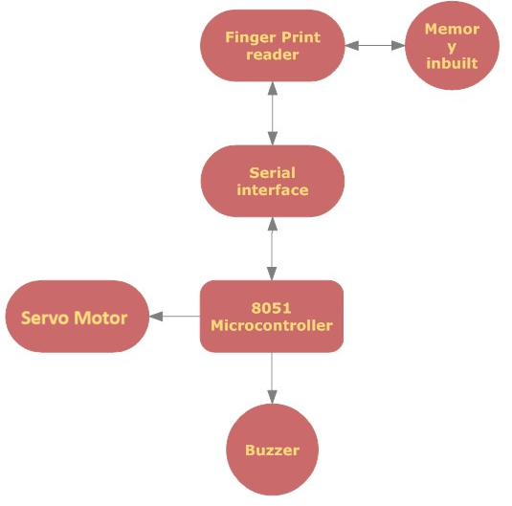

**Fig No: 1** Block diagram of Fingerprint based Door controller

**CIRCUIT DIAGRAM OF METAL DETECTOR**

Power supply Circuit consists of 12-volt adapter and 7805 IC. The second control output (IC 7805) is +5 volts and is used for all other digital functions.

First of all we need to register our fingers into the fingerprint sensing module. For this we need to press the at button for 2 seconds and then place our finger on the fingerprint sensor. The red light of sensor will flash twice that indicates the enrollment process has been completed successfully. Now whenever we put registered finger on the sensor it will transmit valid registration code to the microcontroller. When micro controller received a valid finger code it sends the 90 degree rotation command to the servo motor. The server motor will open the door and automatically close it after 3 seconds.

We have used servo motor instead of DC or AC gear motor because we can control the exact angle of the motor shaft only with server motor. Motor operates on PWM signals so we can easily change the shaft angle by changing the code.

The buzzer will be according to motor operation to alert the user file opening and closing the door to avoid accidents. We can register new person without changing the microcontroller code because we are saving the user data into the fingerprint sensor itself. The delete button provided on the fingerprint controller module will erase the existing user. We need to just put our finger and press the delete button for 2 seconds to delete the user. Long pressing the delete button will delete all the user database.

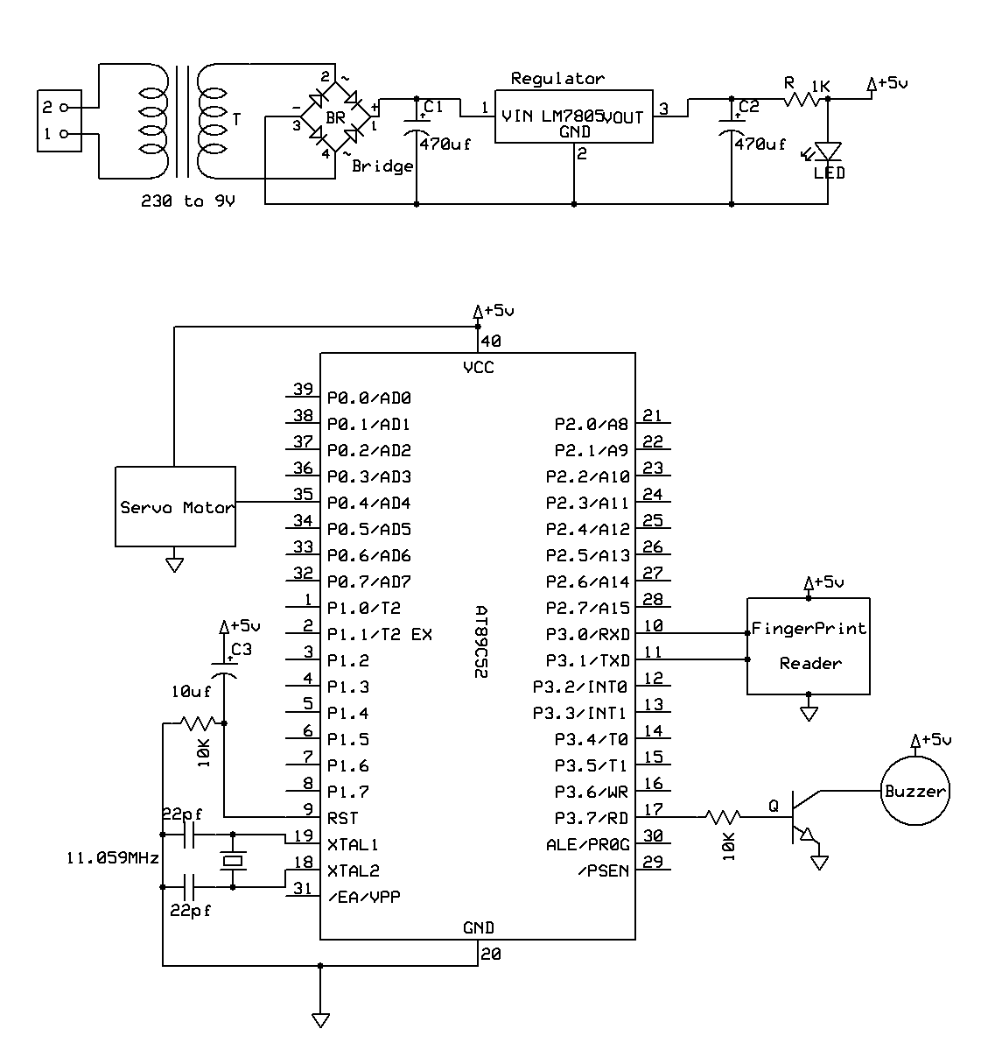

**Fig No: 2** Circuit diagram of Fingerprint based Door controller

**Working Principle of Servo Motor**

A servo motor is basically a [DC motor](http://www.electrical4u.com/dc-motor-or-direct-current-motor/)(in some special cases it is AC motor) along with some other special purpose components that make a DC motor a servo. In a servo unit, you will find a small [DC motor](http://www.electrical4u.com/dc-motor-or-direct-current-motor/), a [potentiometer](http://www.electrical4u.com/potentiometer-working-principle-of-potentiometer/), gear arrangement and an intelligent circuitry. The intelligent circuitry along with the [potentiometer](http://www.electrical4u.com/potentiometer-working-principle-of-potentiometer/) makes the servo to rotate according to our wishes.

As we know, a small [DC motor](http://www.electrical4u.com/dc-motor-or-direct-current-motor/) will rotate with high speed but the torque generated by its rotation will not be enough to move even a light load. This is where the gear system inside a servomechanism comes into picture. The gear mechanism will take high input speed of the motor (fast) and at the output, we will get a output speed which is slower than original input speed but more practical and widely applicable.

**SERVO MOTOR CONTROL SM630 FINGERPRINT MODULE**

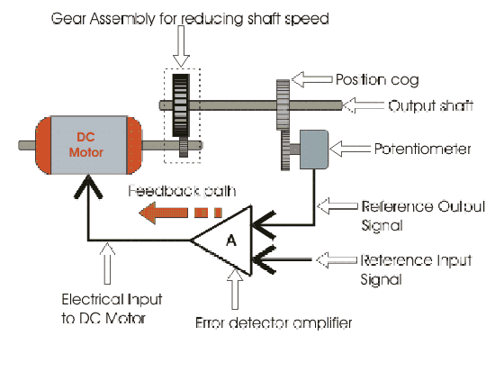 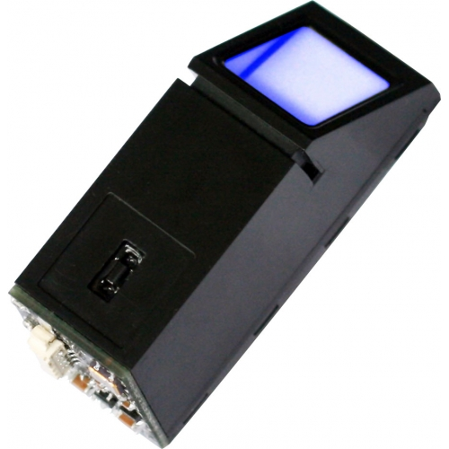

**Fig No: 3** Servo Motor Control **Fig No: 4**  Fingerprint Module

### **Materials Needed for Making PCB**

To start the process, we will first gather all the vital ingredients or materials required for the PCB making. The following fundamental things will be needed for the production

* Copper Clad Laminate
* Ferric Chloride Solution
* Etch Resist Chemical or paint.
* Painting brush or Pen
* Container for etching the PCB
* Drill Machine and Drill Bit.
* Etchant Remover
* Scouring pad, Kitchen Paper

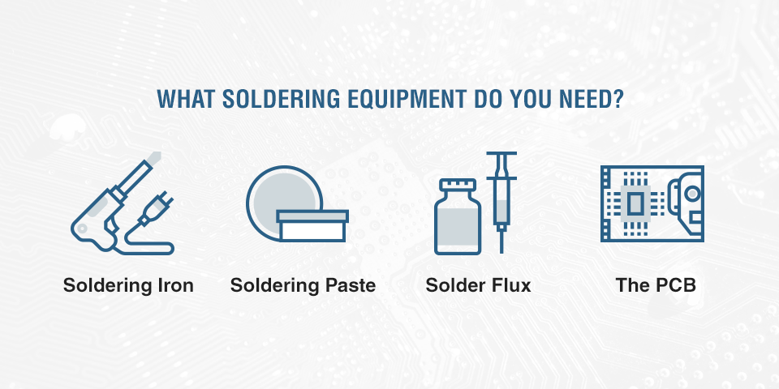

**Fig No: 5** Equipment of PCB Soldering

**PROBLEMS FACED AND MODIFICATIONS:**

We faced problem in setting baud rate for SM630 which operates at 57600 baud rate and later it was modified. SM630 responses in no time which the microcontroller is unable to read, so we used interrupts to store and then read the data as required.

**APPLICATIONS**

1. Public or personal entry control system.
2. If used with relay can control any electric appliance.

**ADVANTAGES**

1. No theft due to finger print detection system
2. Easy to maintain, add and remove users.
3. Small size.

**LIMITATION**

1. Only 200 finger print capacity
2. Slow response of finger reading
3. No undo option

**FUTURE MODIFICATIONS:**

1. Memory of finger print module can be expanded .
2. External memory can be provided for storing the finger print image.
3. Smart Card reader module is supposed to be introduced with the existing module for further security, and to reduce the database storage.

**CONCLUSION**

The design and application of the finger-based door closing system is feasible and simple. This type of door lock is relatively cheaper than the traditional commercially available lock systems. The fingerprint lock system has high accuracy and also features fast fingerprint recognition, helping to connect with users and providing maximum security. Private and public institutions in our country attach great importance to security. Most of the companies want to use this locking system, but the installation costs of the current system are high. Taking into account the installation costs, we have developed a system that should suit the budget of both large and small companies. With advanced developments, the design can be improved and additional features such as multiple locks can be added to the system. For better security, all mechanisms should be placed in front of the door or on the opposite side of the door. Battery systems can also work with solar energy. One of the most important advantages of this system is its simplicity. Many more methods can be applied with the system. The system is safe. The unique fingerprint sensor can detect all fingerprints during testing. Since this system is a closed system, it has disadvantages such as being complex and difficult to change in terms of hardware. It also needs power to run, so getting constant power from the battery can sometimes be a problem. Power outage causes malfunction. In this case, we can connect the system to IPS or add hidden batteries to the system.

**REFERENCES**

* + [www.atlmel.com](http://www.atlmel.com)
  + [www.suprema.com](http://www.suprema.com)
  + [www.8052.com](http://www.8052.com)
  + [www.keil.com](http://www.keil.com)
  + <https://en.wikipedia.org/wiki/Switch>
  + <https://en.wikipedia.org/wiki/Light-emitting_diode>
  + Conte, G., & Scaradozzi, “Viewing ho me automation systems as multiple agents systems”.
  + Alkar, A. Z., & Buhur, “An Internet Based Wireless Home Automation System for Multifunctional Devices”, 2005.

**Reference books:**

1. The 8051 Microcontroller and Embedded Systems, by Ali Mazidi &

Gillispie Mazidi.

2. Embedded Microprocessor Systems: Real World Design by Stuart R. Ball

3. Interfacing with C, Second Edition by Howard Hutchings and Mike James.