**MOTION BASED DOOR OPENER WITH METAL DETECTOR**

**Shanoo Chouhan, Roshani Mahajan, Divyani Mahajan, Prof. Raviraj Singh Sawner**

Department of Electronic and Communication & Engineering

Thakur ShivKumar Singh Memorial Engineering College, Burhanpur,

(Affiliated to RGPV Bhopal), India

**ABSTRACT**

The research focused on a simple way to detect obstacles and paths using an ultrasonic sensor that can detect holes or stairs from up to two meters away. As can be seen, blind people have difficulty making life plans because they cannot see some things. We want to help such people live a free life with our ideas. This modern blind cane has many features that can help blind people navigate the path and recognize obstacles that can really make their lives easier.

**Keywords**: Ultra sonic sensor, Buzzer, light emitting diode Etc.

**INTRODUCTION**

The motion-based automatic door opener is primarily designed to open doors without manual assistance. In hotels, shops, offices, supermarkets, etc. It is difficult to open it manually every time. We are introducing this project that allows the door to open automatically when sensors detect human presence. The system works with PIR sensors (Passive Infrared). The living body emits energy, this energy is detected by the PIR sensor, and as the energy approaches the door, the door opens, and as the energy moves away, it closes. The system can detect all the items the person takes with him and reports this. We can improve the system by incorporating countermeasures to monitor the number of people entering the company. Direction. Thus, it provides a common interface with digital computers. Since the is a proportional motor, the rotor rotates an increasing number of degrees for each input pulse delivered to the motor system. Permanent magnets are connected to the stepper motor. Surrounding the motor body is a series of magnetically active devices that interact with permanent magnets. When the coils open and close, the magnetic field causes the rotor to move. The motor rotates forward or backward as the shutters open and close sequentially. These engines can provide precise positioning without the need for a manual transmission compared to other engines. The position is known only by monitoring the input step pulses. Normally position information can be obtained simply by counting the ,, pulses sent to the motor, eliminating the need for expensive positioning and control feedback. The maximum degree of rotation that the stepper motor changes for a single pulse when fed to a single line or torque is called the step angle. The minimum pitch angle is always a function of the number of teeth in the rotor. That is, the smaller the step angle, the greater the number of teeth of the rotor. Number of steps per full revolution = Number of phases (coil) x Number of teeth in the rotor The smaller the step angle, the greater the number of steps per revolution and the greater the resolution or accuracy of the positions obtained. The angle of the steps can be up to °. The speed of the engine is measured in steps, each time the rotation of the shaft appears continuously when the speed of hormones is high due to command pulses. If the step rate increases too quickly the motor will lose synchronization and stall. Stepper motors are designed to operate for long periods with the rotor held in a fixed position and with rated current flowing in the stator windings whereas for most of the other motors, this results in collapse of back emf and a very high current which can lead to a quick burn out. A stepper motor is a special kind of motor that moves in individual steps.

**METHODOLOGY AND PRINCIPLE OF METAL DETECTOR**

Metal detector is widely used in shopping malls, hotels, cinemas, etc. weapons, explosives, etc. made of steel, widely used to check people, luggage, or bags in places. It is a device used to detect any type of metal or oil. There are different types of metal detectors such as metal detectors, metal detectors and metal detectors. Metal detectors are easy to build and the basic metal circuit is uncomplicated. Weapons, bombs, etc. in our daily lives. We are used to witnessing many metal objects. A security system has been established using various electronic projects that use proximity sensors to prevent the illegal entry of weapons and explosives into public areas. A metal detector is then used to detect nearby metal. Metal detectors are electronic devices used in many places such as theaters, stores and hotels. detecting metallic objects such as metal, firearms or other explosives hidden in that person's luggage. . person responsible for voltage control, any electrical appliance or electronic device that maintains the voltage of an electric current for the permissible period of time. A voltage regulator is needed to keep the voltage within a certain range that the electrical equipment using that voltage can withstand. Transformer can simply be defined as a device that increases or decreases voltage. A step-down converter increases the output voltage and a step-down converter increases the output voltage. The boost converter will reduce the output and the step-down converter will increase the output so that the input and output power of the system will be equal.

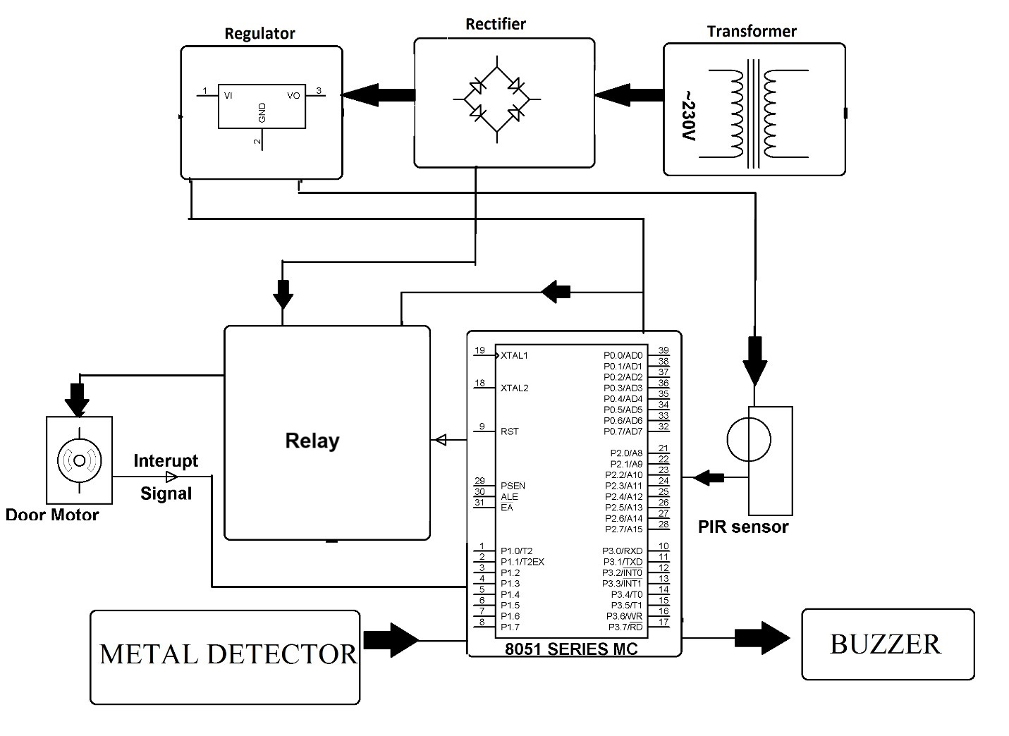

**Fig No: 1** Block diagram of Metal Detector

**CIRCUIT DIAGRAM OF METAL DETECTOR**

When the LC circuit is L1 and C1 receives all the resonant frequencies from all the metal around it, an electric field will be created which will cause current to flow through the coil and change the signal in the coil. Variable transformer is used to convert the sensor to the equivalent in the near LC circuit, it is good to check the value if there is a coil not close to the metal. The LC circuit changes the signal when the sensor is detected. The signal change is transmitted to the adjacent device (TDA 0161), which will display the signal change and operate correctly. The proximity sensor's output will be approximately 1 mA if no metal is detected, or approximately 10 mA if the coil is close to metal. When the output pin is high, resistor R3 will provide positive voltage to transistor Q1. Q1 turns on and the LED lights up and a buzzer sounds. Resistor r2 is used to limit the current. There are three main components in the Metal circuit: LC channel, proximity sensor, LED output and buzzer. The coin and capacitor C1 are connected together, forming an LC circuit.

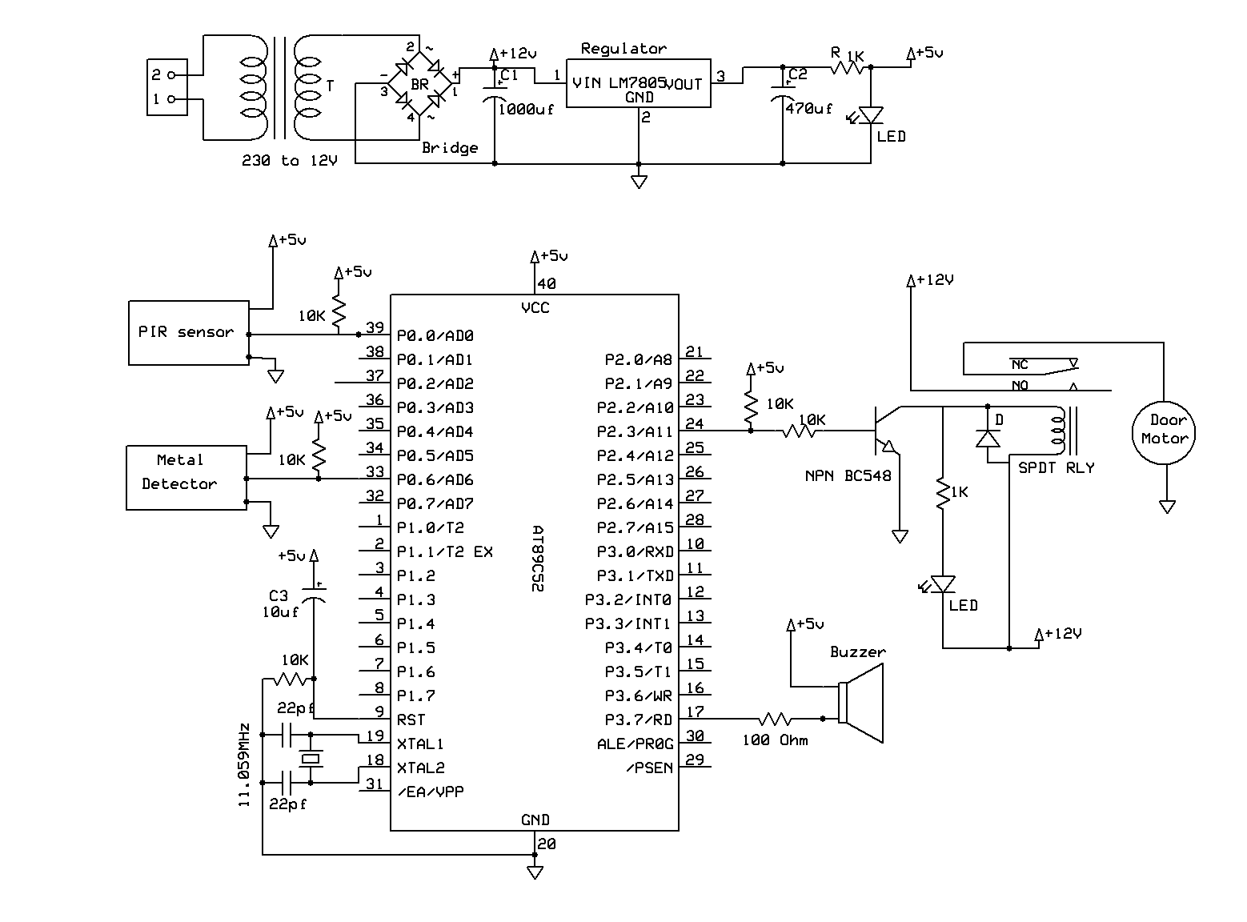

**Fig No: 2** Circuit diagram of Metal Detector

**METAL DETECTOR**

A metal detector is a device that uses electric current to detect the presence of metal. The module usually consists of a transmitting coil that produces a magnetic field and a receiving coil that detects changes in the magnetic field caused by the presence of metal. When a metal object approaches the sensor, it disrupts the magnetic field and the sensor produces an output signal indicating the presence of metal. These types of sensors can be used in a variety of applications such as security systems, industrial applications, and even recreational projects. The output can be digital or analog, and some modules can also provide depth of field. You can use this LC Metal Detector without connection to induction metal detector. It makes a sound when it comes near a metal. It is a method designed to identify metals. The module works by drawing electricity to metal objects and reacting when this occurs. A nice buzzer notifies you when it detects an object, and a potentiometer built into the floor lets you adjust the sensitivity. Electrical Wiring for Metal Detectors Non-contact metal detectors require soldering the positive outside the module and the negative between the potentiometer and electrolytic capacitor for the module to operate. There are different types of metal detectors such as metal detectors, metal detectors and land detectors. Metal detectors are easy to make and the basic metal circuit is not that complicated.

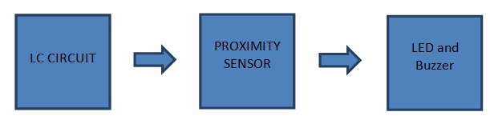

**Fig No: 3** Block Diagram of Metal Detector

There are three main parts in the metal detector circuit: the LC Circuit, the Proximity Sensor , output LED and the Buzzer. The coil and the capacitor C1, which are connected in parallel, will form the LC circuit.

Proximity sensor is triggered by this LC circuit if any metal is detected. The Proximity sensor will then turn on the led and produces alarm using buzzer.

**ADVANTAGE**

1. Automatic Door Opener:- Automatic door opening system is widely used in commercial buildings, shops, theaters etc. It is used in places. This method is used to open the door when a person approaches the door and close the door after they move away from or exit the door. The door was entered. Different types of sensors such as radar sensors, PIR sensors are available in the market to operate such systems.
2. Low power consumption:- With lower voltage comes lower overall power consumption, making a system less expensive to run on any existing battery technology and able to function for longer. This is crucially important for portable or mobile systems.
3. Metal Detector;-Metal detectors work on the principle of transmitting a magnetic field and analyzing a return signal from the target and environment. The transmitted magnetic field varies in time, usually at rates of fairly high-pitched audio signal
4. Design: In semi-arid regions, water stress during seed germination and early fruit development is the main cause of losses. In nature, some seeds (e.g., chia and basil) produce a hydrogel-based liquid that stimulates microbial growth, which retains water, regulates nutrient absorption, and facilitates interaction with beneficial microbes.

**LIMITATION**

1. No person counting:-

2. No human or animal differentiation:-

3. Only large metal detection

**APPLICATIONS**

1. Automatic Door Opening System can be implemented where the door is automatically

opened and closed without any manual control.

2. Since the door is opened only when a person is detected and remains close all other times, it can save a lot of energy in the form air conditioning.

3. Automatic door system with sliding doors can be useful for aged and disabled.

4. Can be implemented with additional features like face detection to track.

**CONCLUSION**

This project was designed with low cost in mind. The equipment has a simple and flexible design and can be used almost anywhere. This circuit can also be built using the CS209A chip or the 555 Timer. A very simple machine model consists of an oscillator that produces an alternating current passing through a coil that produces a magnetic field. If a conductive piece of metal is close to the coil, an eddy current (inductive sensor) is induced in the metal and creates its own magnetic field. If another coin is used to measure the magnetic field (acting as a magnetometer), the change in magnetic field depending on the metal can be detected.

**REFERENCES**

* + 1. https://journals.plos.org/plosone/article?id=10.1371/journal.pone.0198799
    2. <http://www.ghrnet.org/index.php/IJOR/article/view/2068/2425>
    3. <https://en.wikipedia.org/wiki/Photoresistor>
    4. <https://en.wikipedia.org/wiki/Switch>
    5. <https://en.wikipedia.org/wiki/Light-emitting_diode>
    6. A.K.Ray and K.M.Bhurchandi,”Advanced microprocessor and peripherials”,TMH,2000.
    7. Alkar, A. Z., & Buhur, “An Internet Based Wireless Home Automation System for Multifunctional Devices”, 2005.
    8. Conte, G., & Scaradozzi, “Viewing home automation systems as multiple agents systems”.