**INNOVATIVE DESIGN AND FABRICATION OF HIGH ALTITUDE HARVESTING DEVICE FOR FARMING**

**E P Ranganathan 1, Dr.N.Nandakumar2, Dr.S.Periyasamy3** 1Pg Scholar, Department Engineering Design, Government College Of Technology, Coimbatore, Tamil Nadu, India.

2Professor, Department Engineering Design, Government College Of Technology, Coimbatore, Tamil Nadu, India.

3 Professor, Department Engineering Design, Government College Of Technology, Coimbatore, Tamil Nadu, India.

# ABSTRACT

Harvesting fruit from the high altitude trees were challenging and difficult task by the farmers. Conventional method of hand harvesting fruits can have an impact on its quality and require a significant amount of time and labor. In order to minimize these problem current technologies like Robots, drones, and expensive machinery were used. These devices will have high maintenance costs and potentially difficult to use, that may provide a challenge for novice users like agriculture farmers.

The innovate design of a high altitude harvesting device with a flexible arm, and an adjustable telescopic lengthy pole is a creative novel idea to overcome the harvesting issue. In this project work, flexible arm is utilized to mechanically pluck the fruits; With the use of a fabric tunnel connected to a telescopic pole, the harvested fruit is brought to the ground without any damage by gravitational. The telescopic pole's linear guiding rod moment powers the flexible arm, while the rod's twisting moment is responsible for fruit plucking. To shield the fruit from harm, the gripper is composed of lightweight aluminium material .feasibility of gripper components was tested through ANSYS software. The final product is achieved by cutting and joining aluminium material using gas welding, in accordance with the design dimensions.

**Keywords:** Harvesting fruit, High altitude trees, flexible arm, adjustable telescopic lengthy pole***,*** gas welding

# INTRODUCTION

Fruits can be harvested from higher altitudes, roughly equivalent to 15 feet above earth, with the use of innovative design. Getting the fruit at a greater altitude without any harm is more convenient .A 15-foot telescopic pole with an adjustable gripper attached at the top is used to gather fruit, providing an improved solution to the traditional harvesting issue. The gripper's dimensions vary according to the kind of fruit. It is adjusted using the lever that is situated at the telescopic pole's end .Because of a twisting operation performed on the rotating option in the telescopic pole, grabbed fruit is cut from the tree. The fruit from the tree is saved by using a gathering basket. We are able to utilize the design to harvest the fruit of size 5to 25 cm and the Hight of 16feet from the ground .

# 2.ARCHITECTURE OF HARVESTING MACHINE

# Telescopic unit

# The more crucial part of the harvesting apparatus for reaching greater altitudes is the telescopic pole. Three distinct subcomponents with varying diameters and the same height make up the pole. are moved inside of each other at different heights. The telescopic mechanism serves as the basis for the assembly of these parts.

# Gripping Unit

# Gripping unit is the main part of the harvesting device .which is give the output for the entire device. Out put is achieved by gripping and twisting operation of the gripper.

# Operating mechanism

# Two parallelly arranged springs of same length equal to pole lengths are connected by the coupler which is in the middle of telescopic arrangement which is accutaed by the gun operation which is located in the end of telescopic pole .spring tension and compression is the main key for the gripper operation .

Telescopic unit

Operating mechanism

Gripping unit

|  |  |
| --- | --- |
|  | HIGH |
|  | MEDIUM |
|  | LOW |

# LEVEL OF INNOVATION

# Figure 2.1 Level of Innovation

# 3.RESULTS AND DISCUSSIONS

# Design of Telescopic Pole

# This device consists of two aluminum poles that are positioned within one another and vary in length and diameter. Its length can be adjusted from four to ten feet. It is attached to a 2.6-foot-long twisting pole that rotates the gripper unit.

# Table 3.1

|  |  |  |  |
| --- | --- | --- | --- |
| Parameter | Pole 1 | Pole 2 | Twisting pole |
| Length (mm) | 1200 | 1600 | 800 |
| Diameter (OD) (mm) | 32 | 25.5 | 33 |
| Diameter (ID) (mm) | 26 | 21 | 27 |

# Design Of Gripper

Gripper is the assembly of gripper base, gripper ring and gripper finger .Each components are made in specific dimension to form gripper. Centrally assembled spring is employed in gripper opening and closing operation which is operated through the gun arrangement which is locate d at the of telescopic pole .

# Table 3.2

|  |  |  |  |
| --- | --- | --- | --- |
| Parameter | Gripper Base | Gripper Ring | Gripper Finger |
| Length (mm) | 80 | - | 60mm ,40mm |
| Diameter (mm) | 35 | 35 | - |

Each component is designed in NX software and its feasibility was tested in ANSYS software and the results are.

**Gripper Base**

gripper base designed in desire dimension and it tested in the ANSYS software to identify the failure modes . The gripper ring is made up of nylon material and it tested in 50N maximum load Condition. maximum and minimum stress value for the given load is 0.158N/mm2 and 0.001N/mm2 respectively. strain is constant is throughout the base that is 100. displacement is in the range of 0 to 6.978X10^-5mm.

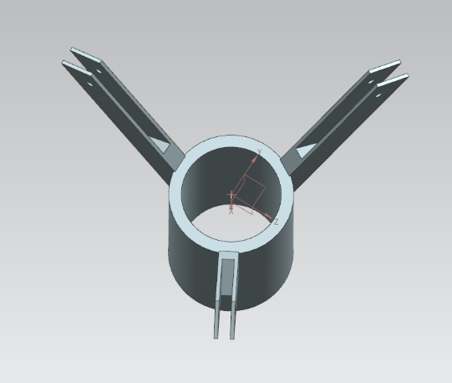

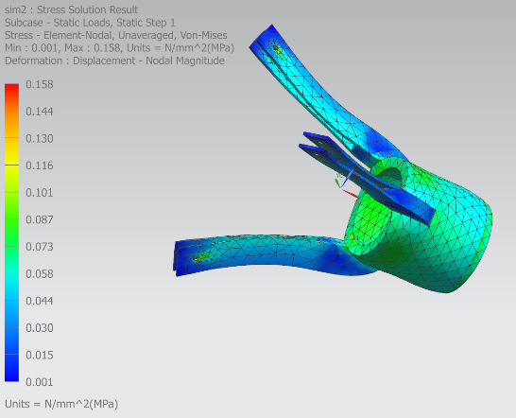

# Figure 3.1 CAD Model Of Gripper Base Figure 3.2stress Value Of Gripper Base

# 

Figure 3.3 Strain Value Of Gripper Base Figure 3.4 Displacement Of Gripper Base

**Gripper ring**

Gripper Ring Designed Based On The Gripper Base And Finger and it tested in the ANSYS software to identify the failure modes . the gripper ring is made up of aluminium material and it tested in 50N maximum load Condition .maximum and minimum stress value for the given load is 4.592N/mm2 and 0.002N/mm2 respectively. Maximum and Minimum strain is 47.26 and 100 respectively. displacement is in the range of 0 to 0.001343mm.

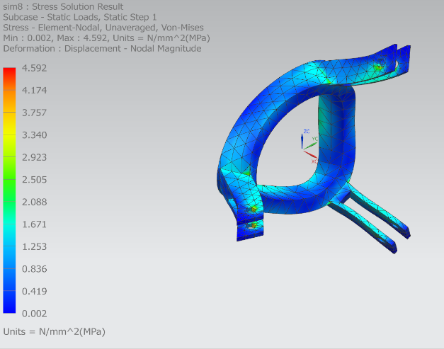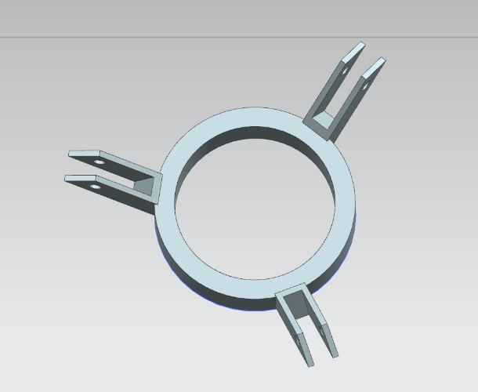

# Figure 3.5 CAD Model Of Gripper Ring Figure 3.6 stress Value Of Gripper Ring

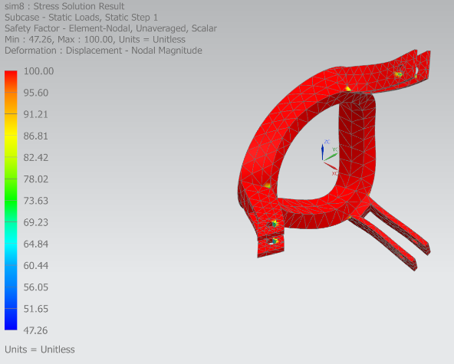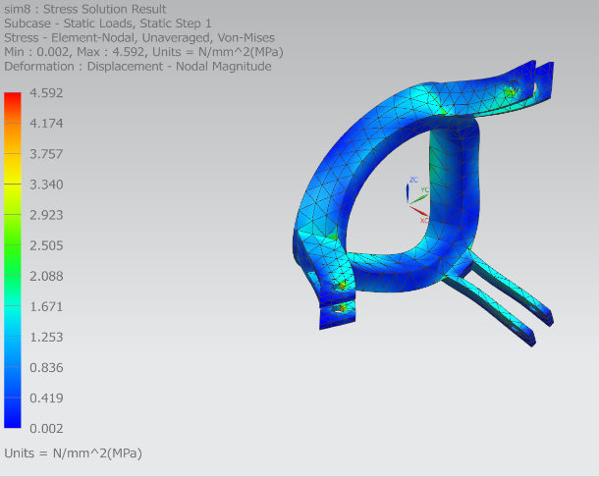

Figure 3.7 Strain Value Of Gripper Ring Figure 3.8 Displacement Of Gripper Ring

**Gripper finger**

Gripper finger is tested in the pressure of 0.5N/mm2and the FEM result are below. the stress is in between 9.786X10^-23N/mm2 to 1.32X10^-6N/mm2. strain is constant is throughout the base that is 100.displacement is in between 0 to 2.468X10^-11mm.

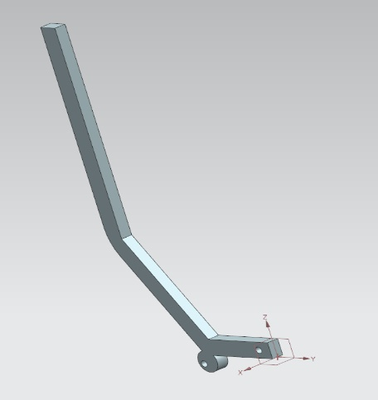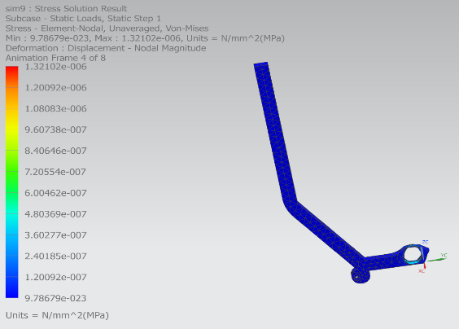

# Figure 3.9 CAD Model Of Gripper Finger Figure 3.10 stress Value Of Gripper Finger

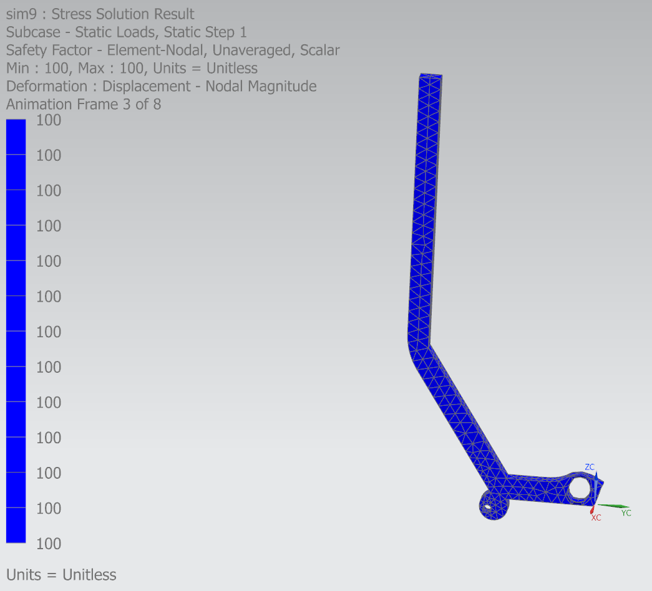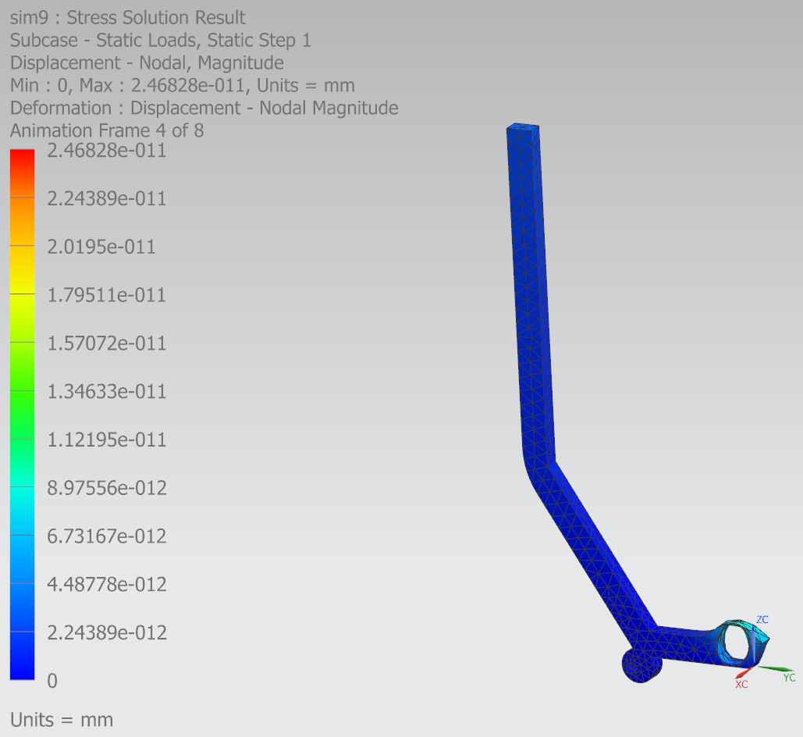

Figure 3.11 Strain Value Of Gripper Finger Figure 3.12 Displacement Of Gripper Finger

**Gripper assembly**

Each components of the gripper are assembled in assembly module to form a complete harvesting device.

All the components in the assembly are mated with another by means of specific constrains used.

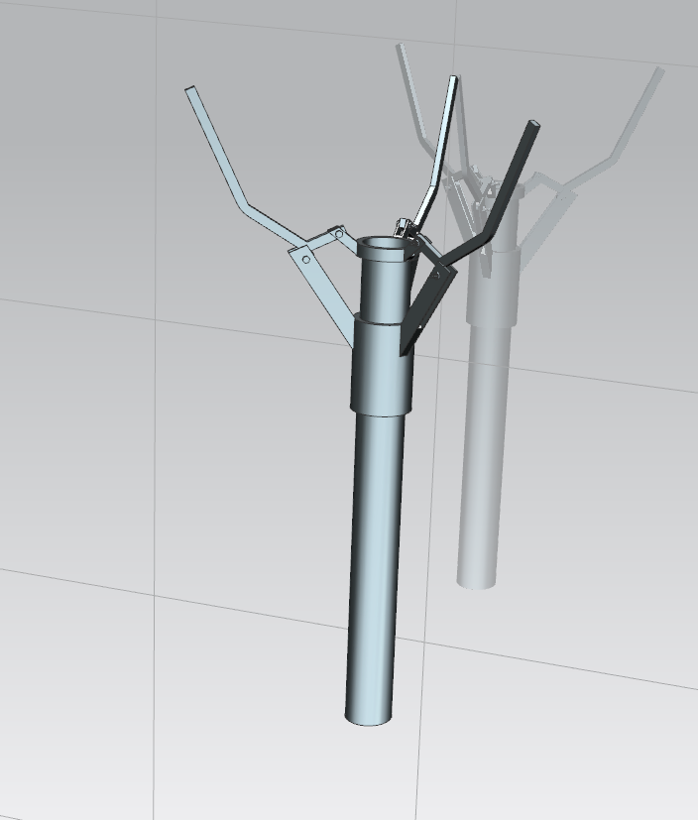

Figure 3.12 Assembled View Of Gripper

**Fabrication harvesting machine**

The fabrication of the harvesting device is done by the cutting and welding of the aluminum material in desired shapes and size. CNC machining is done to get the accurate dimensions of gripper assembly. gripper components are bolted together and the hole assembly is welded with telescopic assembly. inside of the telescopic pole two parallel spring rope is connected in between of gripper and end operator . This springs are actuate the gripper when the gun is actuated by the user .getting immediate action on the gripper compression helical spring is used at gripper center.

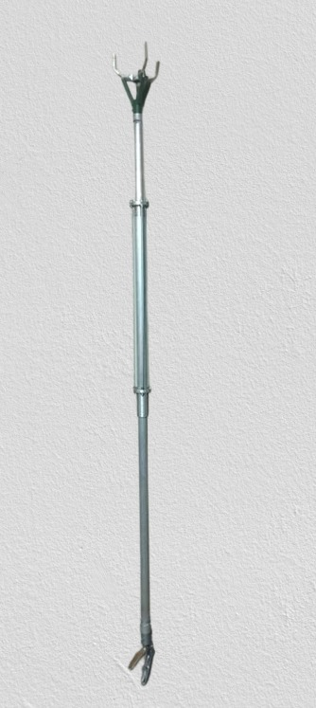

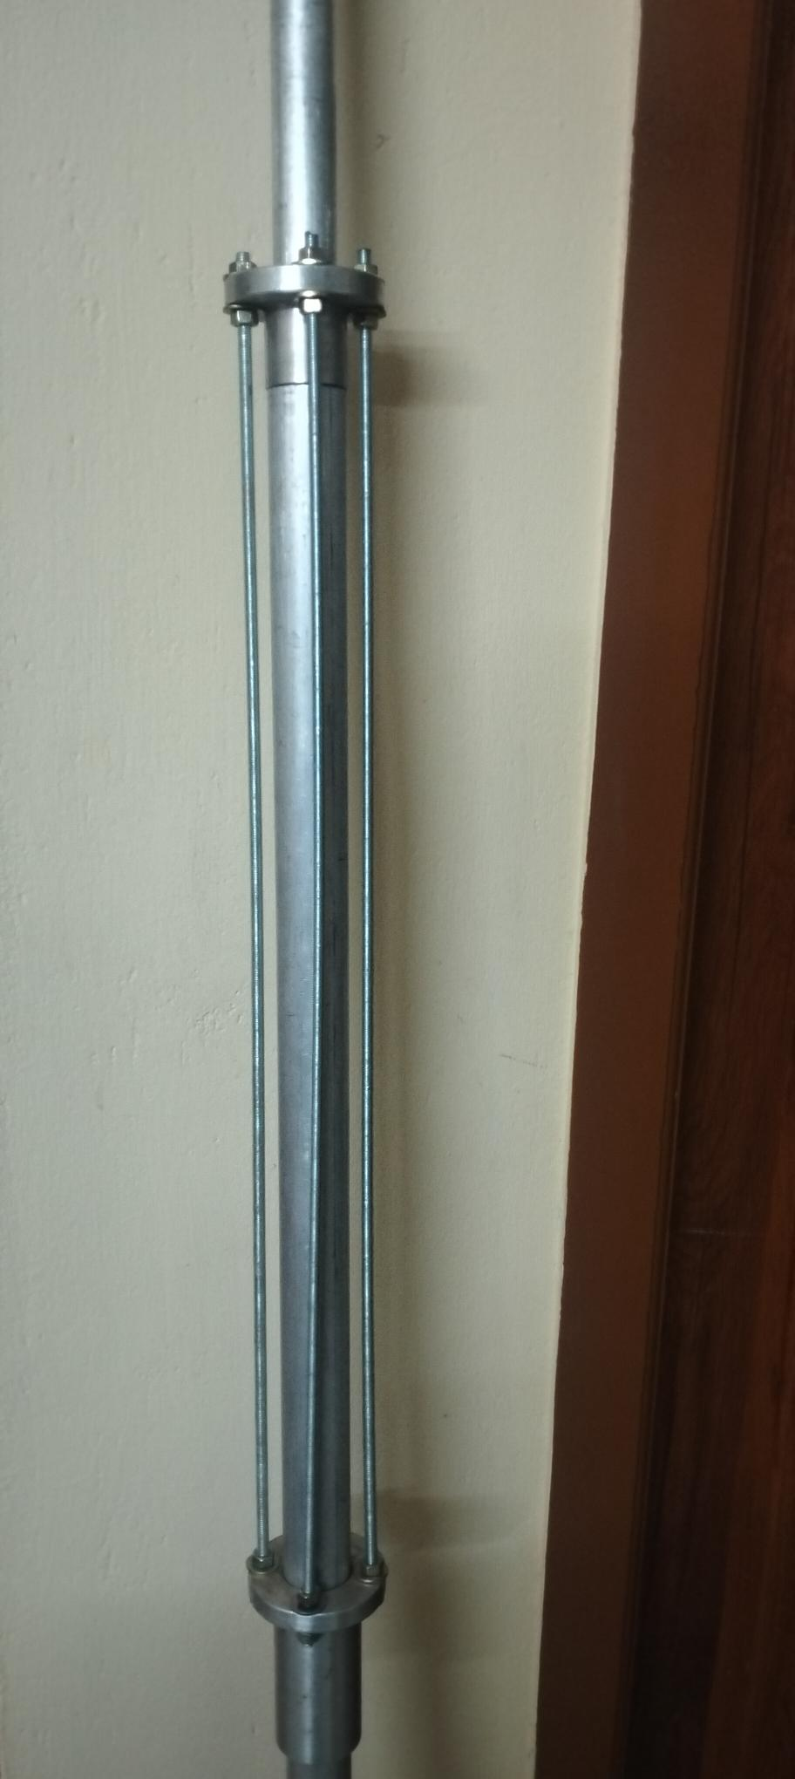

Figure 3.13 Fabricated Model Of Harvesting Device

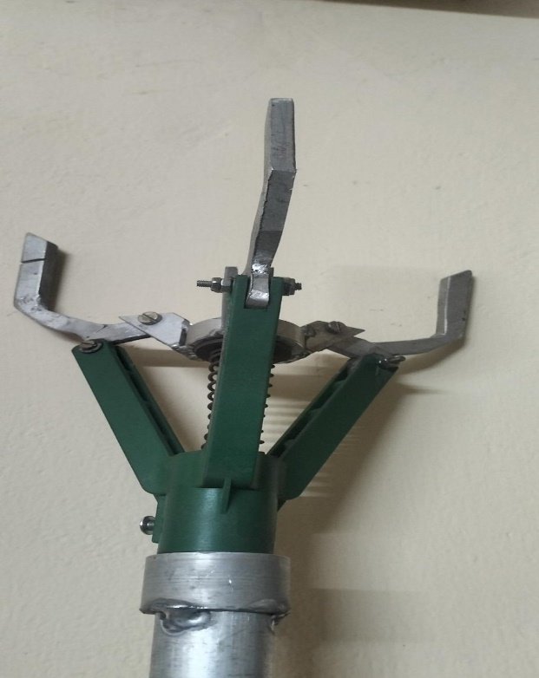

Figure 3.15 Fabricated Model Of Twisting Unit

Figure 3.14 Fabricated Model Of Gripper

**Define Values and Weightage**

The product is categorized under five main categories and its value is assessed using essential factors that define the product in every way. Every classification is assigned a percentage out of 100, determined by the arrangement. The final five categories fall under the three consumer decision criteria, which are likewise ranked in terms of percentage likelihood to purchase the product.

**Table3.3**  **Table3.4**

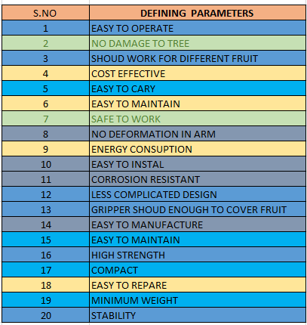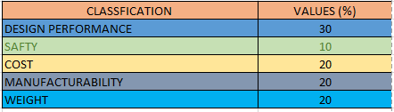

**Table3.5**

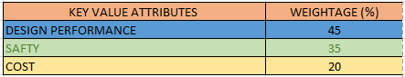

# 4.CONCLUSIONS

An innovative device has been designed and thoroughly analyzed to successfully address the problem of harvesting fruit at higher altitudes. The apparatus is designed to gather fruit at an elevation of approximately 16 feet. The fruit can range in size from 5cm to 25 cm in length and diameter. Gripper is designed based on the safety aspects of the fruit and the capability of the gripper is checked through the ANSYS software. Each component of the gripper is with in the expected range of stress ,strain and displacement Based on the design and analysis fabrication of the harvesting device is done successfully. Finally the customer requirements are assessed in different ways and match with current futures of the product. The product full fill customer in different way like performance ,safety and cost

In the level of 45%,35%,and 20% respectively .

# 5.REFERENCES

[1].P. Murugan, A.Naveen kumar, M.Prabhu, M.Bharani, Mr.R.Ruthuraraj P.A., 2020.

Fabrication of Fruit Harvesting Machine. IJIRT,pp 2349-6002

[2].Lokhande, P., Gawand, S., Mandavkar, S., Kadam, V. and Kharade, P.A., 2019. Agriculture based fruit plucking robot. Int. Res. J. Eng. Technol.(IRJET), 6(4), pp.2395-0056.

[3].Mohamed, T., 2017. An Innovative System for Picking Mango Fruit. Journal of Soil Sciences and Agricultural Engineering, 8(9), pp.411-420.

[4].Homayouni, T., 2021. Enhancing Mechanical Fruit Harvesting Machines Based on Vibration Analysis. University of California, Merced.

[5].Zheng, L., Xu, L. and Chen, X., 2019, April. Design of Portable Fruit Picking Device. In IOP Conference Series: Materials Science and Engineering (Vol. 490, No. 7, p. 072044). IOP Publishing.

[6]. Sanders, K.F., 2005. Orange harvesting systems review. Biosystems Engineering, 90(2), pp.115-125.

[7]. Zhao, Y., Gong, L., Liu, C. and Huang, Y., 2016. Dual-arm robot design and testing for harvesting tomato in greenhouse. IFAC-PapersOnLine, 49(16), pp.161-165.

[8]. Li, P., Lee, S.H. and Hsu, H.Y., 2011. Review on fruit harvesting method for potential use of automatic fruit harvesting systems. Procedia Engineering, 23, pp.351-366.

[9]. Ashwini, K., 2016. Survey paper on fruit picking robots. Int. J. Comput. Sci. Mob. Comput, 5(1), pp.96-101.

[10]. Font, D., Pallejà, T., Tresanchez, M., Runcan, D., Moreno, J., Martínez, D., Teixidó, M. and Palacín, J., 2014. A proposal for automatic fruit harvesting by combining a low cost stereovision camera and a robotic arm. Sensors, 14(7), pp.11557-11579.

[11]. Yamamoto, S., Hayashi, S., Saito, S., Ochiai, Y., Yamashita, T. and Sugano, S., 2010. Development of robotic strawberry harvester to approach target fruit from hanging bench side. IFAC Proceedings Volumes, 43(26), pp.95-100.

[12]. Hayashi, S., Shigematsu, K., Yamamoto, S., Kobayashi, K., Kohno, Y., Kamata, J. and Kurita, M., 2010. Evaluation of a strawberry-harvesting robot in a field test. Biosystems engineering, 105(2), pp.160-171.

[13]. El-Termezy, G., Abd El Hamid, S. and Sabry, H., 2022. Development of a Fruits Harvesting Machine. Middle East Journal of Agriculture Research, 11(01), pp.01-10.

[14].El-Iraqi, M.E., El Khawaga, S.E. and Awais, T.R., 2012. Design and fabrication of an extraction machine for tomato seeds. Misr Journal of Agricultural Engineering, 29(1), pp.39-60.

[15]. Guturu, K., Sahitya, K., Komali, V.N., Kiran, B.R. and Satyanarayana, C.V., 2015. Design and Fabrication of prototype telescopic raising platform for harvesting oil palm fresh fruit bunches. Indian Journal of Science and Technology, 8(17),pp.1-5.

[16]. Shamsi, M., 1998. Design and development of a date harvesting machine.

[17]. Berthet, J.P. and Le Briquer, T., CNH Amercia LLC, 2012. Fruit harvesting machine having a motorised support structure and suspension frame. U.S. Patent 8,336,283.

[18]. Patil, M.M., Kad, V.P., Yenge, G.B. and Shelke, G.N., 2021. Design, Fabrication and Evaluation of a Motorized Fruit Juice Extractor-A Reveiw. Journal of Agriculture Research and Technology, 46(3), p.309.

[19]. Sarig, Y., 1993. Robotics of fruit harvesting: A state-of-the-art review. Journal of agricultural engineering research, 54(4), pp.265-280.

[f20]. Hamedon, Z., Zahid, M.N.O., Tomadi, S.H., Noor, M.M. and MJ, M.R., 2008, December. Design and fabricate the prototype of a motorized cutter for harvesting palm fruit. In Malaysian Science and Technology Congress, MSTC08 (pp. 16-17).