DESIGN AND FLOW ANALSYS OF DIESEL ENGINE MUFFLER
V.Shalini¹, E. Venkatesh², P. Akhil³, V. Abhilash⁴, Y. Kushal Reddy⁵
¹ Assistant Professor, Department of Mechanical Engineering, Ace Engineering College
^{2, 3,4,5} Students, Department of Mechanical Engineering, Ace Engineering College
ABSTRACT

Noise pollution is the major drawback of I.C. engines. Automotive engineers and researchers have been working consistently on reducing automotive noise as well as pollution. Automobile Engineering is one of the fields where advancements are witnessing a steep upward trend. On comparing with early design, the recent automobiles were highly efficient and were formed with sophisticated systems. However, the area that still demands improvisation in automobiles Design exists in areas like fuel economy, efficiency, and exhaust systems.
Exhaust systems focus primarily on reducing the emission of pollutants into the atmosphere and also on controlling the sound that comes through exhaust. Mufflers make use of different techniques.and components to reduce the noise.Usually the noise is reduced when the transmission loss increases inside the muffler.
In this work, the focus was on altering the design of a muffler to further reduce the noise and increasing the performance of the muffler. This is carried out by designing and using flow. Simulation through the muffler. Different materials have been modeled, and CFD gas flow Simulation has been carried out on different materials under various boundary conditions. based upon the gas flow through them. On comparison, we have selected the optimum model, for which the Performance is best, and sound reduction is maximum. The geometry of the model is prepared in CATIA V5 and analysis are carried out in ANSYS 2024 R2 using computational fluid dynamics. (CFD).

INTRODUCTION

Automobile engineering is the one of the stream of mechanical engineering. It deals with the various types of automobiles, their mechanism of transmission systems and its applications. Automobiles are the different types of vehicles used for transportation of passengers, goods, etc. Basically all the types of vehicles works on the principle of internal combustion processes Different types of fuels are burnt inside the cylinder at higher temperature to get the transmission motion in the vehicles Therefore, every mechanical and automobile engineer should have the knowledge of automobile its mechanism and its various applications.

1.1 AUTOMOBILE
Automobile engineering is a branch of engineering which deals with everything about automobiles and practices to propel them.
Automobile is a vehicle driven by an internal combustion engine and it is used for transportation of passengers and goods on the ground. Automobile can also be defined as a vehicle which can move by itself.
Examples: Car, jeep, bus, truck, scooter, etc.

1.2 EXHAUST AND EMISSION CONTROL SYSTEMS
The exhaust system quiets the noise produced during engine operation and routes engine exhaust gases to the rear of the vehicle body. Trace the flow of exhaust gases from the engine exhaust manifold to the tailpipe Learn the names of the parts. Various emission control systems are used to reduce the amount of toxic (poisonous) substances produced by an engine. Some systems prevent fuel vapors from entering the atmosphere (air surrounding the earth). Other emission control systems remove unburned and partially burned fuel from the engine exhaust.

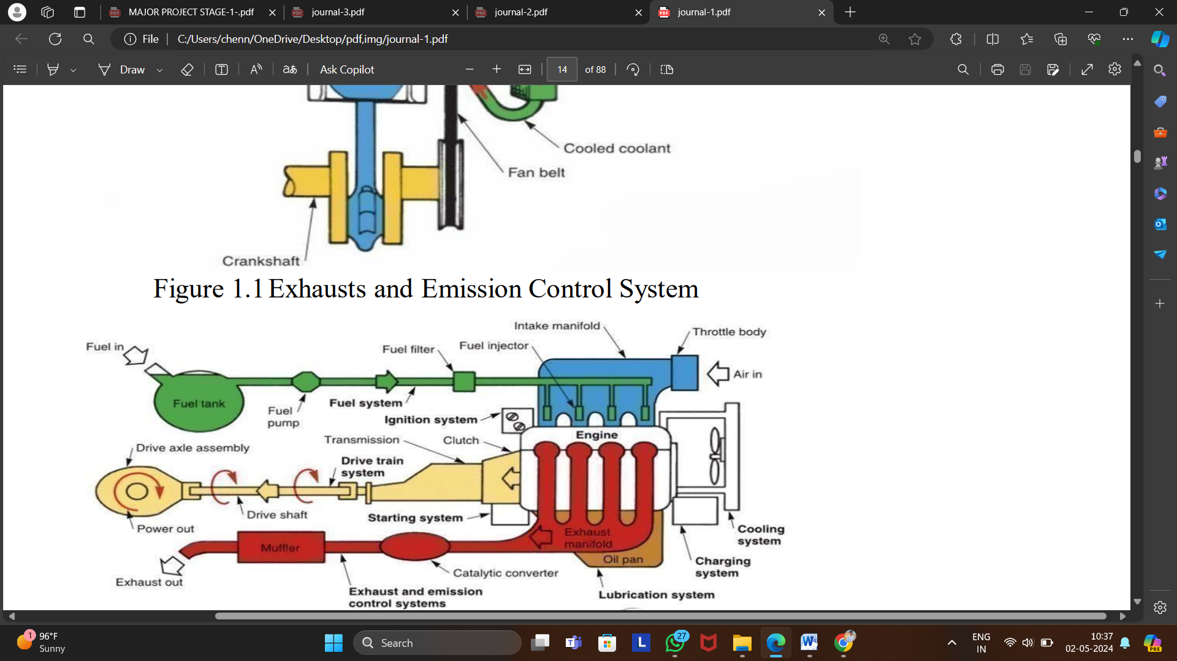
Figure 1.1 Automotive Systems

1.3 EFFECTS TO HEALTH OWING TO AUTOMOBILE EMISSIONS
The emissions from millions of vehicles add up. These emissions are by products from the engine combustion process and from the evaporation of fuel. Despite the ever-growing number of vehicles on the road, studies show that ten to thirty percent of vehicles cause the majority no vehicle-related air pollution.
1.3.1 Carbon Monoxide
Carbon monoxide is a colorless, our less, poisonous gas emitted from the vehicle's exhaust as a result of incomplete combustion. It interferes with the blood's ability to carry oxygen to the Brain, heart, and other tissues. Un born or new-born children and people with heart disease are in greatest danger from this pollutant, but even healthy people can experience headaches, fatigue and reduced reflexes due to CO exposure.
1.3.2 Toxic Air Pollutants
Toxic air pollutants such as benzene and formaldehyde are substances from automobile emissions that are known to cause or are suspected of causing cancer, genetic mutation, Birth defects, or other serious illnesses in people even at relatively low levels. The chemicals can be inhaled directly or carried by small particles (dust or lint) into the lungs.

1.4 INTRODUCTION TO EXHAUST SYSTEMS
A typical exhaust system comprises of a combination of metallic pipes for carrying out the toxic emissions released by the combustion of gases, more often from auto engines. The efficient working of an exhaust is essentially needed for the safe and reliable running of vehicles. The latest exhaust systems are designed to clean the gases before throwing them out in the atmosphere. Modified systems facilitate a smoother flow of gases, and thus enhance the efficiency of engines.
If exhausted gases are not released appropriately, they could prove dangerous on entering the passenger section of the vehicles. Once released. the exhausted gases first reach the piping system of the exhaust. Since the engine generally comprises of more than one cylinder, various pipes are suitably installed to collect the gases from different cylinders to gather them together, before being fed to one single pipe, from where they are released into the atmosphere. The gases keep moving to the rear part of the vehicle, and they are continuously pushed ahead by the gases being continuously released by the engine.
Next, the gases enter the converter before reaching the exhaust system. The function of the convertor is to eliminate the harmful materials Contained in the gases. So, the gases that leave the converter are not as harmful as those entering it. Subsequent to that, the gases pass through a muffler, the main function of which is to significantly reduce the noise produced by the running engine. And at last, the exhaust leaves the system via a tailpipe. The present exhaust system of cars can be modified to slightly enhance the performance of the engine. This can be achieved by minimizing the friction and resistance offered by the system to enable the exhaust to travel faster and more easily. This enhances the efficiency of the engine. Friction can be reduced by making the interiors of the pipe smoother with the help of specially meant after sale parts

1.4.1 MUFFLER
A muffler (silencer in many non US English speaking countries) is a device for decreasing the amount of noise emitted by the exhaust of an internal combustion engine.
1.4.2 Description
Mufflers are installed within the exhaust system of most internal combustion engines, although the muffler is not designed to serve any primary exhaust function. The muffler is engineered as an acoustic soundproofing device designed to reduce the loudness of the sound pressure created by

the engine by way of acoustic quieting. The majority of the sound pressure produced by the engine is emanated out of the vehicle using the same piping used by the silent exhaust gases absorbed by a series of passages and chambers lined with roving Fiberglass insulation and/or resonating chambers harmonically tuned to cause destructive interference wherein opposite sound waves cancel each other out An unavoidable side effect of muffler use is an increase of back pressure which decreases engine efficiency. This is because the engine exhaust must share the same complex exit pathway built inside the muffler as the sound pressure that the muffler is designed .
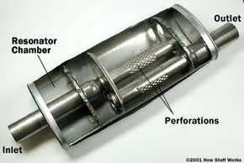
Figure 1.2 Muffler

When the flow of exhaust gases from the engine to the atmosphere is obstructed to any degree back pressure arises and the engines efficiency, and therefore power, is reduced Performance oriented mufflers and exhaust systems thus strive to minimize back pressure by Employing numerous technologies and methods to attenuate the sound. For the majority of such systems however, the general rule of more power, more noise applies.
Several such exhaust systems that utilize various designs and construction methods: Vector muffler: for larger diesel trucks, uses many concentric cones, or for performance automotive applications, using angled baffles to cause exhaust impulses to cancel each other out.
Spiral baffle muffler for regular cars, uses a spiral shaped baffle system.

1.6 NOISESTANDARD IN INDIA
The central pollution control board constituted committee on noise pollution control. The committee recommended noise standards for ambient air and for automobiles according to various zones are as follows.

Area | Day time noise(db) | Night time noise limit(db)
Industrial area | 75 | 70
Commercial area | 65 | 55
Residential area | 35 | 45
Silence zone | 50 | 40

Table 1.1 Noise Standards In INDIA

The Noise Limits for vehicles were notified by Environment (Protection) Amendment Rules, 2000. Noise limits for vehicles applicable at manufacturing stage applicable from 1st April, 2005 are as given in the table below:
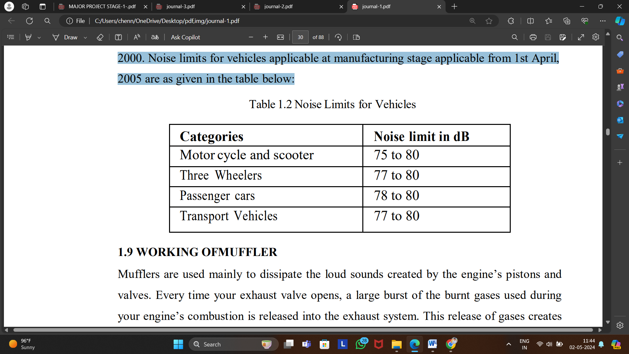
Table 1.2 Noise Limits for Vehicles

1.7 WORKING OF MUFFLER
Mufflers are used mainly to dissipate the loud sounds created by the engine’s pistons and valves. Every time your exhaust valve opens, a large burst of the burnt gases used during your engine’s combustion is released into the exhaust system. This release of gases creates very powerful sound waves. To understand how a muffler dissipates the sound waves created by your engine, one must understand how sound is produced. Sound is a pressure wave formed by vibrations. These vibrations are pulses of alternating high and low air pressure.
So, every time your exhaust valve opens, a very high-pressured gas enters into the exhaust system. These high-pressure gases will collide with low-pressure molecules, create pressure waves (sound), and travel through the exhaust system. Sound can actually be cancelled out. If you can introduce a pressure wave that is the exact opposite of the initial sound wave, meaning their wavelengths, or high- and low-pressure points, are opposite, they cancel each other out, and there is no sound. Another way to describe what happens is when one sound wave is at its maximum pressure, the other sound wave is at its minimum pressure; so, they cancel each other out. This is called destructive interference and is what occurs inside your muffler.
A muffler design is very simple yet very precise. Inside a muffler there are tubes with perforations that direct the sound waves through the inside of the muffler and out the end. Sound waves will enter through a central tube, hit the back wall, pass through a hole and enter the center chamber. Then the sound wave will travel through another hole and enter the resonator chamber, which is back towards the front of the muffler where the sound waves first entered.

LITERATURE REVIEW

1.Amit KumarGupta, Dr. Ashesh Tiwari ,Mufflers are device which are installed within the exhaust system. It is basically used for noise reduction. Reactive muffler plays an important role as noise control element for reduction of automotive exhaust noise, fan noise, and other noise sources involving the flow of gases. Mufflers are typically arranged along the exhaust pipe as the part of the exhaust system of an internal combustion engine to reduce its noise. The expansion chambers with various cross section like Circular, Elliptical, Square & Rectangular are commonly use for noise attenuation. The degree of attenuation can also be improved with design optimization of inlet pipes, outlet pipes & baffle plates. The present paper aims to concentrate to study the acoustic performance of reactive mufflers with various cross sections by one-dimensional wave approach. Here the result shows to identify the transmission loss characteristics by taking different cross sections of simple expansion chambers by taking consideration of constant volume of expansion chamber.

2.Ayush Lal ,Considered CFD Analysis of Flow through Muffler to Select Optimum Muffler Model for CI Engine Mufflers increase the pressure of the exhaust gases (back pressure) thereby reducing the sound levels of the same. Therefore importance is given to muffler designing and a particular design is selected for which the sound reduction is maximum. for this exhaust gas CFD simulation is carried in software's such as ANSYS FLUENT. Two muffler designs have been modelled and CFD gas flow simulation has been carried in both of them. Based upon the gas flow through them, on comparison we have selected the optimum model.
Demonstrates that model is more efficient for noise reduction and other design offers more reduction in gas pressure and hence reduces noise levels.

3.Balraj.D.Kawade, Niranjan D.Khaire,Discussed on Design alternatives for automobile silencer. The exhaust gases coming out from engine are at very high speed and temperature. Silencer has to reduce noise, vibrations. While doing so it is subjected to thermal, vibration and fatigue failures which cause cracks. So it is necessary to analys the Vibrations which would further help to pursue future projects to minimize cracks, improving life and efficiency of silencer. For
silencer vibration analysis we can use FEM simulation methodology described as a better solution over conventional trial and error method for predicting the errors in modal analysis. Natural frequencies can be determined and the mode shapes can be reviewed in the light of its performance contributing to any increased like hood of undesired trends.

4.Prof. Bharat S. Patel, Mr. Kuldeep, D. Patel ,The purpose of this paper is to present Air pollution generated from mobile sources is a problem of general interest. Vehicle population is projected to grow close to 1300 million by the year 2030. Due to incomplete combustion in the engine, there are a number of incomplete combustion products CO, HC, NOx, particulate matters etc. This review paper discusses automotive exhaust emissions and its impact, automotive exhaust emission control by platinum (noble) group metal based catalyst in catalytic converter, history of catalytic convertor, types of catalytic convertor, limitation of catalytic convertor and also achievements ofcatalytic convertor.

5.Jayashri P. Chaudhari and AmolB. Kakade ,Considering different noise parameters produced by the engine. Here different design parameters with ammonia pulsator have been considered to improve the efficiency & emission control of the absorptive muffler. Considering different noise parameters produced by the engine. Here different design parameters with ammonia pulsator have been considered to improve the efficiency & emission control of the absorptive muffler. His Aim is to design, develop and analysis of mathematical modelling and derivation of dimensional parameters of absorptive muffler with ammonia pulsator using UG NX-8.0 and ANSYS workbench. The formulated muffler traditional design problem will be solved by new design and optimization.

METHODOLOGY

3. STEPS AND METHODOLOGIES:

Performance evaluation
Flow analysis methodology
Geomertry design
Material selection
Sensitivity analysis
Material comparison

Figure 3.1: Methodology of flow chart
Designing and analyzing a muffler involves several steps and methodologies:
- MATERIAL SELECTION: Choose materials suitable for muffler construction, considering factors like temperature resistance, corrosion resistance, and weight.
- Materials like aluminium-Aluminum is lightweight, corrosion-resistant, and offers good thermal conductivity, making it suitable for muffler design. Its versatility allows for intricate designs, optimizing acoustic performance and exhaust flow. However, it may require thicker sections for structural integrity, and specialized welding techniques are needed for fabrication.
Top of Form
- Titanium-Titanium's exceptional strength-to-weight ratio, corrosion resistance, and high-temperature performance make it ideal for high-performance muffler design. Its lightweight construction improves vehicle performance, while its durability ensures long-term reliability. However, titanium's high cost and difficulty in fabrication limit its widespread use in automotive applications.
- Stainless steel-Stainless steel is a popular choice for muffler design due to its excellent corrosion resistance, strength, and durability. It offers versatility in fabrication, allowing for complex designs. While slightly heavier than other materials, stainless steel mufflers provide cost-effective performance and aesthetic options for a wide range of vehicles.
- Nickel alloy-Nickel alloys offer superior high-temperature resistance and corrosion resistance, making them suitable for muffler applications exposed to extreme heat and corrosive exhaust gases. Their robust properties ensure durability and performance, especially in high-performance and specialty automotive exhaust systems.

- GEOMETRY DESIGN: Designing a muffler in CATIA V5 involves several steps:
- Sketching: Begin by sketching the basic profile of the muffler's outer shell using the Sketcher workbench.
- Extruding: Use the Pad feature to extrude the sketch profile to create the main body of the muffler.
- Hollowing: Hollow out the muffler body using the Shell command to create the internal cavity.
- Fillet and Chamfer: Apply fillets and chamfers to smooth out edges and improve aerodynamics.
- Validation: Validate the design using analysis tools to ensure structural integrity, acoustic performance, and exhaust flow efficiency.
- Detailing: Add details such as brackets, hangers, and heat shields using additional sketches and features.
- Rendering: Apply materials and textures to the model for visualization and presentation purposes.
- Assembly: If necessary, assemble the muffler with other components of the exhaust system using the Assembly Design workbench.
Throughout the design process, it's essential to consider factors such as space constraints, regulatory requirements, and performance objectives to create an effective and efficient muffler design in CATIA V5.

- FLOW ANALYSIS METHODOLOGY: Flow analysis of a muffler design aims to optimize exhaust gas flow while minimizing pressure drop and backpressure. Here's how you can conduct flow analysis for a muffler design:
- CAD Model Preparation: Import or create a CAD model of the muffler design in a computational fluid dynamics (CFD) software such as ANSYS Fluent.
- Mesh Generation: Generate a high-quality mesh of the muffler geometry using appropriate meshing techniques. The mesh should capture the intricate details of the internal passages, baffles, and chambers accurately.
- Boundary Conditions: Define boundary conditions, including inlet velocity profile, exhaust gas temperature, and outlet pressure. Consider realistic operating conditions to simulate exhaust flow accurately.
- Solver Setup: Set up the CFD solver with appropriate turbulence models, such as k-epsilon or Large Eddy Simulation (LES), depending on the flow regime and complexity of the muffler geometry.
- Solver Execution: Run the CFD simulation to solve the governing equations of fluid flow within the muffler. Monitor convergence and ensure that the solution reaches a steady state or satisfies convergence criteria.
- Post-Processing: Analyze the simulation results to evaluate key performance metrics, including pressure distribution, velocity contours, turbulence intensity, and flow uniformity. Identify regions of high pressure drop and areas where exhaust gas recirculation occurs.
- Documentation: Document the flow analysis process, simulation setup, results, and conclusions thoroughly for future reference and design optimization efforts.
By conducting flow analysis, engineers can gain valuable insights into the flow behavior within the muffler and optimize its design to achieve efficient exhaust gas flow, minimize backpressure, and enhance overall engine performance.

- PERFORMANCE EVALUATION: Evaluate the performance of the muffler design based on criteria such as noise reduction, pressure drop, and thermal performance.

- MATERIAL COMPARISON: Compare the performance of the muffler design using different materials by analyzing factors such as transmission losses.

- SENSITIVITY ANALYSIS: Conduct sensitivity analysis to identify the influence of material properties on muffler performance and explore design variations to improve performance.

MODELLING AND ANALYSIS OF DIESEL ENGINE MUFFLER
DESIGN ANALYSIS AND SIMULATION

This project is based on improving the efficiency of Diesel Engine Muffler. A muffler is a device for decreasing the amount of noise emitted by the exhaust of an internal combustion engine. This whole process is carried out by designing and using flow simulation through the muffler. Two muffler designs have been modelled and CFD gas flow simulation has been carried in both of them at various boundary conditions. The geometry of the model is prepared in CATIA V5 and analysis is carried out in ANSYS FLUENT using Computational Fluid Dynamics (CFD).
Boundary Conditions:
- Velocity at inlet is taken as =6m/s
- Temperature at inlet is taken as =500K
- Backflow temperature at outlet is taken as =300K
- Heat transfer coefficient at wall is taken as =20 w/m2k
The Transition SST(4 equation) model is enabled for models.

Model dimensions are as follows:
- Inlet Dia : 50mm
- Inlet Length : 100mm
- Shell Dia : 110mm
- Shell Length : 230mm
- Outlet Dia : 26mm
- Outlet Length: 70mm
For reference values following data has been considered for air in different materials for the models which has been computed from inlet.
Area (m² ) | 0.33416
Volume (m³) | 0.0024191
Temperature(k) | 500
Velocity(m/s) | 6
Viscosity(kg/ms) | 10
Table 5.1 values considered for air

Continuity equation (Navier-Stokes) is one of basic conservation equations on which code of Fluent software bases.
According to law of conservation of mass in a closed physical system mass of medium cannot neither increase nor decay. Assumption of fluid stream continuity leads to the conclusion that it covers all space of flow (there is so called homogenous flow). On the basis of those assumptions we can make balance mass and in the result we obtain following equation of flow continuity:
$\frac{∂ρ}{∂τ}+∂τ∇∙(ρ$ V)=0
where:
t -time [s],
v- fluid flow rate [m/s],
Navier-Stokes equation is used for description of principle of conservation of mass and momentum of flowing fluid.
One of the major parameters for determination of muffler performance is transmission loss. It is the difference between the power incident at the inlet of a muffler and that transmitted down stream at the outlet and expressed in the unit of decibel. For better noise attenuation a 48 higher value of transmission loss is desired. Mathematically, transmission loss is represented as follows:
$T.L=log{10[\frac{S{iPi}^{2}}{{SoPo}^{2}}}$]
where,
Si and So are the cross-sectional areas of the inlet and outlet of the muffler. pi and po are the acoustic pressure.
In the present case where the inlet and outlet of the muffler are of equal cross- sectional areathe above formula can be represented in modified form as follows:
T.L=20$\log{10[\frac{Pi}{po}}$]
5.1 CATIA MODELS:
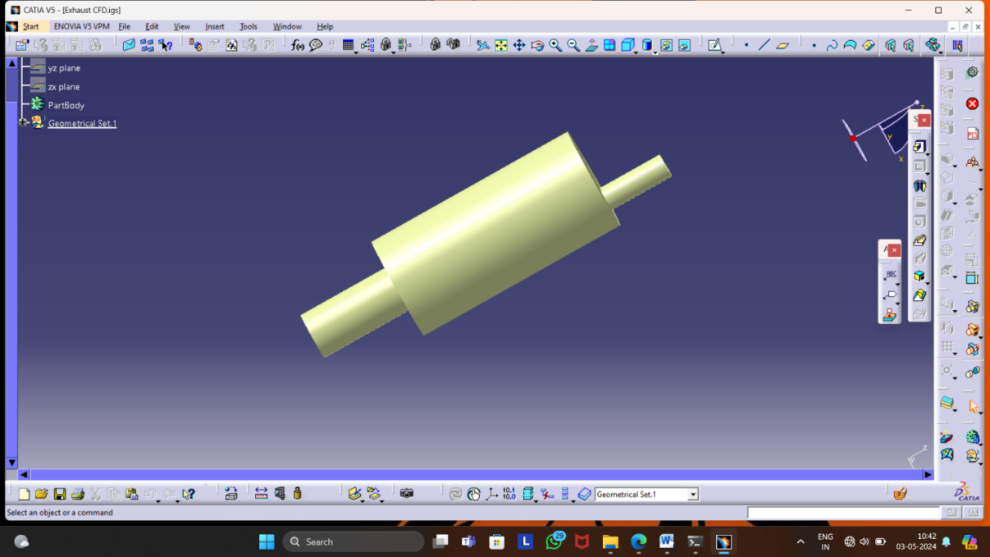
Figure 5.1:Catia Model

5.2 IMPORTED MODELS IN ANSYS:
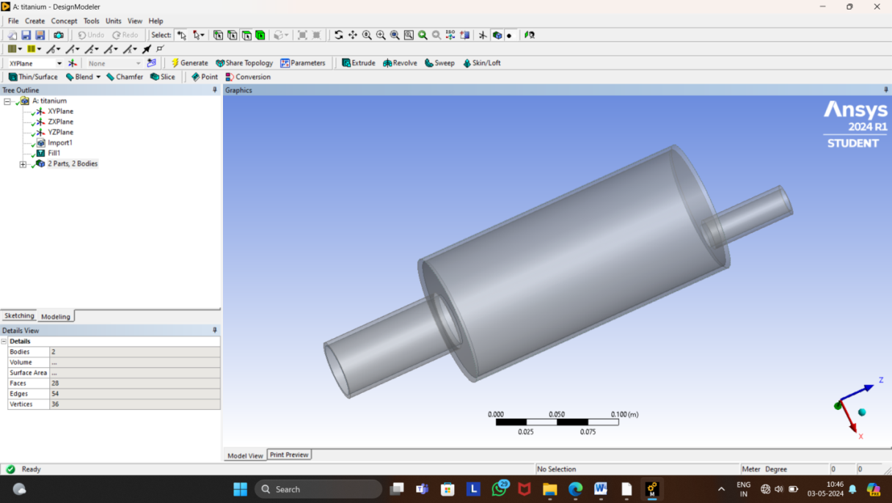
Figure 5.2:Imported Model from Catia in Ansys

5.3 MESHING:
Ansys provides general purpose, high performance, automated, intelligent meshing software that produces the most appropriate mesh for accurate, efficient multi physics solutions from easy, automatic meshing to highly crafted mesh Smart defaults are built into the software to make meshing a painless and intuitive task, delivering the required resolution to capture solution gradients properly for dependable results.
Ansys meshing solutions range from easy, automated meshing to highly crafted meshing Methods available cover the meshing spectrum of high order to linear elements and fast tetrahedral and polyhedral to high quality hexa hedraland mosaic.
Ansys meshing capabilities help reduce the amount of time and effort spent to get to accurate results. Since meshing typically consumes a significant portion of the time it takes to get simulation results, Ansys helps by making better and more automated meshing tools.
Whether performing a structural, fluid or electromagnetic simulation, Ansys can provide us with the most appropriate mesh for accurate and efficient solutions. The below image gives us a glimpse of Ansys meshing.

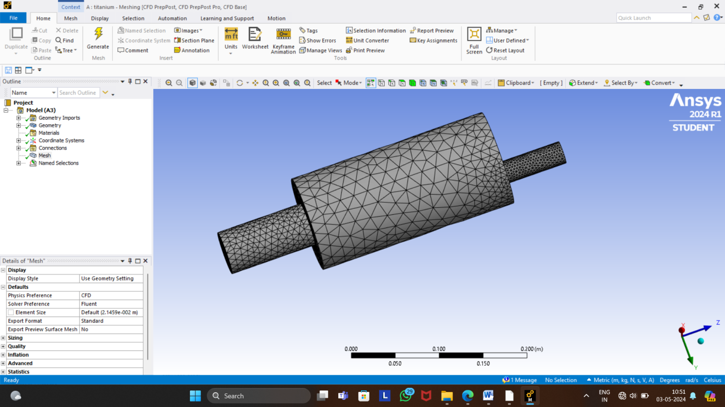
Figure 4.3: Meshing

5.4 DIFFERENT TYPES OF MATERIALS:
In this we are applied different types of materials to muffler individually and we selected best sutaible material for muffler the materials are given below
They are;
- Aluminium
- Titanium
- Nickel alloy
- Stainless steel
4.4.1 Aluminium properties
- Density(kg/m3) =2719
- Specific heat(j/(kg k)) =871
- Thermal conductivity(w/(m k)) =202.4
4.4.2 Titanium properties
- Density(kg/m3) =4850
- Specific heat(j/(kg k)) =544
- Thermal conductivity(w/(m k)) =7.44
4.4.3 Stainless steel properties
- Density(kg/m3) =8030
- Specific heat(j/(kg k)) =503
- Thermal conductivity(w/(m k)) =16.27
4.4.4 Nickel alloy properties
- Density(kg/m3) =8900
- Specific heat(j/(kg k)) =460
- Thermal conductivity(w/(m k)) =91.74

RESULTS AND DISCUSSIONS

6.1 RESULTS FOR ALUMINIUM (al):

6.1.1 Temperature:

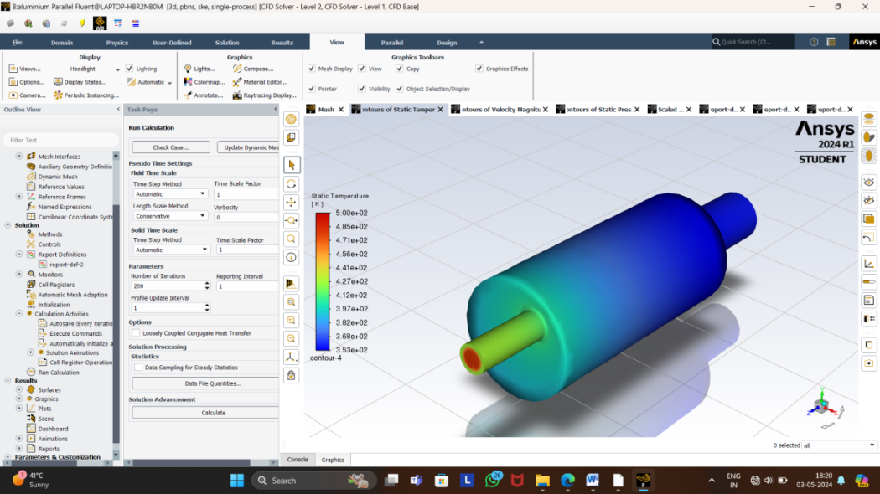
Figure 6.1: Temperature for Aluminium

It can be observed that the temperature is increasing from inlet to outlet.at inlet temperature is 5.00e+02 and outlet temperature is 4.85e+02. maximum temperature is 500k and minimum temperature is 353k.
6.1.2 Velocity:
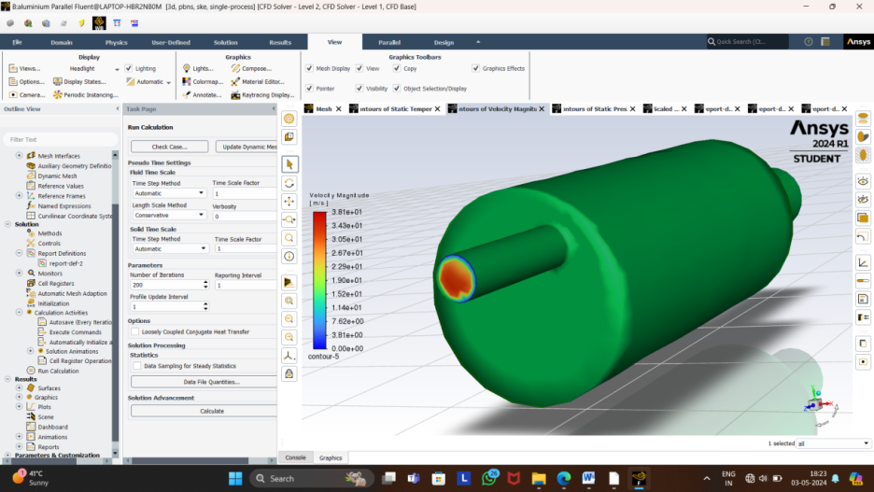
Figure 6.2: Velocity for aluminium

It is observed that velocity is increasing from Inlet to Outlet .Inlet velocity is 10.356m/s and Outlet velocity is 11.0 m/s.
Maximum velocity is 3.31e+01 and minimum velocity is 3.81e+00

    - Pressure
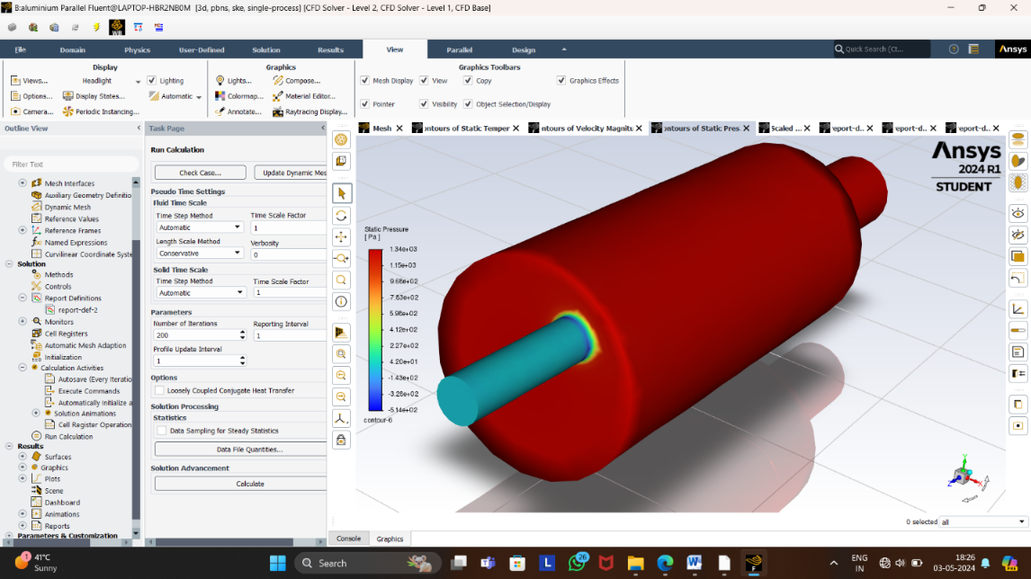
Figure 6.3: Pressure for aluminium

It can be observed that the pressure is decreasing from inlet to Outlet.
Maximum pressure is 1.34e+03 and minimum pressure is -5.14e+02
Transmission losses:
TL=20log10[pi/po]
=20log10[485.12/1337.15]
=7.25
6.2 RESULTS FOR TITANIUM (TI):
6.2.1 Temperature:
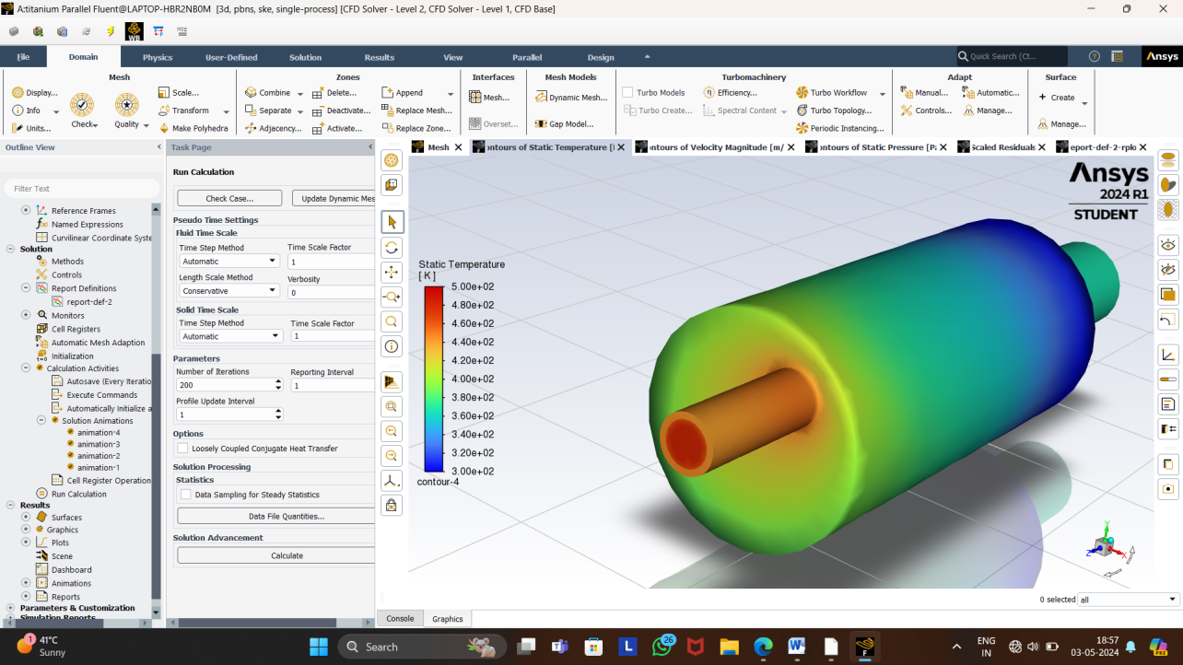
Figure 6.4:Temperature for titanium

It can be observed that the temperature is decreasing from inlet to outlet.at inlet temperature is 5.00e+02 and outlet temperature is 4.80e+02
maximum temperature is 500k and minimun temperature is 300.085k.
6.2.2 Velocity:
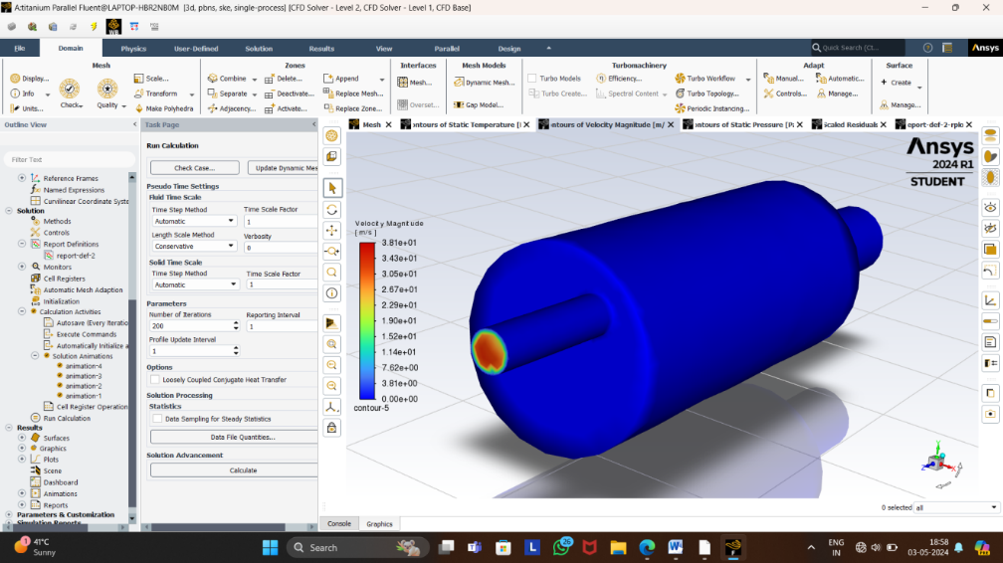
Figure 6.5: Velocity for titanium
It is observed that velocity is increasing from Inlet to Outlet . Inlet velocity is 4m/s and Outlet velocity is 11.3566m/s.
Maximum velocity is 3.81e+01 and minimum velocity 3.81e+00
6.2.3 Pressure:
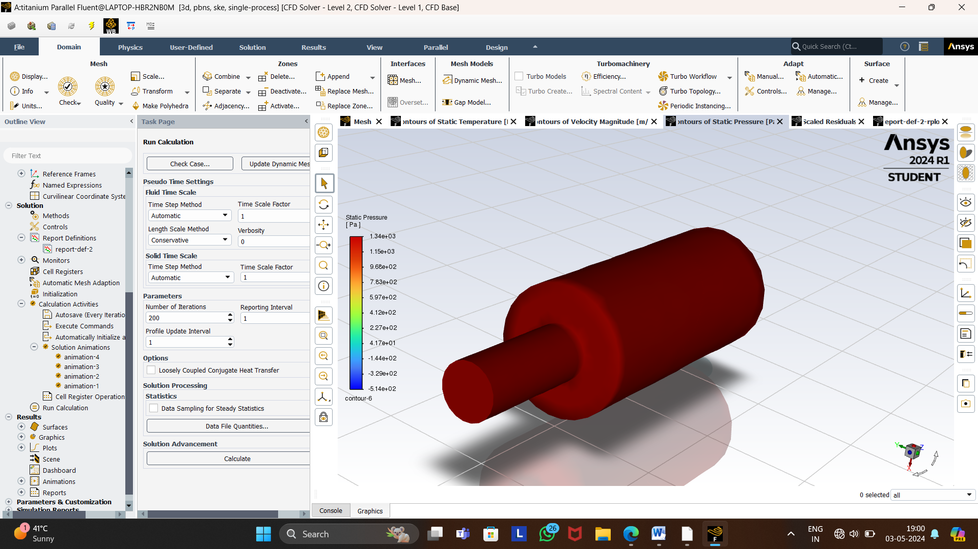
Figure 6.6:Pressure for titanium
It can be observed that the pressure is decreasing from inlet to Outlet.
Maximum pressure is 1.34e+03 and minimum pressure is -1.44e+02
Transmission losses:
TL=20log10[pi/po]
=20log10[455.49/1337.36]
=6.811

6.3 Results for stainless steel(s.s):
6.3.1 Temperature:
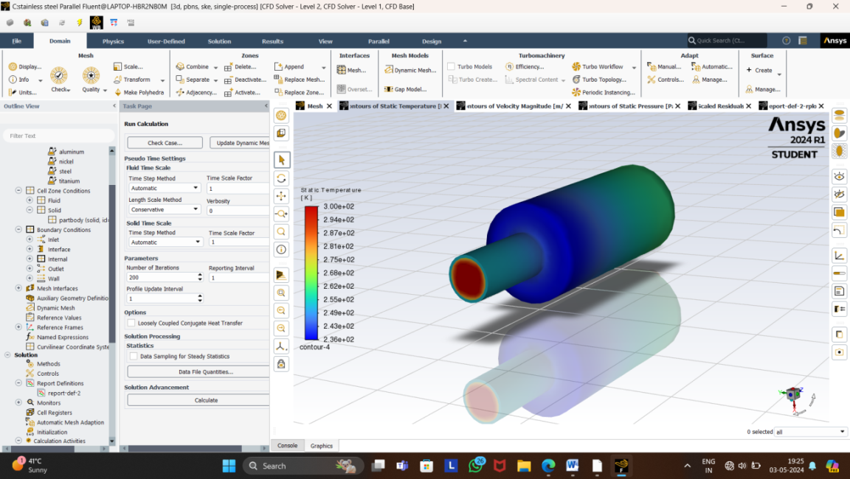
Figure 6.7:Temperature for stainless steel

It can be observed that the temperature is decreasing from inlet to outlet.at inlet temperature is 3.00e+02 and outlet temperature is 2.87e+02
maximum temperature is 500k and minimun temperature is 236k.
6.3.2 Velocity:
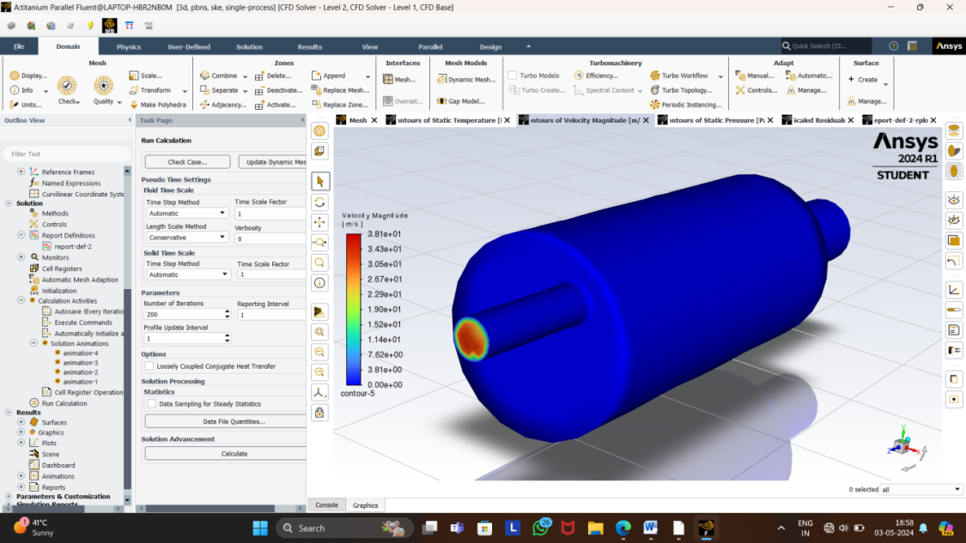
Figure 6.8:Velocity for stainless steel
It is observed that velocity is increasing from Inlet to Outlet .Inlet velocity is 4.09/s and Outlet velocity is 9.290 m/s.
Maximum velocity is 3.81e+01 and minimum velocity is 1.14e+00
6.3.3 Pressure:
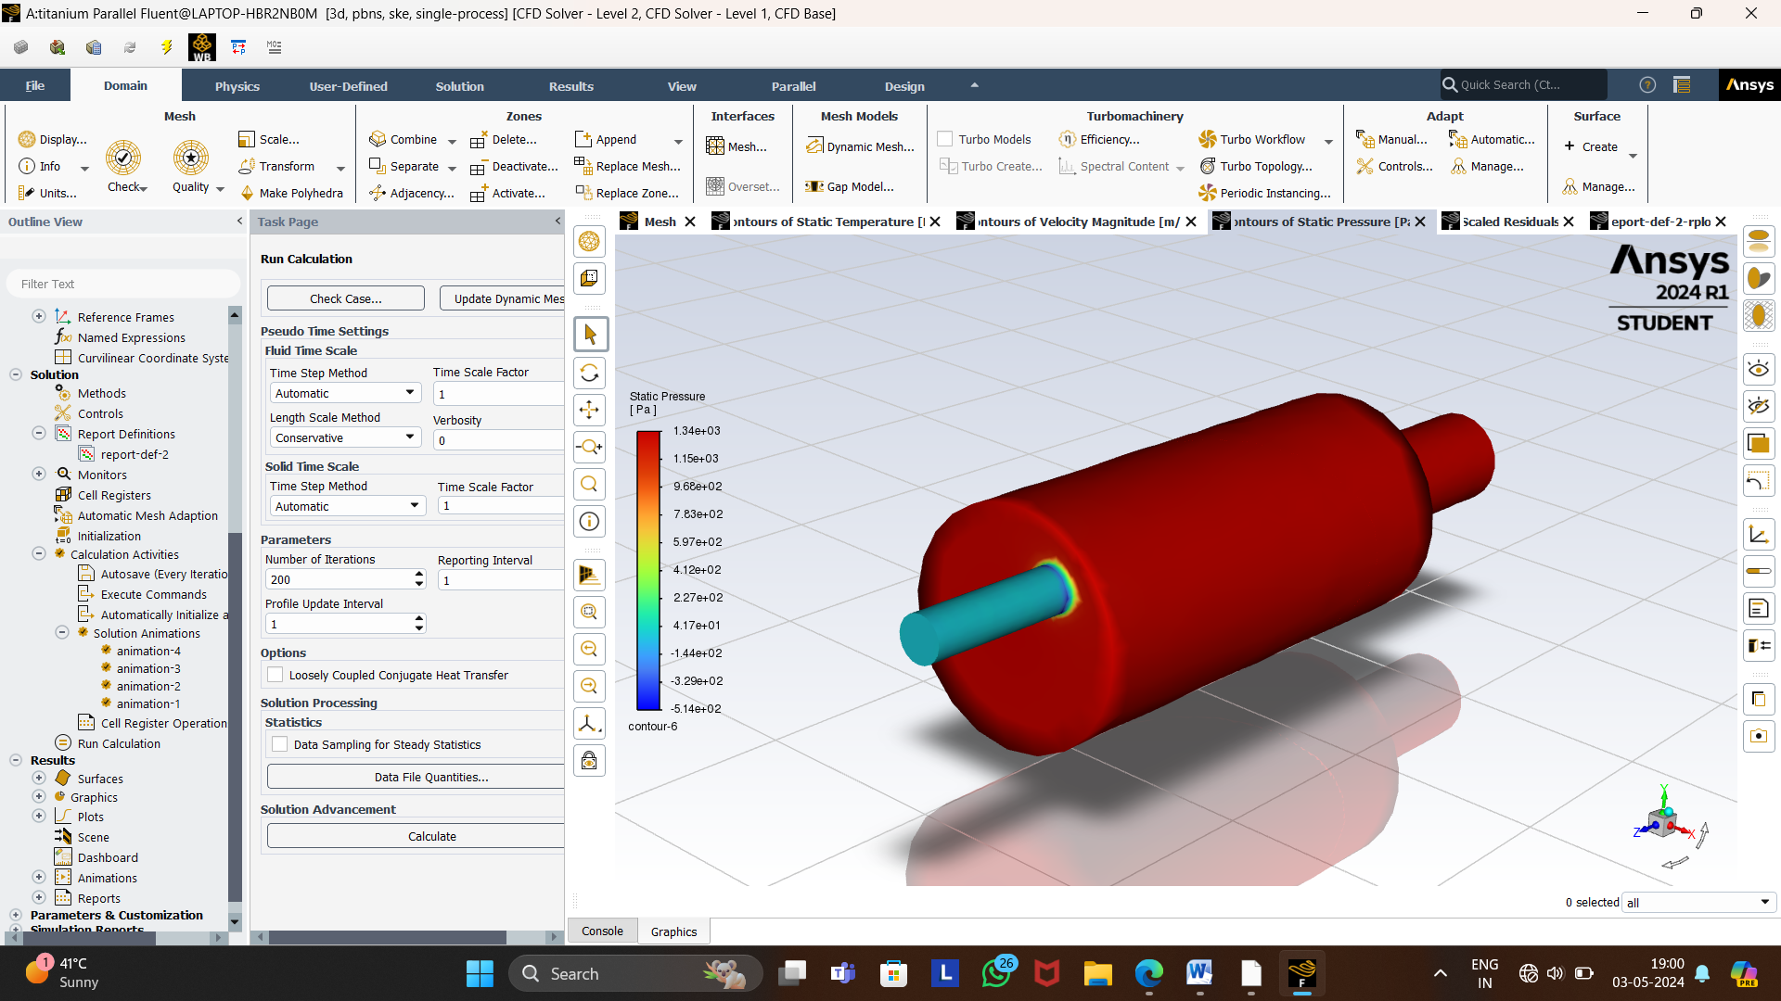
Figure 6.9:Pressure for stainless steel
It can be observed that the pressure is decreasing from inlet to Outlet.
Maximum pressure is 1.34e+03 and minimum pressure is -3.29e+02
Transmission losses:
TL=20log10[pi/po]
=20log10[495.53/1337.15]
=7.404
6.4 Results for nickel alloy:
6.4.1 Temperature:
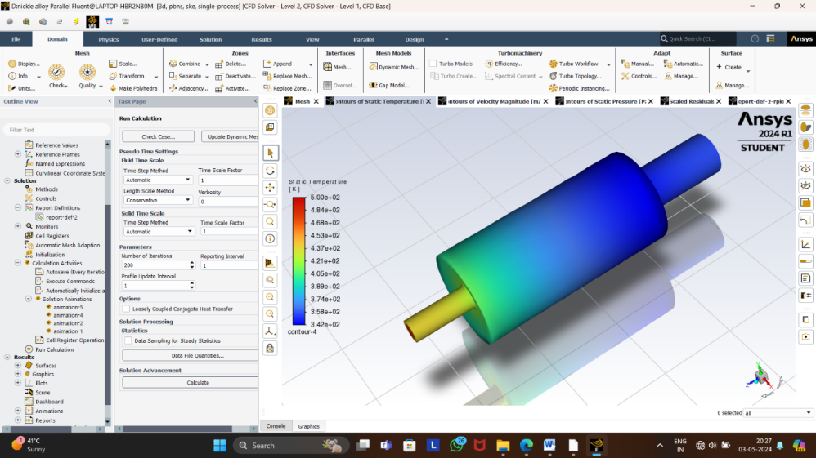
Figure 6.10: Temperature for nickel alloy

It can be observed that the temperature is decreasing from inlet to outlet.maximum temperature is 500k and minimun temperature is 348.88k.
6.4.2 Velocity:
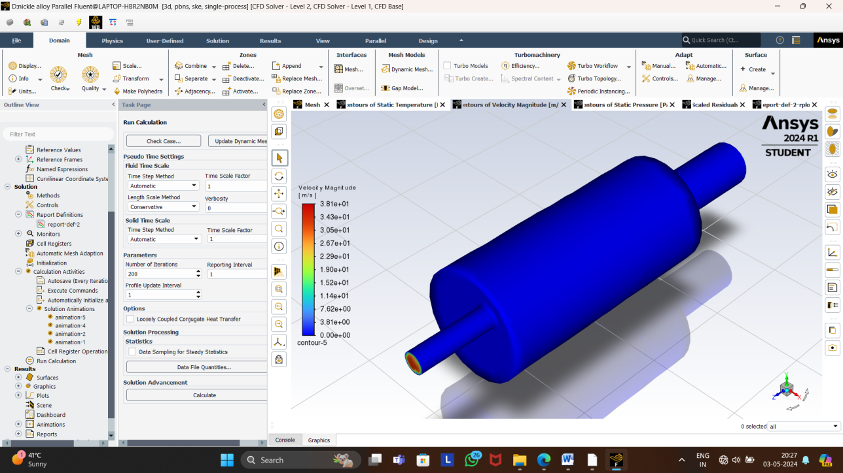
Figure 6.11: Velocity for nickel alloy

It is observed that velocity is increasing from Inlet to Outlet . Inlet velocity is 4.09/s and Outlet velocity is 9.290 m/s.
Maximum velocity is 3.81e+01 and minimum velocity is 1.14e+00
6.4.3 Pressure:
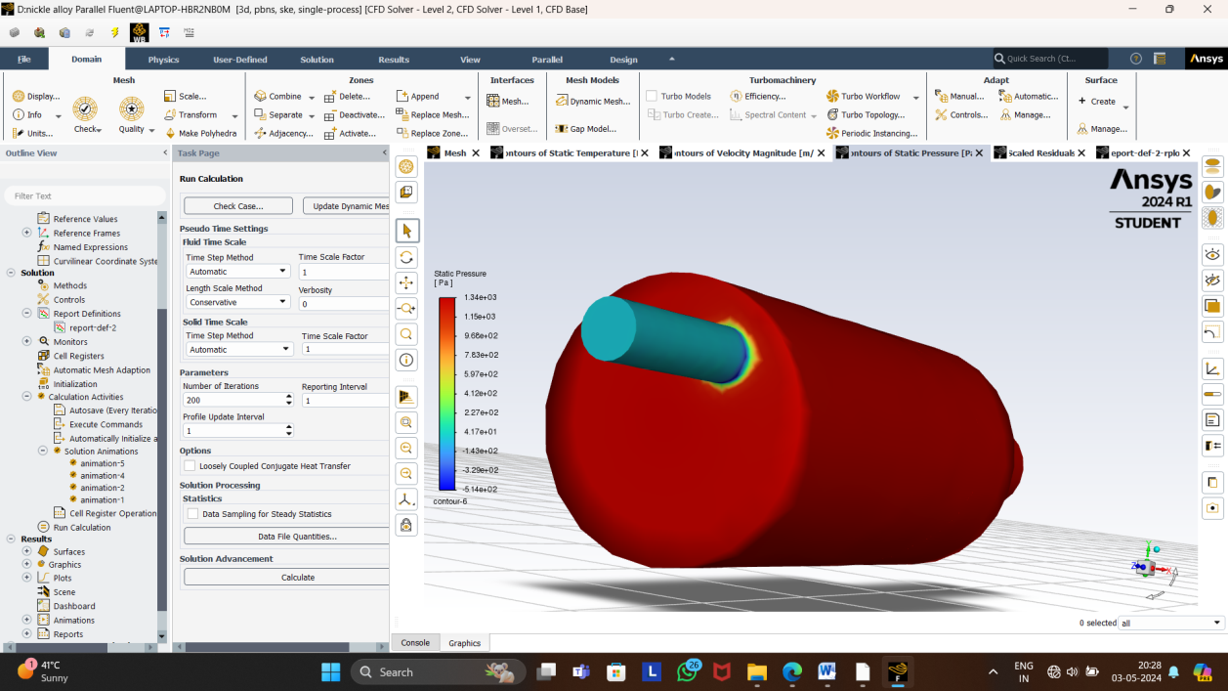
Figure 6.12: Pressure for nickel alloy

It can be observed that the pressure is decreasing from inlet to Outlet.
Maximum pressure is 3.81e+01 and minimum pressure is 00e+00
Transmission losses:
TL=20log10[pi/po]
=20log10[455.539/1337.15]
=6.91

6.5 MATERIAL COMPARISONS:

Material comparison of transmission loses, temperature, velocity and pressure for different materilas.
In high-performance or racing applications where weight reduction is critical, titanium may be preferred despite their higher cost. Titanium offers the highest strength-to-weight ratio, while titanium provides significant weight savings with good corrosion resistance.

Transmission losses:
materials | Transmission losses
Aluminium | 7.25
Titanium | 6.81
Stainless steel | 7.404
Nickel alloy | 6.91
Table 6.1: Transmnission losses for different materials.
From the above table compared other materials titanium material have less transmission losses
So, the transmission loss is less the exhaust sound will be also less.
Velocity:
Materials | Velocity at inlet | Velocity at outlet
Aluminium | 10.35 | 11
Titanium | 4 | 11.35
Stainless steel | 4.09 | 9.29
Nickel alloy | 4.09 | 9.29
Table 6.2: Velocity for different materials

Temperature:
Materials | Temperature [k]
Aluminium | 353
Titanium | 300.08
Stainless steel | 236
Nickel alloy | 348.88
Table 6.3: Temperature for different materials

Column chart of Transmission losses:

Graph 6.1: Transmission losses

From the above graph compared other materials, titanium material have less transmission losses
So, if transmission loss is less in a muffler, it means that the muffler is less effective in attenuating sound or reducing noise levels. Transmission loss refers to the reduction in sound intensity as sound waves pass through a material or structure like a muffler. Here's what could happen if transmission loss is less in a muffler.

Pie chart of outlet temperature:

Graph 6.2: Pie chart of outlet temperature

From above pie chart shows that temperature of different materials, temperature couldn’t be low and high in muffler. from out of this four materials titanium material have medium temperature.
If temperature is less:
Increased Risk of Corrosion: Moisture accumulation due to low muffler temperatures can promote rust and corrosion within the muffler and exhaust system components.
If temperature is high:
Fuel Efficiency Reduction: High temperatures in the exhaust system can lead to increased heat loss, reducing the overall efficiency of the engine. This can result in decreased fuel efficiency.
Column chart of velocity:

Graph 6.3: Column chart of velocity.
From the above graph tells about velocity of different materials, titanium have less inlet velocity and higher at outlet compared to other materials.so,
- Increased Noise Reduction: Higher velocity through the muffler can enhance its noise-reducing capabilities. The increased flow may better engage the sound-absorbing materials inside the muffler, leading to quieter exhaust.
- Improved Exhaust Performance: Higher velocity can help in expelling exhaust gases more efficiently. This might lead to better engine performance due to reduced backpressure, allowing the engine to "breathe" more freely.
- Increased Wear and Tear: High-velocity exhaust gases can also cause increased wear and tear on the muffler itself. The high-speed flow can erode internal components over time, potentially leading to premature failure or decreased effectiveness.

CONCLUSIONS
A numerical analysis is carried out and flow behavior analysis of various materials of muffler designs and the following conclusions are made.
The design and flow analysis of mufflers for titanium materials have shown promising results. Titanium, known for its lightweight and corrosion resistance, offers unique advantages in muffler design, particularly in high-performance applications where weight reduction and durability are paramount. Through computational fluid dynamics (CFD) simulations and experimental validation, it has been demonstrated that titanium mufflers can effectively dampen exhaust noise while minimizing backpressure, thereby optimizing engine performance. The flow analysis revealed smooth and efficient exhaust gas flow through the muffler, reducing turbulence and pressure drop compared to traditional materials. Additionally, the high-temperature resistance of titanium ensures longevity and reliability under extreme operating conditions.
In conclusion, the utilization of titanium in muffler design presents a compelling solution for enhancing both acoustic performance and engine efficiency. However, further research is warranted to explore manufacturing challenges and cost considerations associated with titanium fabrication. Nonetheless, the potential benefits justify continued exploration and development of titanium mufflers for automotive and other industrial applications.

REFERENCES

- Prof. Amar Pandhare, CFD Analysis of Flow through Muffler to Select Optimum Muffler Model for Ci Engine, Vol. 4 Issue 1 May 2014, ISSN: 2278-621X
- K Satyanarayana, A K Viswanath, TVH Rao, SVUM Rao “Investigation of the Stresses Induced in Crank Shaft AISI E4340 Forged Steel” Procedia Engineering vol. 173, pages 1672-1677, ISSN 1877-7058.
- K.Satyanarayana, S.V.UmaMaheswaraRao, Viswanath.A. K, T.V.HanumantaRao “Quasi-dynamic and thermal analysis of a diesel engine piston under variable compression” Materials Today, Volume 5, Issue 2, Part 1,2018, Pages 5103-5109.
- K. Satyanarayana, P. V. J. Mohan Rao, I. N. Niranjan Kumar ” Some studies on Mathematical Modeling and Dynamic stress analysis of a Variable Compression Ratio Diesel Engine Crankshaft” JVE INTERNATIONAL LTD. ISSN PRINT 2351- 5279, ISSN ONLINE 2424-4627, KAUNAS, LITHUANIA , vol 4.1 March 2018
- K .Satyanarayana, T.V. HanumanthaRao, I Niranjan Kumar, P.V.J Mohan Rao, V.V.S. Prasad,”Response optimization of four stroke variable compression ratio diesel engine cylinder head with stress analysis”Materials Today: Proceedings, Volume 5, Issue 9, Part 3, 2018,Pages 19497-19506,ISSN 2214-7853,
- Sunil And Dr Suresh P M “Experimental Modal Analysis Of Automotive Exhaust Muffler Using Fem And FFT Analyzer” International Journal of Recent Development in Engineering and Technology Volume 3 Issue 1,page 185-187 ISSN 2347-6435, 2014.
- Jayashri P. Chaudhari, Amol B. Kakade "Design, Development and Analysis of Absorptive Muffler with Ammonia Pulsator for IC Engine" Journal Page No 429

