AN ANALYSIS OF VARIANCE AND TAGUCHI DESIGN OF EXPERIMENTS WERE CONDUCTED TO EVALUATE THE ACCURACY OF MIG WELDING VARIABLES FOR PROPELLER SHAFT WELDING

**SHAMEEM ANJAR1, Dr. JITENDER KUMAR2**

**1** M.Tech Scholar,Ganga Institute Of Technology & Management Kablana Jhajjar,India

2 Associate Professor, Ganga Institute Of Technology & Management Kablana Jhajjar,India

## **ABSTRACT**

To guarantee the strength and functionality of propeller shaft welding, it is crucial to carefully assess the The impact iveness and dependability of MIG (Metal Inert Gas) welding variables. This thesis conducts a comprehensive analysis of variance (ANOVA) and Taguchi Design of Experiments (DOE) to assess the accuracy of welding settings.

The MIG welding variables such as voltage, current, wire feed rate, and gas flow rate, have a significant impact on the quality of welds. These variables significantly influence properties such as the depth of penetration, form of the bead, and strength of the weld. However, attaining the most favourable values for these variables might be complex because to the interdependencies among them and the inherent fluctuations in welding processes.

ANOVA is employed to statistically assess the variability in welding variables and their influence on the quality of the weld. This method enables the identification of significant variables and interactions, providing crucial insights into the optimisation of variables .

Furthermore, Taguchi Design of Experiments (DOE) offers a systematic approach to experiment design and parameter optimisation, aiming to minimise variability and enhance resilience against external factors. Taguchi methods employ orthogonal arrays and signal-to-noise ratios to identify the most The impact ive parameter settings required to attain the desired characteristics of weld quality.

The combination of ANOVA (Analysis of Variance) and Taguchi DOE (Design of Experiments) allows for a comprehensive evaluation of the accuracy of MIG (Metal Inert Gas) welding variables in the specific context of propeller shaft welding. This project aims to apply statistical analysis and experimental design to further understand the welding process and provide practical recommendations for improving the quality, reliability, and efficiency of welds in propeller shaft manufacturing.

This paper contributes to our comprehension of optimal welding processes and has practical implications for industries that largely depend on MIG welding for critical applications, such as marine propulsion systems.

**Key Words:** Analysis of Variance (ANOVA),Taguchi Method, Design of Experiments (DOE), Metal Inert Gas (MIG) Welding, Welding Parameters, Propeller Shaft Welding, Process Optimization

# INTRODUCTION

The history of joining metals can be traced back upto thousands of years. Earlier it can be traced from iron & bronze ages in middle east. Welding is a metal joining process that is utilized for joining of metals as well as thermoplastics by using heat as a medium to melt the metals and join them together. There are various forms of heat input for the welding processes like Arc, electric resistance, friction, gas etc. The use of these heat sources totally depends over the area of application and the type of metal to be welded. These all welding processes are capable of joining metals as well as non metals .

The strength of joint formed by the welding process is sometimes more than the base metal which depends on the amount of fusion and the penetration of the welding. In previous few decades, welding is inherited with the automation to make the process more efficient and repeatability is enhanced. Robots can be taught to perform a task to perform a operation accurately and precisely. Therefore, they can be used to enhance the accuracy of any process. In MIG welding, robots when added to the process makes it robust and the speed of process is enhanced too. Earlier when MIG was not inherited with the automation the process was not as much as fast as now when inherited with the robots.

The first technique that was used to join two pieces was brazing/Forging/Soldering and was founded by circain 3000 BC and it is used till today. Then after certain decades more types of welding techniques were invented and used. MIG welding comes under the category of arc welding that was founded by Benardows and Gkazewiski in 1865 and is used till date for joining purposes.

More welding techniques like gas welding, resistance welding were also developed with time and started using in various fields of automobile, aeronautics etc. as shown in Fig 1. Moreover, welding was not only used to join two pieces but also used for repair purposes like repairing of railway tracks with the help of thermite welding.

**MIG Welding**

Gas metal arc welding (GMAW) has been available commercially for approximately six decades. The GMAW process involves establishing and maintaining an electrical arc between a base material and a wire electrode that is continuously fed. A constant supply of shielding gas is used to safeguard the melted welding pools and the wire's filler metal from outside elements.The intense heat generated by the electrical arc causes the base metal and the wire filler metal to melt and fuse together during the welding process. The GMAW process involves two variables: burn rate and feed rate. Burn rate pertains to the speed at which the wire filler metal is melted or used up by the thermal energy of the welding arc, whereas feed rate relates to the speed at which the wire filler metal is supplied into the weld.

In order to ensure a consistent welding arc, it is necessary for the burn rate and feed rate to be in equilibrium. If the rate at which the wire filler metal burns is greater than the rate at which it is fed, it will melt back to the contact tip. Conversely, When the rate at which the feed is supplied is greater than the rate at which the material is burned, the wire filler metal will be introduced into the molten weld pool, leading to complications.Robo-MIG Welding.

# OBJECTIVES

The main objective of this research work is to optimize the weld variables listed below :

1) Welding current/voltage

2) Wire feed rate

3) Gas flow rate

All these variables are manually controllable by the operator. So after getting values of optimized variables they are input into the machine.

# LITERATURE REVIEW

**K.R. Madavi, B.F. Jogi, G.S. Lohar: (2005)**

In this study, MIG welding was studied with the application of two different types of fluxs which were magnesium carbonate and iron oxide and there The impact s were studied over the HAZ and weld penetration using Taguchi L9 arrays where three variables with 3 levels were used current, Gas flow rate and the flux used. It was clearly found that MgCo3 flux shows highest UTS of the weld at 180 A and 10 lt per minutes of gas flow rate.

**Harish K. Arya, Kulwant Singh, R. K. Saxena (2010)**

The paper examined the impact of the foundation metal's thicknesses on various end variables of the weld bead, such as weld penetration and bead width, in underwater arc welding. Moreover, the paper concludes about the The impact of various weld variables like current, voltage, welding speed over the weld penetration and the weld bead. The results was analyzed using anova which showed that the weld penetration decreases with the enhance in plate thickness due to enhance in amount in heat loss in thickness direction of the weld and it The magnitude of the The impact grows in proportion to the rise in both welding voltage and current. The breadth of the weld bead expands according to the rise in arc voltage.The user's text is enclosed in tags.

**Shahazad Ali (2014)**

The paper investigates the The impact of various welding variables like Welding current, Welding voltage, Wire feed rate and welding speed over a MIG welding setup inherited with a kuka robot.

It was found that using robot in welding process can make it much more efficient. And The impact of these welding variables was also studied over the tensile strength and ultimate tensile strength of the material. The study showed that the highest strength of material was found at the highest current and the higher wire feed rate. There was a major dip in tensile strength of the material with the decrease in welding current. That simply predicted that current optimization is the most major factor for the MIG welding.

**SP. Arunkumar and C. Prabha (2010)**

The major concern of this paper is to improve the variables of the process by optimizing welding variables like welding current, Voltage,and the bevel angle. The aim was to improve the impact strength of specimen which were A3387 steel alloy and stainless steel of SS316 alloy. In this study, optimization was done through Taguchi method using L9 orthogonal array. The combination of DOE that gave optimal solution was 20 V voltage of welding 140 A of current and 0 degrees of bevel angle.

Observations were that there was a dip in impact strength for some time thereafter impact strength enhanced with the increasing voltage and moreover the impact strength was decreased with the enhance in welding current. The end results showed that The present condition was the primary determining factor in establishing the magnitude of the impact strength of the material.

**Nabendu Ghosh, Pradip Kumar Palb , Goutam Nandic (2009)**

In this research, the X-ray radiography test and visual inspection was done over AISI 316L stainless steel to detect surface defects when it was welded under Various levels of currents, voltages, gas flow rates and nozzle to plate distance. The results were mainly focused to evaluate in terms of UTS, YS and the %age elongation. It was evident that there was spatters, improper penetration that was mainly caused by less current and instability of welding arc moreover it was also caused by poor gas supply. It was also observed that using Dirty environment also enhanced the spatters. It was also seen that when using CO2 as shielding gas spatters were more in comparison when argon was used for the shielding purpose it was to due to using CO2 enhances arc energy but at the cost of arc instability. It was also seen that when faster arc travel speed was used there was lack of fusion at the roots and the wall were seen. When Optimum arc travel speed was used weld penetration was seen in the specification limit.

**Nabendu Ghosha , Ramesh Rudrapatib *, Pradip Kumar Palc , Gotam Nandic ( 2008)**

The study was done in order to inspect and analyse the The impact s of weld variables : Welding current, nozzle to plate distance and gas flow rate over the UTS and the % elongation in MIG welding process over AISI409 stainless steel material. For inspection purpose, X ray radiography and visual inspection method was choosen in order for the detection of defects either over the surface or the sub surface defects in the welded specimens. All the data that we got was analysed with the help of Taguchi methodology.

The results predicted that:

1. Porosity and blow holes were detected in the samples where faster arc travel speed and higher nozzle to plate distance was used
2. Undercuts were found in some samples where faster arc travel speed was used
3. Lack of fusion was observed in the samples with lesser amount of current and faster arc speed.
4. It was also observed that on increasing the gas flow rate leaded to better bead geometry but after certain amount of enhance there were blow holes seen in the bead. The possible cause of this is that on increasing the gas flow rate further enhance the turbulence of the gas that cause unprotected environment for the weld bead.

**Sudhir Kumar and Rajender Singh**

In this research work, the experiments were done over AISI mild steel samples to study the The impact s process variables such as current, voltage and the preheat temperature. Previously, none of the study was done over the The impact of preheat temperature over the weld bead quality.

The results were judged over the basis of UTS and % elongation. The results showed that the highest values of UTS and % elongation were found at 275 degree Celsius, current= 120A and Voltage= 25V. The results showed that

i) 275 degree Celsius temperature is good for this grade of steel.

ii) In comparison with all the factors current, voltage and the preheat temperature. Preheat temperature proved to be the most predominant factor affecting the tensile strength of the weld.

iii) UTS and % elongation decreased when the preheat temperature was enhanced but on increasing the value of current it also enhanced.

iv) When X ray radiography tests were conducted it was concluded that higer voltage, moderate current, and the moderate preheat temperature produced the weld joints with least defects.

**K.R. Madavi, B.F. Jogi, G.S. Lohar ( 2015)**

In the paper, the major focus was to study the affect of activated flux over the weld bead strength. Moreover, the study was orientated towards learning its The impact over the weld penetration. From this study it was evident that MgCO3 flux gave the maximum tensile strength in comparison with Fe2o3, TiO3 and zinc powder. Iron oxide was rated second after the magnesium carbonate. Moreover, in this study weld penetration was studied at various wire feed rate and it was seen that penetration was poor at the lower feed rate ( < 10 m/min). The condition for perfecrt hardness was achieved at 180A, MgO flux, and gas flow rate of 9 It was also proved that by using the MgO flux enhanced the UTS upto a level that its strength enhanced to a level more than the parent material.

**Yanling Xua, and Ziheng Wanga,b (2017)**

The paper was basd on the study of various visual sensing devices that can be used in welding technologies for the improvement of the process. Like one of the study was about the visual sensing camera that was used for ensuring the weld shift during the mig welding. The visual sensing camera senses the position of the torch where the welding will take place and give feedback to the system for

right or wrong weld position.

# METHODOLOGY

**Details of Robo-MIG machine**

For the experimental studies a FANUC ROBO-MIG machine model no. Arc Mate 100id was used that consists of two robotic arms each with 6 DOF that can rotate over its axis and the unit was setup in DAIPL, Dharuhera unit. The robot is abled to weld along 360 degrees points of rotation. The figure shows the Machine setup available at the floor space of the plant. Details of the Robo-MIG machine are as follows:-

|  |  |  |
| --- | --- | --- |
| **S.No** | **Variables** | **Values** |
| 1. | Controlled axes | 6 |
| 2. | Repeatability | +- 0.02 |
| 3. | Mechanical weight | 145kg |
| 4 | Voltage 50/60Hz 3 phase | 380-575 |
| 5 | Average power consumption | 1 kW |
| 6 | Acoustic noise level | 1 dB |
| 7. | Ambient temperature | 0-45 C degrees |
| 8. | Body std. protection | IP54 |
| 9. | Wrist & J3 arm std protection | IP67 |
| 10. | Robot footprint [mm] | 343mm x 343mm |

Table 1: Machine specification

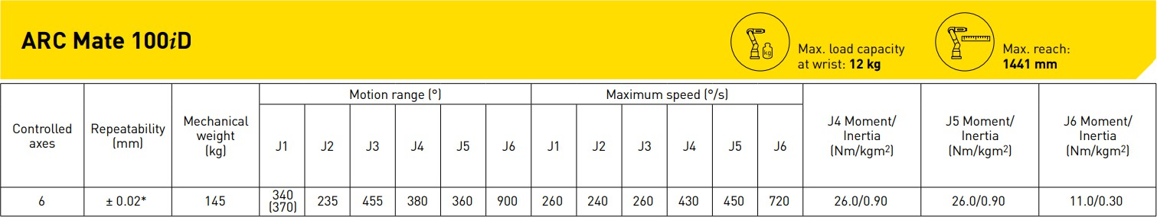

Figure 1: Experimental set up of Robo-MIG

The welding was done on the FANUC ARC Mate 100iD. The setup over the machine consists of 2 V blocks over which the shaft rests, 2 dummy pins that helps to hold the shaft in position, and the clamps that is triggered by the push button and holds the shaft in position. After the start of the welding cycle, first the door closes and the robot senses the exact position for welding to avoid any weld shift. After the confirmation, of the correct weld position the robotic welding gun rotates 180 degrees and then it starts the welding while the shaft is rotated 390 degrees.

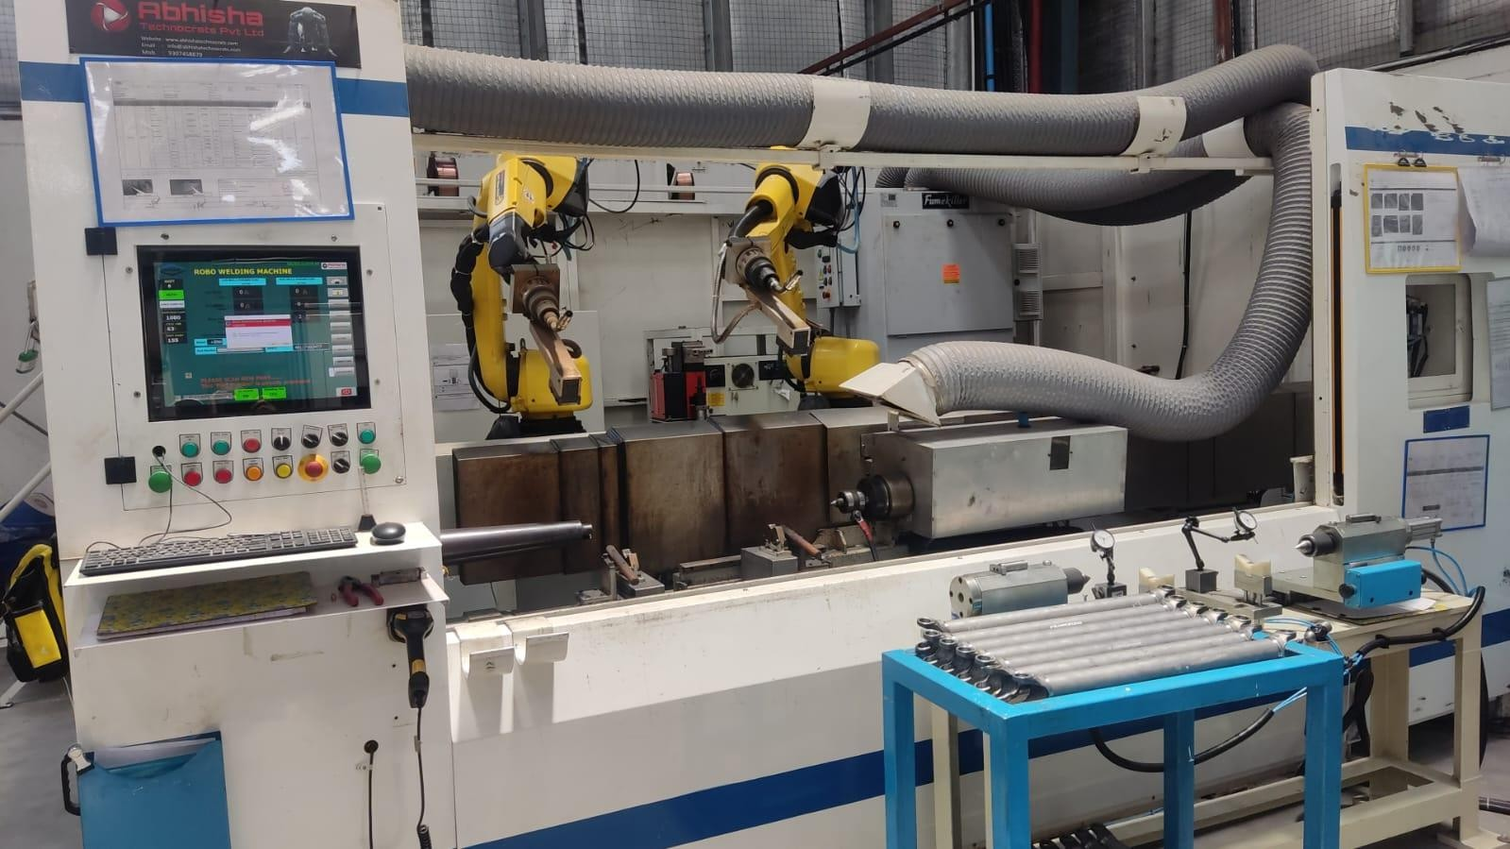

Figure 2 Fanuc ARCMate 100iD

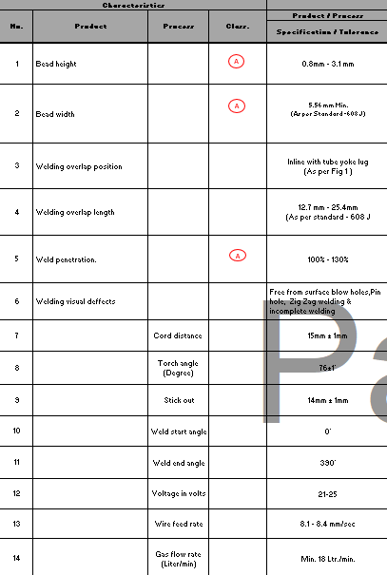

Fig3. Process/Product variables for welding

**Metal cutter**

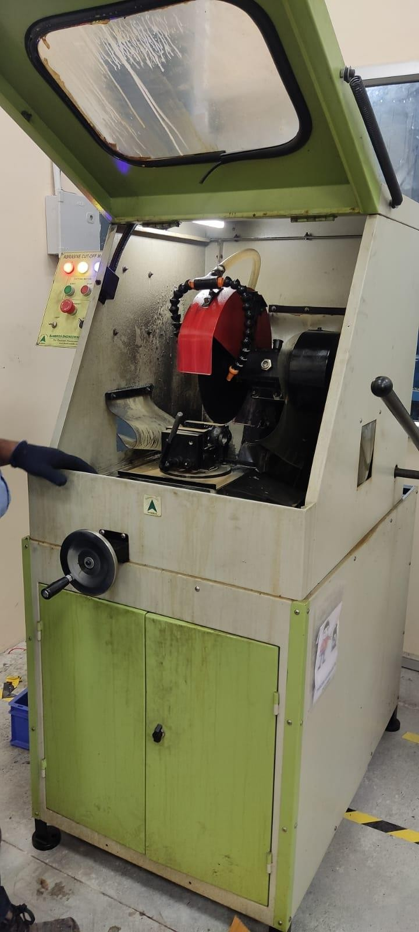The next stage after the welding is to test the penetration of the weld. For this test to be done first we have to cut the shaft from near the weld bead with the help of cutter and thereafter it is cut into 2 pieces as shown in the figure. The cutting machine used for cutting operation is shown below :

Figure 42 Metal cutting machine at the facility of DAIPL,DHR

**Microscope for penetration study**

After the cutting of the shaft and preparation of the specimen, we apply weld penetration oil over the surface of the weld and the specimen is then ready for the penetration test. Then specimen is then put under the Banbros BSZ-608T which is stereo zoom microscope that can display magnified images directly over the screen of the software.

|  |  |  |
| --- | --- | --- |
| **S. No** | **Variables** | **Values** |
| 1. | Viewing Tube | 30° Trinocular viewing head, Inclined at 30° |
| 2. | Diopter Adjustment Eyepiece | WF10X/Ø23 Extra wide field eyepiece WF10X/Ø23 |
| 3. | Zoom Objective | 0.6X‐5X |
| 4 | Magnification | 6X to 50X |
| 5 | Zoom Ratio | 1:8.3 |
| 6 | Working Distance | 115mm |
| 7. | Focusing Range | 105mm |
| 8. | Illumination | 100V‐240V/LED Incident Illumination 100V‐ 240V/LED Transmitted Illumination |
| 9. | Video Adapter | 1x C Mount |
| 10. | Diopter Adjustment Eyepiece | WF10X/Ø23 Extra wide field eyepiece WF10X/Ø23 |

Table 2 Machine specification

**Experimental procedure**

I) First, the DOE was made with the help of Minitab V17.1.0. A design of experiment was made in minitab software by using Taguchi DOE method. The three factors were choosen Wire feed rate, Voltage, and gas flow rate. The design of experiment that was obtained is shown below:

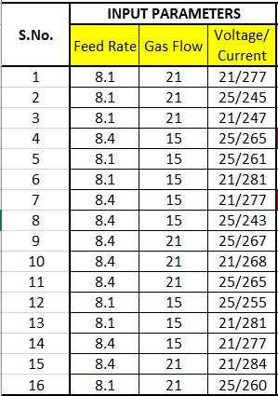

Figure 44Taguchi DOE

II) After welding 48 shafts for all 16 experiments, we have to cut the tube from near the weld bead and then cut it across its cross section as shown in the figure below:

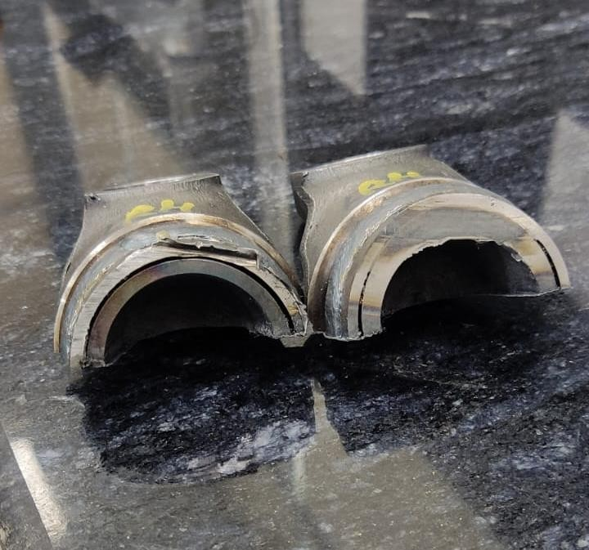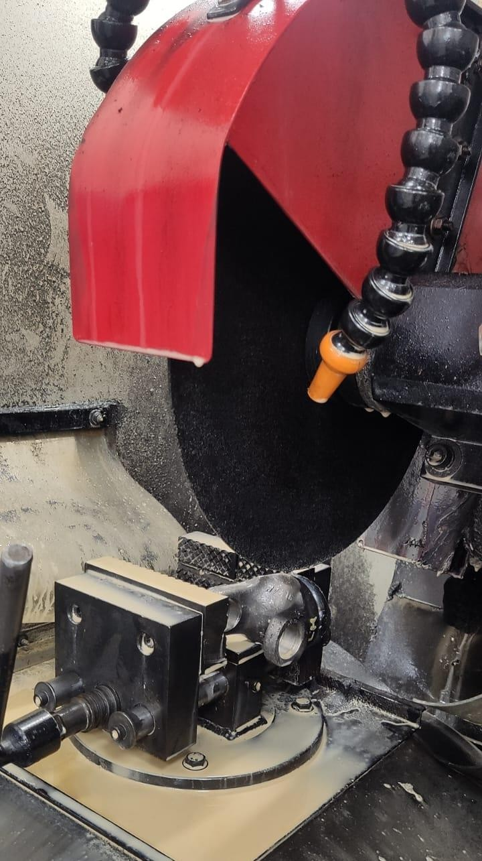

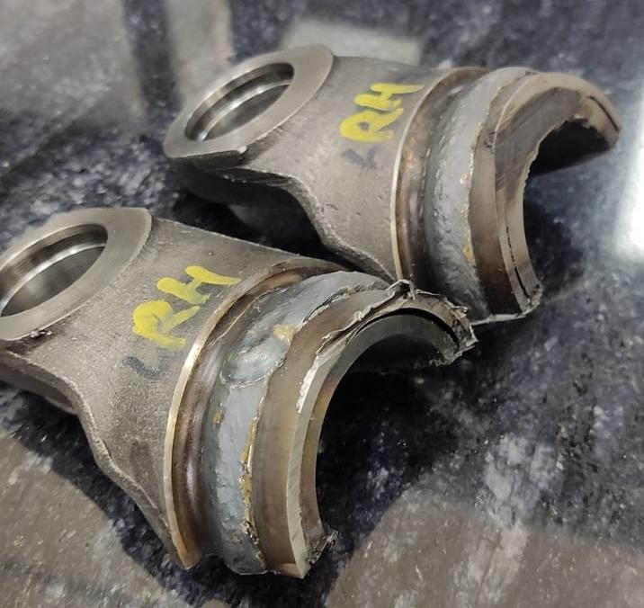

Figure 5 Cut section of shaft

# RESULT

A total 16 DOE were made by using Taguchi DOE method in minitab software[21]. Every experiment is combination of one oth 3 welding variables which were :

Wire feed rate

Current/Voltage

Gas flow rate

Each parameter has its own importance in the weld quality and weld geometry, hence it becomes Significant to know the best combination of all these 3 factors and enter the set parameter into the Robo-MIG welding machine such that all the shafts that will be produced by the machine will be of best quality and must be defects free the DOE and results is shown in the figure below:

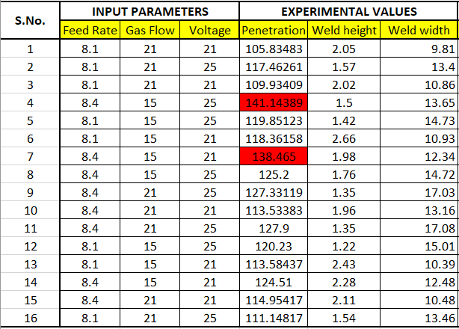

Figure 6 DOE and Results

The above results shows the value of various product variables like weld height, weld width, overlap, run out and the weld penetration. The final product parameter was defined for the shafts and accordance of that pre defined product variables final optimized process variables were to be judged.

**PENETRATION REPORTS:**

Pentration test was done for every experiments and the cut sections of the shafts were scanned under the microscope and then after the results were obtained by calculating the weld penetration percentage:

i) DOE 1 :

Feed rate : 8.1 , Gas flow : 21, Voltage :21 V

Penetration : 105.835 ,Bead height : 2.05 ,Bead height : 9.81

ii) DOE 2 :

Feed rate : 8.1 , Gas flow : 21, Voltage :25 V

Penetration : 117.463 ,Bead height : 1.57 ,Bead height : 12.4

iii) DOE 3 :

Feed rate : 8.1 , Gas flow : 21, Voltage :21 V

Penetration : 109.934 ,Bead height : 2.02 ,Bead height : 9.86

iv) DOE 4 :

Feed rate : 8.4 , Gas flow : 15, Voltage :25 V

Penetration : 161.144 ,Bead height : 1.5 ,Bead height : 12.65

v) DOE 5 :

Feed rate : 8.1 , Gas flow : 15, Voltage :25 V

Penetration : 119.851 ,Bead height : 1.42 ,Bead height : 14.73

vi) DOE 6 :

Feed rate : 8.1 , Gas flow : 15, Voltage :25 V Penetration : 118.362 ,Bead height : 2.66 ,Bead height : 9.93

vii) DOE 7 :

Feed rate : 8.4 , Gas flow : 15, Voltage :21 V

Penetration : 138.465 ,Bead height : 1.98 ,Bead height : 11.34

viii) DOE 8 :

Feed rate : 8.4 , Gas flow : 15, Voltage :25 V

Penetration : 125.2 ,Bead height : 1.76 ,Bead height : 13.72

ix) DOE 9 :

Feed rate : 8.4 , Gas flow : 21, Voltage :25 V

Penetration : 127.33 ,Bead height : 1.35 ,Bead height : 16.03

x) DOE 10 :

Feed rate : 8.4 , Gas flow : 21, Voltage :21 V

Penetration : 113.534 ,Bead height : 1.96 ,Bead height : 12.16

xi) DOE 11 :

Feed rate : 8.4 , Gas flow : 21, Voltage :25 V

Penetration : 127.9 ,Bead height : 1.35 ,Bead height : 16.5

xii) DOE 12 :

Feed rate : 8.1 , Gas flow : 15, Voltage :25 V

Penetration : 104.417 ,Bead height : 1.22 ,Bead height : 14.01

xiii) DOE 13 :

Feed rate : 8.1 , Gas flow : 15, Voltage :21 V

Penetration : 113.584 ,Bead height : 2.43 ,Bead height : 9.39

xiv) DOE 14 :

Feed rate : 8.4 , Gas flow : 15, Voltage :21 V

Penetration : 104.668 ,Bead height : 2.28 ,Bead height : 11.48

xv) DOE 15 :

Feed rate : 8.4 , Gas flow : 21, Voltage :21 V

Penetration : 114.954 ,Bead height : 2.11 ,Bead height : 8.02

xvi) DOE 16 :

Feed rate : 8.1 , Gas flow : 21, Voltage :25 V

Penetration : 111.148. ,Bead height : 1.54 ,Bead height : 11.46

**TAGUCHI DESIGN ANALYSIS:**

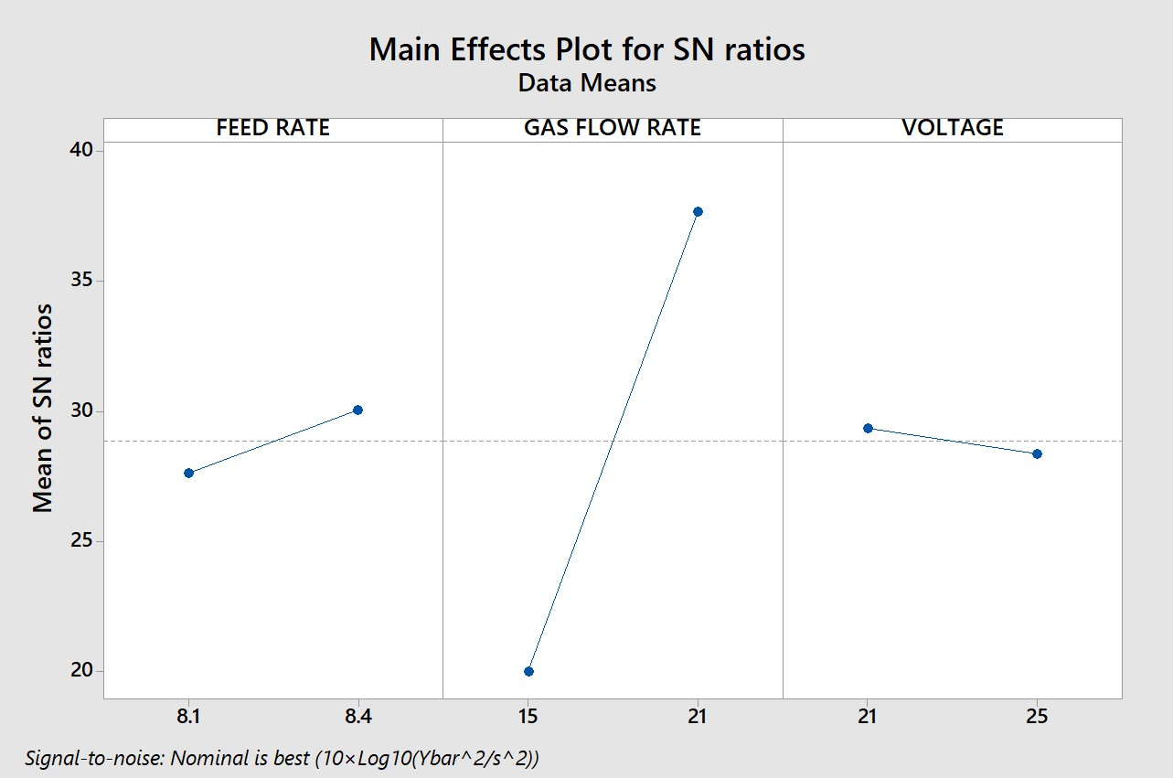After all the experiments are completed the results were optimized with the help of minitab software. This proved to be helpful in knowing the optimized value of all the three factors: Wire feed rate, Gas flow rate and the voltage

.

Figure 7 Taguchi analysis for penetration

# CONCLUSION

The experimental studies were conducted to analyse the The impact of welding variables that were Wire feed rate, Gas flow rate and voltage over the product variables which were Weld bead width, Weld bead height and weld bead penetration. The experiment was done to optimize the machine and reduce the part rejection over the machine due to improper process variables . There were some final points of conclusion after the full analysis of the shafts done after the welding.

There were few points that were concluded after the completion of this work:

a) The final variables that we got after the analysis were:

• Wire feed rate : 8.1 mm/sec

• Gas flow rate : 21 lt/min

• Voltage : 21 V

b) When these variables were practically analysed over the shafts it was found that the variables were optimized and given shafts with lesser defects.

• When the variables were not optimized there were 7 defects in 100 shafts welded.

• After the variables were optimized only 1 shaft was rejected that too due to pinhole.

• No out of specification penetration shaft was found after optimization of variables .

• Rejection percent was reduced to 1% from 7%.

• Defects due to improper penetration are not reworkable but defects like pin holes are

reworkable.

# REFERENCES

1. K.R. Madavi, B.F. Jogi, G.S. Lohar, “Metal inert gas (MIG) welding process: A study of The impact of welding variables ,” Materials Today: Proceedings 51 (2022) 690–698 C, July 2021.
2. [2]. Harish K. Arya, K. Singh, R. K. Saxena, “The impact of Welding Variables on Penetration and Bead Width for Variable Plate Thickness in Submerged Arc Welding.” World Academy of Science, Engineering and Technology International Journal of Mechanical and Mechatronics Engineering Vol:9, No:9, 2015.
3. [3]. S. Ali, A.P. Agrawal, N.Ahamad, T. Singh, A. Wahid,” Robotic MIG welding process parameter optimization of steel EN24T,” Materials Today: Proceedings 62 (2022) 239–244, 2022.
4. [4]. S.P. Arunkumar, C. Prabha, R. Saminathan, J. A. Khamaj, M. Viswanath, C. K. Paul,
5. R. Subbiah, P. Manoj,” Taguchi optimization of metal inert gas (MIG) welding variables to withstand high impact load for dissimilar weld joints.” Materials Today: Proceedings 56 (2022) 1411–1417 C, December 2021.
6. [5]. N. Ghosh, P.K. Pal, G. Nandic, “Parametric Optimization of MIG Welding on 316L Austenitic Stainless Steel by Grey-Based Taguchi Method,” Procedia Technology 25 ( 2016 ) 1038 – 1048, 2016.
7. [6]. N. Ghosha, R. Rudrapati, P. K. Pal, G. Nandic, “Parametric Optimization of Gas Metal Arc Welding Process by using Taguchi method on Ferritic Stainless Steel AISI409.” Materials Today: Proceedings 4 (2017) 2213–2221, 2016.
8. [7]. S. Kumar, R. Singh, “Optimization of process variables of metal inert gas welding with preheating on AISI 1018 mild steel using grey based Taguchi method.” Measurement 148 (2019) 106924 C, 2019.
9. [8]. K.R. Madavi, B.F. Jogi, G.S. Lohar, “Metal inert gas (MIG) welding process: A study of The impact of welding variables .” Materials Today: Proceedings 51 (2022) 690–698 C, 2021. [9]. N. Rakesh, A. M. Navaf, M.S. Harisankar, S. J. Nambiar, M. Harikrishnan, J. S. Devadathan, K. Rameshkumar, “The impact of fluxes on weld penetration during TIG welding.” Materials Today: Proceedings 72 (2023) 3040–3048 C, September,2022.
10. [10]. D. K. Zhang, Y. Zhao, M. Dong, G. Wang, A. ping, J. Shan, D. Meng, X. Liu, “The impact s of weld penetration on tensile properties of 2219 aluminum alloy TIG-welded joints.” Trans. Nonferrous Met. Soc. China 29(2019) 1161−1168, Feb,2019.
11. [11]. Y. Xua, Z. Wang, “Visual sensing technologies in robotic welding: Recent research developments and future interests.” Sensors and Actuators A 320 (2021) 112551, 2021.
12. [12]. H. Cheng, L. Zhou, Q. Li, D. Du, B. Chang, “ The impact of welding variables on spatter formation in full-penetration laser welding of titanium alloys.” Journal of materials research and technology, 2021.
13. [13]. K. D. Ramkumar, B. M. Kumar, M. G. Krishnan, S. Dev, A. J. Bhalodi, N. Arivazhagan,
14. S. Narayanan, “Studies on the weldability, microstructure and mechanical properties of activated flux TIG weldments of Inconel 718.” Material science & Engineering A 639 (2015) 234-244, May, 2015.
15. [14]. A. K. Singh, V. Dey, R. N. Rai, “Techniques to improve weld penetration in TIG welding (A review).” Materials Today: Proceedings 4 (2017) 1252–1259,2016.
16. [15]. A. R. Deshmukha, G.Venkatachalamb, H. Divekarc , M. R. Saraf, “The impact of weld penetration on fatigue life” Procedia Engineering 97 ( 2014 ) 783 – 789, 2016.