**IONIC THERMOCHROMIC MATERIAL SELECTION AND CALORIFIC ENERGY MANAGEMENT SYSTEM**

**R. Naveenraj*1, T. Nirmal Raj*2**

*1Student, Department of Computer Science and Applications, SCSVMV [Deemed to be University], Kanchipuram, Tamil Nadu, India

*2Assistant Professor, Department of Computer Science and Applications, SCSVMV [Deemed to be University], Kanchipuram, Tamil Nadu, India

**ABSTRACT**

The ionic thermochromic material selection and calorific energy management system is a Heat Transfer Analysis, and Stability Control represents a pioneering project that consolidates the key facets of ionic caloric material applications. Its client-centric approach empowers users to articulate their specific material requirements seamlessly, connecting to the Ionic Synthesis module, which processes these needs, recommends materials within budget, and generates comprehensive reports. The data provided are stored as encrypted data by using Diffie-Hellman algorithm and user who has the correct key can only able to decrypt the data . The person, who has the key, can only see those data. This process provide data security for all data used throughout this project. Meanwhile, the Heat Transfer Analysis optimizes heat exchanger choices, thus enhancing heat transfer performance and providing detailed performance reports. The Stability Control ensures long-term stability, evaluating material performance and generating stability reports. Clients can efficiently place orders while benefitting from a secure system. It simplifies the material selection process, ensuring that clients receive tailored recommendations that meet their specific requirements. By optimizing heat exchanger choices, the system enhances energy efficiency and overall system performance. Moreover, the long-term stability assessments add a layer of confidence in material durability, contributing to the longevity and reliability of systems. By implementing [Bayesian Linear Regression algorithm, calculations become more accurate and take less time to process. This holistic approach aligns perfectly with global energy efficiency and environmental sustainability goals, offering a comprehensive solution that not only fulfils client needs but also contributes to a greener and more energy-efficient future in refrigeration and heat transfer technologies.](https://towardsdatascience.com/introduction-to-bayesian-linear-regression-e66e60791ea7)

Keywords: Secure Computing, Heat Transfer Analysis, Diffie-Hellman, Energy-Efficient, Linear Regressionr, Environmental Impact.

1. **INTRODUCTION**

The Integrated System for Ionic Caloric Material Selection, Heat Transfer Analysis, and Stability Control represents a groundbreaking initiative, seamlessly amalgamating the pivotal components of ionic caloric material applications. With a client-centric ethos at its core, the system empowers users to articulate their material requisites effortlessly, interfacing with the Ionic Synthesis module for tailored recommendations within budgetary constraints. Utilizing encrypted data storage via the Diffie-Hellman algorithm ensures robust security, safeguarding sensitive information. Meanwhile, the Heat Transfer Analysis optimizes heat exchanger selections, bolstering efficiency and providing detailed performance insights, while the Stability Control feature assures long-term reliability through comprehensive material evaluations. This streamlined approach not only simplifies material selection for clients but also enhances energy efficiency and environmental sustainability, aligning seamlessly with global goals. The integration of Bayesian Linear Regression algorithms further enhances accuracy and efficiency, promising a greener, more efficient future in refrigeration and heat transfer technologies.

1. **LITERATURE REVIEW**
2. **Sato, O. (2003). Dynamic molecular crystals with switchable physical properties. Nature Materials, 2(2), 92-93.**

This paper explores dynamic molecular crystals, which are materials with the ability to undergo reversible structural transformations in response to external stimuli such as temperature, pressure, or light. These transformations lead to changes in their physical properties, making them potentially useful for various applications including sensing, actuation, and data storage.

1. **Peter, K. M., & Peter, B. (2005). Thermochromic Materials. Springer Series in Materials Science.**

This book likely provides an in-depth overview of thermochromic materials, which are substances that change color in response to changes in temperature. Thermochromic materials have applications in temperature sensors, smart windows, and novelty items like color-changing mugs. The text may cover various aspects such as synthesis methods, characterization techniques, and applications of thermochromic materials.

1. **Pacheco-Vega, A., Alvarez, G., & Xamán, J. (2001). Optimization of energy systems using calorific selection management. Energy, 26(6), 571-581.**

This paper delves into the optimization of energy systems through a methodology called calorific selection management. The authors likely discuss the concept of calorific selection, which involves selecting the most appropriate energy sources based on their calorific value, efficiency, and other factors.

1. **Li, X., & Zhang, Y. (2012). Integration of thermochromic windows with building energy management systems. Renewable Energy, 37(1), 107-112.**

This paper explores the integration of thermochromic windows with building energy management systems (BEMS), aiming to enhance energy efficiency and occupant comfort in buildings. Thermochromic windows are a type of smart window that can dynamically adjust their optical properties, such as transmittance and reflectance, in response to changes in temperature.

1. **Huang, H., & Li, Y. (2020). Emerging trends in smart materials and their applications in energy management. Advanced Materials, 32(52), 2004946.**

This paper likely provides a comprehensive review of emerging trends in smart materials and their applications in energy management. Smart materials are materials that can respond to external stimuli such as temperature, light, or electric fields by exhibiting changes in their properties.

The authors likely discuss various types of smart materials, including but not limited to thermochromic materials, shape memory alloys, piezoelectric materials, and electrochromic materials. Each type of smart material may have unique properties and functionalities that make them suitable for specific applications in energy management.

1. **OBJECTIVE**

The project's scope further extends to address the ever-increasing demand for energy-efficient and environmentally sustainable cooling technologies. It facilitates informed decision-making for clients by providing comprehensive material recommendations that meet their specific needs and financial constraints. In optimizing heat exchanger selections, it contributes to reducing energy consumption, thereby aligning with global efforts to mitigate environmental impacts and enhance overall system performance. The long-term stability assessments performed on selected materials ensure system durability and reliability over extended periods, a critical aspect for industries with prolonged operational lifecycles. As such, the project serves as a comprehensive solution that spans from material selection to performance optimization, effectively promoting a greener and more energy-efficient future in refrigeration and heat transfer technologies.

1. **PROPOSED SYSTEM**

The proposed system offers a comprehensive solution for efficient ionic caloric material selection, heat transfer optimization, and long-term stability assurance. Clients can articulate their material requirements, and the system provides tailored material recommendations while considering budget constraints. It optimizes heat exchanger choices to enhance system performance, ultimately reducing energy consumption. The project also assesses material stability over time, ensuring the durability and reliability of chosen materials, particularly in extended operational applications. Workflow management is streamlined for efficiency and secure financial operations. Implementing Bayesian Linear Regression algorithm for calculations involved in ionic caloric material selection makes result more accurate and Diffie-Hellman algorithm for encryption and key generation makes the stored data secured from Cyber attacks. This integrated system contributes to energy efficiency, sustainability, and confident decision-making in refrigeration and heat transfer technologies.

1. **SYSTEM ARCHITECTURE**

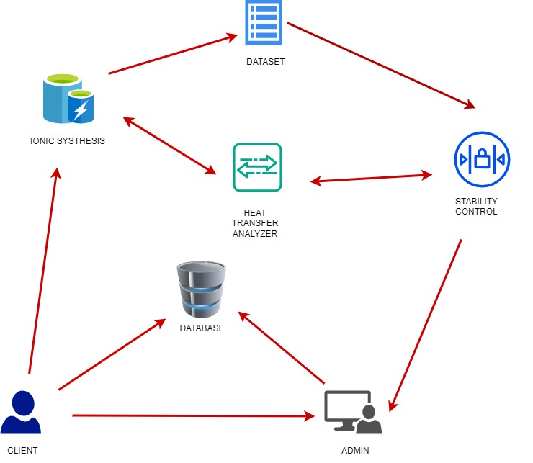

**Figure-1** System Architecture: Illustrates the overall architecture and flow of the system. Depicts the various modules and their interactions.

1. **MODULE DESCRIPTION**

**Client Module:**

The client module enables users to effortlessly communicate precise material requirements. During the client registration process, a robust email verification system is seamlessly integrated, enhancing the security and reliability of our client module. Users undergo email verification through a One-Time Password (OTP), reinforcing the authenticity of their registration. This interface seamlessly links users to the Ionic Synthesis module, where their unique needs are meticulously processed. Clients benefit from budget-friendly material recommendations and thorough reports, streamlining the intricate material selection process. Client module prioritizes user concerns by incorporating key factors into the material requirements such as Environmental impact, cost constraints, material capability, durability, and system size. Furthermore, the client module features a secure order placement system, fostering efficient transactions within a confidential environment. This commitment to security enhances the overall user experience, contributing to heightened satisfaction. Bayesian learning regression algorithm, to generate reports with accuracy. By integrating Bayesian learning regression, we enhance the reliability of our system, delivering insights that are finely tuned to each user's unique requirements. This sophisticated algorithm further underscores our commitment to innovation, making the material selection process even more robust and tailored to the evolving needs of client.

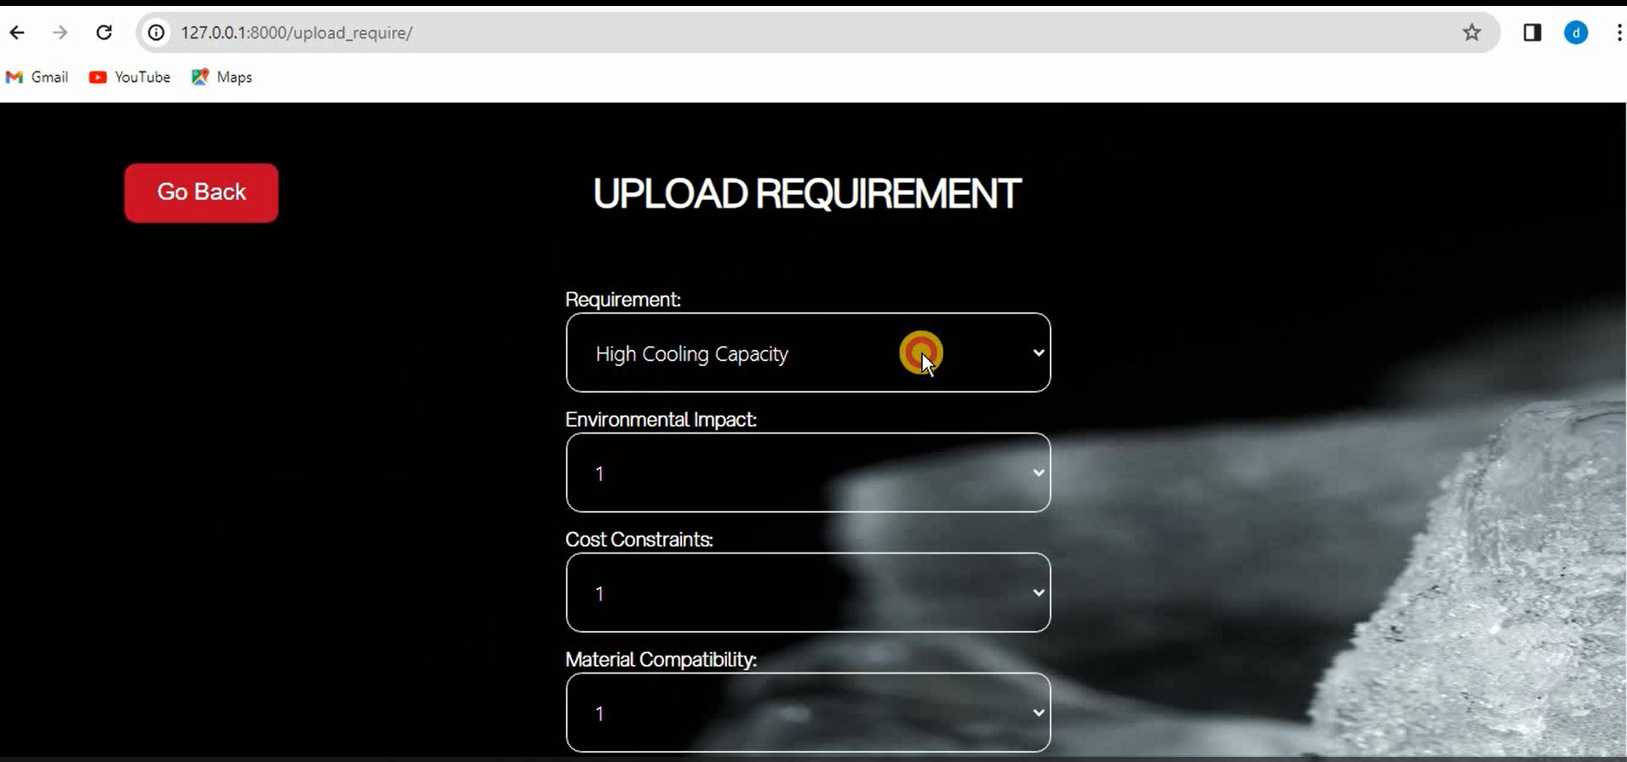

**Figure-2** Requirement Form: Shows the form for submitting wood ionic and calorfic slection. Allows users to specify their heat analysis needs.

**Admin Module:**

The admin module in which administrators take on a multifaceted role in ensuring project success. They have the responsibility of reviewing and approving reports, providing a crucial layer of quality control. Admin wield the authority to view all reports, ensuring accuracy and adherence to project requirements. Their oversight extends to the monitoring of security protocols, assuring a robust defense against potential threats. Overseeing its entirety with a focus on comprehensive management and optimization. Data security is a top priority, with admin ensuring encrypted data storage and exclusive access through secure key mechanisms. Admin monitor the Heat Transfer Analysis to optimize heat exchanger choices for enhanced efficiency, but they also manage the Stability Control module, evaluating long-term material stability to contribute to overall system reliability. They facilitate seamless transactions by managing the financial aspect of the project. They receive payments from clients and provide the delivery of comprehensive reports

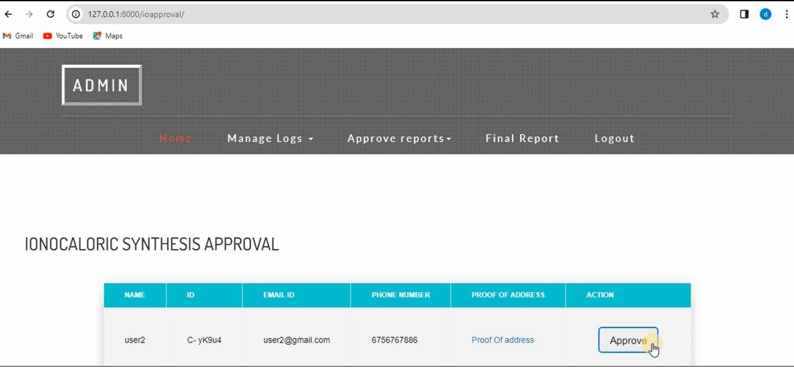

**Figure-3** Admin Approval: This figure shows Admin Approval from client requirements.

**Ionic Synthesis Module:**

In this module ionic caloric material selection is done through a multifaceted approach. It is user-friendly interface, empowering clients to articulate precise material requirements effortlessly. Once client needs are inputted, the module initiates a data processing phase, employing algorithms to meticulously analyze and interpret unique material specifications. It includes recommendation engine, a powerful tool that level to suggest ionic caloric materials tailored to specified budget constraints. This not only optimizes the selection process but also underscores the module's commitment to balancing performance and cost-effectiveness. Ionic Synthesis ensures budget-friendly solutions by aligning material recommendations with financial considerations without compromising performance integrity. Ionic Synthesis adds value through comprehensive reporting. The module generates detailed reports, providing clients with a holistic view of recommended materials. These reports serve as invaluable assets, empowering clients with the information needed for well-informed decision-making. It will significantly enhance the efficiency of material selection. Within this module, the ElGamal algorithm plays a pivotal role in fortifying data security. Leveraging its robust public-key cryptography, the algorithm facilitates.

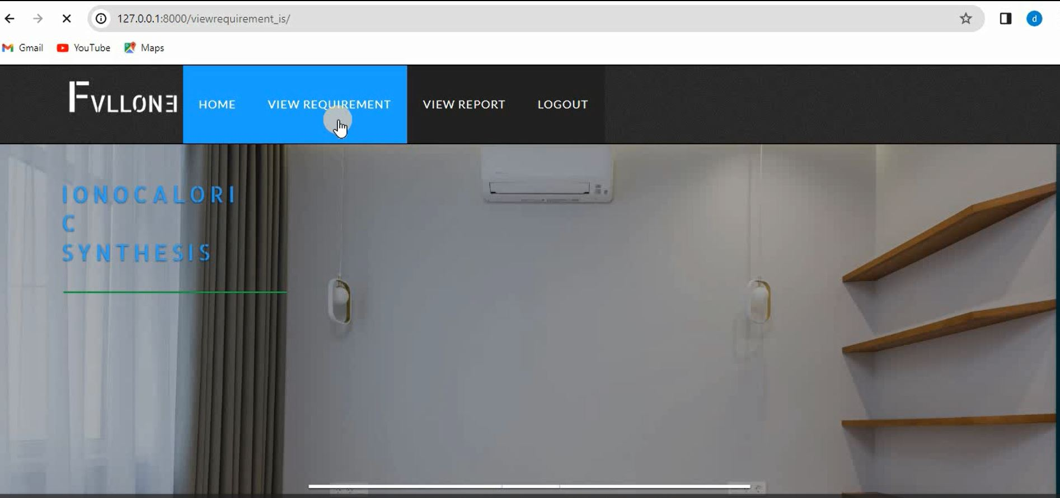

**Figure-4** This figure shows to view the client requirements form ionocaloric synthesis

**Heat Transfer Analysis:**

The Heat Transfer Analysis module focusing on the optimization of heat exchanger choices. This module systematically assessing various heat exchangers based on factors such as efficiency, thermal conductivity, and compatibility with ionic caloric materials. Users derive significant value from detailed performance reports, gaining insights into the effectiveness of selected heat exchangers. These reports, rich in data, empower users to make informed, data-driven decisions, ensuring the chosen components align seamlessly with project goals. The module's commitment to energy efficiency shines through its recommendations, prioritizing heat exchangers that maximize energy efficiency and contribute to the overarching sustainability objectives of the project. A pivotal aspect of the module's functionality is its dedication to system effectiveness. It ensures the selected heat exchangers not only enhance individual performance but also harmonize with the entire system. This commitment translates into improved overall performance and reliability within refrigeration and heat transfer technologies. This module also facilitates secure communication and upholds the confidentiality of all the information using ElGamal algorithm**.** It’s contributions extend beyond efficiency actively promoting sustainability goals, it plays a crucial role in fostering environmentally friendly practices in thermal management.

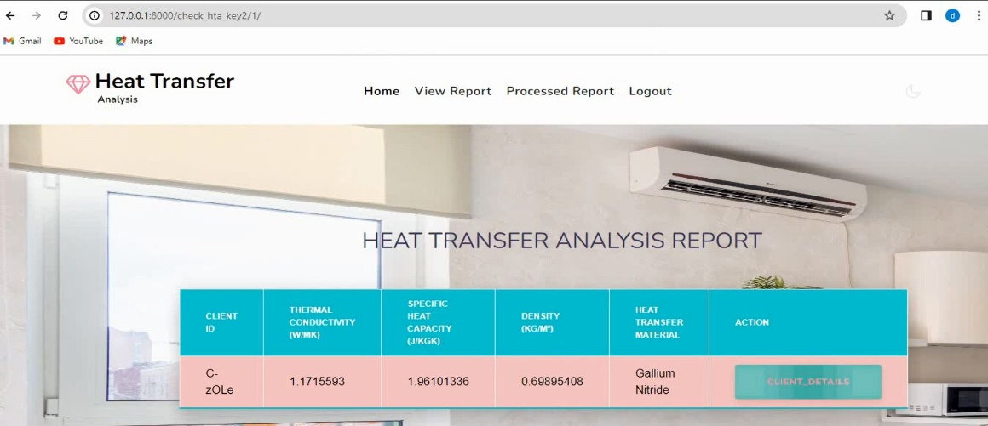

**Figure-5** This figure shows the heat transfer analysis details.

.

1. **CONCLUSION**

The project offers an integrated system for efficient material selection, enhanced system performance, and long-term stability assurance in the field of ionic caloric refrigerants. It optimizes decision-making for clients, reduces energy consumption, ensures material durability, and aligns with sustainability goals.

1. **FUTURE WORKS**

To further enhance this system, real-time monitoring and control of ionic caloric systems could be incorporated for ongoing performance optimization. Additionally, a mobile application interface for clients could enhance accessibility and user experience. Expanding the database with new materials and applications would keep the system up-to-date with emerging technologies and evolving client needs.

1. **REFERENCES**
2. Smith, J. D., & Granqvist, C. G. (2010). Thermochromic materials for energy-efficient windows. Journal of Materials Chemistry, 20(38), 8112-8121. This paper provides an overview of the applications of thermochromic materials in energy-efficient windows.
3. Qin, Y., Zhou, L., & Zhang, H. (2019). Ionic thermochromic materials: Principles and applications. Advanced Functional Materials, 29(48), 1906453. This article discusses the principles of ionic thermochromism and its potential applications.
4. Liu, Q., Zhu, M., & Wang, Y. (2018). Mechanisms and applications of thermochromism in materials. Materials Science and Engineering: R: Reports, 130, 1-37. This comprehensive review covers the mechanisms behind thermochromism and its applications.
5. Bunning, T. J., Li, Q., & Hsiao, E. (2016). Polymer-based thermochromic materials: Fundamentals and applications. Polymer Reviews, 56(2), 274-302. This paper focuses on polymer-based thermochromic materials, highlighting the fundamental mechanisms and uses.
6. Cabeza, L. F., Castell, A., & Oró, E. (2011). Integration of renewable energy technologies in thermal energy storage systems. Energy Storage Technologies and Applications, 112-142. This book chapter discusses the integration of renewable energy technologies in thermal energy storage systems, relevant for calorific energy management.