**Tetrataenite's Kaleidoscopic Symphonies in Complex Tech Orchestration**

**G.P. Venkitaramanan*1 , Dr. S. Babu*2**

*1 PG Scholar, Department of Computer Science and Applications, SCSVMV [Deemed to be University], Kanchipuram, Tamil Nadu, India

*2Assistant Professor, Department of Computer Science and Applications, SCSVMV [Deemed to be University], Kanchipuram, Tamil Nadu, India

## ABSTRACT

The project “Tetrataenite Magnets” integrates a sophisticated system designed for the seamless processing of tetrataenite magnets. Users navigate through an integrated portal system with distinct modules, each dedicated to specific stages of the processing workflow. The system prioritizes user-friendly interfaces, allowing for the effortless communication of requirements and tracking of processing progress. the system ensures transparency, efficiency, and accountability in meeting the project’s objectives. The significance of tetrataenite magnets lies in their exceptional magnetic properties, making them crucial in various applications across advanced technologies and scientific research. These magnets exhibit remarkable characteristics that can be harnessed for enhanced performance in diverse fields. The project incorporates algorithms to optimize the processing of tetrataenite magnets, enhancing precision and efficiency in composition analysis, neutron quenching methods, and permeability testing. The utilization of algorithms contributes to the system’s adaptability and capacity to learn from data, thereby improving the accuracy of results and streamlining the overall processing workflow. The advantages of this concept include a systematic approach to processing tetrataenite magnets, ensuring a standardized and efficient methodology. The algorithms enhance the system’s analytical capabilities, providing more accurate and reliable results. The importance of the project lies in its potential to advance research and technological applications, leveraging the unique properties of tetrataenite magnets for innovations in various industries. The system not only caters to specific processing needs but also contributes to the broader scientific understanding and utilization of these exceptional magnetic materials.

## I. INTRODUCTION

The project “Tetrataenite Magnets” aims to revolutionize the processing of these unique magnetic materials through the development and implementation of a comprehensive system. The scope of the project is expansive, encompassing the establishment of a standardized and user-friendly workflow that seamlessly integrates various stages, from composition analysis to

neutron quenching and permeability testing. The goal is to contribute not only to specific processing needs but also to the broader scientific understanding and application of tetrataenite magnets. In response to the deficiencies of existing systems, the proposed system is designed with meticulous attention to the distinctive properties of tetrataenite magnets. Unlike the current lack of specialization, the envisioned system is finely tailored to optimize the processing workflow, ensuring efficiency and accuracy in the analysis of these magnetic materials. The proposed system introduces a standardized and streamlined processing pathway, guiding analytical processes from composition analysis through neutron quenching to permeability testing. The integration of algorithms in the proposed system aims to significantly enhance precision, addressing potential inefficiencies and providing a powerful and adaptive tool for researchers and industry professionals. This advanced technology not only fills existing gaps but also ensures a more effective utilization of tetrataenite magnets across diverse industries. The overarching goal is to advance research and technological applications in the field of magnetic materials while contributing to a broader scientific understanding. Moreover, the proposed system is expected to facilitate the discovery of new tetrataenite-based materials with enhanced properties and functionalities, expanding the potential applications of these unique magnets. The standardized and streamlined processing pathway will enable effective data sharing and comparison among researchers and industry professionals, accelerating the development of tetrataenite magnet technologies. In essence, the project and proposed system herald a new era in the exploration and utilization of the remarkable properties of tetrataenite magnets.

**Keywords:**

* Secure Computing
* Client
* Composition analysis
* Neutron quenching method
* Permeability testing
* Management

## 

## II. LITERATURE REVIEW

1. The literature surrounding CSA underscores its paramount importance in addressing the ever-evolving landscape of cyber threats. By fostering a deeper understanding of the cyber environment, CSA enables organizations to detect, analyze, and respond to potential security incidents in a timely and effective manner. Franke and Brynielson delve into the multifaceted nature of CSA, exploring its intersections with cognitive psychology, information theory, and network security.
2. Singh and Mahajan (2021) contribute to the growing body of research concerning cyber-physical security by examining the impact of cyber attacks on critical power system infrastructure. Their study, published in Smart Science, delves into the vulnerabilities and consequences associated with such attacks, shedding light on the complexities of safeguarding essential utilities in an increasingly interconnected digital landscape.
3. Their analysis provides valuable insights into the nature of conflict, strategic decision-making, and the dynamics of competitive interactions in both conventional and unconventional warfare scenarios.

## III. PROPOSED SYSTEM

The proposed system for the "Tetrataenite Magnets" project is designed to rectify the deficiencies of the existing system, introducing a dedicated and comprehensive approach that aligns with the unique properties of tetrataenite magnets. In contrast to the current lack of specialization, the envisioned system will be finely tailored to optimize the processing workflow, ensuring a more efficient and accurate analysis of these magnetic materials. A pivotal aspect of the proposed system involves the implementation of a standardized and streamlined processing pathway, effectively guiding analytical processes from composition analysis through neutron quenching to permeability testing. Leveraging state-of-the-art machine learning algorithms, the proposed system aims to significantly enhance precision, addressing potential inefficiencies and providing researchers and industry professionals with a powerful and adaptive tool to fully exploit the distinctive properties of tetrataenite magnets.

This integration of advanced technology not only fills existing gaps but also ensures a more effective utilization of tetrataenite magnets across diverse industries, aligning with the project's overarching goal of advancing research and technological applications in the field of magnetic materials and contributing to broader scientific understanding. Additionally, the proposed system is expected to facilitate the discovery of new tetrataenite-based materials with enhanced properties and functionalities, further expanding the potential applications of these unique magnets. Furthermore, the system's standardized and streamlined processing pathway will enable researchers and industry professionals to share and compare data more effectively, accelerating the development of tetrataenite magnet technologies.

**SYSTEM ARCHITECTURE:**

# By leveraging this comprehensive system architecture, our project aims to deliver accurate, from the tetrataenite magnets in easy method to the understanding of the diagram from the composition, neutron quenching, permeability testing.

# WhatsApp Image 2024-05-24 at 4.47.31 PM.jpeg

## Fig 3.1 System architecture

## IV. Result and Discussions

**HOME PAGE:**

The home page provides an introduction to the platform, explaining its purpose and the benefits in Offers it. It outlines how the platform can help from thetetrataenite magnets.



Fig 4.1.Home Page

**CLIENT LOGIN PAGE:**

The client login page an first signup from the register then login to the tetrataenite

Magnets.



Fig 4.2. Client login page

**CLIENT PAGE:**

The client page is used to see them in requirement of creative tetrataenite and product status and payment of the product.



Fig 4.3.client page

**CLIENT STATUS:**

The client status is display view product status on tetrataenite magnets. In the composition, neutron quenching and permeability testing.

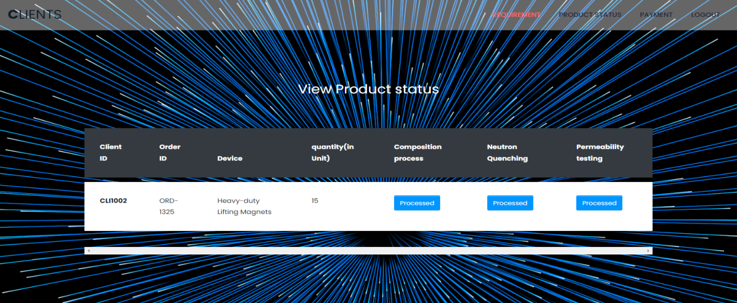

# 

# Fig 4.4.Client Status

# CLIENT PAYMENT:

# The client payment of the tetrataenite magnets in the credit/debit card paymet of the client status

# cltpayment.png

# Fig 4.5.Client payment

**FINAL REPORT:**

The final report of the tetrateanite magnets of the composition, neutron Quenching, permeability in the action.

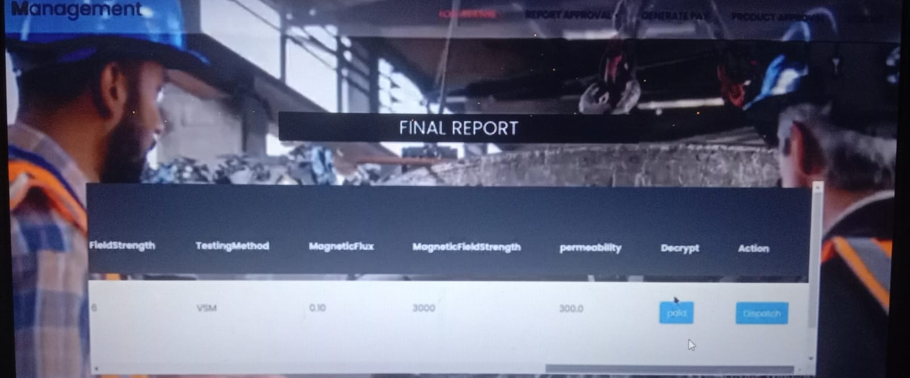

Fig 4.6.Final report

**V. CONCLUSIONANDFUTUREENHANCEMENT**

The suggested system for the "Tetrataenite Magnets" project heralds a pioneering advancement in the processing of these distinctive magnetic materials. Beyond addressing existing limitations, the system introduces a specialized, fine-tuned approach that not only streamlines workflows and leverages algorithms but also fosters adaptability for continuous improvement. By enhancing precision and optimizing utilization, this innovative system holds the potential to revolutionize the application of tetrataenite magnets, offering unprecedented opportunities for advancements in research, technology, and industry. The future work for this project involves continual refinement and adaptation of the system based on emerging technologies and research findings. Further integration of advanced models, exploration of novel analytical techniques, and collaboration with experts in magnetic materials can contribute to ongoing improvements. Additionally, expanding the application scope of tetrataenite magnets in emerging technologies and industries presents an avenue for future research and development, ensuring the sustained relevance and impact of the project in the dynamic field of magnetic materials.

## ACKNOWLEDGEMENTS

I express my deep appreciation to Assistant Professor Dr**.** S.BABU, whose sincere care and commitment to my advancement and evolution have been a consistent source of motivation. His support and genuine interest have been instrumental in influencing my academic pursuits and fostering within me a strong sense of assurance and resolve. I consider myself incredibly fortunate to have had the guidance of such an outstanding mentor who consistently placed emphasis on my growth and welfare.

## REFERENCES

1. U. Franke and J. Brynielson, ”cyber situational awareness-A systematic review of the literature, “comput. secur., vol.46,pp.18-31,2014.
2. N.K. Singh and v. Mahajan, “Analysis and evalution of cyber-attack impact on critical power system infrastructure, “Smart sci., vol.9,no.1,pp.1-13,2021.
3. J. boyd and G.G.Richards, “patterns of conflict, “Defence and the National interest,2007