Conveyor using linear induction motor
Shreyash Patil1, Prajval Bavade2
Student Electrical Department NMCOE Peth1,2
Abstract—In this project, Design of three phase linear induction motor for conveyor is proposed. In present the rotary induction motor are used for conveyor. We apply linear motion on conveyor which applies linear force through out uniformly. The main advantage is to that the use of three phase liner induction motor to move the conveyor is that it applies force uniformly without any contact. Hence in this drive absences of friction between belt and roller. The main disadvantages in designing three phase linear induction motor is that works it efficiently with low frequency power. In combination of conveyor belt we can generate electricity by using magnets and coil this can increase efficiency of conveyor belt system and these generated energy can be stored in battery and used for lighting scheme.
Keywords Three phase Linear Induction Motor, Arduino, Aluminium sheet, Magnet, Copper Coil.
INTRODUCTION
Linear Induction Motors it was subjected by linear motors might be given with advantage to that to driving of certain type of conveyor. In conventional coal or sugar conveyors which are normally controlled through rollers driven by ordinary three phase induction motors have the limitations that force applied to belt is over a small area there is problem of belt stretch.
If stretching occurs there is problem of belt slippage some of the drive system subjected to excessive wear the condition of working may ranges from drive, dusty to very wet, it is difficult to operate conventional motor driven conveyors The proposal to utilize three phase linear induction motor includes the use of belt of conducting material which passes between a pair of linear stator slots carrying a three phase system of coils connected so as to travel the magnetic field through the belt, the later constituting the rotor of induction machine would exert a uniformly distributed force over a large area of belt without any contact the drive is therefore independent of the friction.
This project describes to possible forms of flexible belts, the first use copper wire with stainless steel wire for mechanical strength and the second type made from conducting material carried on chains. The magnets N52 are placed on lower side of conveyors which produces revolving magnetic field and mounted coils which are stationary cut the magnetic field EMF induces in that coil. That EMF taken of to battery side and stored and used in various purpose of industry such as lighting scheme etc.
LITREATURE SURVEY
The idea of a three phase linear induction motor had been suggested in 1895 and was first introduced by electrical engineer, Eric Laithwaite. He spend his career investing this special machine. The history of three phase linear induction motors in the past 19th century. these machines have been outdated for the last 40 or 50 years, there appears to be a genuine revival of interest in them. The fascinating history of these linear motion motors and their theory of operation are discussed in this paper.
In now days rotary induction motors are used for conveyors which has problem of belt slippage and also there is problem of belt slippage. In this paper we are developing the linear induction motor which is used for conveyor. Because of LIM there is absence of friction coefficient.
The practicals work was carried out at a belt speed of 6.5ft/sec, the selection of speed being quite arbitrary. It is clear that three phase linear machines with properties almost as same as that of conventional rotating machines can be design for surface speed. The main disadvantage of three phase linear induction motor for conveyors it require low frequency supply. From this we know that machine can be built to have good efficiency and good power factor.

METHODOLOGY
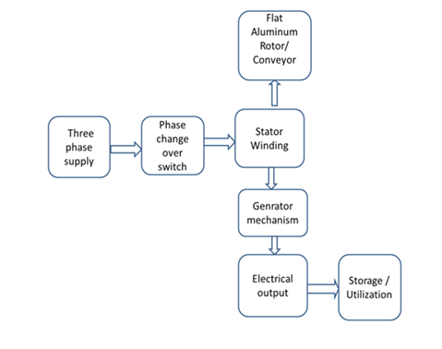Fig.1
When three phase supply is connected to the stator of LIM through Three phase changeover switch. The stator produces travelling magnetic flux., which travels along the length of stator and produces the linear force hence AL sheet starts to move. The linear force exerts uniformly on the Al sheet. The magnet placed below the sheet produces the flux which links with the coils placed on base plate and EMF is induced in it, this is the methodology of fig.1. When three phase linear induction motor is basically rotating cage motor cutted out flat. Instead of developing rotary torque from a cylindrical equipment it develops linear force from flat one. Depending on size and ratings of the three phase linear induction motor, they can produce thrust up to several thousand Newton. The speed of three phase Linear induction motor depends on winding design and supply frequency.
The reaction SLIM is equivalent to conventional rotor. The reaction plate is made up of non magnetic material of high conductive. The induced magnetic field is increased backing up the reaction plate with an iron plate.

The iron plate serves to amplify the magnetic field produced in coil. The air gap between the stator and the reaction plate must be as small as possible. Otherwise the amount of current through stator becomes undesirable. When ac supply given to the coils, a travelling magnetic field is produced. The phase reverse the direction of travel. The induced current in the reaction plate by the travelling magnetic field create an another magnetic field. It is not possible to keep the field synchronized with reaction plate. A force thrust is produced with the reaction between travelling magnetic field and secondary magnetic field. The magnets are placed below the AL sheet when sheet travels an changing magnetic flux are produced which is cut by windings placed on base an EMF is induced in it, that is used for various purpose of industry.
A.Three Phase Liner Induction Motor: -

A linear induction motor is basically a cage induction motor cutted out flat. Instead of producing rotating torque from a cylindrical motor it produces linear force instead of producing rotary torque from flat one. It produce thrust depending on size and rating of linear induction motor up to several of Newton. The speed of three phase linear induction motor depends on winding design and supply frequency.
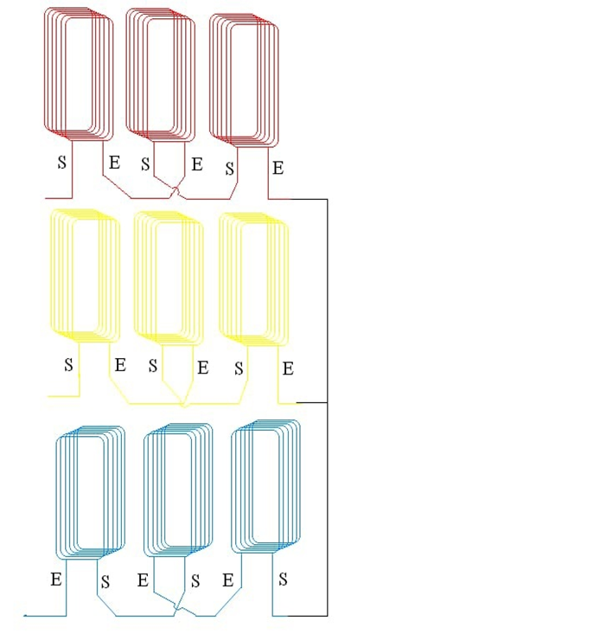

Fig.2
B. Magnet:-

N52 neodymium magnet is used to produce revolving magnetic field with the help of revolving conveyor belt. It is also called as earth magnet. It is a permanent magnet and it is made up from alloy of neodymium and boron of crystalline structure. Its a strongest ‘n’ type of permanent magnet used in commercial it is used where strong magnetic field is required.
The N52 Magnet is the highest degree of permanent magnet in the market. All N52 Neodymium magnets provide the same MGOe 52 as high energy magnets regardless of their sizes or shapes as the magnetic flux density of course.
As the size of magnet increases the holding force capability.

C . Phase Changeover Switch: -
A phase change over switch is an electrical switch that cut off a load between two phases . Some phase change over switches are operated manually, in that an operator change the transfer by throwing a switch, while others are automatic and operate when they sense one of the phases has cut off or supplied with power.
.
D. Arduino Uno :-

Arduino Uno is based on the ATmega328P.This microcontroller board has has 14 digital input/output pins, 6 analog inputs, a 16 MHz quartz crystal, a USB connection, a power jack, and a reset button.

IV. PROJECT HARDWARE :- -
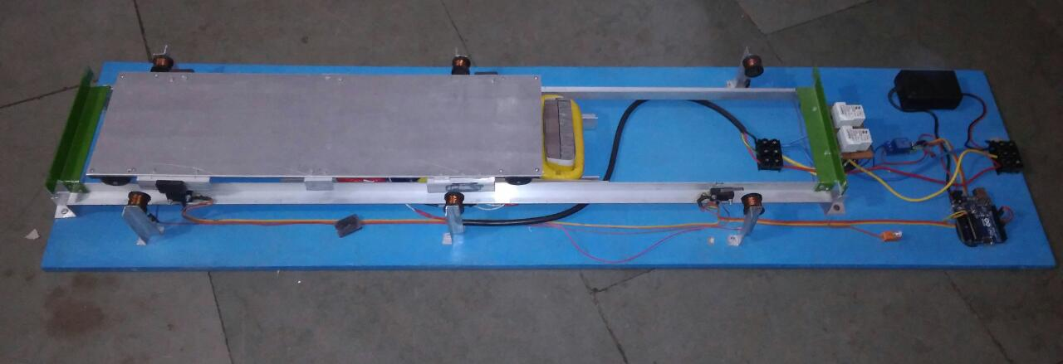

Fig.3

Three phase linear induction motor operates on three phase supply. The linear motor is supplied with three phase ac supply through three phase auto transformer the speed of motor is proportional to the supply voltage square. voltage as supply is increased linear fluxes travels along the length of stator and due to interaction the linear force is produced the AL sheet which act as rotor then start to move due to linear force. Also we are generating the energy by magnets which are placed below the conveyor which develop change in magnetic field which is cut by coils placed on base the coils are connected in series the energy is used for various purpose.

V. CONCLUSION:-

It is seen that three phase linear induction motors as same as conventional three phase cage induction motors. It posses good efficiency. In this project we generate electricity hence reduction in the energy bill of industry because generated energy utilized for lighting or various purpose in industry.

VI . REFERENCES:-

[1]E. R. Laithwaite, D. Tipping, D. E. Hsmondhalgh, The application of linear induction motor to conveyors, Associate member of Singapore technical , Singapore.
[2]Arun Dominic Dn, Thanga Raj Chelliah,Analysis of field-oriented controlled induction motor drives under sensor faults and an overview of sensor less schemes, Department of Water Resources Development and Management, Indian Institute of Technology, IIT-Roorkee, Roorkee, Uttarakhand 247667,India.
[3]Marcello Pucci,Direct field oriented control of linear induction motors, ISSIA-CNR, Section of Palermo, Via Dante, 1290141, Palermo, Italy.
[4]J. A. Tudor, D. M. Platt,The application of electric motor in the pulp and paper industry, Department of Westinghouse electric corporation, Portland, org.
[5]G. Bellamy, E. Lewis,The development of advanced linear induction motor system, ALSTOM Power Conversion Ltd. Rugby, UK.
[6] Arun Dominic ,Thanga Raj,Analysis of field-oriented controlled induction motor drives under sensor faults and an overview of sensor less schemes, Department of Water Resources Development and Management, Indian Institute of Technology,IIT-Roorkee,Uttarakand247667,India.

