**IMPLEMENTATION OF** **THREE LEVEL PASSWORD AUTHENTICATIONS**

**Prof. Akansha Bondade**

Dept. of computer science and engineering

TGPCET mohgaon, Nagpur

**Suyash Janbandhu Bhushan Mungantiwar**

Dept. of computer science and engineering Dept. of computer science and engineering

TGPCET mohgaon, Nagpur TGPCET mohgaon Nagpur

**Piyush Dhunde Sumit Hajare**

Dept. of computer science and engineering Dept. of computer science and engineering

TGPCET mohgaon, Nagpur TGPCET mohgaon, Nagpur

**Suraj Solanke**

Dept. of computer science and engineering

TGPCET mohgaon, Nagpur

**Abstract:**

*A protection breach could also be hazard to nationwide personal records or the non-public records of a business or a person. The utmost renowned type of password used for cover function is Text-based. However, those passwords could also be without difficulty broken and one might also lose his/her personal records to the wrong hands. With the upward thrust in cyber-crime, hacker, protection threats related to login & accesses have mature to be a primary concern. Also, exploitation unwed protection authentication is not enough adequate to maintain you blanketed from cyber threats. In spite of severe endeavour’s taken today nonetheless protection risks could also be visible all around the place. Also, from the beginning, we’re using merely unwed degree mystery key validation factors, that isn’t adequate to offer a lot of protection. To be safer we have a tendency to will believe 3 level arcanum authentication. In these studies, painting, three degree arcanum authentication is proposed and prompt experimental results. From the top result analysis , its miles discovered that the three degree authentication offers a dependable protection degree in assessment to the current mechanism.*

I. **INTRODUCTION**

The project is associate in nursing authentication system that solely allows users to access the system if they need entered the proper parole. The project includes three levels of user authentication. There square measure a variety of parole systems, several of that have failed because of larva attacks. Whereas some have pushed them to their limits. In short, the majority passwords available these days may be cracked to some extent. Therefore, this project aims to attain most security in user authentication. Contains 3 logins that have 3 differing types of parole systems. The difficulty of the parole will increase with every level. Users should enter the proper parole to log in with success. Users have the proper to line passwords as they need. The project includes text passwords, i.e., passphrase, associate in nursing image-based parole, and a graphic-based password. for all 3 levels. That way there would be negligible probabilities of the larva or anyone else cracking the passwords, though key crack the primary or second level it be not possible to crack the third. Therefore, once developing the technology, the stress was on the employment of innovative and non-traditional strategies. Most of the widely used text-based password systems square measure unfriendly for several users, thus within the case of three-level passwords, we have a tendency to try and produce a straightforward user interface and supply users with maximum amount convenience as doable in password resolution.

**II. LITERATURE SURVEY**

In an analysis product, tolling observe and technologies are conferred. doubtless development and improvement are reviewed, along with potential to different intelligent transportation system.

1. IEEE Xplore, 3 Level Password Authentication System. This paper counsel the use of each hardware token (smart-card) and therefore the software token (HOTP that is system generated). These 2 tokens are used as separate levels of authentication to make sure the security to user profile.

2. Implementation of Security System Using 3- Level Authentication This paper could be distinctive and an esoteric study of using pattern as password and implementation of secured system secured system, employing three levels of security-(Text Password, Pattern-Lock, and One-Time machine driven generated password).

3. IEEE Xplore , 4, April 2014 , 3-Level Password Authentication System. They planned a multifactor authentication scheme that mixes the benefits of the present authentication schemes and thereby, overcomes the pitfalls of the presently used authentication schemes.

4. In 2018 Aparna M and Anjusree CM proposed “Three level security system using Image based Authentication”. This paper introduces OTP (one time password) concept password as their third level. They recommended using image choice Authentication where user can select particular image from given options as second level. Author has proposed a different types of Authentication system, which are secured highly.

5. In June, 2020 Rahul Chourasia proposed “Three level password authentication system”. This paper proposed a trading approach for textual content passwords. They recommended changing textual content passwords with the aid of using graphical passwords, which makes easy to remember and less difficult for humans to use. In addition, the graphical password is greater security.

6. In December, 2022 Gauri Sankar Mishra, Pradeep Kumar Mishra and Parma Nand proposed “User Authentication: A Three level password Authentication Mechanism”. This paper is based on Users Authentication for Verification and Validation methodology. They proposed a method where system verifies user if he or she claim to be by using Three level password verification

**III. SYSTEM ARCHTECTURE**

user

USER

Text based authentication

Graphical based authentication

Image based authentication

login to system

Fig. working diagram

A Registration

User ought to login 1st and want to fill details in registration type.

B Password Set-up

1) Whereas registering, the user has to fill all three-level password as per their need

2) Following are the 3 levels for password set-up.

a) First Level: The primary level may be traditional text-based password system.

b) Second Level: The second level is associate image-based password.

c) Third Level: The third level may be graphical-based password technique.

C. Login

After registration users will login and check all the 3 security levels and want to recollect all three security levels for login in future.

Authentication

As the users can begin coming into the password for 1st level then after verification of 1st level it goes to second level and equality, the second level and third level.

Generally, authentication method are classified into three categories (Manjunath et. Al., 2013)(Suo et al.,2005).

1. Text based authentication
2. Graphical based authentication
3. Image based authentication

**Text based authentication**

A password could be a secret word or phrase that offers users access to personal computer resource such as program, files, massage, printer, web etc. Password are bigger than just a key. They guarantee our privacy, keeping our sensitive data secure. There are following two type of password.

1. Static password
2. Dynamic Password

Static password is that the ancient password that is usually modified only when it is necessary. It is changed once the users has got to reset password, i.e. either the users has forgotten the password or the password has invalid. whereas dynamic password also known as One Time Password (OTP), is a password which changes each time the users log in. An OTP is a set of character that can act as a form identity for time only. Once the password is used, it is no longer used for any further authentication. Moreover, the first level employs the static password due to the complexity of the One Time Password .

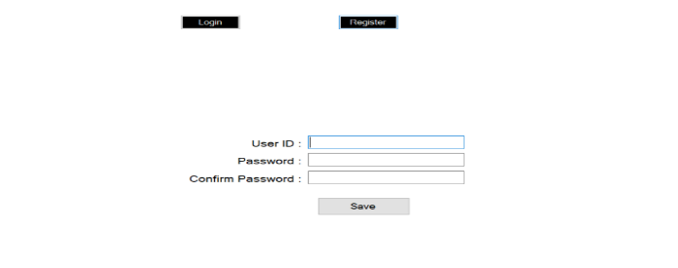

Fig 1.Text based authentication

**Graphical based authentication**

* In this we have to set a code such as a colour code e.g. colour is red green blue so the colour code will be red -green-blue.
* If the users forgets the password then he/she can click on forgot password and he/she can reset new password.

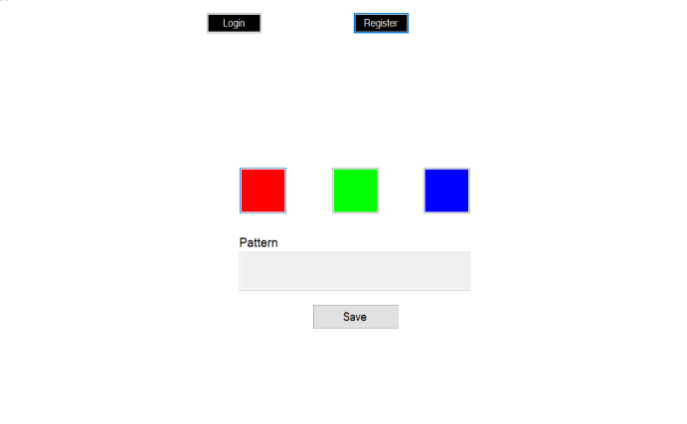

Fig 2. Graphical based authentication

**Image based authentication**

* In this level users need to upload an image and then the image will be cut into parts then while logging the user need to set the image according previous image.
* If the users forgot the image, he/ she can upload it by clicking on reset button.

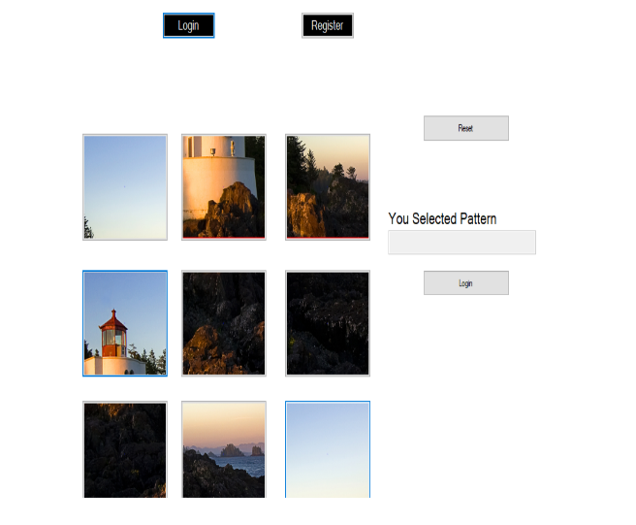

Fig 3 Image based authentication

**IV. PROPOSED METHODOLOGY**

In the registration phase in Fig1, the user should provide user’s details along with his/her user name and user conventional textual password which is as strong as much and difficult to guess. This will protect the system from Tempest attack, Brute-force attack at client side. User have to register with his/her mobile number along with one security question for validation phase of authentication and forget password recovery purpose simultaneously. Above all, user has to select position of pattern according to his/her choice it’s nothing but pattern-lock for that individual user, one advantage that selecting pattern is user can provide any kind of pattern he wanted while registration. Security at text-based level has been imposed by using Text based password (with special characters), which is a usual and now an anachronistic approach. At pattern-lock level the security has been imposed using patterns, where the user will be asked to select a pattern as difficulty level which is unique one for each and every Individual user. After preceding above two levels in registration system will generate random-code which is used to provide one-time password authentication level that is next and uppermost third level of authentication. This generated random code is valid for that particular registration phase only. After the successful registration only all the related data about user for authorised/legal use of system (or) application will stored in database. In the authentication phase in Fig 2 ,the user should provide user name along with its registered text-base password for textual password authentication which is level1,after preceding level1 user will ask for entering pattern in pattern-lock at level2, this pattern should match to the pattern in pattern-lock which is unique one and different for each and every user and has selected by user at the time of registration. At this stage pattern should be same as that of registered pattern in pattern-lock for individual user. If it’s fails to match simply that user is unauthorised user to access that particular system (or) application. After preceding above two levels, random-code which has generated by system, will send to registered user’s mobile number (or) for application flexibility purpose it can be send to user’s entered mobile number at level3 , it’s a six digit code, and advantage of this code is that it’s valid for current login session only. If any one of above 3 levels of security get mismatched (or) compromised user will not authenticate to system (or) application simply that would be restricted user. This unique and user-friendly 3-Level Security System is involving three levels of security. Where the preceding level must be passed in order to proceed to next level. · Security at level1 has been imposed by using Text based password (with special characters), which is a usual and now an anachronistic approach. · At level2 the security has been imposed using Pattern-Lock authentication where the user will be asked to select pattern levels. For each and every user will have different levels with unique pattern lock, from where the user has to select any kind of pattern he want. · After the successful clearance of the above two levels, the Level3 Security System will then generate a one-time numeric password that would be valid just for that registration (or) login session only

**V. CONCLUSION**

The three-level authentication system had been applied to the higher than system that makes it extremely secure at the side of additional user-friendly. This technique will facilities with Man-in-the-middle attacks and Brute-force attacks on the user’s facet. A three-level security system may be a long approach since the user has to enter details carefully for all 3 security levels and eventually, the user will add any image for its final level Authentications. Therefore, this technique isn’t suitable for the overall purpose of security since it takes time to fill altogether 3 security level details. However it’ll undoubtedly be useful in high-security levels wherever the protection of information may be concern and time quality is secondary. Within the future, we are able to add additional features like OTP (One Time Password) Authentication and Captcha Authentication where if the user uses VPN (Virtual Private Network) to browse then multiple Captcha will stop the user to use the actual software package The main objective of this project is to enhance the security level of the systems for several survey papers wherever researched. It’s found that a three-level authentication system helps to produce more security compared to one-level and two-level authentication systems. 3 levels are more important because the user needs to enter critical details and log in with 3 completely different levels of authentication.

**VI. REFERENCES**

I. In Sept.2008 Alsulaiman, F.A. : EI Saddik , A. proposed a Three for secure IEEE transaction on instrumentation and measurement This paper counsel the use of each hardware token (smart-card) and therefore the software token (HOTP that is system generated). These 2 tokens are used as separate levels of authentication to make sure the security to user profile.

II. In October 2012 Grover Aman, Narang winnie proposed a 4-D password Strengthening the authentication Scene. Implementation of 3 level of password authentication system. This paper could be distinctive and an esoteric study of using pattern as password and implementation of secured system secured system, employing three levels

of security-(Text Password, Pattern-Lock, and One-Time machine driven generated password).

III. IEEE Xplore , 4, April 2014 , 3-Level Password Authentication System. They planned a multifactor authentication scheme that mixes the benefits of the present authentication schemes and thereby, overcomes the pitfalls of the presently used authentication schemes.

IV. In 2018 Aparna M and Anjusree CM proposed “Three level security system using Image based Authentication”. This paper introduces OTP (one time password) concept password as their third level. They recommended using image choice Authentication where user can select particular image from given options as second level. Author has proposed a different types of Authentication system, which are secured highly.

V. In June, 2020 Rahul Chourasia proposed “Three level password authentication system”. This paper proposed a trading approach for textual content passwords. They recommended changing textual content passwords with the aid of using graphical passwords, which makes easy to remember and less difficult for humans to use. In addition, the graphical password is greater security.

VI. In December, 2022 Gauri Sankar Mishra, Pradeep Kumar Mishra and Parma Nand proposed “User Authentication: A Three level password Authentication Mechanism”. This paper is based on Users Authentication for Verification and Validation methodology. They proposed a method where system verifies user if he or she claim to be by using Three level password verification

VII.https://ieeexplore.ieee.org/xpl/articleDetail.jsp?tp=&amp;ar-number=6076505&amp;query-Text%3DMulti+Level+Password.

VIII.https://ieeexplore.ieee.org/xpl/articleDetails.jsp?tp=&amp;ar-number=5542954&amp;query-Text%3DMulti+level+Password.

IX. D.V. Klein, “Foiling the Cracker: A Survey of, and Improvements to, Password Security,” Proc. Second USENIX Workshop Security, 1990.

Biometrics: Personal Identification in Networked Society, A.K. Jain, R. Bolle, and S. Pankanti, eds. Kluwer, 1999.

.

X. D. Maltoni, D. Maio, A.K. Jain, and S. Prabhakar, Handbook of Fingerprint Recognition. Springer-Verlag, 2003.

XI. Ed. Dawson, J. Lopez, J.A. Montenegro, and E. Okamoto, “BAAI: Biometric Authentication and Authorization infrastructure,” Proc. IEEE Int’l Conf. Info Technology: Research and Education (ITRE ’03), pp. 274-278, 2004.

XII.<https://www.researchgate.net/publication/347973363_User_Authentication_A_Three_Level_Password_Authentication_Mechanism>

XIII. A.B.Gadicha , V.B.Gadicha , ―Virtual Realization victimisation 3D Password‖, in International Journal of Electronics and Computer Science Engineering, ISSN 2277-1956/V1N2-216-222.

XIV.https://en.wikipedia.org/wiki/File: Merkle Damgard_hash_big.svgppt of tips

HTTPs://www.slideshare.net/RaghuVam sySirasala/graphical-password-authenticationimpdocx2

[http://www.ijiere.com/FinalPaper/FinalPa per201543213256525.pdf](http://www.ijiere.com/FinalPaper/FinalPa%20per201543213256525.pdf)

XV.https://www.researchgate.net/publication/321698441_Graphical_Password_Authentication_using_Images_Sequence

XVI. https://krazytech.com/technical-papers/gra