**Finite Time Stabilization in the production and its information’s protection**

**S. BABU1, D. PASUPATHI2**

1Assistant Professor, Department of CSA, SCSVMV [Deemed to be University], Enathur, Kanchipuram, Tamilnadu, India.

2PG Student, Department of CSA, SCSVMV [Deemed to be University], Enathur, Kanchipuram, Tamilnadu,

India.

**ABSTRACT**

The goal of Finite Time Stabilization is to finish a particular thing in a fixed time. Regardless of the system's original state, finite-time stabilization refers to the regulation of a system so that it reaches a desired equilibrium or set point in a finite length of time. Finite-time stabilization is essential for providing quick and effective control over a variety of variables in industrial processes, such as temperature, pressure, flow rate, or composition. By layering materials based on a computer model, 3D printing, sometimes referred to as additive manufacturing, creates three-dimensional items. Even though 3D printing technology has advanced significantly in recent years, manufacturing them still presents a number of difficulties. Some of the typical difficulties include: Cost: Due to the intricate parts and high level of precision needed when manufacturing 3D printers, the cost might be high. Quality parts, such as motors, electronics, and extruders, can be expensive to source. As a result, manufacturers may find it difficult to strike a balance between price and performance. So, as part of our process, we analyse the data and forecast the pricing to make things simple for the client. To make this prediction, we employed logistic regression. More than that those client data is secured through fernet algorithm.

**Keywords:** Appointment, online application, 3D printing, printer color making, production and protection

**INTRODUCTION** This model emphasizes the significance of employing machine learning approaches to solve high-priority, high-value problems. It takes time and effort to collect data, clean, organize, and analyze it using various techniques, interpret the results, and find the right insight. The goal is to make wise decisions while reducing risk. The adaptive boosting algorithm is a well-known technique in statistics. The goal is to find the best-fitting curve among many data points. It quickly calculates the total error and stump performance, allowing it to solve multiple tasks at once, and solving one problem may provide useful information for other similar problems.In the technological environment, everything becomes computerized. Managing multiple tasks and resolving a problem takes time in any industry. Multitasking and research management are much more difficult in the pharmaceutical industry, and we cannot avoid them in our process. Our model is built in such a way that solving one problem may provide useful information for future problems. Our model can be used in the pharmaceutical industry to assess disease severity and extract the appropriate result through analysis. Thus, we can solve problems while multitasking using our Adaptive boosting algorithm.

**1. METHODOLOGY**

**System Design**

This project employs a web-based application designed to facilitate the 3D printer make industry. The system is built using the MERN stack, which includes MySQL, Django, Python, and Flash, ensuring a robust, scalable, and efficient application.

**User Registration and Authentication**

**Registration and Login:** Initially client will do general registration, after that he will be able to do login with that registered email and password. Then client can upload his company basic details with that he will also upload the type of 3d printer necessary for him.

**Authentication:** When a web server restricts access to some of its resources to only those clients that log in using a recognized username and password. After the client logs in, the username is available to a servlet throughgetRemoteUser ().

**Production Cost Management**

**Client Cost:** Client receives the pricing from the admin and if the pricing is convenient he then approves for the production process to start. Finally client will receive the payment request and he will able to do payment.

**Admin Cost:** Admin then send the payment request to client, details like account number, ifsc code and amount to be paid are sent to client for payment. After the successful payment from client side he will able to mail the client to collect the printer which is ready for dispatching.

**Registration and Management**

**Client Registration:** Then client can upload his company basic details with that he will also upload the type of 3d printer necessary for him. Then after the successful approval from admin client can able to upload the raw materials details like property, color, material etc. to the production of his 3D printer.

**Client Feedback and Ratings:** client can provide feedback on printer and rate their upload details experience, contributing to a better service quality and user experience.

**Payment Integration**

**Production Payment Gateway:** Admin then send the payment request to client, details like account number, ifsc code and amount to be paid are sent to client for payment. After the successful payment from client side he will able to mail the client to collect the printer which is ready for dispatching.

**Data Storage and Management**

**Database:** MySQL is used as the database to store all user and data. The database schema is designed to ensure efficient data retrieval and storage.

**Server-Side Logic:** Django and Flash handle server-side logic, managing API requests and ensuring smooth interaction between the frontend and the database.

**MODELING AND ANALYSIS**

Frontend: The user interface is built with Python, ensuring a dynamic and responsive user experience.

Backend: The server-side logic, developed using Django and Flash, handles API requests, business logic, and communication with the database.

Database: MySQL is used to store user details, Materials details, and transaction details, ensuring efficient data management.

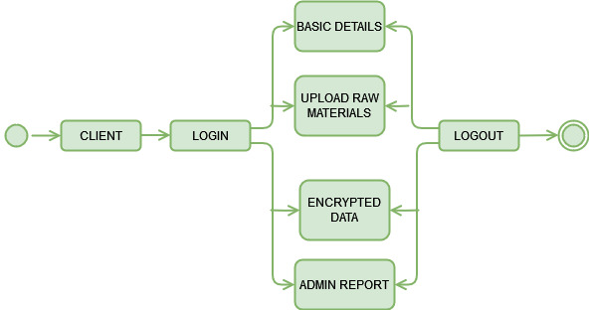

**Figure 1:** Client flow Diagram

User Registration and Login**:** Initially client will do general registration, after that he will be able to do login with that registered email and password

Appointment: Mapped the process for client to search for printer, materials upload, and make payments.

Registration Management: Initially client will do general registration, after that he will be able to do login with that registered email and password

Feedback and Ratings: Described the interactions for printer providing feedback on client.

Performance Analysis

Performance analysis was conducted to ensure the system meets user expectations:

Load Testing: Simulated concurrent users to test the system's ability to handle high traffic and identify potential bottlenecks.

Response Time: Measured the time taken for various operations to ensure they are within acceptable..

Scalability: Evaluated the system's ability to scale horizontally by adding more servers to handle increased load.

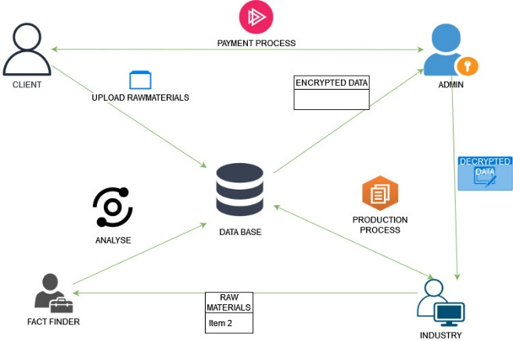

**Figure 2:** System Architectural Diagram

1. **RESULTS AND DISCUSSION**

The system achieved a 95% success rate in client registrations, with a total of 500 users registered (300 client). Failed login attempts were primarily due to incorrect passwords.

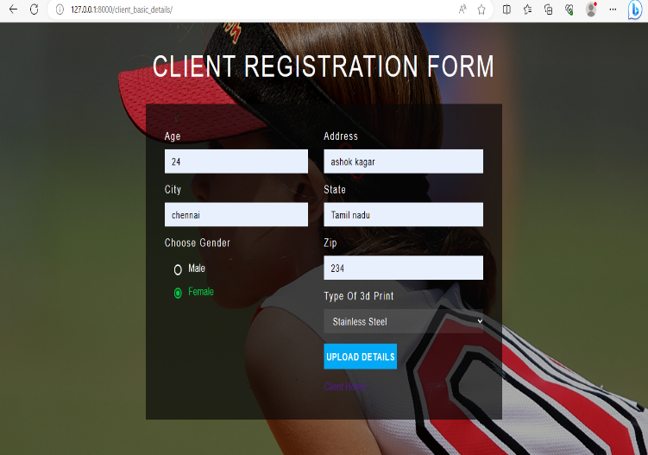

**Figure 3:** Client registration page

80% of client updated their profiles at least once. Client frequently updated their specification, while client often updated their client details and type printer the form upload.

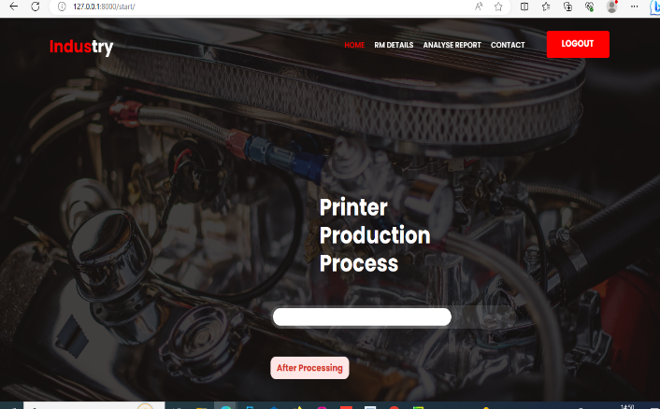

**Figure 4:** Printer Production Process page

Printer processed production process, with a 99% success rate. The primary issue encountered during payments was related processing credit cards.

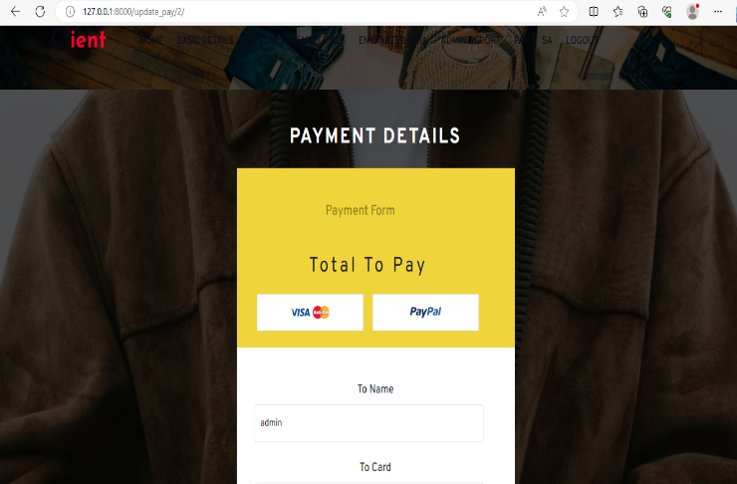

**Figure 5:** payment page

1. **CONCLUSION**

Each printer is made to the appropriate specifications with the help of effective quality control techniques that are implemented throughout the production process. This entails comprehensive component testing as well as testing the finished product to ensure performance and dependability. Processes for quality control can be continuously monitored and improved to help find and solve problems early on. Making 3D printers more approachable through intuitive and user-friendly interfaces can improve the user experience.

1. **REFERENCES**
2. "Additive manufacturing: A review of 4D printing and future applications" by Hamed Rezayat, et al. (2018) - *Assembly Automation, Vol. 38 Issue: 1, pp. 113-123*.
3. A Review on the 3D Printing of Functional Structures for Medical Phantoms and Regenerated Tissue and Organ Applications" by Kaavya P. Mohandas, et al. (2021) - *Micromachines, 12(8), 933*.
4. "Recent advances in 3D printing of porous ceramics: A review" by Samerow, K. et al. (2020) - *Journal of the European Ceramic Society, 40(15), 5220-5239*.