Optimization of Process Parameters for MIG Welding by Using Grey Relational Analysis

Abstract-The welding of Aluminium is a big challenge by conventional arc welding process and repeatability of welding depends on its control on welding speed and other processing parameters. In this study, GMAW welding of 5 mm thick mild steel was done by changing the welding current, gas flow rate and nozzle to plate distance to get a high strength joint. To get better strength welding of the MS plate is done from both sides. The main aim of the study was to analyse the Effect of welding current, gas flow rate and nozzle to plate distance on the tensile strength of weld joint, micro hardness of the weld pool and macrostructure of the joint. The mechanical properties under consideration for present work were the Tensile Strength and Hardness. Tensile Strength and Hardness were determined using UTE100, with capacity of 100kN and Rockwell hardness tester respectively. It was found that preheat temperature has the most significant effect on the tensile strength and hardness. The maximum tensile strength and hardness achieved was welding current 124 A, gas flow rate 15 l/min and preheat temperature 275°C.

***Keyword*s-** GMAW welding, tensile strength, hardness, preheat temperature, UTE100, Rockwell hardness

# I.INTRODUCTION

Welding is a process used to permanently join the different materials like metals, alloys or plastics, together at their contacting surfaces by application of heat and pressure. During welding process, the work-pieces which have to be joined are melted and after solidification of this melted metal a permanent joint can be achieved. Sometimes a filler material is added to form a weld pool of molten material in between the two or more work pieces which after solidification gives a strong bond between the work pieces.

Gas Metal Arc Welding is a process in which the source of heat is an arc format between consumable metal electrode and the work piece, and the arc and the molten puddle are protected from contamination by the atmosphere (i.e. oxygen and nitrogen) with an externally supplied gaseous shield of gas either inert such as argon, helium or an argon-helium mixture or active such as carbon dioxide, argon-carbon dioxide mixture, which is chemically active or not inert. Initially GMAW was called as MIG Welding because only inert gasses were used to protect the molten puddle.

The application of this process was restricted to aluminum, deoxidized copper and silicon bronze. Later it was used to weld ferrite and austenitic steels, and mild steel successfully by using active gasses in place of inert gasses and hence was term MAG (Metal Active Gas) welding. In the GMAW (MAG) process, the metal transfer from the electrode tip to the weld pool across thearc is either globular, spray type or short-circuiting type depending upon many factors, which are the magnitude of welding current, Shielding gas, Current density, Electrode extension and, Electrode chemistry. With CO2 shielding, the globular and non-axial, whatever may be the value of the welding current, current density and other factors. Hence there is considerable spatter. Drops become smaller in size as the current increases and they continue to be directed axially and non-axially.

# LITERATURE REVIEW

**Sudhir Kumar et al. (2019) research work**, AISI 1018 mild steel samples have been welded in V-butt joint configuration using MIG welding. The design of experiment is Taguchi based Orthogonal Array (L9). Effect of process parameters such as current, voltage and preheat temperature has been studied and welds are

enhanced welding quality because they do not react with each other. Argon and Helium gases protect the welding area from outer environment and helps to maintain a stable arc due to low ionization potential.

**Prakash BabuKanakavalli, et al. (2019)** discussed application of Taguchi and Grey relational analysis methodologies in determining optimal process parameters for MIG Welding are presented. In the present work welding current, voltage, speed, bevel angle were considered as input parameters in joining two dissimilar metals (AISI1010 & AISI1018), as these influence the output characteristics like tensile strength and hardness, these parameters need to be optimized.

**Ashish Chafekar, at al. (2019)** discussed on semi- automatic pulse MIG welding machine according to the L9 orthogonal array with replication. The process parameters viz. welding voltage, wire feed rate and dynamic is significant in intelligent MIG welding machine have been considered as variables.

**Dharmendra B.V. et al. (2019)** discussed multi-objective optimization technique for identifying a set of optimum abrasive water jet machining (AWJM) parameters to achieve maximum material removal rate (MRR) and minimum surface roughness.

**Priyanka Devidas Shinde, et al. (2018)** presented the effect of welding parameters such as welding current, welding voltage and gas flow rate on depth of penetration and ultimate tensile strength using Taguchi technique. Two types of oxides MgCO3 and Cr2O3 were used to examine the effects of activating flux on penetration in mild steel Fe 410 of size 100×65×6 mm by GMAW with a V-groove weld joint design.

**Nabendu Ghosh et al. (2018)** discussed dissimilar joints between AISI 409 ferritic stainless steel and AISI 316L austenitic stainless steel, are made by GMAW (Gas metal arc welding) using ESAB AUTO Rod 316L as filler wire. Welding has been conducted as per L9 orthogonal array of Taguchi method. Three levels of the input parameters: welding current, gas flow rate and nozzle to plate distance, have been selected.

**Arham Khan, et al. (2018)** carried out Taguchi method is used to formulate the experimental design. Design of experiments using L9 orthogonal array is employed to perform cladding operation. The input process parameters of pulse current GMAW considered include mean current, arc voltage, pulse frequency and wire feed rate.

**Saadat Ali Rizvi, et al. (2018)** discussed centre on optimizing different welding parameters which affect the weldability of SS304H, Taguchi technique was employed to optimize the welding parameters and fracture mode characterization was studied.In this study we aor found out minimum surface roughness

**Shekhar Srivastava et al. (2017)** carried out effect of the various process parameters has been studied on welding of IS:2062 mild steel plate using gas metal arc welding process with a copper coated mild steel wire of 0.8 mm diameter. A set of experimentshas been performed to collect the data using Box Behnken Design technique of Response Surface Methodology. Based on the recorded data, the mathematical models have been developed. Further an attempt has been made to minimize the bead width and bead height and maximize the depth of penetration using response surface methodology.

**NabenduGhosh et al. (2017)** investigated the effects of welding parameters: welding current, gas flow rate and nozzle to plate distance, on ultimate tensile strength (UTS) and Yield Strength (YS) in MIG welding of AISI409 ferritic stainless steel to AISI 316L Austenitic Stainless-Steel materials. Experiments have been conducted as per L9 orthogonal array of Taguchi method. The observed data of UTS and YS have been interpreted, discussed and analyzed with use of Taguchi Desirability analyses.

**ArunkumarSivaraman et al. (2017)** focuses on the optimization of process parameters for MIG welding of the material AA219-T87 using Taguchi based grey relational analysis. The welding input parameters play a vital role in optimized desired weld quality. The input parameter chosen were the welding current, Voltage and welding speed. The experiments were conducted according to L9 orthogonal array.

**Kumar Rahul Anand et al. (2017)** studied the mechanical properties of the joint of austenitic stainless steel (AISI 316) and mild steel welded by TIG welding. In this paper with the use of Taguchi method of optimization we have tried to optimized the various process parameter such as current, voltage and gas flow ratio (GFR) which has influence on tensile strength and hardness of the joint. However, investigation is based on the Taguchi approach of orthogonal array using analysis of variance (ANOVA) to determine the influence of process parameter and to optimize them.

# METHODOLOGY AND EXPERIMENTATION

Commercial MS plate of thickness 5 mm was selected as work piece material for the present experiment. MS plate was cut with required dimension with the help of power- saw and grinding done at the edge to smooth the surface to be joined. After that surfaces are polished with emery paper to remove any kind of external material.

The working ranges of the parameters for subsequent design of experiment, based on Taguchi’s L9 Orthogonal Array (OA) design have been selected. In the present experimental study welding current, gas flow rate and

nozzle to plate distance have been considered as process variables. After performing the welding, welded specimens were cut with dimension of 100 mm x 25 mm for tensile test, which were further cut in to I shape. Tensile test was performed with universal tensile testing machine (Instron-600) with maximum load capacity of 600 KN.

Table 4. The Deviation Sequences

Table 1. Tensile test result

|  |  |  |
| --- | --- | --- |
| Deviation Sequences | Δ0i (1) | Δ0i (2) |
| 1 | 0.19 | 0.91 |
| 2 | 1.00 | 0.04 |
| 3 | 0.56 | 1.00 |
| 4 | 0.00 | 0.15 |
| 5 | 0.96 | 0.05 |
| 6 | 0.15 | 0.77 |
| 7 | 0.28 | 0.07 |
| 8 | 0.35 | 0.11 |
| 9 | 0.14 | 0.00 |

|  |  |  |  |  |
| --- | --- | --- | --- | --- |
| Experiment no. | Welding current (Amp) | Gas flow rate (l/min) | Preheat temperature (°C) | Tensile strength (MPa) |
| 1 | 100 | 10 | 275 | 257.58 |
| 2 | 100 | 15 | 285 | 244.67 |
| 3 | 100 | 20 | 300 | 251.74 |
| 4 | 112 | 10 | 285 | 260.65 |
| 5 | 112 | 15 | 300 | 245.34 |
| 6 | 112 | 20 | 275 | 258.25 |
| 7 | 124 | 10 | 300 | 256.14 |
| 8 | 124 | 15 | 275 | 255.04 |
| 9 | 124 | 20 | 285 | 258.44 |

Table 2. Rockwell hardness test result

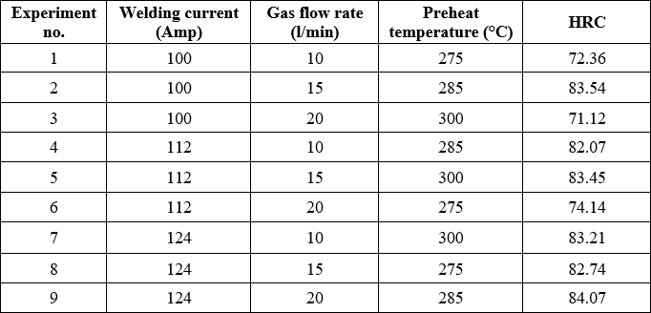

# GREY RELATIONAL ANALYSIS

Table 3. The sequences process of each performance characteristic after data processing

|  |  |  |
| --- | --- | --- |
| Experiment No. | Tensile Strength  Result | Hardness Value Result |
| Reference  Sequence | 1 | 1 |
| 1 | 0.81 | 0.09 |
| 2 | 0.00 | 0.96 |
| 3 | 0.44 | 0.00 |
| 4 | 1.00 | 0.85 |
| 5 | 0.04 | 0.95 |
| 6 | 0.85 | 0.23 |
| 7 | 0.72 | 0.93 |
| 8 | 0.65 | 0.89 |
| 9 | 0.86 | 1.00 |

Table 5. The calculated grey relational grade and its order in the optimization process

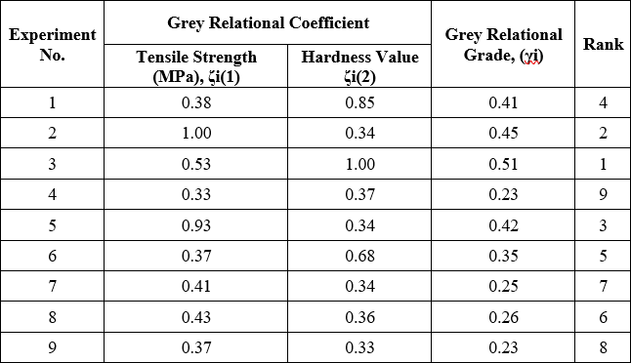

Table 6. Response Table for the Grey Relational Coefficient

|  |  |  |  |
| --- | --- | --- | --- |
| Level | Preheat  temperature | Gas flow  rate | Welding  Current |
| 1 | 0.4567 | 0.2967 | 0.3400 |
| 2 | 0.3333 | 0.3767 | 0.3033 |
| 3 | 0.2467 | 0.3633 | 0.3933 |
| Delta | 0.2100 | 0.0800 | 0.0900 |
| Rank | 1 | 2 | 3 |

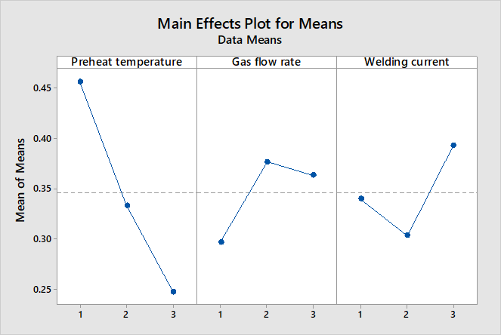

Fig. 1. Effect of welding parameters on the multi- performance characteristics

Table 7. ANOVA of grey relational grade

1. **Preheat temperature** - It is denoted by dark blue colour, it contributes only 74.22 % which is the maximum.
2. **Gas flow rate** - It is denoted by red colour, it contributes 13.33 % which is the minimum contribution. It is mainly responsible to affect the tensile strength of work piece.
3. **Welding current -** It is denoted by green colour, it contributes only 12.22 % which is the minimum contribution.

Table 8. Parameters and their selected levels for maximum tensile strength and maximum hardness

|  |  |  |
| --- | --- | --- |
| Parameter  designation | Process  parameters | Optimal levels |
| A | Welding current  (Amp) | 3 (124) |
| B | Gas flow  rate(l/min) | 2 (15) |
| C | Preheat  temperature | 1 (275) |

## Pie

**Chart Representation Of**

## Percentage

* 1. **Validation**

In order to test the predicted result, confirmation experiment has been conducted by running three trials at the optimal setting of the process parameters determine from the analysis i.e. A1, B2, C3 for tensile strength and hardness value.

|  |  |  |  |  |  |  |
| --- | --- | --- | --- | --- | --- | --- |
| Source | DF | Adj SS | Adj MS | F-  Value | P-Value | Percenta ge |
| Preheat  temperat ure | 2 | 0.06682  2 | 0.0334  11 | 97.  00 | 0.0  41 | 74.22  % |
| Gas flow  rate | 2 | 0.01102  2 | 0.0055  11 | 16.  00 | 0.0  19 | 12.22  % |
| Welding  current | 2 | 0.01228  9 | 0.0061  44 | 17.  84 | 0.0  23 | 13.33  % |
| Error | 2 | 0.00068  9 | 0.0003  44 |  |  |  |
| Total | 8 | 0.090  822 |  |  |  |  |

Table 9. Confirmation test for maximum tensile strength

## Contribution Of Process Parameters For Tensile Strength And Hardness

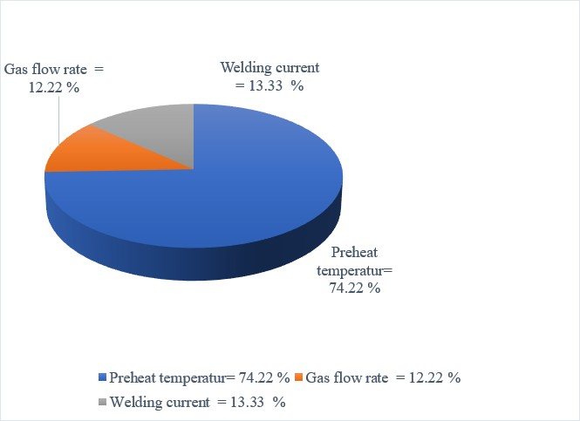

Fig 2. Percentage contribution of process parameters on tensile strength

Table 10. Confirmation test for maximum hardness value

|  |  |
| --- | --- |
| S.no | Predicted Tensile strength (N/mm2) |
| 1 | 261.45 |

|  |  |
| --- | --- |
| S.no | Predicted Hardness value |
| 1 | 88 |

Ghosh et. al. (2015) analyzed the effects of welding parameters: welding current, gas flow rate and nozzle to plate distance, on ultimate tensile strength (UTS) and percentage elongation (PE) in MIG welding of AISI409 ferritic stainless steel materials. Predicted value of tensile strength after confirmation test is 52.8 MPa. However in our work Predicted value of tensile strength after confirmation test is 261.45 MPa.

# CONCLUSIONS

The following conclusions have been noted by applying Taguchi methodology in the experimental investigations of MS plate by GMAW.

* + 1. Taguchi's based Grey relational analysis is suitable to analyse this problem as described in this work.
    2. It is found that the parameter design of Taguchi's based Grey relational analysis provides a simple, systematic and efficient methodology for the optimization of the GMA welding parameters.
    3. From main effect plot preheat temperature, gas flow rate and welding current significant effect on the tensile strength and hardness. This is consistent with the conclusions from the study of other investigators.
    4. The preheat temperature has the most significant effect on the tensile strength and hardness.
    5. The maximum tensile strength and hardness achieved was welding current= 124 A, gas flow rate = 15 l/min and preheat temperature = 275°C. This is the optimized results for achieving maximum tensile strength.

# REFERENCES

1. Kumar, S., & Singh, R. (2019). Optimization of process parameters of metal inert gas welding with preheating on AISI 1018 mild steel using grey based Taguchi method. Measurement, 148, 106924.
2. Yadav, H., & Niranjan, M. S. (2019). A Review on Parametric Optimization of Aluminium Alloy 5754 for MIG Welding.
3. Kumar, R., & Kumar, D. D. (2019). Optimization of Process Parameters on TIG Welding to Enhance Mechanical Properties of AA-6351 T6 Alloy. International Journal of Trend in Scientific Research and Development, 3, 505-509.
4. Kanakavalli, P. B., Babu, B. N., & Sai, C. P. V. (2019). A hybrid methodology for optimizing MIG welding process parameters in joining of dissimilar metals. Materials Today: Proceedings.
5. Chafekar, A., &Sapkal, S. (2020). Multi-objective Optimization of MIG Welding of Aluminum Alloy. In Techno-Societal 2018 (pp. 523-530). Springer, Cham.
6. Dharmendra, B. V., Kodali, S. P., &Boggarapu, N. R. (2019). Multi-objective optimization for optimum abrasive water jet machining process parameters of Inconel718 adopting the Taguchi approach. Multidiscipline Modeling in Materials and Structures.
7. Shinde, P. D., &Madavi, K. R. (2018). Experimental Investigation for Parametric Optimization of Gas metal arc welding process by using Taguchi technique on mild steel Fe 410.
8. Ghosh, N., Pal, P. K., & Nandi, G. (2018). Investigation on dissimilar welding of AISI 409 ferritic stainless steel to AISI 316L austenitic stainless steel by using grey based Taguchi method. Advances in Materials and Processing Technologies, 4(3), 385-401.
9. Khan, A., Agrawal, B. P., Siddique, A. N., &Satapathy, S.

N. (2018). An Investigation on Cladding of Stainless Steel on Mild Steel using Pulse Current GMAW. International Journal of Engineering Trends and Applications (IJETA), 5(2).

1. Rizvi, S. A., & Ali, W. (2018). Optimization of Welding Parameters and Microstructure and Fracture Mode Characterization of GMA Welding by Using Taguchi Method on SS304H Austenitic Steel. Mechanics and Mechanical Engineering, 22(4), 1121- 1131.
2. Srivastava, S., & Garg, R. K. (2017). Process parameter optimization of gas metal arc welding on IS: 2062 mild steel using response surface methodology. Journal of Manufacturing Processes, 25, 296-305.
3. Ghosh, N., Pal, P. K., & Nandi, G. (2017). GMAW dissimilar welding of AISI 409 ferritic stainless steel to AISI 316L austenitic stainless steel by using AISI 308 filler wire. Engineering science and technology, an international journal, 20(4), 1334-1341.
4. Sivaraman, A., &Paulraj, S. (2017). Multi-Response Optimization of Process Parameters for MIG Welding of AA2219-T87 by Taguchi Grey Relational Analysis. Materials Today: Proceedings, 4(8), 8892-8900.
5. Anand, K. R., & Mittal, V. (2017). Parameteric Optimization Of Tig Welding On Joint Of Stainless Steel (316) & Mild Steel Using Taguchi Technique. Int. Res. J. Eng. Technol, 2395-56.
6. Songsorn, K., Sriprateep, K., &Rittidech, S. (2017). Optimization of Metal Inert Gas Pulse Brazing Process on Galvanized Steel Sheets Based on Taguchi Method. The Journal of Industrial Technology, 13(2), 78-95.
7. Chauhan, M. J. OPTIMIZATION OF PARAMETERS FOR GAS METAL ARC WELDING OF MILD STEEL USING TAGUCHI’S.
8. Deshpande, M. U., Kshirsagar, J. M., &Dharmadhikari, D. H. (2017). Optimization of GMAW Process Parameters to Improve the Length of Penetration in EN 10025 S 235 Grade. Journal of Welding and Joining, 35(1), 74-78.
9. Patel, H. M., & Bhatt, B. PARAMETRIC OPTIMIZATION OF GMAW PROCESS ON MILD STEEL IS-2062.
10. Kumar, A., Khurana, M. K., & Yadav, P. K. (2016, September). Optimization of Gas Metal Arc Welding Process Parameters. In IOP Conference Series: Materials Science and Engineering (Vol. 149, No. 1, p. 012002). IOP Publishing.
11. Ghosh, N., Rudrapati, R., Pal, P. K., & Nandi, G. (2017). Parametric Optimization of Gas Metal Arc Welding Process by using Taguchi method on Ferritic Stainless Steel AISI409. Materials Today: proceedings, 4(2), 2213-2221.
12. K. Nandagopal, C. Kailasanathan “Analysis of mechanical properties and optimization of Gas Tungsten Arc Welding (GTAW) parameters on dissimilar metal titanium and aluminium 7075 by Taguchi and ANOVA techniques”. Elsevier, Journal of Alloys and Compounds, 1 August 2016, pp 1-10.
13. Nabendu Ghosh, Pradip Kumar Palb, Goutam Nandic “Parametric optimization of MIG welding on 316L austenitic stainless steel by Grey-Based Taguchi Method”. Global Colloquium in Recent Advancement

and Effectual Researches in Engineering, Science and Technology (RAEREST), 2016, pp. 1038 – 1048.

1. Anil Kumar (2017) “A Review of Metal Inert Gas Welding OnAluminium Alloys”, International Journal of Engineering Sciences & Research Technology, 6(5), 453-456.