**OPTIMISATION OF DISCHARGE THROUGH NOZZLES IN ENGINEERING CONTRIVANCES**

**1Kingsley E. MADU, AKPENYI –ABOH2, EMU A O3, 1Chike M. ATAH and Theophilus E. Kpesu 2**

Corresponding email atahchike44@gmail.com

1-3Department of Mechanical Engineering, Chukwuemeka Odumegwu Ojukwu University, Uli, Anambra State.

**Abstract**

This paper seeks to propose the best possible means of optimizing the discharge and velocity of flow through a nozzle for efficient and maximum output in any engineering contrivance. A nozzle is a device often a pipe or tube of varying cross sectional area designed to control the direction or characteristics of a [fluid](https://en.wikipedia.org/wiki/Fluid) (liquid or gas) flow usually to increase velocity as it exits or enters an enclosed chamber or [pipe](https://en.wikipedia.org/wiki/Pipe_(material)). Nozzles are mostly used to control the rate of flow, speed, direction, mass, shape, and the pressure of the stream that comes from the nozzle. Previous researches conducted have been constrained towards having the maximum jet power delivered from the nozzle assuming a constant coefficient of friction in the approach pipe while neglecting minor losses caused by the nozzle However, this study found possible means of eliminating these minor losses so as to determine the possible increase in discharge and velocity of flow through the nozzle.In many engineering applications, water jet nozzles are used in; impulsive turbines, power delivering free jets, water filters, flotation tanks, sedimentation tanks, water storage tanks, trickling filters, other water and waste-water systems, irrigation systems and water supply systems etc. In order to determine the efficiency of the nozzle, the discharge and velocity of flow through a spray nozzle was optimized during the washing of crushed aggregates used in silica production for efficient operation of the nozzle. The major parameters used in determining optimal performance of the jet nozzle are flow velocity of spray nozzle and discharge of spray nozzle. The study shows an optimal flow velocity, the correlation between theoretical obtained results and simulated results from solid works revealed that the velocity of the water flowing in the spray nozzle have a range of velocities from 38.659m/s to maximum velocity of 77.314m/s as shown in the simulated result. The obtained results revealed close correlation in both modeling and simulation which gave rise to a high discharge with proper scattering of droplets during the washing of the crushed aggregates.

**Keywords:** Optimization, Discharge through Nozzle, Velocity of Flow, Nozzle, Steam Nozzle, Spray Nozzle.

1. **Introduction**

Nozzles are used for a whole lot of engineering purposes such as distribution of air in large rooms through ceiling diffusers, feeding [hot blast](https://en.wikipedia.org/wiki/Hot_blast) into a [blast furnace](https://en.wikipedia.org/wiki/Blast_furnace) or [forge](https://en.wikipedia.org/wiki/Forge), others are found in ovens, gas stoves, carburetors etc to control the rate of flow, speed, direction, mass, shape, and the pressure of the stream that comes from the nozzle(1-4)..A nozzle is a device often a pipe or tube of varying cross sectional area designed to control the direction or characteristics of a [fluid](https://en.wikipedia.org/wiki/Fluid) (liquid or gas) flow usually to increase velocity as it exits or enters an enclosed chamber or [pipe](https://en.wikipedia.org/wiki/Pipe_(material)). Nozzles are of three (3) types, namely:

1. Convergent Nozzle
2. Divergent Nozzle and
3. Convergent-divergent Nozzle (5).

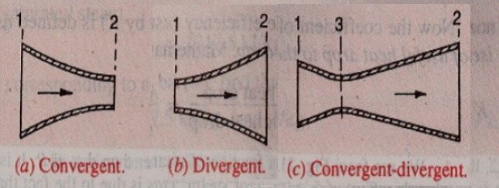

**Fig. 1 Types of Nozzle**

* 1. **Convergent Nozzle**

A convergent nozzle is shown in fig. (1a) above with a cross section which decreases continuously from the entry point to the exit point. The nozzle varying cross-sectional area duct helps in accelerating a steadily flowing fluid. This nozzle helps in converting the internal energy of a fluid into kinetic energy. Convergent nozzles accelerates subsonic fluids, the flow is bound to reach sonic velocity at the narrowest point (the *nozzle throat)* If the nozzle pressure ratio is high enough. At this point, the nozzle is said to be choked.

* 1. **Divergent Nozzle**

A divergent nozzle as shown in fig.(1b) above has a cross sectional area which increases continuously from entry point to its exit point with a back pressure less than the critical pressure ratio. Divergent nozzles accelerates sonic or supersonic fluids but slows down the fluid if the flow is subsonic.

* 1. **Convergent-divergent Nozzle**

A Convergent-divergent Nozzle as shown in fig.(1c) above has a cross sectional area that decreases continuously from its entry point to the throat of the nozzle and suddenly increases continuously from the throat to its exit point. This nozzle is a modification of the convergent type where the divergent section acts as an accelerator for supersonic flow. This type of nozzle is widely used in steam turbines. This process is more efficient than allowing a convergent nozzle to expand supersonically externally, it is useful in accelerating fluids that have choked in the convergent section to supersonic speeds.

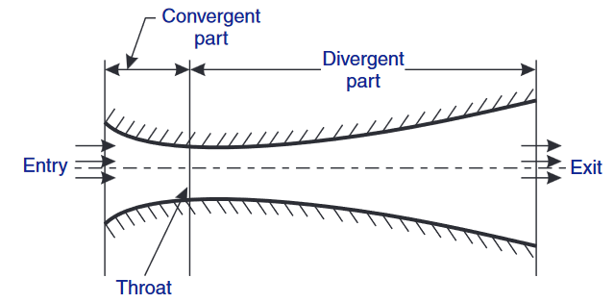

**Fig.2 Convergent-divergent**

Other examples of nozzles include steam nozzle, spray nozzle, flow nozzle, etc

* 1. **Steam Nozzle**

A steam nozzle is as a passage of varying cross-section, through which heat energy of steam is converted to kinetic energy. The major function of a steam nozzle is to produce steam jet with high velocity to drive steam turbines.

The conversion of heat energy of steam to kinetic energy is made possible as result of the following processes:

1. The high pressure, high temperature steam first expands in the nozzles as a result of high velocity fluid stream.
2. The high velocity steam coming out of the nozzles impinges on the blades mounted on a wheel. The fluid stream suffers a loss of momentum while flowing through the blades which is absorbed by the rotating wheel results in the production of torque.
3. The blades moves as a result of the impulse of steam (caused by the change of momentum), also, they move as a result of the expansion and acceleration of the steam relative to them.

The cross-section of a nozzle first reduces to a smaller section which allows for changes which occurs due to changes in velocity, specific volume and dryness fraction as the steam expands, the smallest section being known as throat, then diverges to a large diameter (7).

* + 1. **Steam Flow Through Nozzles**

The flow of steam through the nozzle may be termed as adiabatic flow since during the expansion of steam in nozzle, heat is neither supplied nor rejected. Work, however, is done by increasing the kinetic energy of the steam. As the steam passes through the nozzle it loses its pressure as well as the heat. The work done is equal to the adiabatic heat drop which in turn is equal to Rankine area.

* + 1. **Velocity Of Steam**

As a result of the conversion of heat energy of steam into kinetic energy as it passes through the nozzle, the Steam enters the nozzle with high pressure and low initial velocity which is so small compared to the final velocity that it is generally neglected and leaves the nozzle with high velocity and low pressure. The final velocity of steam can be determined as follows:

Let C = Velocity of steam at the section considered

(m/sec),

h1 = Enthalpy of steam entering the nozzle,

h2 = Enthalpy of steam at section considered, and

hd = Heat drop during expansion of steam in the nozzle = (h1 – h2).

Considering 1 kg of steam and flow to be frictionless adiabatic, we have :

Gain in kinetic energy = Adiabatic heat drop

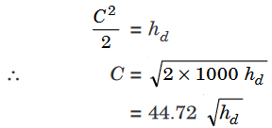 where hd is in KJ……………………………….(1)

Due to friction loss in the nozzle, its value varies from 10 to 15 per cent of total heat drop. As a result of this, The total heat drop is minimized. Let heat drop after deducting friction loss be khd.

.……………………………(2)

* + 1. **Discharge through the Nozzle and Conditions for its Maximum Value**

Let p1 = Initial pressure of steam,

v1 = Initial volume of 1 kg of steam at pressure p1 (m 3),

p2 = Steam pressure at the throat,

v2 = Volume of 1 kg of steam at pressure p2 (m 3),

A = Cross-sectional area of nozzle at throat (m 2), and

C = Velocity of steam (m/s).

The steam flowing through the nozzle follows approximately the equation given below:

pv n = Constant

where, n = 1.135 for saturated steam, and

= 1.3 for superheated steam.

For wet steam, the value of n can be calculated by Dr. Zenner’s equation,

n = 1.035 + 0.1x, where x is the initial dryness fraction of steam

Work done per kg of steam during the cycle (Rankine area)

= n/n-1 (p1v1 – p2v2)

and, Gain in kinetic energy = Adiabatic heat drop

= Work done during Rakine cycle

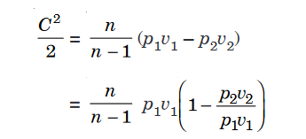.…………….(3)

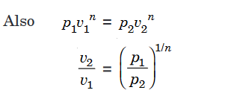.…..(4)

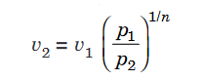.……………………….(5)

Putting the value of v2 /v1 from eqn. (4) in eqn. (3), we get

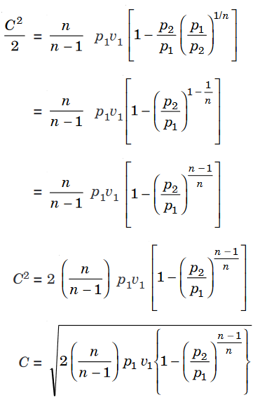 …………………..(6)

if m is the mass of steam discharged in kg/sec.,

Then m = AC/v2 ……………..(7)

Substituting the value of v2 from eqn. (5) in eqn. (7),

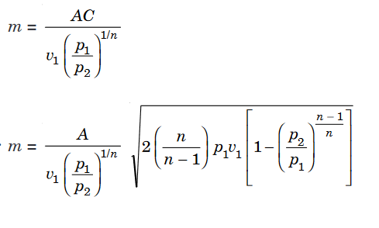

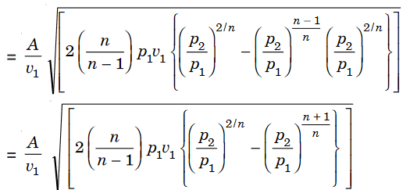.…………..(8)

From the above equation it is obvious that there is only one value of the ratio (called critical pressure ratio) p2/p1 which will produce the maximum discharge. This can be obtained by differentiating ‘m’ with respect to (p2/p1) and equating it to zero. As other quantities except the ratio p2/p1 are constant,

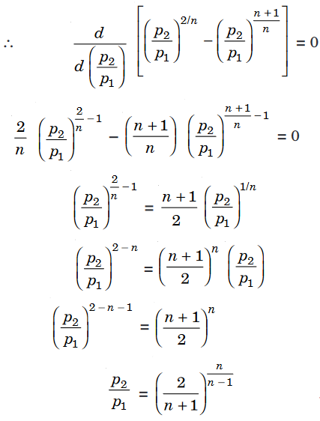 ………………………….(9)

Substituting the value of P2/P1 from eqn. (9) into eqn. (8), we get the maximum discharge

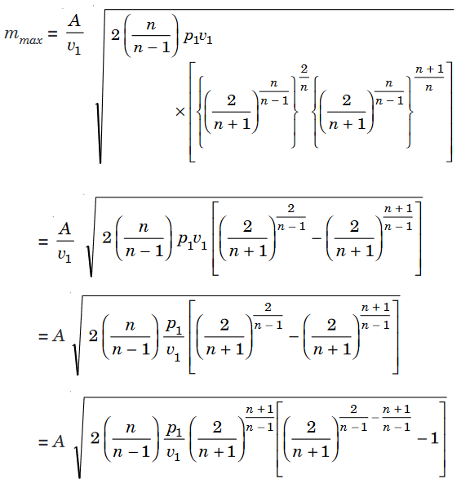

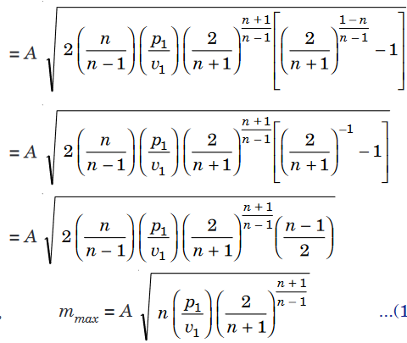 ……………………….(10)

From the above equation it is evident that the maximum mass flow depends only on the initial condition of the steam (p 1, v1) and the throat area and is independent of the final pressure of steam i.e., at the exit of the nozzle. The addition of the divergent part of the nozzle after the throat does not affect the discharge of steam passing through the nozzle but it only accelerates the steam leaving the nozzle. It may be noted that the discharge through nozzle increases as the pressure at the throat of the nozzle (p2) decreases, when the supply pressure p1 is constant. But once the nozzle pressure p2 reaches the critical value [given by equation (9)], the discharge reaches a maximum and after that the throat pressure and mass flow remains constant irrespective of the pressure at the exit.

* 1. **Spray Nozzle**

Most mining industries that are crushing aggregates are faced with several challenges during crushing process. The most common problem reported is poor discharge, flow velocity and operating pressure during the washing of aggregates. This has lead to several environmental heath issues and operating cost. This often leads to reduction in the quality of road-stone produce and the quality of the road to be constructed. The correct spray nozzles must be used during the washing of the aggregates for efficient and more economical washing of aggregates. The spray nozzle must have the required flow rate which helps create a pulsating jet of fluids to wash the dust and other small aggregate sizes (8-10). This can be achieved by designing a spray jet with the require jet pressure, velocity, and discharge for efficient washing of aggregates. It is no doubt that efficient and optimal operation of the jet spray nozzle is need for proper washing of aggregates. For over the years now, most researchers have tried to design a spray nozzle with the required characteristics for washing of aggregates. This has faced several setbacks in terms of operating parameters and behavior during real life operation. One of such parameters facing setback are velocity and discharge produced by the nozzle during aggregates washing process. Most Information which relate the spray velocity of droplets and discharge produced by the spray nozzles with the relevant data relating to the droplet particles size and the flux distributions during operation in the spray are vital factors to be taken into consideration if the behavior of sprays pattern in complex air flows system must be understood. The velocities of spray droplet close to the spray nozzle and the nozzle diameter are vital input parameters to the physical models being derived to predicting droplet trajectories and discharge and any possible risk of drift during washing of aggregates from the spray application (14-16). It is difficult to design a spray with optimal spray velocity and discharge during for washing of aggregates. This is due to lower droplets that usually decelerate from a release velocity line. Researcher like Miller et al. used spray velocity measurements and develops a model which describes en-trained air velocities at varying positions within a flat spray fan. The derived model by Miller et al shows that the Phase Doppler instrument system gave more enhanced droplet density which produced a higher discharge during operation. Few comparative analyses in nozzle spray revealed reasonably agreement between size/velocity profiles measured during operation. This is mostly applied in the development of agricultural spray nozzles, but it has not been applicable in the mining industries during the washing of aggregates. The main problem of optimizing the spray velocity and discharge is creating a serious issue of drift control problem (17-19).

1. **Methodology**

To model the optimal velocity and discharge produced by the spray nozzle, it is important to study the water jet thickness produced by the spray nozzle during operation which is given by Zhou (Zhou, et al., 1996). The Zhou (Zhou, et al., 1996) model focused on the relationship between the flow rate (Q) and spray angle (**∅**) which gives the thickness of the liquid produced by the spray as droplets during operation given as

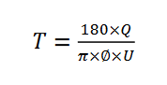 ………………………………..(i)

where T=thickness of liquid sheet, Q=liquid flow rate (m^3/s), **∅**=spray angle (o), U=average velocity (m/s). From Bernoulli’s theory, the spray nozzle average exit velocity is can be computed.

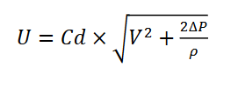.…………………………(ii)

where V=inlet velocity (m/s), Cd=spray nozzle co-efficient,Ƿ=water density (kg/m^3), ∆P= difference in pressure (KPa). To establish the flow of fluid energy from the inlet and exit of the pressure nozzle of the spray it is important to consider to two points which are point A and point B and their flow energy is given as:

.

Their respective velocities at inlet and exit V1 and V2 are computed from the equation of continuity given as V2 = (A1V1/A2). To compute the optimal velocity and discharge during spray of the nozzle, the change in pressure from the nozzle can be computed as:

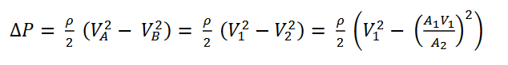.……(iii)

where A1 is the inlet of the spray nozzle and A2 is the area of the spray nozzle at the exit. The different velocity at the inlet and exist can be defined form the equation of Bernoulli given as:

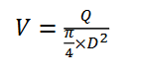.……………………………………………………………………(iv)

Where Q is the flow rate, D is the spray nozzle diameter (mm), V is the velocity (m/s). From equation (iv), the discharge through a spray nozzle can be computed. The relationship between the spray nozzle, flow rate and the spray nozzle diameter given as:

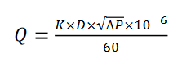.…………………………………………………………….(v)

Where K is the test coefficient, P is the water pressure (MPa). The results in table 1 revealed the performance of BJ flat fan spray nozzles with different flow rates and BJ flat fan spray nozzle at a Pressure of 2Bar, Diameter of 9.65mm and at a Spray angle of 110

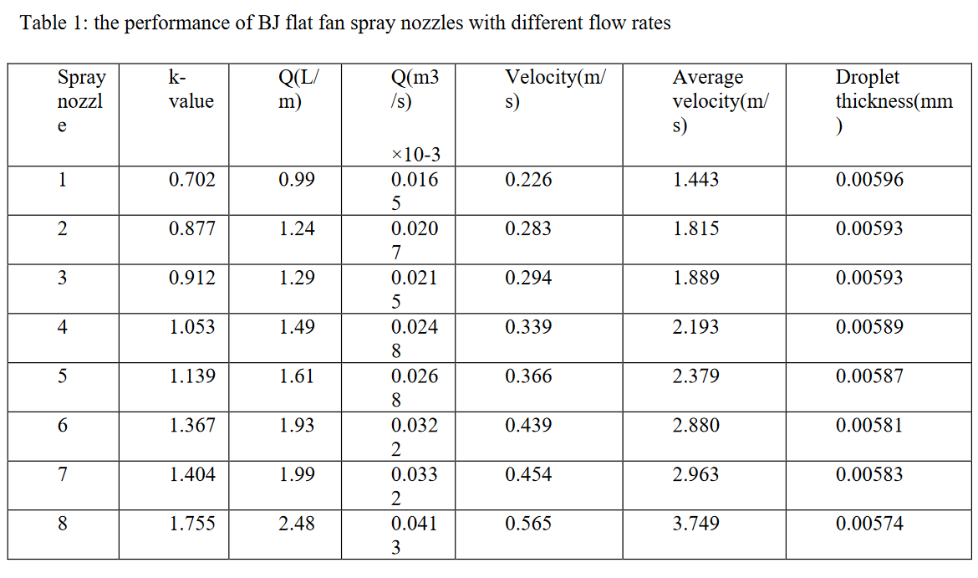

1. **Result**

From table 1 it is revealed that an increase in spray nozzle led to an increase k-value, discharge, and velocities of flow through the spray nozzle. It is shown that as these parameters increases during operation the droplet thickness decreases during operation. This is due to the fact an increase in velocities and discharge led to an increase in pressure which causes molecular breakdown of droplet. At very high pressure the droplet thickness gets more smaller due to more random breakdown of molecules of water. Therefore, an increase in velocities of flow led to an increase in discharge during spray nozzle operation. The graph below shows the relationship between types of spray nozzles flow rate and droplet thickness. An exponential increase of droplet thickness, flow rate and type of spray nozzle is revealed in Fig.3 (a) below. It increases to an optimal droplet thickness and flow rate during operation. However, the increment is not smooth due to air pressure or variation of pressure during operation that impacts the flow trajectory. A similar result was observed for average velocity and type of spray nozzle as shown in Fig.3(b) below

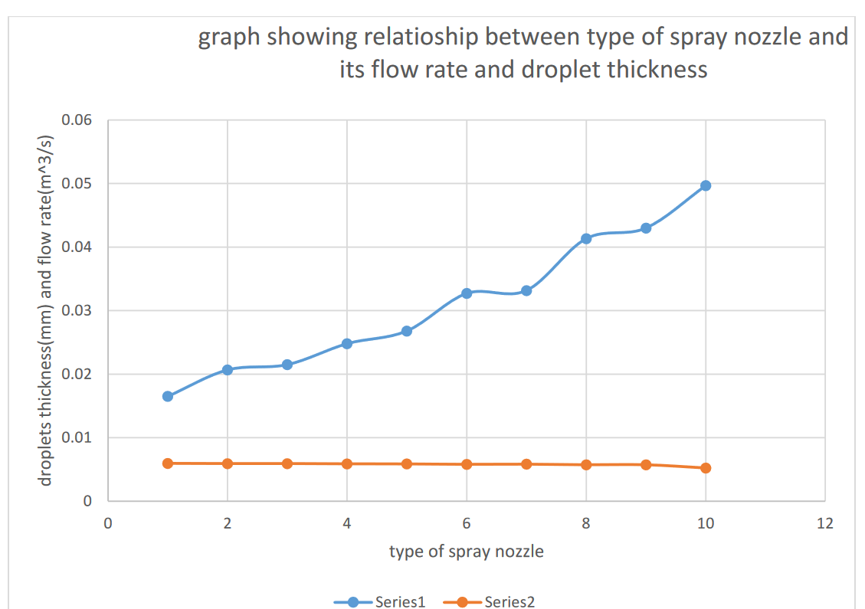

Fig 3(a)The graph below shows the type of spray nozzle and its average velocity.

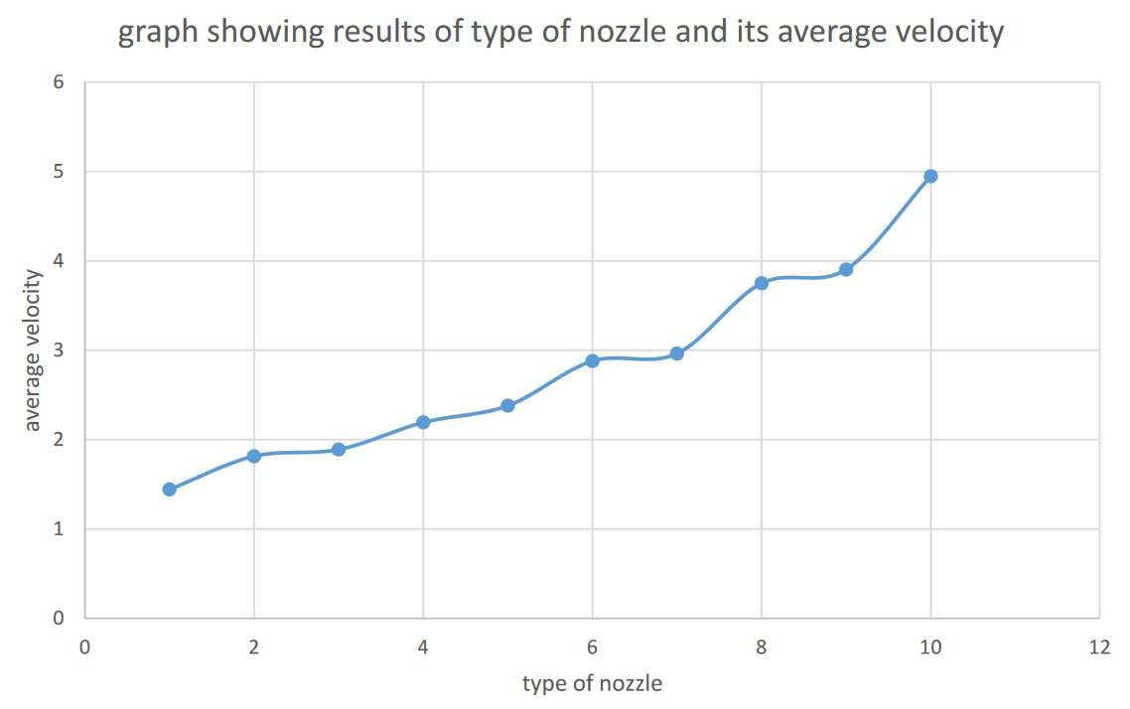

Fig3 (b). Droplet thickness to spray nozzle type (b) average velocity to type of spray nozzle

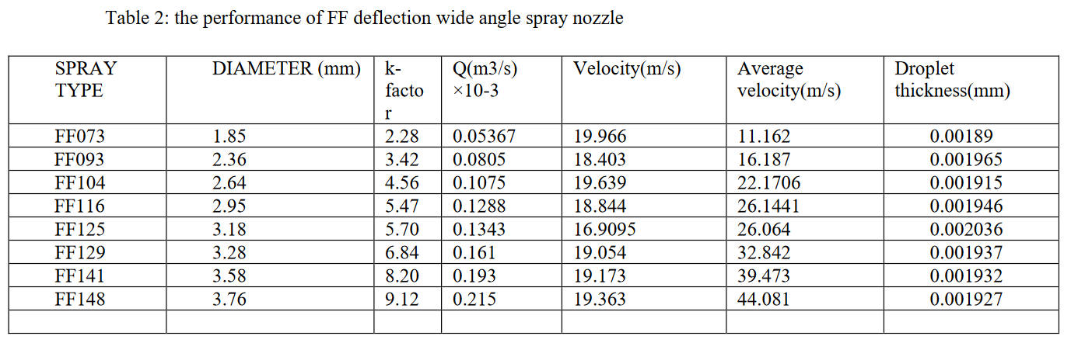

The performance of FF deflection wide angle spray nozzle revealed an increase in velocities and discharge when the diameter increase. It was also revealed that the droplet thickness decreases when the velocities and discharge increases. The obtained results in Fig.4 are like the obtained result revealed in Fig.3. Further investigation was needed to get the optimal velocity and discharge that gave optimal performance during operation. The obtained results revealed in Table 2 is revealed in Fig.4 (a-c) as shown below.

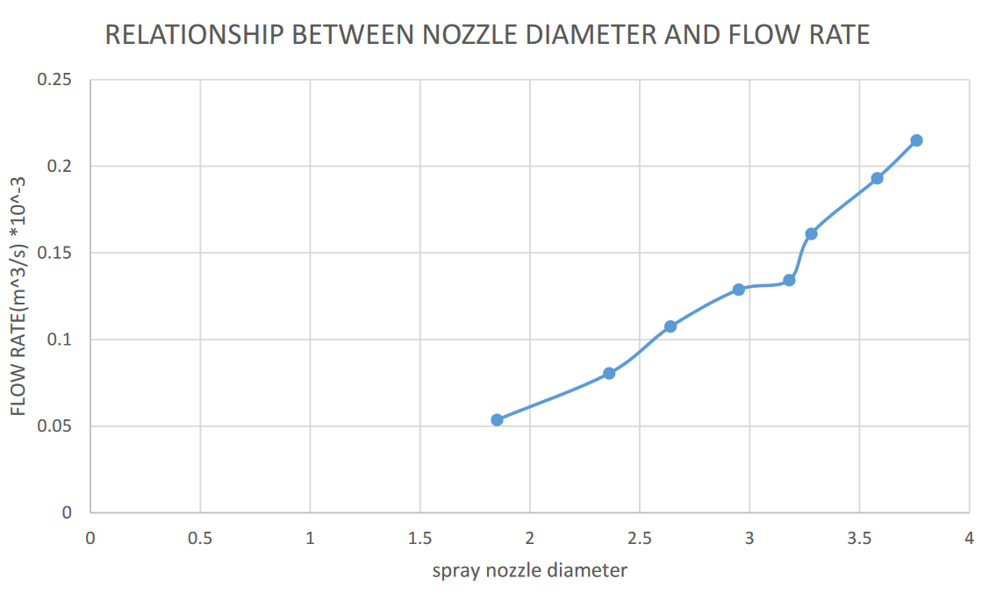

Fig. 4(a) Nozzle Diameter And Flow rate During Operation

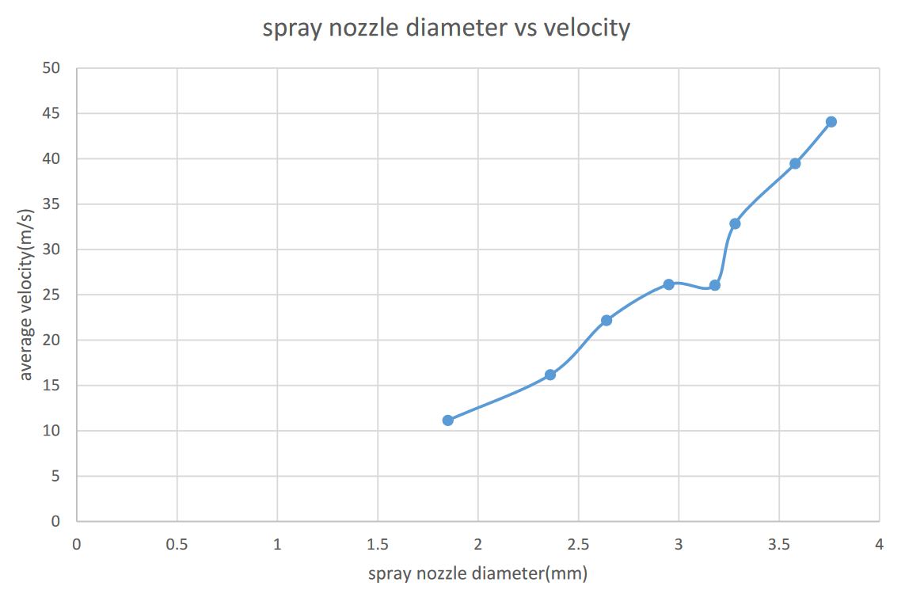

Fig. 4(b) Spray Nozzle Diameter To Average Velocity

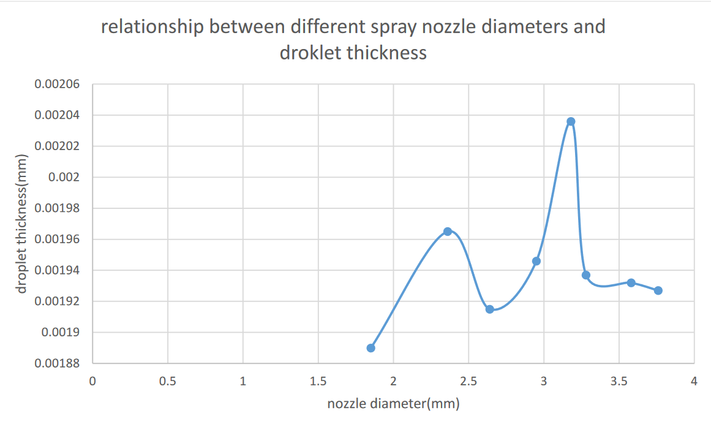

Fig. 4(c) Nozzle Diameter To Droplet Thickness

1. **Conclusion and Recommendation**

The study was aimed at optimizing the velocity and discharge produced by a spray nozzle for efficient washing of aggregates in mining industry. To achieve this objective the principles of fluids mechanics and the relevant simulation was performed by solid works. The following results were revealed in the study. It was revealed that an increase in spray nozzle led to an increase k-value, discharge, and velocities of flow through the spray nozzle. It was also revealed that the flow is impacted by air which was reported to impacts the droplet thickness as velocity and flow rate increases. It was also revealed that the optimal nozzle diameter and droplet thickness gave an optimal discharge and velocity of the spray nozzle during operation. Varying direction of velocities in the system during operation given was revealed by solid works to have different impacts on flow velocity and discharge. The correlation between theoretical obtained results and simulated results from solid works revealed that the velocity of the water flowing in the spray nozzle have a range of velocities from 38.659m/s to maximum velocity of 77.314m/s as shown in the simulated result. The obtained results revealed close correlation in both modeling and simulation. It could be concluded that the design will function efficiently at optimal velocity and flow rate during operation.

**References**

1. Ghobad, A., 2016. liquid flow in a simplex swirl nozzle. international journal of multiphase flow, 30 september, pp. 225-235.

2.Glenn, W. S. et al., 1986. multiple pattern spray nozzle. united states, Patent No. 4618100.

3. KE Madu, CM Atah [Effects of Variation of Ambient Temperature in Energy Interactions in a Closed System](https://scholar.google.com/citations?view_op=view_citation&hl=en&user=Va3CD90AAAAJ&cstart=20&pagesize=80&citation_for_view=Va3CD90AAAAJ:maZDTaKrznsC) International Journal of Progressive Research in Engineering Management and Science 03 2024 pp: 226-233

4. KE Madu, EI Nwankwo [Evaluation of Pump Losses: An Energy Principle - A Review](https://scholar.google.com/citations?view_op=view_citation&hl=en&user=Va3CD90AAAAJ&cstart=20&pagesize=80&citation_for_view=Va3CD90AAAAJ:L8Ckcad2t8MC) Equatorial Journal of Engineering, 85-92

5. Guijun, G., ChangJiang, W. & Ziming, K., 2018. Henderson, G. W. & Pasadena, C., 2003. independent flow rate and droplet size control system for sprayer. Europe, Patent No. 0847307 B1.

6.Kiaoulias, D., Travis, T., Moore, J. & Risha, G., 2019. evaluation of orifice inlet geometries on single liquid injectors through cold-flow experiments. Experimental thermal and fluid sciences, pp. 78-88.

7. Lan, Z. et al., 2013. experimental study on spray characteristics of pressure swirl nozzles in pressurizer. Annalas of nuclear Energy, 28 july, pp. 215-227.

8.Mat, R. M. S. F., Hamid, A. H. A., Sheng, O. C. & Ghaffar, Z. A., 2012. International Symposium on Robotics and Intelligent Sensors 2012 (IRIS 2012). s.l.:s.n.

9. K Madu [Evaluation of the Behaviour of Steam Expanded in a Set of Nozzles, in a Given Temperature](https://scholar.google.com/citations?view_op=view_citation&hl=en&user=Va3CD90AAAAJ&citation_for_view=Va3CD90AAAAJ:_FxGoFyzp5QC) Equatorial Journal of Engineering (2018), 9-13

10. KE Madu, CM Atah [Evaluation of the Variable that affect Nozzle Efficiency](https://scholar.google.com/citations?view_op=view_citation&hl=en&user=Va3CD90AAAAJ&cstart=20&pagesize=80&citation_for_view=Va3CD90AAAAJ:k_IJM867U9cC) International Journal of Progressive Research in Engineering Management and Science 03 2024 pp: 393-401

11. Miller, miller , P. & Butller , m., 2000. effects of spray formulation on spray nozzle performance for applications, silsoe bedford UK: silsoe research institute.

12. Miller, P. & Ellis, B. M., 2000. effects of formulation on spray nozzle performance for applications from ground based boom sprayers. In: Crop protection. bedford UK: silsoe research institute , pp. 609-615.

13. Qun, Z. et al., 2019. effects of droplets formation patterns on the atomization characteristics of a dust removal spray in a coal cutter. power technology, 5 december, pp. 570-580.

14 KE Madu, CM Atah [Evaluation of the Variable that affect Nozzle Efficiency](https://scholar.google.com/citations?view_op=view_citation&hl=en&user=Va3CD90AAAAJ&cstart=20&pagesize=80&citation_for_view=Va3CD90AAAAJ:k_IJM867U9cC) International Journal of Progressive Research in Engineering Management and Science 03 2024 pp: 393-401

15 KE Madu CM Atah Effect of Sudden Pressure Drop in a Nozzle Flow International Journal of Scientific Research and Engineering Trends 2024 10 pp 93- 98

16. Madu K E and Atah C M Shear Property Failure Testing of Gasoline Engine Combustion Chamber Produced with Fique Fibre Reinforced Epoxy Resin Composite Material. International Journal of Research Publication and Reviews 2024 (5) (3) pp 1537-1545

17 KE Madu, EI Nwankwo [Evaluation of Pump Losses: An Energy Principle - A Review](https://scholar.google.com/citations?view_op=view_citation&hl=en&user=Va3CD90AAAAJ&cstart=20&pagesize=80&citation_for_view=Va3CD90AAAAJ:L8Ckcad2t8MC) Equatorial Journal of Engineering, 85-92

18 KE Madu, EA Ani, EI Nwankwo, FO Udeani [Analytical Approach to Determining the Conditions for Maximum Discharge through a Chimney](https://scholar.google.com/citations?view_op=view_citation&hl=en&user=Va3CD90AAAAJ&cstart=20&pagesize=80&citation_for_view=Va3CD90AAAAJ:ULOm3_A8WrAC) Global Scientific Journals 8 (4), 1485-1496

19 KE Madu, EI Nwankwo, MU Orji, AC Aneke [Investigation of the Conditions that Trigger Cavitation in a Pump](https://scholar.google.com/citations?view_op=view_citation&hl=en&user=Va3CD90AAAAJ&cstart=20&pagesize=80&citation_for_view=Va3CD90AAAAJ:9ZlFYXVOiuMC) International Journal of Mechanical and Industrial Technology 7 (2), 1-7

20 KE Madu, EI Nwankwo [Effects of Friction on Critical Pressure Ratio of a Nozzle](https://scholar.google.com/citations?view_op=view_citation&hl=en&user=Va3CD90AAAAJ&cstart=20&pagesize=80&citation_for_view=Va3CD90AAAAJ:IWHjjKOFINEC) Journal of Industrial Technology 3 (1), 47-55