**OPERATIONAL DIVERGENCE OF PETROL AND DIESEL ENGINES IN ENGINEERING MACHINERY.**

**1Chike M. ATAH 1Kingsley E. MADUand Theophilus E. Kpesu 2**

Corresponding email atahchike44@gmail.com

1Department of Mechanical Engineering, Chukwuemeka Odumegwu Ojukwu University, Uli, Anambra State.

**ABSTRACT**

Petrol and diesel engines each operate their separate cycles and as such have their individual parameters and performance conditions. Understanding these disparities is crucial for selecting the most appropriate engine type for specific engineering applications. The primary difference between Petrol and Diesel engines is that the Petrol engine works on the Otto cycle whereas the Diesel engine works on the Diesel cycle. Other differences can be attributed to these engines' structure, types, and uses. Petrol engines can run at stoichiometric air-to-fuel ratio because gasoline is quite volatile and is mixed (sprayed or carbureted) with the air prior to ignition. Diesel engines, in contrast, run lean, with more air available than simple stoichiometry would require. Diesel fuel is less volatile and is effectively burned as it is injected

This article explores the operational divergence between these two engine types, highlighting their unique characteristics and operational parameters. Factors such as power output, torque, fuel efficiency, emissions, and maintenance requirements were elucidated.

**KEYWORDS**

Stoichiometry, scavenging, internal combustion engine, air-fuel ratio, lean mixture, rich mixture.

**INTRODUCTION**

In the world of engineering machinery, the choice between petrol and diesel engines has been a crucial decision-making factor for manufacturers, operators, and enthusiasts alike. This choice not only affects the performance of the machinery but also carries significant implications for efficiency, environmental impact, and cost-effectiveness. The operational divergence of these two engines defines their fundamental characteristics and capabilities (1).

Petrol and diesel engines have each been used extensively since their inventions in engineering machinery application, driven by distinct design principles and operational parameters. The differences in their working mechanisms, fuel delivery systems, and combustion processes yield diverse sets of advantages and limitations (2). Therefore, understanding the operational divergence between these two engine types is essential for selecting the right power source for a specific application.

This article explores the operational divergence of petrol and diesel engines in the context of engineering machinery highlighting the stoichiometry of diesel and petrol fuels. Factors such as power output, torque, fuel efficiency, emissions, and combustion process were compared for both engines.

**LITERATURE REVIEW**

**Internal Combustion Engines**

An internal combustion engine (ICE) is a type of heat engine that converts chemical energy stored in a fuel (typically gasoline, diesel, natural gas, or other hydrocarbons) into mechanical energy through a series of controlled explosions or combustion events (3). These engines are widely used in various vehicles (such as cars, trucks, and motorcycles) and power generation equipment.

Key components and features of an internal combustion engine include:

1. **Cylinder(s)**: Internal combustion engines typically consist of one or more cylindrical chambers called cylinders, where the combustion process occurs.
2. **Piston(s)**: Each cylinder contains a piston that moves up and down within it. The piston's movement is driven by the force generated during combustion.
3. **Valves**: Valves control the flow of air and fuel into the cylinder and the expulsion of exhaust gases. Common types include intake valves and exhaust valves.
4. **Spark Plug (for gasoline engines)**: In gasoline engines, a spark plug generates an electric spark that ignites the air-fuel mixture inside the cylinder.
5. **Injector (for diesel engines)**: In diesel engines, fuel is injected directly into the compressed air in the cylinder, where it ignites due to the high temperature and pressure.
6. **Crankshaft**: The reciprocating motion of the pistons is converted into rotational motion by the crankshaft, which is connected to the pistons via connecting rods.
7. **Combustion Process**: In each cylinder, air and fuel are mixed and compressed, followed by ignition (via spark plug or compression in diesel engines), resulting in a rapid expansion of gases. This expansion pushes the piston downward, creating mechanical work.
8. **Exhaust System**: After combustion, exhaust gases are expelled from the cylinder through the exhaust valves and directed out of the engine through an exhaust system.

**Stoichiometry**

Stoichiometry involves determining the precise ratios in which reactants combine and products are formed in order to optimize processes, ensure efficient resource utilization, and meet desired engineering specifications. Stoichiometry is particularly important in areas like chemical engineering, combustion engineering, and materials science, where understanding and controlling the quantities of substances involved in reactions are critical for designing and operating various engineering processes and systems (5).

**Air Fuel Ratio**

The air-fuel ratio (AFR) refers to the ratio of the mass or volume of air to the mass or volume of fuel in an internal combustion engines mixture. It is a critical parameter that directly affects the combustion process and, subsequently, the engine's performance, efficiency, and emissions. AFR is typically expressed in one of the following ways:

**Mass Air-Fuel Ratio (MAFR):** This is the ratio of the mass of air to the mass of fuel in the combustion mixture. It is often expressed in units such as grams of air per gram of fuel (g/g) or kilograms of air per kilogram of fuel (kg/kg).

**Volume Air-Fuel Ratio (VAFR):** This is the ratio of the volume of air to the volume of fuel in the combustion mixture. It is often expressed in units such as liters of air per liter of fuel (L/L) or cubic feet of air per cubic foot of fuel (ft^3/ft^3).

The ideal air-fuel ratio for complete combustion depends on the type of fuel being used, but in the context of gasoline (petrol) engines, the ideal or stoichiometric AFR is approximately 14.7:1 by mass (14.7 grams of air for every 1 gram of fuel). This ratio is also known as the stoichiometric AFR, and it represents the chemically balanced mixture required for the complete combustion of all the fuel with all the available oxygen in the air. In terms of volume, the stoichiometric AFR for gasoline is approximately 9,000:1 (9,000 liters of air for every 1 liter of fuel).

Different AFRs are used in various operating conditions:

**Rich Mixture:** A mixture with more fuel than the stoichiometric ratio is called a rich mixture. For gasoline engines, an AFR below 14.7:1 by mass (or richer than 9,000:1 by volume) is considered rich. Rich mixtures are used during cold starts and under high load conditions to provide more power and prevent engine knocking.

**Lean Mixture:** A mixture with more air than the stoichiometric ratio is called a lean mixture. For gasoline engines, an AFR above 14.7:1 by mass (or leaner than 9,000:1 by volume) is considered lean. Lean mixtures are used during light-load cruising to improve fuel efficiency and reduce emissions.

**Variable Valve Timing and Direct Injection**: Advanced engine technologies, such as variable valve timing and direct fuel injection, enable more precise control over the air-fuel mixture, allowing engines to operate closer to the stoichiometric ratio under different loads and speeds.

**Stoichiometric Mixture:** As mentioned earlier, this is the ideal AFR for complete combustion, and it is used under normal operating conditions when a balance between power, fuel efficiency, and emissions is desired.

**A/F Ratio outside Stoichiometry:** AFRs either richer or leaner than stoichiometric can be used for specific purposes, such as emissions control (lean burn for lower NOx emissions) or performance (rich burn for more power).

It's important to note that the actual AFR used in an engine is controlled by the engine's fuel injection or carburetion system and can vary dynamically based on driving conditions and engine requirements. Modern engines use sensors and electronic control systems to adjust the AFR in real time for optimal performance and emissions control.

Gasoline

It has 14.7 : 1 ratio by mass and 6.8% fuel by mass. Its main equation for the reaction is

2 C8H18 + 25 O2 → 16 CO2 + 18 H2O

Diesel

It has 14.5 : 1 ratio by mass and 6.8%. Its main equation for reaction is given by

2 C12H26 + 37 O2 → 24 CO2 + 26 H2O

Gasoline engines can run at stoichiometric air-to-fuel ratio, because gasoline is quite volatile and is mixed (sprayed or carbureted) with the air prior to ignition. Diesel engines, in contrast, run lean, with more air available than simple stoichiometry would require. Diesel fuel is less volatile and is effectively burned as it is injected.

**Petrol Engines**

Gasoline engines are any of a class of [internal-combustion engines](https://www.britannica.com/technology/internal-combustion-engine) that generate power by burning a [volatile](https://www.britannica.com/dictionary/volatile) liquid fuel (gasoline or a [gasoline](https://www.britannica.com/technology/gasoline-fuel) mixture such as ethanol) with ignition initiated by an electric spark (7). They can be built to meet the requirements of practically any conceivable power-plant application, the most important being passenger [automobiles](https://www.britannica.com/technology/automobile), small [trucks](https://www.britannica.com/technology/truck-vehicle) and buses, general aviation [aircraft](https://www.britannica.com/technology/aircraft), outboard and small inboard marine units, moderate-sized stationary pumping, lighting plants, [machine](https://www.britannica.com/technology/machine) tools, and power tools. Four-stroke gasoline engines power the vast majority of [automobiles](https://www.britannica.com/technology/automobile), light [trucks](https://www.britannica.com/technology/truck-vehicle), medium-to-large [motorcycles](https://www.britannica.com/technology/motorcycle), and lawnmowers. Two-stroke gasoline engines are less common, but they are used for small outboard marine engines and in many handheld landscaping tools such as chainsaws, hedge trimmers, and leaf blowers**.**

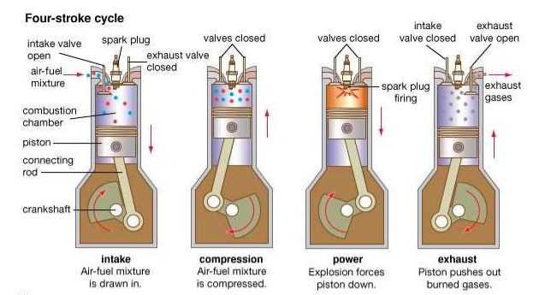

In four stroke cycle engines the four events suction, compression, power and exhaust take place inside the engine cylinder. They are completed in four strokes of the piston ( i.e. 2 revolutions of the crank shaft). The engine has separate valves for controlling the inlet of charge and outlet of exhaust gases. The opening and closing of the valve is controlled by cams, fitted on camshaft. The camshaft is driven by crankshaft with help of suitable gears or chains. The camshaft runs at half the speed of the crankshaft. The events that take place are

a. Suction stroke

b. Compression stroke

c. Power stroke

d. Exhaust stroke

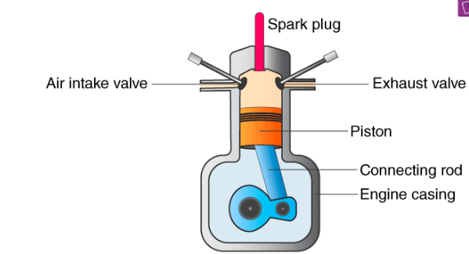

**Diesel Engines**

A diesel engine is an internal combustion engine that operates using diesel fuel as its primary source of energy. It is one type of [internal combustion engine](https://engineering.fandom.com/wiki/Internal_combustion_engine); more specifically, it is a compression ignition engine, in which the [fuel](https://engineering.fandom.com/wiki/Fuel) is ignited by being suddenly exposed to the high temperature and pressure of a compressed gas, rather than by a separate source of ignition, such as a spark plug.

When a gas is compressed, its temperature rises; a diesel engine uses this property to ignite the fuel. Air is drawn into the cylinder of a diesel engine and compressed by the rising [piston](https://engineering.fandom.com/wiki/Piston) at a much higher compression ratio than for a spark-ignition engine, up to 25:1. The air temperature reaches 700–900 [°C](https://engineering.fandom.com/wiki/Celsius), or 1300–1650 [°F](https://units.fandom.com/wiki/degree_Fahrenheit) (8). At the top of the piston stroke, [diesel](https://engineering.fandom.com/wiki/Diesel) [fuel](https://engineering.fandom.com/wiki/Fuel) is injected into the [combustion chamber](https://engineering.fandom.com/wiki/Combustion_chamber) at high pressure, through an atomizing nozzle, mixing with the hot, high-pressure air (10-14). The mixture ignites and burns very rapidly. This contained explosion causes the gas in the chamber to heat up rapidly, which increases its pressure, which in turn forces the piston downwards. The [connecting rod](https://engineering.fandom.com/wiki/Connecting_rod) transmits this motion to the [crankshaft](https://engineering.fandom.com/wiki/Crankshaft), which is forced to turn, delivering rotary power at the output end of the crankshaft. Scavenging of the engine is done either by ports or valves. **Scavenging** is pushing the exhausted gas-charge out of the cylinder, and drawing in a fresh draught of air

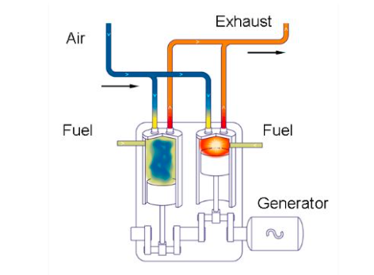

Diesel engines utilize four-stroke combustion cycle to convert chemical energy available in diesel fuel into mechanical energy (9). This mechanical power moves the pistons up and down (pistons are designed inside the cylinder). Hence, the crankshafts connected with pistons move up and down accordingly. This motion is known as the linear motion, which helps create the rotary motion in order to turn the wheel of machinery forward. For a diesel engine, the cycle in an internal combustion engine consists of induction, compression, combustion and exhaust strokes. The air is first compressed, and then the diesel fuel is injected. Air heats up when it is compressed. Finally, the diesel fuel ignites (16).

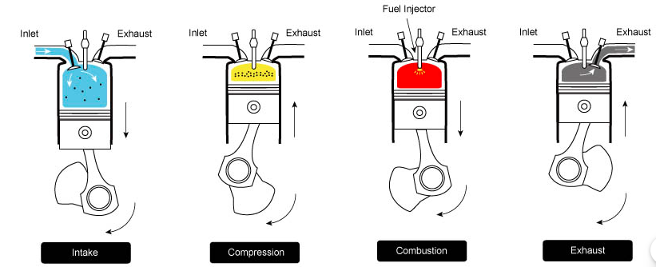

**Operational Divergences:**

**1. Ignition**: Gasoline engines are spark-ignition where the air-fuel is ignited with a spark, whereas, in diesel engine, the heat from compression alone ignites the mixture.

**2. Combustion Process:** Petrol engine operates on the Otto cycle, which uses spark ignition to ignite the air-fuel mixture meanwhile diesel engine operates on the Diesel cycle, which relies on high compression to ignite diesel fuel without spark plugs.

**2. Combustion Process**: The combustion process in a diesel engine is heterogeneous—that is, the fuel and air are not premixed prior to initiation of combustion. Consequently, rapid vaporization and mixing of fuel in air is very important to thorough burning of the injected fuel.

**3. Efficiency**: Diesel engines have higher efficiency than petrol engines. By compressing air rather than using an air-fuel mixture, the diesel engine is not limited by the pre-ignition problems that plague high-compression spark-ignition engines. Thus, higher compression ratios can be achieved with diesel engines than with the spark-ignition variety; commensurately, higher theoretical cycle [efficiencies](https://www.merriam-webster.com/dictionary/efficiencies), when compared with the latter, can often be realized. It should be noted that for a given compression ratio the theoretical efficiency of the spark-ignition engine is greater than that of the compression-ignition engine; however, in practice it is possible to operate compression-ignition engines at compression ratios high enough to produce efficiencies greater than those attainable with spark-ignition systems. Furthermore, diesel engines do not rely on throttling the intake mixture to control power. As such, the [idling](https://www.britannica.com/dictionary/idling) and reduced-power efficiency of the diesel is far superior to that of the spark-ignition engine.

**4. Starting Torque:** Due to the greater compression force required and the increased weight of the stronger components, starting a diesel engine is a harder task. More [torque](https://engineering.fandom.com/wiki/Torque) is required to push the engine through compression. Either an electrical starter or an air start system is used to start the engine turning. On large engines, pre-lubrication and slow turning of an engine, as well as heating, is required to minimize the possibility of damaging the engine during initial start-up and running.

**5. Emission and Exhaust**: Diesel engines produce very little carbon monoxide as they burn the fuel in excess air except when under full load, at which point a full stoichiometric quantity of fuel is injected per cycle. However, they can produce black soot from their exhaust, consisting of unburned carbon compounds. This is often caused by worn injectors, which do not atomize the fuel sufficiently, or a faulty engine management system which allows more fuel to be injected than can be burned with the available air.

**6. Power:** Petrol engines generate power at higher RPM and are better suited for applications that require high-speed performance. While diesel engine produces higher torque at lower RPM, making it suitable for heavy-duty applications that require high torque, such as trucks and construction equipment.

**7. Fuel Type:** Petrol engine uses gasoline as its fuel source, which is lighter and more volatile compared to diesel fuel. Diesel engine uses diesel fuel, which has a higher energy density and is less volatile than gasoline.

**8. Environmental Impact:** Petrol engine typically emits fewer particulates but more greenhouse gases (CO2) compared to diesel engines. Diesel engine can emit more particulates and NOx, contributing to air quality and health concerns, although advancements in emissions control technology have improved this(17-19).

**CONCLUSION**

The operational divergence between petrol and diesel engines in engineering machinery is primarily driven by differences in fuel type and stoichiometry, combustion processes, efficiency, power characteristics, emissions, maintenance requirements, and suitability for specific applications. The choice between the two depends on the intended use and the specific requirements of the machinery or vehicle.

**REFERENCES**

1. KE Madu, EI Nwankwo [Evaluation of Pump Losses: An Energy Principle - A Review](https://scholar.google.com/citations?view_op=view_citation&hl=en&user=Va3CD90AAAAJ&cstart=20&pagesize=80&citation_for_view=Va3CD90AAAAJ:L8Ckcad2t8MC) quatorial Journal of Engineering, 85-92
2. Alliance of Automobile Manufacturers Association. (2014). How automakers are driving innovation. 2014 Innovation Report, 1-8.Rajput, R. K. Thermal Engineering. New Delhi: Laxmi Publications; 2017.
3. K Madu [Evaluation of the Performance of a Spark-Ignition Four Cycle Engine, in a Tropical Environment](https://scholar.google.com/citations?view_op=view_citation&hl=en&user=Va3CD90AAAAJ&cstart=20&pagesize=80&citation_for_view=Va3CD90AAAAJ:u5HHmVD_uO8C) Equatorial Journal of Engineering (2018), 43-50
4. Khurmi R. S., Gupta J. K. A Textbook of Thermal Engineering. New Delhi: S Chand & Company; 2010.
5. Cengel YA, Boles MA. Thermodynamics: An Engineering Approach. 5th ed. Boston: McGraw-Hill College; 2006.
6. Andresen B, Salamon P, Berry RS. Thermodynamics in finite time: extremals for imperfect heat engines. The Journal of Chemical Physics. 1976;66(4):1571–1576.
7. Sonntag RE, Van Wylen GJ. Introduction to Thermodynamics. 3rd ed. New York: Wiley; 1991. 800 p.
8. KE Madu, CM Atah [Effects of Variation of Ambient Temperature in Energy Interactions in a Closed System](https://scholar.google.com/citations?view_op=view_citation&hl=en&user=Va3CD90AAAAJ&cstart=20&pagesize=80&citation_for_view=Va3CD90AAAAJ:maZDTaKrznsC) International Journal of Progressive Research in Engineering Management and Science 03 2024 pp: 226-233
9. Reciprocating internal combustion engines (rice). (2013, November 15). Retrieved from http://[www.epa.gov/region1/rice/](http://www.epa.gov/region1/rice/)
10. Chen LG, Wu C, Sun FR. Finite time thermodynamic optimization or entropy generation minimization of energy systems. J Non-Equilib Thermodyn. 1999;24(4):327–359.
11. “Car Emissions and Global Warming.”Union of Concerned Scientists. N.p., n.d. Web. 13 Apr. 2014. <http://www.ucsusa.org/clean_vehicles/why-clean-cars/global-warming/>.
12. K Madu [Evaluation of the Behaviour of Steam Expanded in a Set of Nozzles, in a Given Temperature](https://scholar.google.com/citations?view_op=view_citation&hl=en&user=Va3CD90AAAAJ&citation_for_view=Va3CD90AAAAJ:_FxGoFyzp5QC) Equatorial Journal of Engineering (2018), 9-13
13. “Where the Energy Goes: Gasoline Vehicles.” *Where the Energy Goes: Gasoline Vehicles*. US Department of Energy, n.d. Web. 04 May 2014.
14. KE Madu, CM Atah [Evaluation of the Variable that affect Nozzle Efficiency](https://scholar.google.com/citations?view_op=view_citation&hl=en&user=Va3CD90AAAAJ&cstart=20&pagesize=80&citation_for_view=Va3CD90AAAAJ:k_IJM867U9cC) International Journal of Progressive Research in Engineering Management and Science 03 2024 pp: 393-401
15. KE Madu CM Atah Effect of Sudden Pressure Drop in a Nozzle Flow International Journal of Scientific Research and Engineering Trends 2024 10 pp 93- 98
16. Madu K E and Atah C M Shear Property Failure Testing of Gasoline Engine Combustion Chamber Produced with Fique Fibre Reinforced Epoxy Resin Composite Material. International Journal of Research Publication and Reviews 2024 (5) (3) pp 1537-1545
17. [Analytical Approach to Determining the Conditions for Maximum Discharge through a Chimney](https://scholar.google.com/citations?view_op=view_citation&hl=en&user=Va3CD90AAAAJ&cstart=20&pagesize=80&citation_for_view=Va3CD90AAAAJ:ULOm3_A8WrAC) KE Madu, EA Ani, EI Nwankwo, FO Udeani Global Scientific Journals 8 (4), 1485-1496
18. KE Madu, EI Nwankwo, MU Orji, AC Aneke [Investigation of the Conditions that Trigger Cavitation in a Pump](https://scholar.google.com/citations?view_op=view_citation&hl=en&user=Va3CD90AAAAJ&cstart=20&pagesize=80&citation_for_view=Va3CD90AAAAJ:9ZlFYXVOiuMC) International Journal of Mechanical and Industrial Technology 7 (2), 1-7
19. KE Madu, EI Nwankwo [Effects of Friction on Critical Pressure Ratio of a Nozzle](https://scholar.google.com/citations?view_op=view_citation&hl=en&user=Va3CD90AAAAJ&cstart=20&pagesize=80&citation_for_view=Va3CD90AAAAJ:IWHjjKOFINEC) Journal of Industrial Technology 3 (1), 47-55.