**THE ROLE AND PARTICIPATION OF TEACHERS AND STUDENTS IN ORGANIZING THE LECTURE (" ENERGY DISTRIBUTION SYSTEMS " COURSE )**

Abstract: Higher education and its system are changing, and universities are setting standards for evaluating and improving their teaching quality based on student satisfaction. The educational activity of the university is a joint active activity of teachers and students aimed at developing students as qualified personnel. Therefore, mutual understanding between the parties involved in the learning relationship, such as teachers, students, and educational institutions, increases learning outcomes.

Within the scope of this research, to study how teaching methods of university teachers affect the process of knowledge acquisition and satisfaction of students and what effect it has on learning outcomes, traditional and innovative lecture classes were organized for 10 and 10 weeks, respectively and the students took exams at the end of each period. The questionnaire to evaluate student satisfaction was developed, by studying similar materials such as questionnaires taken by the SISI, the information system of the National University of Mongolia (NUM), and the students filled in the questionnaire survey. As a result of the survey, the content of the lectures was improved, the participation in the lectures increased and they answered the questions about the teacher as being satisfied. A large percentage of them were satisfied and said that they could give information about the lecture to others and analyze the content of the lectures. Regarding the learning results, the performance of 80% of the participants in the study increased, while the performance of 10% remained the same, and the performance of the other students (10%) decreased.

**The key words**: lecture, satisfaction, student satisfaction, teacher's role

# Introduction

With the aim of preparing competent personnel that meet the modern social, economic, and political needs that are evolving day by day, higher education institutions, in terms of content and methodology, are required to modernize and improve their education activities to the needs and requirements of students. In this era of rapid development of the higher education system, along with globalization, universities in developed countries such as the United States, the European Union, and Japan are setting new and improved standards by determining the quality of their education based on student satisfaction.

In terms of the number of universities, our country is on par with developed countries, but the quality of personnel supplied to the labor market has not yet reached a satisfactory level. This indicates that there is a need to pay attention to the quality of education, the learning environment that affects it, and the teaching staff. Also, it is observed that although the activities to determine whether the content and methodology of the training meet the characteristics and needs of the students and whether the training activities are organized in a way that makes them want to learn have started to be done to a certain extent, results are still insufficient.

Therefore, within the framework of this research, we will study how the teaching methods of university teachers influence the process of knowledge acquisition and satisfaction of students and what effect it will have on the learning outcomes.

* ***Research rationale***

The education activity of the university is a joint active activity of teachers and students aimed at developing students as qualified personnel. Therefore, mutual understanding between the parties involved in the learning relationship, such as teachers, students, and educational institutions, increases learning outcomes. In other words, if the content of the lesson taught by the teacher interests the students and the method used by the teacher is suitable for the student's characteristics, it is useful to continuously manage the student's cognitive process.

Recently, the quality of education and the effectiveness of education have been determined by the satisfaction of students. Therefore, university teachers should feel and know whether their teaching content and methodology meet the needs of students, and if necessary, change their methods depending on what is to be studied and motivate students. To do this, it is important to study and understand the effect of student satisfaction and teachers' teaching methods on students' knowledge acquisition process.

* **Literature review**

The intersection between students and higher education institutions is becoming increasingly complex. The expectations of today's students challenge higher education institutions and create new opportunities. Students want lifelong learning from higher education institutions, which requires new approaches and technology. Students can compare universities based on the quality of services offered, and in turn, participate in determining the quality of universities based on how satisfied they are with the services they receive. The main representative of the higher education institution is the university. The university creates knowledge and is the world where the student finds himself in relation to all the objective and subjective expressions of human biology, psychology, emotions, social, cultural, economic, and communication. (Boulton & Geoffrey, 2011) A university is an institution operating short-term and long-term. In terms of nature, first, for the good development of society, students should be equipped with general and specialized knowledge in universities; and second, universities are major engines operating today for a promising future (Boulton & Geoffrey, 2011).

In recent years, satisfaction surveys have been used for evaluating the quality of educational activities organized by universities, determining the evaluations given by students, identifying the problems they face, improving training taking the interests and requirements of students into account, and other purposes. For example:

* Bat-Undral B. et al conducted a study to determine the possibility of improving the quality of Master's level services at the Business School of NUM on the basis of studying the current state of the higher education sector and the satisfaction of master's students.
* Yanjinlham L. et al determined the quality of university services by evaluating student satisfaction and made recommendations based on the results.
* Sarantuya T., based on the satisfaction survey of undergraduate students, who are the main users of the educational program of the Mongolian University of Science and Technology, determined the assessment of the students on the school services, studied the difficult problems they face, and considered how to improve the activities taking the interests of the customers into account in the satisfaction survey.

Also, the following studies used satisfaction not only in the evaluation of the quality of higher education but also in other fields such as health and business. It includes:

* In the study of Munguntuul E. et al., the results presented that the difference between age and gender in the satisfaction survey of doctors and medical professionals is statistically insignificant.
* Oyun-Olziy N. et al. used software to calculate the results by conducting a questionnaire survey to determine the factors affecting employee satisfaction.
* ***Research goals and objectives***

Among the various teaching methods, the lecture is the one that gives the students the main understanding of the scientific and professional field. So changing the traditional methods and preparing the content of the lectures in an innovative way, that is suitable for the study, will increase the activity and satisfaction of the students, and further, the educational results will be improved. The main goal of this research is to study how it affects the results. To achieve the goal, the following objectives were set. It includes:

* To s***tudy the forms and popular methods of organizing lessons***
* To p***ropose innovative methods of organizing lectures***
* To i***nvestigat***e ***how changing lectur***e ***methods affects students' knowledge acquisition***
* ***To study the satisfaction of students during lectures***
* ***Importance of research***

Changing the method of lectures depending on the subject matter and organizing them in innovative ways has many benefits, such as increasing the activity and participation of students in the course, creating satisfaction, and further improving the learning results, raising the quality and performance.

The innovative aspect of this research is to determine the effect of the teacher's skills on the satisfaction of the students by changing the traditional method of lectures to the innovative method of providing motivational information with time rhythm. Furthermore, it describes how changes occur in learning outcomes.

# Theoretical concepts

# The concept of satisfaction

The 13th century saw the introduction of the word "satisfaction" into the English language. The Latin words satis, which means enough, and facere, which means to make or create, are the sources of the term itself. Satisfaction is defined by researchers in many ways, and the closest source or glossary describes it as follows. According to the Oxford Online Dictionary**, satisfaction** is the fulfillment of one's desires, expectations, or needs, or the pleasure one derives from it.

The basis of satisfaction lies in "humanity's ability to learn from past experiences" (Peyton. R.M, P.S & Kamery. R.H, 2003). Similarly, the user's preferences for items are constantly updated during the learning process.

The concept of satisfaction is an important concept that has appeared in many industries, such as office evaluation through employee satisfaction, hospital evaluation through patient satisfaction, and website evaluation through Internet user satisfaction. Early uses of the concept of satisfaction focused on satisfaction as pleasure freed from wrongdoing. A later reference to this word emphasizes contentment as "a release from uncertainty" (Oxford Library of Words and Phrases, 1993).

However, the word is most widely used in texts related to customer satisfaction, and satisfaction has been a cornerstone of marketing concepts for over 30 years. Several models of satisfaction have been reported to have developed over time in marketing and other fields (Wilton, P. & Nicosia, I., 1986). The models developed so far consider satisfaction as "consumer attitudes related to beliefs and evaluations of consumer goods and purchasing behavior" (Kim, S.-H., 1997).

The most widely accepted concept of customer satisfaction is the theory of expectation rejection (McQuitty, S., FA & Wiley, JB, 2000). Expectation Disconfirmation Theory was developed by the famous researcher Oliver, and the level of customer satisfaction is the result of the difference between "expected and perceived product performance and expectations of future performance". In the set of expectations, it is assumed that products that meet high expectations will lead to greater customer satisfaction than products that meet low expectations (Oliver, RL, 1980a). Some researchers also use perceived performance as another predictor of satisfaction. (Churchill, GAJ & Surprenant, C., 1982), (Tse, DK & Wilton, PC, 1988) .

Satisfaction (positive rejection) occurs when the product or service exceeds expectations. On the other hand, performance that is worse than expected results in dissatisfaction (negative rejection). In this theory, expectations are derived from beliefs about the level of performance that a product/service will provide, which is the predictive meaning of the concept of expectation. In contrast, satisfaction is defined as "a feeling of pleasure or disappointment arising from the comparison of a product's perceived performance (or outcome) with one's expectations." (Kotler, P., 2000).

* ***Customer satisfaction***

Customer satisfaction is defined as the quality of products and services that meet customer expectations. Therefore, customer satisfaction and service quality are inextricably linked (Kolter and Armstrong 1999). Service quality meets customer expectations, or in addition, positively affects customer loyalty and website revisits (Cherri, 2012). There are two general areas of satisfaction research: product/service or purchase/value. (Nsairi & Khadraoui, 2013). Engel (1995) assessed the similarity between the actual performance of a product and the consumer's post-use assumptions and expectations. If these are the same, the customer will be satisfied. On the contrary, if the expectations of the customer before purchasing the product exceed the actual capacity of the product, the customer is not satisfied. Fornell (1992) argued that a satisfied customer is an asset to an organization, a satisfied customer leads to repeated purchases, and "customer satisfaction" is an index of economic leverage. Customer satisfaction maintains customer loyalty (Garga and Bambale, 2016).

Based on this understanding, customer satisfaction is a vital factor in the survival and success of an organization. The higher the level of customer satisfaction, the higher the quality of the organization's products (Hazra, 2013).

* ***Student satisfaction***

Extensive research has been conducted on college and university student satisfaction and student ratings of learning effectiveness. This study found that many factors, including teacher motivation, organization, testing and grading, material coverage, subject knowledge, and communication skills, influence satisfaction and student evaluations (Barth 2008, Hooper and Page, 1986). There has also been extensive research on variables that may bias student evaluations of learning, such as race, age, gender, and expected grades (Merritt, 2008).

Although extensive research has been conducted on student satisfaction, the impact of the learning environment on satisfaction at the college or university level has rarely been studied. Westerman et al (2002) analyzed three factors that influence business school student satisfaction. These factors included the congruence between student ratings and perceived teacher ratings, the fit between student and teacher personality, and the degree to which the overall classroom environment matched student expectations. Both value congruence and overall classroom environmental congruence were found to be significant predictors of student satisfaction.

Other studies that have analyzed student satisfaction with improved classrooms have focused on classroom technology innovations. Tornabene (1998) found that students preferred "smart" classrooms with advanced technology over traditional classrooms. Marcellus and Grayeb (2002) found that students preferred smart classrooms to convey basic facts and information, but traditional instructions written on the teacher's board were more helpful in solving problems.

* ***A measure of student satisfaction***

Student satisfaction is a multifaceted process that depends on various factors. According to Walker-Marshall and Hudson (1999), grade point average (GPA) is the most important factor influencing student satisfaction. According to Day, R. (1980), the impact on student satisfaction in higher education is divided into two groups: individual and organizational factors. Personal factors include age, gender, employment, learning style, and student GPA, while organizational factors include quality of instruction, promptness of teacher feedback, clarity of expectations, and teaching style.

Wilton, P. & Nicosia, I. (1986) identified quality, quality of physical equipment, and effective use of technology as key factors in student satisfaction. In addition, student satisfaction in universities is greatly influenced by the quality of classrooms, quality of feedback, teacher-student relationships, relationships with other students, course content, available learning devices, libraries, and learning materials. In addition, teaching ability, flexible curriculum, university status, reputation and autonomy, faculty care, student growth, student-centeredness, campus environment, organizational effectiveness, and social context are identified as the main factors influencing student satisfaction in higher education (Hansemark, OC & Albinson, M., 2004).

# Organizing lectures

* ***About the lecture course***

The word lecture comes from the Latin word "lectus", meaning to read. Lectures have played an important role in the teaching process since the Middle Ages when there was a shortage of scientific theoretical literature and reference materials. It is said that in the education institutions of this period, teachers with expertise and experience in the field used to convey the knowledge and information they read from books and manuscripts to the students. However, according to modern theory, the lecture is redefined as a form of teaching that uses the teacher's explanations and other teaching techniques to provide students with the basic knowledge of scientific theory in a logical sequence and system over a certain period (J. Davaa, 2013). But there is also an opinion to explain it from another angle. In the traditional form, the lecture was conducted only by the teacher, while the students listened to and noted the teacher's explanations, or it was teacher-centered, while the modern view is moving to an approach where both the teacher and the student can be actively involved.

* ***Role of lectures***

Lectures organized by universities have the following main functions. It includes:

* T***o inform***
* To d***irect and***
* ***To*** educate ***and develop***.

In the case of informing, it must convey the necessary information to the students, while the directing role means to arouse interest in the topic of the lecture. Regarding the role of education and development, it means the role of developing students' thinking and giving evaluations and conclusions to events.

Some scholars interpret the role of lectures differently from the above. For example, Russian psychologist Badmaev B. C. believes that by listening to lectures, students will be able to do creative research, learn independently, and choose the right and optimal way to familiarize themselves with scientific books, writings, and works, and defines the role of lectures as follows ( Davaa J., 2013). It includes:

* T***o inform***
* T***o identify***
* T***o interpret***
* ***T***o p***ersua***de and
* To motivate***.***
* ***Lecture structure***

The lecture course generally consists of the following 3 main parts.

* ***Introductory Section – This section aims to prepare students to study the main content by providing information such as the topic, purpose, objectives, content, and plan of the lecture. In addition to these, this section carefully explains how the lecture relates to the previous content of the course.***
* ***Body – This is the part that explains the most important theoretical content of the lecture and continues with the content of proofs and experimental results. The problems in this section can be divided into main and auxiliary, and the number of main problems should be between 2 and 4. A lecture with too few core issues has the disadvantage of distracting the student. Therefore, it is necessary to prepare the main part of the lecture course carefully and properly planned.***
* ***Final section – This section summarizes and reinforces the theoretical content given in the main section, as well as possible difficulties and ways to solve them. In addition to this section, it is possible to plan a short period of time to check the knowledge acquired by the students in the course of the lecture.***

# Research methodology, experiments and research results

# Research Methodology

Figure 1 shows the sequence of the research methodology to be implemented in the framework of this research. It involves the following steps.

1. To acquire the necessary theoretical knowledge by carrying out theoretical research on the types of teaching activities of universities, the methods of organizing teaching activities, the satisfaction of students, including the effect of the teacher's teaching methods, and how to determine the learning results.
2. To organize the basic form of teaching or lectures in a traditional way for a certain period and to provide the main important information of that science.
3. To give a short-term exam to evaluate the benefits and learning outcomes of traditional lectures and collect data for comparison.
4. To propose innovative methods that are suitable for the characteristics of the subject, to focus students' attention, increasing learning outcomes, and improving the effectiveness of the lessons taught by the teacher.
5. To change the traditional method of lectures and continue organizing them with innovative methods that are suitable for the characteristics of the study and to re-motivate students and increase their participation.
6. To prepare a questionnaire to evaluate the satisfaction of the students who participated in the lectures organized by advanced innovative methods, and use it to evaluate their satisfaction, and further to study and determine how the teacher's teaching methods affect the satisfaction.
7. To evaluate the effectiveness of the course and the learning results within the content of lectures organized by innovative methods, organize a short-term exam and collect data for comparison.
8. To evaluate and summarize the exams taken within the framework of lectures organized by traditional and innovative methods, to study the satisfaction in the course of the lectures, including the impact of the teacher's approach, and to process the results.

***Figure 1. Block diagram of research methodology.***

# Experimental research

In order to study the satisfaction of the students during the lectures, the influence of the teacher's teaching method and how the results of the course are changing, the Energy Distribution System (ECEN480) course was selected, the lectures of the course were organized in a classroom format, and the students participated.

The Energy Distribution System (ECEN480) course is scheduled for the fall semester of the 2021-2022 academic year. Between September 1, 2021 and November 3, 2021, or the first 10 weeks of the course, lectures were organized in a traditional way, and in the 8th week, a progress test was taken and evaluated.

At the same time, in order to study how the teacher's method influences the students' knowledge acquisition process, a lecture method enriched with motivational information was proposed at certain intervals. Figure 2 shows the distribution of time for organizing a lecture course by the proposed method.

***Figure 2.*** *Allocation* ***of lecture time enriched with motivational information at certain intervals.***

Lectures last a total of 90 minutes, which is many times longer than the attention span of adults. Therefore, 90 minutes were divided into 3 parts, and at the beginning of each part, time to draw students' attention, prepare students to receive theoretical knowledge, and give motivational information was planned.

November 10, 2021, and November 24, 2021, or within the framework of the following topics, the content of three lectures was prepared according to the proposed method, and the lecture was given according to the plan shown in Figure 3.

* ***Advanced distribut***ion ***system management techniques***
* ***Control and management system modeling***
* ***Requirements and standards for distribut***ion ***systems*** network

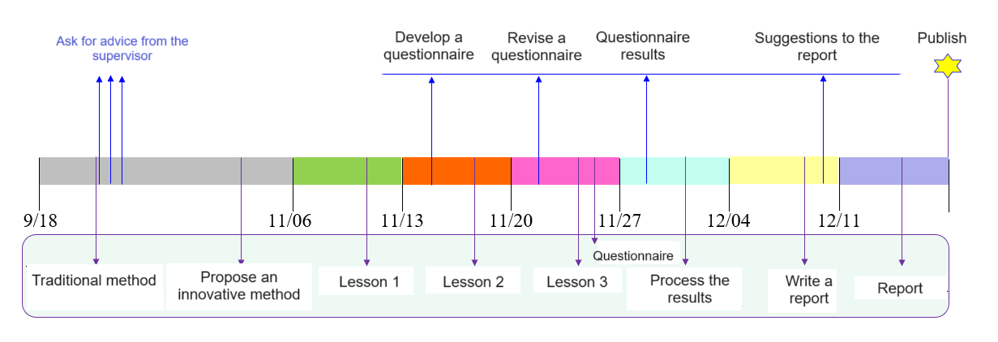

***Figure 3. A plan to organize lecture sessions using a*** *proposed* ***method and study student satisfaction and learning outcomes.***

# Research results

To determine the satisfaction of students during the course, including the impact of the teacher's teaching methods and the changes in the learning outcomes, we have studied similar materials such as questionnaires taken by the SISI system of NUM and prepared a questionnaire to evaluate the satisfaction of students. Figure 4 compares similar materials used in terms of content, structure, and number of questions. The questionnaire consists of 3 main parts. The first part consists of questions about lecture methods and students' satisfaction, the second part consists of questions about teachers and teacher's teaching methods, and the final part consists of questions about lecture effectiveness.

***Figure 4 . Similar materials used to prepare a questionnaire.***

* ***Lecture methods and student satisfaction question*s**

Figure 5 summarizes how students responded to the questions in the first part of the survey: lecture style and student satisfaction. 90% of the students who participated in the survey said that the content of the lecture was good, while 80% rated the lecture as effective.

Regarding the lecture method, each student's opinion was different, and the majority gave positive answers ( 40% effective, 30% interesting, 20% innovative ). It was also agreed that the lecture sessions organized by the proposed method were more interesting and had more content than the previous lectures. Regarding the question of comprehensibility, each student's opinion was different, and half of the students surveyed said that it was clear, while the rest answered that some topics were clear. In terms of satisfaction, 70% of the participants were completely satisfied, according to the results of the survey.

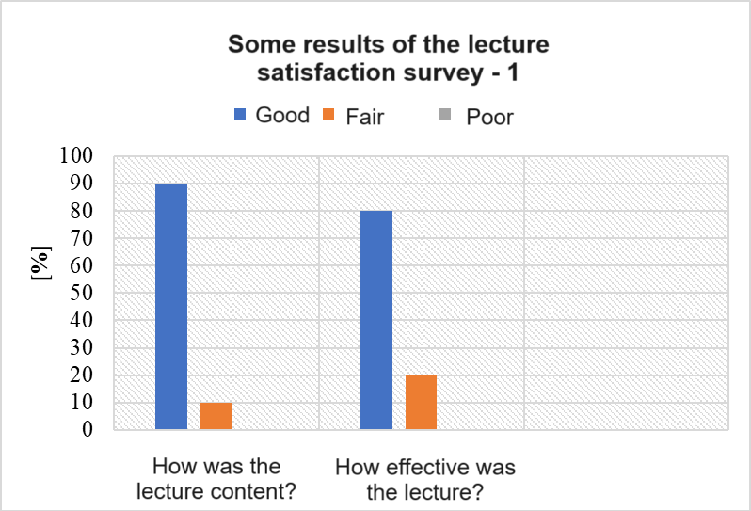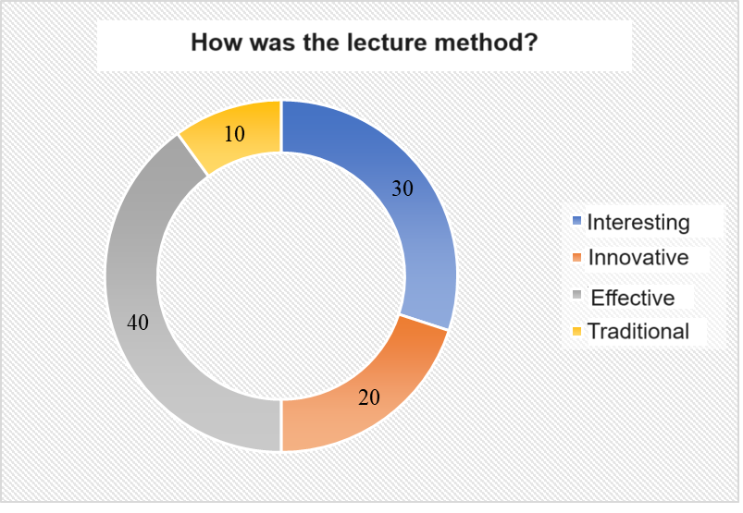

( a ) ( b )

(c) ( d)

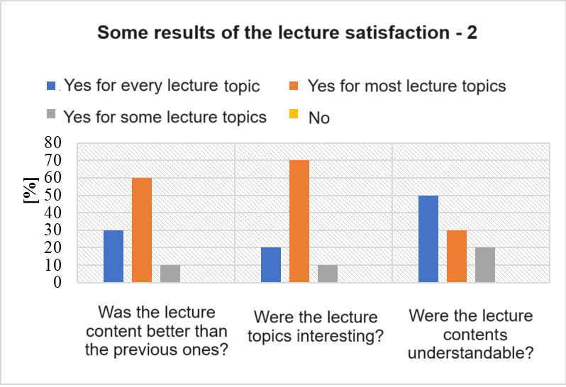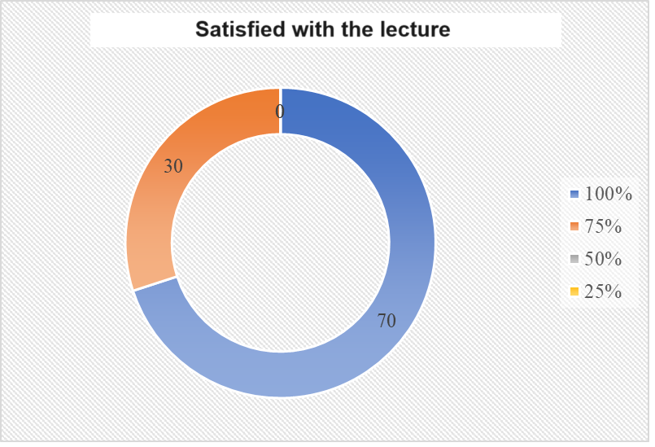

***Figure 5. Aggregated Results of Lecture Satisfaction Survey.***

In addition to the above questions, a free-response question was also included in the questionnaire. The participants answered the question as follows.

If there was an advantage, in which way was it better than the previous lectures?

* ***Interesting and innovative.***
* ***In the middle of the lecture, there were interesting case studies.***
* ***The previous lectures were equally interesting. The content to be understood is simply explained with interesting examples.***
* ***Fresh from previous lectures.***
* Other ***interesting explanation***s were included.
* ***Innovative and interesting examples.***
* The ***contents of each lecture were clearly explained. The variables of each formula were explained in detail.***
* ***The first class at 7:40 in the morning leaves most students feeling unfocused, stressed, or tired.*** Therefore***, it is common for students to fall asleep in class,*** and ***the first*** class ***of every*** week ***in the dark season of winter is*** long***.***
* ***2 students*** submitted ***without answering.***
* ***Question*s *on teacher and* teacher’s *teaching methods***

Figure 6 summarizes the results of the questions asked to determine students' evaluations of teachers and teaching methods. As mentioned in the previous chapter, the majority of the respondents were completely satisfied with the lectures, and they also chose positive answers to the questionnaire about the teacher.

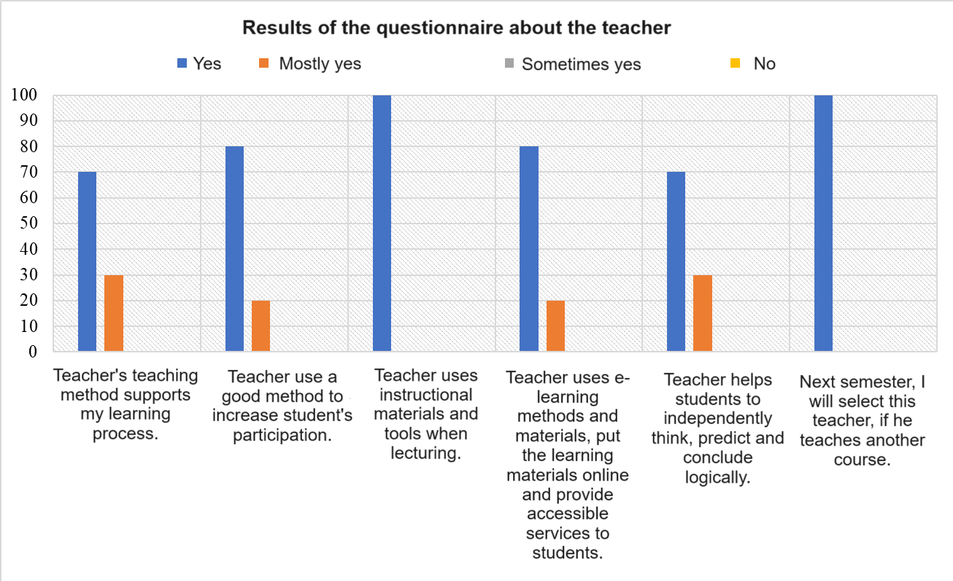

***Figure 6 . Aggregated results*** *of* ***a questionnaire on teacher and teacher****’s* ***teaching*** *methods****.***

* ***Question*son *lecture* effectiveness**

Figure 7 shows the aggregated results of the final part of the questionnaire on the lecture effectiveness. The questions included in the questionnaire were intended to show the effect of the method of organizing the lectures on the student's knowledge acquisition process. According to the results, the answers to the first question indicate that the students are confident that they can determine the importance of the content and facts taught in the lecture, and that they have the knowledge to provide general information to others within the studied topics. Furthermore, it is possible to analyze the specified content, and the activity of attending lectures has increased significantly, which indicates how important the learning outcomes are in how to prepare the content of the lectures. Furthermore, it is possible to analyze the specified content, and the activity of attending lectures has increased significantly, which indicates how the method of preparing the lecture content is significantly related to the learning outcomes.

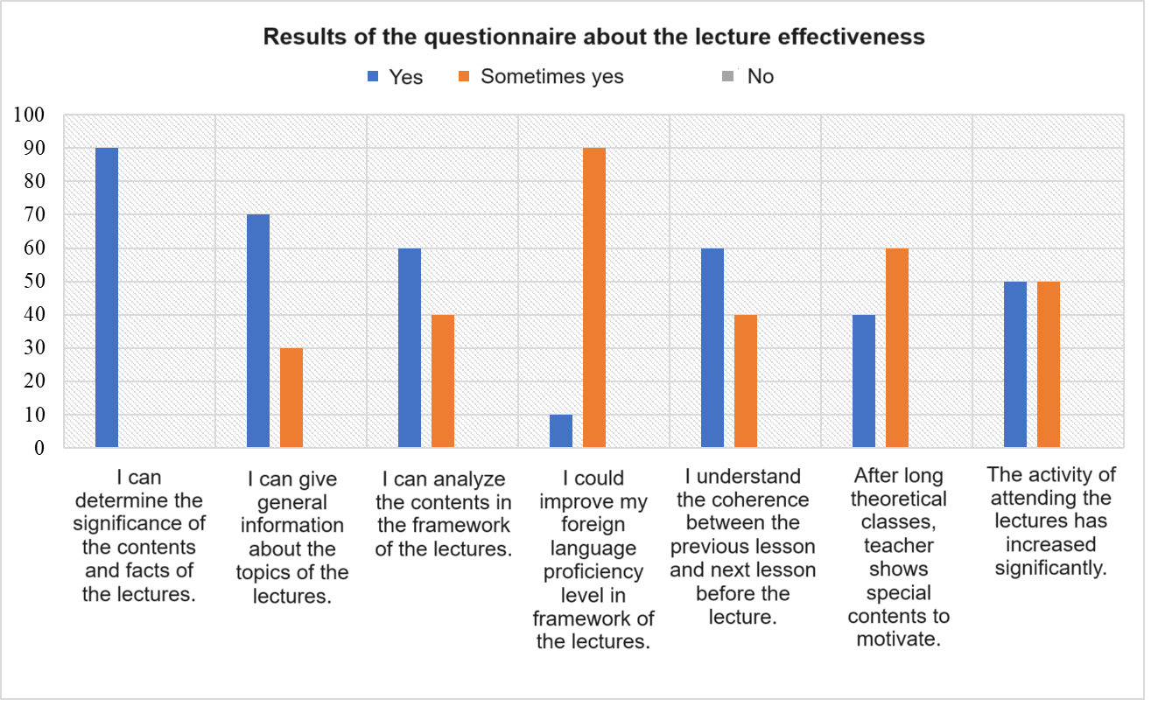

***Figure 7 . Aggregated results*** *of* ***a*** *questionnaire* ***on lecture*** *effectiveness****.***

* ***Effects on learning outcomes***

Figure 8 shows the exam performance differences after organizing the lectures by traditional and proposed methods. A total of 10 students participated in the study, and 8 students' performance increased, 1 student's performance remained the same, and another student's performance decreased. After comparing and analyzing the performance scores of the students, the content of the lecture organized by the proposed method was better determined by the students, and the performance score was 47.7-64.5% with an increase of 16.8%.

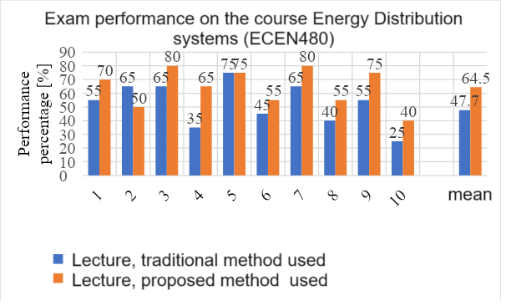

***Figure 8. A graph comparing the changes in*** *exam* ***performance.***

# Conclusion

Within the scope of this study, the aim was to acquire knowledge on the quality of higher education institutions, methods and forms of training, student satisfaction, and how the teacher's teaching methods affect these.

Among the various teaching methods, conducting lectures provides students with the main understanding of the scientific and professional fields. To improve the learning results, improve the students' activity, and motivate them, we changed the traditional lecture methods, prepared the content of the lectures in an innovative way that is suitable for the students, and studied student satisfaction and the changes in learning outcomes.

The students, who took the course Energy Distribution Systems (ECEN480) in the fall semester of the 2021-2022 academic year, were involved in the experiment. Thus, between November 10, 2021, and November 24, 2021, 3 lectures were organized with contents enriched with motivational information at a certain frequency. Then, a questionnaire with 3 parts and 25 questions was prepared for the participants of the study, and the satisfaction of the students was evaluated.

A large percentage of them were satisfied and said that they could inform others and analyze the content of the lectures held during the trial period. Regarding the learning results, the performance of 80% of the participants in the study increased, while the performance of 10% remained the same, and the performance of the other students (10%) decreased.

To generalize the results of the experiment conducted within the framework of this study, the ability of teachers to adjust their methods according to the research subjects supports the process of establishing knowledge of students, creates satisfaction, and increases learning outcomes.

# Bibliography

Bat - Undral. D, (2016 ), Research on customer satisfaction of higher education services. Master's thesis.

Yanjinlham. L, (2018), Evaluating the quality of university services using the Hedperf model: examples of Science school and Natural sciences school, NUM. Master's thesis.

https://catalog.num.edu.mn/cgi-bin/koha/opac-SBDdetailebook.pl?biblionumber=119317

https://www.slideshare.net/SaraaSarantuya2/ss-75185766

http://www.ghsss.gov.mn/wp-content/uploads/2018/09/setgel_hanamj.pdf

Oyuun-Olziy. N, (2013), Employee satisfaction and factors affecting it. Master's thesis.

Badarch. D, Ochirbat. B, Namnan. T, Monkhhuj. B, Ochirbat. B, (2018), Quality of teaching in higher education. Higher Education Policy Recommendations.

Davaa, J, (2013), Teaching technology in higher education. Textbook.

Peyton, RM, PS & Kamery, RH (2003). "Consumer Satisfaction/Dissatisfaction (CS/D): A review of the literature before the 1990s, Proceedings of the Academy of Organizational Culture, Communications, and Conflicts," 7(2). Allied Academies International Conference. Las Vegas. (pp. 41-46).

Engel, J., KD & Blackwell, R. (1968), "Consumer behavior".

Oxford Library of Words and Phrases (1993), Oxford University Press.

Hunt, H. (1982), A 10 based on expectations, but normatively a 3.6371, in Day, RL and Hunt, HK (Eds), Proceedings of the 7th Annual Conference on Consumer Satisfaction, Dissatisfaction and Complaining Behavior, University of Tennessee, Knoxville, TN, October, pp. 130-31.

Anderson, R. (1973), Consumer dissatisfaction: The effect of underperformance, Journal of Marketing Research, Vol. 10(2), pp. 38-44.

Parker, C. & Matthews, BP (2001), Customer satisfaction: contrasting academic and consumers' interpretations Marketing Intelligence and Planning. Vol. 19(1), pp. 38-44.

Wilton, P. & Nicosia, I. (1986), "Emerging paradigms for the study of consumer satisfaction," European Research. Vol. 14(1), pp. 4-11.

Kim, S.-H. (1997), Modeling Residents Satisfaction: Comparison of the Francescato and Fishbein-Ajzen Model Department of Urban and Regional Planning, University of Illinois at Urbana-Champaign. An unpublished doctoral dissertation.

Day, R. (1980), How satisfactory is research on consumer satisfaction? Advances in Consumer Research, In J. Olson (Ed.). Ann Arbor: Association for Consumer Research, Vol. 7, pp. 593-597.

Hunt, H. (1977), "CS/D: Bits and pieces," in R. Day (Ed.), Consumer satisfaction/dissatisfaction and complaining behavior (pp. 38-41). Proceedings of the 2nd Annual Consumer Satisfaction/dissatisfaction and Complaining Behavior Conference. April 20-22, 1977.

McQuitty, S., FA & Wiley, JB (2000), Systematically Varying Customer Satisfaction and its Implications for Product Choice, Academy of Marketing Science Review.

Oliver, RL (1980a), A Cognitive Model of the Antecedents and Consequences of Satisfaction Decisions, Journal of Marketing Research, Vol. 17(11), pp. 460-469.

Churchill, GAJ & Surprenant, C. (1982), An investigation into the determinants of customer satisfaction, Journal of Marketing Research, Vol. 19(4), pp. 491-504.

Tse, DK & Wilton, PC (1988), Models of consumer satisfaction formation: An extension, Journal of Marketing Research, Vol. 25(2), pp. 204-212.

Kotler, P. (2000), Marketing Management 10th ed., Prentice-Hall, New Jersey.

Hoyer, WD & MacInnis, DJ (2001). Consumer Behavior, 2nd ed., Boston. Houghton Mifflin Company.

Hansemark, OC & Albinson, M. (2004). Customer Satisfaction and Retention: The Experiences of Individual Employees, Managing Service Quality, Vol. 14(1), pp. 40-57.