## INTER-SYSTEM HANDOFF IN 4G NETWORKS

1Anmol Chugh , 2Dr. Rupali

1M.Tech Scholar Sat Priya Group of Institutions, Rohtak

2Assistant Professor Sat Priya Group of Institutions, Rohtak

**Abstract**

WiMax and WiFi are key technologies in the realm of wireless communication, facilitating data transmission through diverse methods. In large-scale wireless networks using these technologies, it is common practice to segment the network into clusters to manage its extensive reach more effectively. Each cluster is managed by a base station or cluster head, responsible for the nodes within its domain. As nodes move within the network, they may exit the range of their current cluster head, requiring a transfer of control to a new cluster head, a process known as handover.

The aim of the proposed system is to tackle this challenge by developing a strategy to select the most appropriate cluster head for a node, focusing on reliability and efficiency. This system is particularly concerned with heterogeneous networks that incorporate both Broadband wireless network and Wireless connectivity technologies. The process of switching between these distinct networks is known as inter-network handoff. The primary goal is to fine-tune inter-network handoff. by enhancing both efficiency and reliability. Selection of base stations will involve adjusting various parameters to ensure optimal performance. Main objectives of proposed work are:

1. **Development of Clustered Networks**: Create and implement WiMax and WiFi clustered networks in multiple scenarios to replicate real-world conditions.
2. **Parameter Analysis**: Investigate factors that influence handover processes, such as signal strength, network congestion, and patterns of node mobility.
3. **Algorithm Implementation**: Develop specialized algorithms to enable efficient handover between clusters, aiming to reduce disruptions and maintain continuous connectivity for nodes.
4. **Introduction**

**Introduction-** Next-generation wireless networks have been envisioned as an Internet Protocol (IP) based infrastructure with the integration of various wireless access networks such as IEEE 802.11 wireless local area networks (WLANs), IEEE 802.16 wireless metropolitan area networks (WMANs), Wimax ,Wi-Fi networks and Universal Mobile Telecommunications System (UMTS). Heterogeneous wireless networks need to cooperate to provide users with a ubiquitous environment with seamless mobility and good quality of service (QoS). Mobile nodes (MNs) can automatically switch the connectivity between different types of networks.

The interworking between different wireless access networks has been a hot research and development topic in the past few years. Different radio access technologies present distinct characteristics in terms of mobility management, security support, and QoS providing. To achieve seamless mobility and end-to-end QoS guarantee for the users, these issues should be carefully addressed while developing the interworking and handoff schemes of WMNs with various wireless networks. Mesh routers in the WMNs play an important role. The 802.11 access point (AP) functions and 802.16 base station (BS) functions can be integrated into one mesh router. When an MN switches the network interface, only the link type is changed between the MN and mesh routers, and the MN still connects to the same mesh router. In this case, the traditional mobility management such as Mobile IP leads to a large handoff delay with too much signaling cost. Thus to achieve fast and seamless handoff, a new handoff scheme should be considered. Another factor which can select seamless vertical handoff is how and when to make a handoff decision. In traditional handoff, the received signal strength is the main handoff metric. However, in vertical handoff, only the received signal strength is not enough to make a handoff decision. The handoff metrics may be cost of service, load on network, MN's distance, QoS and user preference. It is a challenge to develop a vertical handoff decision algorithm for optimal radio resource utilization with various QoS support. The vertical handoff may not take place only at the cell edge. It can occur at any time (even when the MN does not move) depending on the network condition and user preference such as in a situation of network congestion. How to make a decision to trigger a vertical handoff according to the system performance and QoS parameters becomes the main part of this kind of vertical handoff. Therefore an effective and efficient vertical handoff decision algorithm in the interworking between 802.11 and 802.16 in WMN is needed to maximize the resource utilization and to avoid unnecessary handoff. In this work we have done the parametric changes while performing the selection of base stations. The analysis is performed respective to the effective throughput and the delay.

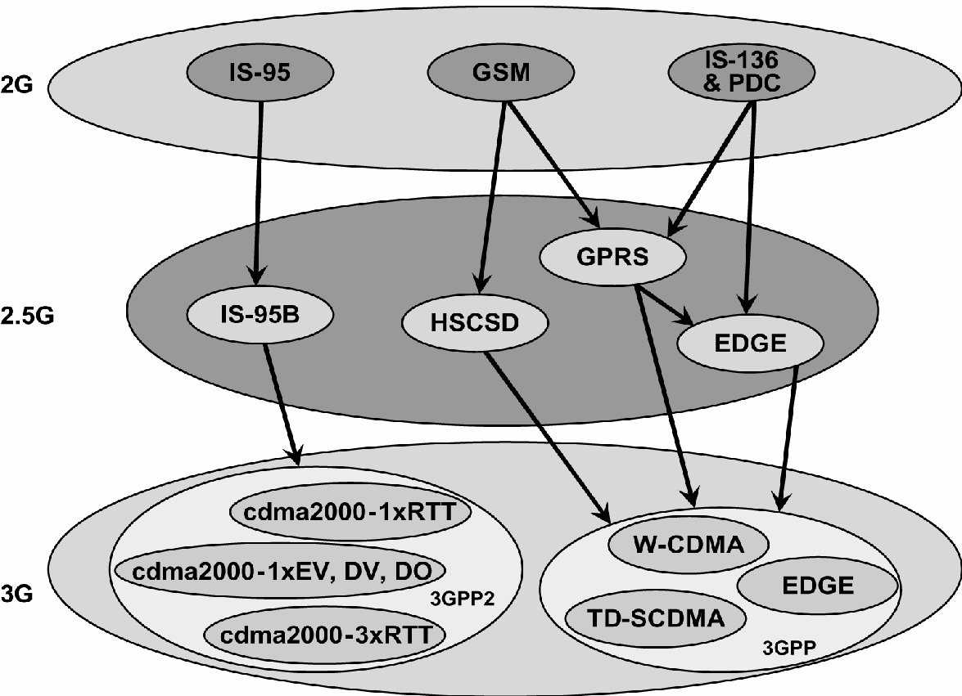

Fig. **Fig. 1 Upgraded Path**

The basic concepts and system model for Wireless Technology is given. Major advantages and drawbacks of WiMax and Wi-Fi networks will be discussed. In Chapter 3,the handoff problem and various existing popular handoff types and different parameters have been addressed. Base paper’s overview and proposed work is included in Chapter 4. An overview of vertical handoff will be discussed and an improved vertical handoff scheme and the analysis on it will be proposed in Chapter 5. Chapter 6 shows computer simulations on the proposed handoff algorithm. And finally, the conclusions and the recommendations for future work are given.

1. **Literature Review**

**Dr. A. P. Dhande and M. Ghanbari, "Vertical handover decision algorithms for heterogeneous wireless networks: A survey and taxonomy," Wireless Personal Communications, vol. 82, no. 4, pp. 2103-2129, 2015.**

These algorithms prioritize the allocation of channel resources based on available bandwidth, aiming to optimize network performance and user experience. One example is a QoS-based algorithm that considers residual bandwidth and user service requirements when deciding whether to handover between different network types, such as WLAN and Wireless Wide Area Network (WWAN).

**S. Misra, S. Paul, and P. R. Kotecha, "A survey of vertical handover decision algorithms for 4G networks," International Journal of Computer Applications, vol. 100, no. 13, pp. 26-31, 2014.**

Vertical Handover Decision (VHD) algorithms play a critical role in the architecture of Fourth Generation (4G) heterogeneous wireless networks, ensuring seamless roaming and maintaining Quality of Service (QoS) across diverse applications. As the demand for ubiquitous communication services continues to surge, the integration of various wireless access technologies, including WLAN, WiMAX, satellite systems, and Bluetooth, alongside traditional cellular networks, becomes imperative for meeting consumer expectations.

**M. Ghaleb and N. A. Abbasi, "A comprehensive review on vertical handover decision algorithms in heterogeneous wireless networks," Journal of Network and Computer Applications, vol. 35, no. 3, pp. 877-892, 2012.**

The introduction sets the stage by highlighting the rapid development of wireless systems and the need for a unified technology infrastructure to serve various wireless applications effectively. It emphasizes the importance of future wireless systems communicating via heterogeneous technologies such as WiFi, WiMAX, UMTS, and mobile applications like Web 2.0 and location-based services.

**Zhiwei Yan,” An Adaptive Multi-criteria Vertical Handover Framework for Heterogeneous Networks”, 978-1-60558-089-0.**

The literature review on LTE networks and handoff processes presents a multifaceted exploration of research endeavors spanning network architecture, deployment strategies, and mobility management. Scholars have meticulously dissected LTE architecture, delineating the intricate interplay of network components, protocols, and interfaces to optimize packet data transmission and minimize operational costs. Deployment strategies have garnered attention for their role in maximizing spectral efficiency and mitigating network congestion, with a concerted effort to balance data usage and maintenance expenditures.

**R. Good,” A Multilayered Hybrid Architecture to Support Vertical Handover between IEEE802.11 and UMTS”, IWCMC’06, 1-59593-306-9/06/0007.**

The literature review in the paper delves into the intricate realm of mobility management within heterogeneous network environments, with a particular focus on the interplay between Mobile IPv4, or Mobile IP, and the Session Initiation Protocol (SIP). It begins by outlining the formidable challenges encountered during vertical handovers, especially when transitioning between WLAN and UMTS networks, necessitating meticulous adjustments in Mobile IP implementations.

**Gracieth Valenzuela, Isac Ferreira, Paulo Cunha," Vertical Handover Decision Based on Quality of experience in Heterogeneous Wireless Networks.**

Prior research in the field of heterogeneous wireless networks has predominantly focused on network selection mechanisms and their impact on user experience. Traditional approaches to network selection often rely on technical metrics such as signal strength, network availability, and load balancing. While these metrics are essential for maintaining network stability and performance, they may not fully capture the subjective aspects of user satisfaction, particularly in multimedia-rich environments.

**Wonjun Lee,” Movement-Aware Vertical Handoff of WLAN and Mobile WiMAX for Seamless Ubiquitous Access”, IEEE Transactions on Consumer Electronics 0098 3063/07 © 2007 IEEE.**

The seamless integration of heterogeneous wireless networks has garnered significant attention in the pursuit of ubiquitous computing environments. Among the diverse array of wireless technologies, IEEE 802.16 WiMAX has emerged as a promising solution, particularly with the advent of the IEEE 802.16e Mobile WiMAX standard, which addresses mobility challenges.

However, the effective interworking between IEEE 802.11 WLAN and IEEE 802.16e Mobile WiMAX remains relatively unexplored in the existing literature. Previous research predominantly centers on vertical handover mechanisms between WLAN and 3G networks, with approaches primarily classified into radio signal strength (RSS)-based and policy-based strategies.

1. **Methodology**

**REQUIREMENT OF VERTICAL HANDOFF**

Efficiency and reliability are crucial for any connectivity. Within rapid networking, data loss can become a significant issue when problems arise. One of the primary hurdles in these fast networks is handover, especially vertical handover, which occurs between different types of networks.

This work addresses the issue of data loss during vertical handovers. To manage a WiMax network effectively, we describe a hybrid network with a defined quantity of nodes and clusters. To achieve this, we must gather information about the network scenario, including:

* No of Nodes
* Mobility
* Cluster Definition
* Channel Type
* Propagation
* Transmission Speed

To ensure precise depiction of these parameters, gathering pertinent scenarios is essential. Additionally, information on parameters that influence cluster head selection criteria which may include factors like proximity (distance) and load considerations should be collected. This configuration will be determined through an examination of existing literature.

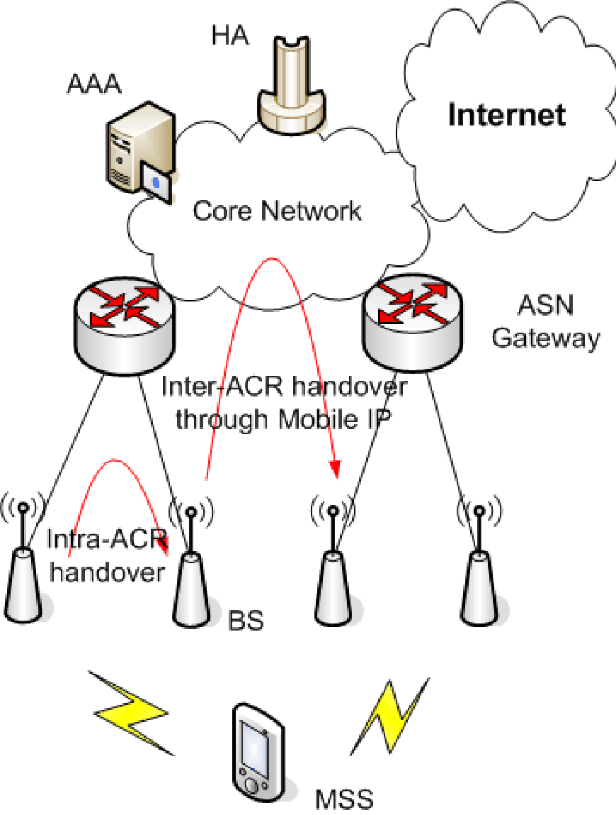

**Fig. 2 Network Architecture of Mobile WiMAX**

**PROPOSED ALGORITHM**

Efficiency and integrity are paramount for any network, and the challenges are even more critical in wireless networks. The decision to trigger a handover will stem from a specific crucial element, electing the base station with the highest operational efficiency as the subsequent base station post-handover. This Mechanism aims to deliver seamless handover with high reliability and minimal energy consumption.

Algorithm

1. Define a network with N nodes, including detection radius and supplementary factors relevant variables.
2. Describe the cornerstone stations considering their rate of recurrence ranges and capacities.
3. Conduct wireless communication with a designated node, N1..
4. Check if handover is needed:
   * + If the separation between the base station (BS) and Node N1 exceeds the range.
     + Print "Handoff required"

**MATLAB TOOL**

MATLAB is a sophisticated language and interactive platform crafted to handle computationally demanding tasks more effectively.

#### Overview and Core Characteristics

MATLAB stands out as a scientific computing language and platform for developing algorithms, data visualization, data analysis, and numerical computation. It enables users to address complex technical computing challenges.significantly faster compared to conventional programming languages.

#### Developing Algorithms and Applications

MATLAB facilitates the development of complex algorithms and applications, catering to a diverse spectrum of fields encompassing signal and image processing, communications, control engineering, testing and measurement, financial analysis, and computational biology. Its capabilities can be expanded with add-on toolboxes—collections of specialized MATLAB functions tailored to specific applications.

#### Analyzing and Accessing Data

With MATLAB, users can efficiently analyze and access data, leveraging its robust computational power and extensive built-in functions for tasks ranging from simple calculations to advanced data processing.

#### Visualizing Data

MATLAB excels in data visualization, providing a rich set of 2-D and 3-D visualizations. These instruments help users to visualize complex data sets, facilitating a deeper understanding and more insightful analysis.

#### Performing Numeric Computation

MATLAB includes a comprehensive set of mathematical functions for performing numerical computations. These functions cover various areas.

#### Publishing Results and Deploying Applications

MATLAB offers features for documenting and sharing your work, allowing for the integration of MATLAB code with other languages and applications. It supports the distribution of MATLAB algorithms and applications, making it easier to publish results and deploy solutions.

### Special Features of MATLAB

* Development Environment: Manage optimize programming, documents, and datasets effectively.
* Engagement instruments: Engage in incremental investigation, design iteration, and problem resolution.
* Numerical operations: Utilize a wide range of functions for diverse numerical computations.
* Graphics Functions: Create sophisticated 2-D and 3-D visualizations.

In summary, MATLAB is a versatile and powerful environment that streamlines the development, analysis, and visualization of technical computing projects, making it an indispensable tool for engineers, scientists, and researchers across various disciplines.

1. **Conclusion**

In conclusion, the hybrid network architecture accommodates various usage models and supports both live and asynchronous voice, data, and interactive media offerings with consistent quality. It also enables seamless operation for mobile stations, including during idle mode and paging.

Through a comparison between our novel handover methodology and current methods, we have determined that our methodology provides superior service quality. By integrating load on base station, distance, and transmission time parameters in the handover process, we have effectively minimized data drop rates, especially in scenarios involving mobile node speed and distance variations. Moving forward, further enhancements to the handover algorithm could focus on optimizing Quality of Service for specific applications and considering additional factors such as cell load, network performance, and security concerns.

**References**

1. Seyed Vahid Azhari,” The Bandwidth Deficit Problem in Loosely Coupled WLAN-to-Cellular Vertical Handover”, IWCMC’07 978-1-59593-695-0/07/0008
2. R. Good,” A Multilayered Hybrid Architecture to Support Vertical Handover between IEEE802.11 and UMTS”, IWCMC’06, 1-59593-306-9/06/0007
3. Gracieth Valenzuela,” Vertical Handover Decision Based on Quality of Experience in Heterogeneous Wireless Networks”.
4. Johann Márquez-Barja, Carlos T. Calafate, Juan-Carlos Cano and Pietro Manzoni, "Vertical Handover When context Matter".
5. Gracieth Valenzuela, Isac Ferreira, Paulo Cunha," Vertical Handover Decision Based on Quality of experience in Heterogeneous Wireless Networks".
6. M. Ghaleb and N. A. Abbasi, "A comprehensive review on vertical handover decision algorithms in heterogeneous wireless networks," Journal of Network and Computer Applications, vol. 35, no. 3, pp. 877-892, 2012.
7. M. Ghaleb and N. A. Abbasi, "A comprehensive review on vertical handover decision algorithms in heterogeneous wireless networks," Journal of Network and Computer Applications, vol. 35, no. 3, pp. 877-892, 2012.
8. K. Al Agha, O. Ait Mohamed, and A. Guitton, "Performance evaluation of vertical handoff decision algorithms for next generation wireless networks," in Proceedings of the International Conference on Wireless and Mobile Computing, Networking and Communications (WiMob), 2014.
9. S. Taha, A. Ahmed, and M. H. Rehmani, "A survey of vertical handover decision algorithms in heterogeneous wireless networks," IEEE Access, vol. 7, pp. 114223-114249, 2019.
10. H. S. Al-Raweshidy, J. Bigham, and B. D. Rathke, "Vertical handover in heterogeneous wireless networks," Wiley Encyclopedia of Telecommunications, 2003.
11. Zhiwei Yan,” An Adaptive Multi-criteria Vertical Handover Framework for Heterogeneous Networks”, 978-1-60558-089-0
12. Pravin Pawar,” Context-Aware Middleware Architecture for Vertical HandoverSupport to Multi-homed Nomadic Mobile Services”, SAC’08, 978-1-59593-753-/08/0003
13. Tae-sub Kim,” Vertical Handover between LTE and Wireless LAN Systems based on Common Resource Management (CRRM) and Generic Link Layer (GLL)”, ICIS 2009 978-1-60558-710-3/09/11
14. Johann Márquez-Barja,” Vertical Handover: When the Context Matters”, PM2HW2N’12 978-1-4503-1626-2/12/10
15. Zhiwei Yan,” A Dual Threshold-based Fast Vertical Handover Scheme with Authentication Support”.