## INTER-SYSTEM HANDOFF IN 4G NETWORKS

1Anmol Chugh , 2Dr. Rupali

1M.Tech Scholar Sat Priya Group of Institutions, Rohtak

2Assistant Professor Sat Priya Group of Institutions, Rohtak

**Abstract**

Wimax and Wifi are thetelecommunications technologies that offer transmission of wireless data via a number of transmission methods; such as portable or fully mobile internet access via point to multipoint links. As the size of a Wireless Network is much vast because of this the complete network is divided in terms of clusters. Each cluster has a cluster head or the base station that controls all nodes of the network. These networks can have a node with mobility. The problem begins when a node moves from the cluster and when outside the range of Cluster head. In such a case the control of that node shifted to another Cluster Head. This process is called the head off mechanism. The proposed system is the scheme to select the best cluster head for this node with respect to the reliability and efficiency. The proposed work is the selection of cluster head or the base station in case of heterogeneous network. Here the heterogeneity is defined in terms of two different networks; WiMax and WiFi Networks. The process of handover between these networks is called vertical handover. The present work is about to optimize the vertical handover. In this work we have done the parametric changes while performing the selection of base stations. The analysis is performed with respect to the effective throughput and the delay.

Main objectives of proposed work are:

* Design and implementation of WiMax and Wifi Clustered Network in Different Scenarios.
* Study of Parameters that can affect Handover.
* Implementation of Proposed Algorithms for Efficient Hand Over between Clusters.

1. **Introduction**

**Introduction-** Next-generation wireless networks have been envisioned as an Internet Protocol (IP) based infrastructure with the integration of various wireless access networks such as IEEE 802.11 wireless local area networks (WLANs), IEEE 802.16 wireless metropolitan area networks (WMANs), Wimax ,Wi-Fi networks and Universal Mobile Telecommunications System (UMTS). Heterogeneous wireless networks need to cooperate to provide users with a ubiquitous environment with seamless mobility and good quality of service (QoS). Mobile nodes (MNs) can automatically switch the connectivity between different types of networks.

The interworking between different wireless access networks has been a hot research and development topic in the past few years. Different radio access technologies present distinct characteristics in terms of mobility management, security support, and QoS providing. To achieve seamless mobility and end-to-end QoS guarantee for the users, these issues should be carefully addressed while developing the interworking and handoff schemes of WMNs with various wireless networks. Mesh routers in the WMNs play an important role. The 802.11 access point (AP) functions and 802.16 base station (BS) functions can be integrated into one mesh router. When an MN switches the network interface, only the link type is changed between the MN and mesh routers, and the MN still connects to the same mesh router. In this case, the traditional mobility management such as Mobile IP leads to a large handoff delay with too much signaling cost. Thus to achieve fast and seamless handoff, a new handoff scheme should be considered. Another factor which can select seamless vertical handoff is how and when to make a handoff decision. In traditional handoff, the received signal strength is the main handoff metric. However, in vertical handoff, only the received signal strength is not enough to make a handoff decision. The handoff metrics may be cost of service, load on network, MN's distance, QoS and user preference. It is a challenge to develop a vertical handoff decision algorithm for optimal radio resource utilization with various QoS support. The vertical handoff may not take place only at the cell edge. It can occur at any time (even when the MN does not move) depending on the network condition and user preference such as in a situation of network congestion. How to make a decision to trigger a vertical handoff according to the system performance and QoS parameters becomes the main part of this kind of vertical handoff. Therefore an effective and efficient vertical handoff decision algorithm in the interworking between 802.11 and 802.16 in WMN is needed to maximize the resource utilization and to avoid unnecessary handoff. In this work we have done the parametric changes while performing the selection of base stations. The analysis is performed respective to the effective throughput and the delay.

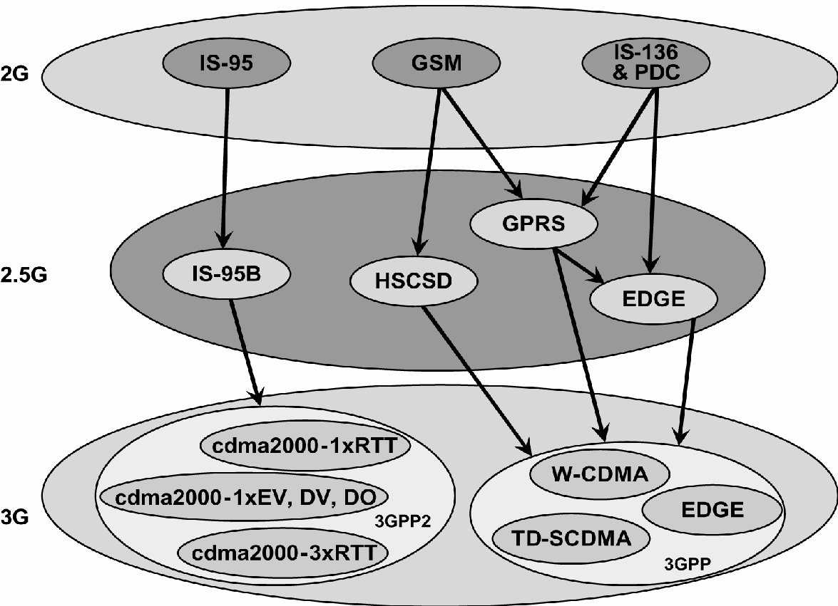

Fig. **Fig. 1 Upgraded Path**

The basic concepts and system model for Wireless Technology is given. Major advantages and drawbacks of WiMax and Wi-Fi networks will be discussed. In Chapter 3,the handoff problem and various existing popular handoff types and different parameters have been addressed. Base paper’s overview and proposed work is included in Chapter 4. An overview of vertical handoff will be discussed and an improved vertical handoff scheme and the analysis on it will be proposed in Chapter 5. Chapter 6 shows computer simulations on the proposed handoff algorithm. And finally, the conclusions and the recommendations for future work are given.

1. **Literature Review**

**Dr. A. P. Dhande and M. Ghanbari, "Vertical handover decision algorithms for heterogeneous wireless networks: A survey and taxonomy," Wireless Personal Communications, vol. 82, no. 4, pp. 2103-2129, 2015.**

These algorithms prioritize the allocation of channel resources based on available bandwidth, aiming to optimize network performance and user experience. One example is a QoS-based algorithm that considers residual bandwidth and user service requirements when deciding whether to handover between different network types, such as WLAN and Wireless Wide Area Network (WWAN).

**S. Misra, S. Paul, and P. R. Kotecha, "A survey of vertical handover decision algorithms for 4G networks," International Journal of Computer Applications, vol. 100, no. 13, pp. 26-31, 2014.**

Vertical Handover Decision (VHD) algorithms play a critical role in the architecture of Fourth Generation (4G) heterogeneous wireless networks, ensuring seamless roaming and maintaining Quality of Service (QoS) across diverse applications. As the demand for ubiquitous communication services continues to surge, the integration of various wireless access technologies, including WLAN, WiMAX, satellite systems, and Bluetooth, alongside traditional cellular networks, becomes imperative for meeting consumer expectations.

**M. Ghaleb and N. A. Abbasi, "A comprehensive review on vertical handover decision algorithms in heterogeneous wireless networks," Journal of Network and Computer Applications, vol. 35, no. 3, pp. 877-892, 2012.**

The introduction sets the stage by highlighting the rapid development of wireless systems and the need for a unified technology infrastructure to serve various wireless applications effectively. It emphasizes the importance of future wireless systems communicating via heterogeneous technologies such as WiFi, WiMAX, UMTS, and mobile applications like Web 2.0 and location-based services.

**Zhiwei Yan,” An Adaptive Multi-criteria Vertical Handover Framework for Heterogeneous Networks”, 978-1-60558-089-0.**

The literature review on LTE networks and handoff processes presents a multifaceted exploration of research endeavors spanning network architecture, deployment strategies, and mobility management. Scholars have meticulously dissected LTE architecture, delineating the intricate interplay of network components, protocols, and interfaces to optimize packet data transmission and minimize operational costs. Deployment strategies have garnered attention for their role in maximizing spectral efficiency and mitigating network congestion, with a concerted effort to balance data usage and maintenance expenditures.

**R. Good,” A Multilayered Hybrid Architecture to Support Vertical Handover between IEEE802.11 and UMTS”, IWCMC’06, 1-59593-306-9/06/0007.**

The literature review in the paper delves into the intricate realm of mobility management within heterogeneous network environments, with a particular focus on the interplay between Mobile IPv4, or Mobile IP, and the Session Initiation Protocol (SIP). It begins by outlining the formidable challenges encountered during vertical handovers, especially when transitioning between WLAN and UMTS networks, necessitating meticulous adjustments in Mobile IP implementations.

**Gracieth Valenzuela, Isac Ferreira, Paulo Cunha," Vertical Handover Decision Based on Quality of experience in Heterogeneous Wireless Networks.**

Prior research in the field of heterogeneous wireless networks has predominantly focused on network selection mechanisms and their impact on user experience. Traditional approaches to network selection often rely on technical metrics such as signal strength, network availability, and load balancing. While these metrics are essential for maintaining network stability and performance, they may not fully capture the subjective aspects of user satisfaction, particularly in multimedia-rich environments.

**Wonjun Lee,” Movement-Aware Vertical Handoff of WLAN and Mobile WiMAX for Seamless Ubiquitous Access”, IEEE Transactions on Consumer Electronics 0098 3063/07 © 2007 IEEE.**

The seamless integration of heterogeneous wireless networks has garnered significant attention in the pursuit of ubiquitous computing environments. Among the diverse array of wireless technologies, IEEE 802.16 WiMAX has emerged as a promising solution, particularly with the advent of the IEEE 802.16e Mobile WiMAX standard, which addresses mobility challenges.

However, the effective interworking between IEEE 802.11 WLAN and IEEE 802.16e Mobile WiMAX remains relatively unexplored in the existing literature. Previous research predominantly centers on vertical handover mechanisms between WLAN and 3G networks, with approaches primarily classified into radio signal strength (RSS)-based and policy-based strategies.

1. **Methodology**

**REQUIREMENT OF VERTICAL HANDOFF**

Efficiency and reliability are the major requirements of any network. In the case of high speed networks like WiMax, or the Wi-Fi Networks, the network gives more data loss as some problem occurs over the network. One of the major problems of such a high speed network is handover. This problem becomes more critical when it is between two different networks. Such a handover is called vertical Handover. In this work we are dealing with the problem of data loss during the vertical handover between WiFi and WiMax network. To work with a wimax network we need to define a hybrid network with n number of nodes and m number of clusters. Some clusters will represent the wimax network and some will represent the wifi network.. For this we need to collect the information about the network scenario. The scenario includes the information like :

* No of Nodes
* Mobility
* Cluster Definition
* Channel Type
* Propagation
* Transmission Speed

To represent all these parameters we need to collect relevant scenarios. We can collect these scenarios either from some existing literature Surveys or by studying the network definition from the ieee itself. We need to collect information about the parameters that can help to decide the cluster head selection such as distance, load etc. These parameters will be decided by studying the existing literature.

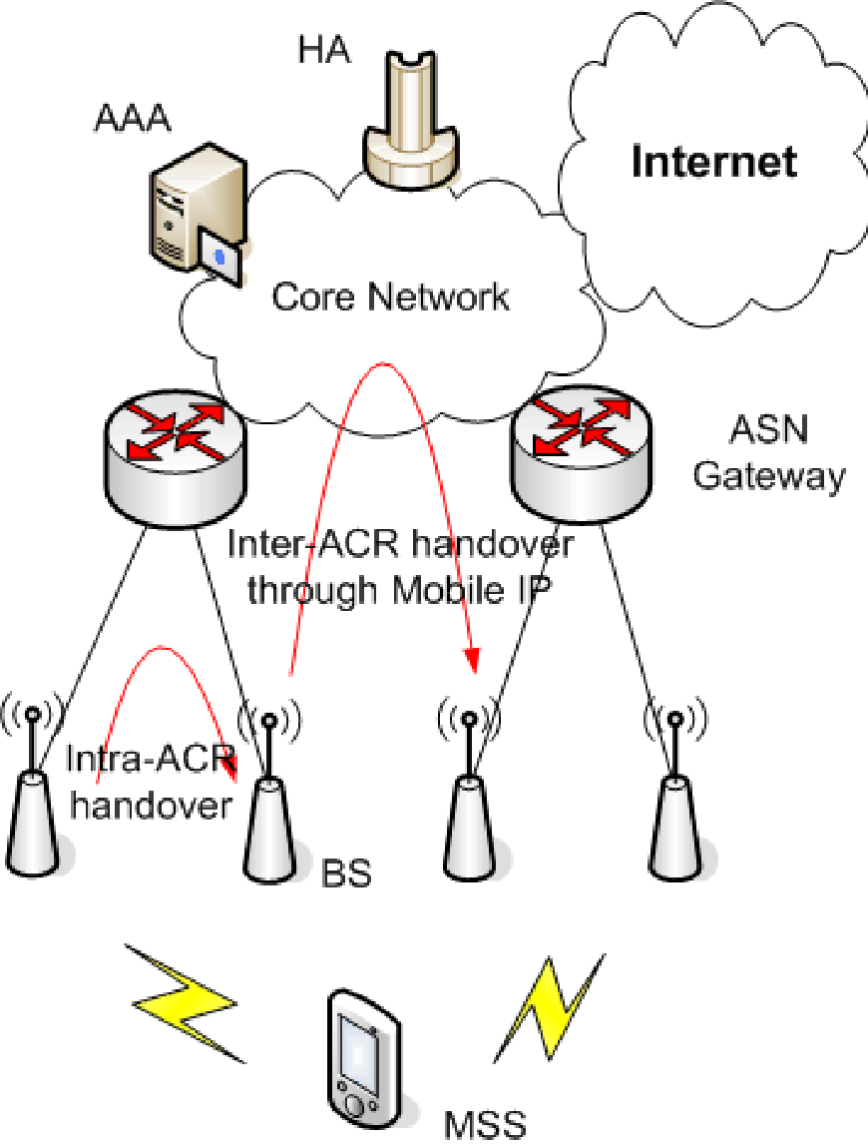

**Fig. 2 Network Architecture of Mobile WiMAX**

**PROPOSED ALGORITHM**

Efficiency and the Integrity are always the major requirements for any network and when we talk about wireless networks the problem is more critical. We are proposing one of such a target cell selection scheme in case of handover in the wimax network. The proposed handover scheme will evaluate the maximum effective capacity and the idle capacity of the base station for any point of time in the network. Then the triggering will be performed based on some decision factor. Base station having the most effective capacity will be elected for the next base station after handover. The proposed system will provide a reliable and energy efficient hand over. The steps involved in the algorithm are given here

1. Let the communication is being performed between 2 nodes present in coverage area of two different base stations or they can be in same base station called Node i and Node j
2. During the data transmission Node i start moving to some indefinite direction.
3. As it moves there can be the requirement of hand over. Now the following steps are performed.

Find the capacity of each base station. For this we need to calculate the number of OFDM(Orthogonal Frequency Division Multiplexing) symbols and the overhead symbols in WiMAX and Wifi Networks MAC frame.

Algorithm

1. Define a network with N nodes over the network with sensing range and other parameters
2. Define the base station for Wimax and Wifi under the frequency range and capacity
3. Perform the mobile communication for particular Node N1
4. If (Distance(BS,N1)>Range)
5. {
6. Print “Handoff required”
7. The periodic estimation of member nodes by the base station.
8. Find all the base stations that are having the particular node in Range. Let b1 is wimax base station and b2 is wifi base station that set for eligibility
9. If(RSS(b1)> RSS(b2) and Throughput (b1)>throughput(b2))
10. {
11. If(Coverage(b1,N1)=true)
12. {
13. Set wimax as the handover base station
14. }
15. Else
16. {
17. Set wifi as the handover base station
18. }
19. }
20. Else
21. {
22. If(Coverage(b2,N1)=true)
23. {
24. Set wifi as the handover base station
25. }
26. Else
27. {
28. Set wimax as the handover base station
29. }
30. }

**MATLAB TOOL**

1. MATLAB Editor is used for writing the code to implement our algorithm.
2. The result will be shown in the command window of MATLAB.

AN OVERVIEW OF MATLAB ENVIRONMENT

MATLAB is a high-level language and interactive environment that enables you to perform computationally intensive tasks faster than with traditional programming languages such as C, C++, and Fortran. [Matlab Toolbox]

1. [Introduction and Key Features](http://www.mathworks.com/products/matlab/description1.html)
2. [Developing Algorithms and Applications](http://www.mathworks.com/products/matlab/description2.html)
3. [Analyzing and Accessing Data](http://www.mathworks.com/products/matlab/description3.html)
4. Visualizing Data
5. [Performing Numeric Computation](http://www.mathworks.com/products/matlab/description5.html)
6. [Publishing Results and Deploying Applications](http://www.mathworks.com/products/matlab/description6.html)

MATLABis a high-level technical computing language and interactive environment for algorithm development, data visualization, data analysis, and numeric computation. Using the MATLAB product, you can solve technical computing problems faster than with traditional programming languages, such as C, C++, and Fortran.

**References**

1. Seyed Vahid Azhari,” The Bandwidth Deficit Problem in Loosely Coupled WLAN-to-Cellular Vertical Handover”, IWCMC’07 978-1-59593-695-0/07/0008
2. R. Good,” A Multilayered Hybrid Architecture to Support Vertical Handover between IEEE802.11 and UMTS”, IWCMC’06, 1-59593-306-9/06/0007
3. Gracieth Valenzuela,” Vertical Handover Decision Based on Quality of Experience in Heterogeneous Wireless Networks”.
4. Johann Márquez-Barja, Carlos T. Calafate, Juan-Carlos Cano and Pietro Manzoni, "Vertical Handover When context Matter".
5. Gracieth Valenzuela, Isac Ferreira, Paulo Cunha," Vertical Handover Decision Based on Quality of experience in Heterogeneous Wireless Networks".
6. M. Ghaleb and N. A. Abbasi, "A comprehensive review on vertical handover decision algorithms in heterogeneous wireless networks," Journal of Network and Computer Applications, vol. 35, no. 3, pp. 877-892, 2012.
7. M. Ghaleb and N. A. Abbasi, "A comprehensive review on vertical handover decision algorithms in heterogeneous wireless networks," Journal of Network and Computer Applications, vol. 35, no. 3, pp. 877-892, 2012.
8. K. Al Agha, O. Ait Mohamed, and A. Guitton, "Performance evaluation of vertical handoff decision algorithms for next generation wireless networks," in Proceedings of the International Conference on Wireless and Mobile Computing, Networking and Communications (WiMob), 2014.
9. S. Taha, A. Ahmed, and M. H. Rehmani, "A survey of vertical handover decision algorithms in heterogeneous wireless networks," IEEE Access, vol. 7, pp. 114223-114249, 2019.
10. H. S. Al-Raweshidy, J. Bigham, and B. D. Rathke, "Vertical handover in heterogeneous wireless networks," Wiley Encyclopedia of Telecommunications, 2003.
11. Zhiwei Yan,” An Adaptive Multi-criteria Vertical Handover Framework for Heterogeneous Networks”, 978-1-60558-089-0
12. Pravin Pawar,” Context-Aware Middleware Architecture for Vertical HandoverSupport to Multi-homed Nomadic Mobile Services”, SAC’08, 978-1-59593-753-/08/0003
13. Tae-sub Kim,” Vertical Handover between LTE and Wireless LAN Systems based on Common Resource Management (CRRM) and Generic Link Layer (GLL)”, ICIS 2009 978-1-60558-710-3/09/11
14. Johann Márquez-Barja,” Vertical Handover: When the Context Matters”, PM2HW2N’12 978-1-4503-1626-2/12/10
15. Zhiwei Yan,” A Dual Threshold-based Fast Vertical Handover Scheme with Authentication Support”.