**A STUDY ON CUSTOMERS SERVICE EFFICIENCY THROUGH**

**E-BANKING AT TNSC BANK.**

**ASHOK M1, Mrs. R. RAAJALAKSHMI 2 Assistant Professor,**

Department of Management Studies, VELS Institute of Science, Technology & Advanced Studies (VISTAS), Chennai.

**Abstract:** This study delves into the realm of customer service efficiency in the banking sector, particularly focusing on the role of e-banking. With the proliferation of digital technologies, e-banking has emerged as a pivotal tool in revolutionizing customer service delivery. Through an extensive analysis of existing literature, this research investigates various facets of e-banking, including its impact on customer satisfaction, convenience, and overall service efficiency. Employing both qualitative and quantitative methodologies, the study seeks to explore the perceptions and experiences of customers regarding e-banking services. Additionally, it examines the challenges and opportunities associated with the adoption and implementation of e-banking solutions. The findings of this study aim to provide valuable insights for banking institutions to enhance their customer service strategies and optimize the utilization of e-banking platforms to meet the evolving needs and expectations of customers in the digital era.

**INTRODUCTION:**

History in making with striking simplicity, the birth, and evolution of banking has many untold stories. It is narrative fascinating that banking introduced in the 14th century in the cities of Italy and the bank of England was the first to begin the permanent issue of banknotes in 1695. Banking is a financial institution and more about elaborative statics and technical jargon where individuals, ideas and ideologies move hand in hand and are highly regimented.

In today’s progressive world, the banking sector has become the backbone of every economy worldwide just like blood is to the veins and unique because of its formation, staffing and extraordinary services rendered by the industry. Banking sector works in the best interest of the country and due to their contribution in the financial stability, banking is highly regulated in most of the countries.

When the banking industry was born the primary job of banks was to mobilize money from individuals and lend most of the money to the companies. Of course, the major chunk was allocated to so-called priority sector of farming in most parts of the world and small-scale industries. But later the trend of lazy banking changed and scope of dynamism increased.

The biggest strength of an entity is the steadiness and banking sector has consistently performed better than others around the world over a few decades. Every company’s growth rate is determined by the industry it is in, and banking is a kind of industry where almost every company growth rate is compounded annually in deposits, advances, net interest income, and net profit margins. In the banking sector, the growth rate of every company is much higher as compared to other industries and in the remarkable history of banking, many companies have outperformed.

**REVIEW OF LITERATURE:**

**Ms. Fozia (2023)** The purpose of this paper is to determine this paper is to determine the customer's perception towards the e-banking services. A total of number of customer taken for the study is 196. Analysis of variance technique is employed to study the significant relationship between the occupation and customer perception of e-banking services and significant relationship between age and customer perception of e-banking services. The result of the study clearly shows that different age group of customer and different occupation group of customers have different perception towards the E-banking services. The result also propose that demographic factors impact significantly internet banking behavior, occupation and age. Finally, this paper suggests that an understanding the customer's perception regarding the e-banking services of public and private banks it will help to the banker to understand the customers need in better way.

**Jayshree Chavan (2023)** In his research paper "Internet Banking- Benefits and challenges in an Emerging Economy". This study New Information technology has taken imperative place in the future expansion of financial services, especially banking sector conversion are affected more than any other financial provider groups. Increased use of mobile services and use of internet as a new division channel for banking transactions and international trading requires more concentration towards e-banking security against deceptive activities. The development and the increasing progress that is being experienced in the Information and Communication Technology have brought about a lot of changes in almost all facets of life. In the Banking Industry, it has been in the form of online banking, which is now replacing the traditional banking practice. Online banking has a lot of benefits which add value to customers satisfaction in terms of better quality of service offerings and at the same time enable the banks gain more competitive gain over other competitors. This paper discusses some challenges in an economy.

**Muhammad s. Alnsour & Al-Hyari (2022)** In their research paper "Internet banking and Jordanian corporate customers: issues of security and trust". This paper research on the reception behavior of technology is sizeable. Yet it is relatively assorted and fragmented in the context of developing economies like Jordan. The paper tries to offer insights about two critical factors in acceptance behavior of Jordanian customers. namely, security and trust.

**Sudhakar A. M., Suryanarayana, (2022)** "Emerging mobile banking scenario and its adoption in India: a study", With broadband communication technological developments and mobile phones penetration (481 million by June 2009) into common have triggered major thrust in the Banking service sector of India. With Mobile Bankinga revolutionary approach to banking transactions has created a strong connectivity between customers and the banks as both will transact with minimum cost and in minimum time. It is a timely and its cost- effective services can deliver mobile money to non-banked poor people and will induce economic growth of the country. This article discusses the status of Mobile Banking in India and other countries with emphasis on data security and standards and its implication on

**Objectives of the study:**

#### Primary Objectives

To evaluate the effectiveness of customer service offered through E-banking platforms.

#### Secondary Objectives

* To evaluate the efficiency of customer service provided through E-banking.
* To analyze customer satisfaction levels regarding E-banking services.
* To identify areas for improvement in E-banking customer service.
* To explore the impact of customer service quality on customer loyalty in the E-banking sector.

**Scope of the study:**

* Examine customer satisfaction levels with the quality and responsiveness of e-banking support services.
* Assess the usability and accessibility of e-banking interfaces and self-service features from a customer service perspective.
* Investigate the resolution time and efficiency of handling customer queries and issues through e-banking channels.
* Identify the impact of e-banking customer service on overall customer loyalty and retention.
* Explore the integration of AI-powered chatbots and virtual assistants in enhancing e- banking customer service experiences.

**RESEARCH METHODOLOGY**

Fundamental to the success of any formal marketing research project is a sound research design. A good research design has the characteristics of problem definition, specific methods of data collection and analysis, time required for research project and estimate of expenses to be incurred. The function of a research design is to ensure that the require data are collected accurately and economically. A research design is purely and simply the framework or plan for an analysis of data. It is a blue print that is followed in completing a study. It resembles the architect`s blue-print (map) for constructing a house. It may be worthwhile to mention here that a research design is nothing more than the framework for the study ensures that the study will be relevant to the problem and the study will employ economical procedures. Claire seltizetal defines Research Design as “Research design is a catalogue of the phases and facts relating to the formulation of a research effort. It is the arrangement of collection and analysis of data in a manner that aims to combine relevant to the research purpose with economy in procedure”. Three important about research design are 1. The design of investigation should stem from the problem 2. Whether the designs are productive in a given problem setting depends on how imaginatively they are applied. An understanding of the basic design is needed so that they can be modified to suit specific purpose 3. The three basic designs are as follows i. Exploratory Research design ii. Descriptive Research design iii. Casual Research design The Research design used in the study is descriptive research design.

**RESEARCH DESIGN:**

The present study was undertaken customer service provided through E-banking.

* I have used SPSS
* I will choose this research design because the main goal of the research design is to describe the data & features what being studied. Descriptive research design is a fact finding investigation with adequate interpretation. It focuses on

|  |  |  |
| --- | --- | --- |
| **Education** | **Frequency** | **Percent** |
| **Graduate** | 30 | 29.4 |
| **Post Graduate** | 38 | 37.3 |
| **Diploma** | 25 | 23.5 |
| **Others** | 10 | 9.8 |
| **Total** | 103 | 100 |

* particular aspect or dimension of the problem studied. It is designed to gather descriptive information.

## **QUESTIONNAIRE STRUCTURE**

Questionnaire was divided into two sections. First part designed to know the general information of the customers and the second part contains the impact and usage of customers on e-banking.

**DATA ANALYSIS & INTREPRETATION:**

## Respondants based on Gender

|  |  |  |
| --- | --- | --- |
| **Gender** | **Frequency** | **Percent** |
| **Female** | 26 | 25.2 |
| **Male** | 77 | 74.8 |
| **Total** | 103 | 100 |

**Respondants based on Gender**

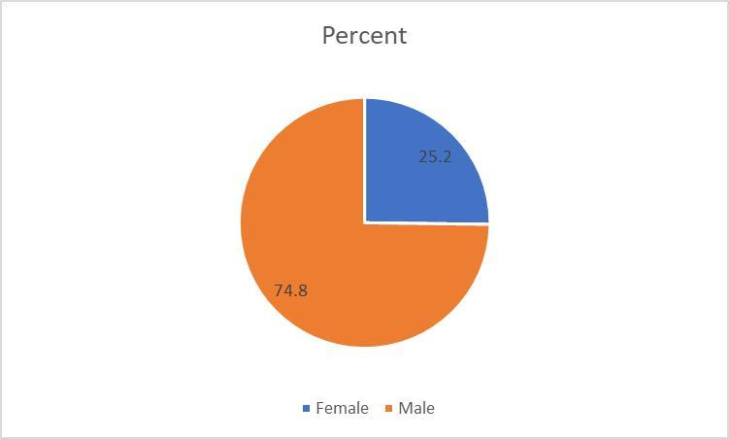

**Interpretation:**

The above table shows that there are 74.8% of respondents male.252% of respondents are female. therefore there are more number of responds male 74.8%.

## **Showing Education**

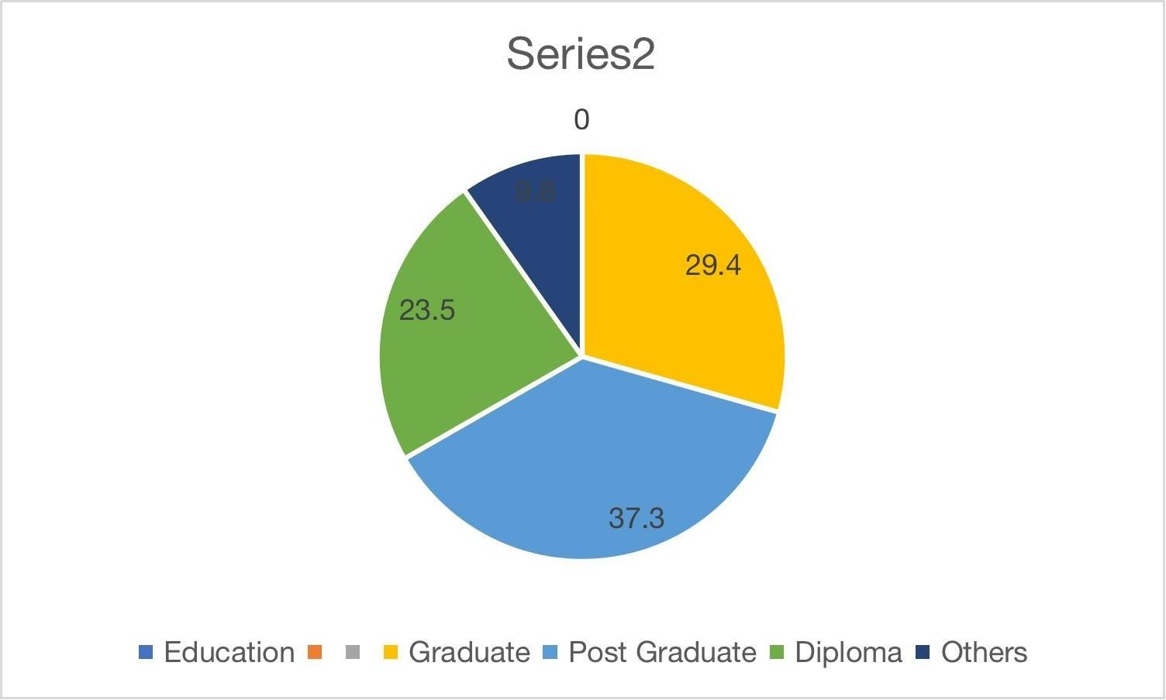**Respondants based on Education**

**Interpretation:**

The data outlines the educational distribution within a group of 103 individuals, revealing that 29.4% hold Graduate degrees, 37.3% have Post Graduate qualifications, and 23.5% possess Diplomas. Additionally, 9.8% of the group falls into the "Others" category.

## **Respondants based on Occupation**

|  |  |  |
| --- | --- | --- |
| **Occupation** | **Frequency** | **Percent** |
| **Govt employee** | 26 | 25.7 |
| **Business** | 28 | 27.7 |
| **Former** | 19 | 18.8 |
| **Others** | 30 | 27.7 |
| **Total** | 103 | 100 |

**Respondants based on Occupation**

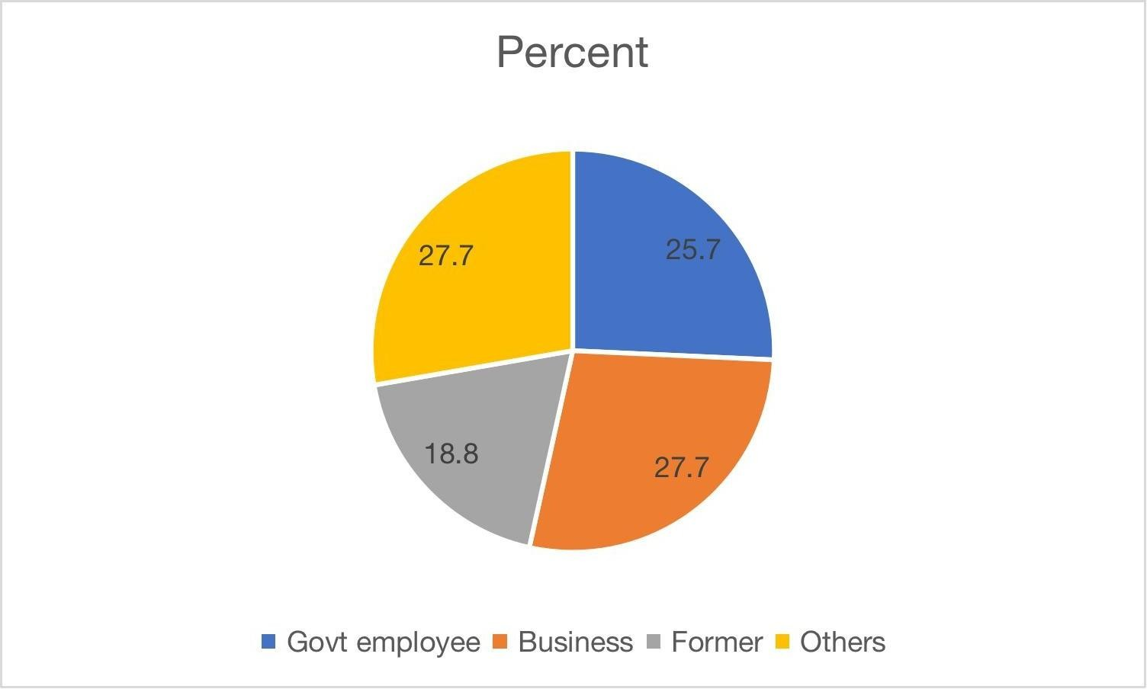

**Interpretation:**

The data shows what kinds of jobs 103 people have. Nearly a quarter of them, 27.7%, work in business, while a similar number, 25.7%, are government employees.About 19 people, or 18.8%, used to have different jobs. Another 27.7% are in various other occupations. This data gives us a glimpse into the different types of work people are doing in this group.

**FINDINGS:**

* As per the survey. Most of the people are using e-banking services for time saving and transaction and Viewing statement of accounts.
* In Chennai area, most of the customers are using internet and aware about the e- banking services
* Customers are satisfied with the e-banking because the all the transaction will be fast & cheap. And also, time is saving.
* All the people are not well educated so they cannot easily trust towards e- banking facility because they have lack of information and confuse how to the use E-banking services.
* More businessmen prefer ATM facility for their daily transaction because they can withdraw the money at any place or anywhere

**SUGGESTION**:

1. Arrange the meeting for customer to defecate and to meet their expectation so that they can satisfy with services.
2. Employee should note the problems which are faced by the customer, So they can easily help the customers
3. To encourage customer that e-banking is totally safe precautionary like protect your password from other.
4. To provide more training to the employee and customer about the handling of the e- banking procedures.

**CONCLUSION:**

* I had great experience to work on this project and learned a lot in this time of project. The study identified the main objectives of the code and conduct and e-banking for customer. Research is also draw an important conclusion from research that customer are interested in E- banking. And according my opinion that you have some awareness about the E-banking