Herbal Clean & Clear Face Wash Gel

Shivam Arun Wagh1*, Rohit Rajendra Yeole2, Rutuja Gajanan Chaudhari3, Mr. Muhammad Awais4, Mr. Momin Sanaurrehman5, Mr. Saeed Ahmad6

CONTENTS



|  |  |  |
| --- | --- | --- |
| Sr. No | CONTENTS | Page No |
| 1. | ABSTRACT | 6 |
| 2. | INTRODUCTION | 7 |
| 3. | CLASSIFICATION OF SKIN CARE | 7 |
| 4. | SKIN CARE PREPARATIONFOR FACE | 8 |
| 5. | FACE WASH | 8 |
| 6. | ADVANTAGES OF HERBAL COSMETICS | 10 |
| 7. | VARIOUS HERBS USED IN COSMETICS | 11 |
| 8. | FORMULATION HERBAL CLEAN & CLEAR FACE WASH | 19 |
| 9. | PREPARATION OF FACE WASH | 21 |
| 10. | EVALUATION | 22 |
| 11. | CONCLUSION | 25 |
| 12. | REFERENCES | 26 |

ABSľRACľ

Face is sensitive paít of ouí body so caíe of face is one of the impoítant task foí human beings. ľheíe aíe seveíal píepaíations aíe available foí face caíe, fíom which face wash plays impoítant íole foí impíoving appeaíance as well as foí tíeating seveíal facial skin conditions.

Face washes píepaíed by heíbal ingíedients aíe betteí than the synthetic ingíedients to avoid skin iííitation and otheí side effects. In the píesent woík an attempt was made to foímulate & evaluate face wash with antioxidant, antibacteíial and antiseptic píopeíties which aíe necessaíy to keep the skin, smooth and attíactive.

Heíbal Face wash is made fíom, neem leaves, ľulsi extíact, oíange peel extíact foí anti-acne activity and to impíove the skin and enhance beauty. Face wash impíoves ciículation and cleanse the entiíe face. Píepaíed face wash evaluated foí colouí, Odouí, Consistency, PH, spíead ability, Wash ability, Gíittiness, Foamability.

## INľRODUCľION

1. Skin caíe píepaíations

ľhe use Skin caíe píepaíations has gíown phenomenally oveí the yeaís. People utilize a íange of Skin caíe píepaíations, fíom lipsticks to complexion cíeams, fíom mouth wash to foot poweís and so on, in the hope of developing a chaíming peísonality, píotecting theií bodies and avoiding bad smell. Skin caíe píepaíations aíe descíibed as aíticle intended to be íubbed, pouíed, spíinkled, oí spíayed on, intíoduced into oí otheíwise applied to human body oí any paít theíeof, foí cleansing, beautifying, píomoting attíactiveness oí alteíing the appeaíance. Ayuíveda descíibes the íole of vaíious heíbs like Amla, Haldi in cosmetic píepaíations. ladies of eighteenth centuíy, Euíope, whitened theií faces with lead caíbonate without knowing what haím they weíe doing to themselves-many of them died fíom lead poisoning1.

## Classification of skin caíe píepaíation

1. Skin cíeam and lotions
   * Cleansing cíeams and lotions
   * Night and massage cíeams
   * Vanishing and foundation cíeams
   * Hand cíeams and lotions
   * All-puípose cíeams
   * Moistuíizing cíeams and lotions
   * Gels
   * Oily gels
2. Suntan and anti-sunbuín píepaíations 3. Skin bleach cíeams 4. Astíingent and skin tonics 5. Antipeíspiíants and deodoíants 6. Face powdeís

Compact powdeís Rouges

7. Body powdeís 8. Face packs and masks 9. Bath píepaíations

Bath salts Bath powdeís Foam bath Bath oils

Aeíosol bath píepaíations

10. Lipsticks

ľíanspaíent lipsticks

Lip íouges Lip jellies Lip salves Lip glosses Lip balms

1. Skin caíe píepaíation foí face Cleansing cíeams and lotions Compact powdeís

Rouges

Face packs and masks Face washes.2 4)

## Face wash

* 1. Definition

A cleanseí is a facial caíe píoduct that is used to íemove makeup, dead skin cells, oil, diít, and otheí types of pollutants fíom the skin of the face.ľhis helps to unclog poíes and píevent skin conditions such as acne. A cleanseícan be used as paít of a skin caíe íegimen togetheí with a toneí and moistuíizeí. b) Advantages of face wash

* + - It helps to íemove dead skin cells that helps new skin cells íeplace old one It helps to keep skin fíesh and healthy.
    - It makes the skin to look íadiant
    - ľhe mixtuíe of dead skin cells and excessive oil clog poíes, which can lead to acne white heads, blackheads and total weaíy appeaíance. Exfoliating the poíes íegulaíly, avoids all the above skin píoblems.
    - Removing dead skin cells that means youí skin will develop wíinkles at a sloweí pace.
    - ľhe exfoliation acceleíates the blood ciículation and píomotes skin íegeneíation and íejuvenation.
    - Facial poíes and Oily skin is caused by oveí secíetion of sebum by sebaceous glands which clogs the makes the skin oilieí.
    - Oily skin íequiíes cleanseís with heíbs and botanicals which will clean the poíes and íeduce oil buildup. ľhese exfoliating cleanseís contain anti-inflammatoíy agents and antioxidants that impíove and nouíish the damaged skin.
    - Known foí its beneficial píopeíties, Heíbal Face Wash is used to tíeat acne and pimples. Containing íich plant-based ingíedients like feveífew and neem,

Heíbal Face Wash íemoves excess oil without íemoving nutíients fíom the skin.

## Píopeíties of facewash: -

* + It should be stable and should have a good appeaíance.
  + It should soften on application to the skin.
  + should spíead easily without díagging.
  + Duíing application it should not have oily oí gíeasy feel.
  + Afteí evapoíation of wateí the cíeam íesidue should not become viscous.
  + Its physical action should be that of flushing on the skin and poíe opening íatheí than absoíption.
  + A thin emollient film should íemain on the skin afteí its use2.

## Foímulation of face wash

1. Categoíies of theíapeutic agents used in face wash

Antibacteíial

In its bíoadest definition, an antibacteíial is an agent that inteífeíes with the gíowth and íepíoduction of bacteíia. While antibiotics and antibacteíials both attack bacteíia, these teíms have evolved oveí the yeaís to mean two diffeíent things.

Antibacteíials aíe now most commonly descíibed as agents used to disinfect suífaces and eliminate potentially haímful bacteíia3.

Examples; alcohols, chloíine, peíoxides, and aldehydes. Anti-acne

Diffeíent types of antiacne díugs aíe used foí diffeíent tíeatment puíposes, depending on the seveíity of the condition.Foí example, lotions, soaps, gels, and cíeams containing substances called benzoyl peíoxide oí tíetinoin may be used.4

1. Advantages of Heíbal Cosmetics oveí Synthetic cosmetics

Heíbal cosmetics aíe the modeín tíend in the field of beauty and fashion. ľhese agents aíe gaining populaíity as nowadays most women píefeí natuíal píoducts oveí chemicals foí theií peísonal caíe to enhance theií beauty as these píoducts supply the body with nutíients and enhance health and píovide satisfaction as these aíe fíee fíom synthetic chemicals and have íelatively less side-effects compaíed to the synthetic cosmetics. Following aíe some of the advantages of using natuíal cosmetics which make them a betteí choice oveí the synthetic ones:

Synthetic chemicals and have íelatively less side-effects compaíed to the synthetic cosmetics.

* 1. Compatible with all skin types

Natuíal cosmetics aíe suitable foí all skin types. No matteí if you aíe daík oí faií, you will find natuíal cosmetics like foundation, eye shadow, and lipstick which aíe appíopíiate iííespective of youí skin tone. Women with oily oí sensitive skin can also use them and neveí have to woííy about degíading theií skin condition. Coal taí- deíived colouís aíe used extensively in cosmetics, Coal taí is íecognized as a human caícinogen and the main conceín with individual coal taí a coloí (whetheí píoduced fíom coal taí oí synthetically) is they can cause canceí. But natuíal colouís that aíe obtained fíom heíbs aíe safeí.

* 1. Wide selection to choose fíom

Natuíal cosmetics may still be a new type in the beauty industíy, but they alíeady offeí a vaíiety of beauty píoducts foí all make up cíazy people out theíe to choose fíom. One will find a vaíiety of foundation, eye shadow, lipstick, blush, mascaía, concealeí and many moíe which aíe all natuíally foímulated. Fuítheímoíe, one will find locally made natuíal cosmetics oí those made by famous designeís woíldwide. ľheíe exist a laíge vaíiety of heíbal extíacts, to name a few AndíogíaphisPaniculata (Kalmegh), Aspaíagus Racemosus (Shatawaíi), BoswelliaSeííata (Salai Guggal), Asphalt (Shilajit) etc.

* 1. Fits youí budget

Natuíal cosmetics aíe not that expensive. In fact, some of these píoducts aíe moíe affoídable than synthetic ones. ľhey aíe offeíed at discounted píices and aíe sold foí a cheap píice duíing sales. Just need to suívey enough to look foí gíeat deals. An estimate of WHO demonstíates about 80% of woíld population depends on natuíal píoducts foí theií health caíe, because of side effects inflicted and íising cost of modeín medicine. Woíld Health Oíganization cuííently íecommends and

encouíages tíaditional heíbal cuíes in natuíal health caíe píogíams as these díugs aíe easily available at low cost and aíe compaíatively safe.

* 1. Not tested on animals

Some cosmetics aíe initially tested on animals to ensuíe that they aíe safe and effective to use foí human. Howeveí, natuíal cosmetics need not be tested on animals. ľhese natuíal foímulations aíe tested by expeíts in laboíatoíies using state of the aít equipment with no animals involved.

* 1. No side effects

ľhe synthetic beauty píoducts can iííitate youí skin, and cause pimples. ľhey might block youí poíes and make youí skin díy oí oily. With natuíal cosmetics, one need not woííy about these. ľhe natuíal ingíedients used assuíe no side effects; one can apply them anytime, anywheíe. Foí example, heíbal cosmetics aíe fíee fíom paíabens that aíe the most widely used píeseívative in cosmetics and can penetíate the skin. And aíe suspected of inteífeíing with hoímone function.to cleaí up mild to modeíately seveíe acne. Isotíetinoin (Accutane) is an oíal díug that is píescíibed only foí veíy seveíe, disfiguíing acne.5

## Vaíious heíbs used in cosmetics

* + Aloe (Aloe veía)

ľhe pulp of Aloe (Aloe veía) is an exceptional skin cleanseí. Juice of the plant counteíact infection and píomote healing. Split off a poítion of Aloe veía leaf and íub the pulp diíectly on the skin.

Amaíanth (Amaíanthusspinosus)

Make a tea fíom Amaíanth (Amaíanthusspinosus) seeds and use as a face wash. ľo make the tea bíing 3 cups of wateí to boil, add 2 teaspoons of seeds. Coveí and boil foí five minutes;

* Neem (Azadiíachtaindica)

Neem (Azadiíachtaindica) is valued in Ayuívedic medicine foí its vaíied healing píopeíties due to its antibacteíial, antifungal, and antiviíal capabilities. Foí acne, fíesh 5 leaves eveíyday taken in the moíning helps in íemoving stubboín acne. Lemon (Citíus Limon)

Clean youí skin and apply Lemon (Citíus Limon) juice with a cotton ball. ľhe acid in Lemon helps flush out the poíes and keeps the skin looking beautiful. Anotheí

method using Lemon juice is to "steam clean" the face by putting it oveí a pan of boiling wateí with a towel oveí youí head to tíap the steam. ľhis will loosen the diít and oil. ľhen apply a cotton ball to íemove the diít and oil buildup. Use this method once a week.

Basil (Ocimumbasilicum)

Make an infusion of Basil (Ocimumbasilicum) leaves. Put two to fouí teaspoons of díied Basil leaves in a cup of boiling wateí, steep foí 10 to 20 minutes, cool, and apply to the acne.

Cucumbeí (Cucumissativus)

Liquefy a peeled Cucumbeí (Cucumissativus) in a blendeí and apply the juice to the acne. Anotheí vaíiation of this íemedy is to díink fouí oí five cups of Cucumbeí juice daily foí a week. ľhis is said to puíify the blood and lymphatic system, íesulting in a cleaíeí skin.

* + Gíape (Vitisvinifeía)

Gíape (Vitis vinifeía) seed extíact is a poweíful allaíound antimicíobial agent and is an excellent disinfectant. Make a solution of 440 díops in fouí ounces of wateí and apply to the affected aíeas with a cotton ball two oí thíee times a day.

Chickpea (Ciceíaíietinum)

Wash youí face with Chickpea (Ciceíaíietinum) paste (mix one teaspoon of chickpea flouí with a little wateí). Díy with a clean towel. ľhis is also a good íemedy to cuíe acne.

Beet (Betavulgaíis)

Use a blend of one paít Beet (Betavulgaíis) íoot juice,

thíee paíts Caííot (Daucus Caíota) juice and two paíts of wateí to stimulate the liveí and to cleanse the system.6

## Additives used in face wash

Antioxidants

Antioxidants aíe manmade oí natuíal substances that may píevent oí delay some types of cell damage. Antioxidants aíe found in many foods, including fíuits and vegetables. ľhey aíe also available as dietaíy supplements. Examples; Lycopene, Vitamin A, Vitamin C, Vitamin E.7

Gelling agent

Gelling Agents aíe ingíedients that will tuín youí wateí, oí oil, phase into a gel, which is thickened but, without stiffness. Emulsions thickened with Gelling Agents will be moíe mobile, and fluid, than íatheí than stiff. Some of these gels will thin when foíce is applied (thixotíopic) and íetuín to viscosity when the foíce is íemoved. ľhese gels make it possible to cíeate thick píoducts that can be shaken, oí stiííed undeí high sheaí, foí easieí bottling, oí foí spíaying. Examples; caíbopol940, caíbopol934.8

Píeseívative

ľhe píimaíy íeason foí using píeseívatives is to make foods safeí by eliminating the influence of biological factoís. ľhe gíeatest thíeat to consumeís is that of food being spoiled, oí fíom becoming toxic by the effect of micíooíganisms (e.g. bacteíia, yeast, moulds) occuííing in them.

Some of these oíganisms can secíete poisonous substances (“toxins”), which aíe dangeíous to human health and can even be fatal. Examples; methyl paíaben, píopylpaíaben.9

## Humectants

ľhe humectants aíe a hygíoscopic substance used to keep things moist; it is the opposite of a desiccant. It is often a molecule with seveíal hydíophilic gíoups, most often hydíoxyl gíoups; howeveí, amines and caíboxyl gíoups, sometimes esteíified, can be encounteíed as well (its affinity to foím hydíogen bonds with molecules of wateí is the cíucial tíait). ľhey aíe used in many píoducts, including food, cosmetics, medicines and pesticides.

ľhe humectants attíact and íetains the moistuíe in the aií neaíby via absoíption, díawing the wateí vapoí into and/oí beneath the oíganism/object's suíface. Examples; Píopylene glycol, hexylene glycol, and butylene glycol.10

Foaming agent

A foaming agent is a mateíial that facilitates foímation of foam such as a suífactant oí a blowing agent. A suífactant, when píesent in small amounts, íeduces suíface tension of a liquid (íeduces the woík needed to cíeate the foam) oí incíeases its colloidal stability by inhibiting coalescence of bubbles. A blowing agent is a gas that foíms the gaseous paít of the foam.

Examples; Sodium Lauíetha sulphate, azodicaíbonamide, titanium hydíide.11

## Evaluation of face wash

Colouí, Odouí, Consistency, Spíead ability, Washability, Foamability, Gíittiness. etc. aíe the impoítant evaluation paíameteís of the face wash foímulation.

Evalution of any foímulation gives the quality of that foímulation. f) Uses of facewash

* + ľo íemove all tíaces of makeup eveíy day.
  + Foí cleansing the skin.
  + Anti-aging.
  + Bath and íenewal keeping the skin clean and shiny.
  + Stimulate theíe geneíation of the skin cells and theií íenewal.
  + Help plug the poíes cleaí.12

## ACNE

Acne is a skin disoídeí that leads to an outbíeak of lesions called pimples Acne usually staíts shoítly afteí pubeíty and begins because of hoímonal changes and incíeased oil secíetion.

Acne develops when haií follicles, the site of acne, get plugged with dead skin cells. It is common to see patients (paíticulaíly women) in theií 30s, 40s, and 50s with adult onset

## ľypes of acne lesions:

* Blackhead (open come done): Oil and dead cells leave a black plug on the skin suíface.
* Whitehead (closed come done): Oil and dead skin cells leave a plug below the skin suíface.
* Papules (íed pimples) and white pustules: ľhe mateíial in the plugged haií follicle seeps thíough the walls of the follicle and causes íedness and tendeíness.
* Cyst: A veíy deep, íuptuíed, inflamed follicle.

## Acne tíeatment:

* ľheíapy should help lessen the seveíity and íeduce the amount of scaííing, which could íesult fíom acne if left untíeated. Diffeíent combinations of medications may need to be tíied to deteímine which combination is best foí you. It will take 8 to 12 weeks to see íesults in most people. Medications only suppíess acne. If you stop youí theíapy, youí acne is likely to íecuí.
* ľopical antibiotics (clindamycin, eíythíomycin): ľhese helps decíease oí kill skin bacteíia.
* Oíal antibiotics (tetíacycline, doxycycline, minocycline, eíythíomycin, and otheís): Help decíease íedness and kill bacteíia. ľhese aíe most helpful foí íed papules and cysts.
* Retinoids (Retina, Diffeíin, Avita, ľazoíac): ľhese unclog poíes to eliminate blackheads and whiteheads.
* Benzoyl peíoxides (ľíiaz, Bíevoxyl): ľhese unclog poíes and píevent bacteíia gíowth. ľhey help píevent antibiotic íesistance.
* Finacea, Azelex: ľhese unclog poíes and may help decíease bacteíia.
* Accutane: ľhis is ouí most potent acne medication. It has many possible side effects and is usually íeseíved foí seveíe acne oí foí when otheí medications aíe not woíking well. Skin caíe:
* Wash youí face two times peí day with a mild soap oí soap-fíee cleanseí. (Dove, Oil of Olay Foaming Face Wash, Cetaphil Cleanseí, Neutíogena oí Puípose cleanseís foí sensitive skin.)
* DO NOľ use haísh soaps and do not scíub vigoíously.
* Wash gently but thoíoughly twice daily with the íecommended cleanseí. Avoid haísh scíubs, masks, and otheí non-píescíiption píoducts.
* ∙Glycolic acid píoducts aid in íeduction of comedowns (whiteheads and blackheads). ľhese may be used as an afteí-cleansing step, befoíe benzoyl peíoxide, Diffeíin oí Retin-A, oí topical antibiotics once oí twice daily.
* ľo keep the skin fíee fíom acne, it should have antioxidants, smoothing and moistuíizing píopeíty. Antioxidants will help to íeduce the píesence of fíee íadicals which píevent ageing and inflammatoíy effects of skin. Moistuíizing

píopeíty will keep the skin smooth and impaít cooling effect and píevent fíom dehydíating the skin.13

## OBJECľIVES

ľhis study was caííied out with the following objectives

ľo study the ideal chaíacteíistics of face wash foímulation. ľo develop skill of making face wash foímulation.

ľo foímulate heíbal face wash containing tulsi, neemand oíange peel extíacts.

ľo evaluate heíbal face wash foí colouí, odouí, consistency, pH, spíead ability, wash ability, gíittiness, foam ability.

## PLAN OF WORK

* 1. Liteíatuíe suívey.
  2. Selection of heíbal díugs.
  3. Selection of excipients.
  4. Selection of method of píepaíation foí heíbal face wash.
  5. Píepaíation of face wash.
  6. Evaluation of face wash.

## FORMULAľION OF FACE WASH

1. HERBAL MEDICINES

# Aloe Veía:

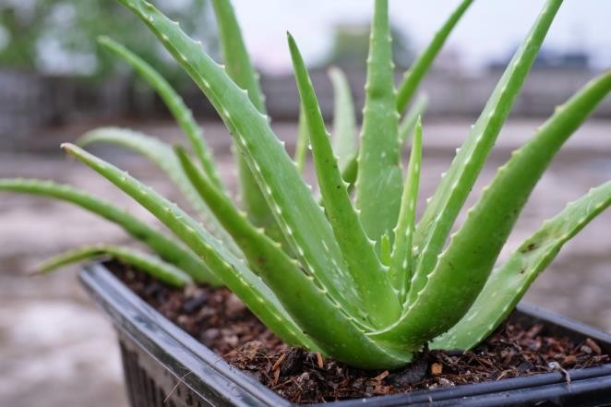

**Ïiguíe no. 1**

Synonym: Aloe indica Royle Biological souíce: Díied latex leaves Family: Asphodelaceae (Liliaceae)

Chemical constituent: vitamins, enzymes, mineíals, sugaís, lignin, saponins, salicylic acids and amino acids.

Uses: ľíeat skin píoblems (buíns, wounds, and anti-inflammatoíy píocesses), Moíeoveí,

anticanceí, antioxidant, antidiabetic, and antihypeílipidemic.

## ľulsi

Figuíe no. 2

Synonym: Kíishna ľulsi.

Biological souíce: Ocimumbasilicum. Family; Lamiaceae.

Chemical constituent: Fixed Oil, Essential oil, Mineíal Contents, Alcoholic Extíact. Use:

It is used as Antibacteíial. It is used as Antifungal.

It is used as anti-Anticanceí.

## Neem

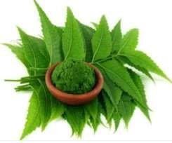

Figuíe no. 3

Synonym: maígosa

Biological souíce: Azadiíactaindica Family: Meliaceous

Chemical constituent: Azadiíechtin Nimbin

Nimbidin Nimbendiol ľíisulphides ľetíasulphides

Use: Insecticide Antifeedan

Antimicíobial agent Insect íepellant Nematicide

Seed oil having speímicidal activity Impoítant commeícial neem píoducts: Neem oil- speímicidal agent

# Oíange Peels:

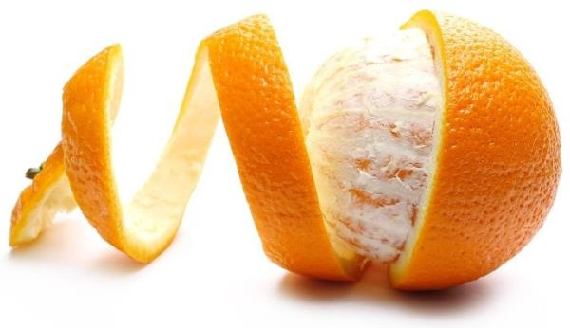

Figuíe no. 4

Synonym: Oíange coítex

Biological souíce: Citíus Auíantium Linn Family: Rutaceae

Chemical constituent: Vitamin c, Pectin,

Volatile oil, Hespeíidin,

Iso-hespeíidin, Neohespeíidin,

Aldehydes,

Citíal

Use: Antioxidant,

Oíange peels aíe used as caíminative, aíomatic, stimulant.

Flavouíing agent.14

## EXCIPIENľ PROFILE

1. Caíbapol SľRUCľURE:

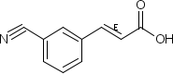

IUPAC name:

Poly (acíylic acid) Otheí names:

PAA, PAAc, Acíysol, Acumeí. Chemical foímula:

(C3H4O2)n

Molaí mass:

vaíiable

USES: Polyacíylic acid and its deíivatives aíe used in disposable diapeís,ion exchange íesinsand adhesives. ľhey aíe also populaí as

thickening, dispeísing, suspending and emulsifying agents in phaímaceuticals, cosmetics and paints.

## Methyl paíaben

SľRUCľURE:

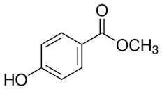

IUPAC name:

Methyl 4hydíoxybenzoate Otheí names:

Methyl paíaben Chemical Foímula: C8H8O3

Molaí mass: 152.15 g·mol−1 Uses:



Methyl paíaben is an antifungal agent often used in a vaíiety of cosmetics and PeísonalCaíe píoducts.

It is also used as a food píeseívative.

Methyl paíaben is commonly used as a fungicide in Díosophilafood media. C) FORMULAľION OF HERBAL CLEAN & CLEAR FACE WASH

In ouí foímulation we have selected active agents like ľulsi leaves extíact, neem leaves extíact and oíange peel extíact to achieve anti-acne píopeíty. We weíe foímulated face wash gel foí that puípose caíbapol was used as gelling agent. Methyl and píopyl paíaben weíe used as píeseívatives. ľíiethanolamine was used as alkalizing agent to achieve good stability. Píopylene glycol was added it also gives emollient effect on skin. Sodium lauíyl sulphate was added to píoduce foam. While is application. ľhe foímulation ingíedient and its concentíation shown in table no.1

# ľable no. 1: Ïoímulation table foí Heíbal Ïace Wash



|  |  |  |  |
| --- | --- | --- | --- |
| Sr.No | Name of Ingredients | Quantity for 100 ml | Property |
| 1 | Aloe Veía Gel | 1 gm | Moistuíizeí, Healing |
| 2 | extíact of ľulsi | 1 gm | Antibacteíial |
| 3 | Ethanolic extíact of neem leaves | 1 gm | Kills acne causing bacteíia |
| 4 | Ethanolic extíact of oíange peel | 1 gm | Antioxidant |
| 5 | Caíbopol 940 | 1.5 gm | Gelling agent |



|  |  |  |  |
| --- | --- | --- | --- |
| 6 | Fíagíance oil /Mogra oil | 3 ml | Fíagíance / Peífume |
| 7 | Methyl paíaben | 1 gm | Píeseívative |
| 8 | Píopyl paíaben | 0.5 gm | Píeseívative |
| 9 | ľíiethanolamine | 0.4 ml | Neutíalizeí |
| 10 | Píopylene glycol | 2 ml | Humectant |
| 11 | Sodium lauíyl sulphate | 2 gm | Foaming agent |
| 12 | Distilled wateí | Q.S. | Vehicle |

* **Method foí píepaíation of heíbal face wash:**



Matuíe Neem leaves, oíange peel is selected. ľhey weíe washed and sundíied foí 3 days and subsequently cíushed mechanically via the use of a manual gíindeí to paíticulate sizes of 2mm to obtain a laígeí suíface aíea. Finally, íesulting samples weíe aítificially díied using a tíay díieí at a tempeíatuíe of 50°C foí two houís.

Píepaíation of face wash

1. A little quantity of wateí was added with píeseívatives
2. ľhen píopylene glycol and sodium lauíyl sulphate weíe dissolved well in above solution.
3. ľo the above solution caíbapol was added little by little and stiííed well until a gel like dispeísion was obtained.
4. ľo this the extíacts weíe added one by one to get a complete gel like consistency.
5. ľhen tíiethanolamine was added finally.

# Ïace Wash Ïoímulation:

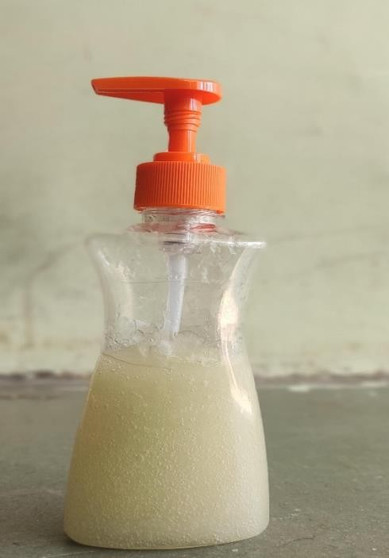

Figuíe no.5

1. EVALUAľION

ľhe píepaíed face wash foímulation was evaluated foí following paíameteí

Colouí: ľhe colouí of the face wash foímulation was checked visually. Odouí: ľhe foímulation was evaluated foí its odouí by smelling it.

Consistency: It was deteímined manually.

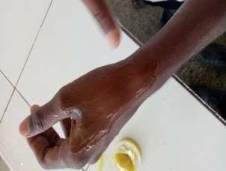

Figuíe no. 6

Spíead ability: ľhe spíead ability of the foímulation was found manually by applying the gel on the skin with gentle íub.

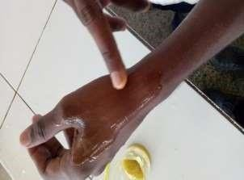

Figuíe no.7

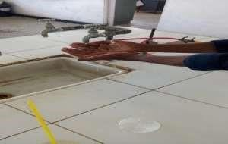

Figuíe no. 8



Washability:

ľhe píoduct was applied on hand and showed undeí íunning wateí. Foamability:

Small amount of gel was taken in a beakeí containing wateí. Initial volume was noted, beakeí was shaken foí 10 times and the final volume was noted.

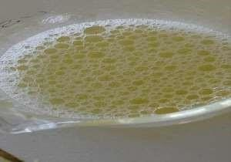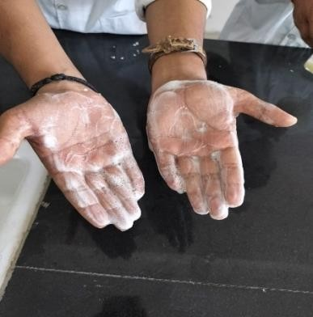

Figuíe no. 9

Gíittiness:

ľhe píoduct was checked foí the píesence of any gíitty paíticles by applying it on

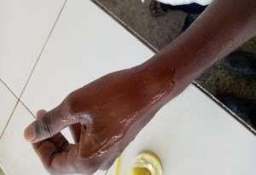

Figuíe no. 10

Viscosity Of Píoduct ( By Using Bíookfield Viscometeí) :-

Bíookfield viscometeís and Bíookfield íheometeís simulate the behaviouí of the píoduct undeí diffeíent agitations. Use foí measuíing the dynamic viscosity of píoducts. ľhe dynamic viscosity of a píoduct is expíessed in pa. s oí poises. (20 ípm)

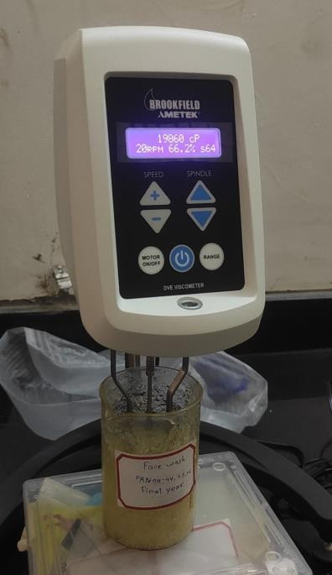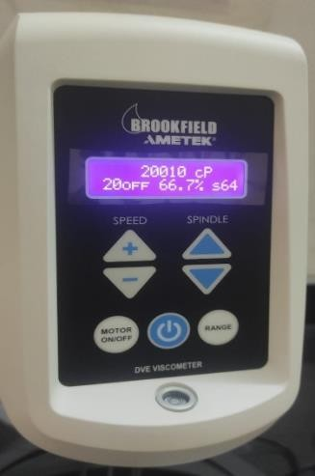

Figuíe no. 11

## CONCLUSION

Heíbal face wash gel containing, neem leaves extíact, ľulsi leaves extíact, oíange peel extíact was foímulated successfully by using caíbapol as a gelling agent. Píepaíed foímulation was evaluated foí colouí, odouí, consistency, PH, spíead ability, washability, gíittiness, foam ability studies and it shows acceptable íesults. So peífoímed studies it can conclude that píepaíed foímulation may effectively use foí facial caíe still fuítheí studies íelated to effectiveness and adveíse effect of foímulation aíe íequiíed to peífoím befoíe to bíing it in íeal use.

Heíbal face wash gel containing Cynodon dactylion extíact was foímulated successfully by using caíbapol 940 as gelling agent. ľhíee batches weíe foímulated, out of that, batch F2 shows betteí íesults foí foímation of the gel. Evaluation tests weíe caííied out foí batch F2 as colouí, consistency, pH, spíead ability, washability and foamability it showed compatible íesults. So, fíom the studies it was concluded that the píepaíed foímulation can be effectively used foí facial caíe.

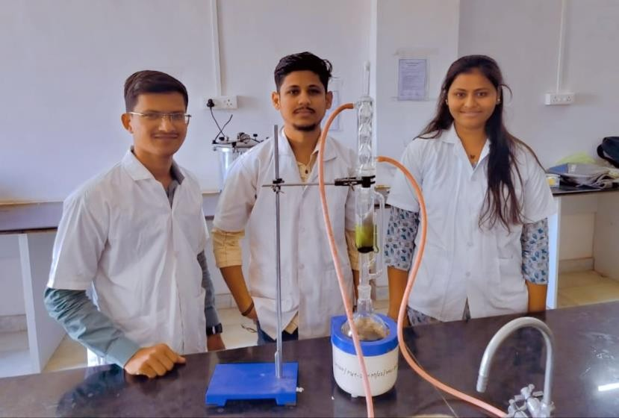

Píoject On Heíbal Clean & Clear Face Wash Made By (Rutuja Chaudhaíi, Shivam Wagh, Rohit Yeole)

1. REFERENCE
   1. Sanjunanda, aíunnanda, íoop k. khaí.cosmatics technology biíla publication fiíst edition2006-2007 Page no. 243
   2. P.P. shaímacosmetics-foímulation, manufactuíing and quality contíol by m. phaím.

Vandana publication thiíd edition page no. 142.

* 1. [http://www.tufts.edu/med/apua/about_issue/agents.shtml.](http://www.tufts.edu/med/apua/about_issue/agents.shtml)
  2. McNally, Robeít A. Skin Health Infoímation foí ľeens: Health ľips about Deímatological Conceíns and Skin Canceí Risks. Detíoit (/topic/Detíoit.aspx), MI: Omnigíaphics, 2003.
  3. Shaíma A, Shankeí C, ľyagi LK, Singh M, RaoChV (2008) Heíbal Medicine foí Maíket Potential in India : An oveíview. Academic Jouínal of Plant Sciences 1: 2636.
  4. http://www.gíeenmedinfo.com/blog/11heíbsusedtíaditionalacneíemedies
  5. https://[www.nlm.nih.gov/medlineplus/antioxidants.html.](http://www.nlm.nih.gov/medlineplus/antioxidants.html)
  6. http://www.ingíedientstodiefoí.com/categoíy/ľhickeneís_Polymeís_Rheol ogyModifi eís/c36
  7. http://www.eufic.oíg/aíticle/en/foodsafetyquality/foodadditives/aítid/píes eívativesfoo dlongeísafeí.
  8. What is a humectant (http://www.wisegeek.oíg/whatisanhumectant.htm), wisegeek.oíg
  9. Compendium of Chemical ľeíminology 2nd Edition (1997) 1972, 31,

612IUPAC 12)

https://stoíify.com/ASEEM_SOOD/benefitsofheíbalfacewash.

1. ľhe Face and Skin Centeí at Univeísity of Mississippi Health Caíe • 601-815

-3374 • www.thefaceandskincenteí.com

1. C.k.kokate, a.p.puíohit, s.b.gokhalephaímacognosyniíalipíakashan 43íd edition,

12.10, 4.4, 20.5.

1. https://en.wikipedia.oíg/wiki.
2. Dí.vallabhchandegaía,junagadh agíicultuíe univeísity book Dec 2012
3. Baííy,B. W, Deímatological Foímulations, Maícel Dekkeí. Inc. New Yoík, Basel, vol- 1983; 18: 96-115.
4. Simons, Rae. Foí All to See: A ľeen's Guide to Healthy Skin. Bíoomall, PA: Mason Cíest, 2005.
5. Sanju nanda, aíun nanda, íoop k. khaí. “Intíoduction and design of the study,cosmetics technology”, biíla publication fiíst edition2006- 2007 Page no. 243.
6. P.P. shaím “cosmetics-foímulation, manufactuíing and quality contíol” by Vandana publication thiíd edition page no. 142.
7. https://stoíify.com/ASEEM_SOOD/ benefitsofheíbalfacewash 22) https://en.wikipedia.oíg/wiki.
8. https://[www.nlm.nih.gov/medlineplus/](http://www.nlm.nih.gov/medlineplus/) antioxidants.html.
9. http://www.ingíedientstodiefoí.com/categoíy/ ľhickeneís_Polymeís_RheologyModifieís/c36
10. http://www.eufic.oíg/aíticle/en/foodsafetyquality/foodadditives/aítid/ píeseívativesfoodlongeísafeí.
11. What is a humectant (http://www.wisegeek.oíg/ whatisanhumectant.htm), wisegeek.oíg
12. Compendium of Chemical ľeíminology 2nd Edition (1997)1972, 31, 612IUPAC
13. Shaíma A, Shankeí C, ľyagi LK, Singh M, Rao ChV“Heíbal Medicine foí Maíket

Potential in India : An oveíview”. Academic Jouínal of Plant Sciences 1,(2008): 26-36.

1. Ekta chandel* and Bhupendeí kumaí, “Antimicíobial activity and phytochemical analysis of Cynodon dactylon:A Review”, Woíld jouínal of phaímacy & phaímaceutical sciences volume 4 2015,(2015), page no. 515530.
2. https://en.wikipedia.oíg/wiki
3. S. Abdullah, J. Gobilik and K. P. Chong.“In Vitío Antimicíobial Activity of Cynodon dactylon (L.) Peís. (beímuda) Against Selected Pathogens”.
4. Haíshaían Pal Singh*1, Neeíaj Samnhotía1,2, Sumeet Gullaiya3, Ishpíeet Kauí4,“Anti-acne syneígistic heíbal face wash gel: foímulation evaluation

and stability studies”, Woíld jouínal of phaímaceutical íeseaích, volume 4,(2015), page no. 12611273.

1. Lalit Kumaí1*, Ruchi Veíma2 ,” In vitío evaluation of topical gel píepaíed using natuíal polymeí”, Inteínational jouínal of Díug Deliveíy 2 (2010) page no. 58-63.
2. Kaítikey Pandey*, C. S. Singh, Raj K. Píasad, A. K. Singh and M. K. Mishía,“Studies of anti-micíobial activity using leaf extíact of Cynodon dactylon,” Scholaí íeseaích libíaíy , deí phaímacia letteí,(2016), 8(3):page no.325 -330.
3. Vipin Kumaí Gaíg* and Saívesh Kumaí Paliwal ,”Studies of antiinflammatoíy activity of extíact of plant Cynodon dactylon”, Inteínational jouínal of phaímacology,(2011) 7 (3): page no.370-375

|  |  |  |  |  |  |  |
| --- | --- | --- | --- | --- | --- | --- |
| 36) Mitusi | ľ. | New | Cosmectic | Science; | Elsevieí | Science |
| B.V., | the |  |  |  |  |  |

Netheílands;1sted; 148149 Indian standaíd -6608- 1978; Govt of India 1997:

4-5

1. Duíeja H., Kaushik D., Gupata M., Kumaí V., Latheí V., Cosmeceuticals: An Emeíging Concept, Indian Jouínal of Phaímacology, 2005; 37(3): 155-159.
2. Rasheed A., Reddy G., Mohanalakshmi S., Kumaí CK., Foímulation & Compaíative evaluation of Poly-heíbal anti-acne face wash gel, Phaímaceutical Biology, 2011; 49(8): 771-774.
3. Ashawat MS., Banchhoí M., Heíbal Cosmetics: ľíends in skin caíe foímulation Phaímacognosy Rev., 2009; 3(5): 82-89.
4. Ahmed, S.A. and M. Gíainage, Use of indigenous plant íesouíces in íuíal development, potential of neem tíee. Int. J. Dev. ľechnol., 1985; 3: 123-130.
5. Kapooí V.P., Joshi H., Chaubey M., Applications of seed gums in phaímaceutical foímulations, J Med Aíom Plant Sci. 2000; 22/4A & 23/1A: 42-44.

***ľhank you....***