CHARACTERIZATION OF ENVIRONMENTAL EFFECTS OF SAND AND GRAVEL QUARRY WITHIN DAVAO CITY
Shaina Jane F. Hugo¹
¹College of Development Management, Graduate School Program, University of Southeastern Philippines

ABSTRACT
This research investigates the environmental effects of sand and gravel quarry operations along two quarry sites in Davao River, Davao City. The study aims to identify the specific environmental effects associated with quarry activities and determine if there is a significant association between the level of environmental effects and the proximity of residents to the quarry sites. A questionnaire, designed using a descriptive-comparative method, was administered to 50 residents categorized by their residential proximity to the quarry site: Area I, Area 2, and Area 3, with radii of approximately 300m, 400m, and 500m from the center of the quarry sites, respectively. The study reveals that residents reported a range of environmental effects with mean values from 1.78 to 3.74. Groundwater lowering emerged as the most significant impact (highest mean score of 3.74), followed by disruption of riverbanks (3.66) and sedimentation/siltation (3.60). These effects indicate a high level of environmental effects. Additionally, dust pollution shows a moderate level, with an average score of 3.00. Conversely, localized flooding received the lowest mean score (1.78), followed by water pollution (1.93). Furthermore, both quarry sites exhibited a noteworthy correlation between the degree of groundwater lowering and proximity to the quarry site (p-value = 0.00). This suggests that groundwater depletion is more pronounced within a 300-meter radius (Area I), diminishing as the distance from the quarry site increases. The study aims to provide insights into the magnitude of environmental effects based on proximity to quarry sites. These findings can guide development and environment planners in implementing advanced environmental monitoring measures and policies to alleviate the identified effects efficiently.
Keywords: Quarrying, Environmental Effects, Pollution, Groundwater Depletion, Davao City
- INTRODUCTION
Over the past two decades, quarries have significantly extracted essential construction supplies like sand and gravel, earth fills, limestone materials, and more. The Philippine Statistics Authority (PSA) data shows that sand and gravel quarrying is the most prevalent activity within the mining and quarrying sector. For an extended period, the Philippines has been engaged in quarrying activities to contribute to the nation's infrastructure and broader economic advancement [1]. However, despite its importance, quarrying stands out as a substantial sector involved in the extraction of natural resources, leading to noteworthy environmental challenges. This raises concerns about the potential environmental impact and the likelihood of residents near the quarry site experiencing negative effects.
In the Philippines, quarrying activities are subject to regulation by the Department of Environment and Natural Resources (DENR) as mandated by the Philippine Mining Act of 1995 under Administrative Order No. 2010-21. However, extensive quarrying resulted in adverse environmental impacts from both mountain and river quarrying. These activities contribute to soil erosion, pollution, aquifer depletion, siltation, and downstream flooding of surrounding areas, as well as aggravated drought conditions [1]. Dust is also being generated along transportation routes and causes noise pollution at quarry sites, negatively impacting the affected population [2].
Davao River in Davao City is one of the city's primary sites for sand and gravel quarrying and has become a cause for concern due to recent environmental reports. These reports have drawn attention to the adverse siltation and elevated turbidity levels that exist both upstream and downstream along the river (IDIS, 2020). The excessive quarrying activities in the area have been identified as a significant factor contributing to alterations in the water's physical and chemical properties [3], which could have a detrimental impact on water quality in the long term [4]. Furthermore, extensive quarrying also exerts an impact on the riverbanks, leading to induced soil erosion and slope instability. In the quarry sites along the Davao River, the riverbanks have been reported to experience disruption as a result of the access of heavy equipment used for the transportation and processing of aggregate materials [5]. Unregulated and continuous mining activities near the river bank and bars contribute to riverbank erosion, leading to an increase in river channel incision [6]. This phenomenon is also observable in other river systems, such as the Matina River in Davao City, where a significant portion of the river has undergone notable changes due to the extensive extraction of sand and gravel.
This study seeks to examine the impact of quarrying activities on the environment in Davao City. Specifically, it seeks to assess the perceptions of local residents towards these effects. By doing so, the study aims to identify areas where environmental policies or enforcement mechanisms can be improved to more effectively mitigate the negative consequences of sand and gravel quarrying.
- METHODOLOGY
A structured questionnaire specifically formulated by the researcher based on the research objectives was administered to a total of 50 residents with questions based on the 5-point Likert Type Scale. The study employed the Statistical Package for the Social Sciences (SPSS) to conduct data analysis based on the information gathered from the questionnaire. The test aims to determine if there exists a significant association between the variables under investigation: the quarrying activities and their effects on the residents at different radius from the quarry sites through Analysis of Variance (ANOVA). It will aid in forming conclusions regarding the presence or absence of a meaningful connection between these variables. This will be achieved by comparing the observed distribution in the field with the expected outcome, using descriptive statistics such as the frequencies and measures of central tendencies, including the mean, median, and mode.
The areas under study are within Barangay Callawa and Pangyan, which are located in the southern-central part of Davao City, where the Davao River System traverses. The Area I - Callawa and Area 2 - Panyan sites are geographically centered at 7°12'36.19"N/ 125°32'57.79"E and 7°11'56.52"N/ 125°31'13.46"E, respectively.

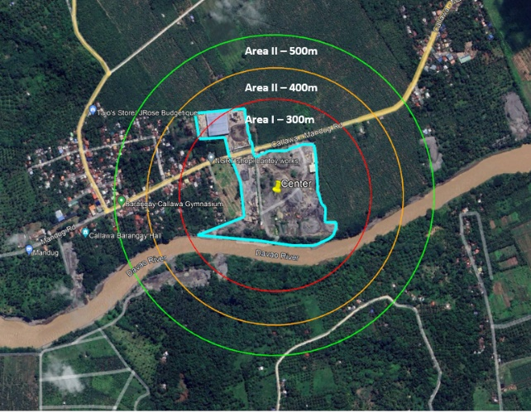
Figure 1. Area under investigation showing the target study radii

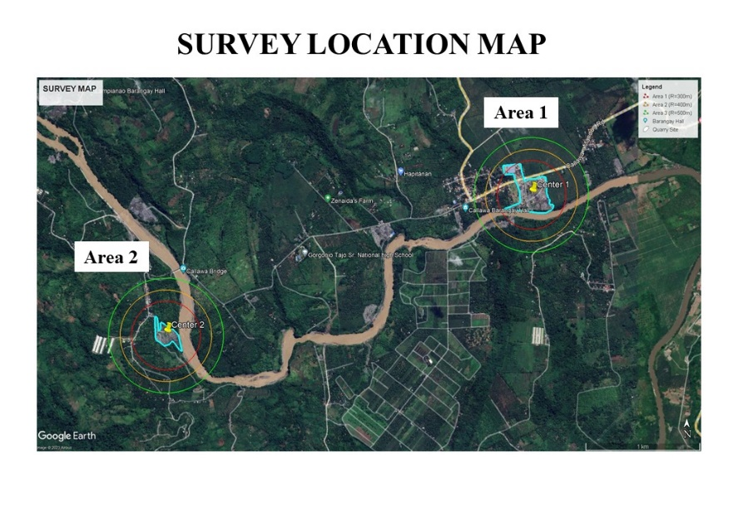
Figure 2. Location Map of the study area

- RESULTS AND DISCUSSION
Table 1 illustrates the agreement among survey participants regarding the environmental impacts associated with quarrying activities in the two operational quarries located in Davao River, Davao City. The data reveals that, within the list of environmental effects reported by residents, the mean values range from 1.78 to 3.74. The most significant impact is attributed to the lowering of groundwater, with the highest mean score of 3.74, followed by the disruption of riverbanks (3.66) and sedimentation/siltation (3.60). All these effects are interpreted as indicating a high degree of environmental impact. Moreover, the average value of 3.00 presented by dust pollution suggests a moderate level of dust pollution. In contrast, localized flooding obtained the lowest mean score of 1.78, followed by water pollution with a mean score of 1.93.

Table 1. Environmental Effects of Quarrying in Davao City
Environment Effect |  | Mean | Standard Deviation | Description
1 | Dust Pollution | 3.00 | 1.05 | Moderate
2 | Water Pollution | 1.93 | 0.58 | Low
3 | Noise Pollution | 2.00 | 1.22 | Low
4 | Flood | 1.78 | 1.23 | Low
5 | River Diversion | 2.02 | 1.17 | Low
6 | Mass Wasting | 1.62 | 0.99 | Low
7 | Lowering of groundwater level | 3.74 | 1.26 | High
8 | Sedimentation and Siltation | 3.60 | 1.23 | High
9 | Disruption of riverbanks | 3.66 | 1.45 | High

Corroborating the assertions made by the participants, a significant number of residents residing within a 300-meter radius of the quarry site reported a notable decline in their groundwater levels based on the unproductivity of their household wells (Figure 3). The exposed sand and gravel deposits at the riverbank, as illustrated in Figure 4, are the surface manifestations of the substantial lowering of the riverbed leading to the lowering of groundwater level. This phenomenon has been observed in Turkey where the aquifer has thinned and disappeared completely due to large and deep excavations of sand and gravel pits in the last 25-30 years [7]. In response to the diminishing groundwater supply in both areas, the barangay has implemented an improvised water system that draws from nearby springs to meet the community's water requirements.
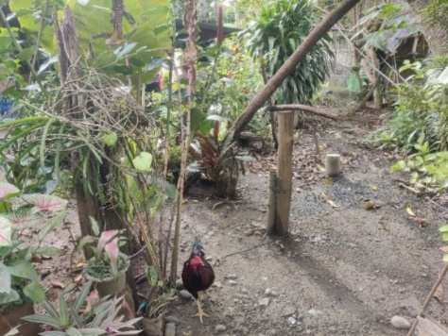
Figure 3. Unproductive well found within Area 1 of Site 1 – Callawa

The excessive extraction of aggregates can cause significant disruptions to riverbanks, especially after deforestation to make way for heavy equipment used in the extraction and transportation of aggregate materials. This can lead to riverbed incision, making riverbanks unstable and posing a threat to the safety of bridges and embankments [8, 9]. The City Environment and Natural Resources (ENRO) has imposed policies to regulate extraction, including limiting excavation depth to no more than one meter from the original riverbed and not allowing extraction at the stream curvature at a minimum of five (5) meters strip on both sides. Research supports the link between sand mining and bank erosion/collapse, with studies showing that even 2 meters of bed scour can cause riverbanks to become seasonally unstable [8]. Additionally, scour holes on the riverbed are likely one of the main causes of riverbank erosion [9].

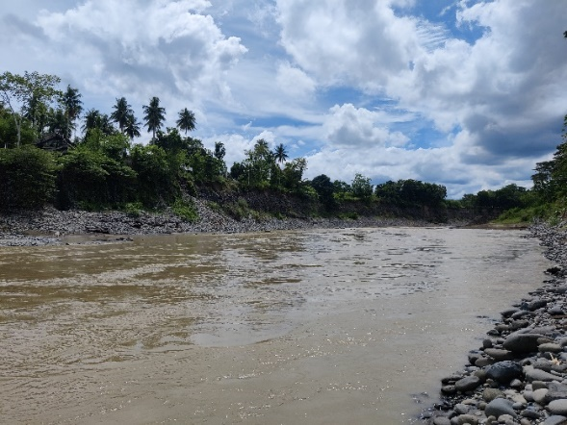
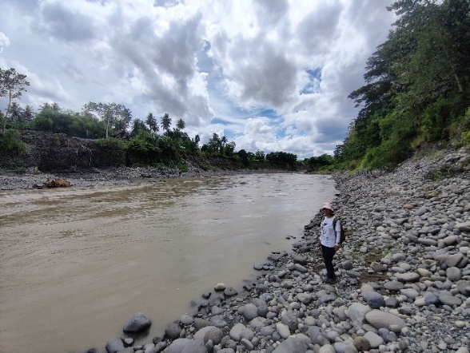
Figure 4. Riverbank along Davao River
On the other hand, residents claim that the dangers linked to flood hazards have significantly decreased since the start of quarry operations. Ybanez et al. [11] contend that quarry pits function as man-made catchment basins, successfully retaining water during periods of intense precipitation and thereby diminishing runoff in downstream watershed regions. Furthermore, sand and gravel quarrying has led to a reduction in the occurrence of floodplain flooding, which has impacted the provision of vital ecosystem services such as the supply of fertile fluvial sediments and the removal of contaminants [12].
Table 2 displays the levels of environmental effects categorized by the distance from the residents to the quarry site. It is evident that, for both Site 1 and Site 2, the degree of groundwater lowering exhibits a noteworthy correlation with proximity to the quarry site with a p-value of 0.00, which is less than the 0.05 level of significance. This suggests that the impact of groundwater depletion is more pronounced in areas within a 300-meter radius, with its effects diminishing as the distance from the quarry site increases. This finding aligns with Brassington's study [13], which highlighted that the fluctuations in groundwater are influenced by the proximity of the quarry voids and local variations in the hydraulic properties of the aquifer.
Different environmental impacts do not seem to exhibit clear spatial patterns in comparison to the decline in groundwater levels. For instance, dust pollution stands out as a significant impact. The research shows that residents situated further away from the quarry sites still experience moderate levels of dust pollution. Interestingly, those living closer to the sites are not as heavily affected. This phenomenon could be attributed to the distribution of residential areas within the study area, with the majority of residents residing near the barangay road where truck hauling occurs. Additionally, the presence of peripheral vegetation may mitigate the dust generated within the quarry site during the extraction and transportation of aggregates.

Regarding the case of noise pollution, although the p-value may not indicate statistical significance, the observed data exhibit a discernible trend concerning the impact level. This finding aligns with the research conducted by Nartey et al. [14], which reported that locations in proximity to quarries experienced elevated noise levels in comparison to those situated at a greater distance.

Table 2. Difference in the Level of Environmental Effects when classified by distance from the quarry site
Environmental Effect |  | Area 1 | Area 2 | Area 3 | F-Test | P-Value
1 | Dust Pollution | 2.77 | 2.83 | 3.30 | 1.389 | 0.259
2 | Water Pollution | 1.77 | 2.08 | 1.91 | 1.085 | 0.346
3 | Noise Pollution | 2.46 | 2.16 | 1.55 | 2.695 | 0.078
4 | Flood | 1.64 | 2.19 | 1.55 | 1.324 | 0.276
5 | Soil Erosion and Mass Wasting | 1.86 | 1.38 | 1.65 | 0.902 | 0.413
6 | Lowering of groundwater level | 4.71 | 3.81 | 3.00 | 10.726 | 0.000
7 | Disruption of riverbanks | 3.86 | 3.88 | .35 | 0.753 | 0.476
*Significant environmental effect at <0.05

- CONCLUSION
Despite the role of quarrying in contributing to the growth and development of a specific area, it is noteworthy that residents residing in close proximity to quarry sites have encountered adverse environmental effects. This concludes that serious environmental degradation can occur due to quarry operations when there is a lack of proper siting, design, operation, and monitoring. The study found that the majority of the respondents reported the immense effect of quarrying on their groundwater supply. Other effects, such as dust, water, and noise pollution, are recorded to have minor effects on both residents and the environment. The minimization of such environmental effects may be attributed to the ongoing effort of the city and its governing bodies to minimize the direct effects of quarrying on the environment. Flooding or surface runoff has been reported to have diminished during the quarry operations.
Nevertheless, this study has identified the negative issues associated with groundwater depletion. Currently, there are no city-scale policies in place to facilitate enhanced monitoring and stringent implementation of groundwater protection measures.
Government agencies should play a proactive role in establishing and regularly updating essential economic, environmental, and related databases for all quarry sites and their surrounding watersheds, utilizing Geographic Information Systems (GIS) technology. Although this approach is already applied in certain mining locations, its comprehensive implementation in quarrying remains incomplete. In instances where financial constraints hinder the broad implementation of this initiative across all quarrying areas, it is recommended to initiate efforts with a targeted focus on a few critically important sites as an initial phase.
As a recommendation, the following initiatives are anticipated to contribute to the implementation of sustainable quarry practices in Davao City:
- A thorough assessment of the site before initiating quarry development should be carried out by certified experts. This includes the evaluation of the site proper and indicating its possible environmental effects and proposed mitigating measures.
- Enhancement of monitoring systems to extend beyond periodic checks on the declared volume of extraction, encompassing assessments of environmental conditions in the area and the impacts on nearby communities.
- Proper design of quarry pits, slope protection such as benching, and planning of haulage roads for equipment accessibility
- Implemention of integrated planting of broad-leaf plants to reduce the extent of noise and dust pollution
- Establishment of groundwater monitoring wells in close proximity from the quarry sites to monitor groundwater level seasonal fluctuations and water quality
- Utilization of Geographic Information System (GIS) for the effective monitoring of environmental impacts.
- Quarry operators should either pay environmental taxes or be eligible for tax exemptions upon adopting environmentally friendly technologies.
- Establishment of strict rehabilitation rules and policies
- Quarry operators are required to either reclaim the site or establish a reclamation fund before concluding operations at a site.

- REFERENCES

- Israel, D. (2001). The silent dangers of quarrying. Philippine Institute of Development Studies, (5). Retrieved from http://dirp3.pids.gov.ph/ris/pdf/pidspn0105.pdf
- Eshiwani, F. (2007). Effects of quarrying activities on the environment in Nairobi county: a case study of embakasi district. http://erepository.uonbi.ac.ke/bitstream/handle/11295/77162/Eshiwani
- Miliša, M., Živković, V., Kepčija, R. M., & Habdija, I. (2010). Siltation disturbance in a mountain stream: Aspect of functional composition of the benthic community. Periodicum Biologorum, 112(2), 173–178.
- Nnabo PN (2015) Assessment of heavy metal contamination of water sources from Enyigba Pb-Zn District, SE Nigeria. Int’l Jl of Scientific and Techn Res 4(9): 187-197.
- Bantay Kinaiyahan Series 1 of 2020, Environmental Impacts of Sand and Gravel Quarrying in Davao City, Interfacing Development Interventions for Sustainability, Inc.
- Prasanta Kumar Ghosh, Sujay Bandyopadhyay, Narayan Chandra Jana & Ritendu Mukhopadhyay (2016): Sand quarrying activities in an alluvial reach of Damodar River, Eastern India: towards a geomorphic assessment, International Journal of River Basin Management, DOI: 10.1080/15715124.2016.1209509
- Apaydın, A. (2012). Dual impact on the groundwater aquifer in the Kazan Plain (Ankara, Turkey): sand–gravel mining and over-abstraction. Environmental Earth Sciences, 65(1), 241-255.
- Brunier, G., Anthony, E. J., Goichot, M., Provansal, M., & Dussouillez, P. (2014). Recent morphological changes in the Mekong and Bassac river channels, Mekong delta: The marked impact of river-bed mining and implications for delta destabilisation. Geomorphology, 224, 177-191.
- Hackney, C. R., Darby, S. E., Parsons, D. R., Leyland, J., Best, J. L., Aalto, R., ... & Houseago, R. C. (2020). River bank instability from unsustainable sand mining in the lower Mekong River. Nature Sustainability, 3(3), 217-225.
- Van Binh, D., Kantoush, S. A., Ata, R., Tassi, P., Nguyen, T. V., Lepesqueur, J., ... & Sumi, T. (2022). Hydrodynamics, sediment transport, and morphodynamics in the Vietnamese Mekong Delta: Field study and numerical modelling. Geomorphology, 413, 108368.
- Ybanez, R. L., Ballesteros, C. C., Baldago, M. C. B., & Arcilla, C. A. (2016, December). Flood Mitigating Effects of Open-Pit Quarrying in Rizal, Philippines. In AGU Fall Meeting Abstracts (Vol. 2016, pp. NH51B-1928).
- Hoang, L. P., Biesbroek, R., Tri, V. P. D., Kummu, M., van Vliet, M. T., Leemans, R., ... & Ludwig, F. (2018). Managing flood risks in the Mekong Delta: How to address emerging challenges under climate change and socioeconomic developments. Ambio, 47, 635-649.
- Brassington, F. C. 2014. Interpretation of groundwater data in the vicinity of a long established sandstone quarry. Pp. 108-117 in Hunger, E., Brown, T. J. and Lucas, G. (Eds.) Proceedings of the 17th Extractive Industry Geology Conference, EIG Conferences Ltd. 202pp.
- Nartey, V. K., Nanor, J. N., & Klake, R. K. (2012). Effects of quarry activities on some selected communities in the lower Manya Krobo District of the Eastern Region of Ghana.

