**DUAL AXIS SOLAR TRACKER SYSTEM**

**Prof Umesh Bonde1,**

**Sanket Dupare2, Abhirup Kopulwar2,**

**Deep Khobragade2,Rohit Bhaisara2**

*Department of Electrical Engineering*

*Shri Sai College of Engineering and Technology,Bhadrawati(MS), India*

1. **Professor**
2. **Student**

**Abstract**:

As the energy demand and the environmental problems increase, the natural energy sources have become very important as an alternative to the conventional energy sources. The renewable energy sector is fast gaining ground as a new growth area for numerous countries with the vast potential it presents environmentally and economically. Solar energy plays an important role as a primary source of energy, especially for rural area. This project aims at the development of process to track the sun and attain maximum efficiency using Arduino and LDR Sensor for real time monitoring. The project is divided into two stages, which are hardware and software development. In hardware development, two light dependent resistor (LDR) has been used for capturing maximum light source. Servo motor has been used to move the solar panel at maximum light source location sensing by LDR. The performance of the system has been tested and compared with static solar panel. This project describes the design of a low cost, solar tracking system. In this project a dual axis solar tracking system has been developed by which more energy from the sun can be harnessed. In this project, an , Aurdino , has been used as the main controlling unit. To detect the position of the sun on the sky, two LDRs have been used and to rotate the orientation.

**Keywords: *10 rpm gear motor,4 volt small solar plate,L293D motor driver, IR sensor,4 LDR sensor, Arduino uno***

**Introduction:**

Solar energy is an unlimited source of energy which if harnessed properly will get the mankind devoid of using the conventional sources of energy he has been long using. This project has been designed

keeping this in view to make the harnessing of solar energy more efficient. The conversion of solar light into electrical energy represents one of the most promising and challenging energetic technologies, in continuous development, being clean, silent and reliable, with very low maintenance costs and minimal ecological impact. A photovoltaic panel is a device used to capture the suns radiation. These panels consist of an array of solar cells. The solar cells are made up of silicon (sand). They are then connected to complete a photovoltaic (solar) panel. When the sun rays are incident on the solar cells, due to the photovoltaic effect, light energy from the sun is used to convert it to electrical energy. We know that most of the energy gets absorbed, when the panels surface is perpendicular to the sun. Stationary mounted PV (photo voltaic) panels are only perpendicular to sun once a day but the challenge for is to get maximum energy from the source, so for it we use trackers on which the whole system is mounted. In tracking system, solar panels move according to the movement of sun throughout the day**.**

Tracker systems follow the sun throughout the day to maximize energy output. The Solar Tracker is a proven single-axis tracking technology that has been custom designed to integrate with solar modules and reduce system costs. The Solar Tracker generates up to 25% more energy than fixed mounting systems and provides a bankable energy production profile preferred by utilities.

**Objectives**:

The main objective of the dual-axis tracker is to follow the position of the sun for maximum energy efficiency. Given that the sun moves at 15 degrees per hour and assuming, the tracker would make position changes every. 01 seconds, the change in angular velocity is calculated.

**Circuit Diagram:**

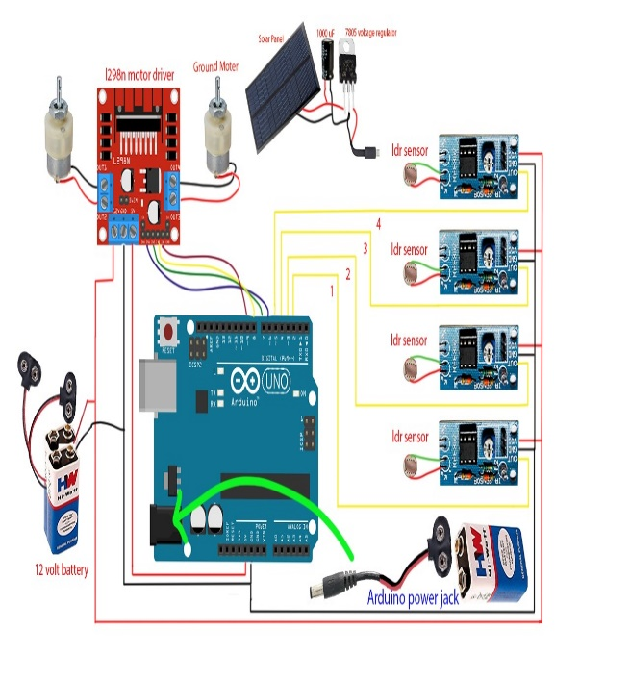

*Figure 1: Circuit Diagram of Dual axis solar tracker*

**Working:** The principle of the solar tracking system is done by Light Dependant Resistor (LDR). Four LDR’s are connected to Arduino analog pin AO to A4 that acts as the input for the system. The built-in Analog-to-Digital Converter will convert the analog value of LDR and convert it into digital. The inputs are from analog value of LDR, Arduino as the controller and the DC motor will be the output. LDR1 and LDR2, LDR3 and LDR4 are taken as pair .If one of the LDR in a pair gets more light intensity than the other, a difference will occur on node voltages sent to the respective Arduino channel to take necessary action. The DC motor will move the solar panel to the position of the high intensity LDR that was in the programming.

1. LDRs are used as the main light sensors. Two servo motors are fixed to the structure that holds the solar panel. The program for Arduino is uploaded to the microcontroller. The working of the project is as follows.

2. LDRs sense the amount of sunlight falling on them. Four LDRs are divided into top, bottom, left and right.

3. For east – west tracking, the analog values from two top LDRs and two bottom LDRs are compared and if the top set of LDRs receive more light, the vertical servo will move in that direction.

4. If the bottom LDRs receive more light, the servo moves in that direction.

5. For angular deflection of the solar panel, the analog values from two left LDRs and two right LDRs are compared. If the left set of LDRs receive more light than the right set, the horizontal servo will move in that direction.

6. If the right set of LDRs receive more light, the servo moves in that direction.

**Advantages:**

* Trackers generate more electricity than their stationary counterparts due to increased direct exposure to solar rays.
* Solar trackers generate more electricity in roughly the same amount of space needed for fixed-tilt systems, making them ideal for optimizing land usage.
* Advancement in technology and reliability in electronics and mechanics have drastically reduced long ter0m maintenance concerns for tracking systems.
* Trackers generate more electricity than their stationary counterparts due to increased direct exposure to solar rays. This increase can be as much as 10 to 25% depending on the geographic location of the tracking system.
* There are many different kinds of solar trackers, such as single-axis and [dualaxis](https://www.solarpowerworldonline.com/2017/09/dual-axis-solar-tracker/) trackers, all of which can be the perfect fit for a unique jobsite. Installation size, local weather, degree of latitude and electrical requirements are all important considerations that can influence the type of solar tracker best suited for a specific solar installation.
* Solar trackers generate more electricity in roughly the same amount of space needed for fixed-tilt systems, making them ideal for optimizing land usage.

**Applications:**

Solar Photovoltaic plants require continuous orientation towards sun for consistent efficiency output. This product will prove a great boon for them.

Solar water heating applications can also implement the same technique to heat water throughout the day.

Concentrated applications like concentrated photovoltaic panels require a high degree of accuracy to ensure the sunlight is directed precisely at the focal point of the reflector or lens.

Non concentrating applications do not require tracking but using a tracker can improve the total power produced by the system. Photovoltaic systems using high efficiency panels with trackers can be very effective

**Conclusion:**

1. The proposed dual axis solar tracker automatically tracks position of sun and maximise the solar power with help of arduino.
2. As compared to single axis, dual-axis system provide high abundant electrical energy output when compared to the fixed mount system. The Dual axis tracker is having more efficiency.
3. The main aim of this work is to develop two axis solar tracker system that uses four sensors(ldr s) to predict the sun position. Secondly, program is dumped on to Arduino (ATmega 328 p) so that rotation of servo motor can be controlled by employing the microcontroller.
4. The programming part consists of 5 cases which has been stated and analyzed. Thirdly, to investigate the voltage differences from the sensor (light depending resistor LDR) based on intensity of light received by the sensor.
5. The output has plotted into a graph and compared with static system. And proposed system is eco friendly, and widely used.

**FUTURE SCOPE:**

* In future this Tilting mechanism with collector can be implemented on large solar plants and also can be operated automatically.
* We can make the work very easy with the help of electric tilting mechanism. We are working on the same to implementing automation for same mechanism with electric or mechanical actuators or components.
* This mechanism can be implemented on the Solar Cookers, Ovens, and Driers and on thermal solar
* heater.
* The main advantage of such systems is maximum amount of power generated due to the biaxial motion.

**REFERENCES:**

[1] Solar Tracking Hardware and Software by Gerro J Prinsloo

[2] Design and Implementation of a Sun Tracker with a Dual-Axis Single Motor “Jing-Min Wang and Chia-Liang Lu’’

[3] Sensors and Transducers...Second Edition...’’D.Patranabis”

[4]ATmega48A/PA/88A/PA/168A/PA/328/P-datasheet

[5] Utilisation of Electrical Power. Author, Er. R. K. Rajput.

[6] Arduino Programming Book. Author, Brian W. Evans

[7] Pradeep, K., Reddy, K.S.P., Mouli, C.C and Raju, K.N., 2014. Development of dual-axis solar tracking using Arduino with lab view. International Journal ofEngineering Trends and Technology, 17(7), pp.321-324.

[8] Kaur, T., Mahajan, S., Verma, S. and Gambhit, J., 2016. Arduino based low cost active dual axis solar tacker. In 2016 IEEE 1st International conference on Power Electronics, Intelligent Control and Energy Systems (ICPEICES) (pp. 1-5). IEEE.

[9] Das, S., Chakraborty, S., Sadhu, P.K. and Sastry, O.S., 2015. Design and experimental execution of a microcontroller (μC)-based smart dual-axis automatic solar tracking system. Energy Science & Engineering, 3(6), pp.558-564.

[10] Catarius, A.M. and Christiner, M.P., 2010. Azimuth -altitude dual axis solar tracker.

[11] Sidek, M.H.M., Azis, N., Hasan, W.Z.W., Ab kadir, M.Z.A., Shafie, S. and Radzi, M.A.M., 2017. Automated positioning dual-axis solar tracking system with precision elevation and azimuth angle control. Energy, 124, pp.160-170.

[12] Vieira, R.G., Guerra, F.K.O.M.V., Vale, M.R.B.G. and Araujo, M.M., 2016. Comparative performance analysis between static solar panels and single-axis tracking system on a hot climate region near to the equator. Renewable and Sustainable Energy Reviews, 64, pp.672-681.

[13] Reddy, J.S., Chakraborti, A. and Das, B., 2016. November. Implementation and practical evaluation of an automatic solar tracking system for different weather conditions .In 2016 IEEE 7th Power India International Conference (PIICON) (pp. 1-6). IEEE