SAFETY MANAGEMENT AND ACCIDENT PREVENTION IN CONSTRUCTION PROJECTS

***AVHAD BHAGVAN JAYPRAKASH1,AVHAD SAHIL GANPAT 2, THORAT GANESH SUKDEV3,BHUSAL PRAGWANSH MAHESH4, Prof. Shinde P.B 5***

1,2,3,4 Student, Department of Civil Engineering, Vidya Niketan College of engineering, Bota.

5 Lecturer, Department of Civil Engineering, Vidya Niketan College of engineering, Bota.

# ABSTRACT

Safety management and accident prevention in construction projects are paramount for ensuring the well-being of workers and the successful completion of projects. This paper aims to explore various strategies and practices employed in safety management within the construction industry, focusing on accident prevention measures. It discusses the importance of proactive safety planning, hazard identification, risk assessment, training programs, and the implementation of safety protocols. Additionally, it examines the role of leadership commitment, worker involvement, and regulatory compliance in fostering a safety culture on construction sites. By emphasizing the significance of effective safety management systems, this paper highlights the potential to mitigate accidents and injuries, enhance productivity, and improve overall project outcomes in the construction sector.

**Keywords:** Safety management, Accident prevention, Construction projects, Risk assessment, Safety protocols, Safety culture, Leadership commitment.

# I. INTRODUCTION

Accidents as an unplanned and unexpected occurrence, which upsets a planned sequence of work; are resulting to loss of production, injury to personnel, damage to plant and equipment and eventually interrupting production flow. Control measures as an act of limiting or making something to happen in a particular way, stop something from spreading, going out of hand or getting worse. Identify safety in construction as the process or way of protecting the health and life of those who build, operate, maintain and demolish engineering works; and others affected by those works. Construction industry a deadly working place. Accidents on building sites are inevitable, but could be controlled to prevent minor or serious-consequences on the workers. Thus, control measures of accidents to ensure safety of workers and minimize accident-related waste on sites are essential. Hence, the ultimate aim of this research is to minimize accidents’ occurrence on sites. The specific objectives are to identify types of accidents on sites and their control measures, to identify accidents prevention methodologies, to examine the frequency of usage of control measures on sites and to Most accidents can be prevented by taking simple measures or adopting proper working procedures. This handbook is intended to outline important issues on safety and health that should be paid attention to on construction sites for easy reference by the workers. If we work carefully and take appropriate safety measures, there will definitely be fewer work injury cases, and our sites will become a safe and secure place to work in. The Occupational Safety and Health Ordinance, which came into operation on 23 May 1997, cover most workplaces in order to protect the safety and health of employees at work. Other legislation applicable to construction sites includes the Factories and Industrial Undertakings Ordinance and its subsidiary legislation, particularly the Construction Sites (Safety) Regulations.

## Objectives

* + 1. The purpose of this research is to look at the security control techniques on construction site.
    2. To investigate the many sorts of accidents and their consequences.
    3. To investigate different safety-related technology, building components, and substances.
    4. To determine the reasons of accidents and provide recommendations for improving safety performance.
  1. Accident

Various types of accidents and their respective control measures from literatures are:

* + 1. Scaffold Accidents

Fall of person from scaffold and collapse of scaffolds has constantly been the number one killer in Hong-Kong construction industry (U.S Department of Labour, 2005). Between 2000 and 2004, the department shows that fatal accident arising from bamboo scaffold and working on platform have accounted for nearly half of the total number of fall-from-height fatal accidents in the period. Similarly, O.S.H.A (2005) reports that hazards occur due to improper erection of scaffold. They add that 4,500 injuries and 50 fatalities from 2.3 million construction workers annually can be

prevented with proper erection and use of scaffolds.

* + 1. Accident Due To Slip, Trip and Falls

Increase in international and national attention is being placed on occupational strips, trips and falls (STF) as the extent of the problem is recognized. This growing interest reflects an understanding that strips, trips and falls are preventable in lieu of daily occurrence on building sites. More than a million people suffer from these accidents annually. Slips, trips and falls account for 15% to 20% of all workers’ compensation cases; with older ones having higher percentage of falls compare to younger ones. This is as a result of the fact that, regardless of the kind of work to be done or the position of such work, slip or trip falls can occur at any place or point on the construction site, thus, the reason for its control to prevent casualty.

* + 1. Crane Accident

Factors associated with mobile cranes failure include support failure, failure to use outriggers, crane failure or collapses and rigging failure. Though, the collapse of tower cranes is rare, accidents and near misses do occur. Failure of any part of the crane or load carry systems are likely to cause serious accidents, with both crane operators, site personnel and general public involved posits that significant and serious injuries of fatality may occur if cranes are not inspected before use and if they are not used properly. Often, these injuries occur when a worker is struck by an overhead load or caught within the crane’s swing radius. It therefore implies that, crane accidents are associated with erection or assembling, usage, dismantling and supervision or inspection and are major treat to life of workers on any building site.

* + 1. Ladder Accident

Ladder falls or accidents increased significantly in 2001-2005, which gives a significant rise in serious injury from ladder falls. A fall from height, more than one meter, was the most common mechanism of injury accounting for 59% of the total. It was also established that about 20% of ladder-related falls greater that one meter and major trauma cases occurred while people are working on site. despite the knowledge of the dangers of falls from ladders, there has being a significant increase in the number of casualties from ladder falls which resulted into broken limb, fracture and bruises on building sites.

* + 1. Electrical Accidents

It implies that electrical works involving the use of electricity on site is very risky. He further shows that most people affected by electrical injuries are electrical workers (i.e electricians; electrical power installers and repairers; their apprentices and their supervisors). These workers had one-third of the electrical deaths followed by general labourers on site. also conclude that the majority of electrocution death resulted either from direct or indirect contact with power lines; but having the power de-energized in close proximity to building sites and other settings, where there are potential for power line contact reduces this hazard. Where not possible or practicable to de-energize lines, adequate clearance must be maintained or lines encased in insulated sleeves to prevent electrocution of whatever kind.

* 1. Employment Accidents on Construction Sites in the Years 2008–2012

Any irregularities and deficiencies in the system of employee’s protection, can directly or indirectly contribute to accidents. For several years Poland has been witnessing increasing awareness of OHS issues related to the various working positions present in the construction industry. Based on published data from the Central Statistical Office from years 2008–2012 (Fig. 2), we can notice a decrease in the number of accidents in 2012 relative to previous years, but we cannot yet conclude that this trend will be maintained in the future. Based on the analysis of statistical data, lots of factors have been determined that influence the probability of accidents in the construction industry.

The age groups of the employees undergoing most accidents have not changed considerably over the past years. In 2008 persons aged 20–29 years were those most prone to accidents, over time the accident rate in that age group has leveled out, and then slightly decreased relative to the 30–39 age group (Fig. 1). Such a distribution of age groups in relation to employment accidents is the result of insufficient training of young, newly employed staff, while further attention should be paid to workers aged 40–49 years, for whom the number of accidents is still very high.

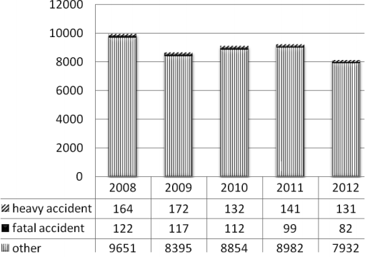

## Fig 1. 1:Accidents at construction sites in the years 2008–2012

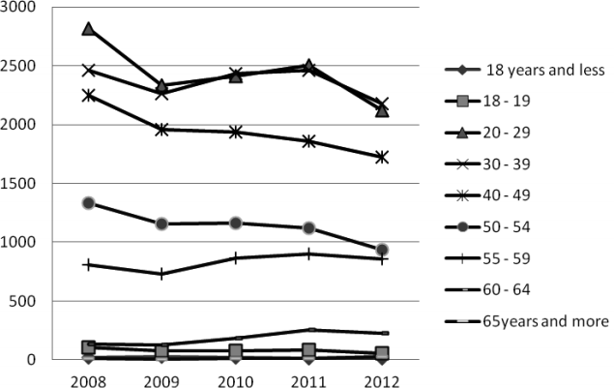

**Fig 1. 2:Injured in accidents at work in the construction industry – divided by age – 2008–2012 (CSO)**

* 1. Importance of construction safety culture

In the bustling realm of construction, where towering structures emerge from mere blueprints and raw materials, safety stands as the cornerstone upon which every project is built. The construction industry is notorious for its inherent risks, ranging from precarious heights to heavy machinery and intricate processes. Amidst this dynamic environment, fostering a robust safety culture becomes paramount. It transcends mere compliance with regulations; it embodies a collective mindset ingrained within every worker, from the construction site to the executive boardroom. The importance of a strong construction safety culture cannot be overstated. It not only safeguards the well-being of workers but also ensures the successful execution of projects, adhering to timelines and budgets. Beyond these tangible benefits, a safety-centric culture cultivates trust among stakeholders, enhancing the industry's reputation and attracting top talent. Safety culture, a concept originating from the aftermath of the Chernobyl nuclear disaster in 1986, has garnered increasing attention and significance in the realm of organizational management, particularly concerning health and safety protocols. Initially recognized as a crucial factor contributing to the Chernobyl incident, safety culture has evolved into a prominent discourse in various industries, emphasizing the paramount importance of its effective implementation.

* 1. Prevailing accidents in construction industry

As one of the key pillars supporting the development of global infrastructure, the construction sector makes a substantial contribution to both economic expansion and social advancement. Nevertheless, there are difficulties in this industry, with workplace accidents becoming a continuous and worrisome problem. Comprehending the frequency of accidents in the construction sector is essential to guaranteeing the security and welfare of labourers and efficiently reducing potential hazards. The high accident rate in the construction industry when compared to other industries is one of the most concerning elements of the business. Heavy equipment, intricate procedures, high workstations, and exposure to many dangers including falls, electrocution, and item strikes are what make construction sites intrinsically dangerous places. As a result, employees in this industry deal with a wide range of possible risks every day. One of the main causes of deaths and injuries in the construction industry are falls from heights. The effects of a fall, whether from roofs, ladders or scaffolding, may be disastrous. Similar risks arise from mishaps involving large machinery and equipment, particularly

when appropriate safety precautions are not taken. Moving equipment has the potential to crush, entangle, or strike workers, killing or seriously injuring them.

* 1. Need for preventive measures

Taking preventive measures are more important than ever in an age of unparalleled global connection and interdependence. In the fields of public health, cybersecurity, environmental conservation, and social cohesion, among others, proactive approaches that try to stop possible crises before they get out of hand have become essential components of modern accountability and governance. Preventive interventions are justified by their ability to proactively address underlying risks and vulnerabilities, hence reducing the potential negative consequences. Societies may drastically lower the costs of crises and catastrophes on people, the economy, and society at large by putting prevention above response. The area of public health is leading this paradigm change, as the difficulties presented by chronic illnesses, new infectious diseases, and global health inequities have highlighted the need of preventative interventions.

* 1. Relationship between safety culture and accidents

Investigation of the relationship between safety culture and accidents is necessary in a variety of industries, including aviation, construction, healthcare, and manufacturing, among others. When it comes to safety, the concepts, attitudes, beliefs, and behaviours that are prevalent inside an organisation are collectively referred to as the "safety culture" of that company. This encompasses all of the rules, procedures, and practices that are implemented inside the business that prioritise safety and support it at every level. Accidents, on the other hand, are unforeseen events that result in injuries to humans, damage of property, or consequences on the environment. In order to cultivate a proactive approach to risk management and accident prevention, it is necessary to have an awareness of the intricate relationships that occur between safety culture and accidents. Within the scope of this introduction, we will investigate the complex link that exists between safety culture and events, with a particular focus on the ways in which the attitudes of an organisation towards safety influence the frequency and severity of accidents. There will be a discussion on the leadership's duty in establishing and preserving a safe working environment, as well as an examination of the components that constitute a strong safety culture and the ways in which these components minimise the chance of accidents.

Throughout the context of the International Atomic Energy Agency's (IAEA) investigation into the factors that led to the Chernobyl catastrophe in 1986, the phrase "safety culture" was first presented to the nuclear sector for the first time. The International Nuclear Safety Advisory committee (INSAG), which is an advisory committee that reports to the Director General of the International Atomic Energy Agency (IAEA), came to the conclusion that "Formal procedures, properly reviewed and approved, must be supplemented by the creation and maintenance of a nuclear safety culture" (INSAG, 1986). In their examination of the disaster that occurred at Three Mile Island (TMI) in 1979, the United States Nuclear Regulatory Commission (NRC) acknowledged the significance of organisational elements to accidents, despite the fact that they did not label the concept of "safety culture" at the time this occurred. According to the findings of the research conducted by the National Research Council (NRC), "The one theme that runs through the conclusions we have reached is that the principal deficiencies in commercial reactor safety today are not hardware problems, they are management problems" (Rogovin, 1980). Investigations into accidents like this led to stimulate study in the field of safety culture, with the goal of gaining an understanding of how the shared, fundamental ideas and values that exist within an organisation may either support or impede safe performance.

# II LITERATURE REVIEW

## Massey, A et,al (1998)

Safety should be part of the process right from the very beginning. In working toward establishing a safer workplace, construction companies can tap the extensive knowledge of risk management experts who are well versed in their industry. Massey & Walford, 6 describes the safety beliefs, values and attitudes that are shared by the majority of people in an organisation or workplace (“the way we do things around here”) Project planners should also work with their insurers to determine the most effective risk management strategies before a project begins and while it’s being built. A safety culture can only be built through management commitment and involvement righ from the boardroom to the lowest level of employees. A poor culture encourages an atmosphere where not complying with safe working practices is acceptable, and it doesn’t help the organisation to take effective action to solve health and safety problems.

## Barling, J et.al (2002)

Specific empirical studies conducted by Barling, Loughlin 3 and Kelloway 3 , Zohar 9 , Kelloway 2 , Mullen and Francis 10 illustrate the significant impact of safety-specific transformational leadership on 56 Industrial Engineering and Operations Management Conference, Detroit, Michigan, 23- 25 September 2016 safety-related events and workplace injuries. It emerged from these studies that the safety climate facilitates the relationship between transformational leadership and occupational safety.

## Winkler, C et.al (2003)

Winkler (2003), in a report to Construction Productivity Network, pointed out that over a 12 year period between 1990 to 2001, the HSE statistics showed that the construction industry has made improvements regarding the number of fatalities, decreasing from over 150 in 1990 to just over 100 in 2001, with a low of 65 in 1999. Despite the overall fatalities figure reduction from 1990 to 2001, the number remains significantly high. For instance, accidents by fall, whilst not the largest single cause of death, are a significant cause of mortality on sites (CIRIA2003).

## Davies, V.J et.al (1996)

Moreover, while there has, reportedly, been some improvement in site safety in recent years, Davies and Tomasin (1996) suggested that statistics are unreliable due to under reporting and that the number of fatalities in the construction industry

is only a tip of the iceberg. There are thousands of major injuries each year and even more minor injuries, which result in absence from work on more than three consecutive working days, which go unreported. The Health and Safety Executive recognises that only a fraction of non-fatal injuries are reported each year. In spite of this apparent improvement, it is clear that injury rate for the construction industry is still at an unacceptably high-level.

## Nutt, B. Mclennan et.al (1998)

Accidents on construction sites are a major cause of avoidable ill- health; injury and death DOH (1993). Nutt et al (1998) suggest that 20% of reported construction accidents could be attributed to poor site logistics. Every week, more than one person is severely injured or dies of accident cause CIRIA (2003). Accidents on sites are one of the most important factors in health service utilisation (DOH 1993). Efforts to improve Health and Safety on site have been of primary importance in an industry that continues to kill and maim its people every week.

## Stig Winge et.al (2019)

The analyses identified seven causal factors consistently connected to worker actions, for example immediate supervision and local hazards. Immediate supervision was found to be strongly connected to both worker actions and risk management, underlining the importance of the supervisor controlling unsafe conditions/acts and planning the work to reduce risk. Strong connections were also found between risk management and immediate supervision, and between risk management and worker actions. Risk management and immediate supervision is to a large degree about planning and risk control at different levels, underlining the importance of risk being addressed at different levels and by different actors in construction projects.

## Amir Mohammadi et.al (2018)

This paper aims to review and extract the factors influencing safety performance on construction projects. In the presented work, methodologies, results, discussions and findings from a total of 90 previous papers are investigated to achieve the paper objectives. The reviewed papers are categorized based on their type, methods of data collection, analytical method, research objectives, key findings and contributions, limitations, year, and the country of origin. A qualitative content analysis procedure is used to extract variables and factors. Furthermore, a hierarchical framework is developed to illustrate how the extracted factors influence safety on construction projects. The proposed framework is validated by using interviews with experts. The hierarchical framework explicitly confirms that safety performance not only is determined by management activities within project levels, but also by the interactions among factors at different hierarchical levels.

**Bo Shao et.al (2018)** The data presented in this study come from short reports of accidents published by the Ministry of Housing and Urban-Rural Development. The results are obtained by analyzing the factors related to month, day of week, time interval of day, province, type of accident, and severity of accident. It’s mainly found that more fatal accidents occur

(1) in July and August, (2) on Monday and (3) during the time intervals 10:00–11:00 and 15:00–16:00, and excessive laboring hours still exist in building construction activities. It’s also notable that relatively underdeveloped provinces have experienced higher mortality rate per hundred million yuan of gross domestic product in the building industry, especially Qinghai, Hainan and Heilongjiang. Moreover, fall is the predominant type of fatal accidents, accounting for more than 55% overall. There exists the significant correlation between the types of accidents and the severities of accidents, and each collapse and hoisting damage can cause more fatalities compared to other types. The corresponding recommendations are ultimately put forward to prevent fatal accidents of building construction activities. The patterns found in this paper can provide valuable direction for formulating accident prevention strategies.

## Clive Q.X. Poh et.al (2018)

This paper presents a ML approach to developing leading indicators that classify sites in accordance to their safety risk in construction projects. This study was guided by the industry-recognized Cross Industry Standard Process for Data Mining (CRISP-DM) framework and the key types of data used include safety inspection records, accident cases and project-related data. These data were obtained from a large contractor in Singapore and the data were accumulated from year 2010 to 2016. Out of thirty-three input variables (also known as features or independent variables), 13 input variables were selected using a combination of Boruta feature selection technique and decision tree. Of the 13 selected input variables, six of them are project-related (project type, project ownership, contract sum, percent completed, magnitude of delay and project manpower) and seven of them are items in the contractor's safety inspection checklists (crane/lifting operations, scaffold, mechanical-elevated working platform, falling hazards/openings, environmental management, good practices and weighted safety inspection score).

## Yuling Li et.al (2018)

This paper discusses that SMSs studies and models are developed for two main purposes: control and compliance. To control means by implementing safety systems or subsystems, an SMS is able to control risks and to improve continuously, as well as comply with the appropriate standard management systems. As the key to implementing a functional SMS is to carry out common managerial processes, we map the elements of various SMSs to a generic SMS to explore the extent to which they correspond. Like a diamond needs to be cut with facets to show its brilliance, this paper intends to determine and clarify the ‘facets’ of an SMS, and to distinguish all issues clear-cut for the modelling of an SMS.

2.1 Research gap

While the reviewed literature provides valuable insights into safety management in construction projects, a notable research gap emerges in terms of the integration of risk management expertise and proactive safety measures right from the project initiation phase. Massey and Walford emphasize the importance of embedding safety into the organizational culture, highlighting the role of management commitment. However, there is a need for further investigation into specific strategies and frameworks for incorporating risk management expertise early in the project planning process.

Additionally, the literature touches on the impact of transformational leadership on safety outcomes, as demonstrated by Barling, Loughlin, and Kelloway. However, a more in-depth exploration of practical implementation strategies and the nuances of leadership styles that contribute to a safety culture is warranted.

# METHODOLOGY

3.1 Introduction

The methodology employed in studying safety management and accident prevention in construction projects is crucial for understanding the multifaceted nature of ensuring safety within this dynamic industry. This research utilized a mixed- method approach, combining quantitative analysis through surveys and qualitative insights through interviews. The quantitative aspect involved administering structured questionnaires to construction professionals involved in various roles within construction projects, including project managers, site engineers, safety officers, and workers.

Research Design Study area

Sampling and Population (sample size calculation)

Data collection Data analysis

Result and Discussion

**Fig 3.1: framework of methodology**

# RESULT AND DISCUSSION

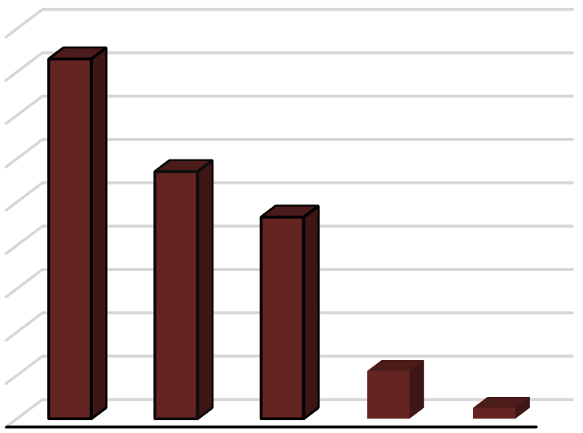

180

160

140

120

100

80

60

40

20

0

166

114

93

22

5

18-25 26-35 36-45 46-55 56 and

above

## Graph 4. 1:Age

The table presents age distribution data from a sample of 400 individuals. It indicates that the largest proportion falls within the 18-25 age range, comprising 41.5% of the sample. The subsequent age brackets show decreasing frequencies, with 26-35 constituting 28.5%, 36-45 at 23.3%, 46-55 at 5.5%, and individuals aged 56 and above at 1.3%.

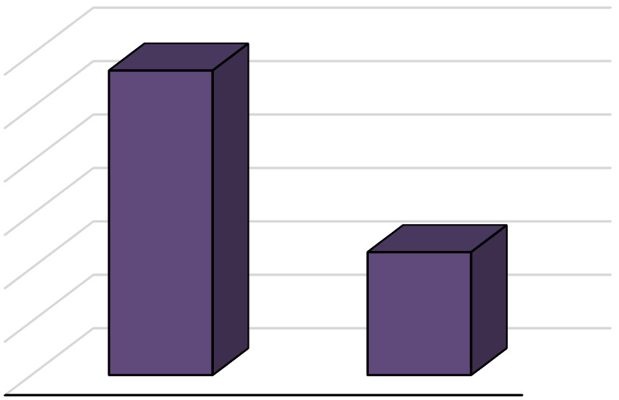

285

300

250

200

150

100

50

0

115

Male Female

## Graph 4. 2:Gender

The table presents data on gender distribution within a sample population of 400 individuals. It indicates that 71.3% of the respondents identify as male, while 28.7% identify as female. This suggests a notable gender imbalance, with males comprising a significantly larger proportion of the sample compared to females.

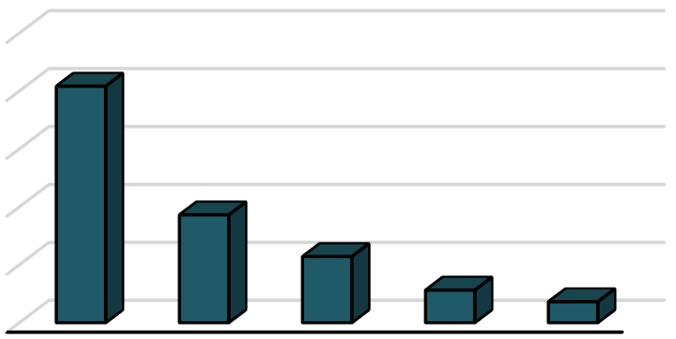

250

200

150

100

50

0

204

93

57

28

18

## Graph 4. 3:Educational Qualification

The table illustrates the educational qualifications of a sample population, with a total of 400 individuals surveyed. Among them, 51% possess a High School Diploma or equivalent, making it the most common qualification. Bachelor's Degrees follow, representing 23.3%, followed by Master's Degrees at 14.2%, and Doctoral Degrees at 7.0%. A small proportion, 4.5%, holds qualifications categorized as 'Other'.

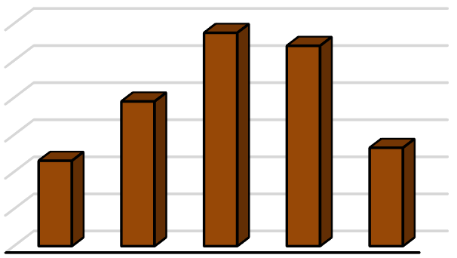

120

100

80

60

40

20

0

115

108

78

46

53

Less 1-5 6-10 11-15 16

than 1 years years years years year and

above

## Graph 4. 4:Years of Experience in Construction Industry

The table illustrates the distribution of years of experience within the construction industry among a sample of 400 individuals. The majority of respondents have 6-10 years (28.7%) and 11-15 years (27.0%) of experience, indicating a substantial portion of seasoned professionals. Conversely, those with less than 1 year of experience represent the smallest proportion (11.5%), suggesting fewer newcomers.

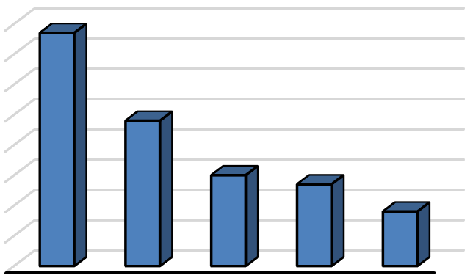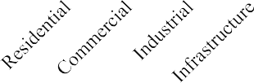

154

160

140

120

100

80

60

40

20

0

96

60

54

36

## Graph 4. 5:Type of Construction Work

The table presents the distribution of different types of construction work based on frequency and percentage. Residential projects constitute the highest proportion at 38.5%, followed by commercial (24.0%) and industrial (15.0%) constructions. Infrastructure projects account for 13.5%, while other types comprise 9.0% of the total.

## Table 4.6:Reliability Statistics

|  |  |
| --- | --- |
| Cronbach's Alpha | N of Items |
| .960 | 42 |

A reliability test on a scale with 42 items showed a Cronbach's Alpha coefficient of .960 out of 400 valid cases, indicating exceptional internal consistency. This suggests strong reliability, ensuring consistent and accurate measurement of the underlying construct. Researchers can confidently use this scale for assessing variables.

# CONCLUSION

In conclusion, effective safety management and accident prevention measures are crucial in construction projects to protect workers and minimize the consequences of accidents. The study highlights scaffold accidents as significant contributors to fatalities, stressing the importance of proper usage and erection. Demographic analysis reveals insights into the construction workforce, including age, gender distribution, educational qualifications, and experience levels. Reliability testing demonstrates strong internal consistency in the survey. Leadership's impact on safety culture is generally positive, but improvements in communication and accountability are needed. Overall, fostering a sustainable safety culture, implementing control measures, and adhering to safety standards are vital for accident prevention and a secure working environment in the construction industry. Implementation of identified control measures, continuous improvement, and adherence to safety standards are crucial for accident prevention and creating a secure working environment for construction professionals.

# REFERENCES

* 1. Massey, A. & Walford, G. 1998. Children learning: Ethnographers learning, in Children learning in context edited by G. Walford & A. Massey. New York: JAI Press, pp. 1–18
  2. Barling, J., Loughlin, C., and Kelloway, K.K. (2002). Development and test of a model linking transformational leadership and occupational safety. Journal of Applied Physiol., 87; (488-496) 4. Barrett, G. 2000. Management’s impact on behavioural safety. Professional Safety, March, 50(3): 26–28.
  3. Winkler, C. (2003), CIRIA: Designing for Health and Safety, Wrexham, June 2003,p3.
  4. Davies, V.J and Tomasin, K (1996), Construction Safety Handbook, 2nd Edition, Thomas Telford Publishing, London.
  5. Nutt, B. Mclennan, P. and Walters, R (1998), Refurbishing Occupied Buildings: Management risk under the CDM Regulations. Thomas Telford, London.
  6. Poh, C. Q. X., Ubeynarayana, C. U., & Goh, Y. M. (2018). Safety leading indicators for construction sites: A machine learning approach. *Automation in Construction*, *93*(October 2017), 375–386. https://doi.org/10.1016/j.autcon.2018.03.022
  7. Shao, B., Hu, Z., Liu, Q., Chen, S., & He, W. (2019). Fatal accident patterns of building construction activities in China. *Safety Science*, *111*(September 2017), 253–263. https://doi.org/10.1016/j.ssci.2018.07.019
  8. Mohammadi, A., Tavakolan, M., & Khosravi, Y. (2018). Factors influencing safety performance on construction projects: A review. *Safety Science*, *109*(December 2017), 382–397. https://doi.org/10.1016/j.ssci.2018.06.017
  9. Winge, S., Albrechtsen, E., & Mostue, B. A. (2019). Causal factors and connections in construction accidents.

*Safety Science*, *112*(7491), 130–141. https://doi.org/10.1016/j.ssci.2018.10.015

.