**METAMORPHOSING PAPYRUS CIRCUITRY SUBSTRATE**

**MANIPULATION VIA ECOCENTRIC CUSTODIANSHIP**

**Mr. R. Saravanan 2, N. Kishore Kumar 1**

2Assistant Professor, Department of Computer Science and Applications, SCSVMV [Deemed to be University], Enathur, Kanchipuram

1PG Scholar, Department of Computer Science and Applications, SCSVMV [Deemed to be University], Enathur, Kanchipuram

**ABSTRACT**

The project embarks on a transformative journey to revolutionize traditional circuit board technology through the development of sustainable, paper-based alternatives. With a steadfast commitment to environmental responsibility, this endeavor seeks to minimize ecological footprints by harnessing the power of biodegradable materials. Leveraging cutting-edge image processing techniques, the project streamlines the analysis of circuit board designs and calculates precise ink requirements, optimizing the manufacturing process for efficiency and sustainability. Through rigorous testing and prototyping, the functionality, durability, and composting capabilities of the paper circuit boards are meticulously evaluated, ensuring they meet rigorous standards of performance and eco-friendliness. In collaboration with interdisciplinary experts, the project ventures into uncharted territories of materials science and electronics manufacturing, pushing the boundaries of innovation to achieve unprecedented levels of sustainability. Composting experiments shed light on degradation timelines, ensuring that the resulting materials pose no harm to the environment.

**Keywords:** Paper-based circuit boards, Machine Learning, Naive Bayes algorithm

1. **INTRODUCTION**

The world is at a critical juncture, facing unprecedented environmental challenges exacerbated by unsustainable consumption and production practices. Within the electronics industry, conventional circuit board manufacturing processes contribute significantly to these challenges, generating vast amounts of non-biodegradable waste and harmful pollutants. Recognizing the urgent need for change, this project sets out to pioneer a paradigm shift towards sustainable electronics manufacturing through the development of paper-based circuit boards. At the heart of this endeavor lies a commitment to environmental responsibility and innovation. By replacing traditional circuit boards with biodegradable alternatives, we aim to significantly reduce the ecological footprint of electronic devices, mitigating their impact on ecosystems and human health. Leveraging advancements in image processing technology, we streamline the design and production of paper circuit boards, optimizing efficiency and resource utilization. Through rigorous testing and prototyping, we assess the functionality, durability, and composting capabilities of the paper-based circuits, ensuring they meet or exceed industry standards. Collaborating with experts across disciplines, we explore novel materials and manufacturing techniques, pushing the boundaries of sustainable technology innovation. Composting experiments shed light on the degradation process of our paper circuit boards, confirming their environmentally benign nature. By prioritizing the development of eco-friendly conductive inks and substrates, we demonstrate our unwavering commitment to minimizing environmental impact throughout the entire product lifecycle. As we embark on this journey, we recognize the transformative potential of our work. By disseminating our findings and engaging with industry stakeholders, we seek to inspire widespread adoption of sustainable electronics manufacturing practices. Together, we can forge a path towards a more resilient and sustainable future, where technology and environmental stewardship converge to create lasting positive change..

**2.LITERATURE SURVEY**

1. G. Montavon, S. Lapuschkin, A. Binder, W. Samek, and K.-R. Muller(2017) . This method addresses the "black box" nature of deep neural networks (DNNs) by breaking down the classification decisions into contributions from individual input elements, making the decision-making process of DNNs more interpretable.

2. S. Dutta, X. Chen, and S. Sankaranarayanan(2019). The paper proposes a novel technique that combines Taylor model-based flowpipe construction with regression-based polynomial mapping to overapproximate reachable sets of neural feedback systems.

3. D. Balduzzi, B. McWilliams, and T. Butler-Yeoman(2017) .The paper introduces a theoretical framework for analyzing rectifier networks using Taylor series approximations, which helps to elucidate the behavior of these networks during training and their convergence properties.

4. D. Guo, Z. Nie, and L. Yan(2017). The paper introduces a discrete-time Zhang neural network (DTZNN) specifically designed for time-varying matrix inversion, which utilizes a novel numerical difference rule based on Taylor series expansion​ (MDPI)​.

5. A. S. Gaikwad and M. El-Sharkawy(2018). The paper is well-received for advancing the field of neural network compression and pruning, offering a valuable tool for researchers and practitioners aiming to optimize neural network architectures for efficiency without compromising their capabilities.

**3.OBJECTIVES**

The primary purpose of the system is to address environmental concerns associated with traditional circuit board manufacturing by introducing biodegradable paper-based alternatives. By utilizing sustainable materials and manufacturing processes, the system aims to significantly reduce the generation of non-biodegradable electronic waste, contributing to global efforts towards waste reduction. Through efficient design and production processes facilitated by image processing technology, the system optimizes resource utilization, minimizing material waste and energy consumption.

**4.PROPOSED SYSTEM**

The existing system of paper circuit boards represents a significant departure from traditional manufacturing methods, offering a sustainable and environmentally friendly alternative to conventional circuit boards. At the heart of this system lies the use of paper as a substrate, a renewable and biodegradable material that reduces the environmental impact of circuit board production and disposal. Unlike traditional circuit boards, which rely on non-biodegradable materials such as fiberglass and epoxy resins, paper circuit boards minimize waste accumulation and environmental pollution. One of the key advantages of paper circuit boards is their versatility and adaptability to various applications, from consumer electronics to educational tools and wearable technology. By integrating conductive inks and adhesives into paper substrates, circuit patterns can be printed directly onto the surface, eliminating the need for complex and resource-intensive manufacturing processes. Moreover, paper circuit boards offer improved flexibility and lightweight characteristics compared to their traditional counterparts, making them ideal for applications where space and weight constraints are critical. This flexibility extends to design customization, allowing for rapid prototyping and iteration without the need for specialized equipment or expensive tooling. Another notable feature of paper circuit boards is their compatibility with existing recycling infrastructure, enabling easy and environmentally responsible disposal at the end of their lifecycle. Unlike traditional circuit boards, which often end up in landfills or incinerators, paper circuit boards can be recycledalongside other paper products, further reducing waste and conserving resources..Despite these advantages, the existing system of paper circuit boards is not without its limitations. One such limitation is the conductivity and durability of the conductive inks used in printing circuits, which may not match the performance of traditional metal traces in certain applications. Additionally, the moisture sensitivity of paper substrates can pose challenges in humid environments, affecting the reliability and longevity of electronic devices. Furthermore, the relatively low temperature resistance of paper materials may limit the operating conditions of paper circuit boards in high-temperature environments or industrial applications. Addressing these limitations requires ongoing research and development efforts to improve the performance and reliability of paper-based electronics while maintaining their sustainability and environmental benefits. Overall, the existing system of paper circuit boards represents a promising step towards a more sustainable and environmentally friendly electronics industry, offering innovative solutions to complex challenges in manufacturing and design.

**5.CLASS DIAGRAM**

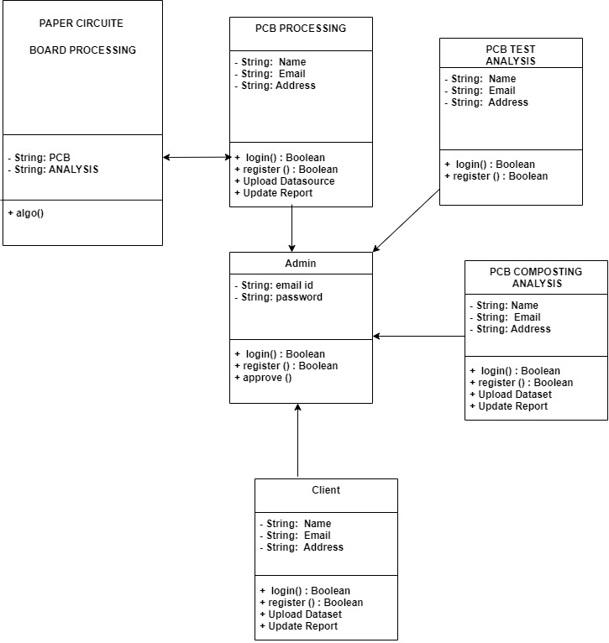

**Figure 1: Class Diagram :** Shows the classes and their relationships in the system design. Provides a structural view of the systems architecture**.**

**6.SYSTEM ARCHITECTURE**

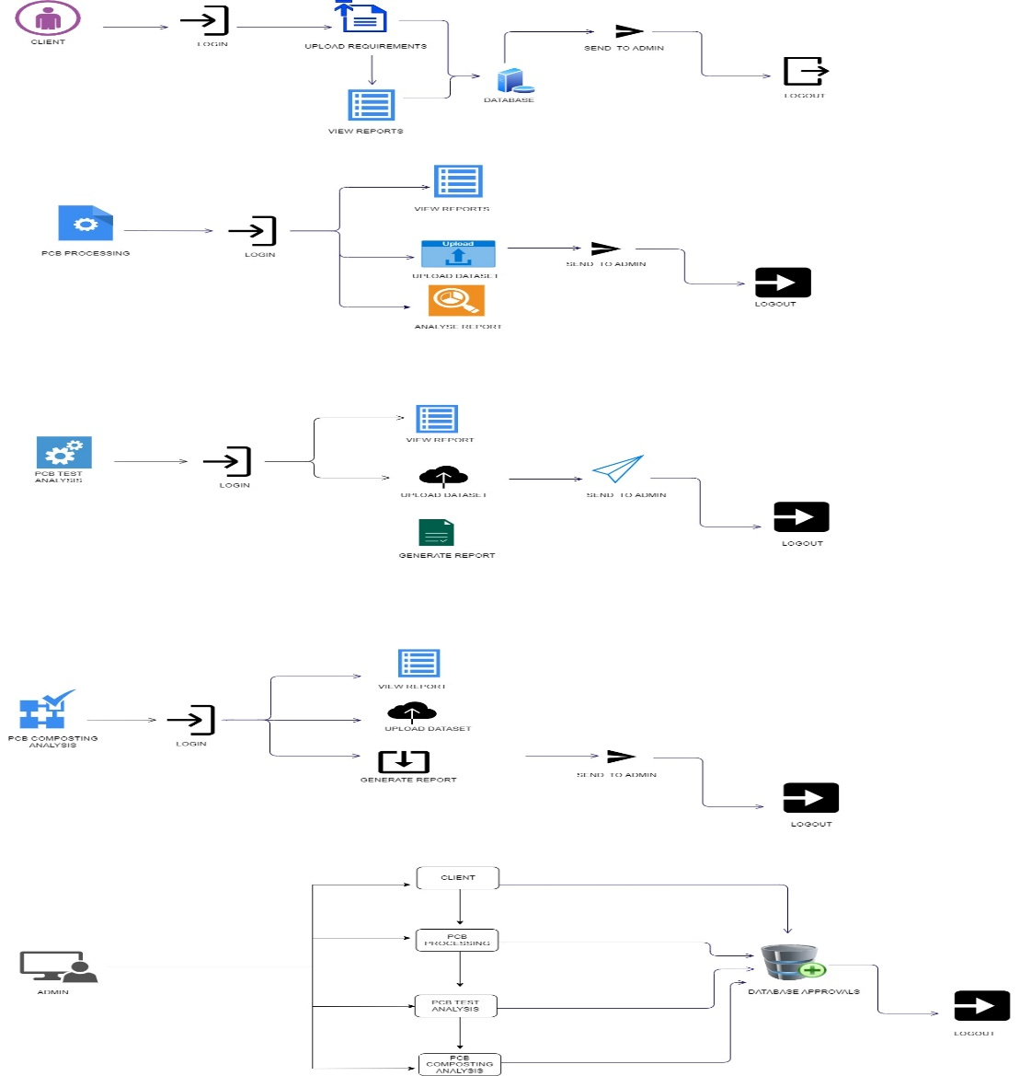

**Figure 2: System Architecture: Illustrates the overall architecture and flow of the system depicts the various modules and their interactions.**

**7.MODULE DESCRIPTION**

**CLIENT:**

The client can conveniently review reports generated by PCB Processing and PCB Test Analysis, providing valuable insights into the materials and testing results. The module also facilitates secure financial transactions, enabling clients to make payments upon receiving pay slips from the Admin. This interactive platform fosters a transparent and collaborative relationship between clients and the PCB lifecycle, enhancing user engagement and satisfaction. Additionally, the Client Module acts as a communication hub, allowing clients to provide feedback and actively participate in the decision-making process. It ensures that clients are well-informed at every stage, promoting transparency and trust in the PCB development journey. The module is designed with an intuitive dashboard, providing a comprehensive overview of the entire product lifecycle, including current processing status, test analysis reports, and recommendations for composting. With a user-centric approach, the Client Module not only streamlines the submission of requirements but also enriches the overall experience by offering a collaborative platform where clients can contribute to the sustainable evolution of single-use PCBs. This fosters a sense of ownership and environmental responsibility among clients, aligning with the overarching goals of the project.

**PCB PROCESSING :**

The PCB Processing Module plays a pivotal role in transforming client specifications into tangible single-use paper circuit boards (PCBs). Upon receiving client requirements, the module engages in a systematic process of uploading datasets pertaining to PCB paper materials. This includes detailed information on fiber paper, wax, conductive inks, printing ink, electrolyte, and solder, ensuring a meticulous record of the materials used in the production of each PCB. The module employs advanced algorithms to process client requirements, optimizing the selection of materials and determining the precise quantities needed for the desired single-use PCBs. Once the processing is complete, the module logs out, generating comprehensive reports that encapsulate the chosen materials, quantities, and any other pertinent information. These reports serve as a valuable resource for clients to gain insights into the composition of their PCBs and contribute to the transparency of the manufacturing process. The PCB Processing Module not only ensures efficiency in material selection and quantity determination but also sets the foundation for the subsequent testing and composting phases in the PCB lifecycle.

**PCB TEST ANALYSIS :**

The PCB Test Analysis Module is a critical component in ensuring the reliability and performance of the single-use paper circuit boards (PCBs) produced in the PCB Processing phase. This module receives reports generated by the PCB Processing Module and focuses on evaluating the PCBs under various conditions. Upon accessing the system, the module reviews reports detailing the materials and quantities used in the PCBs. It then proceeds to upload comprehensive test data, including stress testing and reliability testing results. The collected data undergoes rigorous analysis, assessing the impact of environmental conditions and the repeating cycle of power on the PCBs. The module utilizes advanced algorithms to process the test data, generating insightful reports that provide a thorough understanding of how the PCBs perform in real-world scenarios. These reports include detailed findings on stress tolerance, reliability, and the overall environmental impact of the PCBs. The PCB Test Analysis Module serves as a crucial quality control checkpoint, ensuring that the single-use PCBs meet the required standards and exhibit robust performance. The valuable insights gleaned from this module contribute to informed decision-making in subsequent phases of the PCB lifecycle.

**PCB COMPOSTING ANALYSIS:**

The PCB Composting Analysis Module takes a forward-thinking approach to the end-of-life phase of single-use paper circuit boards (PCBs), emphasizing environmentally responsible disposal. This module receives reports from both the PCB Processing and PCB Test Analysis modules, consolidating information on the materials used and the performance of the PCBs under various conditions. Upon accessing the system, the module uploads datasets related to the composting of PCBs. This includes information on the biodegradability of materials used in the PCBs and recommendations on how to compost them after their useful life. The module processes client-specific PCB data, considering the environmental impact and the sustainable disposal of the materials. Utilizing advanced algorithms, the module generates comprehensive reports outlining best practices for composting single-use PCBs. These reports offer insights into eco-friendly disposal methods, fostering a circular economy approach. By providing clients with clear guidelines on composting their PCBs, this module ensures a responsible end-of-life strategy, aligning with the project's overarching goal of promoting sustainability throughout the entire PCB lifecycle.

**ADMIN:**

The Admin Module serves as the central control hub, overseeing and managing the entire lifecycle of single-use paper circuit boards (PCBs). This module is integral to the project's success, handling administrative tasks, ensuring transparency, and maintaining the efficiency of the PCB development process. Upon logging into the system, the admin manages log statuses, providing a comprehensive overview of the current workflow. The module plays a crucial role in approving reports generated by both the PCB Processing and PCB Test Analysis modules. Admin approval is a key step in validating the chosen materials, quantities, and the quality of the manufactured PCBs. Furthermore, the Admin Module is responsible for generating pay slips for clients based on approved products, facilitating secure financial transactions. It acts as the bridge between clients and the PCB development process, ensuring that clients receive accurate information and can make payments seamlessly. By maintaining a robust administrative workflow, the module enhances the overall efficiency of the project. Admin approval is the final checkpoint before clients receive their products, contributing to the reliability and credibility of the entire PCB lifecycle. The Admin Module thus plays a pivotal role in coordinating, approving, and streamlining the entire process for a successful and sustainable PCB development journey.

**8. FINAL REPORT:**

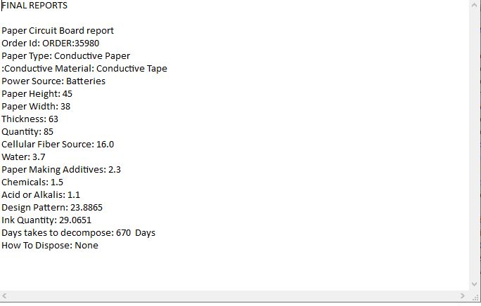

**9. CONCLUSION**

The environmental impact of traditional is significant, with their reliance on non-biodegradable materials and toxic chemicals contributing to pollution and resource depletion. However, the advancement of paper-based PCBs offers a promising solution, providing a sustainable alternative that minimizes waste and reduces environmental harm. By utilizing renewable paper substrates and eco-friendly conductive inks, paper-based PCBs mitigate the negative effects of electronics manufacturing on the environment while maintaining functionality and performance. Furthermore, the safety of advanced PCB materials and manufacturing processes is paramount, with a focus on eliminating hazardous substances and ensuring worker and consumer well-being. The shift towards greener PCB technologies not only benefits the environment but also promotes safer working conditions and healthier products for end-users. Looking ahead, future enhancements in PCB technology will continue to prioritize sustainability, safety, and innovation. This includes further research into biodegradable materials, development of more efficient recycling methods, and improvement of conductivity and durability in paper-based PCBs. Additionally, advancements in automation and digital design tools will streamline manufacturing processes, reducing energy consumption and improving resource efficiency. Ultimately, the future of PCBs lies in sustainable practices and responsible innovation. By embracing environmentally friendly materials and manufacturing techniques, we can create a more resilient and eco-conscious electronics industry that meets the needs of today without compromising the well-being of future generations.

**10.REFERENCES**

1. G. Montavon, S. Lapuschkin, A. Binder, W. Samek, and K.-R. Müller, “Explaining nonlinear classification decisions with deep Taylor decomposition,” *Pattern Recognit.*, vol. 65, pp. 211–222, May 2017

2. S. Dutta, X. Chen, and S. Sankaranarayanan, “Reachability analysis for neural feedback systems using regressive polynomial rule inference,” in *Proc. 22nd ACM Int. Conf. Hybrid Syst., Comput. Control*, Montreal, QC, Canada, Apr. 2019

3. D. Balduzzi, B. McWilliams, and T. Butler-Yeoman, “Neural Taylor approximations: Convergence and exploration in rectifier networks,” in *Proc. 34th Int. Conf. Mach. Learn.*, Sydney, NSW, Australia, vol. 70, Aug. 2017

4. D. Guo, Z. Nie, and L. Yan, “Novel discrete-time Zhang neural network for time-varying matrix inversion,” *IEEE Trans. Syst., Man, Cybern.,* *Syst.*, vol. 47, no. 8, pp. 2301–2310, Aug. 2017.

5. A. S. Gaikwad and M. El-Sharkawy, “Pruning convolution neural network (SqueezeNet) using Taylor expansion-based criterion,” in *Proc.* *IEEE Int. Symp. Signal Process. Inf. Technol. (ISSPIT)*, Dec. 2018

6. G. Lai, Z. Liu, Y. Zhang, and C. L. P. Chen, “Adaptive position/attitude tracking control of aerial robot with unknown inertial matrix based on a new robust neural identifier,” *IEEE Trans. Neural Netw.* *Learn. Syst.*, vol. 27, no. 1, pp. 18–31, Jan. 2016.

7. C. Huang, J. Fan, W. Li, X. Chen, and Q. Zhu, “ReachNN: Reachability analysis of neural-network controlled systems,” *ACM Trans. Embedded* *Comput. Syst.*, vol. 18, no. 5s, pp. 106:1–106:22, Oct. 2019

8. H. J. Sussmann, “Uniqueness of the weights for minimal feedforward nets with a given input-output map,” *Neural Netw.*, vol. 5, no. 4, pp. 589–593, Jul. 1992.

9. R. R. Bunel, I. Turkaslan, P. Torr, P. Kohli, and P. K. Mudigonda, “A unified view of piecewise linear neural network verification,” in *Advances* *in Neural Information Processing Systems*, S. Bengio, H. Wallach, H. Larochelle, K. Grauman, N. Cesa-Bianchi, and R. Garnett, Eds. Red Hook, NY, USA: Curran Associates, 2018