**Solar Wireless Electric Vehicle Charging System**

Saurabh Chirde, Vaishali Gayakwad, Rajat Varma, Prof Ankita Deogade

Department of Electronics and Communication Engineering,

Shri Sai College of Engineering and Technology Bhadrawati , Maharashtra, India

***Abstract: As the new era of the automobile, the industry is rapidly transforming from an IC engine vehicle to an electric vehicle. The demand for an electric vehicle is increasing, these lead to an increase in charging station as well. In this project, a wireless charging system is used to charge the vehicle wirelessly via inductive coupling. we just simply need to park the car on the charging spot. The transmission of electrical energy from source to load from a distance without any conducting wire or cables is called Wireless Power Transmission. The concept of wireless power transfer was the greatest invention by Nikola Tesla. This system doesn’t require any human interaction. Wireless power transmission might be one of the technologies that are one step towards the future. This project can open up new possibilities of wireless charging that can use in our daily lives.***

**Introduction:**

Energy crisis is one of the major problems that the world faces today. The energy crisis can be reduced to a certain extent by properly monitoring our energy consumption and avoiding energy wastage. Nowadays people face many problems like power theft. Power theft may be a measure crime and it also directly affects the economy of our country. This system will find energy theft easily. This IOT electricity meter is consisting of Atmega 328 microcontroller with a WIFI module for IOT connection and GSM module for mobile connection, on which users will receive information via SMS. This smart electricity meter also consists of a current sensor that sends the current reading to the microcontroller. We have to connect cell phones with the system via SMS which will help to configure with the system. In case of an emergency, the information will be shared on the configured number. We have to set costs for the unit and for which we have four buttons. With the help of buttons, we can set costs for the unit. As we start the system, it shows reading on the IOT screen. Reading will be changed with respect to time. In the case of energy theft, the theft will be caught and displayed on the IOT screen. Even the information will be received through SMS on the configured number. After receiving the alert, the operator can switch off the system using IOT to avoid theft. It also shares turn off the message of the system on the cell phone.

# Wireless Power Transmission (WPT)

Wireless Power Transmission (WPT) is the efficient transmission of electric power from one point to another point through a vacuum or an atmosphere without the use of wire or any other substance. This can be used for applications where either an instantaneous amount or a continuous delivery of energy is needed, but where conventional wires are unaffordable, inconvenient, expensive, hazardous, unwanted, or impossible. The power can be transmitted using Inductive coupling for short-range, Resonant Induction for mid-range and Electromagnetic wave power transfer for high range. WPT is a technology that can transport power to locations, which are otherwise not possible or impractical to reach. Charging the battery of electric vehicles by means of inductive coupling could be the next big thing.

**Objectives:**

The objective of this paper is to implement an electric vehicle wireless charging station and charging platform to transmit electrical power wirelessly through space and charge the battery of an electric vehicle. The system will work by using inductive coupling to transmit power from a transmitter to a resistive load or battery of an electric vehicle.

**Literature Review**

Supriyadi and Edi Rakhman. [1] demonstrate the effect of wire diameter (AWG) and a number of turns used is directly proportional to the amount of power that can be transferred. When the number of windings increases, more the power will be transferred. When we use the enameled copper wire of 0.5mm diameter and keep the number of turns to 26, and apply the input frequency of 470KHz. The power efficiency obtained at a distance of 1 cm is about 1.51%. This result can turn on 1 Watt LED lamp.

N.UthayaBanu and U.Arunkumar. [2] This study representing the various technologies related to Wireless Power Transfer System, which is used to avoid the flux leakage during the transmission of power and to operate the cars with high efficiency and improve the quality parameters. This project also shows the progress of generating power source through renewable energy.

Govind Yatnalkar and Husnu Narman. [3] present a survey of Duration of Charging of Electric Vehicles is limited. Therefore, wireless charging is important for Electric Vehicles in order to overcome the charging duration problem. This paper also provides a current scenario of the art in electric vehicle wireless charging and the parameters that require for charging section. The most important parameters for electric vehicle wireless charging are the distance between the transmission and reception coils, the position of the coils placed on Electric Vehicle, battery sizes, and the time for charging.

**Block Diagram**

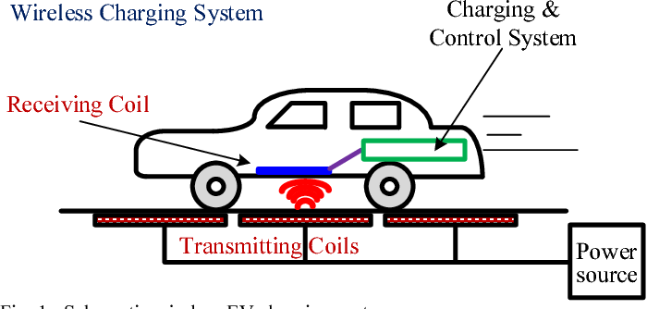

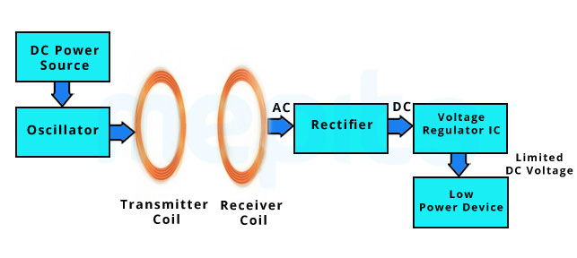

## Software Requirements

### Arduino IDE

The ATMega328p microcontroller IC with Arduino bootloader makes a lot of work easier in this project as Arduino code is written in C++ with an addition of special methods and functions, which we’ll mention later on. C++ is a human-readable programming language. When you create a ‘sketch’ (the name given to Arduino code files), it is processed and compiled to machine language.

The Arduino Integrated Development Environment (IDE) is the main text editing program used for Arduino programming. It is where you’ll be typing up your code before uploading it to the board you want to program. Arduino code is referred to as sketches.



Figure 1: Arduino IDE

## MAJOR HARDWARE COMPONENTS

**Arduino Nano**

"The Arduino Nano is a small, complete, and breadboard-friendly board based on the ATmega328P released in 2008. It offers the same connectivity and specs of the Arduino Uno board in a smaller form factor. The Arduino Nano is equipped with 30 male I/O headers, in a DIP30-like configuration, which can be programmed using the Arduino Software integrated development environment (IDE), which is common to all Arduino boards and running both online and offline. The board can be powered through a type-B mini-USB cable or from a 9 V battery."

## IR Sensor:

An infrared sensor is an electronic device, that emits to sense some aspects of the surroundings. An IR sensor can measure the heat of an object as well as detects the motion. These types of sensors measure only infrared radiation, rather than emitting it that is called a passive IR sensor. Usually, in the infrared spectrum, all the objects radiate some form of thermal radiation. These types of radiations are invisible to our eyes, which can be detected by an infrared sensor. The emitter is simply an IR LED (Light Emitting Diode) and the detector is simply an IR photodiode that is sensitive to IR light of the same wavelength as that emitted by the IR LED. When IR light falls on the photodiode, the resistances and the output voltages will change in proportion to the magnitude of the IR light received.

## Rechargeable Battery:

A rechargeable battery, storage, secondary battery, or accumulator is a type of electrical battery which can be charged, discharged into a load, and recharged many times, while a non-rechargeable or primary battery is supplied fully charged, and discarded once discharged. Several different combinations of electrode materials and electrolytes are used, including lead – acid, nickel cadmium (NiCd), nickel metal hydride (Ni-MH), lithium ion (Li-ion), and lithium-ion polymer (Li-ion polymer).

* Lead acid battery universal
* Voltage: 12 V
* Capacity: 1.3 Ah
* Dimensions: 151 mm x 65 mm x 95 mm



## Copper Coil

The wireless power transmission can be defined as, the energy can be transmitted from the transmitter to a receiver through an oscillating magnetic field.AC current back into DC current, that becomes working power. Wireless Power Transfer Circuit requires components of this circuit mainly include 20-30 magnet wire (gauge copper wire), A battery-1, transistor (BC548) and LED. The construction of this circuit comprises of a transmitter and a receiver.

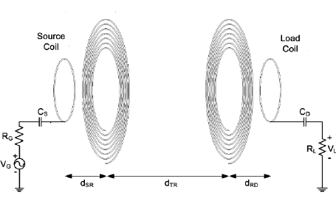

# Advantages

Environmentally Friendly – The most compelling reason to drive an electric vehicle is to help the environment. When compared to gasoline-powered vehicles, they do not emit poisonous emissions that pollute the air.

No Costs of Fuel or Gas – Because electric automobiles do not require fuel or gas to operate, consumers may avoid the escalating costs of these items. All you have to do now is connect and you'll be ready to travel the additional 100 miles.

## Conclusion

In this system, we are presenting the Wireless Power Transmission. As the electric vehicle in the market is increasing. We can use the wireless charging system to charge our vehicles. This system shows the efficiency and implementation of the charging station in future technology. Overall this paper compares various smart parking, charging and combined charging-parking system, which can help to solve various issues related with it. Also, it contains a table of comparison of various research paper. There are various types of methods and techniques used for parking and charging are discussed.

**Future Scope**

Based on policy guidelines and emerging technologies. This section should visualize the future of WEVC Today, the international EV list is growing exponentially. Under the trend of industrial prosperity, the two possible approaches to WEVC include how to ensure sustainable growth of EV ownership and how to allow full play of uncontrolled EV development. In addition, the emergence of new technologies, building materials and ideas can make WEVC even more competitive. Powerful electrical appliances can benefit from advanced features as well. First, apart from flux leakage, reversing losses are another major source of energy wastage in the WEVC system

# REFERENCES

1. Supriyadi, Edi Rakhman, Suyanto, Arif Rahman and Noor Cholis Basjaruddin, “Development of a Wireless Power Transfer Circuit Based on Inductive Coupling, “TELKOMNIKA, Vol.16, No.3, June 2018, pp. 1013~1018
2. N. uthaya Banu, U. Arun Kumar, A. Gokula Kannan, M.K. Hari Prasad and A.B. Shathish Sharma, “Wireless Power Transfer in Electric Vehicle by Using Solar Energy, “ Asian Journal of Electrical Sciences, Volume 7, Issue 1, January-June 2018
3. Govind Yatnalkar and Husnu Narman, “Survey on Wireless Charging and Placement of Stations for Electric Vehicles, “Conference: 2018 IEEE International Symposium on Signal Processing and Information Technology (ISSPIT), December 2018
4. Md M. RANA, WEI XIANG, Internet of Things Infrastructure for Wireless Power Transfer Systems, IEEE Access, volume 6, pp.19295-19303, 24 Jan 2018.IEEE
5. Sahil Rupani, Nishant Doshi, A review on smart parking using internet on things (IOT), The 3rd International Workshop on Recent advances on Internet of Things: Technology and Application Approches (IoT-T&A 2019) Nov 2019, Coimbra, Portugal.
6. Julian Timpner, Lars Wolf, A Back-end System for an Autonomous Parking and Charging System for Electrical Vehicles, International Electrical Vehicle Conference Greenville, SC, USA IEEE 2012
7. Mehmet Sukru Kuran, Aline Carnerio Viana, Luigi Iannone, Daniel Kofman, Gregory Mermound, Jean P. Vasseur, A Smart Parking
8. Adilet Sultanbek, Auyez Khassenov, Yerassyl Kanapyanov, Madina Kenzhegaliyeva, Mehdi Nagheri, Intelligent Wireless Charging Station for Electrical Vehicles, International Siberian Conference on Control and Communication, 2017, IEEE

### [9] Zhe Wei, Yue Li, Yongmin Zhang, Lin Cal, Intelligent Parking Garage EV Charging Scheduling Considering Battery Charging Characteristic, IEEE Transaction on Industrial Electronics, Vol 65, 3 March 2018