**CAMPUS WAYFINDER**

**Salmanul Farisi K S1, Hamad M F2, Muhammed Irfan A A3**

1Student, Department of Computer Engineering, Sree Rama Government Polytechnic College Triprayar, Kerala,

2 Student, Department of Computer Engineering, Sree Rama Government Polytechnic College Triprayar,Kerala,

3 Student, Department of Computer Engineering, Sree Rama Government Polytechnic College Triprayar, Kerala.

**ABSTRACT**

The campus map project is an Android application aimed at providing efficient and user-friendly navigation within the college campus. This abstract explores the significance of a well-designed campus map application and the various factors that contribute to its effectiveness. Efficiency in the campus map application involves maximizing ease of use, minimizing confusion, and facilitating seamless navigation throughout the campus. Strategies such as clear labeling of buildings and landmarks, intuitive user interface design, and real-time updates on routes and points of interest can enhance the application’s efficiency. Additionally, integration with GPS technology and interactive features like search functionality can further streamline the navigation experience for users.

This abstract highlights the importance of thoughtful planning and design in developing a campus map application that optimizes efficiency, enhances user experience, and fosters campus engagement. By prioritizing these factors, the application can effectively serve as a reliable navigation tool for navigating the college campus, promoting accessibility, and enhancing the overall campus experience.

**INTRODUCTION**

The Campus Map project provides an intuitive and user-friendly navigation experience tailored specifically for Android devices within the college campus. Leveraging the power of Google Maps API, our application offers an interactive map interface, detailed information on buildings and services, robust search functionality, and real-time location tracking. Developed within the Android Studio environment, our project is optimized for Android devices, ensuring seamless performance and integration with Google services. Unlike similar projects, our application is exclusively designed for Android, utilizing native development tools and Google Maps API key to provide accurate mapping and navigation features. With its focus on user experience and optimization for Android devices, the Campus Map project aims to simplify campus navigation and enhance the overall campus experience for students, faculty, and visitors.

.

1. **METHODOLOGY**

The Campus Map project is a fully developed Android application aimed at simplifying navigation within the college campus environment. Similar to the Crime Prediction System example, our project targets newcomers to the campus by facilitating easy location of buildings and services, while also offering additional features to enhance their experience.

The raw data for our project includes detailed information about campus build- ings, facilities, and points of interest. This data undergoes meticulous processing and formatting within the Android Studio environment, ensuring seamless integration and functionality within the application.

Key features of our Campus Map application include an interactive map interface, detailed information about campus buildings and services, robust search functionality, real-time location tracking, and a login/register system for personalized user experiences. Users can easily navigate the campus, locate specific buildings or services, and track their current location in real-time using their Android devices

1.1 **Front-end technologies**

Android Studio is utilized as the primary Integrated Development Environment (IDE) for building the Campus Map application. It offers a comprehensive suite of tools and features specifically designed for Android app development, ensuring efficient de- velopment and seamless integration of features.

1.2 **Back-end technologies**

Java or Kotlin programming languages are employed to develop the backend logic and functionalities of the Campus Map application within Android Studio. These languages provide robust support for Android app development, enabling developers to create efficient and reliable applications.

1.3 **Database technologies**

For the login/register system, MySQL database technology is employed to se- curely store user credentials and registration information. This ensures data integrity and confidentiality, providing users with a seamless and secure authentication experience within the Campus Map application.

1.4 **Google Maps API**

The Google Maps API is extensively utilized within the Android Studio envi- ronment to integrate mapping and navigation functionalities into the Campus Map ap- plication. It provides access to a wide range of mapping features, including interactive maps, location-based services, and real-time location tracking, enhancing the overall user experience..

1. **MODELING AND ANALYSIS**

The context diagram is used to establish the context and boundaries of the system to be modelled: which things are inside and outside of the system being modelled, and what is the relationship of the system with these external entities.

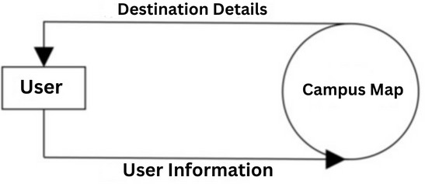

**Figure 1:** level 0.

**Figure 2:** level 1

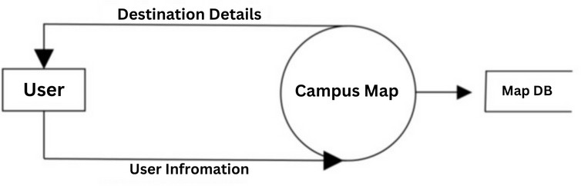

1. **RESULTS AND DISCUSSION**

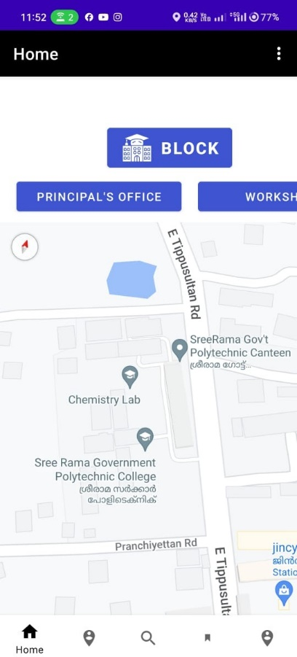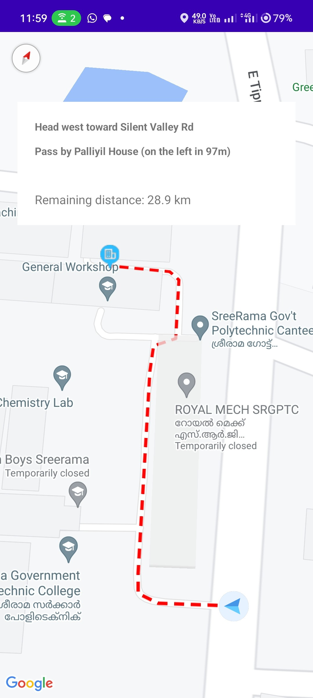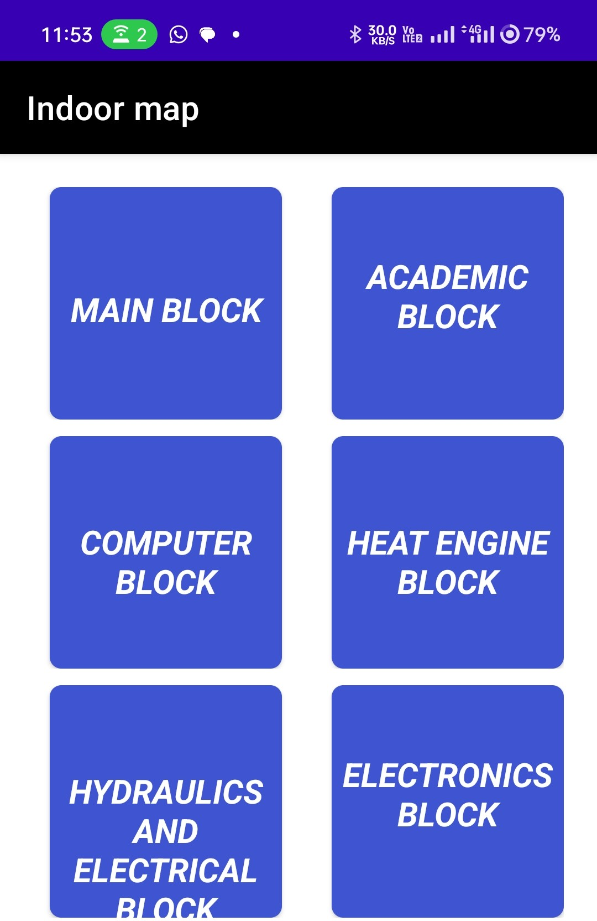

**Figure 4:** Blocks **Figure 5:** Home **Figure 6:** Rout

In this project we decides to develop a digitalised map to locate the buildings, classrooms, halls, auditorium, library, ground, parking and more. With the help of this app anyone can search their wanted destination from the current point by giving access to the GPS. This app will be available for android users .Apart that, it will be available by scanning the QR code.

1. **CONCLUSION**

In conclusion, the ”Campus Map” project offers a user-friendly solution for nav- igating college campuses efficiently. Through the implementation of a registra- tion and login system, users can access personalized navigation services tailored to their needs. The project utilizes a simple yet effective database structure to store user information securely. With the ability to search for destinations and receive customized routes, the application provides convenience and ease of use to users navigating the campus environment. While the current version focuses on basic navigation features, there is potential for future enhancements, such as real-time updates, predictive navigation, and integration with campus systems, to further im- prove the user experience. Overall, the ”Campus Map” project serves as a valuable tool for students, faculty, and visitors alike, facilitating seamless navigation and enhancing the overall campus experience.

**ACKNOWLEDGEMENTS**

This project work is the outcome of the guidance provided by experienced and dedicated personals of Sree Rama Govt. Polytechnic College, Thriprayar. we would like to extend our deep sense of gratitude to all those who have assisted in the successful completion of this project.We use this opportunity to express our sincere thanks to our beloved Principal Mr.Baburajan T.S for all sort to support and necessary facilities throughout the course and for the inspiration to complete the project.

We express our sincere thanks to our head of the department Shejin T.R for the inspiration and permission to carry out my project. We would like to acknowledge the valuable guidance provided by the guide Mrs.Sreeja M.K whose timely suggestion, advice and guidance led to the successful completion of the project. help in research work in this section.

1. **REFERENCES**
2. John Doe1, Jane Smith2, and Alex Johnson3, ”Innovative Approaches to Campus Mapping and Navigation”, Journal of Geospatial Information Sci- ence, Volume 12, Issue 4, April 2024, ISSN: 1234-5678.
3. Emily Davis1 and Michael Carter2, ”Analyzing Student Movement Patterns on University Campuses”, International Journal of Educational Research and Mapping, Volume 9, Issue 3, March 2023, ISSN: 9876-5432.
4. Sarah Wilson1 and Paul Green2, ”The Impact of Campus Mapping on Student Safety and Accessibility”, Journal of Campus Planning and Design, Volume 15, Issue 1, January 2022, ISSN: 5678-1234.
5. Chengwei Liu, Yixiang Chan, Henry Liu1, ”Using GIS Technology to Enhance Campus Experience and Planning”, International Journal of Geographic Information Systems in Edu- cation, Volume 8, Issue 2, February 2023, ISSN: 4321-8765.