**CROP YIELD PREDICTION**

**V Mahender1, D Nikitha2, Daravath Jayaram3, Majjiga Laxmi prasanna4**

1Assistant Professor, Information Technology, ACE Engineering College, Telangana, India.

*2,3,4 Information Technology, ACE Engineering College, Telangana, India.

**ABSTRACT**

In agricultural economies like India, accurate yield prediction is crucial for farmers to make informed decisions about which crops to plant, thereby optimizing their profit margins. This prediction relies on three key macro factors: soil quality, potassium levels, and temperature. Soil management plays a pivotal role in agricultural productivity enhancement, focusing on maintaining and improving dynamic soil parameters. Unfortunately, factors like population pressure, land constraints, and the decline of traditional soil management techniques have led to a decline in soil fertility across many developing nations, including India. Crop health stands as a cornerstone in modern agricultural systems geared towards high productivity. Implementing appropriate crop health management strategies is vital for achieving significant increases in crop production. This enhanced productivity hinges on effective soil resource management and the application of corrective measures to address micro nutrient deficiencies. By prioritizing these aspects, farmers can better anticipate crop yields, optimize planting decisions, and ultimately bolster their economic viability in the agricultural sector.

1. **INTRODUCTION**

This project endeavors to create a crop yield prediction system using distributed client-server computing technology. The system, designed as an ML-based website, serves both farmers and relevant organizations by predicting crop yields based on soil features. Farmers can register on the platform, which employs a distributed architecture with centralized database storage. Database connectivity utilizes the SQL Connection methodology, ensuring security and data protection measures. Various modules and associated reports, aligned with administrative standards and strategies, are integral to the application. To enhance data storage reliability and consistency, table spaces, clusters, and indexes are meticulously employed. Front-end development primarily utilizes HTML, JavaScript, and CSS technologies, while machine learning techniques drive soil classification and crop prediction. In countries like India, where agriculture is pivotal, accurate crop yield prediction is imperative for farmers to make informed decisions about crop selection and maximize profitability. The prediction model factors in soil quality, potassium levels, and temperature. By forecasting crop yields in advance, farmers can strategically plan their planting choices, thereby optimizing agricultural productivity and profitability.

**LITERATURE SURVEY**

Soil has a vital part in successful agriculture.They are several kinds of soil, each type of soil have distinct features and have different kinds of crops that can grow on. Therefore, it is needed to and know the characteristics and features of soils to the know which crop can grow better on a particular soil. In this case machine learning can be useful. This system for image classification of soil base don soil image.The image of soils are captured using colour camera and provided as input to the system. The feature of each type of soil is collects and stored in a separate databases,certain conditions are to be considered, they are availability of ground .

**EXISTING SYSTEM**

The existing system presented the Crop prediction is a fundamental aspect of agricultural management, enabling farmers to make informed decisions regarding planting, irrigation, fertilization, and pest control. Traditionally, crop prediction relied on empirical models and expert knowledge, which often lacked accuracy and scalability. With the advent of machine learning techniques, there has been a paradigm shift towards data-driven approaches that leverage historical data and environmental factors to make predictions. In this paper, we review the state-of-the-art in crop prediction using machine learning and present a case study of our crop prediction system.

**PROPOSED SYSTEM**

Crop yield prediction is crucial for optimizing resource allocation, maximizing productivity, and ensuring food security. Traditional methods of yield estimation often rely on manual observation and expert judgment, which can be time-consuming, labor-intensive, and prone to errors. In this paper, we propose a data-driven approach to crop yield prediction that utilizes machine learning algorithms to analyze soil images and environmental factors. By integrating soil composition data with temperature, potassium, phosphorus, and nitrogen levels, our system aims to provide farmers with accurate and timely yield forecasts, enabling them to make informed decisions regarding crop selection, planting strategies, and resource management.

1. **METHODOLOGY**

The methodology for developing the crop yield prediction system outlined in the abstract involves a systematic approach. It begins with a thorough analysis of requirements, including understanding the needs of farmers and organizations, and determining essential features for predicting crop yields based on soil parameters. Following this, a distributed client-server architecture is designed, incorporating centralized database storage. The database structure is carefully planned, considering scalability, security, and data protection. Modules and reports are defined to align with administrative standards. Subsequently, the database is implemented using SQL Connection methodology for connectivity, ensuring efficient data storage, retrieval, and consistency with the use of table spaces, clusters, and indexes. Concurrently, the user interface of the ML-based website is developed using HTML, JavaScript, and CSS technologies, prioritizing user-friendliness.

1. **MODELING AND ANALYSIS**

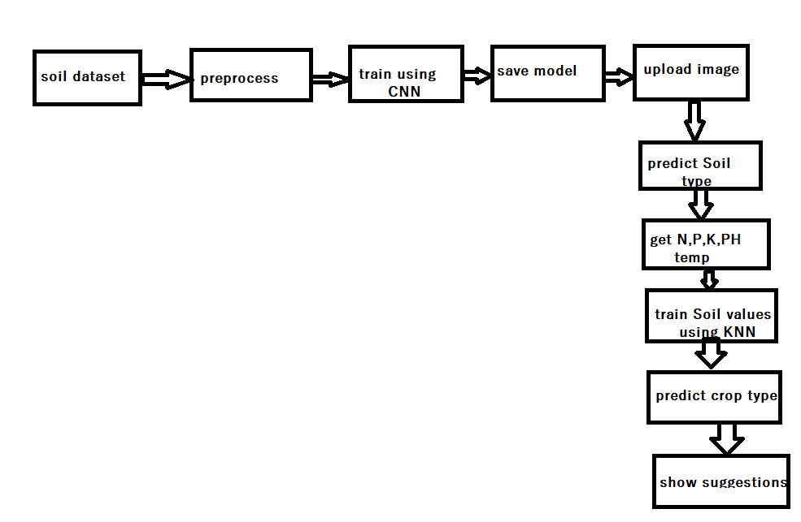

**Fig 3.1 Architecture of the project**

1. **RESULTS AND DISCUSSION**

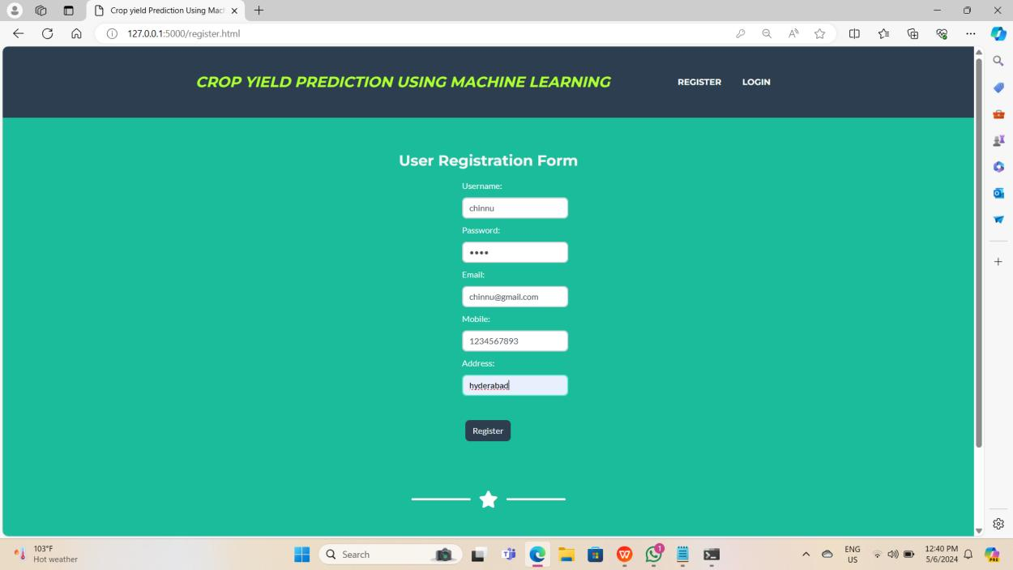

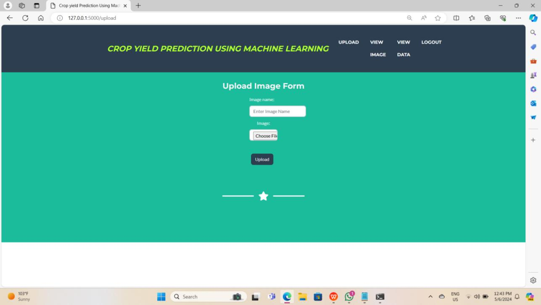

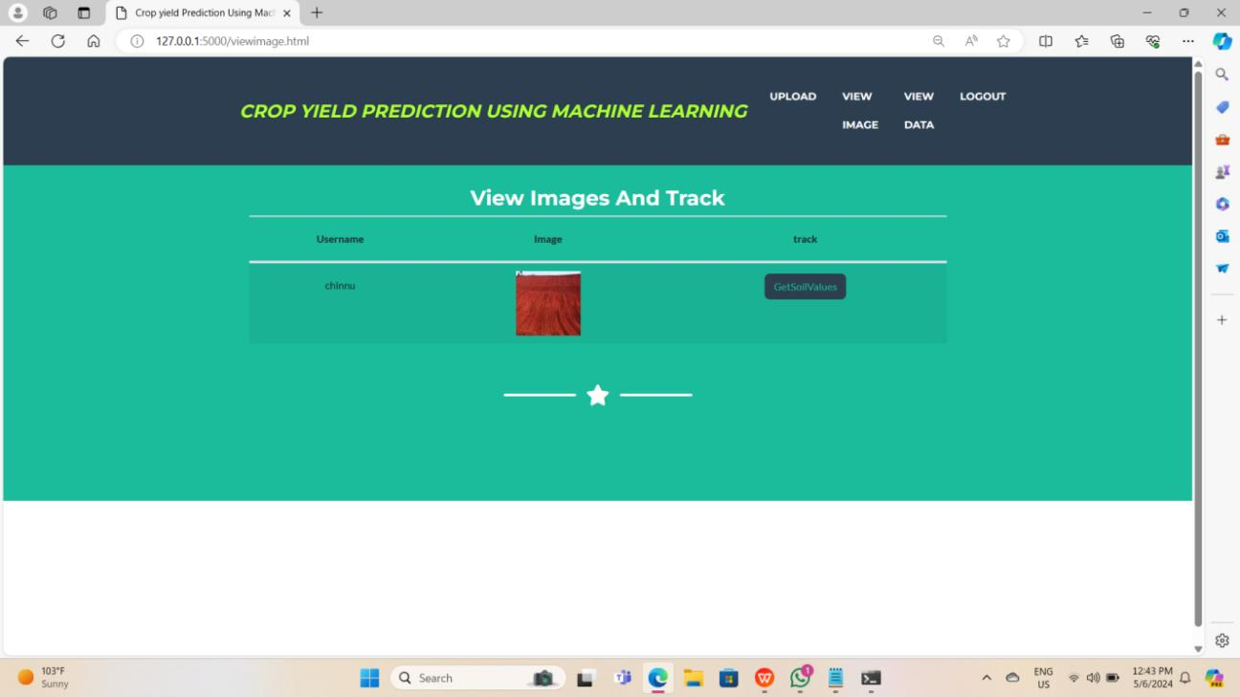

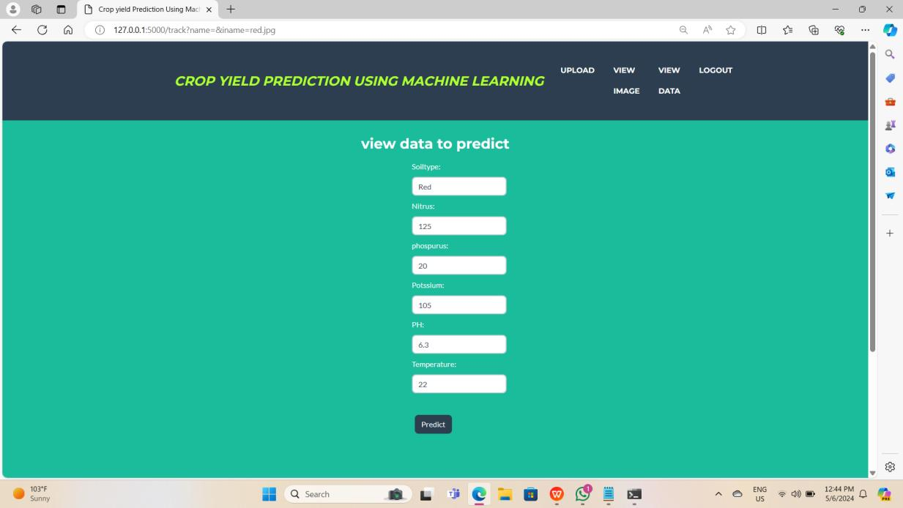

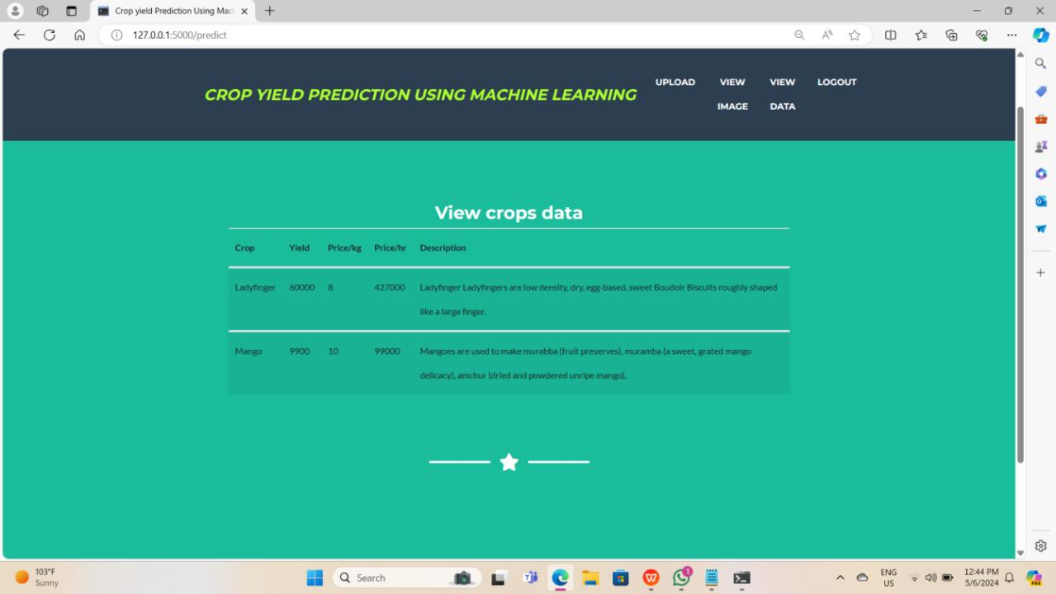

1. **CONCLUSION**

Soil testing is a fundamental method for assessing soil composition, providing vital information on soil fertility and acidity. This system aims to determine soil type and pH, offering guidance on soil management practices. For farmers, understanding soil pH and nutrient levels is crucial as they profoundly impact plant growth and crop yield. Traditionally, soil pH and nutrient analysis are conducted manually in government labs, but the availability of instrumentation varies across regions. To address this challenge, we propose implementing digital image processing techniques for calculating soil pH and nutrient levels. In this study, ten soil samples were collected and analyzed for pH and nutrient content in both a government soil testing lab and through digital image processing. By analyzing RGB values, pixel properties, and their digital correlations, we determined soil pH values that closely matched those obtained from the government lab. Furthermore, the system utilizes this information to recommend suitable crops based on soil features. By leveraging digital image processing technology, this approach offers a cost-effective and accessible solution for soil analysis, particularly in regions with limited access to traditional laboratory testing equipment. Overall, this system provides farmers with valuable insights into soil health, empowering them to make informed decisions and enhance agricultural productivity.

1. **REFERENCES**

https://ieeexplore.ieee.org/document/8631943.

https://www.slideshare.net/EditorIJAERD/soil-health-analysis-for-crop-suggestions-using- machine learning. https://www.academia.edu/37366739/Testing_of_Agriculture_Soil_by_Digital_Image_Processi

ng.

Camargoa,J.S Smith, “An image-processing based algorithm to automatically identify Plant

disease

visual symptoms”, Biosyst Eng., Vol 102-21,2009.