UNDERSTANDING ENVIRONMENTAL GOVERNANCE IN THE CONTEXT OF THE PHILIPPINES ENVIRONMENTAL IMPACT STATEMENT SYSTEM (PEISS)

**Edwin G. Bacalso, Jr.**

ORCID Number: 0009-0004-3889-1096

University of Southeastern Philippines, College of Development Management, Graduate School Program, Mintal Campus, Davao City.

# ABSTRACT

This study explored the intricacies of environmental governance within the context of the Philippines Environmental Impact Statement System (PEISS). It aims to identify the fundamental components of environmental governance within the PEISS framework, examine the interplay between these components and their effects on PEISS effectiveness, and offer insights into the strengths and limitations of PEISS in addressing environmental governance challenges in the country. The research employs a mixed-methods approach, utilizing online and manual surveys to gather data from 150 respondents with direct or indirect knowledge of PEISS. The results indicate that environmental governance within PEISS is influenced by three key factors: community and stakeholder engagement, impact assessment and management, and transparency and communication. These findings underscore the importance of integrating environmental considerations into development initiatives and the need for effective governance mechanisms to ensure sustainable development and environmental protection in the Philippines.

## Keywords:

Environmental Governance, Philippines Environmental Impact Statement System (PEISS), Sustainable Development, Environmental Protection, Environmental Management, Conservation Practice.

# INTRODUCTION

Amidst the traditional perspectives that often dissect environmental challenges through technical, managerial, or behavioral lenses, there is an emerging recognition of environmental governance as a comprehensive approach to addressing these complexities (Armitage et al., 2012; Lockwood et al., 2010; Ostrom, 1999). The growing interest in environmental governance has prompted research on a broad scale, from local to global. This research explores issues like resource scarcity, conflicts, fair allocation and access, and biodiversity conservation across different ecosystems (World Bank, 2017). This research's overarching and consistent revelation underscores the pivotal role of governance in either bolstering or undermining the efficacy of conservation and environmental management initiatives (Armitage et al., 2012; Lockwood et al., 2010; Ostrom, 1999).

Environmental governance is crucial to sustainable development, particularly in countries like the Philippines, where environmental degradation and climate change pose significant challenges (United Nations Development Programme, 2019). The Philippine Environmental Impact Statement System (PEISS) is a crucial mechanism for ensuring that environmental considerations are integrated into development projects. However, the effectiveness of PEISS in promoting sustainable development and environmental protection has its challenges (Department of Environment and Natural Resources, 2018).

Despite the importance of environmental governance in the PEISS framework, we need a complete understanding of what makes it work well (World Bank, 2017). The PEISS system has been criticized for needing to be more bureaucratic and effective at dealing with environmental issues (Philippine Daily Inquirer, 2020). Also, getting the public and stakeholders involved in the PEISS process is a big challenge (Civil Society Organizations, 2019). This study aims to fill these gaps by examining how environmental governance works within PEISS and determining what factors affect how well it works.

This study endeavors to investigate the intricacies of environmental governance within the context of the Philippines Environmental Impact Statement System (PEISS) through exploratory factor analysis. Its primary objective is to discern and analyze the core factors influencing environmental governance concerning PEISS implementation in the Philippines. Specifically, the research aims to identify the fundamental components of environmental governance within the PEISS framework, examine the interplay between these components and their effects on PEISS effectiveness, and offer insights into the strengths and limitations of PEISS in addressing environmental governance challenges in the country.

**METHODOLOGY**

This study adopted a quantitative research approach, utilizing both online surveys conducted through Google Forms and manual surveys distributed in Davao City, reaching 150 respondents with direct or indirect knowledge of the PEISS. The research instrument, a questionnaire, underwent validation by experts in the field before administration. Modern data collection processes, facilitated by platforms like Google Forms and Qualtrics, are highlighted, ensuring the continuity and quality of quantitative research outputs (Torrentira, 2020). Exploratory Factor Analysis (EFA) was then applied to identify critical factors, a commonly used technique in quantitative research for uncovering latent variables (Auerswald & Moshagen, 2019). The factors were visually represented and identified using a scree plot. These factors are analyzed using content analysis techniques to develop the resilience framework.

# RESULTS AND DISCUSSION

This section presents the study's findings derived from exploratory factor analysis (EFA) and their implications. The collected data undergoes rigorous analysis to identify significant patterns and trends through the EFA process. Subsequently, these results are situated within the context of existing research literature, enriching the understanding of the studied phenomenon. The overarching goal is to provide insights into the importance of the findings generated by EFA and their potential implications for guiding future research directions in the field.

The Kaiser-Meyer-Olkin (KMO) measure and Bartlett's Test of Sphericity are pivotal assessments for evaluating the suitability of data for factor analysis and identifying underlying factors influencing environmental governance within the Philippines Environmental Impact Statement System (PEISS). A KMO score of 0.926 indicates a high degree of correlation among variables, surpassing the recommended threshold for factor analysis.

Similarly, Bartlett's test yielded a significant result, rejecting the null hypothesis of no correlation among variables and affirming the presence of identifiable factors contributing to our understanding of environmental governance within PEISS. These findings underscore the appropriateness of our dataset for analyzing environmental governance dynamics. Further analysis, such as factor analysis or structural equation modeling, holds promise for delineating specific factors influencing environmental governance within PEISS and devising targeted strategies to enhance environmental management practices in the Philippines.

## Table 1. KMO and Bartlett's Test

|  |  |  |
| --- | --- | --- |
| Kaiser-Meyer-Olkin Measure of Sampling Adequacy | | .926 |
| Bartlett’s Test of Sphericity | Approx. Chi-Square | 4568.182 |
|  | df | 435 |
|  | Sig. | .000 |

Scree Plot. Figure 1 visually represents the total variance explained and the Eigenvalues graph, showing the importance of each component. The graph demonstrates a gradual decline of Eigenvalues, indicating the relative significance of each factor. This visual aid is crucial for determining the best number of factors to keep, significantly where the curve flattens.

The graph shows a flattening trend around component number 5, where Eigenvalues fall below 1. This is crucial because it indicates a decrease in importance. In our analysis, if items within a dimension drop below a minimum threshold, we discard that dimension. As a result, Eigenvalues for the first four factors are much higher than those for later factors, suggesting they play a more significant role in explaining the data.

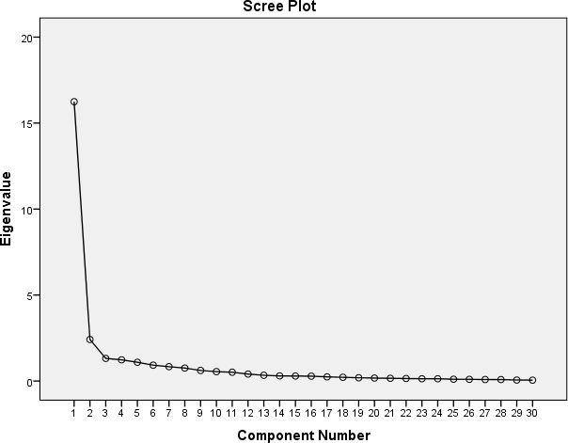

***Figure 1. Scree Plot***

## Component Matrix

The exploratory factor analysis (EFA) results are presented in three tables, each representing a distinct factor. These factors are derived from the IBM SPSS Statistics 21 software and are based on the common denominators of the attributes in the dataset.

Table 2 presents the attributes grouped under "Community and Stakeholder Engagement." The factor loadings, which range from 0.620 to 0.819, indicate the strength of the relationship between each attribute and the underlying factor. The attributes that load firmly on this factor are primarily related to community engagement, stakeholder involvement, and the importance of familiarizing oneself with the Philippine Environmental Impact Statement System (PEISS). These findings are consistent with the idea that effective environmental governance relies heavily on the active participation of local communities and stakeholders (Paavola, 2007; Armitage et al., 2012).

**Table 2. Rotated component matrix with grouped attributes of “**Community and Stakeholder Engagement.**”**

|  |  |  |
| --- | --- | --- |
| **Factor** | **Attributes** | **Loadings** |
| Community and Stakeholder Engagement | 7. Community engagement is crucial for the success of PEISS projects. | 0.819 |
| 8. Community events pertaining to environmental impact assessments must be publicly announced. | 0.817 |
| 5. Involvement of key stakeholders in the PEISS is important. | 0.795 |
| 1. Familiarity with the Philippine Environmental Impact Statement System (PEISS) is crucial for all people. | 0.789 |
| 2. Participation in consultations for projects requiring adherence to PEISS regulations is important. | 0.784 |
| 10. The purpose of project outreach within the PEISS framework must be reiterated during each outreach session. | 0.774 |
| 13. The PEISS can boost communication and outreach by incentivizing participation rather than resorting to bribery. | 0.773 |
| 20. It is important to be familiar with the key messages related to key audiences during PEISS projects. | 0.735 |
| 28. Hazardous waste management must be emphasized as a potential impact in PEISS assessments. | 0.641 |
| 14. Accessing information about PEISS projects poses a significant challenge. | 0.620 |
| 24. Urbanization is recognized as a significant impact within PEISS assessments. | 0.552 |

As presented in Table 3, the attributes are grouped under the "Impact Assessment and Management." The factor loadings, which range from 0.535 to 0.760, indicate the strength of the relationship between each attribute and the underlying factor. The attributes that load firmly on this factor are primarily related to assessing potential environmental impacts from various activities such as air pollution control, forest management, tourism development, and chemical pollution control. These findings are consistent with the idea that effective environmental governance involves carefully assessing and managing potential environmental impacts (Rockström et al., 2009; Stewart, 2001).

**Table 3. Rotated component matrix with grouped attributes of “**Impact Assessment and Management.**”**

|  |  |  |
| --- | --- | --- |
| **Factor** | **Attributes** | **Loadings** |
| Impact Assessment and Management | 25. The PEISS addresses the potential impacts of air pollution control on environmental assessments. | .760 |
| 26. The PEISS effectively addresses the potential impacts of forest management on environmental assessments. | .759 |
| 27. PEISS assessments address potential impacts stemming from tourism development. | .750 |
| 30. The PEISS effectively addresses the potential impacts of chemical pollution control on environmental assessments. | .748 |
| 21. The PEISS addresses the potential impacts of water resource management on environmental assessments. | .699 |
| 23. Potential impacts of energy production can be addressed in PEISS assessments. | .631 |
| 18. The PEISS effectively addresses the potential impacts of waste management on the environment. | .583 |
| 22. The PEISS effectively communicates the importance of biodiversity awareness. | .542 |
| 19. Environmental assessments effectively address the potential impacts of transportation projects. | .535 |

Table 4 presents the attributes grouped under "Transparency and Communication." The factor loadings, which range from 0.535 to 0.747, indicate the strength of the relationship between each attribute and the underlying factor. The attributes that load firmly on this factor are primarily related to the accessibility of information about environmental impact assessments, the effective communication of critical messages to the public, and the involvement of local communities in environmental decision-making. These findings are consistent with the idea that transparency and effective communication are essential to effective environmental governance (Lemos & Agrawal, 2006; Walter & Ugelow, 1979).

**Table 4. Rotated component matrix with grouped attributes of “**Transparency and Communication.**”**

|  |  |  |
| --- | --- | --- |
| **Factor** | **Attributes** | **Loadings** |
| Transparency and Communication | 4. Information about environmental impact assessments conducted under the PEISS is easy to access. | 0.747 |
| 9. The PEISS effectively communicates its key messages to the public. | 0.714 |
| 6. The PEISS adequately involves local communities in environmental decision-making. | 0.703 |
| 3. The PEISS effectively protects the environment in the Philippines. | 0.602 |
| 12. The PEISS addresses the concerns of affected communities during environmental assessments. | 0.586 |

# STUDY FRAMEWORK

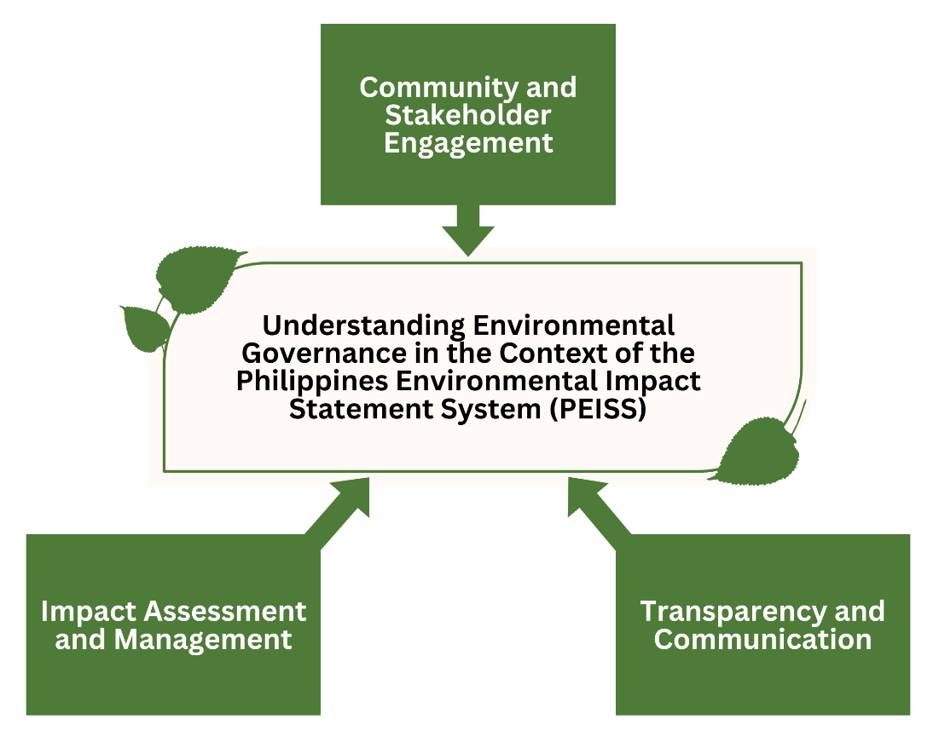

***Figure 2: Factors of Understanding Environmental Governance in the Philippines Environmental Impact Statement System (PEISS) Context.***

This was developed based on the study's findings that identified three factors: community and stakeholder engagement, impact assessment and management, and transparency and communication.

# ACKNOWLEDGEMENT

The author extends heartfelt gratitude to the study participants for their invaluable contribution by dedicating their time to completing the survey, which enabled the realization of this research. Sincere appreciation is also extended to the supportive families and friends whose unwavering encouragement fuels our academic pursuits. Furthermore, this research is dedicated to all individuals tirelessly striving and advocating for environmental preservation and sustainability, as their dedication inspires us to continue our efforts in understanding and protecting our environment.

# CONCLUSION

The study highlights the significance of environmental governance in the Philippines Environmental Impact Statement System (PEISS) and its role in promoting sustainable development and environmental protection. The findings emphasize the importance of community and stakeholder engagement, impact assessment and management, and transparency and communication in ensuring the effectiveness of PEISS. The study's results provide valuable insights into the strengths and limitations of PEISS and suggest that a comprehensive approach to environmental governance is necessary to address the country's complex environmental challenges. The study's findings can inform policy and decision-making processes, ultimately contributing to developing more effective and sustainable environmental management practices in the Philippines.

# REFERENCES

1. Armitage, D., de Loë, R., & Plummer, R. (2012). Environmental governance and its implications for conservation practice. Conservation Letters, 5(4), 245-255. doi:10.1111/j.1755-263X.2012.00238.x
2. Armitage, D., de Loë, R., & Plummer, R. (2012). Environmental governance and the public interest. Journal of Environmental Policy & Planning, 14(2), 147-164.
3. Auerswald, M., & Moshagen, M. (2019). How to determine the number of factors to retain in exploratory factor analysis: A comparison of extraction methods under realistic conditions. Psychological Methods, 24(4), 468–491. https://doi.org/10.1037/met0000200
4. Civil Society Organizations. (2019). Strengthening Environmental Governance in the Philippines. Retrieved from [https://www.civilsociety.org.ph/strengthening-environmental-governance-in- the-philippines](https://www.civilsociety.org.ph/strengthening-environmental-governance-in-the-philippines)
5. Department of Environment and Natural Resources. (2018). Philippine Environmental Impact Statement System (PEISS). Retrieved from https://[www.denr.gov.ph/peiss](http://www.denr.gov.ph/peiss)
6. Lemos, M. C., & Agrawal, A. (2006). Environmental governance. Annual Review of Environment and Resources, 31, 297-324.
7. Lockwood, M., Davidson, J., Curtis, A., Stratford, E., & Griffith, R. (2010). Governance principles for natural resource management. Society & Natural Resources, 23(10), 986-1001. doi:10.1080/08941920802178214
8. Ostrom, E. (1999). Coping with tragedies of the commons. Annual Review of Political Science, 2(1), 493-535. doi:10.1146/annurev.polisci.2.1.493
9. Paavola, J. (2007). Environmental governance and the role of local communities. Environmental Policy and Governance, 17(2), 123-136.
10. Philippine Daily Inquirer. (2020, January 15). PEISS: A Bureaucratic Red Tape. Retrieved from https://opinion.inquirer.net/124144/peiss-a-bureaucratic-red-tape
11. Rockström, J., Steffen, W., Noone, K., Persson, Å., Chapin III, F. S., Lambin, E. F., ... and Nykvist, B. (2009). A safe operating space for humanity. Nature, 461(7263), 472.
12. Stewart, R. B. (2001). A new generation of environmental regulation. Capital University Law Review, 29, 21.
13. Torrentira, M. C., Jr. (2020). Online data collection as adaptation in conducting quantitative and qualitative research during the COVID-19 pandemic. European Journal of Education Studies, 7(11), 78-84. DOI: 10.46827/ejes.v7i11.3336
14. United Nations Development Programme. (2019). Sustainable Development Goals Report 2019. Retrieved from <https://www.undp.org/content/undp/en/home/librarypage/sustainable-development-> goals/sustainable-development-goals-report-2019.html
15. Walter, I., & Ugelow, J. L. (1979). Environmental policies in developing countries. Ambio, 8(2), 102–109.
16. World Bank. (2017). Environmental Governance: A Review of the Literature. World Bank Policy Research Working Paper No. 8121. Retrieved from <https://openknowledge.worldbank.org/> handle/10986/28341