**IOT BASED MILITARY SURVEILLANCE ROBOT CONTROLLED FROM WEB**

**Mr. A. Rajesh*1, P. Shiva Krishna*2, K. Ajay Kumar*3, M. Bhanu Prasad*4**

1Assistant Professor, ACE Engineering College, Ankushapur, Telangana, India

2Student, ACE Engineering College, Ankushapur, Telangana, India

3Student, ACE Engineering College, Ankushapur, Telangana, India

4Student, ACE Engineering College, Ankushapur, Telangana, India

**ABSTRACT**

The project focuses on the development of an IoT-based military robot equipped with video surveillance capabilities for human detection and control via a web interface. The system utilizes a Raspberry Pi Zero Was the main controlling unit, along with a Pi Camera and an SD card for video input. Pi camera is used to capture the real time images and SD card is used to store and transfer digital data. Power is supplied by a 12V battery regulated by an LM2596 module. This LM2596 coverts the 12v to constant 5v. The output control for the robot's movement is managed by an L293D motor driver interfaced with DC motors. The web interface allows remote monitoring and control of the robot's movements, making it suitable for military applications such as reconnaissance and surveillance in hazardous environments.

**Keywords:** Analysis, investigation, research, military.

1. **INTRODUCTION**

The various and fast advancements in the field of Automation and Robotics, labor. A surveillance robot is a robot used for spying/monitoring purposes. Any remote/inaccessible areas can be monitored using surveillance robots. Surveillance is the method of systematic close observation of a person or area of suspicion. Surveillance is mainly required in the area of defense, intelligence gathering, disaster affected areas and in public places.

The main goal of this project is to design and develop a surveillance robot that can reduce the casualties in the war field.

The robot movement can be controlled by the user from web page using smart phone. This robot consists of pi camera which can be uses to send the live video to the user mobile over IOT. While seeing the video use can control the robot as well as laser light and BUZZER from web browser. Here laser light works as a gun to shoot the enemies. This Robot controlled by the user using IoT technology. Input and output modules are connected to the Raspberry pi zero W processor which has an inbuilt wi-fi. To achieve this task raspberry pi loaded program written in python language.

1. **LITERATURE SURVEY**

The integration of Internet of Things (IoT) technology with military video surveillance robots represents a significant advancement in defense and security systems. These systems leverage IoT to enhance situational awareness, automate surveillance processes, and improve response times in military operations. This literature survey explores various aspects of IoT-based military video surveillance robots, including their design, functionalities, challenges, and applications

* 1. **Functional Capabilities:**

Real-Time Video Streaming: Advances in video compression and transmission technologies allow for real-time streaming with minimal latency. H.264 and H.265 codecs are often employed to optimize bandwidth usage. Autonomous Navigation: Integration of GPS, IMU, and machine learning algorithms enables autonomous path planning and obstacle avoidance, enhancing the robot's operational efficiency in diverse terrains. Edge Computing: Deploying edge computing capabilities on robots allows for local data processing, reducing the reliance on constant internet connectivity and enabling faster decision-making.  
**2.2 Security and Privacy Concerns:**

Data Encryption: Ensuring secure transmission of video and telemetry data through end-to-end encryption methods such as AES-256 and RSA. Access Control: Implementing robust access control mechanisms to prevent unauthorized access to the robot and its data.

1. **MODELING AND ANALYSIS**

The IoT-based military video surveillance robot is built around a Raspberry Pi 2W, serving as its central processing unit and connectivity hub. Powered by a rechargeable battery pack, the robot's locomotion is facilitated by four DC motors, each controlled by a motor driver circuit. Mounted on the robot is a Pi Camera module, enabling high-resolution video capture of the surroundings. Operating on a lightweight Linux distribution, the Raspberry Pi hosts control software responsible for managing motor control, sensor data processing, and communication with the IoT platform. Utilizing standard IoT protocols such as MQTT or HTTP, the robot transmits sensor data and real-time video streams to the cloud for remote monitoring and control. Autonomous navigation algorithms enable obstacle avoidance and path planning, while users can remotely control the robot's movement and camera direction through the IoT platform. Challenges such as power management and network connectivity are addressed through efficient power optimization techniques and robust communication protocols. Overall, the integration of hardware components and software functionalities provides a versatile platform for enhancing situational awareness and security in military operations.

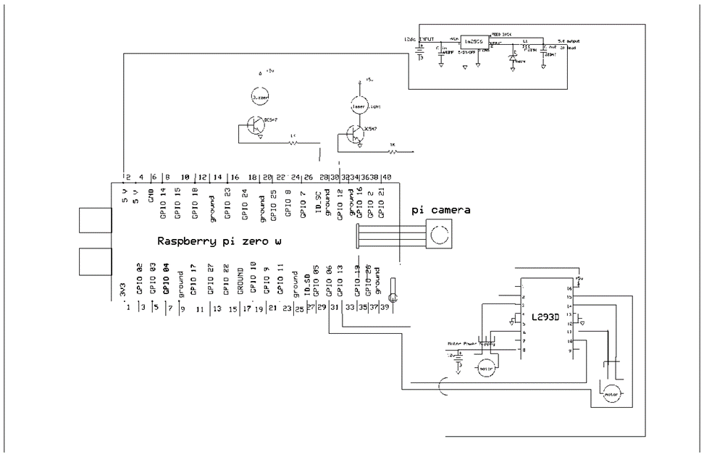

**Figure 1:** schematic diagram of IOT BASED MILITARY SURVEILLANCE ROBOT CONTROLLED FROM WEB

* 1. **Working:**
* The robot initializes by powering on and booting up its Raspberry Pi-based control system.
* Sensors, including a Pi Camera and other environmental sensors, continuously gather data about the robot's surroundings.
* Autonomous navigation algorithms analyze sensor data to detect obstacles and plan collision-free paths for the robot.
* The Pi Camera captures live video footage, which is processed and compressed for real-time streaming.
* The robot transmits the video stream to an IoT platform using protocols like MQTT or HTTP for remote access.
* Operators can remotely control the robot's movement and camera direction through the IoT platform.
* Sensor data, including video streams and telemetry information, is transmitted to the IoT platform for remote monitoring and analysis.
* After completing its mission or when battery levels are low, the robot initiates shutdown procedures.
* Maintenance tasks such as battery recharging and software updates are performed during downtime to ensure optimal performance.

1. **RESULTS AND DISCUSSION**

The robot begins its operation by powering on and booting up its control system, which is based on the Raspberry Pi platform. Sensors, including a Pi Camera and various environmental sensors, continuously collect data about the robot's surroundings. Autonomous navigation algorithms process this data to identify obstacles and devise collision-free paths for the robot to follow. Concurrently, the Pi Camera captures live video footage, which undergoes real-time processing and compression for streaming purposes. The robot then transmits this video stream to an IoT platform, utilizing protocols like MQTT or HTTP to facilitate remote access. Operators can remotely manage the robot's movements and adjust the camera direction through the IoT platform interface. Moreover, sensor data, encompassing video streams and telemetry information, is transmitted to the IoT platform for remote monitoring and in-depth analysis. Upon completion of its mission or when battery levels become low, the robot initiates shutdown procedures. During downtime, maintenance tasks such as battery recharging and software updates are conducted to uphold optimal performance levels.

* 1. **Software Used:**

Raspbian is a Debian-based computer operating system for Raspberry Pi. There are several versions of Raspbian including Raspbian Buster and Raspbian Stretch. Since 2015 it has been officially provided by the Raspberry Pi Foundation as the primary operating system for the family of Raspberry Pi single-board computers.Raspbian was created by Mike Thompson and Peter Green as an independent project. The initial build was completed in June 2012. The operating system is still under active development. Raspbian is highly optimized for the Raspberry Pi line's low-performance ARM CPUs.

Raspbian uses PIXEL, Pi Improved X-Window Environment, Lightweight as its main desktop environment as of the latest update. It is composed of a modified LXDE desktop environment and the Openbox stacking window manager with a new theme and few other changes. The distribution is shipped with a copy of computer algebra program Mathematica and a version of Minecraft called Minecraft Pi as well as a lightweight version of Chromium as of the latest version.

There are different types of Raspbian OS. Raspbian Jessie is one kind of OS using in our project

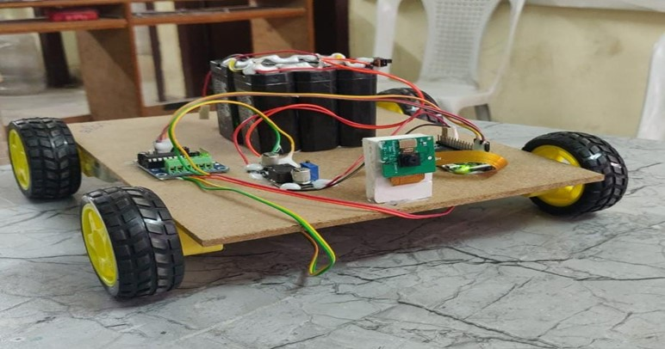

**Figure 2:** IOT BASED MILITARY SURVEILLANCE ROBOT CONTROLLED FROM WEB

1. **CONCLUSION**

In conclusion, the IoT-based military video surveillance robot presents a significant advancement in enhancing situational awareness and operational efficiency in military environments. By integrating a Raspberry Pi 2W, Pi Camera, and autonomous navigation capabilities, the robot provides real-time video streaming and remote-control functionalities that reduce risks to personnel and improve response times. While it offers numerous advantages such as cost-effectiveness, scalability, and enhanced surveillance, challenges like limited battery life, connectivity issues, and maintenance requirements must be addressed to ensure optimal performance. Overall, this project demonstrates the potential of IoT and robotics to revolutionize military surveillance, offering a promising solution for modern defense strategies.

* 1. **Future Scope:**

##### The future scope of the IoT-based military video surveillance robot is vast and promising. Advancements in artificial intelligence and machine learning can enhance the robot's autonomous navigation and object recognition capabilities, making it more adept at identifying potential threats and adapting to dynamic environments. Improvements in battery technology and energy management systems can extend the robot's operational duration, while advancements in communication technologies, such as 5G, can ensure more reliable and faster data transmission even in remote or hostile areas. Additionally, the integration of advanced sensors, such as thermal imaging and LIDAR, can expand its functionality for various military applications, including night surveillance and detailed terrain mapping. Future developments could also focus on miniaturization and ruggedization of components to enhance durability and operational efficiency in extreme conditions. With continuous innovation, this project has the potential to evolve into a more sophisticated and indispensable tool for military operations, providing enhanced security and strategic advantages.

1. **REFERENCES**

Shah, Mohammad Shoeb, and P. B. Borole. "Surveillance and rescue robot using Android smartphone and the Internet." 2016 International Conference on Communication and Signal Processing (ICCSP). IEEE, 2016.

G. Anandravisekar, A. Anto Clinton, T. Mukesh Raj, L. Naveen, M. Mahendran, “IOT based Surveillance Robot”. Department of Electronics and Communication Engineering Saranathan College of Engineering Trichy, Tamilnadu, India. “International Journal of Engineering Research & Technology (IJERT)”,2018.

S. Jagadesh, R. Karthikeyan, R. Manoj Prabhakaran, R. Ramesh and C. Shanmugam. "Surveillance Robot Using Microcontroller ESP8266". IJAREEIE Vol. 8, Issue 3, March 2019

Telkar, Aishwarya K., and Baswaraj Gadgay. "IoT Based Smart Multi Application Surveillance Robot." 2020 Second International Conference on Inventive Research in Computing Applications (ICIRCA). IEEE, 2020.

Sunitha, M., et al. "IP Based Surveillance Robot Using IOT." 2020 Fourth International Conference on I-SMAC (IoT in Social, Mobile, Analytics and Cloud) (I-SMAC). IEEE, 2020.