## ROLE OF NGOS TRANSFORMING LIVES THROUGH QUALITY EDUCATION AT MAGIC BUS INDIA FOUNDATION

**INTRODUCTION**

Transforming Lives through Quality Education" is an NGO dedicated to advancing the United Nations Sustainable Development Goal SDG 4 Quality Education. Our mission is to provide equitable and inclusive educational opportunities, empowering individuals to break the cycle of poverty and contribute to sustainable development. Making education a catalyst for positive change and a key driver towards achieving the SDGs.

Transforming Lives through Quality Education" encapsulates our commitment to empower individuals with the knowledge and skills needed for a brighter future. Through our initiatives, we strive to bridge educational gaps, promote inclusivity, and create opportunities that unlock the full potential of every learner. Together, let's build a foundation for lasting positive change.

Organization is dedicated to breaking barriers and fostering inclusive educational environments. By providing access to high-quality education, we aim to empower individuals, uplift communities, and contribute significantly to the realization of SDGs. Transformative journey where education becomes the cornerstone of positive change.

A quality education is one that focuses on the whole child-the social, emotional, mental, physical, and cognitive development of each student regardless of gender, race, ethnicity, socioeconomic status, or geographic location. It prepares the child for life, not just for testing.

Aims to ensure inclusive and equitable quality education and promote lifelong learning opportunities for all. This goal supports the reduction of disparities and inequities in education, both in terms of access and quality.

SDG 4 serves as a cornerstone in reducing inequalities by providing marginalized communities with access to quality education. India's efforts in this direction have led to a decline in wealth inequalities, with the decreasing from 35.9 in 2020 to 34.6 in 2023.

Education is not only a fundamental human right but also an essential tool for breaking the cycle of poverty and fostering sustainable development.

**INDUSTRY BACKGROUND**

The education industry plays a pivotal role in transforming lives by providing access to quality learning experiences. It empowers individuals, equipping them with knowledge and skills essential for personal and professional growth. As technology continues to advance, the industry adapts, offering innovative tools and platforms to enhance education accessibility worldwide. Through effective educational practices, individuals can overcome barriers, broaden their horizons, and contribute meaningfully to society.

The industry, especially through NGO initiatives, actively contributes to achieving Sustainable Development Goal 4 - Quality Education. NGOs play a crucial role in addressing educational disparities (SDG 4.1) and ensuring inclusive learning environments (SDG 4.5). They innovate teaching methods to meet SDG 4.4, emphasizing lifelong skills. NGOs engage communities to create localized impacts and forge partnerships to monitor progress (SDG 4 Targets). Together, they are pivotal in making quality education accessible and transformative, aligning with the broader vision of sustainable development.

**Accessible Learning Opportunities:**

Bridging Gaps in Quality Education

**Inclusive Education Practices:**

Fostering Diverse and Equitable Learning Environments

**Technological Integration for Impact:**

Innovations Shaping Educational Transformation

**Skills for a Lifetime:**

Empowering Individuals through Lifelong Learning

**Collaborative Initiatives:**

Industry Partnerships in Driving Educational Excellence

**Global Reach:**

These organizations operate on an international scale, addressing educational challenges and disparities across diverse regions. They often collaborate with local communities, governments, and other stakeholders to implement sustainable education initiatives.

**National scenario:**

NGOs operating at the national level align their efforts with SDG 4, focusing on key targets such as addressing educational disparities, promoting inclusive learning environments, and enhancing skills development. These organizations often tailor their interventions to the specific needs of the local population, working closely with communities and educational institutions. Through strategic partnerships with government bodies and local stakeholders, they contribute to the implementation of national education policies and initiatives.

**Regional scenario**:

In the realm of regional development, the transformative power of quality education is akin to a beacon illuminating the path towards progress. As communities prioritize and invest in educational initiatives, a profound metamorphosis occurs, touching the lives of individuals and shaping the trajectory of entire regions. Access to quality education becomes a catalyst for empowerment, breaking the chains of generational limitations.

Through a well-structured educational framework, individuals gain essential skills, fostering innovation and entrepreneurship that contribute to the socioeconomic upliftment of the region.

**Educational Empowerment Unleashed:**

In the paradigm of regional development, the unleashing of educational empowerment acts as a dynamic force, profoundly transforming lives and fostering sustainable progress. Through a commitment to quality education, individuals are equipped with the knowledge and skills necessary to navigate an ever-evolving world. This empowerment transcends traditional boundaries, breaking the shackles of limited opportunities and propelling individuals towards personal and collective success.

**COMPANY PROFILE**

**Company overview**

Magic Bus was founded in 1999 by Matthew Specie, a former advertising executive, with the aim of using sports to help children from impoverished backgrounds. The organization has since expanded to include a range of programs that focus on education, gender equality, and life skills development. Magic Bus operates in 22 states across India, reaching over a million children and young people annually.

**History**

The Magic Bus organization in India was founded in 1999 by Matthew Specie, a British national who was then working for the advertising agency Ogilvy & Mather in Mumbai. Specie was inspired to start the organization after seeing the impact of sports-based programs on street children in Rio de Janeiro, Brazil.

The organization's early focus was on using sports-based activities to teach life skills and provide education to underprivileged children living in Mumbai's slums. Over time, the organization expanded its programs and services to reach out to more children and youth across India, and to address a wider range of social and economic challenges.

Today, the Magic Bus organization is one of the largest poverty alleviation programs in India, with a presence in 22 states and 80 districts across the country. The organization has impacted the lives of over a million children and youth, and is recognized both nationally and internationally for its innovative and effective approach to empowering underprivileged communities.

In 2018, the organization underwent a significant restructuring, with a renewed focus on sustainable impact and a shift towards outcome-based programming. The Magic Bus organization continues to work towards its vision of a poverty-free India, where every child and youth is able to realize their full potential and lead a life of dignity and opportunity.

**NEED FOR THE STUDY**

• Studying is essential for quality education because it cultivates a thorough understanding of subjects, encourages active engagement with material, facilitates the development of critical thinking skills and fosters a lifelong passion for learning.

• Without study, education lacks depth and fails to prepare individuals for success in a rapidly evolving world.

Magic Bus India Foundation is a non-profit organization that works towards the education and holistic development of underprivileged children in India. There are several reasons why studying the operations and impact of Magic Bus India Foundation can be important

**OBJECTIVES OF THE STUDY**

**Primary:**

A study on role of Transforming lives through quality education strives to ensure that education is accessible to all peoples.

**Secondary:**

* To analyze Life skill development programs to youth to enhance their employability and economic prospects.
* To promoting gender equality by providing equal opportunities for boys and girls through sports and education programs.
* To community development beyond its core mission of using sports to empower children and youth magic bus India foundation.

**BOOT STRAPPING TECHNIQUE**

These bootstrapping techniques can help the NGO achieve its mission of transforming lives through quality education while operating within budgetary constraints.

**Grassroots Fundraising:** Organize events, crowdfunding campaigns, and outreach programs to raise funds from the community. In-Kind Donations: Seek donations of goods, services, and expertise instead of relying solely on monetary contributions.

**Grant Writing**: Research and apply for grants from foundations, government agencies, and international organizations that align with your mission.

**Cost-Effective Operations:** Keep overhead costs low by operating out of shared spaces, utilizing technology for communication, and recruiting skilled volunteers for specific tasks.

**Strategic Planning:** Develop a long-term strategy for sustainability, including diversifying revenue streams and building a strong donor base.

**Transparency and Accountability:** Demonstrate the impact of your work to donors and supporters to build trust and credibility.

**Community partnerships:** Forge alliances with local organizations, schools, and businesses to access resources and expertise.

**Crowd funding campaigns:** Launch online fundraising campaigns to gather financial support from a wide audience.

**In-kind donations:** Solicit donations of educational materials, books, and technology from individuals and businesses.

**Grant writing:** Invest time in researching and applying for grants from government agencies, foundations, and corporations.

**Resource sharing:** Collaborate with other NGOs to share resources, knowledge, and best practices.

**Online learning platforms:** Utilize free or low-cost online platforms to deliver educational content and training.

**MARKET ANALYSIS**

Market analysis for NGOs involves assessing the landscape of potential donors, partners, and beneficiaries. It includes identifying trends in philanthropic giving, understanding the needs of the community, and evaluating the competitive landscape to position the NGO effectively. Factors such as economic conditions, government policies, and societal attitudes towards social issues also play a crucial role. Conducting surveys, analysing data, and staying updated on industry news are essential for NGOs to make informed decisions and tailor their strategies to maximize impact and sustainability.

Conducting a market analysis for an NGO involves understanding the needs of the community it serves, identifying potential collaborators and competitors, assessing funding sources, analysing demographic data, and evaluating trends in social issues relevant to the NGO's mission. This comprehensive understanding helps the NGO make informed decisions about resource allocation, program development, and outreach strategies. Additionally, NGOs may conduct market analysis to assess the availability of funding and resources, understand regulatory frameworks, and anticipate potential risks or obstacles. This holistic approach enables NGOs to develop strategic plans, allocate resources effectively, and build sustainable partnerships to further their mission and achieve long-term success in their efforts to make a positive difference in society.

1. Target audience: Identify the specific demographic groups that Magic Bus India Foundation serves, such as underprivileged children from urban or rural areas. Understand their needs, challenges, and aspirations to tailor programs effectively.

2. Competition: Research other non-profit organizations or initiatives working in the field of education, youth development, and community empowerment in India.41Analyze their strengths, weaknesses, and unique selling points to differentiate Magic Bus India Foundation in the market.

3. Trends and Challenges: Stay updated on the latest trends, challenges, and developments in the social sector in India. This includes changes in government policies, funding opportunities, technological advancements, and societal attitude towards education and child welfare.

**DATA ANALYSIS**

**Levels if SDG monitoring:**

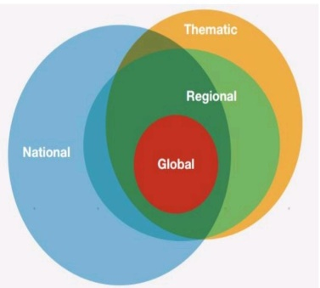

**National:**

Indicators that monitor nationally relevant education issues

**Regional:**

Indicators that monitor regionally relevant education issues (AU2063)

**Thematic:**

Indicators to cover education policy issues more comprehensively (43+ indicators)

**Global:**

Small set of leading indicators part of larger global framework (11+ indicators)

**Survey results:**

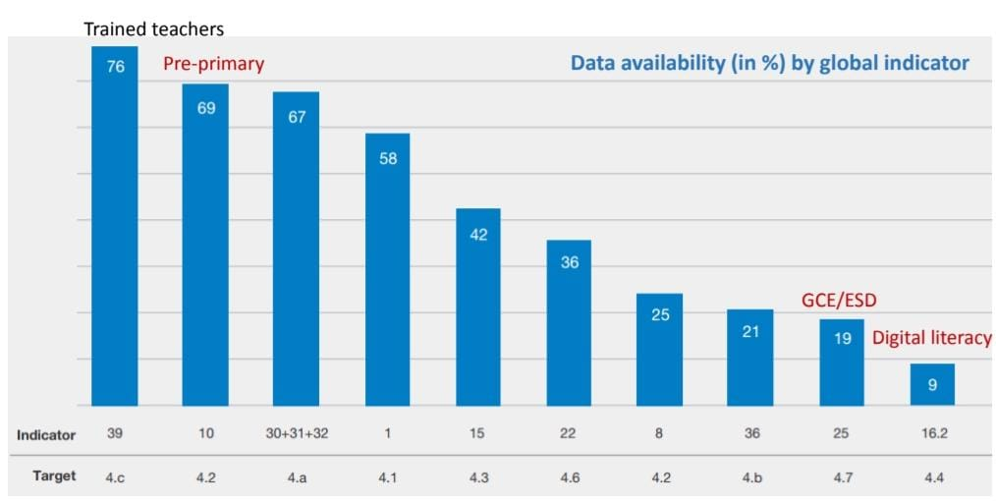

**Data availability by disaggregation is limited for specific markers of disadvantage**

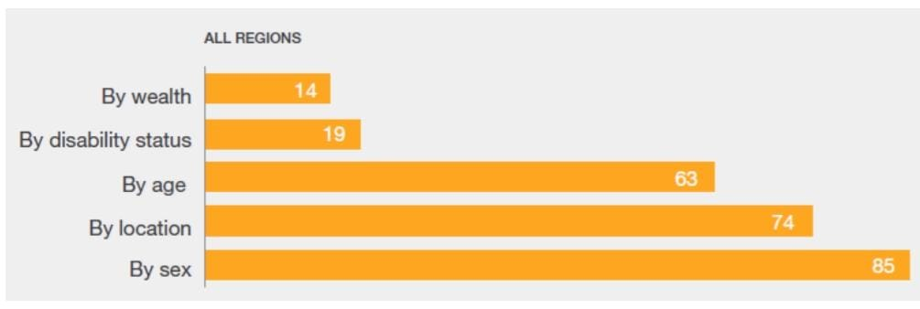

**Flows of data reporting,dssemination and development**

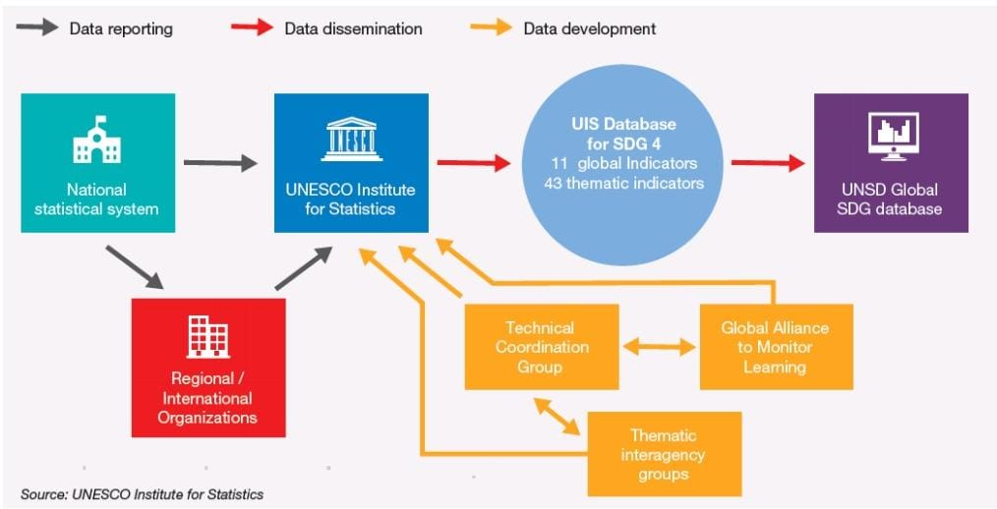

**Thematic indicators for dissemination and development**

A common thematic indicator for dissemination and development theory could be Knowledge Transfer and Adoption.This encompasses the dissemination of information, ideas, and technologies from sources of innovation to adopters, often in the context of development initiatives.

**FINDING AND SUGGESTIONS**

Magic Bus focuses on the holistic development of children and youth from marginalized communities through sports-based interventions.

They provide life skills education, including leadership, communication, and problem-solving, to empower children and youth to break the cycle of poverty.

* Magic Bus engages with communities to create awareness about issues such as education, health, and gender equality, fostering sustainable change.
* The foundation empowers young people to become role models and mentors within their communities, creating a ripple effect of positive change.
* Using sports as a tool for development, Magic Bus promotes physical health, teamwork, and personal growth among children and youth.
* They provide educational support, including scholarships, tutoring, and vocational training, to enhance opportunities for children and youth to succeed academically and professionally.
* Magic Bus advocates for policy changes and social inclusion to address systemic barriers faced by marginalized communities, aiming for long-term impact beyond their direct interventions.
* Prioritize investment in education at both the community and government levels to ensure access to quality education for all children, regardless of socioeconomic background.
* Encourage the integration of sports-based interventions in schools and community programs to foster holistic child development, including physical health, teamwork, and leadership skills.
* Provide opportunities for youth empowerment through skills training, mentorship programs, and leadership initiatives to enable them to become agents of change in their communities.
* Implement programs and policies that address gender disparities in education, health, and employment, promoting gender equality and empowering girls and women.

**CONCLUSION**

The Magic Bus India Foundation is dedicated to transforming lives through quality providing education and support to underserved communities, they empower individuals to break the cycle of poverty and achieve their full potential. In conclusion, their efforts contribute significantly to advancing global efforts to ensure inclusive and equitable quality education for all. The Magic Bus India Foundation stands as a beacon of hope in the realm of education, tirelessly working to transform the lives of underserved communities across the country Through their innovative sports-based curriculum and holistic approach, the foundation not only opens the doors of formal education to children from marginalized backgrounds but also equips them with essential life skills necessary for success in today's world. By prioritizing gender equality, community engagement, and rigorous monitoring and evaluation, Magic Bus ensures that their impact is meaningful and sustainable. Their advocacy efforts further amplify their influence, driving systemic change and fostering a future where every child has the opportunity to thrive academically and personally.