**PRODUCTIVE EMPLOYMENT FOR INCLUSIVE AND SUSTAINABLE DEVELOPMENT BY MAGIC BUS INDIA FOUNDATION**

**INTRODUCTION**

Productive employment for Inclusive and sustainable development decent work and economic growth. By focusing on productive employment, these NGOs contribute to fostering inclusive societies while safeguarding the environment for future generations. Through innovative programs and partnerships, NGOs are at the forefront of promoting fair labor practices, enhancing access to education and skills training, and empowering marginalized communities to participate meaningfully in the economy. This introduction sets the stage for exploring the transformative impact of NGO-led initiatives in driving inclusive and sustainable development under SDG 8.

In today's global landscape, the pursuit of inclusive and sustainable development stands as a paramount objective, encapsulated within the United Nations' Sustainable Development Goal 8 (SDG 8) - Decent Work and Economic Growth. At the heart of this goal lies the imperative of productive employment, a cornerstone for fostering equitable societies and safeguarding our planet's resources. In this endeavour, non-governmental organizations (NGOs) emerge as crucial actors, championing initiatives that not only generate employment opportunities but also ensure the participation of all individuals, including the most marginalized, in the economic sphere. Through collaborative efforts and innovative approaches, these NGOs serve as catalysts for transformative change, driving forward the agenda of inclusive and sustainable development. This introduction sets the stage for an exploration into the pivotal role of NGOs in advancing SDG 8 and promoting a future where prosperity is shared by all.

(NGOs) have emerged as key players in fostering productive employment opportunities worldwide. Through their tireless efforts, NGOs strive to ensure that economic growth benefits everyone, particularly marginalized communities and vulnerable populations. By focusing on creating jobs that are both socially inclusive and environmentally sustainable, these organizations play a critical role in advancing the broader agenda of sustainable development. This introduction sets the stage for an exploration of how NGOs contribute to the realization of SDG 8 by promoting productive employment practices that prioritize inclusivity and sustainability.

**INDUSTRY BACKGROUND**

NGOs operate within a landscape shaped by diverse industries, each with its unique challenges and opportunities concerning employment and sustainability. In sectors such as manufacturing, agriculture, services, and technology, NGOs play a crucial role in addressing labor rights violations, promoting fair wages, and advocating for environmentally responsible practices. For instance, in the garment industry, where labor exploitation and unsafe working conditions are prevalent, NGOs collaborate with stakeholders to implement ethical sourcing initiatives, ensuring that workers are treated fairly and provided with safe working environments. Similarly, in agriculture, NGOs work with smallholder farmers to enhance productivity through sustainable farming practices, thereby improving livelihoods and mitigating environmental degradation. Across various industries, NGOs leverage their expertise to bridge gaps in access to education and skills training, empowering marginalized populations to participate in the workforce and contribute to economic growth. By addressing systemic barriers to employment and advocating for policies that promote inclusivity and sustainability, NGOs play a pivotal role in shaping industry practices towards a more equitable and environmentally conscious future.

**Skills Development and Education:** Investing in education and vocational training programs is crucial for equipping individuals with the skills needed to thrive in the workforce. These initiatives should be inclusive and tailored to the needs of diverse populations, including vulnerable groups and those in remote or underserved areas.

Partnerships between governments, educational institutions, and private sector entities can facilitate the development of relevant skill sets aligned with industry demands, promoting employment inclusivity.

**Entrepreneurship and Innovation:** Supporting entrepreneurship and innovation fosters economic diversification and creates new opportunities for job creation, particularly for underrepresented groups such as women and minorities.

Access to finance, mentorship, and supportive regulatory environments are critical factors in enabling aspiring entrepreneurs to launch and sustain successful enterprises, contributing to inclusive economic growth.

**Global Reach:**

These organizations operate on an international scale, addressing educational challenges and disparities across diverse regions. They often collaborate with local communities, governments, and other stakeholders to implement sustainable education initiatives.

**National scenario:**

NGOs operating at the national level align their efforts with SDG 4, focusing on key targets such as addressing educational disparities, promoting inclusive learning environments, and enhancing skills development. These organizations often tailor their interventions to the specific needs of the local population, working closely with communities and educational institutions. Through strategic partnerships with government bodies and local stakeholders, they contribute to the implementation of national education policies and initiatives.

**Regional scenario**:

In the realm of regional development, the transformative power of quality education is akin to a beacon illuminating the path towards progress. As communities prioritize and invest in educational initiatives, a profound metamorphosis occurs, touching the lives of individuals and shaping the trajectory of entire regions. Access to quality education becomes a catalyst for empowerment, breaking the chains of generational limitations.

Through a well-structured educational framework, individuals gain essential skills, fostering innovation and entrepreneurship that contribute to the socioeconomic upliftment of the region.

**Empowerment Unleashed:**

In the paradigm of regional development, the unleashing of educational empowerment acts as a dynamic force, profoundly transforming lives and fostering sustainable progress. Through a commitment to quality education, individuals are equipped with the knowledge and skills necessary to navigate an ever-evolving world. This empowerment transcends traditional boundaries, breaking the shackles of limited opportunities and propelling individuals towards personal and collective success.

**COMPANY PROFILE**

**Company overview**

Magic Bus was founded in 1999 by Matthew Specie, a former advertising executive, with the aim of using sports to help children from impoverished backgrounds. The organization has since expanded to include a range of programs that focus on education, gender equality, and life skills development. Magic Bus operates in 22 states across India, reaching over a million children and young people annually.

**History**

The Magic Bus organization in India was founded in 1999 by Matthew Specie, a British national who was then working for the advertising agency Ogilvy & Mather in Mumbai. Specie was inspired to start the organization after seeing the impact of sports-based programs on street children in Rio de Janeiro, Brazil.

The organization's early focus was on using sports-based activities to teach life skills and provide education to underprivileged children living in Mumbai's slums. Over time, the organization expanded its programs and services to reach out to more children and youth across India, and to address a wider range of social and economic challenges.

Today, the Magic Bus organization is one of the largest poverty alleviation programs in India, with a presence in 22 states and 80 districts across the country. The organization has impacted the lives of over a million children and youth, and is recognized both nationally and internationally for its innovative and effective approach to empowering underprivileged communities.

In 2018, the organization underwent a significant restructuring, with a renewed focus on sustainable impact and a shift towards outcome-based programming. The Magic Bus organization continues to work towards its vision of a poverty-free India, where every child and youth is able to realize their full potential and lead a life of dignity and opportunity.

**NEED FOR THE STUDY**

* Productive employment provides individuals with opportunities to earn income, lifting them out of poverty and improving their quality of life.
* Access to decent work promotes social inclusion by providing marginalized groups, such as women, youth, persons with disabilities, and minorities, with equal opportunities for employment and economic participation.
* Through employment, individuals can develop valuable skills and expertise, enhancing their human capital and increasing their employability in the labor market.

**OBJECTIVES OF THE STUDY**

**Primary:**

* A study on role Productive employment for inclusive and sustainable development decent work and economic growth

**Secondary:**

* To analysing decent work policies and initiatives
* To analyse the significance of decent work and economic growth
* To promoting global trends in productive employment

**BOOT STRAPPING TECHNIQUE**

Bootstrapping technique in protective employment refers to the practice of creating job opportunities specifically tailored to individuals with disabilities or other barriers to employment.

**Community Needs Assessment:** Conducting thorough assessments to understand the specific skill gaps and employment opportunities within target communities.

**Tailored Skill Development:** Designing skill development programs based on identified needs, ensuring relevance and effectiveness in preparing individuals for employment.

**Resource Optimization:** Leveraging existing resources within communities, such as local expertise and infrastructure, to maximize the impact of employment initiatives.

**Empowerment through Education:** Integrating education components into employment programs to equip individuals with both practical skills and foundational knowledge for long-term success.

**Network Building:** Facilitating connections between program participants and potential employers or entrepreneurship opportunities.

**Continuous Learning and Adaptation:** Implementing a feedback loop to continuously assess program effectiveness and adapt strategies based on evolving community needs and market dynamics.

**Utilizing Local Resources:** Partnering with local vocational training centers or community colleges to provide skill development courses at affordable rate.

**Apprenticeship Programs:** Establishing apprenticeship programs with local businesses or industries.

**Microfinance Support:** Offering microfinance loans or grants to aspiring entrepreneurs within the community.

**MARKET ANALYSIS**

A market analysis focused on productive employment for inclusive and sustainable development, decent work, and economic growth involves a comprehensive examination of various factors shaping the labor market and employment opportunities. This analysis encompasses trends in employment rates, skills demand, and working conditions across different sectors and demographics. It also considers the inclusivity of employment practices, wage levels, and the impact of technological advancements on job creation and displacement. Moreover, the analysis evaluates the environmental sustainability of economic activities and the effectiveness of existing labor market policies and regulations. By engaging with stakeholders and identifying opportunities for collaboration, policymakers and businesses can develop strategies to promote inclusive growth, decent work, and long-term prosperity for all members of society.

Analyze trends in employment rates, job creation, and unemployment rates across different sectors and demographics. Identify sectors experiencing growth and those facing challenges in providing decent work opportunities.

Assess the alignment between skills demanded by employers and those possessed by the workforce. Identify gaps in education and training programs to ensure that individuals are equipped with the skills needed for productive employment in emerging industries.

Conducting a market analysis for Magic Bus India Foundation involves examining various aspects related to their operations, impact, and the broader landscape in which they operate. Here are some key points to consider:

1. Target Audience: Identify the specific demographic groups that Magic Bus India Foundation serves, such as underprivileged children from urban or rural areas. Understand their needs, challenges, and aspirations to tailor programs effectively.

2. Competition: Research other non-profit organizations or initiatives working in the field of education, youth development, and community empowerment in India.

**DATA ANALYSIS**

**Share of working age to total population in India from 2011 to2021, with projections for 2036**

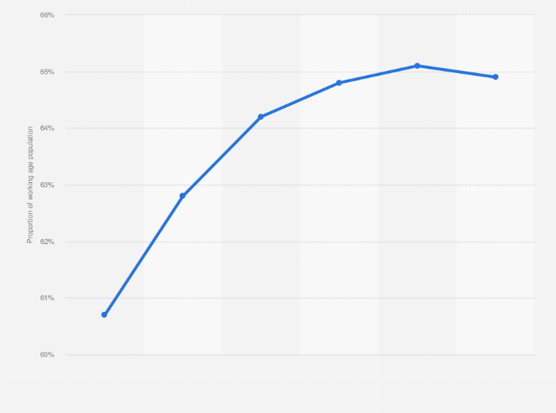

India's working-age population constituted over 60 percent of its total population in 2011 and was expected to grow until 2031. By 2036, a decline is expected in the share of working population from 65.1 percent in 2031 to 64.9 percent in 2036.

**Age distribution of the population in India from 2002 to 2024**

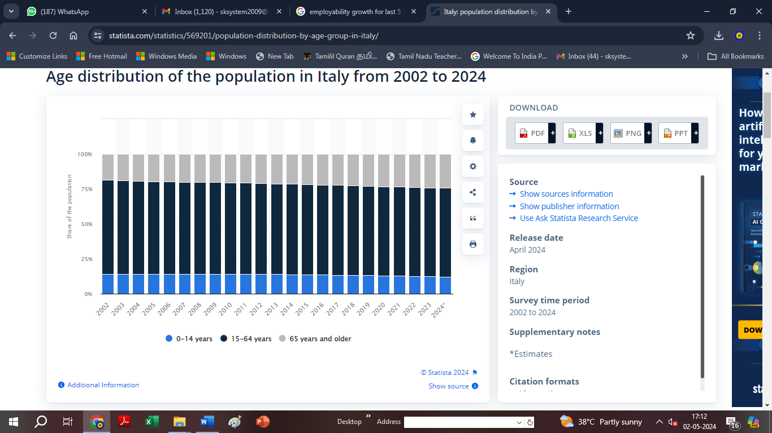

In the past years, the share of people aged over 65 years grew constantly in India. Estimates for 2024 report that 24.3 percent of the Indian inhabitants are aged 65 years and older. Moreover, 63.5 percent of the residents are predicted to be aged between 15 and 64 years and only 12.2 percent to be 14 years old and younger.

**FINDING AND SUGGESTIONS**

* Provide youth with employability skills training, including vocational training, entrepreneurship education, and job readiness programs, to enhance their ability to secure decent employment opportunities.
* Support marginalized communities in developing sustainable livelihoods through income-generating activities, microenterprise development, and access to financial services, contributing to poverty reduction and economic empowerment.
* Advocate for policies and initiatives that promote economic inclusion and equal opportunities for all, including marginalized groups such as women, persons with disabilities, and ethnic minorities.
* Address the challenges of youth unemployment by creating pathways to employment through skills development, internship programs, and job placement services, thereby reducing the risk of social exclusion and economic vulnerability.
* Promote social entrepreneurship among youth and community members, fostering innovation and sustainable business solutions to address local challenges and create positive social impact.
* Foster partnerships with government agencies, businesses, and civil society organizations to leverage resources, expertise, and networks in promoting economic growth, job creation, and sustainable development at the grassroots level.
* Implement skills development programs tailored to the needs of marginalized youth, focusing on areas with high demand in the local job market, such as technology, hospitality, and healthcare.
* Establish job placement services to connect trained youth with employment opportunities, including partnerships with local businesses and industries to facilitate recruitment and placement.

**CONCLUSION**

Magic Bus India Foundation's approach to promoting productive employment for inclusive and sustainable development stands out for its comprehensive and community-centered strategies. By employing purposeful sampling techniques, the foundation ensures that its programs target those most in need and have the greatest potential for impact. Through extensive community engagement, the foundation is able to understand the nuanced needs and aspirations of the communities it serves, allowing for the development of tailored programs that address these specific needs.The foundation's focus on data collection and monitoring and evaluation enables it to track the progress and impact of its programs, ensuring that they remain effective and responsive to the evolving needs of the community. By collaborating with local governments, NGOs, and other stakeholders, the foundation is able to create a holistic approach to employment generation that is sustainable and scalable.Moreover, the foundation's emphasis on capacity building and innovation ensures that its programs not only provide immediate employment opportunities but also empower individuals and communities to create sustainable livelihoods in the long term. Through these efforts, the Magic Bus India Foundation is not only promoting inclusive and sustainable development but also fostering a sense of agency and empowerment among the communities it serves, paving the way for a more equitable and prosperous future.