**A STUDY ON CAPITAL BUDGETING OF WESTWIND FOOD PROCESSING PRIVATE LIMITED**

**SRI PATHI P1, Mrs. R. RAAJALAKSHMI 2 Assistant Professor,**

Department of Management Studies, VELS Institute of Science, Technology & Advanced Studies (VISTAS), Chennai.

**Abstract:** This article provides a comprehensive analysis of capital budgeting, a critical process for firms in allocating resources to long-term investment projects. It explores the theoretical foundations and practical applications of capital budgeting techniques, including Net Present Value (NPV), Internal Rate of Return (IRR), and Payback Period. Additionally, the article examines the challenges and complexities involved in capital budgeting, such as risk assessment, uncertainty, and the consideration of qualitative factors. Furthermore, it discusses the strategic implications of capital budgeting decisions on firm performance, growth, and competitive advantage. By synthesizing academic research and real-world examples, this article offers valuable insights for practitioners and scholars alike, aiming to enhance understanding and effectiveness in capital allocation strategies.

**INTRODUCTION:**

The term capital budgeting is a process that businesses use to evaluate potential major projects or investments. Building a new plant or taking a large stake in a outside venture are examples of initiatives that typically require capital budgeting before they are approved or rejected by management.

As a part of capital budgeting, a company might assess a prospective project’s lifetime cash inflows and outflows to determine whether the potential returns it would generate meet a sufficient target benchmark. The capital budgeting process is also known as investment appraisal.

Capital budgeting is important because it creates accountability and measurability. Any business that seeks to invest its resources in a project without understanding the risks and returns involved would be held as irresponsible by its owners or shareholders. Furthermore, if a business has no way of measuring the effectiveness of its investment decisions, chances are the business would have little chance of surviving in the competitive marketplace.

Companies are often in a position where capital is limited and decisions are mutually exclusive. Management usually must make decisions on where to allocate resources, capital, and labour hours. Capital budgeting is important in this process, as it outlines the expectations for a project. These expectations can be compared against other projects to decide which one is most suitable.

Businesses exist to earn profits. The capital budgeting process is a measurable way for business to determine the long-term economic and financial profitability of any investment project. While it may be easier for a company to forecast what sales may be more difficult to assess how a five-year, $1 billion manufacturing headquarter renovation will play out. Therefore, businesses need capital budgeting to assess risks, plan ahead, and predict challenges bef

ore they occur.

**REVIEW OF LITERATURE:**

**Kengatharan Lingesiya (2016),** “Capital Budgeting Theory and Practice: A Review and

Agenda for Future Research.” Applied Economics and Finance, 3(2), pp. 15-38. The main purpose of this research was to delineate unearth lacunae in the extant capital budgeting theory & practice during the last two decades and ipso facto become springboard for future scholarships.

**Sihlaer William W. et.al (2015),** Financial Management: Theory and Practice, Mumbai: Jaico Publishing House, according to this book, financial management is designed to help the chief executive of a smaller enterprise & particularly of a rapidly growing business, ensuring that the company’s financial management is in harmony with the company’s strategy. Through structured framework of book all the concepts are systematically covered.

.

**Prof. Tatikonda Neelakantam (2015),** Advancements in Capital Budgeting Evaluation Practices: A Conceptual Analysis, 9, pp.6-15, this study investigates the evaluation in capital budgeting practices on the basis of advancements; all the concepts are properly analyzed through this study to find out the most used capital budgeting method. Study concluded that the modern methods are very helpful in decision making about the long term investment for companies.

**Mawih Kareem Al-Ani. (2015),** A strategic Framework to use payback period in evaluating the capital budgeting in energy and oil and gas sectors in Oman.” International Journal of Economics and financial Issues, 5(2), pp. 469-475,this research article aims to examine the associations between strategic variables & use the payback period in evaluating the capital budgeting decisions from the perspective of managers and investors in Oman

**Tomasz Wnuk-Pel (2015),** “Factors determining the selection of capital budgeting methods in companies operating in Poland.” Stowarzyszenie Ksiegowych w Polsce, 84(140), pp. 217-240, this paper aimed to explore the extent of the use of capital budgeting methods.

**Objectives of the study:**

#### Primary Objectives

To study on capital budgeting with reference to westwind food processing Pvt Ltd

#### Secondary Objectives

To study the relevance of capital budgeting in evaluating the project.

To study the techniques of capital budgeting for decision-making.

To measure the present value of rupee invested.

To understand an item wise study of the company of financial performance of the company.

To make suggestions if any for improving the financial positions of the company.

**Statement of the problem:**

* There are a few negative impacts on both the workforce and the trade generally when there are frail, incapable pioneers in put.
* Businesses with destitute administration regularly perform underneath desires since they need vision, solid communication abilities, and positive working connections.
* Incapable directors and pioneers can have a serious negative affect on staff assurance and commitment to the organization, which can lead to lower quality work and a slower rate of completion.

**Scope of the study:**

* The study can help the organization to take investment decisions in forthcoming years.
* It can be used as a reference.
* It will be helpful for fund allocation.
* To estimate the project’s future cash inflows and outflows over its projected life.

**RESEARCH METHODOLOGY**

There are many financial analysis methods that can be used to determine the economic value of an investment. Capital Budgeting is the process by which investors determine the value of a potential investment project. The most common approaches to project selection are the Payback period (PP), Average rate of return (ARR), Profitability index (PI), Net present value (NPV), Internal rate of return (IRR).

**RESEARCH DESIGN:**

A research design is a conceptual framework for a research study; establishes standards for data collection, measurement and analysis. Research design is the collection of data in accordance with the purpose of education and the functioning of the process and the preparation of events for analysis.

## **DESCRIPTIVE RESEARCH**

Descriptive research determines the relationship between two or more variables. It includes surveys and fact-finding inquiries of different kinds. The major purpose of descriptive research is the description of the state of affairs as it exists at present. The main characteristics of this method are that the researcher has no control over the variables, he can only report for the happening. The method of research utilized in descriptive research is a survey method of all kinds including the comparative method and correlation

**DATA ANALYSIS & INTREPRETATION:**

1. **PAYBACK PERIOD (PB):**

This method calculates the time it takes for a project to generate enough cash inflows to recover the initial investment.

**PAYBACK PERIOD**

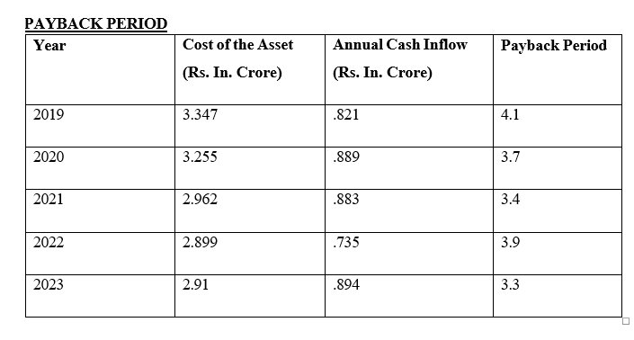

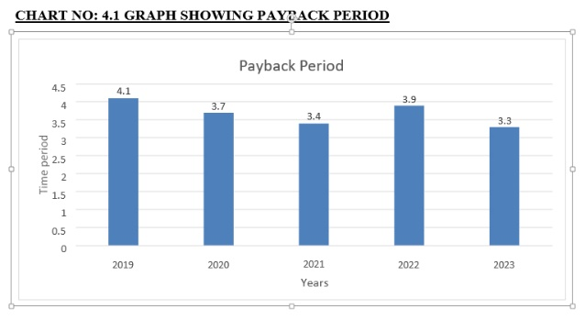**Interpretation:**

The above table clearly shows that the payback period differs according to the amount invested in particular years. The ‘X’ axis denotes first 5 years from 2019. The ‘Y’ axis denotes time period. In the first year 2019, annual cash inflow is .821 crores and the payback period is 4.1 and the payback period for the fifth year 2023 are 3.3. Comparatively payback period for the year 2023 is less.

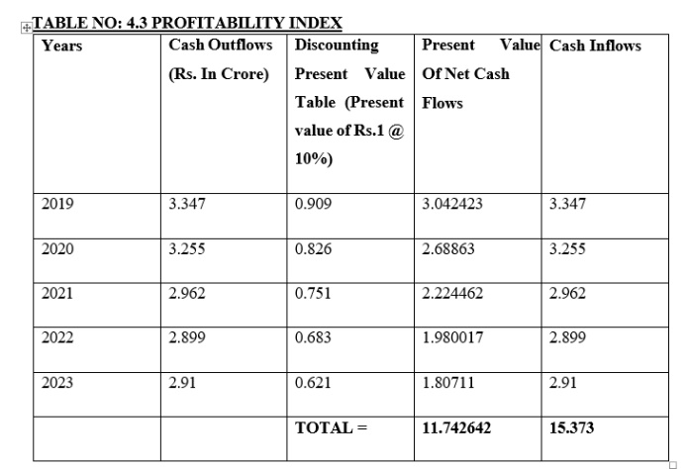

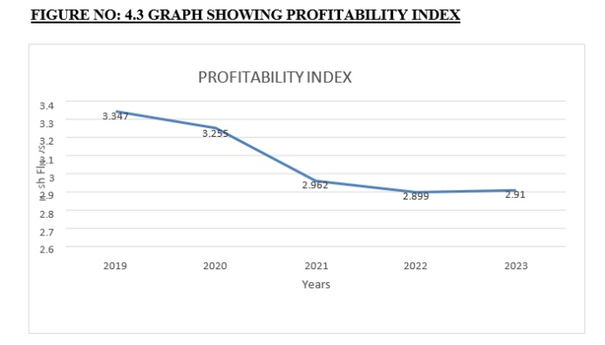

**Interpretation:**

In the above table showing that the profitability index in 2019 was 3.347, it was decreasing year by year drastically.

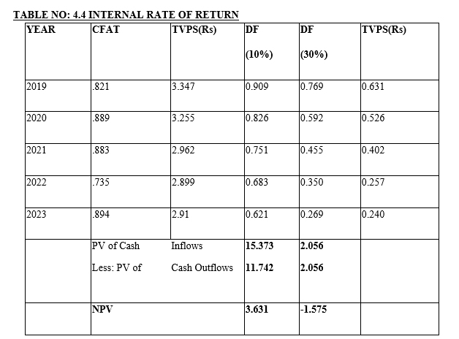

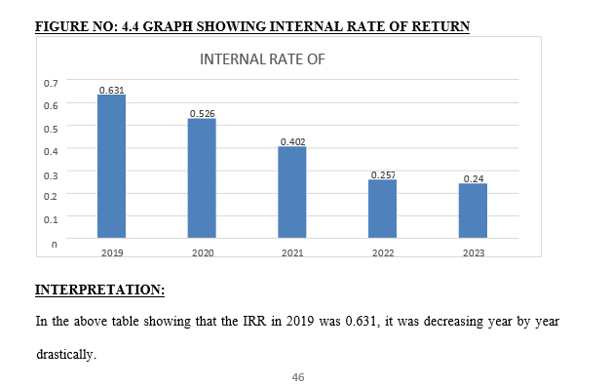

**FINDINGS:**

1. The payback period differs according to the amount invested in particular years. The ‘X’ axis denotes first 5 years from 2019. The ‘Y’ axis denotes time period. In the first year 2019, annual cash inflow is .821 crores and the payback period 4.1and the payback period for fifth year 2023 are 3.3. Comparatively payback period for the year 2023 is less.
2. The company’s estimated rate of return was below the minimal rate in 2019 and 2023, allowing for a reduction in the investment in the specific project. The project has a better rate of return than the minimal rate in 2019, 2020, 2021 and 2022. A grater rate of return means that an investment made in a given year will likely generate more cash in the future.
3. In profitability index in 2019 was 3.347, it was decreasing year by year drastically and becomes 2.91 in 2023

**SUGGESTION**:

* + 1. It has been suggested to the Westwind Food Processing Pvt Ltd, to select the project which all are having lesser pay-back period like the investment made in the year 2021 and 2023.
    2. The company is suggested to avoid the projects which all having higher payback period like the financial year 2019,2020 and 2022 because it does not bears any profit to the company.
    3. The company is advised to concentrate in return on investment. It increases the earning capacity of the project.
    4. It is suggested that the company wants to reduce their borrowings for increasing their profit.

**CONCLUSION:**

* Capital budgeting is an analysis of long-term investment, which mainly focus upon acquisition and improvement on fixed assets it is a part of long-term decision taken by the top management and involves large expenditure. The capital budgeting is very important to firms future capital budgeting. It is long term planning for making and financing major long-term projects. Each of the capital budgeting techniques outlined has advantage and disadvantages. The traditional method is simple but it does not consider the time value of money. Discounted cash methods consider the time value of money.
* Through this study it is very clear that capital budgeting essentially involves evaluation of the worth of capital investment proposals based on estimates of cash inflows and outflows. The study emphases that efficient allocation of capital is the most important finance function in the modern times. Thus, capital budgeting or investment decisions are of considerable importance to the firm, since they tend to determine its value by influencing its growth, profitability and risk. The analysis of payback period and Average Rate of Returns conclude that management should take efforts to perform the capital budget in efficient manner.