**SANTHOSH S, MBA Shipping and logistics management, Vels Institute of Science and Technology and Advanced Studies (VISTAS), Pallavaram, Chennai,** [**sandysanthoshss74@gmail.com**](mailto:sandysanthoshss74@gmail.com)

**Corresponding Author: DR.M. Kotteeswarn, Professor, School Management studies, Vels Institute of Science and Technology and Advanced Studies (VISTAS), Pallavaram, Chennai,**

**I** **ABSTRACT**

*In the dynamic and constantly developing world of marketing, promotional methods are essential for shaping customer behavior and achieving company objectives. This research studies different marketing promotional methods and looks at how they affect customer involvement, brand recognition, and, eventually, company performance. The study highlights the importance of innovation and originality in marketing efforts and the necessity of strategic alignment with overarching corporate objectives. It also emphasizes how crucial it is to track and evaluate results to maximize advertising expenditures and guarantee long-term company development.*

***Keywords:*** *marketing, innovation, promotional methods, strategies.*

**II INTRODUCTION**

In the ever-changing and competitive world of marketing, promotional techniques are essential tools that help businesses connect with their target markets, build brand awareness, and encourage customer interaction. The success of these tactics may have a big impact on company results, such higher market share and sales as well as enhanced customer loyalty and brand reputation. The goal of this research is to examine the field of marketing promotional methods and their effects, with a particular emphasis on the ways in which various approaches influence customer behavior and advance organizational success. The main objective of this study is to examine how marketing and promotional methods impact customer behavior and business outcomes.

**III OBJECTIVE OF THE STUDY**

* To provide an extensive overview of the several marketing and promotional strategies firms use.
* To analyze how each strategy affects sales performance, customer engagement, and brand recognition.
* Determine the typical obstacles that companies have while putting beneficial marketing strategies into practice.

**IV NEED FOR THE STUDY**

Considering the quick evolution of marketing practices, it is important to understand the requirement of researching marketing promotional techniques and their results. With the introduction of new platforms and technology, the marketing environment is always evolving, and companies must modify their approaches to remain competitive. This study helps organizations effectively manage these shifts by offering essential insight into the efficacy of existing advertising efforts. Identifying oneself is essential for firms in today's global market due to the increased competition. A key to continuing out in a crowded market is having effective advertising techniques. Through the identification of the most effective promotional strategies for certain sectors, this study helps organizations allocate resources more effectively and obtain a competitive advantage.

**V SCOPE OF THE STUDY**

The study's scope "A Study on Marketing Promotional Strategies and Their Outcomes" covers a wide variety of marketing promotion-related areas in an effort to provide consumers with an in-depth understanding of their significance and efficacy. The several dimensions and parameters that the study works within are described in this section. The studyhighlights typical obstacles and restrictions that companies have when putting marketing and promotional plans into practice. These include financial limitations, market saturation, shifting customer preferences, and problems with regulatory compliance. Businesses may create more resilient and flexible strategies by having a better understanding of these obstacles.

**VI REVIEW OF LITERATURE**

Yasa, N., Giantari, I. G. A. K., Setini, M., & Rahmayanti, P. J. M. S. L. (2020). The purpose of this study is to elucidate how promotional strategy affects marketing performance and enhances the competitive advantage of Bali, Indonesia's Tenun Ikat business. To do this, a sample of one hundred owners or managers of Tenun Ikat SME in Bali, Indonesia, were chosen, and their data was evaluated using structural equation modeling (SEM). The findings demonstrate that promotional strategy was very capable of enhancing competitive advantage and that it had a favorable and significant impact on it. Additionally, the attainment of marketing success is positively and significantly impacted by competitive advantage.

Wang, K., Wang, E. T., & Farn, C. K. (2009). This study determines the best way to utilize on-line media for advertising purposes is a critical question. This research, based on the Elaboration Likelihood Model (ELM), incorporates consumer goal-directedness and involvement as moderators influencing when a particular advertising strategy (i. e., variation strategy vs. appeal strategy) will be appropriate for Web advertisements. The results of a laboratory experiment supported the use of ELM in the Web environment and showed how advertising strategies should be designed and implemented in accordance with consumer goal-directedness and involvement to achieve Web advertising effectiveness. The results demonstrated the uniqueness of the Web media and the importance of goal-directedness and consumer involvement in the Web advertising context.

Jiang, H., & Ma, J. (2018) Two crucial instruments for specialized marketing communications are advertising and sales promotion. This research presents a quantitative investigation of Internet sales promotion inside a differential advertising paradigm. We derive the existence and stability conditions of periodic solutions. Analytical research is done on the flip bifurcation of periodic solutions. The findings demonstrate that the sales promotion parameter can alter the differential advertising model's stability and cause chaos through flip bifurcation; that by varying the parameter's value, the sales level will eventually equal a given value; and that the best sales promotion plan can result in the highest possible profit. Bifurcation diagrams, periodic solutions, and the consequences of sales marketing strategies—which are demonstrated with an example—all have numerical results in strong agreement with the theoretical framework. These findings have important theoretical and practical implications for connected markets.

**VII STATEMENT OF THE PROBLEM**

The study on marketing promotional strategies and their outcomesis to address some of the major issues that businesses confront, such as figuring out which promotional strategies work best, comprehending how quickly customer behavior is changing, and precisely assessing the impact of promotions. In addition, it looks at how to integrate conventional and digital marketing, adjust to new technology, make sure it's cost-effective, and deal with ethical and legal issues. The study also looks at the effects of globalization and the requirement for cultural sensitivity in marketing campaigns. By tackling these problems, the study hopes to offer useful information and suggestions that will help companies improve the effectiveness of their marketing campaigns and produce better results.

**VIII RESEARCH GAP**

The limitations of the study are as follows. The study's outcomes might be limited by the availability and reliability of the data. The period of the study is restricted to 2 months. So, potentially missing long-term effects of promotional strategies. Some of the data has not been collected accurately as the information is sensitive.

**IX RESEARCH METHODOLOGY**

The methodical process and structure that scientists use to collect, analyze, and assess data in an orderly fashion is referred to as research methodology. It covers the overall approach as well as the procedures followed during a research study. A robust research methodology ensures the validity and reliability of findings and provides a clear plan for conducting the investigation. Researchers describe the data collection methods and talk about ethical concerns and potential research restrictions. Because of this, it is essential to all research projects and helps the researcher at every stage, from formulating research questions to presenting findings. The planned study has a mostly descriptive design. It describes how to collect, measure, and analyze data in order to test hypotheses successfully.

**X PERCENTAGE ANALYSIS**

1. **Promotions and sales events have a positive impact on our sales and brand visibility.**

**TABLE 1**

|  |  |  |
| --- | --- | --- |
| Statements | No of Response | Percentage |
| Strongly Agree | 32 | 32 |
| Agree | 40 | 40 |
| Neutral | 20 | 20 |
| Disagree | 6 | 6 |
| Strongly Disagree | 2 | 2 |
| Total | 100 | 100 |

**Promotions and sales events have a positive impact on our sales and brand visibility.**

**CHART 1**

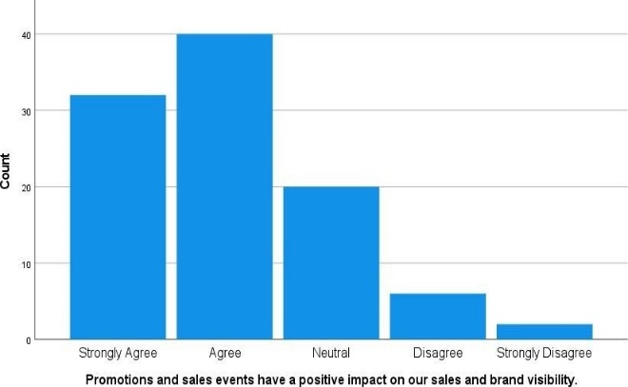

**INFERENCE:**

Most people agree or strongly agree with the statements, making up 72% of the responses. About 20% are neutral, while a smaller portion, totaling 8%, disagree or strongly disagree with the statements.

1. **We regularly analyze competitor strategies to improve our own promotional activities**

**TABLE 2**

|  |  |  |
| --- | --- | --- |
| Statements | No of Response | Percentage |
| Strongly Agree | 23 | 23 |
| Agree | 43 | 43 |
| Neutral | 19 | 19 |
| Disagree | 8 | 8 |
| Strongly Disagree | 7 | 7 |
| Total | 100 | 100 |

**We regularly analyze competitor strategies to improve our own promotional activities**

**CHART 2**

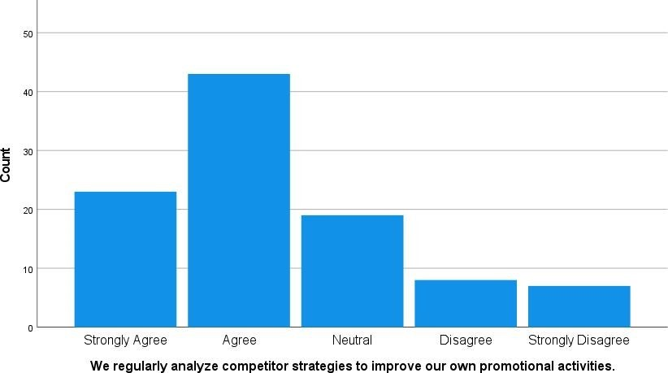

**INFERENCE:**

Most people agree or strongly agree with the statements, making up 66% of responses. About 19% are neutral, while a smaller portion, totaling 15%, disagree or strongly disagree with the statements.

**CORRELATION**

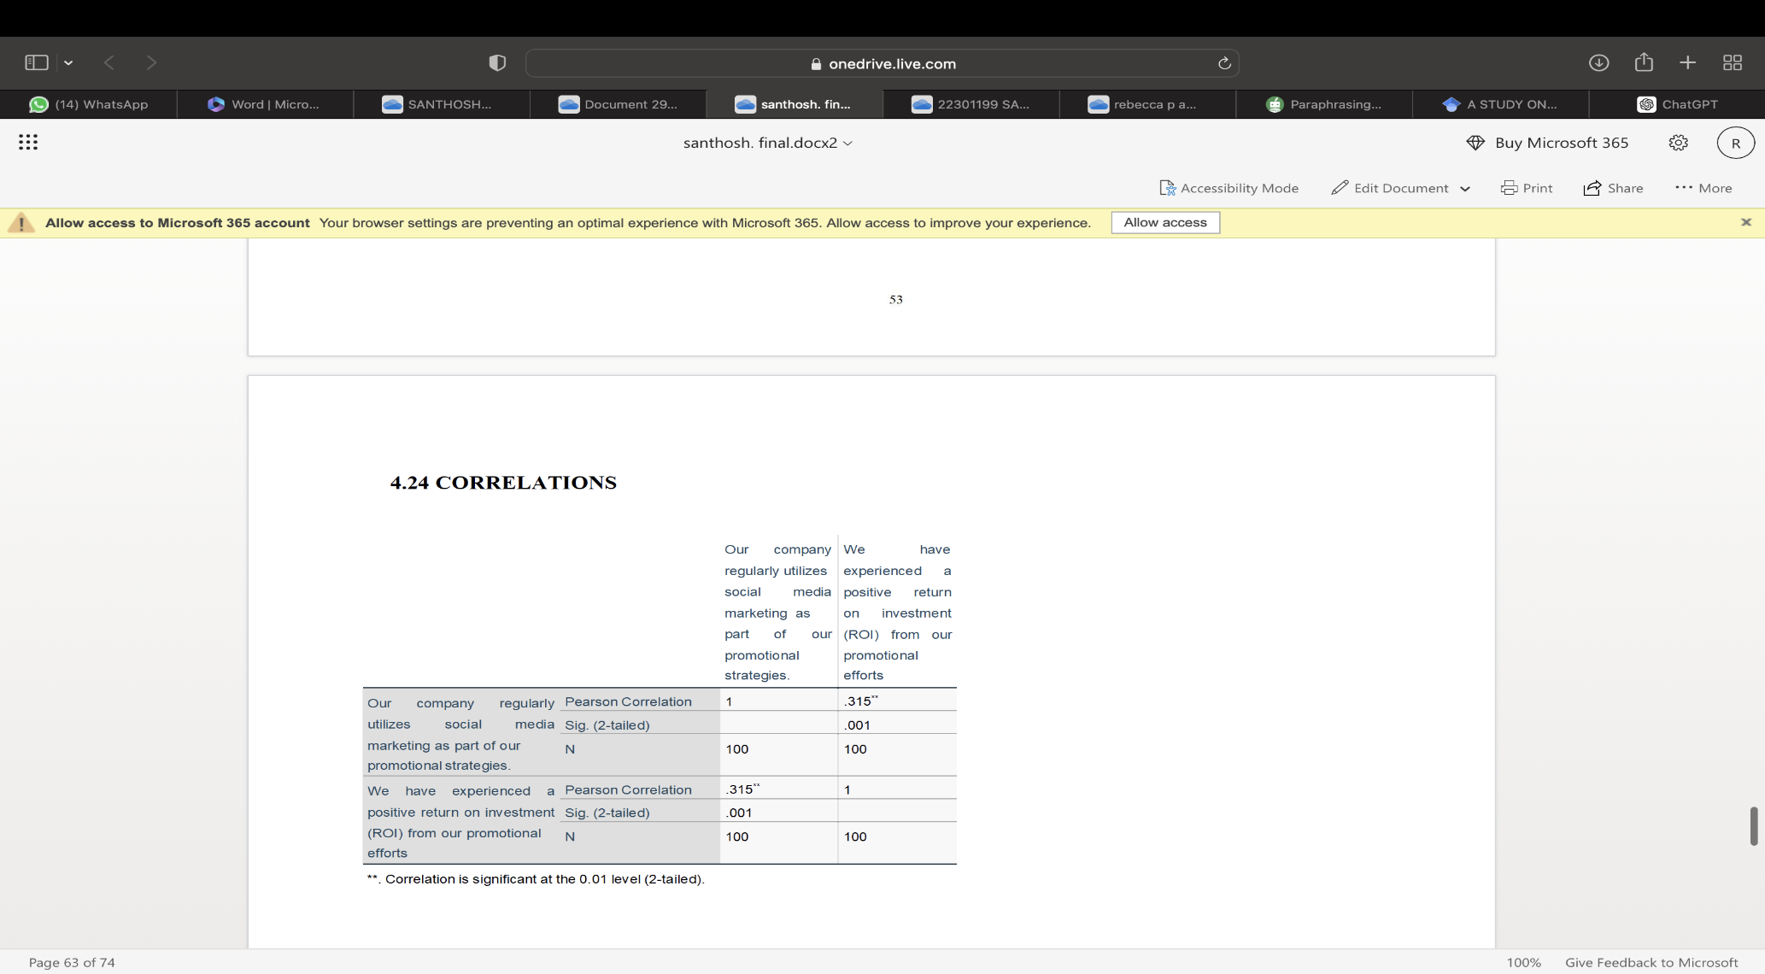INFERENCE:

Using social media marketing is strongly associated with experiencing a positive return on investment (ROI). When our company increases its social media marketing efforts, we tend to see better returns from our promotional activities.

**XI CONCLUSION**

The study on marketing promotional tactics and their results emphasizes how crucial it is to use a diversified strategy in order to successfully connect customers and meet corporate goals in a market that is highly competitive. After a thorough investigation, the study shows that when promotional techniques are adapted to changing customer tastes, combining digital and traditional marketing strategies may greatly increase their efficacy. Important conclusions show that companies need to use data analytics and keep up with technological developments in order to precisely measure and optimize promotional results. The report also emphasizes how important it is to strike a balance between cost-effectiveness and ethical and legal compliance to preserve customer confidence and support long-term growth. Furthermore, it becomes clear that cultural sensitivity in international marketing initiatives is essential for success in a variety of countries. By taking care of these components, companies may grow stronger, more flexible, and more responsive marketing tactics that increase audience engagement, brand loyalty, and ROI. The study's conclusions and suggestions offer a useful foundation for companies looking to improve the efficiency of their marketing campaigns and boost overall performance.

**XII REFERNCES**

* Yasa, N., Giantari, I. G. A. K., Setini, M., & Rahmayanti, P. J. M. S. L. (2020). The role of competitive advantage in mediating the effect ofpromotional strategy on marketing performance. Management Science Letters, 10(12), 2845-2848.
* Wang, K., Wang, E. T., & Farn, C. K. (2009). Influence of web advertising strategies, consumer goal-directedness, and consumer involvement on web advertising effectiveness. International Journal of Electronic Commerce, 13(4), 67-96.
* Jiang, H., & Ma, J. (2018). Effects of internet sales promotion on a differential advertising model. Discrete Dynamics in Nature and Society, 2018.
* [**https://www.wikipedia.org/**](https://www.wikipedia.org/)
* [**https://g.co/kgs/aYmCCdG**](https://g.co/kgs/aYmCCdG)