**Vulnerability Assessment of Coastal Areas in Panabo City**

**to Flooding Hazard**

**Abstract**

This study assesses the vulnerability of coastal areas in Panabo City to climate-related hazards, with a focus on potential impacts. It takes a multidisciplinary approach, integrating geographical information systems (GIS), climate modeling, and socio-economic data. The goal is to evaluate the susceptibility of the coastal zones to various climate-induced threats, particularly flooding, both presently and in the future. The study also examines the adaptive capacity of local communities, infrastructure, and ecosystems in the face of these hazards. The findings will identify specific vulnerable areas and provide insights into potential adaptation strategies to enhance resilience and promote sustainable development in Panabo City's coastal areas. The research contributes valuable information for urban planning, disaster preparedness, and climate change mitigation efforts in other coastal cities facing similar challenges.

***Keywords***: coastal vulnerability, Vulnerability Assessment, natural hazards, flooding

**Introduction**

Living on the coast makes communities more at risk from climate change impacts and their effects on the ever-increasing human utilization of the coastal zone will invariably result in increasing coastal risk (Ranasinghe, R & Jongejan, R 2018). Panabo City, for example, faces significant challenges due to its location along the coast. As the city's population and economy continue to grow, it becomes even more important to evaluate the risks posed by climate change to its coastal areas. Conducting a thorough assessment is essential to better prepare for and respond to potential threats.

Panabo City, located along the coast of the Davao Gulf, is prone to several climate-related hazards, such as flooding. The purpose of the vulnerability assessment is to gain a better understanding of the city's susceptibility to flooding hazard and their potential impacts on the local population, infrastructure, and ecosystems.

**Objectives**

The main goal of this study is to carry out a Vulnerability Assessment (VA) in four coastal barangays of Panabo City: Barangays J.P. Laurel, Cagangohan, San Pedro, and San Vicente. The assessment will specifically concentrate on the climate-related hazard of flooding. The study identifies and analyzes the potential risks and impacts of these hazards. By comprehending the vulnerabilities in the coastal areas, this assessment will facilitate informed decision-making and the formulation of effective adaptation strategies..

**Methodology**

This study utilized a descriptive research design using quantitative methods. Both primary and secondary data sources were utilized to assess the VA of Panabo City's coastal areas. The researcher conducted Key Informant Interviews (KIIs) with participants such as LGU officials, Barangay Captains, Barangay *kagawad*, Barangay secretaries, and Barangay Disaster Risk Reduction and Management Officers (BDRRMO). Additionally, environmental groups and local households residing in the four coastal barangays of Panabo City were also included as respondents. Supplementary data, including climate events and GIS process maps from the Local Government Unit of Panabo, were also taken into account. In measuring the vulnerability assessment of coast barangays, the study followed the systematic procedure of the new modified formula for the Vulnerability Assessment Tool (*Coastal Facilities Vulnerability Assessments - Climate Change (U.S. National Park Service). (n.d.)*.

*Vulnerability = Exposure + Sensitivity*

**Results and Discussion**

A natural hazard refers to an extreme event that occurs naturally and brings harm to humans, or to other things that we care about (Kininmonth, W., 2003). It can be categorized into several broad groups: geological hazards, hydrological hazards, and meteorological hazards. Examples of meteorological hazards include earthquakes, volcanic eruptions, droughts, floods, coastal erosion, and storm surges. Many of these geophysical hazards are interconnected. For instance, earthquakes can trigger tsunamis, which can then cause coastal flooding and erosion. These hazards expose resources and communities in lowland, upland, and coastal areas to the risk of property damage, loss of life, and environmental degradation (Breton, F., & Sauri‐Pujol, D., 1997). In Panabo City, only the coastal barangays are affected by flooding and storm surge hazards.

A flood is a natural event wherein dry land areas of suddenly get submerged under water. Flooding is sometimes resulting from a coastal storm, dam break, or heavy rainfall within coastal zones (Kirschen et al., 2008; Moser and Tribbia, 2006). This is usually experienced by the four (4) coastal barangays of Panabo City. In 2017, PAGASA placed Davao del Norte into blue alert status after experiencing heavy rainfall due to the tail end of the cold front that flooded several communities and displaced hundreds of families (Revita, 2017). This natural hazard continuously disrupts social and economic activities as well as physical assets; thus, considering it as a significant problem for many areas (Arctic Climate Impact Assessment, 2005; Polyak, et al., 2010; United States Government Accountability Office, 2009).

The recorded data of the city on the previous disasters from 2012 to current shows that flooding is experienced in población specifically in the coastal areas because of heavy rainfall and the occurrence of typhoons. There are no causalities recorded but there are affected families and damages on the properties as shown in the table below.

Table 1: Records of Previous Disasters, City of Panabo

| **Hazard Events and**  **Description** | **Affected**  **Barangays** | **No. of Casualties**  **(Number of Individual)** | | | **No. of Affected** | | **Source of**  **Information** |
| --- | --- | --- | --- | --- | --- | --- | --- |
| Dead | Injured | Missing | Persons | Families |
| August 25, 2014 at 4:00  pm heavy rains  occurred in the  Poblacion of Panabo  City that resulted to  Flash Flood | Sto. Niño, Gredu  and **San Vicente** | - | - | - | - | - | CDRRMO |
| Strong winds and big  sea waves were  experienced In Panabo  City brought by  Southwest Monsoon | **San Vicente, San**  **Pedro and**  **Cagangohan** | - | - | - | 70  Fishermen  were affected  in San  Vicente, 215  persons in  Barangay  Cagangohan | 84 Families  in Barangay  Cagangohan | CDRRMO |
| Flooding occurred on  February 16, 2017  cause by tail end of a  cold front | Barangay Gredu  and Sto. Niño | - | - | - | 0 | 0 | CDRRMO |
| On January 18, 2017  Flash Flood was  experienced by the few Urban Barangays due to heavy rainfall | Barangay Gredu,  **J.P. Laurel**,  Salvacion, Sto.  Niño and  **Cagangohan** | - | - | - | 215 | 47 | CDRRMO |
| The occurrence of  Typhoon Pablo on  December 4, 2012 | **Cagangohan**, Sto.  Niño, **J.P. Laurel,**  **San Vicente**, New  Visayas, Quezon | - | - | - | 12 | 46 | CDRRMO |
| The Occurrence of  Typhoon Ofel on  October 26, 2012 | **Cagangohan and**  **San Vicente** | - | - | - | 7 | 0 | CDRRMO |
| Big waves caused by  Southeast Monsoon | **Cagangohan** | - | - | - | 68 | 14 | CDRRMO |

*Source: CDRMO, Panabo City, 2023*

Figure 1: Coastal Barangays Vulnerability Map in Flooding

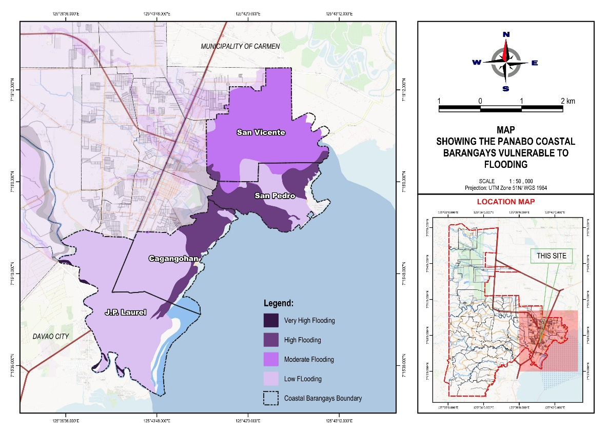

*(Source: GIS Generated by CPDO-LGU Panabo)*

Figure 2: Households Vulnerability in Flooding

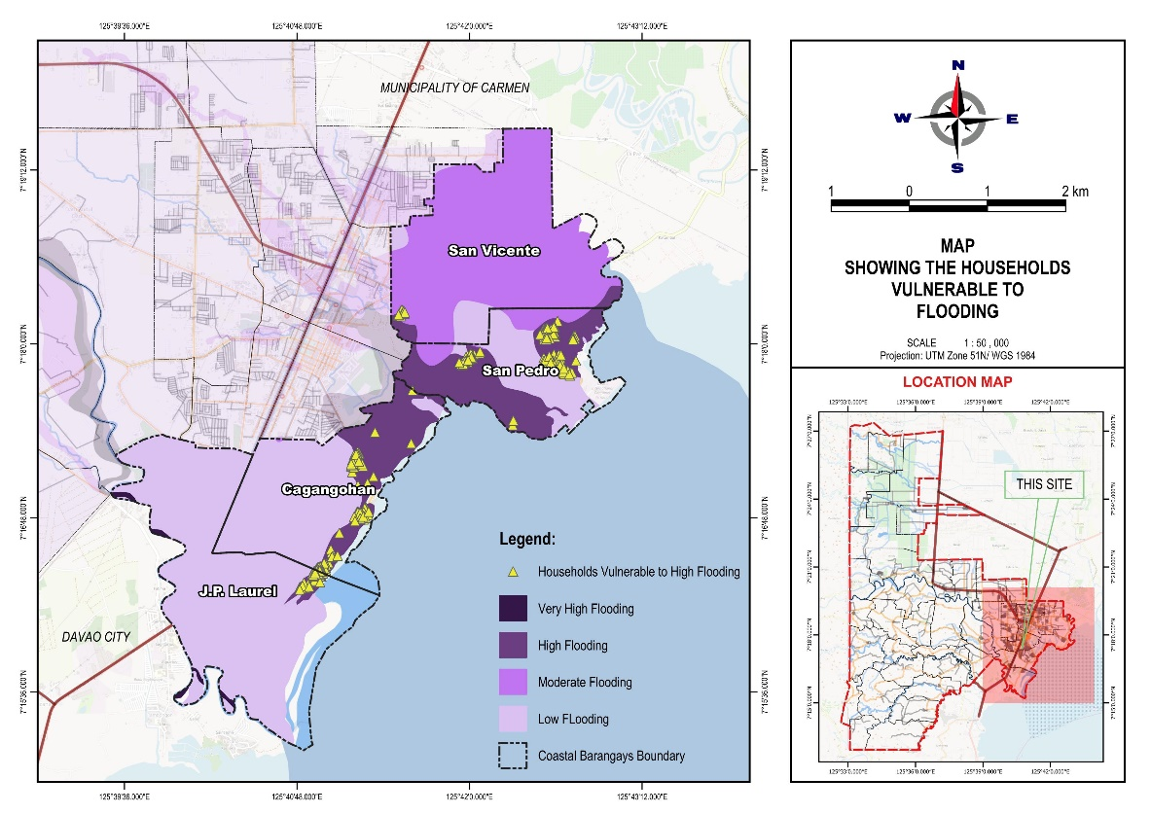

*(Source: GIS Generated by CPDO-LGU Panabo)*

Table 2: Households per barangays vulnerable to flooding

|  |  |  |
| --- | --- | --- |
| Barangay | Hazard | No. of Households |
| Cagangohan | High Flooding | 134 |
| Moderate Flooding | 2 |
| Low Flooding | 2089 |
| J.P. Laurel | High Flooding | 85 |
| Moderate Flooding | - |
| Low Flooding | 1270 |
| San Pedro | High Flooding | 143 |
| Moderate Flooding | 6 |
| Low Flooding | 586 |
| San Vicente | High Flooding | 20 |
| Moderate Flooding | 2325 |
| Low Flooding | 197 |

*Source: Data Generated by CPDO-LGU Panabo*

As on shown on the table above the data presents the number of households on four barangays categorized by their exposure to different levels of flooding. San Pedro and Cagangohan have significant numbers of households in high flooding risk areas. San Vicente has the highest concentration of households in moderate flooding risk, and Cagangohan and J.P. laurel have the majority of their households in low risk zone, indicating a lower overall vulnerability.

**Conclusions and Recommendation**

To reduce potential impacts and increase the adaptive capacity of natural and man-made physical resources in the coastal barangays of Panabo City, the following actions are recommended:

1. Establish early warning systems and formulate flooding contingency plans.

2. Implement sustainable livelihood programs for families below the poverty threshold.

3. Manage vegetation to control soil erosion.

4. Provide comprehensive housing programs for affected families.

5. Construct drainage systems.

6. Develop regulations for hazard-resistant design.

7. Implement mandatory relocation policies for structures near water bodies.

8. Promote climate-sensitive production practices.

Integrating these measures through collaboration with local authorities, community stakeholders, and relevant government agencies is crucial. This will ensure long-term sustainability and adaptability to changing conditions.

**Acknowledgement**

The researcher would like to acknowledge to those people who have contributed to the completion of this research. To my “Chula Masters”, to Engr. Lovena A. Adlawan, Architect Jessa A. Cortel, and to Dr. Moises C. Torrentira, Jr., EnP. for their guidance, and support and for sharing their expertise in the process of research. The researcher is also grateful to the participants, and respondents who generously shared their time and insights by carefully answering the questionnaires.

**References**

Ranasinghe, R., & Jongejan, R. (2018). Climate Change, Coasts and Coastal Risk. Journal of Marine Science and Engineering, 6(4), 141. https://doi.org/10.3390/jmse6040141

Coastal Facilities Vulnerability Assessments - Climate Change (U.S. National Park Service). (n.d.). <https://www.nps.gov/subjects/climatechange/vulnerabilityandadaptation.htm>

Kininmonth, W. (2003, May). Climate Change — A Natural Hazard. Energy & Environment, 14(2–3), 215–232. <https://doi.org/10.1260/095830503765184600>

Breton, F., & Sauri‐Pujol, D. (1997, January). Toward a redefinition of resources and hazards in coastal management: Examples from the lowland coastal areas of Catalonia, Spain. Coastal Management, 25(4), 363–385. https://doi.org/10.1080/08920759709362330

Kirschen, P., Watson, C., Douglas, E., Gontz, A., Lee, J., & Tian, Y. (2008). Coastal flooding in the Northeastern United States due to climate change. Mitigation and Adaptation Strategies for Global Change, 13(5-6), 437-451.

Klein, R.J.T & Nicholls, R.J. (1999). Assessment of coastal vulnerability to climate change. Ambio 28(2), 182-187.

Nicholls, R. J., & Tol, R. S. (2006). Impacts and responses to sea-level rise: a global analysis of the SRES scenarios over the twenty-first century. Philosophical Transactions of the Royal Society A: Mathematical, Physical and Engineering Sciences, 364(1841), 1073-1095.

Polyak, L., Andrews, J., Brigham-Grette, J., Darby, D., Dyke, A., Funder, S., Holland, M., Jennings, A., Savelle, J., Serreze, M., & Wolff, E. (2010). History of sea ice in the Arctic. Quarterly Sciences Review, 1-22.

Revita, J. (2017). Hundreds displaced in Davao flooding, red alert on Thursday. Sunstar. Retrieved from http://www.sunstar.com.ph/davao/local-news/2017/02/16/ hundreds-displaced-davao-flooding-red-alert-526228.