**ASSESSMENT OF BUILDING CODE COMPLIANCE AND ENFORCEMENT IN DAVAO CITY: CHALLENGES AND OPPORTUNITIES**

Jennylyn R. Saniel

ORCID Number: 0009-0009-9624-2664

Graduate School of Government and Management, University of Southeastern Philippines,

Philippines

**ABSTRACT**

This study delves into the compliance and enforcement of building codes in Davao City, highlighting the various challenges and opportunities involved. The study highlights the crucial factors that impact compliance and enforcement efforts. The analysis focuses on the challenges of limited stakeholder awareness, resource constraints, corruption, rapid urbanization, and informal settlements, emphasizing their negative effects on the safety and quality of the built environment. The study highlights several potential areas for improvement, such as public awareness campaigns, capacity-building initiatives, technological solutions, stakeholder collaboration, streamlined permitting processes, and incentive mechanisms. These opportunities could help address the challenges identified in the study. The research paper enhances our understanding of the dynamics influencing building code compliance and enforcement in Davao City by synthesizing these findings. This analysis can provide valuable information for policymakers and organizations looking to improve regulatory frameworks, enforcement mechanisms, and overall safety and resilience in urban development.

**Keywords:** building codes, compliance, enforcement, challenges, opportunities, corruption, urbanization, safety, quality, public campaigns, technology, regulations, urban development.

**INTRODUCTION**

Building codes are essential regulatory tools that ensure the safety, health, and welfare of the public by setting minimum standards for construction quality and performance. These codes address various aspects of building design and construction, including structural integrity, fire safety, accessibility, and energy efficiency (Meacham, 2010). In developing countries, building regulations for resilience is crucial due to rapid urbanization often occurring without comprehensive regulatory frameworks. This lack of regulation can result in buildings that are prone to spontaneous collapse, high energy costs, exclusion of certain populations, or damage from natural disasters (GFDRR, 2016).

Davao City, one of the major urban centers in the Philippines, exemplifies these challenges. The city has experienced rapid urbanization and economic growth in recent years, necessitating stringent enforcement of building codes to ensure that new constructions adhere to safety and quality standards (Philippine Statistics Authority, 2020).

Building owners in Davao City generally exhibit an awareness of the local building code, and building plans undergo thorough reviews to ensure compliance (Office of the Building Official, 2023). The construction materials used typically meet the specified standards, and regular inspections are conducted to maintain adherence (Department of Public Works and Highways, 2021). Effective sanctions are in place for those who fail to comply with the code (Local Government Academy, 2022). However, the complexity and cost of compliance pose significant challenges for property owners, often seen as burdensome (World Bank, 2018).

Despite the overall awareness, a segment of property owners still lacks sufficient knowledge about the building code. Instances of building permits being issued despite non-compliance, alongside corruption, undermine the enforcement process (Transparency International, 2019).

Collaboration between the City Building Office and other relevant agencies, such as barangays and the fire department, is essential for effective enforcement (Department of the Interior and Local Government, 2021). Public engagement through reporting violations and prioritizing public safety in enforcement actions highlight the community's role (Local Government Academy, 2022). Yet, there are concerns regarding the severity of penalties for non-compliance, the efficiency of the appeals process, and the challenges posed by informal settlements (United Nations Habitat, 2019).

The study underscores the need for further research to enhance building code enforcement strategies. Public education campaigns, the utilization of technology, and collaboration with professional organizations are identified as potential avenues to streamline and strengthen the enforcement process (American Institute of Architects, 2019; International Code Council, 2020). Notably, recent improvements in compliance have contributed to residents feeling safer in compliant buildings, although the process remains perceived as costly and time-consuming (Philippine Institute of Civil Engineers, 2022).

By addressing these challenges and leveraging the identified opportunities, Davao City can enhance its building code enforcement, ensuring a safer and more resilient urban environment.

**METHODOLOGY**

This study was conducted in Davao City, with 150 respondents randomly selected to serve as research participants using a mixed-methods approach, utilizing both online surveys conducted through Google Forms and manual surveys. According to Torrentira (2020), an online survey is a process of distributing the instrument or the questionnaire to the target respondents using online platforms through Google Forms. The research participants were asked to respond to a questionnaire, which served as the research instrument for data collection. Experts in the field reviewed and validated the survey questionnaire.

The factors were identified using Exploratory Factor Analysis (EFA). Exploratory factor analysis is frequently used to identify the underlying factors of several observable variables (Auerswald & Moshagen, 2019). To test the magnitude of partial correlations among variables, the Kaiser Meyer-Olkin (KMO) measure of sampling adequacy was performed. Bartlett’s test of sphericity was conducted to identify the identity of the correlation matrix. The factors were visually represented and identified using a scree plot. These factors are analyzed using content analysis techniques to develop the resilience framework.

**RESULTS AND DISCUSSION**

This section encompasses the analysis and interpretation of the data. The chapter dives into the results and findings of the study, utilizing the statistical software SPSS, where the KMO and Bartlett’s Test are applied. The study involved 150 respondents residing in Davao City.

**KMO and Bartlett’s Test**

Table 1 shows the results of the Kaiser-Meyer-Olkin (KMO) Measure and Bartlett's Test of Sphericity, which are statistical tests used to determine the suitability of your dataset for factor analysis. The KMO Measure of Sampling Adequacy (0.896) indicates high adequacy. This value, which is close to 1, indicates that the dataset has significant common variance and is suitable for factor analysis; values greater than 0.8 are generally considered good. Furthermore, Bartlett's Test of Sphericity, which yields an approximate Chi-Square of 3070.044 and a significance level of 0, confirms that the variables are inter-correlated rather than orthogonal and that the data's correlation matrix does not resemble the identity matrix. This statistically significant result underscores the importance of using factor analysis to determine the underlying factors or dimensions in our data about building code compliance and enforcement challenges and opportunities.

***Table 1. KMO and Bartlett’s Test***

|  |  |  |
| --- | --- | --- |
| Kaiser-Meyer-Olkin Measure of Sampling Adequacy. | | 0.896 |
| Bartlett’s Test of Sphericity | Approx. Chi-Square | 3070.044 |
| df | 435 |
| Sig. | 0 |

The scree plot illustrated the total variance, and Eigenvalues plotted against all factors in a graphical manner. This plot depicts the decreasing trend of Eigenvalues and helps determine the significance of each component. The Scree Plot is a valuable tool for deciding the number of factors to retain, with the inflection point indicating where the curve flattens. The scree plot shows the total variance, with Eigenvalues plotted against all factors in a graphical representation. This plot shows the decreasing trend of Eigenvalues and aids in determining the significance of each component. With the inflection point signifying where the curve becomes flatter, the Scree Plot is useful for determining the number of factors to retain. The eigenvalues decrease considerably after the first component but still show relevant decreases up through the third component. Based on this plot, focusing on the first two or three components would likely be sufficient for most analyses, as they capture the major variance within the data, thereby reducing dimensionality while maintaining crucial information.

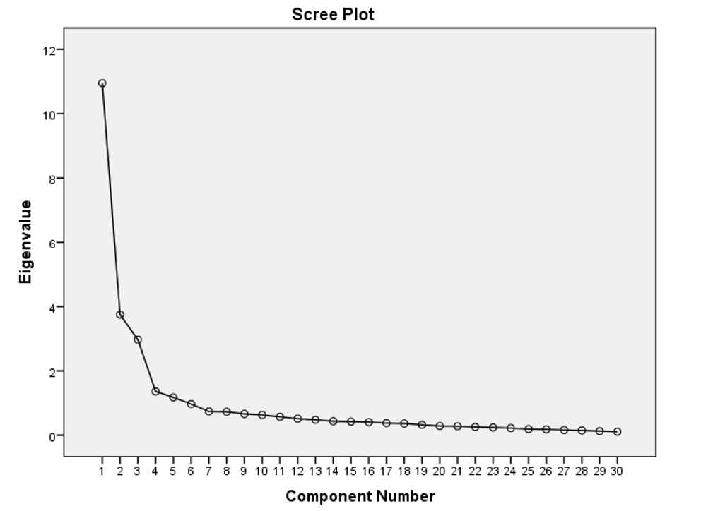

***Figure 1. Scree Plot Rotated Component Matrix***

**Rotated Component Matrix**

Table 2 shows the attributes grouped as “Building Code Compliance and Enforcement Integrity,” which encompasses the effectiveness of building code compliance measures, the integrity of enforcement practices, and the collaboration between relevant agencies. The data show that participants rated Item 4 with a score of 0.803, indicating that regular inspections play a crucial role in ensuring that buildings comply with the building code, thereby promoting safety, accountability, and public welfare in the built environment (ICC, 2021). Various agencies, such as local government units and fire departments, collaborate in the enforcement of building codes to ensure comprehensive safety and compliance (NIST, 2020). It highlights the vital role of building inspectors who are well-trained to accurately assess compliance and identify deficiencies (InterNACHI, 2021). It emphasizes the necessity of using quality construction materials, which directly impact building integrity and safety (ASTM, 2020). Furthermore, it underscores the importance of reviewing plans for compliance before construction begins to prevent non-compliance issues and ensure proposed designs meet safety and regulatory requirements (APA, 2019).

***Table 2: Rotated component matrix with grouped attributes of Building Code Compliance and Enforcement Integrity***

|  |  |  |  |
| --- | --- | --- | --- |
| Item | Attributes | Loading | Factor |
| Item 4 | Buildings are regularly inspected to ensure compliance with the building code. | .803 | Building Code Compliance and Enforcement Integrity |
| Item 3 | The quality of construction materials used meets building code specifications. | .780 |
| Item 14 | Collaboration exists between the City Building Office and other relevant agencies (e.g., barangays, fire department) to enforce the building code. | .778 |
| Item12 | Building inspectors are well-trained and qualified to assess building code compliance. | .757 |
| Item 2 | Building plans are thoroughly reviewed for compliance with the building code. | .750 |
| Item 13 | The City Building Office has the necessary resources (e.g., equipment, technology) for efficient building code enforcement. | .746 |
| Item 11 | The City Building Office has sufficient personnel to effectively enforce the building code. | .659 |
| Item 1 | Building owners are generally aware of the city's building code. | .656 |
| Item 5 | Sanctions for non-compliance with the building code are effectively enforced. | .647 |
| Item 17 | The building code enforcement process is fair and impartial. | .624 |
| Item 16 | The City Building Office prioritizes public safety concerns when enforcing the building code | .621 |
| Item 27 | Building code compliance has improved in recent years. | .610 |
| Item 15 | The public actively reports violations of the building code. | .532 |

Table 3 presents the rotated component matrix with grouped attributes of External Factors Impacting Building Code Compliance. Professionals like architects and engineers play a critical role in ensuring that buildings comply with codes during the design and construction phases (ICC 2018). However, rapid urbanization can overwhelm enforcement agencies, making it challenging to keep up with inspections and approvals. This can lead to gaps in compliance and increased risks (Cohen, B. 2006). Additionally, informal settlements often lack proper planning and resources, making it difficult to enforce building codes. These areas can pose significant safety and health risks due to non-compliance with building standards (UN-Habitat 2003). On the other hand, strengthening the role of barangays or local government units can enhance local compliance and address issues promptly (DILG 2020). Furthermore, conducting research on enforcement strategies helps to understand their effectiveness and identify areas for improvement. This is essential for tailored strategies that address specific local challenges (May, P. J. 2007). Technology, such as online permitting systems, can enhance efficiency and transparency. These technologies help in tracking applications, approvals, and inspections (Gann, D. M., & Barlow, J. 1996).

***Table 3: Rotated component matrix with grouped attributes of External Factors Impacting Building Code Compliance***

|  |  |  |  |
| --- | --- | --- | --- |
| **Item** | **Attributes** | **Loading** | **Factor** |
| Item 26 | Collaboration with professional organizations (e.g., architects, and engineers) can strengthen enforcement efforts. | .846 | External Factors Impacting Building Code Compliance |
| Item 22 | Informal settlements pose a significant challenge to building code compliance. | .807 |
| Item 25 | Utilizing technology (e.g., online permitting systems) can streamline the building code compliance process. | .784 |
| Item 30 | The role of barangays in building code enforcement should be further strengthened. | .761 |
| Item 18 | There is a need for more research on the effectiveness of building code enforcement strategies in Davao City | .751 |
| Item 24 | Public education campaigns can raise awareness about the building code and its importance. | .737 |
| Item 28 | Residents feel safe living and working in buildings that comply with the building code. | .642 |
| Item 21 | The rapid pace of urbanization puts a strain on building code enforcement resources. | .634 |
| Item 8 | A lack of awareness about the building code exists among some property owners. | .585 |
| Item 10 | Corruption weakens the enforcement of the building code. | .550 |

Table 4 highlights compliance burden and accessibility issues, including high costs, complex requirements, time-consuming processes, instances of non-compliance in permit issuance, and cumbersome appeal procedures. The high loading value of item 7, with a score of 0.895, indicates that the financial burden of adhering to building codes is a major concern for property owners. This financial burden is significant because compliance often requires substantial investment in materials, labor, and permits, which can be prohibitive (Freeman, 2014). Moreover, stringent and complex requirements can make it challenging for property owners to meet building code standards, a difficulty that is reflected in the strong loading value, indicating that the complexity of the codes is a significant barrier (Harris, 2006). Additionally, the cost and time required to comply with building codes are substantial, making the process burdensome. This attribute underscores the need for streamlining and simplifying compliance procedures to alleviate the burden on property owners (Gann & Barlow, 1996). Furthermore, a cumbersome appeal process adds to the burden on property owners, making it difficult to resolve disputes or correct violations efficiently. This attribute suggests the need for reforms to make the appeals process more accessible and efficient (May, 2007). Therefore, addressing these issues through policy reforms and streamlined processes can alleviate the burden on property owners and enhance overall compliance with building codes.

***Table 4: Rotated component matrix with grouped attributes of Compliance Burden and Accessibility***

|  |  |  |  |
| --- | --- | --- | --- |
| **Item** | **Attributes** | **Loading** | **Factor** |
| Item 7 | The cost of complying with the building code is a significant burden for property owners. | .895 | Compliance Burden and Accessibility |
| Item 6 | The requirements of the building code make compliance difficult for property owners. | .826 |
| Item 29 | The building code compliance process is too expensive and time-consuming for property owners. | .798 |
| Item 9 | There are instances where building permits are issued despite non-compliance with the building code. | .677 |
| Item 20 | The process for appealing building code violations is lengthy and cumbersome. | .641 |

**STUDY FRAMEWORK**

Presented in Figure 2 is the framework developed based on the findings. The researchers found that the factors of the assessment of building code compliance and enforcement in Davao City: challenges and opportunities are (1) Building Code Compliance and Enforcement Integrity, (2) External Factors Impacting Building Code Compliance, and (3) Compliance Burden and Accessibility.

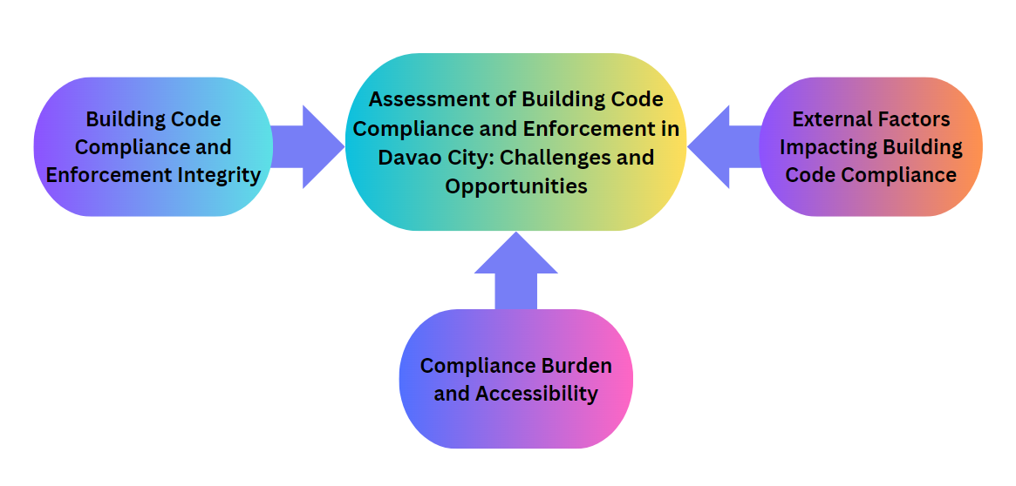

***Figure 2. Assessment of Building Code Compliance and Enforcement***

**CONCLUSION**

The study highlights the multi-faceted nature of building code compliance, emphasizing the importance of enforcement integrity, external influences, and the compliance burden on property owners. Key findings indicate that regular inspections, quality construction materials, and professional collaboration are crucial for effective enforcement. External factors such as informal settlements, rapid urbanization, and corruption pose significant challenges that require tailored strategies. The high costs and complexity of compliance processes underscore the need for procedural efficiency and reduced financial burdens. Overall, a comprehensive approach that addresses these internal and external factors can significantly enhance building code compliance, ensuring safer and more sustainable urban development.

**REFERENCES**

American Planning Association (APA) 2019, <https://www.apawood.org/wall-bracing>

American Society for Testing and Materials (ASTM) (2020), <https://www.astm.org/products-services/standards-and-publications/standards/building-standards.html>

American Institute of Architects. (2019). Professional Collaboration in Building Code Enforcement, <https://content.aia.org/sites/default/files/2019-06/ADV19_Disruption_Evolution_Change.pdf>

Auerswald, M., & Moshagen, M. (2019). How to determine the number of factors to retain in exploratory factor analysis: A comparison of extraction methods under realistic conditions. Psychological Methods, 24(4), 468–491, <https://doi.org/10.1037/met0000200>

Cohen, B. (2006). Urbanization in developing countries: Current trends, future projections, and key challenges for sustainability. Technology in Society, 28(1-2), 63-80. <https://sswm.info/sites/default/files/reference_attachments/COHEN%202006%20Urbanization%20in%20Developing%20Countries.pdf>

Department of the Interior and Local Government (DILG). (2020). Barangay Governance Performance Management System (BGPMS), <https://www.region12.dilg.gov.ph/programs-projects/barangay-governance-performance-management-system-bgpms>

Department of Public Works and Highways. (2021). Challenges in Building Code Enforcement. <https://www.iibh.org/kijun/pdf/Philippines_02_IRR_of_NBC_of_the_Philippines.pdf>

Freeman, H. (2014). Building Code Basics: Residential. International Code Council.

Gann, D. M., & Barlow, J. (1996). Flexibility in Building Use: The Technical Feasibility of Using

Prefabrication to Improve Building Performance. Journal of Construction Engineering and Management, <https://doi.org/10.1080/01446199600000007>

Global Facility for Disaster Reduction and Recovery (GFDRR) (2016). Building Regulations for resilience, Promoting Safe, Green, and Inclusive Built Environments, <https://www.gfdrr.org/en/building-regulation-for-resilience>

Harris, S. (2006). National Building Codes Handbook. McGraw-Hill Professional

Ian Fulgar (2021). National Building Code Of The Philippines – Its History, Current State, and Future, <https://www.ianfulgar.com/architecture/national-building-code-of-the-philippines-its-history-current-state-and-future/>

International Association of Certified Home Inspectors (InterNACHI) 2021, <https://www.nachi.org/communication-for-inspectors.htm>

International Code Council (ICC). (2018). International Building Code. <https://www.iccsafe.org/building-safety-journal/bsj-dives/bring-on-building-safety-code-enforcement-explained/>

International Code Council (ICC) (2021). International Building Code (IBC), <https://codes.iccsafe.org/content/IBC2021P1/chapter-17-special-inspections-and-tests>

International Code Council. (2020). Technological Innovations in Building Code Compliance, <https://www.iccsafe.org/building-safety-journal/bsj-dives/building-code-compliance/>

Local Government Academy. (2022). Public Participation in Building Code Enforcement, <https://www.dilg.gov.ph/PDF_File/reports_resources/dilg-reports-resources-2021812_46c8987b7e.pdff>

May, P. J. (2007). Regulatory Regimes and Accountability. Regulation & Governance, <https://onlinelibrary.wiley.com/doi/10.1111/j.1748-5991.2007.00002.x>

Meacham, B. J. (2010). Risk-informed performance-based approach to building regulation, <https://www.iccsafe.org/wp-content/uploads/Risk-informed-performance-based-approach-to-building-regulation-Meacham-April-2010.pdf>

National Institute of Standards and Technology (NIST), 2020,

<https://www.nist.gov/buildings-construction/understanding-building-codes>

Office of the Building Official. (2023). Building Code Review Process. Davao City Government. <https://www.davaocity.gov.ph/infrastructure-development/ocbo-calls-for-developers-to-ensure-building-integrity/>

PD 1096 -National Building Code of the Philippines, <https://republicact.com/docs/statute/1019/pd-1096-national-building-code-philippines>

Philippine Statistics Authority (2020). Population of Provinces and HUC: Davao Region (Based on 2000, 2010, 2015, and 2020 Censuses, <https://rsso11.psa.gov.ph/2020-census-population>

Philippine Institute of Civil Engineers, 2022, https://app.xperto.ph/event/picemidcon2022

Transparency International. (2019). Corruption in Construction Permits <https://www.transparency.org/en/cpi/2019>

Torrentira, M. (2020). Online data collection as adaptation in conducting quantitative and qualitative research during the COVID-19 pandemic. European Journal of Education Studies, 7(11). DOI: <http://dx.doi.org/10.46827/ejes.v7i11.3336>

United Nations Habitat. (2003). The Challenge of Slums: Global Report on Human Settlements, <https://unhabitat.org/sites/default/files/download-manager-files/The%20Challenge%20of%20Slums%20-%20Global%20Report%20on%20Human%20Settlements%202003.pdf#:~:text=URL%3A%20https%3A%2F%2Funhabitat.org%2Fsites%2Fdefault%2Ffiles%2Fdownload>

United Nations Habitat. (2019). Informal Settlements and Building Code Compliance. <https://unhabitat.org.ph/wp-content/uploads/2019/07/As-of-20190719.pdf>

World Bank. (2018). The Cost of Compliance: Regulation and Construction. <https://openknowledge.worldbank.org/server/api/core/bitstreams/6fc4142f-93b1-5496-bfd5-79d8b02094e1/content>