**WHATSAPP BIRTHDAY BOT**

**Mr. G. PRASAD 1, Barmavath Srikanth2, Sayam Roshini3, Thoomu Manideep4**

*1Assistant Professor, Information Technology, ACE Engineering College, Telangana, India.

*2,3,4 Information Technology, ACE Engineering College, Telangana, India.

**ABSTRACT**

In this project, we propose the development of a WhatsApp Birthday Bot, aimed at enhancing user experience and fostering stronger social connections by automating birthday reminders and greetings. The bot will be designed to integrate seamlessly with WhatsApp, a popular messaging platform, allowing users to subscribe to birthday notifications for their contacts. The primary objective of the bot is to simplify the process of remembering and acknowledging birthdays, which can often be challenging amidst busy schedules and numerous social connections. The bot will leverage user consent and contact information to compile a personalized birthday calendar, ensuring that important dates are never forgotten.

**KEYWORDS:** Artificial Intelligence, Python, Personalization, Chatbot.

1. **INTRODUCTION**

In the contemporary landscape of digital communication, the traditional practice of extending birthday wishes has undergone a transformative evolution. Primary function is automation of the entire process, eliminating time-consuming task of individually crafting messages. Users can preset messages, ensuring that the wishes are delivered at the perfect moment, such as the stroke of midnight on the actual birthday. By incorporating personal details such as the recipient's name, age, or specific interests, the bot elevates the meaningfulness of the messages. Furthermore, the bot supports the integration of multimedia elements, allowing users to include images, GIFs, or short videos in their birthday messages. The bot then utilizes the WhatsApp API to seamlessly integrate with the messaging platform, sending out the personalized birthday wishes to the designated recipients.

1. **LITERATURE SURVEY**

The literature survey for the proposed WhatsApp Birthday Bot encompasses various themes relevant to automated messaging systems, social connections, and user experience enhancement. Firstly, studies on user preferences and behaviors in digital communication tools provide insights into the importance of convenience and personalization. Additionally, research on the impact of digital platforms on social connections sheds light on the role of technology in strengthening interpersonal bonds, particularly on special occasions like birthdays. Examination of existing literature on automation and personalization strategies in messaging systems informs the design process, ensuring effective task automation while maintaining personalized interactions. Furthermore, exploring literature on privacy concerns and data protection guides the development of mechanisms for obtaining user consent and handling personal information ethically. Lastly, investigating the psychological effects of receiving automated reminders and greetings aids in understanding how the proposed bot can positively influence memory recall and relationship maintenance. Through this comprehensive literature survey, the development of the WhatsApp Birthday Bot is informed by established knowledge and insights, contributing to the enhancement of user experience and social connections in digital communication.

1. **METHODOLOGY**

First, we conduct user research to understand preferences and requirements for birthday reminders on WhatsApp. Then, we design the bot's architecture and functionalities, emphasizing seamless integration with WhatsApp and user-friendly features for subscribing to notifications. Technical implementation follows, utilizing programming languages and frameworks to develop features such as notification scheduling and contact synchronization. Thorough testing ensures functionality and reliability, while user consent mechanisms safeguard privacy. Pilot deployment and user feedback inform iterative improvements, culminating in documentation and dissemination of findings to contribute to the enhancement of digital communication and social connection facilitation.

1. **MODELING AND ANALYSIS**

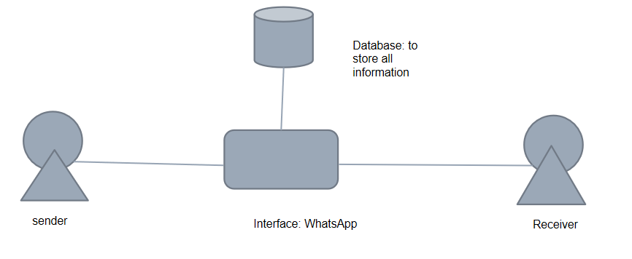

**Figure 1:** Architecture of the Project

1. **RESULTS AND DISCUSSION**

When the code is run in the command prompt, we get the following results gets displayed on the screen. This is like the notification that the birthday wishes have been delivered to the particular people.

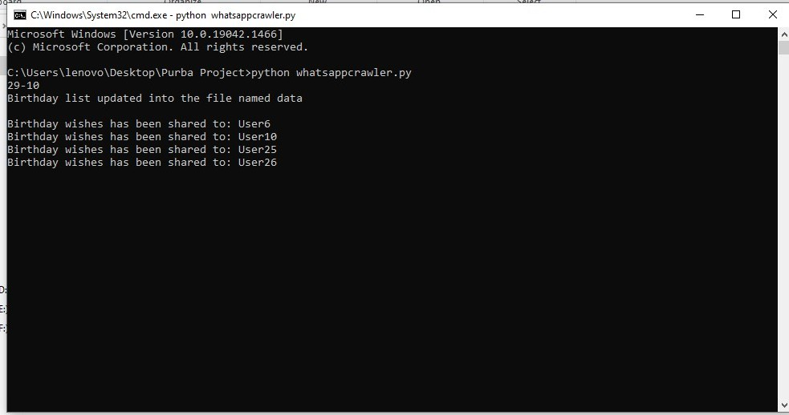Here, we are executing the python code which has been saved as “whatsappcrawler” file. **Command to run** – python whatsappcrawler.py

**Figure 2:** Output of the code in the command prompt of python**.**

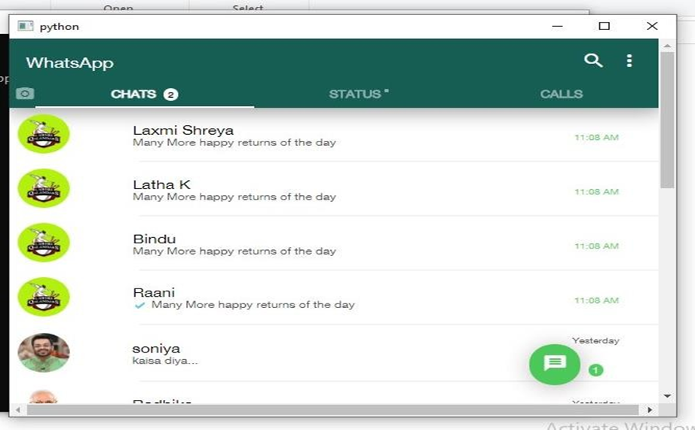

**Figure 3:** Interface for WhatsApp Birthday Bot

1. **CONCLUSION**

In summary, the creation and implementation of the WhatsApp Birthday Bot represent a significant advancement in leveraging technology to enhance personal connections and celebrations. By automating the process of sending birthday wishes, the project seamlessly integrates technological innovation with the warmth of human interaction. Through the adept use of programming languages and API integrations, the bot effectively identifies birthdays from contact lists and delivers personalized greetings, thereby enriching the user experience on the messaging platform.

Moreover, the adoption of automation not only simplifies the birthday greeting process but also ensures that no significant occasion is inadvertently missed amidst the fast-paced realm of digital communication. This initiative underscores the potential of technology to facilitate meaningful connections and foster a sense of closeness, even in the digital sphere.

Looking ahead, the success of the WhatsApp Birthday Bot opens doors for further exploration into how automation can be harnessed to enrich various aspects of interpersonal communication. By continuing to innovate and refine such technologies, we can cultivate deeper connections and foster moments of joy and celebration in the lives of individuals worldwide.

1. **REFERENCES**
2. <https://www.quora.com/What-is-the-future-scope-of-chatbot#:~:text=In%20the%20future%2C%20chatbots%20may,providing%20guidance%20on%20medication%2C%20answeri>
3. <https://www.searchenginejournal.com/future-of-chatbots/278595/>
4. <https://botup.com/what-is-the-future-of-chatbots>
5. <https://www.toptal.com/insights/innovation/chatbot-technology-past-present-future>
6. <https://www.educba.com/what-is-bot/>