**FRUIT QUALITY PREDICTION**

**V Mahender1, A Nikitha Reddy2, P Pooja Shree3, F Suthej4**

1Assistant Professor, Information Technology, ACE Engineering College, Telangana, India.

*2,3,4 Information Technology, ACE Engineering College, Telangana, India.

**ABSTRACT**

The quality of fruits and vegetables significantly influences consumer consumption and, consequently, impacts their sales. In India, where a large portion of the population relies on agriculture for their livelihood, ensuring the quality of produce is crucial. Businesses and organizations involved in producing, displaying, transporting, or preparing food for sale must rigorously check food quality. Identifying the maturity level of fresh fruits can greatly benefit farmers by allowing them to optimize their harvesting process. This capability can help prevent the issues of harvesting fruits that are either under-mature or over-mature.

To achieve this, image processing techniques can be employed to extract various attributes such as color, size, and texture from images of fruits. These extracted attributes form the basis of a training dataset. Using both supervised and unsupervised learning methods, we can train models on this dataset. When a new image of a fresh fruit, whose quality needs to be assessed, is introduced, it undergoes similar image processing. The attributes extracted from this new image are then input into a machine learning algorithm, specifically a Deep Neural Network (DNN). By referencing the trained dataset, the algorithm predicts the quality of the fruit based on the learned patterns and attributes. This approach not only helps in ensuring better quality control but also supports farmers in making more informed harvesting decisions, thereby enhancing overall agricultural productivity.

1. **INTRODUCTION (Font-Times New Roman, Bold, Font Size -12)**

In the realm of agriculture and food production, ensuring the quality of fruits and vegetables is crucial for both farmers and consumers. In a country like India, where a significant portion of the population relies on agricultural products for their livelihoods, understanding and optimizing the quality of these produce items is of paramount importance. The quality of agricultural products directly impacts consumer consumption patterns and, consequently, influences sales.

**LITERATURE SURVEY**

As discussed above, the number of researchers are working in this area. In paper [2], the authors observed that the number of classification algorithms is available in remote sensing methods like minimum distance, maximum likelihood, support vector machine, K-NN, and multilevel classification. All the classifiers work for the same – classification and accuracy. Edaphic factors are the external factors include the soil moisture, soil air, soil mineral, soil temperature, soil organic matter, soil organism, and soil reactions [3]. The growth of the plant is completely depending on these factors. In our focus, organic matters are important because it provides the entire major, minor, and micronutrient to the plant. The role of the organic component is improving the texture of the soil, helping to increase The water holding capacity of the soil. It is the food for most micro-organisms. It is observed that the growth of crops depends on two factors as shown in figure- external factors and internal factors.

**Existing System**

Several classification algorithms are currently available in remote sensing methods, such as minimum distance, maximum likelihood, support vector machine, K-NN, and multilevel classification. In addition, a group of researchers led by A. Iriars developed an algorithm for weed detection in crops using computational vision. This approach utilizes a binary classification method, taking an image as input and performing feature classification with the binary method.

**Proposed System**

Classifying soil and identifying its quality level, along with determining which contents need improvement, can help define the soil type. This information is extremely useful for cultivation. To analyze the soil type in a specific geographical area, soil samples can be collected and classified into various categories using different machine learning algorithms. With the advent of machine learning and its application in image processing, soil samples can be efficiently classified into their respective categories.

1. **METHODOLOGY**

The methodology begins with the collection of soil samples from various geographical locations and images of fruits at different maturity stages. These samples and images are then preprocessed; soil samples are cleaned and prepared for imaging, while fruit images are standardized for lighting, orientation, and background consistency. Next, image processing techniques are employed to extract relevant features such as texture, color, and granularity from soil samples, and attributes like color, size, shape, and texture from fruit images. These extracted features are compiled into a structured dataset, which is then labeled and split into training and testing sets. Subsequently, suitable machine learning algorithms, such as Support Vector Machine (SVM), K-NN, Decision Trees, or Deep Neural Networks (DNN), are selected for classification tasks. The models are trained using the training dataset and validated with the testing dataset to fine-tune parameters and enhance accuracy. Once trained, the models are used to classify new soil samples, determining their quality and suggesting necessary improvements, and to predict the maturity level and quality of new fruit images. The performance of the models is evaluated using metrics like accuracy, precision, recall, and F1-score, and optimized based on these results to ensure reliable predictions. The trained models are then deployed in real-world scenarios, allowing farmers and agricultural stakeholders to input soil samples or fruit images and receive quality assessments and recommendations. Continuous improvement is ensured by regularly updating the models with new data to maintain and enhance their accuracy and adaptability to changing conditions. This comprehensive approach leverages machine learning and image processing to provide valuable insights for soil and fruit quality assessment, aiding farmers in making informed decisions for optimal cultivation and harvesting.

**3** **MODELING AND ANALYSIS**

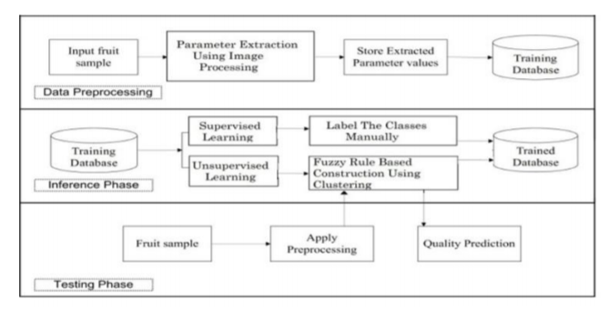

Fig 3.1 System Architecture

**4.RESULTS AND DISCUSSION**

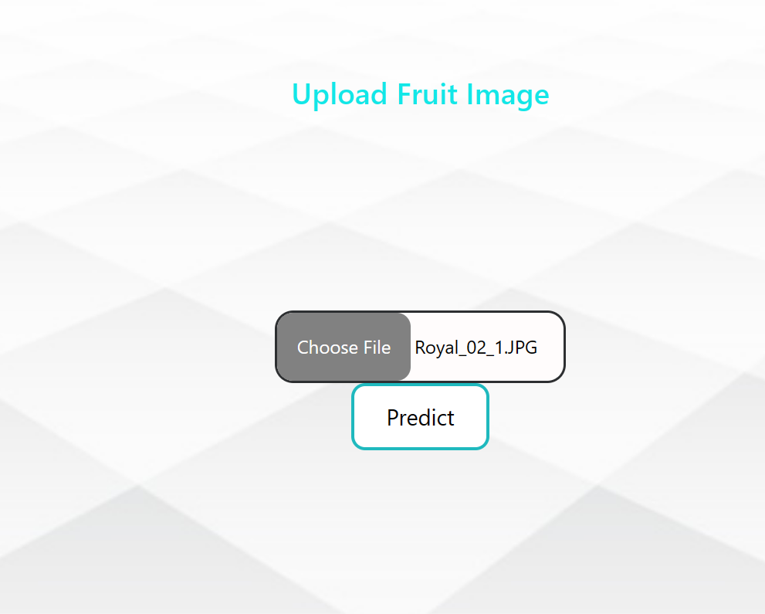

**Fig 4.1 Upload Fruit Image**



**Fig 4.2 Get Prediction Result**

**5.CONCLUSION**

Fruit quality prediction, through the application of advanced machine learning techniques, represents a transformative approach to modern agriculture and food supply chain management. This approach involves harnessing the power of data analytics to make accurate forecasts regarding various attributes of fruits, including their ripeness, sweetness, firmness, and shelf-life. By integrating diverse sources of data such as weather patterns, soil conditions, cultivation practices, and historical harvest data, along with sensor technology and imaging techniques, predictive models can be developed to anticipate fruit quality with remarkable precision.

**6.REFERENCES**

* T.-H. Kim, D.-C. Park, D.-M. Woo, T. Jeong, and S.-Y. Min, “Multi-class classifier-based adaboost algorithm,” in Proceedings of the Second Sinoforeign-interchange Conference on Intelligent Science and Intelligent Data Engineering, ser. IScIDE’11. Berlin, Heidelberg: Springer-Verlag, 2012, pp. 122–127.
* [3] P. Viola and M. J. Jones, “Robust real-time face detection,” Int. J. Comput. Vision, vol. 57, no. 2, pp. 137–154, May 2004.