**VIRTUAL PIANO USING RASPBERRY PI PICO**

**Mr. R. NARENDER*1, N. Sai Sri Dharani*2, N. Yashwanth*3, B. Balaji*4**

1Assistant Professor, ACE Engineering College, Ankushapur, Telangana, India

2Student, ACE Engineering College, Ankushapur, Telangana, India

3Student, ACE Engineering College, Ankushapur, Telangana, India

4Student, ACE Engineering College, Ankushapur, Telangana, India

**ABSTRACT**

This project aims to construct a portable virtual piano system utilizing Raspberry Pi, touch sensors, and additional key components. Leveraging the computational prowess of Raspberry Pi and touch sensor technology, users can emulate the tactile sensation of playing a traditional piano without the constraints of physical keys. Raspberry Pi serves as the central processing unit, analysing touch sensor inputs to generate corresponding piano notes. Incorporating suggested components such as DF mini player for superior audio output, an LCD display for intuitive user interaction, a mode changer for dynamic functionality, and a robust power supply ensures an enriched musical experience. The integration of the DF mini player enhances audio quality, providing authentic sound reproduction through connected speakers or headphones. The LCD display offers real-time feedback on selected modes, settings, and musical notes being played, enhancing user engagement.

This project enables users to enjoy the advantages of portability and sound customization, empowering them to create music on the go and experiment with diverse instrument voices and sound effects. Furthermore, seamless integration with other digital music software and systems fosters collaboration and access to a wide array of music production tools.

**Keywords:** Analysis, investigation, research (5-6 Keywords, Font-Times New Roman, Font Size – 10).

1. **INTRODUCTION**

This project aims to develop a portable virtual piano system using Raspberry Pi and touch sensor technology. Leveraging Raspberry Pi's computing power and touch sensors, users can replicate the experience of playing a traditional piano without physical keys. The Raspberry Pi serves as the central processing unit, interpreting touch sensor data to generate corresponding piano notes. Key components integrated into the system include a DF mini player for high-quality audio output, an LCD display for user interaction, a mode changer for dynamic functionality switching, and a reliable power supply. These enhancements elevate the musical experience by providing superior audio quality, intuitive user interface, and seamless transitions between different functionalities.

The virtual piano offers advantages such as portability and sound customization, enabling users to create music anywhere and experiment with various instrument voices and effects. Additionally, the system facilitates easy integration with other digital music software and systems, fostering collaboration and access to diverse music production tools.

1. **LITERATURE SURVEY**

The literature survey serves as a foundational aspect of research and project development, providing insights into existing knowledge, technologies, and methodologies relevant to the project. By reviewing existing literature, researchers gain a comprehensive understanding of the field, identify gaps in knowledge, and inform their approach and design decisions.

In the context of this project, the literature survey aims to explore previous research, studies, and projects related to the development of a portable virtual piano using Raspberry Pi Pico, touch sensors, DF mini player, LCD display, mode changer, and a power supply unit. The survey will encompass various topics, including microcontroller-based musical instruments, touch sensing technologies, audio output systems, user interface design, power supply design, integration of components, and educational applications of virtual musical instruments

* 1. **Touch Sensing Technologies In Musical Interfaces:**

In this project, touch sensing technologies, particularly capacitive touch sensing, are integral to the virtual piano interface. Capacitive touch sensors will be used on each key, enabling users to trigger notes by touching the sensor surface. Research on optimizing capacitive touch sensors for musical applications will inform sensor design to ensure reliable and responsive touch detection. Additionally, exploration of multi-touch gesture recognition and pressure sensitivity will enhance the expressive capabilities of the virtual piano. Integration with digital signal processing algorithms will enable advanced features such as polyphonic touch response and dynamic sound modulation based on touch input. Overall, touch sensing technologies play a vital role in creating an intuitive and immersive musical experience for users.

* 1. **Raspberry Pi Pico And Microcontroller-Based Musical Instruments:**

In recent years, people have been using small computer boards like the Raspberry Pi Pico to make musical instruments. These boards are cheap and can do lots of things, so they're great for creating synthesizers, drum machines, and other musical gadgets. Researchers have been studying how these boards work for making sounds and handling music-related tasks.

1. **MODELING AND ANALYSIS**

The virtual piano system utilizes the Raspberry Pi Pico microcontroller as its core processing unit. Capacitive touch sensors are integrated into piano keys, detecting user input. The DF Mini Player handles audio playback via serial communication with the Raspberry Pi Pico. A 16x2 LCD display provides user feedback, while a mode changer component enables mode switching. Power is supplied either via battery pack or DC adapter. Programming is done in MicroPython or C/C++, with UART for communication. GPIO pins are configured for sensor interfacing. Efficient power management and audio signal processing algorithms ensure optimal performance.

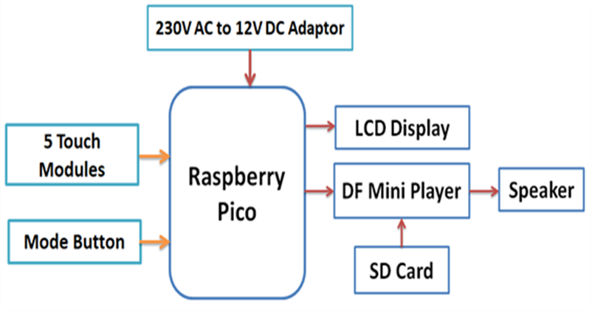

**Figure 1:** Block Diagram of Virtual Piano Using Raspberry pi Pico.

* 1. **Working:**
* Raspberry Pi Pico initializes system components.
* Touch sensors detect key presses.
* Signal sent to Raspberry Pi Pico.
* Raspberry Pi Pico generates audio signal.
* DF Mini Player plays corresponding note.
* LCD display updates with key pressed.
* User can switch modes via mode changer.
* Virtual piano operates continuously.
* Power off Raspberry Pi Pico to stop operation.

1. **RESULTS AND DISCUSSION**

To implement a virtual piano system using a Raspberry Pi Pico, DF Mini Player, capacitive touch sensors, an LCD display, and a mode changer component, you start by powering on the Raspberry Pi Pico and initializing the necessary GPIO pins. Capacitive touch sensors detect touch events on the piano keys, each connected to a GPIO pin. Upon detecting a touch event, the Raspberry Pi Pico generates the corresponding audio signal and sends it via serial communication to the DF Mini Player, which then plays the pre-recorded musical note through a connected speaker. Simultaneously, the LCD display, connected via I2C, is updated to provide visual feedback, such as indicating the pressed key or current mode. A mode changer component, like a rotary encoder or buttons, allows the user to switch modes or settings, sending signals to the Raspberry Pi Pico to trigger these changes. The system operates continuously, checking for touch events and mode changes, updating the display, and playing sounds in real-time. The system can be terminated by powering off the Raspberry Pi Pico or disconnecting the power supply, resetting all components to their initial state for future use.

* 1. **Software Used:**

The Arduino Integrated Development Environment (IDE) is a versatile cross-platform application written in Java. It is derived from the IDEs used for the Processing programming language and the Wiring projects. The Arduino IDE includes a user-friendly code editor that allows for easy compiling and uploading of programs to the board with a single click. In the context of Arduino, these programs or codes are referred to as "sketches"

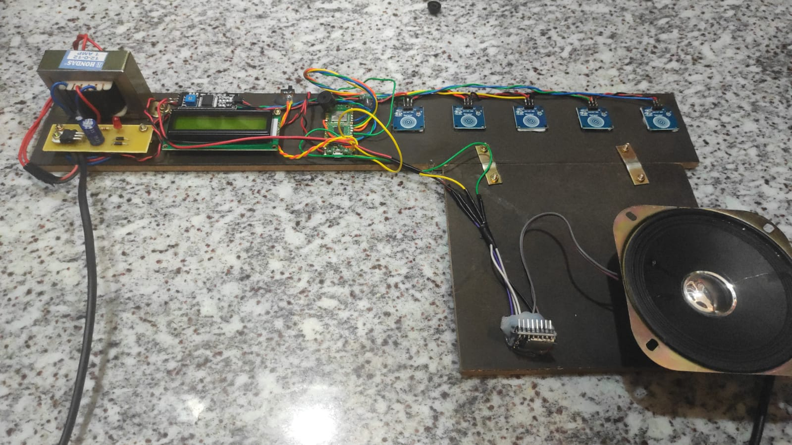

**Figure 2:** Virtual Piano Using Raspberry Pi Pico

1. **CONCLUSION**

In conclusion, the Raspberry Pico piano with touch module and DF Mini Player integration represents a compelling fusion of technology and creativity, offering users a versatile and engaging platform for musical expression. Through the seamless interaction between hardware components and software programming, this project demonstrates the potential of microcontroller-based systems to facilitate interactive musical experiences.

By harnessing the touch-sensitive capabilities of the 5-touch module and the audio playback capabilities of the DF Mini Player, users can effortlessly explore the creation of melodies, experiment with different sound modes, and immerse themselves in a world of sonic possibilities. The intuitive user interface, coupled with immediate auditory feedback, encourages experimentation and empowers users to unleash their musical creativity.

* 1. **Future Scope:**

The future scope of your virtual piano project using Raspberry Pi Pico and touch sensors includes the exploration of advanced features like support for multiple instrument sounds, recording and playback functionalities, and real-time effects processing, enhancing the creative possibilities for users. Additionally, integrating a graphical user interface (GUI) with interactive controls, wireless connectivity options for remote access, and compatibility with digital audio workstations (DAWs) could further elevate the user experience and extend the project's applications to collaborative music-making, educational tools, and therapeutic programs. By continually refining and expanding the virtual piano's capabilities and interfaces, your project has the potential to become a versatile and accessible platform for music creation, learning, and expression, catering to a wide range of users and use cases.

1. **REFERENCES**

• **McPherson, A., Kim, Y., Bianchi, F., & Papetti, S. (2016).** In their paper titled "Raspberry Pi as a Platform for Musical Instrumentation," presented at the International Conference on New Interfaces for Musical Expression, the authors explore how the Raspberry Pi can be utilized in the development of new musical instruments (pp. 348-351).

• **Rathod, C. S., Panchal, K. P., & Chavda, K. M. (2018).** The article "Touch Sensitive Musical Interface using Raspberry Pi," published in the International Journal of Engineering Research and Technology, discusses the creation of a musical interface using touch sensors and a Raspberry Pi, providing detailed insights and results from their experiments (Vol. 11, Issue 4, pp. 551-556).

• **Fried, L. (2017).** In the Adafruit Industries guide "DF Player Mini MP3 Module and Its Applications," Fried provides a comprehensive overview of the DFPlayer Mini MP3 module, including its features, uses, and practical applications. Retrieved from [Adafruit](https://learn.adafruit.com/dfplayer-mini-mp3-module/overview).

• **Gunda, A. B., Ghugare, S. S., & Baviskar, A. V. (2020).** The study "Design and Implementation of Touch Sensor-Based Piano using Arduino," published in the International Journal for Research in Applied Science & Engineering Technology, details the process of creating a piano interface using touch sensors and an Arduino board, presenting both the design and implementation phases (Vol. 8, Issue 3, pp. 1275-1280).

• **Fiebrink, R., Cook, P. R., & Trueman, D. (2011).** The research article "Exploring Human-Computer Interaction in Digital Musical Instrument Design," featured in the Computer Music Journal, investigates the interaction between humans and computers in the context of digital musical instrument creation, providing valuable insights into HCI principles (Vol. 35, Issue 1, pp. 28-42). doi:10.1162/COMJ_a_00024

• **Monk, Simon. (2020).** In "Raspberry Pi Cookbook: Software and Hardware Problems and Solutions," published by O'Reilly Media, Monk offers a collection of practical solutions and tips for tackling both software and hardware issues encountered when working with the Raspberry Pi.