**UNVEILING THE GREEN DEFICIENCY:**

**AN EXPLORATORY FACTOR ANALYSIS INTO**

**INSUFFICIENT GREEN SPACES IN URBAN ENVIRONMENTS IN DAVAO CITY**

By: Mary Lizbeth M. Singco

https://orcid.org/0009-0004-1618-8922

Graduate School of Development Management, University of Southeastern Philippines,

Davao City, Philippines

**Abstract**

This study explored the insufficiency of green areas in urban settings, specifically in Davao City, emphasizing their contribution to biodiversity, environmental sustainability, public health, and overall well-being. The decline of urban greening in numerous developing nations can be attributed to the rapid process of urbanization despite its significant relevance.

Employing exploratory factor analysis, the study identified key factors affecting the availability, accessibility, and quality of green spaces. Results underscored the importance of factors such as the multifaceted significance of green areas, accessibility, management, and satisfaction of the community, positive impacts of green space, environmental vitality, and equal distribution of green spaces in urban areas.

By providing a comprehensive framework, this research offered valuable guidance to government planners tasked with balancing urbanization and green space preservation, ultimately striving for a prosperous and sustainable future for Davao City and its inhabitants.

Keywords: *green deficiency, green spaces, urban environments*

**INTRODUCTION**

Green spaces are areas of grass, trees, or other vegetation set apart for recreational or aesthetic purposes in an otherwise urban environment, according to the Oxford Dictionary. Internationally, areas of greenery such as parks, gardens, and natural settings are recognized as crucial components of biodiversity, serving to maintain ecological balance, especially within urban environments. Moreover, they contribute significantly to promoting environmental sustainability, public well-being, and overall quality of life (Rehman, Aziz, Anwar, Majeed, Albanai, Almohamad, & Abdo, 2023).

Urban environments are crucial hubs of human activity, serving as centers for economic, social, and cultural development. Davao City is a rapidly growing urban center in the Philippines, the metropolitan center serving as Mindanao's leading trade, commerce, and industry hub (NEDA-XI).

Understanding the factors behind insufficient green spaces is crucial for informed urban planning and sustainable development in Davao City. Given the prevalence of this issue, there's a clear need for a thorough investigation. This research employed exploratory factor analysis (EFA) to uncover the underlying causes of green deficiency, aiming to identify critical factors affecting the availability, accessibility, and quality of green spaces in urban areas. By systematically analyzing these factors, the study offered valuable insights and recommendations to address the green deficiency and enhance urban green spaces in Davao City.

**METHODOLOGY**

This study utilized an exploratory factor analysis (EFA) to identify underlying factors contributing to the green deficiency. A structured questionnaire was developed that consisted of Likert-scale items designed to measure various factors contributing to the green deficiency that perceived the importance of green spaces.

A survey of 150 people was conducted across different demographic areas within Davao City. Data was gathered using both printed questionnaires and electronic questionnaires, the latter being an avenue for reaching the intended respondents and achieving the needed number of research participants (Moises C. Torrentira, Jr., 2020).

This data was then tallied, summarized, and subjected to statistical treatment using SPSS Statistics. It is a statistical software suite developed for data management, advanced analytics, multivariate analysis, business intelligence, and criminal investigation (https://en.wikipedia.org/wiki/SPSS). One of its results was the Kaiser-Meyer-Olkin (KMO) test, which measures the strength of partial correlations between variables, and the correlation of the matrix's identity as a matrix was tested using Bartlett's test of sphericity (Noora Shrestha, 2021). The study also employed the Scree Plot or Scree Test, which is a line plot of the eigenvalues of factors or principal components in an analysis (George Thomas Lewith, 2010), which graphically shows the variety of elements that went through.

**RESULTS AND DISCUSSION**

**Factor Analysis**

This section provides the findings of the KMO and Bartlett's Test as well as the Principal Component Analysis. The calculation of the number of factor structures and the rotation matrix of the model is also demonstrated using Varimax with Kaiser Normalization.

**KMO and Bartlett's Test.** To assess the suitability of the construct for factor analysis, the Kaiser Meyer-Olkin Measure (KMO) of Sampling Adequacy and Bartlett's test of sphericity were conducted. Table 1 reveals that the KMO value is 0.861, surpassing the suggested threshold of .5. KMO values between 0.8 and 1 indicate the sampling is adequate (Ali-Abadi, T., Talepasand, S., & Boyle, C., 2020). This suggests that the sample is commendable and suitable for factor analysis. Meanwhile, Bartlett's test was conducted to determine if there is any duplication among the variables that can be summarized using a small number of components. The findings indicated that the p-value is statistically significant (p<.05), suggesting that the data exhibit structured relationships and can be presumed to be factorable.

Table 1. KMO and Bartlett's Test

|  |  |  |
| --- | --- | --- |
| Kaiser-Meyer-Olkin Measure of Sampling Adequacy | | 0.861 |
| Bartlett's Test of Sphericity | Approx. Chi-Square | 1579.546 |
| Df | 300 |
| Sig. | 0.000 |

As shown in the preliminary analysis, it can be generalized that the items in the tool are suitable and adequate for the extraction of factors and, thus, ready for factor analysis.

**Derivation of the Number of Factor Structure and Total Variance Explained.** The derivation of factor structure was determined through the eigenvalues of the components. As a rule of thumb, components with an Eigenvalue of at least 1 are selected. Table 2 displays the number of constructs identified, their initial Eigenvalues, the percentage of total variance they account for, and the cumulative percentage for each construct. Applying the Eigenvalue criterion, it appears that the 25 items in the scale assess five underlying factors, as the first five components each have an Eigenvalue exceeding 1.

Table 2. Total Variance Explained

|  |  |  |  |  |  |  |  |  |  |
| --- | --- | --- | --- | --- | --- | --- | --- | --- | --- |
| Compo-nent | Initial Eigenvalues | | | Extraction Sums of Squared Loadings | | | Rotation Sums of Squared Loadings | | |
| Total | % of Variance | Cumulative % | Total | % of Variance | Cumulative % | Total | % of Variance | Cumulative % |
| 1 | 8.004 | 32.017 | 32.017 | 8.004 | 32.017 | 32.017 | 5.086 | 20.342 | 20.342 |
| 2 | 2.595 | 10.380 | 42.396 | 2.595 | 10.380 | 42.396 | 3.437 | 13.747 | 34.090 |
| 3 | 1.415 | 5.660 | 48.056 | 1.415 | 5.660 | 48.056 | 2.718 | 10.874 | 44.963 |
| 4 | 1.391 | 5.566 | 53.622 | 1.391 | 5.566 | 53.622 | 1.914 | 7.656 | 52.620 |
| 5 | 1.214 | 4.857 | 58.479 | 1.214 | 4.857 | 58.479 | 1.465 | 5.860 | 58.479 |
| 6 | .998 | 3.992 | 62.471 |  |  |  |  |  |  |
| 7 | .903 | 3.612 | 66.083 |  |  |  |  |  |  |
| 8 | .804 | 3.215 | 69.298 |  |  |  |  |  |  |
| 9 | .741 | 2.964 | 72.261 |  |  |  |  |  |  |
| 10 | .713 | 2.850 | 75.112 |  |  |  |  |  |  |
| 11 | .684 | 2.738 | 77.850 |  |  |  |  |  |  |
| 12 | .604 | 2.418 | 80.267 |  |  |  |  |  |  |
| 13 | .574 | 2.296 | 82.563 |  |  |  |  |  |  |
| 14 | .549 | 2.196 | 84.759 |  |  |  |  |  |  |
| 15 | .530 | 2.121 | 86.880 |  |  |  |  |  |  |
| 16 | .513 | 2.054 | 88.934 |  |  |  |  |  |  |
| 17 | .411 | 1.646 | 90.580 |  |  |  |  |  |  |
| 18 | .382 | 1.527 | 92.107 |  |  |  |  |  |  |
| 19 | .366 | 1.462 | 93.569 |  |  |  |  |  |  |
| 20 | .333 | 1.333 | 94.903 |  |  |  |  |  |  |
| 21 | .327 | 1.309 | 96.211 |  |  |  |  |  |  |
| 22 | .276 | 1.103 | 97.315 |  |  |  |  |  |  |
| 23 | .270 | 1.079 | 98.394 |  |  |  |  |  |  |
| 24 | .228 | .913 | 99.307 |  |  |  |  |  |  |
| 25 | .173 | .693 | 100.000 |  |  |  |  |  |  |

Extraction Method: Principal Component Analysis.

To further fortify the results of the previous table, Figure 1 presents the scree plot, which displays the number of factors versus their corresponding Eigenvalues. The scree plot shows that the first five factors account for most of the total variability in data (given by the Eigenvalues). The Eigenvalues for the first five factors as presented are all greater than 1. The remaining factors account for a very small proportion of the variability and are likely unimportant (Konalingam, K., 2017).

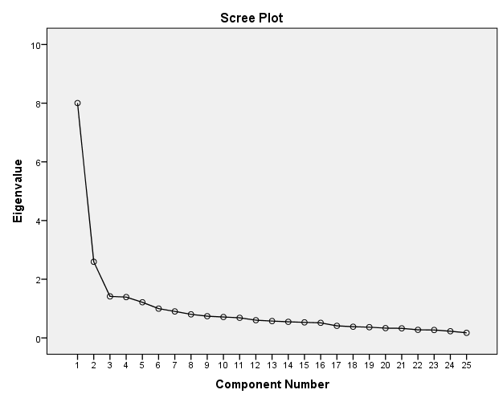

Figure 1. Scree Plot

**Rotated Component Matrix.** After identifying the number of factor structures, the 30-item construct is then subjected for rotation. Table 3 shows the pattern matrix using Principal Component Analysis with a rotation method of Varimax with Kaiser Normalization. Based on the standard rule of factor analysis, items with a loading value of less than .40 should be excluded. This is supported by Hair et al. (2010), categorizing these loadings using another rule of thumb as ±0.30=minimal, ±0.40=important, and ±.50=practically significant. If no correlations go beyond 0.30, then the researcher should reconsider whether factor analysis is the appropriate statistical method to utilize. Pattern coefficients ≥.37 were considered salient (i.e., both practically and statistically significant, as per Norman & Streiner, 2014).

**Table 3. Principal Component Analysis**

|  |  |  |  |  |  |
| --- | --- | --- | --- | --- | --- |
|  | Component | | | | |
|  | 1 | 2 | 3 | 4 | 5 |
| i14 | .774 |  |  |  |  |
| i16 | .767 |  |  |  |  |
| i15 | .752 |  |  |  |  |
| i23 | .615 |  |  |  |  |
| i20 | .615 |  |  |  |  |
| i24 | .608 |  |  |  |  |
| i19 | .595 |  |  |  |  |
| i12 | .587 |  |  |  |  |
| i18 | .574 |  |  |  |  |
| i25 | .544 |  |  |  |  |
| i13 | .478 |  |  |  |  |
| i6 |  | .782 |  |  |  |
| i7 |  | .727 |  |  |  |
| i21 |  | .699 |  |  |  |
| i9 |  | .659 |  |  |  |
| i22 |  | .647 |  |  |  |
| i17 |  | .643 |  |  |  |
| i1 |  |  | .748 |  |  |
| i10 |  |  | .713 |  |  |
| i3 |  |  | .664 |  |  |
| i8 |  |  | .556 | .458 |  |
| i5 |  |  |  | .703 |  |
| i4 |  |  | .425 | .616 |  |
| i2 |  |  |  |  | .799 |
| i11 |  |  |  |  | .737 |

**Rotated Component Matrix with Grouped Items**

Based on the criterion, items were categorized into five constructs, namely: significance of green areas, community engagement, impact of green space, potential effects, and green space imbalance.

As indicated in Table 4, exploratory factor analysis revealed the first dimension is the significance of green spaces with the following indicators: I think the government should prioritize the creation and maintenance of green spaces in urban planning, had a load score of 0.774; Urban development projects in Davao City should prioritize preserving existing green spaces, with the load score of 0.767; The presence of green spaces influences my decision to engage in outdoor activities, 0.752; Green spaces provide important habitats for local wildlife in urban areas, with the load score of 0.615; Green spaces contribute to biodiversity conservation efforts in Davao City, got 0.615; I would support initiatives to repurpose vacant lots into green spaces in urban areas with the load score of 0.608; The green spaces positively impacts property values in urban neighborhoods, load score of 0.595; Green spaces are important for fostering a sense of community in urban areas, had a 0.587 as loading score; I feel safe when using green spaces in urban areas of Davao City with the load score of 0.574; The presence of green spaces encourages me to engage in physical exercise, 0.544; and I would be more inclined to live in an area with ample green spaces, got a load score of 0.478.

Urban green spaces are crucial for preserving biodiversity and enhancing human well-being within cities. It's essential to recognize these green areas as integral parts of urban sustainability moving forward, as stated by Xuancheng Zhao, Fengshi Li, Yongzhi Yan, and Qing Zhang (2022)

Table 4. Rotated Component Matrix with Items grouped under Multifaceted Significance of Green Areas

|  |  |  |  |
| --- | --- | --- | --- |
| **Item No.** | **Items** | **Factor Coefficient** | **Construct** |
| i14 | I think the government should prioritize the creation and maintenance of green spaces in urban planning. | .774 | **MultifacetedSignificance of Green Areas** |
| i16 | Urban development projects in Davao City should prioritize preserving existing green spaces. | .767 |
| i15 | The presence of green spaces influences my decision to engage in outdoor activities. | .752 |
| i23 | Green spaces provide important habitats for local wildlife in urban areas. | .615 |
| i20 | Green spaces contribute to biodiversity conservation efforts in Davao City. | .615 |
| i24 | I would support initiatives to repurpose vacant lots into green spaces in urban areas. | .608 |
| i19 | The green spaces positively impact property values in urban neighborhoods. | .595 |
| i12 | Green spaces are important for fostering a sense of community in urban areas. | .587 |
| i18 | I feel safe when using green spaces in urban areas of Davao City. | .574 |
| i25 | The presence of green spaces encourages me to engage in physical exercise. | .544 |
| i13 | I would be more inclined to live in an area with ample green spaces. | .478 |

Table 5 items fall under dimension 2, Accessibility, Management, Satisfaction of the community, are Urban development projects in Davao City should prioritize preserving existing green spaces, with a score of 0.782; I believe there are adequate opportunities for urban gardening and community agriculture in Davao City, got a score of 0.727; I am satisfied with the accessibility of green spaces from my residence in Davao City, gain a score of 0.699; The green spaces positively impact property values in urban neighborhoods, with loading factor of 0.659; I believe the public is adequately involved in decisions regarding green space management in Davao City, with loading score of 0.647. I believe there are adequate opportunities for urban gardening and community agriculture in Davao City, and got a score of 0.643.

Research findings from Ward Thompson et al. (2014) demonstrate community interest in assuming more significant roles in the maintenance of green spaces for local advantages. Additionally, they found that leveraging modern mapping and visualization tools has effectively encouraged community involvement, facilitated information gathering, and facilitated the development of grassroots green space plans.

Table 5. Rotated Component Matrix with Items grouped under Accessibility, Management and Satisfaction of the Community

|  |  |  |  |
| --- | --- | --- | --- |
| **Item No.** | **Items** | **Factor Coefficient** | **Construct** |
| i6 | Urban development projects in Davao City should prioritize preserving existing green spaces. | .782 | **Accessibility, Management, and Satisfaction of the Community** |
| i7 | I believe there are adequate opportunities for urban gardening and community agriculture in Davao City. | .727 |
| i21 | I am satisfied with the accessibility of green spaces from my residence in Davao City | .699 |
| i9 | The green spaces positively impact property values in urban neighborhoods. | .659 |
| i22 | I believe the public is adequately involved in decisions regarding green space management in Davao City. | .647 |
| i17 | I believe there are adequate opportunities for urban gardening and community agriculture in Davao City. | .643 |

The third dimension is the positive impacts of green space, and it has four items shown in Table 6. The first item is The availability of green spaces influences my decision to visit certain areas in Davao City, with a loading score of 0.748; The presence of green spaces in urban areas positively contributes to my physical and mental well-being, had a 0.713 as its loading score; The presence of green spaces enhances the overall aesthetic appeal of Davao City, got 0.664; and the Green spaces play a role in reducing air pollution and improving air quality in Davao City, got a loading score of 0.556.

This aspect corresponds with Mark J. Nieuwenhuijsen's research (2021), which highlights the various health advantages associated with green spaces. These benefits encompass decreased premature death rates, extended life expectancy, reduced instances of mental health disorders and cardiovascular ailments, improved cognitive function in both young and elderly individuals, and enhanced infant well-being. Additionally, green spaces play a role in mitigating air pollution, minimizing heat and noise pollution, and offering settings for physical activity and social engagement.

Table 6. Rotated Component Matrix with Items grouped under Positive Impacts of Green Space

|  |  |  |  |
| --- | --- | --- | --- |
| **Item No.** | **Items** | **Factor Coefficient** | **Construct** |
| i1 | The availability of green spaces influences my decision to visit certain areas in Davao City. | .748 | **Positive Impacts of Green Space** |
| i10 | The presence of green spaces in urban areas positively contributes to my physical and mental well-being. | .713 |
| i3 | The presence of green spaces enhances the overall aesthetic appeal of Davao City. | .664 |
| i8 | Green spaces play a role in reducing air pollution and improving air quality in Davao City. | .556 |

Potential effects is the fourth dimension identified in this exploratory factor analysis. Table 7 shows the two (2) items belonging to this dimension: I believe enhancing tree cover in urban areas in Davao City would be beneficial, and Access to parks and recreational areas contributes positively to the quality of life in urban environments, with loading scores of 0.703 and 0.616.

The research study of Zhu, J. et al (2020), suggests that by developing small parks in densely populated urban areas and improving the density and diversity of peripheral parks in developing urban districts or urban-rural regions, we can increase the vitality of urban parks and ultimately improve human well-being. Utilizing urban parks, which include the intangible benefits of park usage, provides a viable approach to addressing and maintaining wildlife in urban areas.

Table 7. Rotated Component Matrix with Items grouped under Environmental Vitality

|  |  |  |  |
| --- | --- | --- | --- |
| **Item No.** | **Items** | **Factor Coefficient** | **Construct** |
| i5 | I believe enhancing tree cover in urban areas in Davao City would be beneficial. | .703 | **Environmental Vitality** |
| i4 | Access to parks and recreational areas contributes positively to the quality of life in urban environments | .616 |

The fifth dimension is the Equal Distribution of Green Spaces in Urban Areas, as revealed in table 8: I believe there is a lack of parks and gardens in urban areas of Davao City, with loading score of 0.799; and I perceive a disparity in the distribution of green spaces across different neighborhoods in Davao City, got 0.737.

Table 8. Rotated Component Matrix with Items grouped under Equal Distribution of Green Spaces in Urban Areas

|  |  |  |  |
| --- | --- | --- | --- |
| **Item No.** | **Items** | **Factor Coefficient** | **Construct** |
| I2 | I believe there is a lack of parks and gardens in urban areas of Davao City. | .799 | **Equal Distribution of Green Spaces in Urban Areas** |
| I11 | I perceive a disparity in the distribution of green spaces across different neighborhoods in Davao City. | .737 |

**STUDY FRAMEWORK**

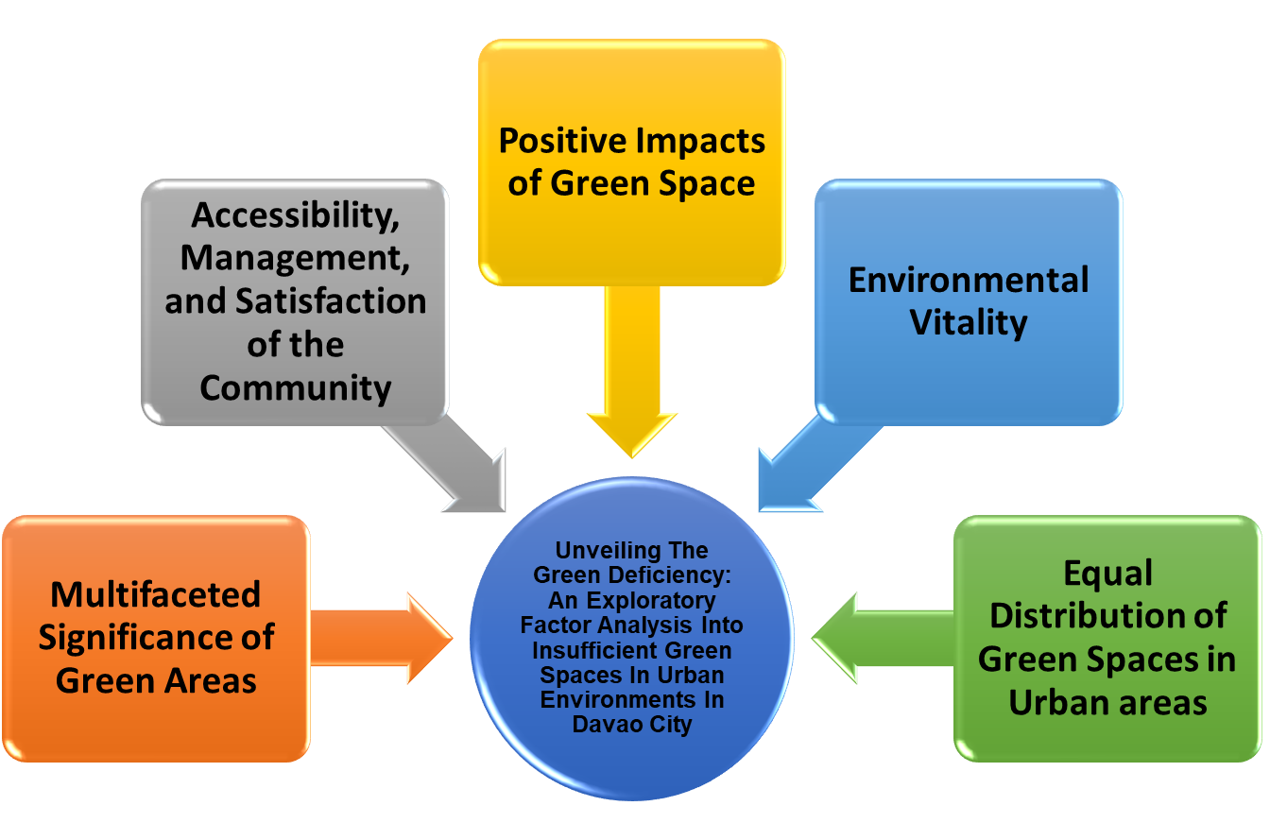

**CONCLUSION**

The results of the study highlight five key elements that require careful consideration: the multifaceted significance of green areas, accessibility, management and satisfaction in the community, positive impacts of green space, environmental vitality, and equal distribution of green spaces in urban areas. This all-encompassing framework is positioned to provide important direction to government planners who are navigating the intricate equilibrium between urbanization and the preservation of green spaces inside a rapidly growing city. With this understanding, urban planners may create plans that give priority to sustainability, improve the quality of life, and promote a balanced relationship between urban development and the natural environment, guaranteeing a prosperous future for future generations.

**ACKNOWLEDGEMENT**

I express my sincere appreciation to Dr. Moises C. Torrentira, Jr., my highly regarded professor in this area, for his essential assistance and mentorship during the research process.

**REFERENCES**

Lewith, George Thomas; Jonas, Wayne B.; Walach, Harald (23 November 2010). Clinical Research in Complementary Therapies: Principles, Problems and Solutions. Elsevier Health Sciences. p. 354. https://books.google.com.ph/books?id=CSNwspnFdkC&pg=PA354&redir_esc=y#v=onepage&q&f=false

Hair, J.F., Black, W.C., Babin, B.J., & Anderson, R.E. (2010). Multivariate data analysis. Seventh Edition. Prentice-Hall, Upper Saddle River, New Jersey. https://www.drnishikantjha.com/papersCollection/Multivariate%20Data%20Analysis.pdf

National Economic and Development Authority Region XI (NEDA-XI). Davao City. https://nro11.neda.gov.ph/davao-region/davao-city/#:~:text=The%20City%20also%20serves%20as,are%20located%20in%20the%20City.

Nieuwenhuijsen, Mark J (October 28, 2021). Why More Green Space Is Essential for Cities. https://www.isglobal.org/en/healthisglobal/-/custom-blog-portlet/why-more-green-space-is-essential-for-cities/4735173/0

Norman, G. R., & Streiner, D. L. (2014). Biostatistics: The bare essentials (4th ed.). Shelton, CT: People’s Medical Publishing.

Rehman, A., Aziz, A., Anwar, M. M., Majeed, M., Albanai, J., Almohamad, H. & Abdo, H.G. (30 November 2023) https://link.springer.com/article/10.1007/s43621-023-00169-z#:~:text=Globally%2C%20green%20spaces%20are%20considered,particularly%20due%20to%20rapid%20urbanization.

Röbbel, Nathalie. Green Spaces: An Invaluable Resource for Delivering Sustainable Urban Health. https://www.un.org/en/chronicle/article/green-spaces-invaluable-resource-delivering-sustainable-urban-health#:~:text=An%20increasing%20number%20of%20epidemiological,and%20mortality%2C%20obesity%20and%20diabetes.

Shrestha, Noora (2021, January) Factor Analysis as a Tool for Survey Analysis https://www.researchgate.net/publication/348653341_Factor_Analysis_as_a_Tool_for_Survey_Analys is

Statistics How To (2024). Kaiser-Meyer-Olkin (KMO) Test for Sampling Adequacy. https://www.statisticshowto.com/kaiser-meyer-olkin/

Sturt, Ben (28 August 2023) #wegotmail: There is a lack of green space in Davao City. https://www.sunstar.com.ph/davao/opinion/wegotmail-there-is-a-lack-of-green-space-in-davao-city

Torrentira, M. (2020). Online data collection as an adaptation in conducting quantitative and qualitative research during the COVID-19 pandemic. European Journal of Education Studies, 7(11). DOI: http://dx.doi.org/10.46827/ejes.v7i11.3336

Ward Thompson, C., Roe, J., Robertson, L., Aspinall, P., Mitchell, R., Miller, D., Clow, A., Brewer, M., & Duff, E. (2014). Landscape Perceptions and Use of Green Space. https://core.ac.uk/download/160483514.pdf

Xuancheng Zhao, Fengshi Li, Yongzhi Yan, and Qing Zhang (October 19, 2022). Biodiversity in Urban Green Space: A Bibliometric Review on the Current Research Field and Its Prospects. https://www.ncbi.nlm.nih.gov/pmc/articles/PMC9566254/#:~:text=Urban%20green%20space%20is%20built,construction%20strategies%20of%20different%20cities.

Zhu,J., Lu, H., Zheng, T., Rong, Y., Wang, C., Zhang, W.,Yan, Y., Tang, L. (March 2, 2020). Vitality of Urban Parks and Its Influencing Factors from the Perspective of Recreational Service Supply, Demand, and Spatial Links. https://www.mdpi.com/1660-4601/17/5/1615