**ELECTRIC GRASS CUTTER**

**THOOL PRASHIK RAMESH1, ABHISHEK MANIK MESRAM2, UJJWAL ARUN SIRSIKAR3,MUKESHKUMAR RAM4,ABHISHEK UDDEBHAN CHAUDHARI5, GOLANGE ADAESH GUNWANT6, CHAWHAN SWAPNIL RAMESH7, BISANE PRATIKKUMAR NATTHUJI8, PRATIK CHAPHALE9**

*12345678Student, VIT, ME Dept.,Nagpur

*9Asst. Prof. VIT, ME Dept.,Nagpur

**ABSTRACT**

Electric grass cutters, commonly known as electric lawn mowers, are devices designed for the maintenance of grassy areas through the use of electrical power. These machines offer a more environmentally friendly and quieter alternative to traditional gasoline-powered mowers. This abstract explores the various types of electric grass cutters, their operational mechanisms, advantages, and considerations for use. Electric grass cutters can be classified into two main categories: corded and cordless. Corded models require a constant connection to a power outlet, providing unlimited runtime but restricting mobility due to the length of the power cord. Cordless models, powered by rechargeable batteries, offer greater flexibility and ease of movement, though their operation time is limited by battery life.The operational mechanism of electric grass cutters typically involves a high-speed motor that drives a blade or a set of blades to cut the grass. These motors are often brush less, contributing to increased efficiency and reduced maintenance needs. The cutting deck, where the blades are housed, is designed to facilitate efficient grass collection and mulching, depending on the model.Advantages of electric grass cutters include lower noise levels, reduced emissions, and decreased operational costs compared to gasoline mowers. They are also generally lighter and easier to maintain. However, factors such as battery life, charging time, and cord length must be considered when selecting an appropriate model. In conclusion, electric grass cutters represent a significant advancement in lawn maintenance technology, aligning with contemporary environmental and convenience considerations. Future developments may focus on enhancing battery life, improving motor efficiency, and integrating smart technology for optimized performance and user experience.

**Keywords:** Electric lawn mower,Cordless mower,Corded mower,Battery-powered mower,Grass cutter, Lawn maintenance

Brushless motor, Mulching mower,Low-emission mower

1. **INTRODUCTION**

The earliest walk-behind style lawnmower was the reel type with both motive and cutting power being supplied by the operator. Modern rotary mowers began appearing in the 1930s, when light and powerful enough engines became available to spin a blade at high enough speeds. Powered versions and riding mowers have become ubiquitous but the technology has not fundamentally changed. That is, until very recently when modern electronics has made it possible to completely automate the machine. In 1995, Husqvarna released the first version of its Automower. Since then, they have sold over 100,000 robots around the world (1). It would seem that they have pretty much figured out how to build autonomous lawnmowers, but how well do they perform? One of the key features of a freshly cut lawn is the regular pattern or parallel lines left behind on the grass. Cutting grass cannot be easily accomplished by elderly, younger, or disabled people. Motor powered push lawn mowers and riding lawn mowers can help to ease out their task and require a little maintenance of motor. Even though electric lawn mowers are environmentally friendly, and are practically noise free as compare to petrol or diesel based lawn movers In large size of lawn in the park, schools, college, are maintained manually. The gardener used hand scissors used to cut and maintain lawn uniformly. Moving the grass cutters with a standard motor powered grass cutters reduces inconvenience, and one takes pleasure in it. This project is a grass cutter that will allow the user with the ability to cut the grass with minimum effort. Hence we design to make a grass cutter without any power source due to reduce the power consumption. Design motor based lawnmower that utilizes electric power as an energy source is meant to address a number of issues that standard internal combustion engine mowers do not. An electric lawnmower will be easier to use. It will eliminate those unnecessary trips to the gas station for fill-ups. The unskilled gardener is enough to operate the grass cutter. Most importantly it eliminates the emissions of an internal combustion mower which are mostly responsible for environmental pollution and causes the green house gases effect believed to be responsible for the worsening global warming of our planet*.* This is so because solar energy is green/renewable energy.

It uses the electric energy to power the motor to run the mower. It is assumed that a lawnmower using electricity as the energy source will address a number of issues that the standard internal combustion engine lawn mowers do not. A lawnmower with electric energy will be easier to use, it eliminates down time by frequent trips to the gas station for fill-ups and danger associated with gasoline spillage. The dangerous emissions generated by the gasoline spillage and that of the internal combustion engine into the atmosphere are eliminated. The project work was very successful one. It can be used to maintain lawn of our college.

**2**. **LITERATURE REVIEW**

## The first lawn mower was invented by Edwin Budding in 1830 just outside Stroud, in Gloucestershire, England. Bedding’s mower was designed primarily to cut the grass on sports grounds and extensive gardens, as a superior alternative to the scythe, and was granted a British patent on August 31, 1830. Budding’s first machine was 19 inches (480 mm) wide with a frame made of wrought iron. The mower was pushed from behind. Cast iron gear wheels transmitted power from the rear roller to the cutting cylinder, allowing the rear roller to drive the knives on the cutting cylinder; the ratio was 16:1. Another roller placed between the cutting cylinder and the main or land roller could be raised or lowered to alter the height of cut. The grass clippings were hurled forward into a tray-like box. It was soon realized, however, that an extra handle was needed in front to help pull the machine along. Overall, these machines were remarkably similar to modern mowers. Two of the earliest Budding machines sold went to Regent's Park Zoological Gardens in London and the Oxford Colleges. In an agreement between John Ferrabee and Edwin Budding dated May 18, 1830, Ferrabee paid the costs of enlarging the small blades, obtained letters of patent and acquired rights to manufacture, sell and license other manufacturers in the production of lawn mowers. Without patent, Budding and Ferrabee were shrewd enough to allow other companies to build copies of their mower under license, the most successful of these being Ransoms of Ipswic, which began making mowers as early as 1832.

His machine was the catalyst for the preparation of modern-style sporting ovals, [playing fields](http://en.wikipedia.org/wiki/Pitch_%28sports_field%29" \o "Pitch (sports field)) (pitches), [grass courts](http://en.wikipedia.org/wiki/Grass_court" \o "Grass court), etc. This led to the codification of modern rules for many sports, including for [football](http://en.wikipedia.org/wiki/Football" \o "Football), [lawn bowls](http://en.wikipedia.org/wiki/Bowls" \o "Bowls), [lawn tennis](http://en.wikipedia.org/wiki/Tennis" \o "Tennis) and others From the late nineteenth century through the middle of the twentieth century, DC-to-AC power conversion was accomplished using rotary converters or motor-generator sets (M-G sets). In the early twentieth century, vacuum tubes and gas filled tubes began to be used as switches in inverter circuits. The most widely used type of tube was the tetrathlon The origins of electromagnetically inverters explain the source of the term inverter. Early AC-to-DC converters used an induction or synchronous AC motor direct-connected to a generator (dynamo) so that the generator's commentator reversed its connections at exactly the right moments to produce DC. A later development is the synchronous converter, in which the motor and generator winding are combined into one armature, with slip rings at one end and a commentator at the other and only one field frame. The result with either is AC-in, DC-out. With an M-G set, the DC can be considered to be separately generated from the AC; with a synchronous converter, in a certain sense it can be considered to be "mechanically rectified AC". Given the right auxiliary and control equipment, an M-G set or rotary converter can be "run backwards", converting DC to AC. Hence an inverter is an inverted converter.

## 3.OBJECTIVE

For the manufacturing of a electric grass cutter we referred various literature, papers etc. On the basis of review carried out. This lawn mower uses electricity based energy source, which is easier to use, more advantageous comparing to other energy source.

1. To design and fabricate electric grass cutter which required minimum supervision.
2. Design is intended to be simple and effective thereby making electric grass cutter is inexpensive.
3. The electric grass cutter is to come up with a mower that is portable, durable, easy to operate and maintain.
4. **WORKING PRINCIPLE OF ELECTRIC GRASS CUTTER**

The working principle of electric grass cutter is it has panels mounted in a particular arrangement at an in such a way that it can easy to use. These electric energy convert into mechanical energy. This mechanical energy is transmit by using a chain drive.The motor is connected to the electricity through connecting wires .Between these circuit switch is provided. It starts and stops the working of the motor. From this motor, the power transmits to the mechanism and this makes the blade to slide on the fixed blade and this makes to cut the grass.

The main components of the Electric grass cutter

* AC Motor
* Reel blade cutter
* Push handle
* Mechanism used
* Wheels
* Bag (grass collector)

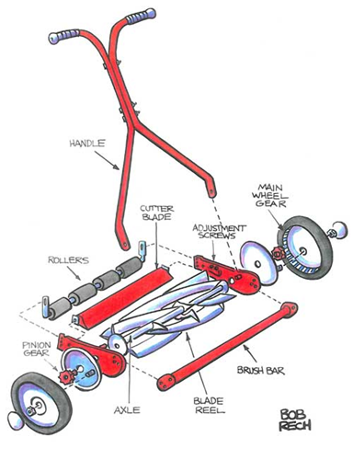

Figure. parts of grass cutter

**5. CUTTING PATTERNS**

The lawn mower will have two types of cutting styles: spiral and random. The user will place the cutter on the lawn and let it cut. To achieve this cutting pattern both wheels must turn at same speeds.

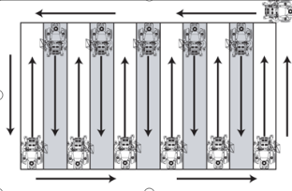

Figure: Cutting pattern

**6. THEORY OF AC MOTOR SPEED CONTROL**

The speed controller works by varying the average voltage sent to the motor. It could do this by simply adjusting the voltage sent to the motor, but this is quite inefficient to do. A better way is to switch the motor's supply on and off very quickly. If the switching is fast enough, the motor doesn't notice it, it only notices the average effect. When we watch a film in the cinema, or the television, what you are actually seeing is a series of fixed pictures, which change rapidly enough that your eyes just see the average effect - movement. Your brain fills in the gaps to give an average effect.

Now imagine a light bulb with a switch. When you close the switch, the bulb goes on and is at full brightness, say 100 Watts. When you open the switch it goes off (0 Watts). Now if you close the switch for a fraction of a second, and then open it for the same amount of time, the filament won't have time to cool down and heat up, and you will just get an average glow of 50 Watts. This is how lamp dimmers work, and the same principle is used by speed controllers to drive a motor. When the switch is closed, the motor sees 12 Volts, and when it is open it sees 0 Volts. If the switch is open for the same amount of time as it is closed, the motor will see an average of 6 Volts, and will run more slowly according

**7. MECHANICAL ARRANGEMENTS**

In the first phase we just considered only about the mechanical arrangements, which is responsible for rotating the dynamo. For this the team members divided the work into two divisions. The mechanical arrangement consisting of

* Shaft with free-wheeling bearing
* Wheels
* Reel Blades
* Chain drive

**8. SHAFT WITH FREE-WHEEL BEARING**

The shaft is clamped between the iron frame work and the freewheeling type bearings are attached on the shaft. The free-wheel bearing rotates forward and reverse in direction which resembles the cycle. Hence the pressure applied is perfectly delivered to the shaft. In this Shaft we have connected a spring which gets straightened when the load is applied and it gets to compress when it is removed hence it pull the shaft which will give additional rotation for the pulley.

**WHEELS**

The wheels are connected to the base frame which is used to cut the grass very fast and smooth. Because of bearing arrangement in it wheels moves fast. This bearing are arranged both the side of electric grass cutter.

**REEL BLADES**

The blades are mounted according to the need. After the blade mount was finished being fabricated I inserted it on to the shaft. Then to make sure the mount was supported vertically drilled a small hole completely through the mount and shaft. This allowed me to insert a bolt as an added safety measure. It is easy to cut the grass and the moving of blades will be freely.

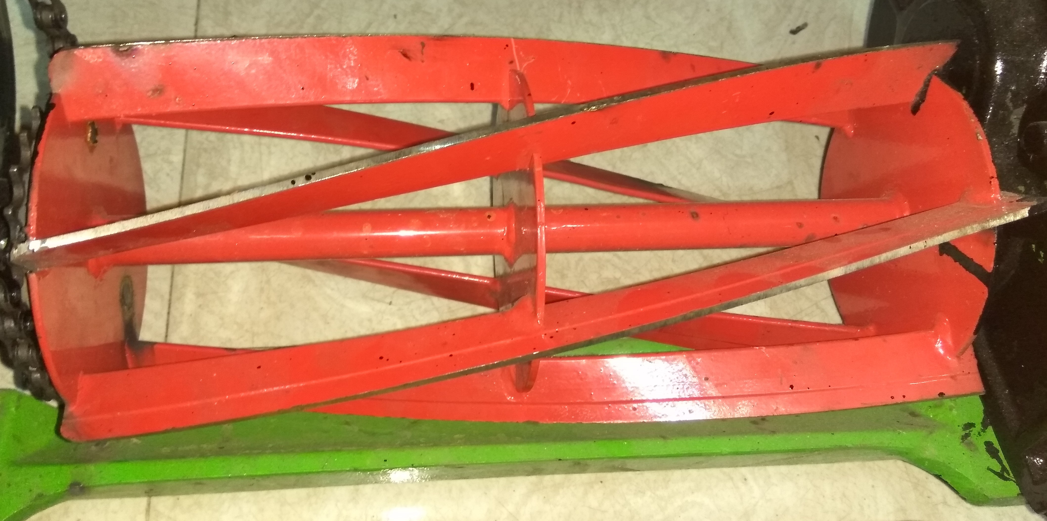

Figure: 4.7 Reel blade cutter

This blade rotates with the help of a dc motor which is connected with this blades. Due this dc motor the blades rotates very fast which uses to cut the grass. This dc motors are 1000 rpm with hydraulic gear motors 12 watts. There are two blades one in arranged front of the solar grass cutter and another blade is arranged at the back side of the grass cutter.

**Chain drive**

Chain drive is a way of transmitting mechanical power from one place to another it is often used to convey power from shaft to reel cutter. Most often, the power is conveyed by a roller chain, known as the drive chain or transmission chain, passing over sprocket gear with the teeth of the gears meshing with the holes in the link of the chain.

**9. AC MOTOR OF ELECTRIC GRASS CUTTER**

An AC motor is an electric motor driven by an alternating current (AC). The AC motor commonly consists of two basic parts, an outside stator having coils supplied with alternating current to produce a rotating magnetic field, and an inside rotor attached to the output shaft producing a second rotating magnetic field. The rotor magnetic field may be produced by permanent magnets, reluctance saliency, or DC or AC electrical winding. Fluid and Material which are used is presented in this section. Table and Fluid should be in prescribed format.

**10.DESIGN CALCULATION**

**CALCULATION PROCEDURE**

Design power (Pd) =1HP

Speed of motor (N1 ) = 1440 RPM

1. Selection off chain no.& Pitch for Pd = 1HP & N1=1440 RPM

Selecting chain no. = 25 ….. ( T–XVI-3)Pitch = 6.25mm

Now, deciding the no.of tooth on spocket

T1=21 Teeth

1. Pitch diameter of sprocket,

Dp1=P/sin(180/T1)

= 6.25/sin(180/21)

Dp1=41.93mm

1. Recommended velocity,

Vp = πDp1N1/1000 m/min.

= π×41.93×1440/1000

Vp = 189.18 m/min < 450 m/min.

Now, N1/N2=T2/T1

1440/350 = T2/21

T2=86.4

T2=86

Dp2=6.25/sin(180/86)

Dp2=171.12mm

1. Power per strands

P= p2 (Vp/104-Vp1.41/526(26-25cos(180/T))

Where,

P = chain pitch = 6.25mm

Vp = Recommended velocity = 3.16 m/sec.

T=T1 = 21

=6.252 (3.16/104-3.161.41/526(26-25cos180/21))

P =0.705 kw

1. Standard dimensions of sprockets
2. Width of sprocket tooth

To=0.56p-0.15

T0= 0.56×6.25-0.15

T0=3.35mm

1. Transverse pitch

A=1.1525p

A=1.525×6.25

A=7.20mm

1. Corner relief

e=0.125p=0.125×6.25

e=0.781mm

1. Chamber radius (r)

r=0.54p =0.54×6.25

r=3.375mm

1. Outsides diameter of driver & driven sprockets

Do1=p(0.6+cot(180/T1))

=6.25 (0.6+cot(180/21))

Do1=45.21mm

D02=174.76mm

1. No. of strands required

N= Pd/Pwer/Strand

N=736/0.706 kw

N=1.04

wh

N=2

No. of strands=2

1. Length of chain pitches

L=T1+T2/2+2C/p+p(T1-T2)2/40.C

Where,

T1=21

T2=86

p=6.25

C=center distance

C=Dp2+1/2×41.93

C=192.085mm

Lp=21+86/2+2×192.08/6.25+6.25(21-86)2/40×192.08

Lp=118.40mm

1. Design of shaft ( Bore dia.)

D < (T1-5)/4×p

d<(21-5)/4×6.25

d<25mm

d=25mm

1. **CONCLUSION**

Our project entitled Manufacturing of Electric grass cutter is successfully completed and the results obtained are satisfactory. It will be easier for the people who are going to take the project for the further modifications. This project is more suitable for a common man as it is having much more advantages i.e, no fuel cost, no pollution and no fuel residue, less wear and tear because of less number of moving components and this can be operated by using electric energy. This will give much more physical exercise to the people and can be easily handled. So it is much more suitable for grass cutting. This efficiency can be increased by using some other mechanism. and speed of motor is reduce because we have used heavy material and this material can be replaced by using light weight material .and design of blades should be done based on types of grass is used to cut. The project which we have done surly reaches the average families because the grass can be trimmed with minimum cost and with minimum time finally this project may give an inspiration to the people who can modify and can obtain better results.

**REFERENCES**

1. Dinesh kumar, Rajesh Burua, Sarmistha mondal ,Manaskr, Parai, Rakesh Chandra kumar , Md.Saddam Khan, “Obstacle Avoiding Robot –A Promising one,’’ International journal of advanced research in electrical, electronics and Instrumentation engineering vol. 2 issue 4 , 2013.
2. Pratik patil, ashiwini bhosale,Prof.shital jagatap, “Design and implementation of automatic lawn cutter”.International journal of emerging technology and advanced engineering, volume 4 issue 11 November 2014 options for autonomous control of robotics platform.
3. B.D.Shivalkar “Design data book” chapter no.14 chain drive, page no.150.
4. Sharma, P.C., Non-conventional power plants, Public printing service, New Delhi, 2003.
5. Gagen, M. J. Novel acoustic sources from squeezed cavities in car tires, J AcoustSoc Am, 794–801,1999.[7] Makarewicz, R., Gałuszka, M., Road traffic noise prediction based on speed-flow diagram. ApplAcoust; 72:190–5, 2011
6. Arora, C.P., Fundamentals of renewable energy systems, New Age international limited publishers, New Delhi, 2005.
7. Raja, A.K., Non-conventional power engineering, public printing service, New Delhi, 2007.
8. Annual reports and accounts 2007, Kenya Power and Lighting Company Limited.

1. Home Power Magazine Company. *Home Power Magazine.*U.S.A

Web links

* [http://nevonproject.com/electric-grass-cutter](http://nevonproject.com/electric-grass-cutter/)
* <http://en.m.wikibooks.org/wiki/atmelmicrocontroller>
* [http](http://engineersgarage.com/articles/avr)[//www.slideshare.net/electric-grass-cutter](http://www.slideshare.net/electric-grass-cutter)
* <http://engineersgarage.com/articles/avr>
* http://www.kengen.co.in