iDonor: Blood Donation and Management System

*KABILAN T., 2 DR. VAIDEHI V.*

*1 PG Student, Department of Computer Applications, Dr. M.G.R Educational and Research Institute*

*Chennai, Tamil Nadu, India, kabi.lan.2578@gmail.com*

*2 Professor, Department of Computer Applications, Dr. M.G.R Educational and Research Institute*

*Chennai, Tamil Nadu, India,* [*vaidehi.mca@drmgr.ac.in*](mailto:vaidehi.mca@drmgr.ac.in)

**ABSTRACT**

Blood donation is crucial for healthcare, providing essential transfusions to patients in need, yet managing this process and ensuring adequate supplies can be challenging. This paper details the design and implementation of a Blood Donation Information System (BDMS) to streamline the donation process and enhance service accessibility. Key features include donor registration, appointment scheduling, inventory management, eligibility screening, and communication tools. Through a user-friendly interface, donors can register, book appointments, and receive notifications about donation opportunities. Healthcare professionals can manage donor records, monitor inventory, and ensure regulatory compliance efficiently. The system uses modern database techniques for secure data storage and retrieval, employs algorithms for eligibility screening, and integrates with external systems for seamless information exchange. Benefits of the BDMS include improved process efficiency, enhanced donor engagement, and better inventory management, promoting transparency and accountability with real-time data access. Ultimately, the BDMS advances blood donation management, encouraging voluntary donations and saving lives.

**Keywords:** Blood donation, Blood Donation Information System (BDMS), donor registration, appointment scheduling, blood inventory management, donor eligibility screening, healthcare, database management, real-time data, voluntary blood donation.

**I. INTRODUCTION**

Django, JavaScript, HTML, CSS, MySQL, and Agile Methodology with the Adaptive Software Development (ASD) framework. The system offers adaptability to evolving requirements, user-friendly feedback, and maintainable code through separation of concerns. It ensures efficient data management, secure information storage, real-time inventory visibility, and streamlined request processing, addressing the need for swift blood distribution and accessibility. The user-friendly web interface facilitates seamless interactions for donors, recipients, and administrators. This technology stack supports efficient data management, real-time inventory optimization, and reduced response times, promoting collaboration among stakeholders and enhancing system flexibility. Implementing this software represents a significant step toward efficient blood distribution, improved accessibility, and saving lives [1].

With the increasing need for blood donors, hospitals are struggling to find them despite many people willing to donate. To bridge this gap in emergencies, this research proposes a web-based online blood donation system. This platform facilitates interaction between donors and recipients during critical times. The system includes information about enrolled hospitals, organizations, and donors. In emergencies, users can post alerts on the website about the blood requirement and time constraints. Hospitals and organizations will receive these alerts, and willing donors can then contact the users directly [2].

The Online Blood Donation Management System serves as a vital link between patients in need of blood and potential donors. This automated system is crucial for saving lives in various situations. Existing systems have notable drawbacks, such as donor privacy issues visible on the interface. Our robust system addresses these issues by connecting hospitals, NGOs, and blood banks to assist patients in critical situations, supported by the HIPAA model for security. The user-friendly interface ensures fast, efficient, and reliable access to lifesaving blood at no cost. Additionally, the system includes data visualization and a COVID module to facilitate plasma donation for both COVID-19 and other patients [3].

Intelligent Blood Management System employs weight-detecting sensors and image processing with a color-coding mechanism to accurately monitor blood quantities across connected blood banks via Cloud connectivity. The system features internal analytics to ensure blood availability and uses predefined logic to pre-stock blood banks based on the most needed blood types in specific areas. The user-friendly mobile application allows users and hospitals to request blood, verify app details, find the quickest route to blood banks, and track live deliveries from blood banks to hospitals [4].

The healthcare system, a crucial and complex industry, provides diverse services to address people's health needs and improve health determinants. This paper introduces a high-level system designed to connect blood donors with those in need. The Blood Donation System application synchronizes individuals and hospitals in their care efforts. It allows hospitals to check blood availability online and request blood from nearby hospitals. Additionally, potential donors can use the application to locate the nearest blood donation center [5].

II. LITERATURE SURVEY

Qunyh et al (2021) proposed a new system leveraging blockchain, specifically Hyperledger Fabric, to provide comprehensive data on blood usage. This will enhance supply management, particularly in emergencies. Today, due to demographic shifts like lower fertility rates and aging populations, the demand for blood is rising. Current blood management systems lack detailed information, hampering quality control and distribution [6].

Ghulam Muhammad et al. (2022) presented a case study that aims to create a mobile blood donation management application using Android and ERP model database management. We utilize mobile development IDEs and APIs for desired functionalities. Focusing on Android OS, we surveyed existing applications to inform our development. The system enables hospitals to request blood groups, connecting them with nearby donors online. Users' real-time locations are tracked, facilitating coordination with hospitals [7].

AlZu’bi et al. (2021) proposed a study which compares existing blood donation and assignment systems to optimize supply and predict donation trends. Immediate access to blood saves lives during emergencies, essential for surgeries and operations. Managing blood supply from donors to hospitals and transfusion centers is crucial. It aims to minimize blood wastage and reduce reliance on external sources by managing shortages and monitoring expiration. The study discusses findings, limitations, and suggests improvements for future research [8].

Hridoy deb das et al. (2020) presented a paper, where they introduce a blood donation system prototype leveraging smartphone crowdsourcing, aiding in finding donors during emergencies. Their system utilizes GPS to locate nearby donors, allowing requesters to search for desired blood groups either from their current or destination location. By enabling parallel donor searches and requesting multiple blood groups simultaneously, our system saves time and reduces disappointment. With a search radius of 5km, locating donors and reaching them quickly becomes feasible. Additionally, future plans involve incorporating user information into the blockchain for enhanced security [9].

Al Zu’bi et al. (2022) proposed an intelligent system for recruiting donors at short notice to prevent shortages and reduce wastage. Optimization equations are developed to address blood wastage and shortages, considering insights on stored blood product deterioration from medical literature. Blood transfusion is in high demand for surgeries and critical operations, necessitating effective blood supply management from donors to hospitals. Recent research focuses on optimizing blood product supply chains to minimize wastage due to the inverse relationship between donations and demand [10].

**III. METHODOLOGY :**

Requirement Gathering and Analysis: The initial phase involves a comprehensive examination of the entire blood donation workflow. This includes understanding the specific needs and challenges faced by blood banks, hospitals, and other stakeholders involved in the blood donation process. Interviews, surveys, and observations are conducted to gather detailed insights from all parties. The collected information is then meticulously analyzed to identify key requirements. This results in a detailed and prioritized list of both functional requirements (such as features the system must have) and non-functional requirements (such as performance, security, and usability standards).

**System Design:**

Building on the requirements analysis, the system design phase focuses on creating a blueprint for the system. This begins with developing the overall system architecture, which outlines how different components of the system will interact. Next, a detailed database schema is designed to efficiently manage and store data related to blood donations, donors, and recipients. User interface (UI) wireframes are then created to visualize the layout and functionality of the system's front end, ensuring it is intuitive and user-friendly. During this phase, the selection of appropriate technologies and development tools is crucial, as they must align with the system's requirements and ensure robust performance, scalability, and maintainability.

**System Development:**

The blood donation management system is developed using Java and JDBC within the Eclipse IDE. This phase involves creating the necessary database tables to store donor information, blood inventory, and hospital data. The business logic, which includes the core functionalities like donor matching, request processing, and notification systems, is implemented. The user interface is developed to ensure a seamless and intuitive experience for all users. The development process follows an iterative approach, with each iteration adding new functionalities and features. This approach allows for continuous testing and feedback, ensuring that each new feature integrates smoothly with the existing system and meets user expectations. Regular code reviews and integration tests are conducted to maintain code quality and functionality.

**System Testing**

After development, the system undergoes rigorous testing to ensure it meets all requirements and is free from bugs and errors. This phase includes several levels of testing:

* Unit Testing: Each individual component or module is tested to ensure it functions correctly.
* Integration Testing: Combined parts of the system are tested together to ensure they interact properly.
* System Testing: The entire system is tested as a whole to verify it meets the specified requirements.
* Performance Testing: The system is tested under various loads to ensure it can handle high traffic and large volumes of data without degrading performance.
* Scalability Testing: The system's ability to scale up or down based on demand is tested.
* Security Testing: Rigorous tests are conducted to ensure that the system is secure from unauthorized access and data breaches.

Any issues identified during testing are addressed promptly, and the system is refined until it operates flawlessly.

**System Deployment :**

Once testing is complete, the system is deployed in a production environment. This involves several critical steps:

* Setting Up Infrastructure: Necessary hardware and software infrastructure, including servers and network configurations, are set up to support the system.
* System Configuration: The system is configured to work in the production environment, which includes setting up user roles, permissions, and security settings.
* Data Migration: If applicable, data from any existing systems is migrated to the new system. This includes donor information, blood inventory data, and hospital records.
* Final Testing: A final round of testing is conducted in the production environment to ensure everything works as expected.
* Go Live: The system is then made available to end-users, including hospitals, blood banks, and donors. Training sessions may be conducted to familiarize users with the new system.

**System Maintenance :**

* Post-deployment, the system requires ongoing maintenance and support to ensure it continues to operate smoothly and efficiently. This involves:

* Monitoring: Continuous monitoring of the system for any issues or performance bottlenecks.
* Routine Maintenance: Regular maintenance tasks such as database optimization, software updates, and backups.
* User Support: Providing support to users through a helpdesk or support team to address any issues or questions they may have.
* Updates and Enhancements: Making updates and enhancements to the system as needed to address changing requirements, improve performance, or add new features. This may include responding to user feedback, incorporating new technologies, or updating security measures to protect against new threats.

Throughout the project, an agile methodology is employed, involving short iterations, frequent feedback, and continuous improvement. This approach allows for greater flexibility and adaptability to evolving requirements, ensuring the system remains effective and responsive to the needs of all stakeholders. The iterative process ensures that the system evolves over time, continually improving and adapting to meet the dynamic needs of the blood donation community.

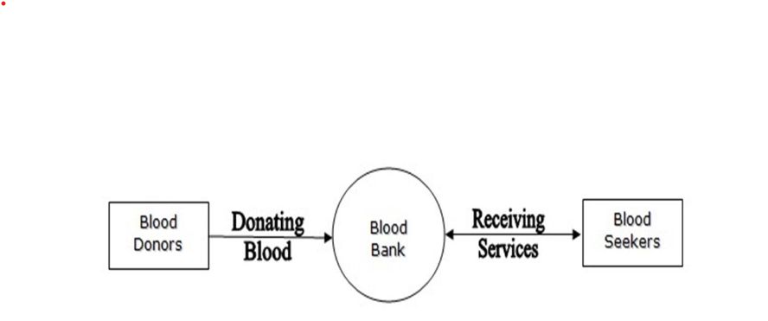

***Figure 1. System Design***

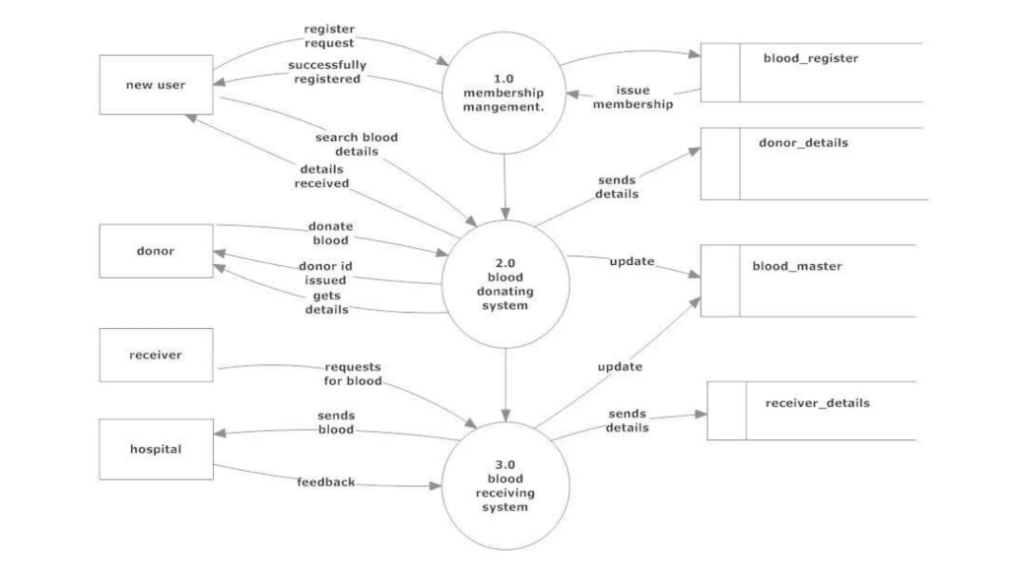

***Figure 2 : System Architecture of the proposed system***

**IV. SCREENSHOTS**

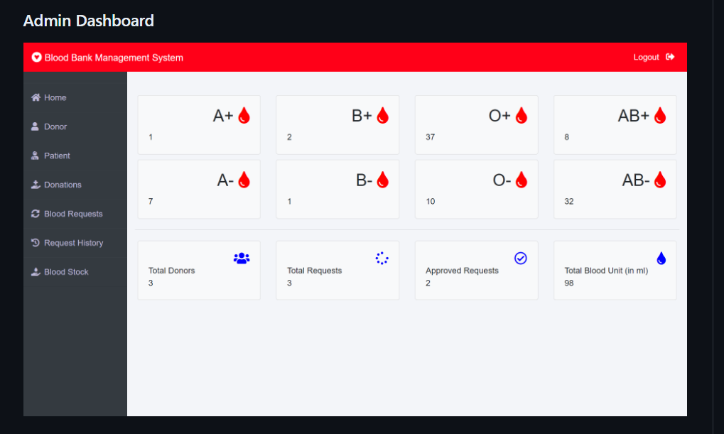

*Figure 3*: *Display of Blood Donors / Requests*

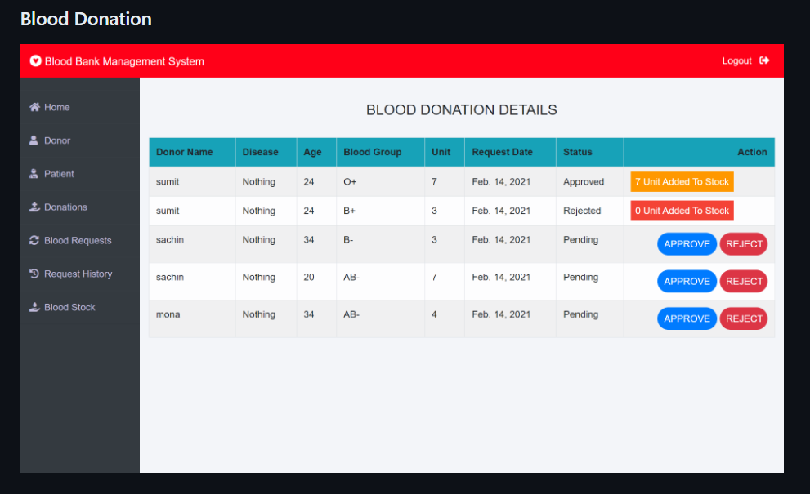

*Figure 4: Approval / Rejection of Blood Requests*

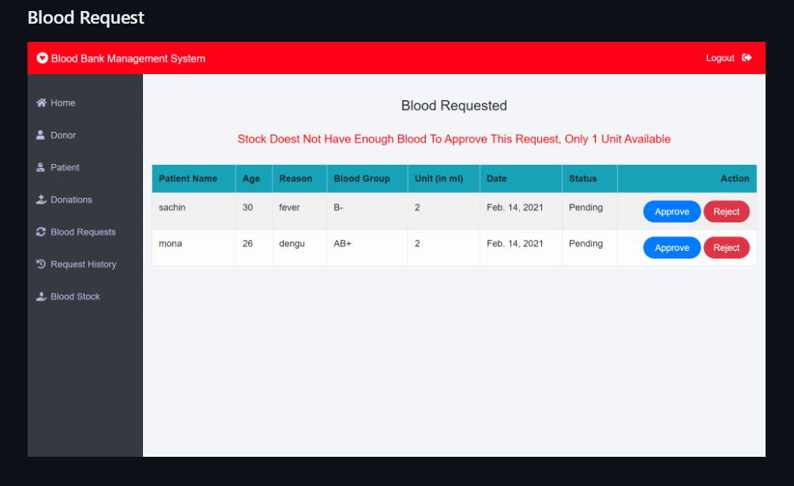

*Figure 5. Blood Requests Page*

**V. CONCLUSION :**

In conclusion, an online blood donation management system is vital for enhancing the efficiency and responsiveness of blood banks. It ensures real-time coordination, secure data handling, and streamlined communication between donors and healthcare providers. By facilitating quick access to blood supplies and optimizing inventory management, such systems play a crucial role in saving lives, especially during emergencies. The integration of user-friendly interfaces and robust security measures further underscores their importance in modern healthcare. Such systems also promote donor engagement by making the donation process more accessible and convenient. They help mitigate the common challenges of blood shortages and mismatches by providing accurate and up-to-date information on blood availability across multiple locations. Moreover, by leveraging technologies like cloud connectivity and data analytics, these systems can predict and preemptively address blood demand patterns, ensuring a stable and reliable blood supply.

These systems foster better collaboration among hospitals, NGOs, and blood banks, creating a cohesive network that can respond swiftly to blood needs. They enhance transparency and trust by maintaining rigorous privacy standards and enabling users to track donations and requests in real time. The educational features of these systems can also raise awareness about the importance of regular blood donations, further bolstering the donor base. Overall, online blood donation management systems are essential tools in improving healthcare outcomes, reducing the time and effort required to find compatible donors, and fostering a more connected and efficient healthcare ecosystem. By streamlining operations and enhancing communication, these systems ensure that life-saving blood reaches those in need promptly and reliably.

REFERENCES :

[1] OVRI, S.O., SHOBOWALE, T. and EDEWHOR, V., (2023) “Automated Blood Management System: Streamlining Search, Inventory, and Patient Care Information Administration” , Niger Delta Journal of Library and Information Science, 4(2).

[2] Pratyusha, P.U., Chaitanya, K., Saranam, A., Manideep, K. and Kranthi, S., (2021), “ Smart Intelligent Web based Online Blood Donation System” , 2nd International Conference on Smart Electronics and Communication (ICOSEC) (pp. 1813-1819). IEEE

[3] Kaur, M., Nazir, N., Kaur, N., Ali, S.F., Agarwal, C., Dubey, U., Gupta, V., Sarwar, A., Rakhra, M. and Dahiya, O., (2022), “A Web-based Blood Bank System for Managing Records of Donors and Receipts” , In 2022 International Conference on Computational Intelligence and Sustainable Engineering Solutions (CISES) (pp. 459-464). IEEE

[4] Sarode, M., Ghanekar, A., Krishnadas, S., Patil, Y. and Parmar, M., 2019, July. Intelligent Blood Management System (2019) , IEEE Bombay Section Signature Conference (IBSSC) (pp. 1-5). IEEE.

[5] Ahma, G., Boshnjaku, E. and Hajrizi, E., 2022. Healthcare Application for Blood Donation. UBT Knowledge Center, p.42.

[6] Quynh, N.T.T., Son, H.X., Le, T.H., Huy, H.N.D., Vo, K.H., Luong, H.H., Tuan, K.N.H., Anh, T.D., Nguyen, T.A. and Duong-Trung, N., (2021), “ Toward a design of blood donation management by blockchain technologies” , In Computational Science and Its Applications–ICCSA 2021: 21st International Conference, Cagliari, Italy, September 13–16, 2021, Proceedings, Part VIII 21 (pp. 78-90). Springer International Publishing

[7] Muhammad, G., Asif, H., Abbas, F., Memon, I. and Fazal, H., (2020), “An ERP Based Blood Donation Management System for Hospital and Donor”, Sukkur IBA Journal of Emerging Technologies, 3(1), pp.44-54.

[8] AlZu’bi, S., Aqel, D. and Mughaid, A., (2021) , “Recent intelligent approaches for managing and optimizing smart blood donation process” , In 2021 International Conference on Information Technology (ICIT) (pp. 679-684). IEEE.

[9] Das, H.D., Ahmed, R., Smrity, N. and Islam, L., (2020)” Bdonor: A geo-localised blood donor management system using mobile crowdsourcing” In 2020 IEEE 9th International Conference on Communication Systems and Network Technologies (CSNT) (pp. 313-317). IEEE

[10] AlZu’bi, S., Aqel, D. and Lafi, M., (2022), “An intelligent system for blood donation process optimization-smart techniques for minimizing blood wastages” , Cluster Computing, 25(5), pp.3617-3627.