**VEHICLE SAFETY AND ACCIDENT DETECTION SYSTEM USING RASPBERRY PI**

**DR.P.Satish Kumar1, Kasam Rohith2, M.Gopikrishna3 ,M.Ramchandra Mohan4**

1Associate Professor, Electronics and Communication Engineering, ACE Engineering College, Hyderabad, India

2,3,4Students, Electronics and Communication Engineering, ACE Engineering College, Hyderabad, India

**ABSTRACT**

Our project, the "Vehicle Safety and Accident Detection System," utilizes Raspberry Pi, advanced sensors, and intelligent algorithms to detect accidents and notify emergency services promptly. By combining accelerometers, GPS, and other sensors, we can identify accidents and relay precise location data to responders, reducing response times and enhancing road safety. Our goal is to minimize the time between accidents and emergency response, ultimately saving lives.

**Keywords:** Vehicle Safety, Accident Detection System, Raspberry Pi, Advanced Sensors, Intelligent Algorithms, Accelerometers, GPS, Emergency Services, Response Times, Road Safety, Saving Lives.

**1. INTRODUCTION**

The "Vehicle Safety and Accident Detection System" leverages technology like Raspberry Pi, sensors, and GPS to swiftly detect accidents and notify emergency services. By analyzing real-time data, including sudden motion changes via accelerometers and precise locations via GPS, the system can alert responders promptly, potentially saving lives. This innovative solution aims to enhance road safety by reducing response times and addressing the critical issue of traffic-related hazards.

Top of Form

**2. LITERATURE SURVEY**

Nowadays, the rate of accidents has increased rapidly. Due to employment, the usage of vehicles like cars, bikes have increased, because of this reason the accidents can happen due to over speed. People are going under risk because of their over speed, due to unavailability of advanced techniques, the rate of accidents can’t be decreased. To reduce the accident rate in the country this paper introduces a solution. Automatic accident detection and alert systems are introduced. The main objective is to control the accidents by sending a message to the registered mobile, hospital and police station using wireless communications techniques. When an accident occurs in a city or any place, the message is sent to the registered mobile through GSM module in less time. Arduino is the heart of the system which helps in transferring the message to different devices in the system. Vibration sensor will be activated when the accident occurs and the information is transferred to the registered number through the GSM module. The GPS system will help in finding the location of the accident spot. The proposed system will check whether an accident has occurred and notify nearest medical centers and registered mobile numbers about the place of accident using GSM and GPS modules. The location can be sent through a tracking system to cover the geographical coordinates over the area. The accident can be detected by a vibration sensor which is used as a major module in the system.

**3.MODELING AND ANALYSIS**

The proposed Vehicle Safety and Accident Detection System addresses the escalating issue of road accidents, a leading cause of global injury and mortality. This system leverages advanced technology, notably Raspberry Pi, along with a suite of sensors and GPS, to promptly identify and respond to accidents. By processing real-time data, the system can swiftly assess accident severity and relay critical information to emergency services, thus minimizing response delays that can prove fatal. Through the integration of accelerometers and GPS, the system can accurately detect accidents and pinpoint their exact locations, enabling efficient deployment of emergency resources. This innovative approach underscores the pivotal role of technology in enhancing road safety and underscores the system's potential to mitigate traffic-related hazards, ultimately saving lives. This introduction lays the groundwork for further exploration into the detailed design, implementation, and transformative impact of the Vehicle Safety and Accident Detection System.

POWER SUPPLY

GSM

RASPBERRY PI

ZERO

GPS

MQ3 SENSOR

RELAY

TILT SENSOR

MOTORS

ADXL 335 SENSOR

Figure 1:Block Diagram

The Vehicle Safety and Accident Detection System integrates Raspberry Pi, sensors like MQ3, Tilt Sensor, and ADXL355, along with components such as GSM, GPS, relay, and motors. Raspberry Pi acts as the central processing unit, coordinating data from various sensors and modules. The MQ3 sensor detects alcohol concentration, while the Tilt Sensor measures angular movement. The ADXL355 sensor provides precise acceleration data. The GSM module facilitates communication with emergency services, and GPS ensures accurate location tracking. Relays control electrical circuits, and motors enable mechanical actions. This system finds applications in accident detection and emergency response, real-time location tracking, fleet safety management, insurance claims, driver monitoring, smart city infrastructure, public transportation safety, and parental safety monitoring.Top of Form

Bottom of Form

**4. RESULTS AND DISCUSSION**

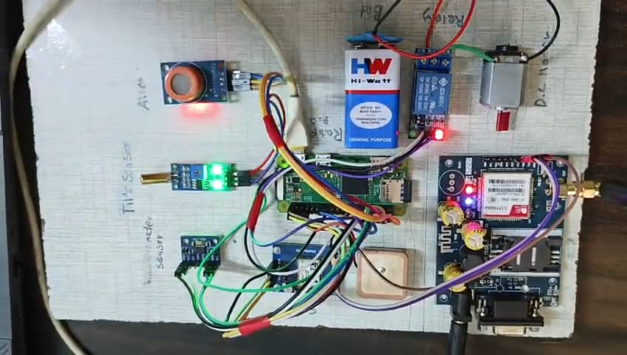

**Figure 2: Vehicle Safety And Detection Using Raspberry Pi**

The Vehicle Safety and Accident Detection System offers promising benefits for road safety and emergency response, including rapid accident detection and automated response. However, challenges like false positives, complexity, and costs need to be addressed, especially for smaller operators. Privacy, reliability, and network dependence are also concerns. To overcome these, robust measures for reliability and data security are necessary, along with addressing integration challenges. Despite these hurdles, ongoing research and refinement can lead to widespread adoption, improving road safety and emergency response capabilities.

**5. CONCLUSION**

The Vehicle Safety and Accident Detection System presents a groundbreaking approach to enhancing road safety and emergency response. Its utilization of modern technology like Raspberry Pi, advanced sensors, GPS, and intelligent algorithms offers a swift and automated means of detecting accidents and notifying emergency services. This capability has the potential to significantly reduce emergency response times, ensuring accurate information for first responders and ultimately saving lives. While the system offers clear benefits such as enhanced emergency response and real-time data analysis, it poses challenges like false positives, privacy concerns, and implementation costs. However, we can ensure its success and broader adoption by addressing these challenges through robust design, thorough testing, and a focus on data security and privacy. Education about the system's benefits and safety enhancements will be crucial in overcoming resistance to new technology and gaining acceptance. By continuing to innovate and refine the system and addressing implementation challenges, we can contribute to a safer future where technology plays a pivotal role in reducing risks and saving lives on the road.

**6. REFERENCES**

• https://www.raspberrypi.com/products/raspberry-pi-3-model-b-plus/• https://www.raspberrypi.com/documentation/accessories/camera.html• https://www.nfon.com/gb/get-started/cloud-telephony/lexicon/knowledge-base-detail/headset#:~:text=A%20headset%20is%20a%20combination,listen%20at%20the%20same%20time.• https://robu.in/product/6x6x5mm-tactile-push-button-switch-pack-of-20/?gad_source=1&gclid=CjwKCAjwh4-wBhB3EiwAeJsppIs7VaYRsWXe5fP0UVAzO5EPqnrJEmrcpimHWUltzO8k31fDMjWEWxoCplgQAvD_BwE