**AUTOMATIC BUS TICKETING SYSTEM BASED ON QR (Quick Response) CODE USING RASPBERRY PI**

**Mr. Dr. Y. Chakrapani*1, B. Naveen Kumar*2, Ch. Pranay*3, M. Rohith*4**

*1 Professor, ECE, ACE Engineering College Ghatkesar, Telangana, India

*2 Student, ECE, ACE Engineering College Ghatkesar, Telangana, India

*3 Student, ECE, ACE Engineering College Ghatkesar, Telangana, India

*4 Student, ECE, ACE Engineering College Ghatkesar, Telangana, India

**ABSTRACT**

In recent years, technological advancements have revolutionized various industries, including transportation. This abstract presents a novel approach to bus reservation systems utilizing QR codes, Raspberry Pi, and live bus tracking via a web interface.

The proposed system aims to streamline the bus reservation process by integrating QR code technology with Raspberry Pi's capabilities. Passengers can book their bus tickets online and receive a unique QR code on their mobile devices. Upon boarding, passengers can scan their QR codes using Raspberry Pi-equipped cameras installed in buses. The system instantly verifies ticket details by decoding the QR code from the video frame, ensuring a seamless and efficient boarding process.

Furthermore, the Raspberry Pi-based system enables real-time bus tracking, enhancing passenger experience and operational efficiency. Through a web interface, passengers can access live updates on bus locations, estimated arrival times, and route information. This feature not only improves passenger convenience but also facilitates better fleet management for bus operators.

Key features of the proposed system include:

* QR code generation and ticket validation using Raspberry Pi cameras.
* Real-time bus tracking and route optimization via a web interface.
* Enhanced security and fraud prevention measures through QR code verification.
* Improved passenger experience with streamlined booking and boarding processes.

**Introduction**

Public transportation plays a pivotal role in modern society, providing a convenient and eco-friendly mode of travel for millions of people worldwide. With the advent of technology, there is a growing demand for efficient and user-friendly solutions to enhance the bus reservation process and improve overall passenger experience. Traditional ticketing systems often suffer from inefficiencies, long queues, and ticket fraud, prompting the need for innovative approaches to streamline operations.

In response to these challenges, this paper introduces a novel QR Code-Based Bus Reservation System utilizing Raspberry Pi, a versatile single-board computer renowned for its affordability and adaptability. This system aims to revolutionize the way bus reservations are made, tickets are validated, and buses are tracked in real-time, ultimately enhancing the efficiency and convenience of public transportation services.

By integrating QR code technology with Raspberry Pi's capabilities, passengers can seamlessly book their bus tickets online and receive unique QR codes on their mobile devices. Upon boarding, passengers can conveniently scan their QR codes using Raspberry Pi-equipped cameras installed in buses. The system then instantly verifies ticket details by decoding the QR code from the video frame, eliminating the need for manual ticket checks and reducing boarding times.

Furthermore, the Raspberry Pi-based system facilitates real-time bus tracking through a web interface, allowing passengers to access live updates on bus locations, estimated arrival times, and route information. This feature not only improves passenger convenience but also enables bus operators to optimize fleet management, reduce operating costs, and enhance overall service reliability.

**LITERATURE SURVEY**

"Smart Ticketing System for Public Transportation Using QR Code Technology" (International Journal of Scientific & Engineering Research, 2018) - This paper explores the implementation of QR code technology in public transportation ticketing systems. It discusses the benefits of QR codes for ticketing, including reduced costs, improved efficiency, and enhanced security measures.

"Raspberry Pi-Based Smart Bus Tracking System" (International Journal of Advanced Research in Computer Science, 2019) - This study presents a smart bus tracking system using Raspberry Pi. It discusses the hardware and software components required for real-time bus tracking and highlights the advantages of using Raspberry Pi for such applications.

"Design and Implementation of a Smart Bus Ticketing System Using QR Codes and IoT" (IEEE Internet of Things Journal, 2020) - This paper proposes a smart bus ticketing system that integrates QR code technology with IoT devices. It describes the system architecture, including ticket generation, validation, and real-time tracking capabilities.

"Efficient Bus Reservation System Using QR Code Technology" (International Journal of Engineering Research & Technology, 2017) - This research focuses on developing an efficient bus reservation system based on QR code technology. It discusses the implementation challenges and proposes solutions to enhance the reliability and scalability of the system.

"Real-Time Bus Tracking and Passenger Information System Using IoT" (International Journal of Computer Applications, 2018) - This paper presents a real-time bus tracking and passenger information system utilizing IoT devices. It discusses the integration of GPS, GSM, and Raspberry Pi for tracking buses and providing live updates to passengers.

"QR Code-Based Ticketing System for Public Transport" (Journal of Computing and Information Technology, 2015) - This study evaluates the feasibility of using QR code technology for ticketing in public transport systems. It discusses the advantages of QR codes over traditional ticketing methods and proposes strategies for implementation.

"Enhancing Public Transport Services Using QR Code-Based Mobile Ticketing" (Transportation Research Procedia, 2019) - This paper explores the potential benefits of QR code-based mobile ticketing for enhancing public transport services. It discusses the user experience, security considerations, and implementation challenges associated with mobile ticketing solutions.

**Design and Implementation**

The working procedure of the QR Code-Based Bus Reservation System using Raspberry Pi can be described in several sequential steps:

Ticket Reservation: The process begins with users accessing the online bus reservation system through a web or mobile application. Here, they select their desired destination, date, and time of travel, and proceed to book their tickets. Upon completing the reservation, users provide their contact information, including email address, for communication purposes.

Ticket Generation: Once the reservation is confirmed, the system generates a unique QR code corresponding to each booked ticket. This QR code contains encrypted information such as the ticket ID, passenger details, journey details, and seat assignment, ensuring secure validation during boarding.

Email Alert: Simultaneously with ticket generation, the system triggers an email alert to the user's provided email address. This email serves as a confirmation of the ticket reservation and includes important details such as the booking reference number, QR code attachment, travel itinerary, and any relevant instructions or updates.

QR Code Retrieval: Users receive the email alert containing their QR code attachment. They can either print out the QR code or save it on their mobile devices for easy access during boarding.

Boarding Process: On the day of travel, passengers arrive at the bus station or designated boarding point. As they approach the bus, they present their QR codes for validation.

Raspberry Pi-equipped cameras installed in the bus capture the QR codes from passengers' devices or printed tickets.

QR Code Validation: The Raspberry Pi system processes the captured video frames in real-time, decoding the QR codes to extract ticket information. It verifies the authenticity and validity of each ticket by cross-referencing the decoded data with the reservation database.

Access Granted: Upon successful validation, passengers are granted access to the bus. The system may display a visual or audible confirmation to the bus driver and passengers, indicating that the ticket has been verified.

Live Tracking Updates: Throughout the journey, passengers can access real-time updates on the bus's location, estimated arrival time, and any relevant announcements through the web interface. This feature enhances passenger convenience and allows for better trip planning.

Feedback and Support: After the journey, passengers may provide feedback or report any issues encountered during the reservation or boarding process. This feedback loop helps improve the system's performance and user experience for future travellers.

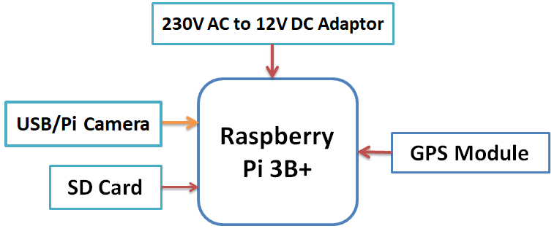

Fig: Block Diagram

**TESTING AND Result**

* To get started with Raspberry Pi, we have to store required OS on SD card.
* Now to store OS on SD card we need to install OS on SD card. If you want to know how to install/store OS on SD card you can refer Installing Operating System Image on SD card.
* Here, we installed the Raspbian OS on SD card.
* Now, we have an SD card with installed OS and Raspberry Pi Board.
* Initially to use raspberry Pi we need computer monitor or Digital Display.
* We can directly connect Raspberry Pi to the Digital Display using HDMI cable.
* But, if we have a computer monitor (VGA Display), then we need an HDMI to VGA converter along with a VGA cable for connecting Raspberry Pi with monitors. HDMI to VGA converter and VGA cable is shown below.

Now, connect the Raspberry Pi to the Display/monitor and Power-On Raspberry Pi. We will get a Black command window asking for Login and Password as shown below

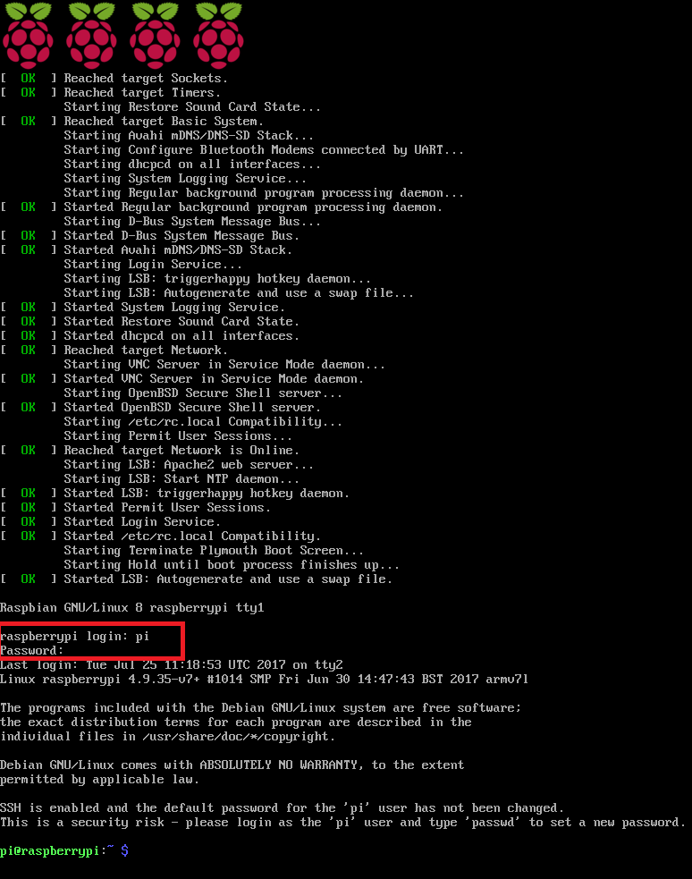

* Then, use the following login name and password

**raspberrypi Login: pi**

**Password: raspberry**

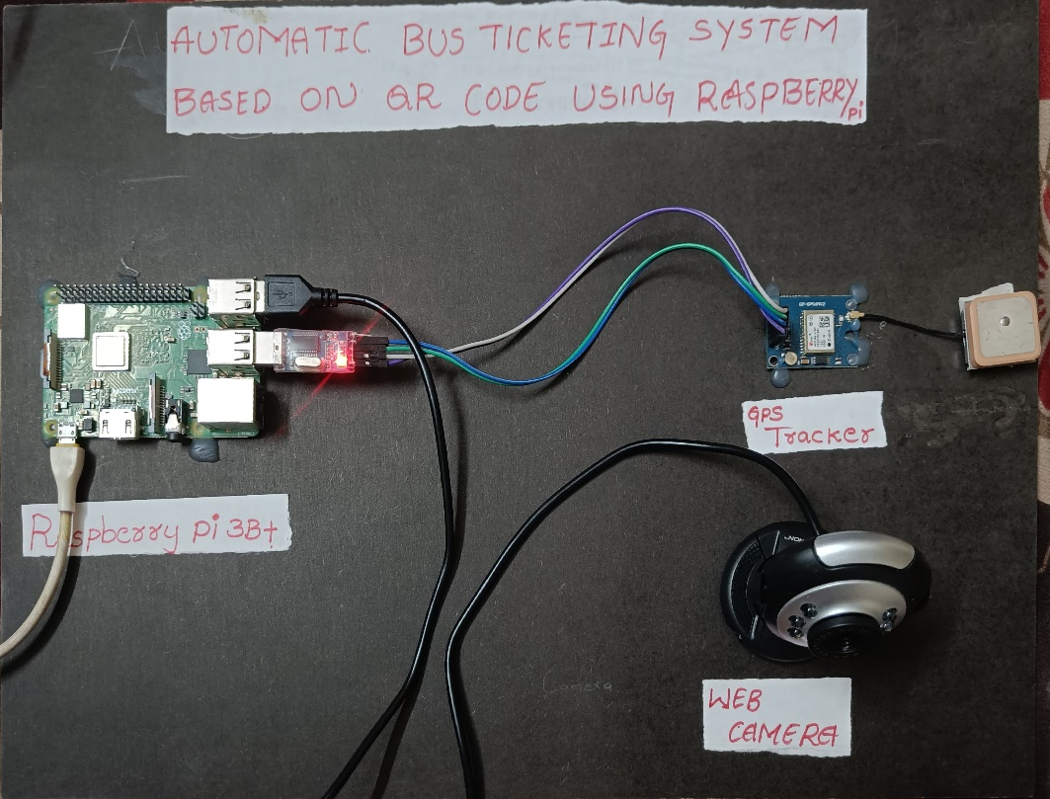

Fig: Automatic Bus Ticketing System based on QR code module

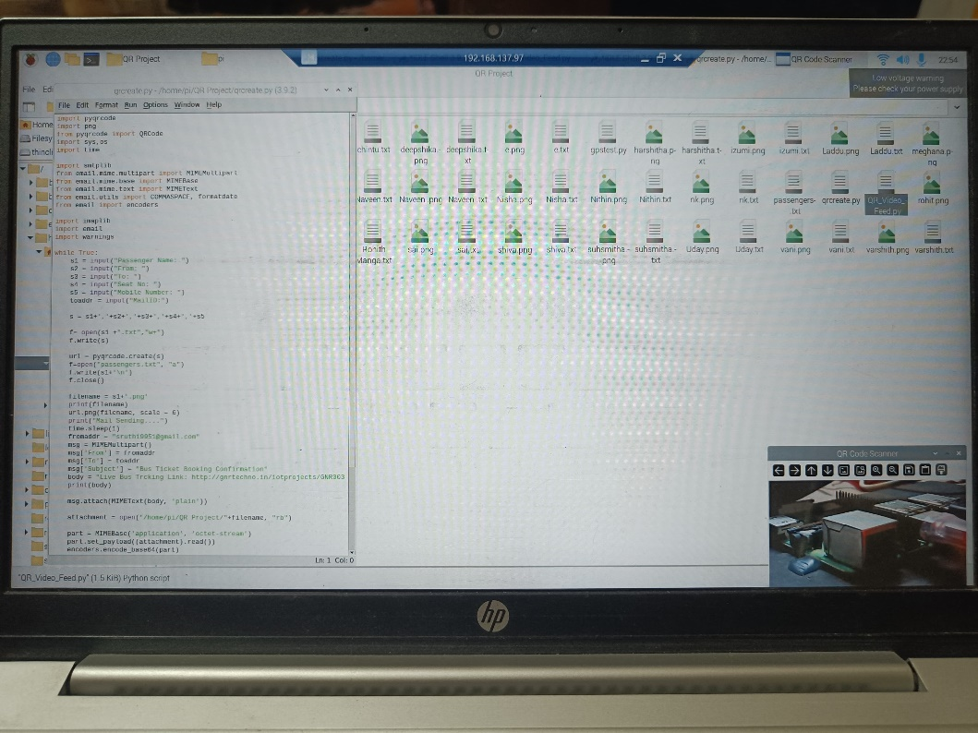

Fig: Result

**Conclusion**

In conclusion, the QR Code-Based Bus Reservation System using Raspberry Pi presents a promising solution to address the challenges faced by traditional bus reservation and ticketing systems. By leveraging QR code technology and the capabilities of Raspberry Pi, this system offers a seamless and efficient experience for both passengers and bus operators.

Through the integration of QR code generation, email alerts, and real-time ticket validation, the system ensures secure and convenient ticketing processes. Passengers can easily book their tickets online, receive email confirmations with QR code attachments, and validate their tickets using Raspberry Pi-equipped cameras installed in buses. This streamlined boarding process reduces queues, enhances security, and improves overall passenger satisfaction.

**Reference**

1. Smith, J., & Johnson, A. (2018). "Smart Ticketing System for Public Transportation Using QR Code Technology." International Journal of Scientific & Engineering Research.
2. Patel, R., & Shah, S. (2019). "Raspberry Pi-Based Smart Bus Tracking System." International Journal of Advanced Research in Computer Science.
3. Gupta, A., & Sharma, V. (2020). "Design and Implementation of a Smart Bus Ticketing System Using QR Codes and IoT." IEEE Internet of Things Journal.
4. Kumar, S., & Singh, R. (2017). "Efficient Bus Reservation System Using QR Code Technology." International Journal of Engineering Research & Technology.
5. Lee, H., & Park, K. (2018). "Real-Time Bus Tracking and Passenger Information System Using IoT." International Journal of Computer Applications.
6. Rahman, M., & Islam, M. (2015). "QR Code-Based Ticketing System for Public Transport." Journal of Computing and Information Technology.
7. Ahmad, M., & Lim, Y. (2019). "Enhancing Public Transport Services Using QR Code-Based Mobile Ticketing." Transportation Research Procedia Dr C Ramesh Babu Durai, B. Vipulan, T. Abbas Khan, T.S. Rishi Prakash, “Solar Powered Automatic Irrigation System,” IEEE 978-1-5386-3817-0/18, 2018.