Vol.23 No.01 DOI:10.10543/f0299.2024.41916

Jan, 2024 MATERIAL SCIENCE AND TECHNOLOGY

# AUDIO SYNC ASSISTANT FOR BLIND

*M. RAVI KUMAR,S.SHREEJA,A.MAHESWARI,B.ANVESH*

*1Professor,234B.Tech Students*

*DEPARTMENT OF ELECTRONICS AND COMMUNICATION ENGINEERING*

*ACE Engineering College, Ankushapur (V), Ghatkesar (M), Medchal(Dist)-501 301*

**ABSTRACT**

This project is an automatic document reader for visually impaired people, developed on the Audio Sync Assistant platform. It controls peripherals like a camera and a speaker, which act as interfaces between the system and the user. Optical character recognition (OCR) technology is utilized for the identification of printed characters using image sensing devices and computer programming. The OCR process is executed using online and offline methods, converting images of typed or printed text into machine-encoded text. These encoded texts are then converted into audio output (speech). The Audio Sync Assistant platform is employed for the translation of printed documents into data files using the Tesseract library and Python programming. These data files are then processed by the OpenCV library and Python programming language to generate the audio output.

**INTRODUCTION**

**1.1 PROJECT OVERVIEW:**  In today's digital era, the intersection of technology and accessibility has opened doors to a more inclusive society, where individuals with visual impairments can navigate the world with greater independence and autonomy. Among the pioneering innovations in this realm is the Audio Sync Assistant for Blind, tailored specifically to empower individuals who are blind or visually impaired. By integrating components such as cameras and speakers, the Raspberry Pi establishes a seamless interface between the user and the technology, facilitating intuitive interaction and access to printed text. Central to the reader's functionality is the application of Optical Character Recognition (OCR)

.**1.2 BLOCK DIAGRAM:**

RASPBERRY PI 3B+

HEADSET

CAMERA

PRESS BUTTON

POWER SUPPLY

Figure 1.1 Block Diagram of Audio Sync Assistant

**1.3 BLOCK DIAGRAM DESCRIPTION:**

**1.3.1 POWER SUPPLY:**  **RASPBERRY Pi 3B+:**

The Raspberry Pi Model B+ is an iteration of the Raspberry Pi single-board computer (SBC) series, released in July 2014. It is an enhanced version of the original Raspberry Pi Model B, featuring several improvements and additional features while maintaining compatibility with existing Raspberry Pi software and accessories

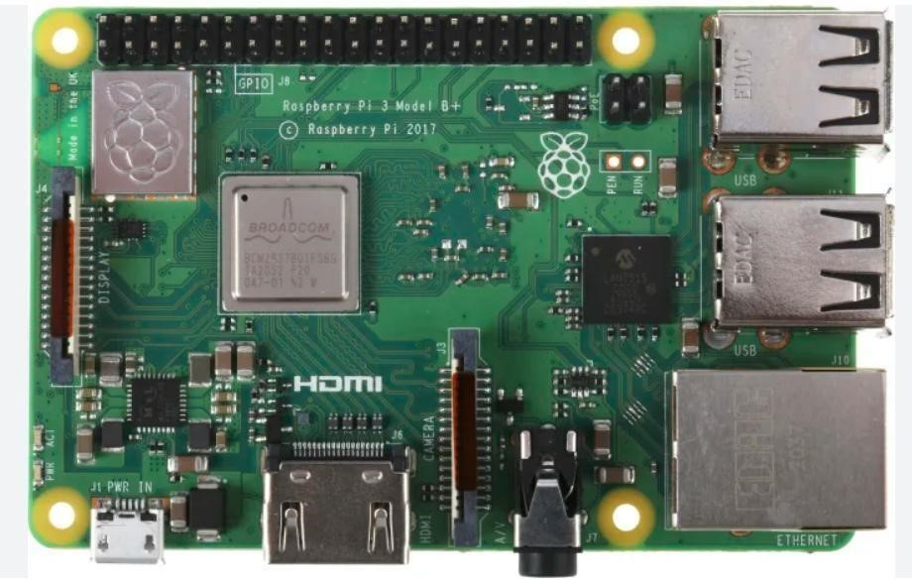

**1.3.2 CAMERA:**

|  |
| --- |
| ISSN: 1005-0299 |

Input to the machine is given through Webcam. It takes snapshots or videos of the area and similarly, the system is sent to the controller/processor. The resolution of the webcam is 640*480 and up to 30 Megapixels can be used. USB Webcams generally have the inferior quality to the camera modules that connect to the CSI interface. They can also not be controlled using the commands in the terminal or by the recording package in Python. Nevertheless, there may be reasons, why you want to connect a USB camera to your Raspberry Pi, such as because of the benefit that it is much easier to set up multiple cameras with a single Raspberry Pi.

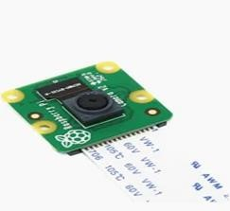

Figure 1.3 Camera

**1.3.3 HEADSET:**

With a direct connection to your device, these headphones provide a crisp and clear sound that lets you hear every nuance and detail in your favorite tracks. Whether you're a music lover, an audiophile, or a professional who needs accurate sound reproduction, wired headphones with Mic are the way to go.

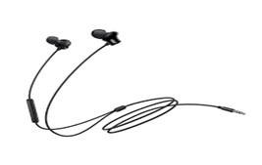

Figure 1.4 Headset

**1.3.4 PRESS OR PUSH BUTTON:**

A push button switch is a mechanical device used to control an electrical circuit in which the operator manually presses a button to actuate an internal switching mechanism. They come in a variety of shapes, sizes, and configurations, depending on the design requirements.

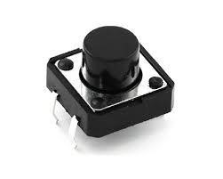

Figure 1.5 Push Button performance.

Different charging circuits exist, such as constant voltage, constant current, and pulse charging, depending on the battery type and requirements.

**1.3.5 POWER SUPPLY:**

Its function is to supply a stable voltage to a circuit or device that must be operated within certain power supply limits. The output from the regulated power supply may be alternating or unidirectional, but is nearly always DC.

All Raspberry Pi computers since inception require 5V power, but the recommended amperage varies between models. Using a power supply that doesn’t deliver enough current or meet the requirements otherwise will cause a low voltage warning to show at the top of the screen. Older models may show rainbow-colored squares or a flashing lightning icon instead.

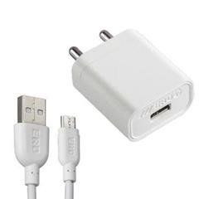

Figure 1.6 Adapter

**LITERATURE SURVEY**

**2.1 INTRODUCTION**

A comprehensive literature survey on Audio Sync Assistants for the Blind reveals a burgeoning field at the intersection of assistive technology and accessibility. Numerous studies highlight the potential of Audio Sync Assistants as cost-effective and versatile platforms for developing reading aids tailored to the visually impaired. Research has delved into various aspects, including hardware design, software development, user interface optimization, and usability testing. Studies emphasize the importance of audio feedback, speech synthesis, and braille integration to enhance reading experiences. Additionally, investigations explore the integration of advanced audio synchronization algorithms for text recognition, enabling real-time conversion of printed text to audible formats. Collaborative efforts between engineers, computer scientists, educators, and individuals with visual impairments have led to the refinement and validation of Audio Sync Assistant prototypes through user centered design approaches

**THEORETICAL ANALYSIS**

**3.1 HARDWARE DESCRIPTION**

**3.1.1 FEATURES OF RASPBERRY PI 3B+:**

The key features of Raspberry Pi 3B+ are

* Quad Core 1.2GHz Broadcom BCM2837 64bit CPU.
* 1GB RAM.
* BCM43438 wireless LAN and Bluetooth Low Energy (BLE) on board.
* 100 Base Ethernet • 40-pin extended GPIO.
* 4 USB 2 ports.
* 4 Pole stereo output and composite video port.
* Full-size HDMI.

**3.1.2 PIN CONFIGURATION:**

GPIO stands for General Purpose Input Output pins these pins are used to connect the Raspberry Pi board to external input/output devices. Like the previous model, model B+ also consists of a 40-pin GPIO. A standard interface for connecting a single-board computer or microprocessor to other devices is through General-Purpose Input Output (GPIO) pins. As these pins don’t have a specific function, they can be customized using the software.

This whole process lets us use the energy from our footsteps to make electricity for simple gadgets, making walking a way to generate power.

**3.1.3 PROCEDURE:**

**SPECIFICATIONS:**

* **Type:** Push buttons come in various types, including momentary and latching. Momentary push buttons return to their original state when released, while latching push buttons maintain their state until pressed again.
* **Contact Configuration:** Push buttons can have different contact configurations, such as normally open (NO) or normally closed (NC), depending on whether the switch is open or closed in its resting state.

**3.1.4 HEADSET:**

In today's interconnected world, headsets have become indispensable tools for communication, entertainment, and productivity. These versatile devices, worn over the head or in the ear, enable users to listen to audio, make phone calls, participate in virtual meetings, and immerse themselves in multimedia experiences with ease and convenienceSRAM is 2 KB

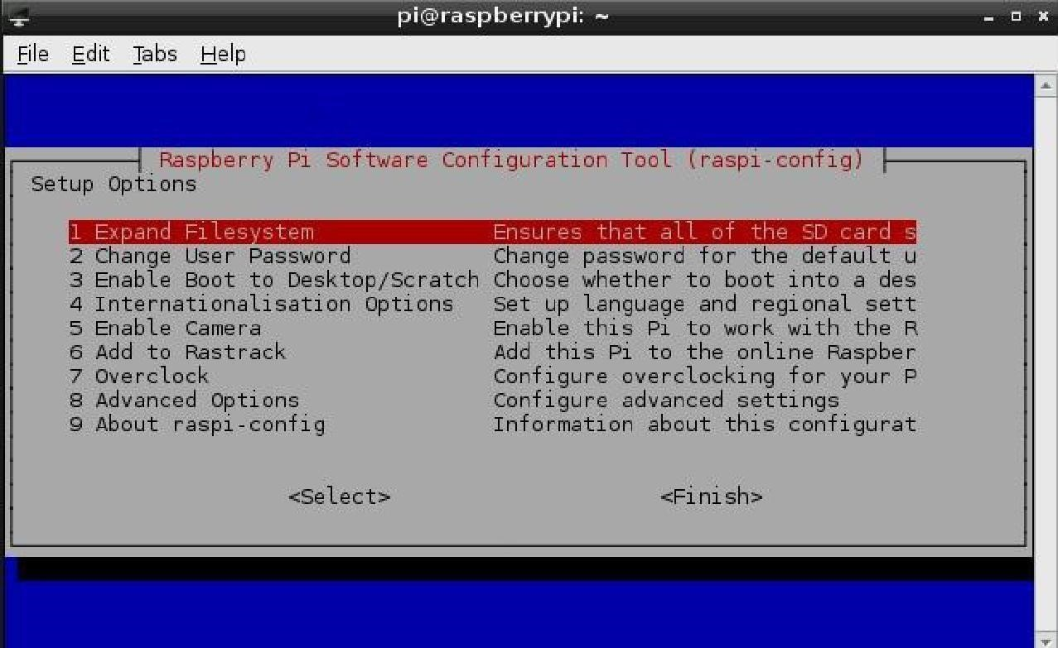

**EXPERIMENTAL RESULTS**

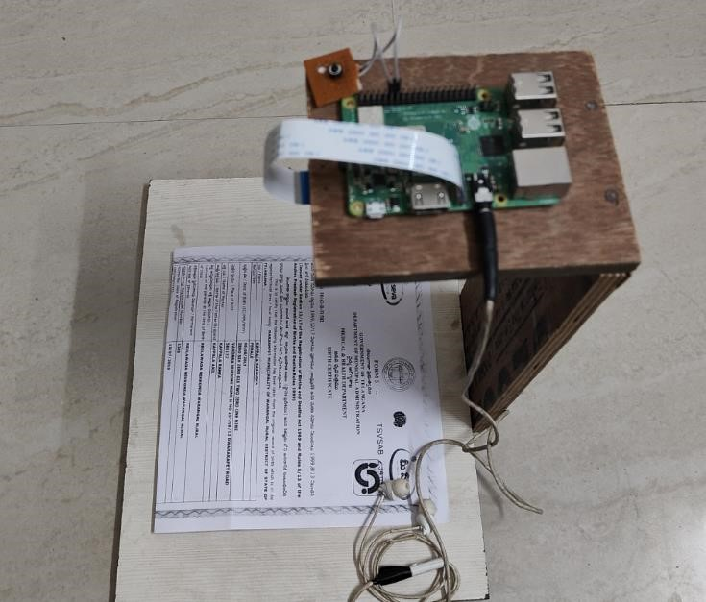

Figure 4.1 Audio Sync Assistant for Blind .

**ADVANTAGES, DISADVANTAGES AND**

**APPLICATIONS**

**5.1 ADVANTAGES:**

**ACCESSIBILITY:** The Audio Sync Assistant for Blind enhances accessibility for individuals with visual impairments by converting printed text into audio output, allowing them to access a wide range of printed materials independently.

**COST-EFFECTIVENESS:** Audio Sync Assistant for Blind solutions are often more affordable compared to dedicated assistive devices, making them accessible to a broader range of users, including those with limited financial resources

**5.2 DISADVANTAGES:**

**TECHNICAL COMPLEXITY:** Developing and configuring a Audio Sync Assistant for Blind may require technical expertise in programming, electronics, and system integration, which can pose challenges for non-technical users or individuals with limited technical skills.

**5.3 APPLICATIONS:**

**EDUCATION**: These readers can be utilized in educational settings to provide visually impaired students with access to printed textbooks, worksheets, and other learning materials. By enabling them to independently read and study alongside their peers, these devices promote inclusivity and support academic success.

**CONCLUSIONS & FUTURE**

**SCOPE 6.1 CONCLUSION:**

The Audio Sync Assistant for the Blind represents a significant advancement in assistive technology, offering a versatile and accessible solution for individuals with visual impairments to access printed materials independently. Through the integration of advanced audio synchronization technology, OCR capabilities, and audio output features, the assistant empowers users to overcome barriers to information access and enhances their overall quality of life.

development in this field will likely enhance its effectiveness and applicability over time.

**6.2 FUTURE SCOPE:**

The future scope of advanced footstep power generation using Arduino lies in improving efficiency and integrating the technology into smart city infrastructure and wearable devices. As innovations progress, footstep power generation could become a widespread and integral component of urban planning and sustainable energy solutions, contributing to a greener and more energyefficient future.

**BIBLIOGRAPHY**

The sites which were used while doing this project:

[1]

[https://en.wikipedia.org/wiki/ Arduino_Uno](https://en.wikipedia.org/wiki/Arduino_Uno)

1. <https://www.electronicforu.com/>
2. <https://www.allaboutcircuits.com/>