RESEARCH ON THE PRACTICAL UTILISATION OF BUTANOL, ETHANOL AND DIESEL IN A COMPRESSION IGNITION ENGINE

**MUBASHAR NABI1, Mr. BHOOP SINGH2**

**1** M.Tech Scholar,Ganga Institute Of Technology & Management Kablana Jhajjar,India

2 Assistant Professor, Ganga Institute Of Technology & Management Kablana Jhajjar,India

## **ABSTRACT**

This paper examines the actual usage of butanol, Ethanol and Diesel is utilized as an energy source in an engine with compression ignition. with a specific focus on their Efforts , emitting characteristics, and fuel efficiency. The study is to investigate alternative Potentially viable sources to decrease the environmental Resulting of diesel engines while preserving or improving their Efforts . The study involves a sequence of Scientific tests executed on a compression ignition engine with a single cylinder. A range of fuel mixtures , such as pure diesel, diesel-butanol, diesel-ethanol, and various combinations of these three, underwent testing. Brakes thermal effectiveness, particular consumption of fuel, and output of power were quantified as key Effort measures. In addition, the emitting characteristics, such as CO, hydrocarbons, nitrogen oxides and particulate matter were investigate to assess the environmental consequences of each fuel mixture.

The findings suggest that the addition of butanol and ethanol to diesel has a substantial influence on both the engine's Efficiency and ecological influence. Diesel-butanol mixtures exhibited enhanced Enhanced brake heat effectiveness and reduced releases of CO and HC in comparison to pure diesel. Butanol was shown to be more effective than ethanol mixes in improving fuel efficiency. The integration of diesel, butanol, and ethanol outcomeed in a harmonious Efforts , accompanied by modest enhancements in efficiency and reductions in releases . The study also emphasises the practical obstacles linked to the use of alcohol-based fuels in compression ignition engines, including fuel stability, corrosiveness, and the necessity for engine changes. Although there are limitations, butanol and ethanol have the potential to be competitive replacements to conventional diesel due to their ability to cut releases and improve Efforts .

Ultimately, this study showcases that the utilisation of butanol and ethanol, in suitable mixtures By utilising diesel fuel, it is possible to recover the efficiency and diminish the releases of ignition systems with compression engine. These findings endorse the possibility of wider acceptance of alcohol-based fuels in diesel engines, hence promoting more sustainable and eco-friendly transportation. Future research should prioritise the optimisation of Combinations of fuels and the resolution of technical obstacles to enable the practical integration of these alternative fuels in the automobile sector.

**Key Words:** Compression Ignition Engine, Butanol Utilization, Ethanol Utilization, Diesel Fuel Alternative Fuels, Fuel Blending, Combustion Characteristics

# INTRODUCTION

The current state of global energy is experiencing a substantial shift due to the pressing necessity of decreasing greenhouse gas emissions and addressing climate change. The transportation sector is a significant contributor to environmental pollution, primarily because it heavily depends on fossil fuels. Diesel engines, specifically, are extensively utilised for their efficacy and resilience, although they significantly contribute to air pollution and carbon dioxide emissions. The investigation of alternate fuels suitable for compression ignition (CI) engines, without requiring significant changes, is receiving growing attention in this particular context. Butanol and ethanol, which are both significant biofuels, have emerged as promising contenders for blending with diesel in order to produce more environmentally friendly fuel alternatives.

The practical application of butanol and ethanol in compression ignition (CI) engines poses a complex research problem that involves engine performance, emission characteristics, fuel compatibility, and overall sustainability. Butanol, because to its superior energy content and improved miscibility with diesel in comparison to ethanol, has significant potential advantages. The features of this substance are more similar to regular diesel fuel, with a higher cetane number and reduced hygroscopicity. These characteristics have the potential to improve combustion efficiency and decrease engine wear. However, ethanol is known for its high oxygen content and good ability to prevent knocking in engines. As a result, it plays a key role in promoting cleaner combustion and reducing the amount of particulate matter released into the atmosphere. Integrating these biofuels with diesel could result in synergistic benefits that enhance the overall performance and environmental impact of compression ignition (CI) engines.

An essential factor in the use of butanol and ethanol in CI engines is comprehending their combustion properties. The cetane number, which quantifies the ability of a fuel to ignite, is of utmost importance in the process of combustion. Diesel possesses a notable cetane value, guaranteeing prompt ignition and effective combustion. Blending butanol, which has a cetane number that is more similar to diesel, has the ability to preserve comparable ignition characteristics. On the other hand, ethanol has a lower cetane number, which can result in increased ignition delays and altered combustion characteristics. Research is required to optimise the ratios of fuel blends and engine settings in order to maximise the advantages of each fuel while minimising any negative impact on engine performance and durability.

Another crucial aspect is the influence on emissions. Diesel engines are renowned for their elevated amounts of nitrogen oxides (NOx) and particulate matter (PM) emissions, which have adverse impacts on air quality and human health. Introducing ethanol, which has a high oxygen concentration, can enhance combustion efficiency and hence decrease particulate matter (PM) emissions. When blended effectively, butanol can assist preserve engine power and efficiency by taking advantage of its higher energy density, while potentially decreasing NOx emissions. Gaining insight into the interaction between these fuels and the ensuing emission profiles is crucial for the development of more environmentally friendly combustion techniques.

A thorough examination is necessary to assess the economic and environmental viability of butanol and ethanol as biofuels. Butanol can be synthesised by fermentation methods using biomass feedstocks, which are sustainable and can decrease reliance on fossil fuels. The manufacture of ethanol is already firmly established, especially from commodities such as maize and sugarcane. Nevertheless, the life cycle assessment of these biofuels, encompassing their entire manufacturing process and ultimate utilisation, necessitates the examination of variables such as land utilisation, water usage, and overall carbon emissions. The implementation of policies and incentives that promote the use of biofuels in the transportation industry will be crucial in ensuring their effective utilisation.

Moreover, the assessment of the compatibility between butanol and ethanol with current diesel engines and fuel infrastructure is a crucial factor to take into account. Although butanol is more compatible with diesel and current fuel systems due to its chemical properties, ethanol's reduced viscosity and ability to absorb water necessitate cautious handling and modifications to fuel systems in order to prevent corrosion and phase separation. Ensuring the smooth integration of these biofuels into present and future diesel engines will need the development of strong fuel blends and engine calibration techniques.

# OBJECTIVES

1. Assess the combustion properties of butanol-diesel and ethanol-diesel mixtures in compression ignition (CI) engines.

2. Evaluate the influence of butanol and ethanol on engine performance and efficiency.

Evaluate the emission characteristics of mixes of butanol and ethanol in comparison to pure diesel fuel.

4. Calculate the most efficient combination of blend ratios to get maximum performance while minimising emissions.

5. Examine the time it takes for ignition to occur and the characteristics of the combustion process in mixtures of butanol and ethanol.

6. Investigate the enduring impacts of butanol and ethanol on engine wear and durability.

7. Perform a life cycle study on the production and utilisation of butanol and ethanol.

8. Create engine calibration methods that seamlessly incorporate mixes of butanol and ethanol.

# LITERATURE REVIEW

He et al. (2015), deliberate the influence of Ethanol with diesel fuels on a four- cylinder DI diesel engine operating at 1700 rpm. Two blend concentrations, 10% and 30% ethanol by volume, were investigated. The inclusion of ethanol in diesel fuel led to alterations in the Features of the blended fuels. Comparing the releases from these ethanol-diesel mixtures to The dissipates come from clean diesel fuel smoke were noted to have reduced at high engine loads, with minimal Resulting on CO, acetaldehyde, and unburned ethanol releases . Moreover, there were some reductions in NOx and CO2 releases as well. However, at low loads, the reduction in smoke releases was marginal due to the overall leaner mixture. Nevertheless, by incorporating supplement s and ignition improvers, releases of CO, unburned ethanol, acetaldehyde, and total hydrocarbons could be moderately reduced , even surpassing the releases of pure diesel (E0) at low loads.

Wei et al.(2015) , studied the influences of ESR and EGR on various presentation parameters of RCCI engines with high load by using Converge CFD code at a uniform speed of 2000 rpm. The study proposed that increasing the ESR led to significant increases in in-cylinder pressure, gas temperature, and peak pressure. However, the knocking tendency enhanced rapidly with the increase of ESR. Additionally, the implementation of EGR outcomeed in a decrease in NOx but a rise in the soot, Hydrocarbon, and CO in the cylinder.

Chen et al. (2018) investigate the influence of ESR on the various ignition and Effort Features of a double -fuel engine was examined. The study involved conducting Scientific tests with mixtures of diesel and methanol, ethanol, and n-butanol. The test was executed at a consistent speed of 1600 rpm and medium load while varying the ESR from 0% to 40%. Among the alcohols tested, methanol exhibited the most significant influence on ID and Period of burning. Considering a rise in the ESR, the BTE improved for engines running on methanol and ethanol mixtures , while it reduced for the n-butanol blend. Additionally, the Proportion of particles in the diesel engine reduced with the incorporation of alcohol, and the nitrogen oxide releases varied depending on the specific alcohol used and the level of ESR.

Ge et al. (2019) evaluated the influence on the Effort parameters and PM morphology of the CI engine. The experiment reveals that introducing ethanol to diesel fuel did not notably affect the peak pressure, but it did postpone the SOC, increase the maximum HRR, and reduce the ignition duration. Additionally, blending ethanol with diesel fuel outcomeed in reduced smoke releases and NOx while reducing the particle diameter. These findings suggest that ethanol is likely to be a valuable substitute for diesel oil, leading to enhanced engine Effort and reduced releases .

Saravanan et al. (2020) , devised a configuration for an EFDE integrated with EGR and conducted Scientific tests to estimate the various Effort parameters of the EFDE under various EGR scenarios. These scenarios encompassed the utilization of ethanol with a coating, ethanol with a coating and 10% EGR, and ethanol with a coating and 20% EGR. The outcomes of the study revealed that the BTE of ethanol at peak load was highest for the LHR-RT (Low Heat Rejection - Ricardo Twin Swirl) engine. However, as the EGR rates enhanced , the BTE reduced due to a reduction in the available air for ignition. At maximum load, the NOx releases were enhanced when ethanol was used in correlate to the Recirculating dissipateed gas at rates of between 10 and 20 percent.scenarios. Generally, the introduction of dissipate gas, through EGR, outcomeed in a reduction in heat release owing to the presence of already combusted gases in the process.

Shanmugam et al. (2018) carried out a study to assess the influence of different supplement s, namely oleic acid, ethylene acetate and isopropanol, on the stability of ethanol mixtures for compression ignition The test were implemented at a consistent speed of 1500 rpm. Among the supplement s investigated, oleic acid demonstrated the highest efficacy in achieving a uniform mixture. The Practical findings showcased enhanced Effort Features when DEE was added to the blend, including an increase in BTE and a reduction in SEC. However, higher concentrations of ethanol in the blend outcomeed in enhanced releases of hydrocarbon and carbon monoxide, which can be accounted for the higher LHV of ethanol.

Asad et al. (2017) carried out a Effort assessment of double -fuel ignition using ethanol Compares to pure diesel high-temperature ignition (HTC) utilizing a solitary-cylinder diesel engine. The Practical investigation were executed at a consistent speed of 1500 rpm, covering various load conditions. The findings indicated that double -fuel ignition demonstrated notably reduced tailpipe releases comparison to diesel HTC. Moreover, the ignition exhibited higher gross indicated efficiency at enhanced loads. The research also Investigate the influence of a NOx SCR system on net ITE. The findings revealed that ignition necessitated a lower SCR conversion efficiency and lower urea consumption in comparison to diesel HTC to attain comparable levels of NOx releases . This suggests that double -fuel ignition with ethanol can achieve desirable releases control with more efficient use of the SCR system.

Yoon et al. (2020) investigate engine Effort parameters with various diesel-bioethanol mixtures in a CRDI engine at a uniform speed and variable engine loads. Nevertheless, the incorporation of ethanol caused lesser releases of NOx, CO, and smoke. However, one disadvantage of utilizing ethanol was an improvement in BSFC because of its lesser Calorific value in correlate with diesel fuel.

A study done by Lin et al. (2018) Investigate the influence of fuel depth and ullage height on the dispersion of liquid flames in diesel fuel and 5% ethanol-diesel mixtures . The study produced some remarkable discoveries. Initially, when the fuel depth grew while taking into account the ullage effect, the rate of flame dispersion

# METHODOLOGY

In this section, a thorough explanation of the conducted experiment and the methodologies employed to achieve the objectives outlined in the preceding chapter is presented. The research methodology used in this study is summarized in Figure 1, providing an overview of the research process.

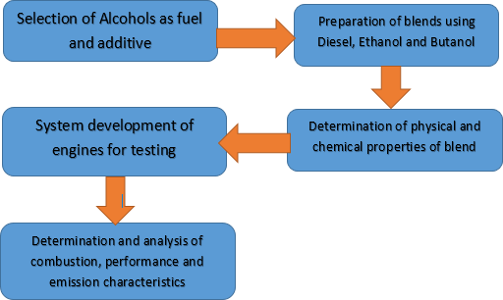

**Figure 1: Methodology for research diagram**

**ETHANOL**

Ethanol, chemically called ethyl alcohol or C2H5OH is a clear, colourless liquid with a slightly sweet odour. It is produced through the process of fermentation, wherein sugars or carbohydrates from diverse sources such as grains, fruits, or vegetables are enzymatically or microbially broken down by yeast or bacteria into ethanol and carbon dioxide. Bioethanol also referred to as biofuel ethanol, is a Sustainable type of ethanol that is derived from biomass sources such as crops, agricultural residues, and cellulosic materials. Bioethanol is considered a form of biofuel, which is an environmentally friendly energy source obtained from biological materials. Commonly used as a substitute for fossil fuel or utilized as a fuel supplement or standalone fuel in transportation. The production process of bioethanol is similar to traditional ethanol, involving the fermentation of carbohydrates in biomass by yeast or bacteria. Bioethanol, a Sustainable fuel, generated from diverse biomass sources such as sugarcane, corn, wheat, agricultural residues, forest residues, and dedicated energy crops like switchgrass. It is widely acknowledged for its environmental benefits and cleaner ignition Features in comparison to fossil fuels. The application of bioethanol as a fuel has the potential to mitigate GHGs releases and decrease air pollutants, contributing to a sustainable and clean energy alternative.

**BUTANOL AS SUPPLEMENT**

Butanol, also referred to as n-butanol or normal butanol, is an alcohol compound represented by the chemical formula C4H9OH. It occurs in four isomeric configurations: n-butanol, isobutanol, tert-butanol, and sec-butanol. Among these isomers, n-butanol is the predominant form employed in diverse industrial sectors due to its widespread applicability. It is a colourless liquid with a relatively high boiling point, making it less volatile Compares to other alcohols like ethanol or methanol, and has a mild, sweet odour. Butanol is miscible with many organic solvents but has limited solubility in water.

The primary method of producing butanol is through the fermentation of biomass, similar to ethanol, where sugars or carbohydrates from feedstocks such as

starch, cellulose, or lignocellulose are converted into butanol by microorganisms like bacteria or yeast. Butanol can also be produced through chemical synthesis, typically via the oxo process or through the hydrogenation of butyraldehyde.

Butanol has a large range of industrial applications, including its use as a solvent, a chemical intermediate in the production of plastics, resins, coatings, and other chemicals, as a component in printing inks, and as a fuel supplement . It is also being researched as a potential biofuel due to its higher energy content than ethanol and its ability to be blended with gasoline without significant modifications to existing engines or fuel distribution systems. Furthermore, butanol is considered a more sustainable alternative to ethanol as it has lower hygroscopicity, and higher energy density, and can be generated from a wider range of biomass feedstocks.

Bio-butanol has potential applications as a biofuel in transportation, as a chemical intermediate in the generation of plastics, resins, and other chemicals, as a solvent, and in other industrial processes. However, there are still challenges to overcome in terms of cost, scalability, and commercial viability of bio-butanol production processes, as well as regulatory and infrastructure considerations for its widespread adoption. Ongoing research and development efforts are focused on improving the efficiency and economics of bio-butanol production, and it is considered a promising Sustainable energy option with potential environmental and economic benefits.

**PREPARATION OF FUEL SAMPLE TEST MIXTURES**

Ethanol and butanol obtained from Agarwal Chemical Store in Delhi were combined with diesel in different ratios for this study. The research considered mixtures of 10%, 15%, 20%, 25%, and 30% ethanol in diesel, with a consistent 10% blend of butanol in each sample. The test fuel samples were formulated using volumetric computation s. For instance, to create a 10% ethanol blend and 10% butanol blend in diesel, 10ml of ethanol and 10ml of butanol were added to 80ml of diesel in a total volume of one litre. Similar procedures were followed for the other mixtures . The fuel samples that were prepared are displayed in fig.2 , and the specific names and compositions of the various test fuels can be found in Table 1. To ensure a consistent blend, the mixing procedure involved both intense stirring and high-speed agitation utilizing a handheld blender. Over a period of 60 days, the samples were closely monitored to assess their uniformity and the potential occurrence of phase separation. However, no signs of separation were detected, confirming the homogeneity of the mixture.

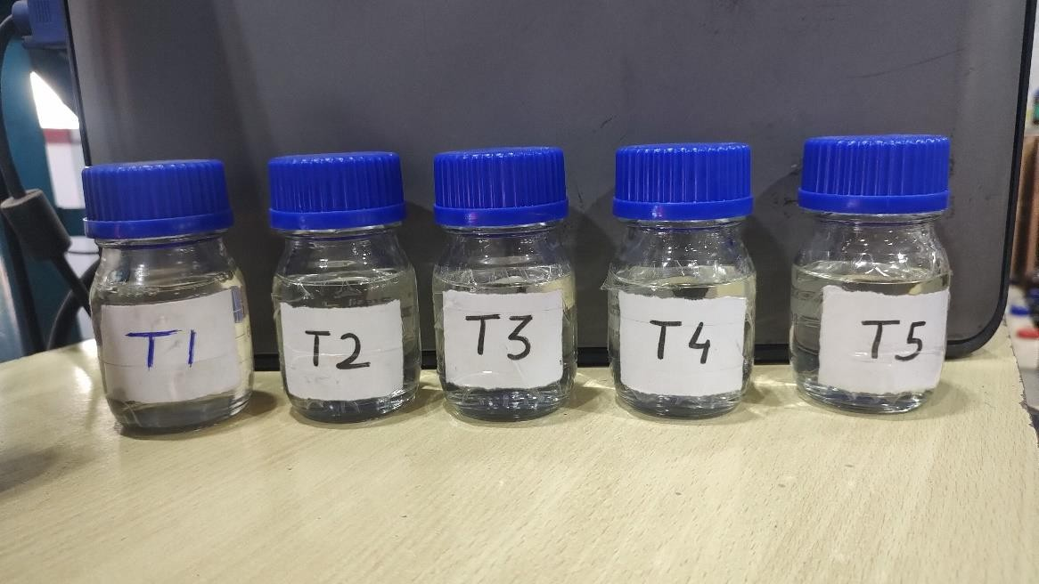

fig.2: Various Fuel Samples

Table 1 Composition of various test fuels and it’s nomenclature

| Fuel Nomenclature | Diesel (%) | Butanol (%) | Ethanol (%) |
| --- | --- | --- | --- |
| D100 | 100 | 0 | 0 |
| D90B10 | 90 | 10 | 0 |
| D80B20 | 80 | 20 | 0 |
| D90E10 | 90 | 0 | 10 |
| D80E20 | 80 | 0 | 20 |
| D85B10E5 | 85 | 10 | 5 |
| D70B20E10 | 70 | 20 | 10 |
| D60B20E20 | 60 | 20 | 20 |

**TEST METHODS FOR DETERMINATION OF PHYSICO-CHEMICAL FEATURES**

The characterstics of the fuel and the operational parameters of the engine play a vital role in influencing Engine's operational efficiency, burning characteristics, and effluent pollutants. The test fuels in this study are a mixture of diesel, ethanol, and butanol, a solvent. Consequently, the aromatic content in diesel, oxygen composition in ethanol and butanol, and the solvent Features of butanol, including its dosage, will have a notable influence on the fuel Features . Therefore, before conducting the Scientific tests , it is essential to thoroughly analyze and correlate the physio-chemical Features of the Practical fuels with those of diesel as a reference fuel. The following sections of the research present a detailed description of the methodologies, techniques, and apparatus utilized to evaluate the fuel Features . To facilitate this analysis, a volume of 500 ml was prepared for each test sample, enabling the assessment of both the physio-chemical attributes of the fuel. The following sub-sections provide an in-depth explanation of the various fuel Features and the corresponding testing procedures employed.

**Density**

The DMA 4500 model of an Anton Paar density metre was used to calculate the densities of the Practical fuels. The equipment utilized for these computation s is depicted in fig.3 The instrument follows the ASTM D-4052 standard for measuring the specific gravity of the test fuels. The temperature for specific gravity computation s was set at a constant value of 15°C. To prepare the test fuel line, it underwent a flushing process using toluene. In a specific procedure, the sample injection port was utilized to introduce 10 ml of toluene, followed by the indroduction of 10 ml of the test sample using the same port. To ensure consistency and accuracy, the same sample was measured three times, and the obtained readings were deemed satisfactory. The final number was then calculated by averaging the three values.

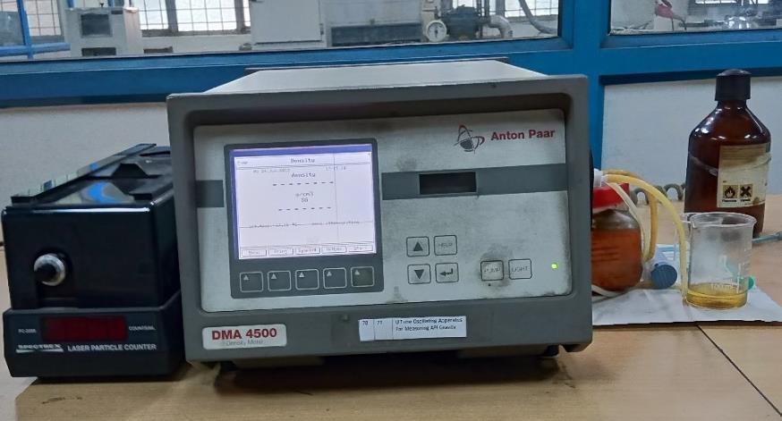

fig.3**:** Instrument used to determine the density

**PRACTICAL SET-UP**

As mentioned earlier, the main objective of this present Practical study is to assess the viability of utilizing alcohol as an environmentally friendly fuel for diesel engines. Hence, the first phase entails the careful selection of appropriate diesel engines, followed by a comprehensive series of trials to study the Efforts , ignition, and emitting attributes across different operational scenarios. The goal is to evaluate alcohol's suitability as a viable alternative fuel for engines powered by diesel fuel.

Selection of Diesel Engine.

In this study, a single cylinder, water-cooled, and direct injection diesel engine was utilized. The engine had a power output of 3.5 kW and operated at a rated speed of 1500 rpm. This particular engine model is widely used in rural agrarian economies, such as in countries like India, and serves as a reliable backup power supply when necessary. A wet-sump lubrication system was utilized. The camshaft was responsible for actuating the intake and dissipate valves located above the cylinder, as well as the fuel pump. Furthermore, the piston contained a hemispherical ignition chamber within its structure.

A piezoelectric transducer was installed on the surface of the cylinder head to measure the in-cylinder pressure. Additionally, the eddy current dynamometer used to load the engine entailed a crank angle encoder attached to the end. The signals collected by these sensors were transmitted to a personal computer via a data acquisition system (DAS), utilizing an NI USB 6210 device. The acquired data were subsequently analyzed using the "Enginesoft" software which is available on the computer. The engine loading system, fuel and air flow monitoring system, and data acquisition system (DAS) were all located on the control panel. Both the engine and the eddy current dynamometer were cooled using a central water cooling system. The water flow rate for the engine was set at 250 litres per hour, while for the dynamometer, it was maintained at 120 litres per hour.

Furthermore, the engine test rig was equipped with separate fuel tanks to ensure distinct storage for neat diesel and test fuels. An in-cylinder Kistler piezoelectric pressure transducer (model 6613CA) was installed to measure the variations in cylinder pressure throughout each engine cycle. Moreover, a crank angle encoder was mounted at the crankshaft's end to ensure accurate crank angle computation.To ensure accurate temperature computation of the combusted gases, a K-type thermocouple was placed upstream of the dissipate manifold inlet. Furthermore, the airflow rate was measured by utilizing a differential pressure sensor that was connected to orifice plates positioned at the rear of the engine control panel unit. Similarly, the fuel flow rate was determined using a calibrated 20cc standard burette, along with a stopwatch for accurate timing. To ensure proper functioning and avoid issues such as overflowing or emptying of the burette, photoelectric sensors are employed.

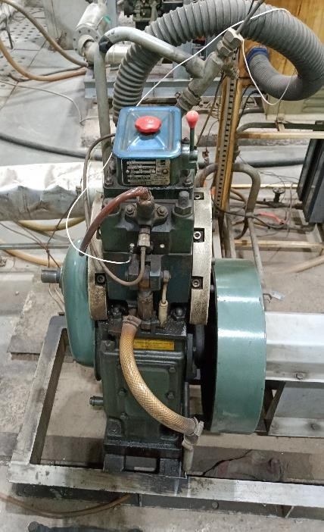

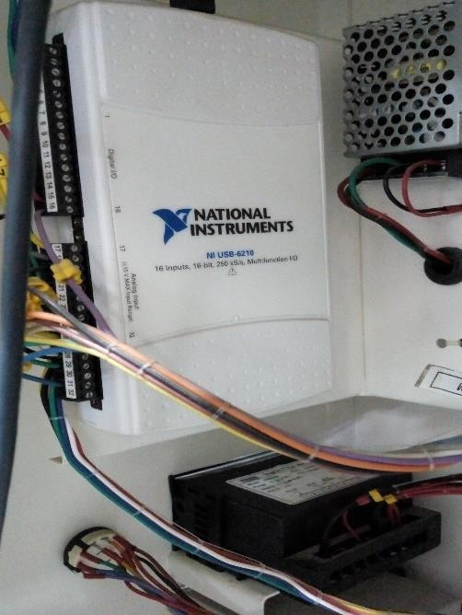fig.4**:** Test engine set-up

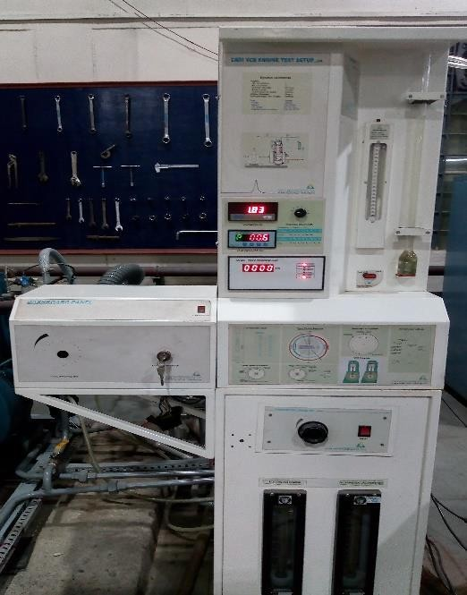 fig.5**:** Test engine set-up**:** NI Data acquisition system

fig.6**:** Control panel

# RESULT

This section provides an exposition of the research's discoveriesbeginning with an investigation into the physio-chemical Features of a blend comprising Diesel, Ethanol, and Butanol. Additionally, the influence of supplement s on the long-term storage stability of the blend is examined. The chapter also encompasses a thorough analysis of engine Scientific tests conducted using Ethanol-diesel blended fuel. Detailed discussions are provided to evaluate the ignition, Efforts , and emitting Features of the engine when utilizing Ethanol blended fuel, with a comparison made to the baseline diesel fuel.

**COMPARATIVE EVALUATION OF PHYSICAL AND CHEMICAL FEATURES AMONG DIESEL AND ETHANOL-BLENDED FUEL**

Both diesel fuel and the Practical test fuels were subjected to analysis to assess their physio-chemical Features . The outcomes indicated that ethanol-blended fuel has a lower energy content Compares to pure diesel fuel, primarily due to the relatively lower calorific value of ethanol.

Table 2: Features of Diesel and Testing Fuel Combinations: Physico-chemical Analysis

|  |  |  |  |
| --- | --- | --- | --- |
| **Property**  **Fuel sample** | **3**  **Density(kg/m )** | **Kinematic Viscosity at 40°C (cSt)** | **Calorific value (MJ/kg)** |
| **D100** | 840 | 4.04 | 43.2 |
| **D80E10B10** | 830.5 | 3.647 | 40.055 |
| **D75E15B10** | 828 | 3.5135 | 39.24 |
| **D70E20B10** | 825.5 | 3.38 | 38.425 |
| **D65E25B10** | 823 | 3.2465 | 37.61 |
| **D60E30B10** | 820.5 | 3.113 | 36.795 |

However, these fuels exhibit a higher octane rating than pure diesel fuel, attributed to the higher octane rating of ethanol. The density of the blended fuel can also vary depending on the ethanol content. The physio-chemical Features of the different test fuels are presented in Table 2.

**EFFORT PARAMETERS OF ENGINES USING ETHANOL- DIESEL BLENDED FUEL**

During the initial phase, the Scientific tests were executed using pure diesel fuel. Subsequently, the tests were conducted using blend fuels consisting of diesel, ethanol, and butanol. The engine load was systematically adjusted in 25% increments of its maximum load capacity. This section primarily focuses on evaluating the ignition, Efforts , and emitting Features of the engine while utilizing these test fuels.

**Ignition Characteristics**

The process of ignition occurring within the engine cylinder greatly influences both the efficiency of the engine and the features of its releases . The process of ignition in an engine with compression ignition can be categorised into four stages: (i) the delay in ignition (ID) stage, (ii) premixed/uncontrolled burning, (iii) diffusion/controlled the ignition process, and (iv) after burning/late ignition. The configuration and dynamics of the flames front during burning also have a pivotal influence on the functioning of a diesel engine. Several parameters, including fuel quality, air-fuel ratio, compression ratio, and ignition effectiveness influence the movement of the flame front. A higher flame speed promotes efficient ignition, leading to improved engine Effort and reduced releases of CO, hydrocarbons, and soot. However, the quantities of nitrogen oxides (NOx) increase due to an increase in-cylinder temperature. Conversely, an excessively high flame speed is unfavourable as it can give rise to enhanced pressure, noise, and detonation. Therefore, maintaining an optimal flame speed range is crucial for the efficient operation of a CI engine.

**Thermal power output (HRR)**

The HRR is a significant parameter that provides insights into the rate at which heat energy is released during the ignition of fuel at various crank angle positions throughout different ignition stages. Analyzing the HRR curve is essential for determining the occurrence of ID, SOC/EOC, and the fraction of fuel mass burned.

Figure 7 presented demonstrates the fluctuation of the HRR for ethanol- diesel blended fuel containing 10% butanol as a co-solvent without any modifications, specifically under rated power conditions. The graphs were generated for different load conditions, and for clarity, with the HRR specifically displayed at the rated power condition to ensure clarity. The outcomes show that the incorporation of ethanol up to a volume of 25% significantly enhancement in the HRR due to improved ignition behaviour outcomeing from better atomization. Furthermore, the figure illustrates that Combinations of fuels such as D80E10B10, D75E15B10, D70E20B10, and D65E25B10 showcase higher Thermal power output s (HRR) in comparison to pure diesel fuel, whereas D60E30B10 exhibits a lower HRR. Notably, the peak HRR for these mixtures occurs at a distinct angle in comparison to diesel. Additionally, mixtures with lower ethanol content exhibit shorter ignition durations when Compares to mixtures with higher ethanol content. It is noteworthy that the HRR increases by 8.8% for D65E15B10 and 12.9% for D55E25B10 Compares to diesel, while the HRR of mixtures with ethanol content beyond 25% is lower due to poor atomization.

**Heat Release Rate (J/deg. CA)**

**Crank Angle (degree)**

**-15**

**405**

**395**

**385**

**375**

**365**

**355**

**55**

**45**

**35**

**25**

**15**

**5**

**-5345**

D75E15B10

D60E30B10

D80E10B10

D65E25B10

D100

D70E20B10

Figure 7: Thermal power generation when operating at maximum capacity

**In-Cylinder Pressure (P-THETA CURVE)**

An important characteristic for comprehending the ignition process taking place within the engine cylinder, a crucial aspect involves analyzing the in-cylinder pressure. Rapid variations in pressure and temperature gradients occur during different ignition phases, requiring detailed analysis to optimize the Effort and emitting Features of engines. Usually, once the piston's position reaching the highest point of the strokeat the end of the compression stroke, the amount of pressure inside the cylinder reaches its highest point, which shows that the premixed ignition process is finished. Subsequently, in the expansion

stroke linked to the diffusing stage, the amount of pressure inside the cylinder starts to decline and reaches its minimum point when the piston reaches the Bottom Dead Centre (BDC). In order to measure the changes in pressure within the cylinder at different points of the crankshaft, a Transducer for measuring pressures is placed at the cylinder head.



**Crank Angle (degree)**

**420**

**410**

**400**

**390**

**380**

**370**

**360**

**350**

D75E15B10

D60E30B10

D80E10B10

D65E25B10

D70E20B10

**75**

**70**

**65**

**60**

**55**

**50**

**45**

**40**

**35**

**30**

**25**

**20**

**15**

**10**

**5**

**0**

**-5340**

**-10**

D100

Figure 8: Fluctuations in the pressure inside the cylinder when the engine is operating at maximum load.

The outcomes depicted in Figure 4.2 indicate that certain blend fuels, namely D80E10B10, D75E15B10, D70E20B10, and D65E25B10, exhibit higher in-cylinder pressure as Compares to diesel. This improvement can be attributed to the enhanced ignition efficiency achieved through the addition of ethanol in these mixtures . However, the blended fuel D60E30B10 demonstrates lower in-cylinder pressure than diesel. This discrepancy can be ascribed to the suppressive influence of the elevated ethanol content in the mixtures , stemming from its higher heat of vaporization. Moreover, as illustrated in Figure 4.2, it is observed that the peak in-pressure values of D80E10B10 and D65E25B10 are 6.5% and 14.8% higher, respectively, Compares to diesel.

**Effort Characteristics**

**Variation of Brake Thermal Efficiency (BTE)**

The BTE serves as a metric to assess the efficiency of an engine in Transforming the potential energy stored in fuel into practical and productive output.

Figure 9 demonstrates the fluctuations in BTE for various fuels under various loading conditions, spanning from no load to 100% load of rated load. Notably, the mixtures D80E10B10, D75E15B10, D70E20B10, and D65E25B10 showcase as comparable BTE in comparison with diesel across all loads. This is attributed to the enhanced volatility and improved spray Features of the fuel mixtures , up to a certain ethanol content even at lower CV of test fuels. The D60E30B10 blend exhibits a highest diminished in BTE than all other test fuels. This can be attributed to the reduced self-ignition Features of the blend, which are a outcome of its higher ethanol content and the associated increase in heat of vaporization.



**120**

**100**

**80**

**60**

**LOAD (%)**

**40**

**20**

**0**

**30**

**25**

**20**

**15**

**10**

**5**

**0**

D75E15B10

D60E30B10

D80E10B10

D65E25B10

D100

D70E20B10

Figure 9: Brakes thermal effectiveness under different load conditions

Consequently, this induces a cooling effect within the cylinder, leading to lowered temperatures and subsequently affecting the reaction of oxygen with the fuel, thereby impeding ignition. The minimum decrease in BTE for D80E25B10 is 0.6 %, while the maximum decrease for D65E30B10 is 5.2% Compares to diesel.

**Variation of Brake Specific Energy Consumption (BSEC):** The assessment of fuel consumption plays a crucial role in comprehending the engine Effort of various fuels. Traditionally, the computation of BSFC has been utilized as a parameter to quantify the relationship among the fuel mass flow rate and the generated brake power. However, when test fuels exhibit significant variations in calorific values and densities, BSFC may not be considered a reliable indicator.

**Brake Specific Fuel Consumption (kg/kWh)**



**120**

**100**

**80**

**60**

**LOAD (%)**

**40**

**20**

**0**

**0**

**0.25**

**0.5**

**0.75**

**1**

D75E15B10

D60E30B10

D80E10B10

D65E25B10

D100

D70E20B10

Figure 10: BSEC at various Loads Figure 4.4 illustrates the BSEC of the test fuels at various loading conditions:

25%, 50%, 75%, and full load. A noticeable observation is that all the Combinations of fuels demonstrate higher BSFC in comparison to diesel across all load conditions. Among the mixtures , D80E10B10, D75E15B10, D70E20B10, and D65E25B10 exhibit lower BSFC Compares to D60E30B10. The engine's power can be sustained at a consistent level when using various fuel mixtures , albeit with a slight rise in fuel consumption. However, as the ethanol proportion in the mixtures rises, fuel consumption also increases. The maximum increment in BSFC is observed for D60E30B10, with a 9.1% increase, while the minimum increment is seen for D65E25B10, with a 4.2% increase Compares to diesel. The increase in fuel consumption can be attributed to the lower heating value of ethanol Compares to pure diesel., which also demonstrates a similar trend of increasing fuel consumption with the proportionate rise in ethanol percentage within the mixtures . Similar trends in fuel consumption can also be observed when the engine operates at 1500 rpm under different load conditions.

**Variation In Dissipate Gas Temperature (EGT)**

EGT holds significant importance as an operational parameter for CI engines, as it actively regulates the emitting of harmful gases discharged during the ignition process.

Figure 10. illustrates the variation in EGT among the Combinations of fuels and diesel across different load conditions. It is evident that all the Combinations of fuels exhibited higher EGT than diesel at all loading conditions except D60E30B10.



**120**

**100**

**80**

**60**

**LOAD (%)**

**40**

**20**

**0**

**400**

**350**

**300**

**250**

**200**

**150**

**100**

D75E15B10

D60E30B10

D80E10B10

D65E25B10

D100

D70E20B10

**Exhaust Gas Temperature (oC)**

Figure 10: Dissipate gas temperature at various Loads

Specifically, mixtures D80E10B10, D75E15B10, D70E20B10, and D65E25B10 demonstrated higher EGT values than that of diesel. Conversely, the fuel blend D60E30B10 outcomeed in lower EGT than other test fuels. The lower EGT observed in mixtures with a higher volume of ethanol can be attributed to the cooling effect caused by the higher prevalence of heat of vaporization within these mixtures . This cooling effect in the in-cylinder environment reduces the reaction rate among fuel

particles and available oxygen, outcomeing in lower EGT. The maximum increase in EGT for D65E10B10 is 9.1%, while the maximum decrease in EGT for D60E30B10 is 4.2% Compares to diesel.

**Emitting Characteristics**

This section discusses the process by which dissipate releases are generated in a diesel engine and examines the influence of blended fuels on their formation and control. The analysis concentrates on examining the releases of NOx, HC, CO, and smoke opacity throughout the ignition of different fuels. The engine loads ranges from 25% to 100% to study the releases under a consistent speed of 1500 rpm. The computation s of dissipate releases were conducted using a smoke meter and an AVL gas analyzer installed at the dissipate of the engine. The assessment was executed based on a brake-specific (g/kWh) approach, taking into account the varying fuel compositions. This allows for a comparison of the releases produced by different Combinations of fuels and supplement s.

**Unburnt Hydrocarbon (UBHC) releases**

Unburnt hydrocarbon pollutants are formed when fuel particles do not participate in the ignition process and are released into the dissipate without being fully processed. The level of unburnt hydrocarbon releases can be considered an indicator of the ignition quality within the engine. Several factors like fuel composition, ignition reaction time, ignition temperature, cylinder crevices, oxygen availability, and engine configuration can influence the formation of unburnt hydrocarbon releases in diesel engines.

Figure 11 demonstrates that the blend containing 30% ethanol content displays elevated hydrocarbon (HC) releases , whereas the mixtures comprising 25% ethanol content exhibit reduced HC releases than diesel. This variation can be attributed to the distinctive ignition Features of the mixtures . Mixtures with lower ethanol volume tend to have improved ignition characteristics, while mixtures with higher ethanol volume exhibit reduced ignition characteristics.

Moreover, it is evident that D75E25B10 and D65E10B10 outcome in 12.8% and 7.9% lower hydrocarbon (HC) releases Compares to diesel, respectively.



**120**

**100**

**80**

**60**

**Load (%)**

**40**

**20**

**0**

**30**

**25**

**20**

**15**

**10**

**5**

**0**

D75E15B10

D60E30B10

D80E10B10

D65E25B10

D100

D70E20B10

**35**

**Unburnt Hydrocarbon Emission (ppm)**

Figure 11: Unburned hydrocarbons emitting at various Loads

# CONCLUSION

This study aimed to assess the practicality of incorporating diesel-ethanol blended fuels containing Butanol into an unaltered diesel engine. The primary objective was to assess the viability of Ethanol as a fuel option for a CI engine and examine its influence on ignition, Efforts , and emitting attributes. The obtained Practical outcomes of this investigation are promising, and the primary discoveries can be outlined as follows:

The engine's the ignition process, efficiency, and releases Features can be enhanced by blending up to 25% ethanol into diesel fuel, along with the addition of 10% butanol as an supplement .

The presence of ethanol in diesel fuel leads to a higher LHV, outcomeing in an ignition delay. This ID improves the ignition process by facilitating proper fuel-air mixing.

Compares to diesel, the ignition process in ethanol-blended fuel outcomes in enhanced peak in-cylinder pressure and HRR. This improvement in the ignition process leads to enhanced Effort in terms of peak cylinder pressure and HRR.

When the engine was fueled with ethanol-blended fuels, the thermal efficiency of the engine was as comparable or slightly lower than diesel and the BSEC of the engine was enhanced . This indicates that the engine achieved a enhanced efficiency in converting fuel energy into productive work and had a higher energy consumption rate when running on ethanol mixtures .

The engine emitted higher levels of nitrogen oxides (NOx) throughout the Practical range Compares to diesel fuel. This is a significant emitting characteristic of plant oil. Various methods, including EGR, can be employed to mitigate these NOx releases and reduce their influence.

The releases of CO, Hydrocarbon, and Smoke from the ethanol-blended fuel were consistently lower than those from the diesel fuel throughout the entire Practical range.

The study's findings suggest that incorporating fuel supplement s into diesel- ethanol mixtures can yield considerable advantages and better environmental outcomes, and may serve as a viable alternative fuel for CI engines in the future.

# REFERENCES

1. Energy - Our World in Data.” https://ourworldindata.org/energy#citation (accessed May 28, 2023).
2. “World Energy Outlook 2018 – Analysis - IEA.” https://www.iea.org/reports/world- energy-outlook-2018 (accessed May 28, 2023).
3. “India Energy Outlook 2021 – Analysis - IEA.” https://www.iea.org/reports/india- energy-outlook-2021 (accessed May 28, 2023).
4. “Ministry of Coal, Government of India.” https://coal.nic.in/en/major-statistics/coal- indian-energy-choice (accessed May 28, 2023).
5. “Perform, Achieve, Trade (PAT) Scheme – Policies - IEA.” https://www.iea.org/policies/1780-perform-achieve-trade-pat-scheme (accessed May 28, 2023).
6. İ. A. Reşitoğlu, K. Altinişik, and A. Keskin, “The pollutant releases from diesel- engine vehicles and dissipate aftertreatment systems,” Clean Technol Environ Policy, vol. 17, no. 1, pp. 15–27, Jan. 2015, doi: 10.1007/s10098-014-0793-9.
7. R. Prasad and V. R. Bella, “A Review on Diesel Soot Emission, its Effect and Control,” BULLETIN OF CHEMICAL REACTION ENGINEERING AND CATALYSIS, vol. 5, no. 2, Jan. 2011, doi: 10.9767/bcrec.5.2.794.69-86.
8. A. Demirbas, A. Bafail, W. Ahmad, and M. Sheikh, “Biodiesel production from non- edible plant oils,” Energy Exploration & Exploitation, vol. 34, no. 2, pp. 290–318, Mar. 2016, doi: 10.1177/0144598716630166.
9. T. Mizik and G. Gyarmati, “Three Pillars of Advanced Biofuels’ Sustainability,”
10. Fuels, vol. 3, no. 4, pp. 607–626, Oct. 2022, doi: 10.3390/fuels3040037.
11. S. Tamalampudi and H. Fukuda, “Biodiesel,” in Comprehensive Biotechnology, Elsevier, 2011, pp. 63–70. doi: 10.1016/B978-0-08-088504-9.00163-X.
12. A. K. Agarwal, “Biofuels (alcohols and biodiesel) applications as fuels for internal ignition engines,” Prog Energy Combust Sci, vol. 33, no. 3, pp. 233–271, Jun. 2007, doi: 10.1016/j.pecs.2006.08.003.
13. T. J. Deka, A. I. Osman, D. C. Baruah, and D. W. Rooney, “Methanol fuel production, utilization, and techno-economy: a review,” Environ Chem Lett, vol. 20, no. 6, pp. 3525–3554, Dec. 2022, doi: 10.1007/s10311-022-01485-y.