MARINE DEBRIS DETECTION IN OCEAN SUB-SURFACE USING DEEP VISUAL MODELS
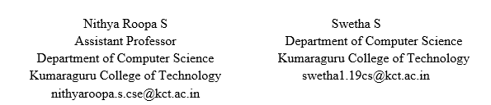

Abstract— Quantifying positively buoyant marine plastic litter is crucial for comprehending the global accumulation of plastic waste in oceans and identifying areas requiring focused cleanup efforts. Currently, the prevalent approach for measuring marine plastic involves labor-intensive and expensive manual sampling using manta trawls. However, this study proposes an autonomous alternative that leverages neural networks and computer vision models trained on images captured from different depths of the ocean column. By adopting this method, the need for manual sampling is eliminated. The study reports a calculated Mean Average Precision of 84% and an F1-Score of 0.82, indicating the effectiveness of the approach in accurately quantifying marine plastic litter.
Keywords—marine debris, data augmentation, You Only Look Once (YOLOv5), hyperparameters, mean average precision

Introduction
Marine debris is a persistent and growing environmental issue that has an influence on oceans, shorelines, and marine ecosystems all over the world. This issue is caused by human activities like littering, ineffective waste management, and garbage-producing industrial operations. Marine waste contains a variety of substances, including plastic, rubber, glass, metal, and even used fishing gear. The rubbish may put marine life in risk or cause it to die, damage fragile ecosystems, and negatively affect people's health and way of life. In recent years, as more people have become aware of the pressing need for solutions, scientists, policymakers, and the general public have all paid increased attention to the issue of marine trash. Many studies have been conducted to ascertain the sources, types, and distribution of marine.

Global production of plastic has topped 500 million tones. The shocking volume of plastic waste here could have a negative effect on ecosystems and marine life. It's important to remember that this estimate is simply a general guide because the actual amount of plastic that actually enters the ocean each year may be very higher or considerably lower. Also, the amount of plastic in the water is increasing over time as it might take years for plastic debris to breakdown there. The cleanup of marine debris is a vital step in protecting marine life and upholding the integrity of our oceans. The accumulation of plastic trash in the ocean can lead to a variety of problems, including the entanglement and ingestion of marine animals, water contamination, and harm to human health. By clearing the ocean of trash, we can mitigate these adverse consequences and promote a healthier, more sustainable marine ecosystem. Marine trash can be disposed of in a variety of ways, including technological solutions and manual cleanup efforts.

Even though eliminating marine debris is an essential first step in addressing the problem of ocean pollution, it is only one component of the solution. To genuinely make an impact, we must address the root causes of pollution and plastic waste. An essential part of this is the detection of marine debris. Identifying marine debris is an important first step in addressing the problem of ocean pollution. The ecology, human health, and marine life could all be negatively impacted by plastic garbage and other debris in the water. By detecting marine debris, we can determine where it is accumulating, evaluate the problem's seriousness, and take steps to remove it from the water. However, the garbage that has sunk to the ocean floor requires underwater detection techniques. Massive debris patches on the ocean's surface can be identified using aircraft surveys and satellite images. Many methods can be used to locate marine debris underwater. One approach is to use remotely operated vehicles (ROVs) that are equipped with cameras and sensors to scan the ocean floor for garbage. As ROVs may be operated remotely from the surface, they can explore ocean areas that could be difficult or dangerous for humans to access. Another technique for locating trash on the ocean floor involves the use of sound sensors. In order to work, acoustic sensors discharge sound waves into the water and track the reflections they receive.

Finally, it should be noted that safeguarding marine ecosystems and fostering a better, more sustainable environment both depend on the ability to detect marine debris underwater. In rivers and oceans and other naturally existing aquatic ecosystems, human-produced garbage is frequently discharged. It is essential to find marine litter in rivers and oceans so that its effects on the ecosystem can be identified and reduced. The debris region needs to be automatically located and extracted from the input image. Finding maritime garbage using ML algorithms is the major objective. Machine learning-based methods for recognizing and categorizing marine rubbish from images and other types of data are intended to be automatic and exact. Machine learning algorithms can be trained to recognize patterns in data and used to assess the presence and location of trash in images or other data sources. This enables them to identify different types of trash and pinpoint it in images and other data sources. The use of machine learning to find marine trash has a variety of potential benefits. It can improve the efficacy and precision of debris detection by doing away with the requirement for manual inspection and time-consuming data processing. Environmentalists can use this to quickly identify and track down areas with a high concentration of rubbish. The benefits of using machine learning to detect marine debris may include improved techniques for managing resources, improved methods for preventing pollution, and more support for scientific research. The use of machine learning for the detection of marine debris can significantly advance our understanding of the effects of marine pollution and the development of workable methods to address it. To measure floating plastic using the most widely used monitoring method, a manta trawl is now necessary. Due to the high cost and labor-intensive needs of physical removal, it is impossible to scale up the installation of a real-time marine plastic monitoring service across the oceans. It will be hard to ascertain the full scope of plastic pollution's effects on the ecosystem as a whole and the details of its affects within certain maritime regions without enhanced monitoring and sampling methodologies. An automated system uses images and videos captured in the ocean's epipelagic layer as input to give real-time measurement of marine plastic for accurate quantification and eradication. In paper [6], according to study's author, employs a variety of deep-sea observational equipment, including AUVs and deep-sea observatory systems. More than 4860 deep water dives have been completed by these scientific submersibles. Each dive was videotaped and is preserved in a film collection. Some of them are contained in a database that has been made public and online accessible. The database and the video clip both show that there is rubbish in the deep water. To follow changes in deep-sea litter buildup over time, research submersibles can collect deep sea rubbish in situ together with environmental data and samples.

METHODOLOGY

Marine debris detection plays an important role in marine environment protection. YOLOv5 is an effective method to detect the debris in real time. Ultralytics developed the cutting-edge object identification technique known as YOLOv5 (You Only Look Once version 5). One of the most popular object recognition algorithms at the time, it is a development of earlier YOLO iterations. The deep learning-based method YOLOv5 uses convolutional neural networks to recognize objects in photos. After disassembling a picture into its component pieces, the algorithm forecasts bounding boxes and class probabilities for each grid cell. By adjusting the bounding boxes based on surrounding cells and their anticipated probabilities, high accuracy item detection is made possible. One of the key improvements of YOLOv5 over previous iterations is the design at the core. The effectiveness is increased by the usage of Cross-Stage Partial connections, a distinctive backbone design by YOLOv5. YOLOv5 additionally makes use of a variety of additional strategies, such as Data augmentation, which entails modifying the training set of data to make it more generalizable to different scenarios, Label smoothing, which reduces overconfidence in the network's predictions by smoothing the classification probabilities and weighting the loss function to place more emphasis on difficult-to-detect things. Photos and videos of marine plastic were gathered in California Bay to build the dataset. To enhance the diversity and representation of marine plastics in various contexts, this study incorporated images from databases established by the Japan Agency for Marine-Earth Science and Technology. By leveraging these additional image sources, a broader range of plastic waste scenarios and variations were incorporated into the analysis, contributing to a more comprehensive understanding of marine plastic pollution. In order to process each individual model, the input data—which consists of bounding box labels and image annotations—must be converted into PyTorch. Using the 2D coordinates provided in the associated annotation file and the corresponding bounding boxes, the regions of interest (ROIs) for each image were identified. This step allowed for focusing specifically on the relevant areas within the images. Additionally, during the image pre-processing phase, the exchangeable image file format (EXIF) data was removed from the photos using auto-orient functionality. This ensures that the models can interpret the images accurately, irrespective of the original image format. Moreover, Data Augmentation is used to avoid generalization in terms of forecasting undesirable things in the image. Before being tested on a validation dataset to ascertain its precision, recall, and mean average precision, the model would go through several training rounds. The testing and validation datasets are used, which accept images from the training dataset as input but are exclusive, to assess the network's performance after it has been trained. When a model successfully recognises an object and receives a confidence score of at least 50, it generates a bounding box around it. The evaluation is based on the ratio of true positive bounding boxes, which accurately identify marine plastic waste, to true negative bounding boxes, which correctly identify non-plastic waste areas or background regions. This ratio serves as a measure of the model's performance in distinguishing and accurately localizing marine plastic waste.
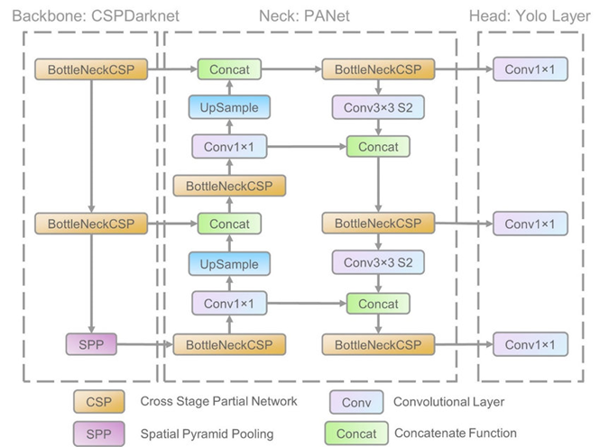

Fig 1: Model Architecture

In the proposed model, the dataset is constructed from California Bay and from JAMSTEC , in order to represent marine debris from different sub-surfaces. The input data is then annotated with labels where object class, object coordinates , width and height are specified. Data augmentation is done using PyTorch, which strips off the EXIF data enabling the model to detect the output irrespective of its format. The dataset is then split into train, test and validation set and the hyperparameters are specified properly. The model is trained and run for 100 epochs for validation. F1-score and Mean Average Precision are calculated and bounding boxes are labelled with F1-score in the output image.

ANALYSIS AND RESULT EVALUATION
To locate maritime debris, we must analyze the image and assign labels. For each image file in the same directory with the same name as the images, labels are created as txt files in YOLOv5. A txt file has the annotations for each matched image file, which include the object class, object coordinates, height, and width.

EXIF data is removed from images during preprocessing. Metadata is stored in image files using the EXIF (Exchangeable Image File) format by digital cameras and other devices. The time and date, GPS location, camera settings, and other information are all included in this metadata. Auto orientation is used to remove the EXIF format from the images so that the model can read them regardless of their format.

Use PyTorch, an open-source machine learning toolkit, to design and train neural networks. In PyTorch, tensors are multidimensional arrays that may hold both scalar and vector data. Tensors in PyTorch are similar to arrays in other programming languages like numpy when it comes to deep learning applications, but they have a few more features and optimizations. Deep learning models can make use of a range of PyTorch's tools and features for data augmentation. By making random changes to the input data, new training instances are added, increasing the diversity and variability of the data. This process is known as data augmentation.
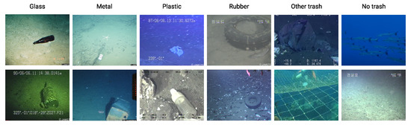

Fig 2: Sample of images from the dataset.

The PyTorch transformations set of image processing algorithms can be used for data augmentation. They include resizing, cropping, flipping, rotating, jittering the color, and other modifications. Transforms can be applied to images or tensors before putting them into a neural network, either during training or testing. The dataset is then split into train, test and validation sets in the ratio 8:1:1 and the parameters are specified. In YOLOv5, anchors are used to help the model recognize items that are present in an input image at a variety of scales and aspect ratios. Anchors are a set of pre-determined bounding boxes that are centered at each grid cell in the YOLOv5 output feature map. During training, the model learns to adjust the size and positioning of these anchor boxes to fit the objects in the input image.

YOLOv5 is built on a deep convolutional neural network, which is in charge of extracting features from the input image. The backbone network in YOLOv5 is by default a customised version of EfficientNet, but we can alternatively utilise ResNet, Darknet, or CSPNet as alternatives. The confidence threshold specifies the least amount of confidence necessary for an item detection to be taken seriously. The project's confidence level is set at 0.50. The model is assessed using performance indicators after a predetermined number of training epochs. Real positive values are used to illustrate instances where models properly predicted a positive class, and real negative values are used to illustrate instances where models correctly predicted a negative class. Precision and recall indicate how well the model performed at identifying plastic in an image.
Recall = 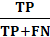

Precision = 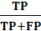

Mean Average Precision measures the frequency with which a network can find plastic in a set of images. The F1-Score is used to assess how precision and recall levels are balanced.
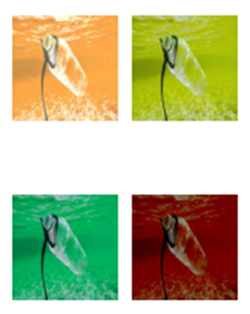
Fig 3: Object Detection

Model Evaluation
It is required to apply the proper weights and configure the training parameters, such as the batch size, learning rate, number of epochs, and other hyperparameters. The parameters of the neural network that are learned during training are the weights in YOLOv5. These weights are available in binary form in files with the ".pt" extension. The weights file contains the weight values for each layer in the YOLOv5 model. YOLOv5 contains pre-trained weights for many models created on the COCO dataset.

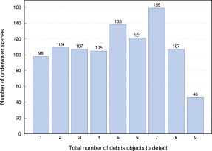

Fig 4: Performance Evaluation

The YOLOv5 algorithm is used to train the model, and it is enhanced with the integration of Weights & Biases. This integration allows for comprehensive experiment metric tracking, versioning of both the model and dataset, and provides visualizations of rich model predictions. The model is trained over the course of 100 epochs, enabling it to learn and improve its performance over multiple iterations.

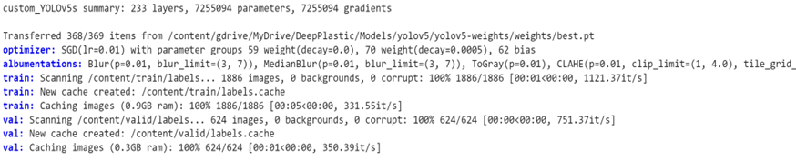

Early stopping is used, which is a method used to avoid overfitting while training the images.

Table 1. Model Evaluation in Training and testing Phase

Model | Accuracy (%) | F1-Score (%) | Kappa
Training Phase
YOLOv5 | 86.16 | 86.15 | 0.83
Testing Phase
YOLOv5 | 80.08 | 78.84 | 0.75

Model Check Point is used to save the snapshot of the model which contributes in resilience, generalization and tuneability.

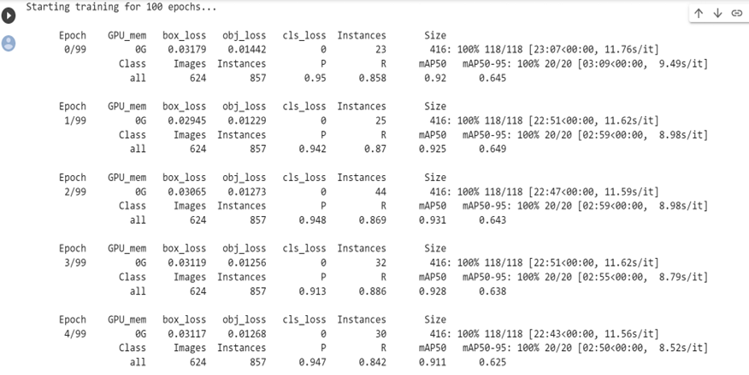

The model is now tested with the test data set. We can learn about the mean average precision and F1 score which were recorded to be 85% and 0.89 respectively. The model produces the results, rendering bounding boxes and confidence ratings over marine debris.

Fig 4: Rendering Bounding Boxes

Conclusion
A deep learning vision model that could accurately identify and measure maritime debris needed to be created. The results demonstrate that utilizing the YOLOv5-S model for a marine plastic debris detection system would offer notable advantages, including speed, accuracy, and reliability. These findings suggest that the system has the potential to enable real-time identification of marine debris, providing a valuable tool for efficient and effective monitoring and management of marine pollution. Additionally, it concludes that good object identification models can be produced at low costs by utilizing commonly available, pre-enabled GPUs.

References
- Barboeza, Luíes Gabrieel Antãio, et al. "Marine microplastic debris: Deep neural network for oil spill detection using Sentinel-1 data: application to Egyptian coastal regions. Remote Sensing, 12(6) 1015." Marine pollution bulletin 133 (2018): 336-348.
- Windoom, Herrbert L. "Oil Spill Detection Using Machine Learning and Infrared Image." Marine Pollution Bulletin 25.1-4 (1992): 32-36.
- Vann Emmeriik, Tiom, et al. " A novel deep learning method for marine oil spill detection from satellite synthetic aperture radar imagery." Frontiers in Marine Science 5 (2018): 372.
- Schmidet, Christiean, Tobieas Krauth, and Stephaen Wagneer. "Export of plastic debris by rivers into the sea." Environmental science & technology 51.21 (2017): 12246-12253.
- Miyakie, Hiroshie, Haruika Shibaata, and Yasuio Furushima. "Deep-sea litter study using deep-sea observation tools." Interdisciplinary studies on environmental Chemistry-Marine environmental modeling and analysis Terrapub (2011): 261-269.
- Ren, Shaoiqing, et al. "Faster r-cnn: Towards real-time object detection with region proposal networks." Advances in neural information processing systems 28 (2015).
- Magalhães, Sandiro Augustio, et al. "Evaluating the single-shot multibox detector and YOLO deep learning models for the detection of tomatoes in a greenhouse." Sensors 21.10 (2021): 3569.
- Jiang, Peiyuain, et al. "A Review of Yolo algorithm developments." Procedia Computer Science 199 (2022): 1066-1073.
- Macie, Thomaas H. "At-sea detection of marine debris: overview of technologies, processes, issues, and options." Marine pollution bulletin 65.1-3 (2012): 23-27
- Kieim, Jun-Hwaie, et al. "Object detection and classification based on YOLO-V5 with mproved maritime dataset." Journal of Marine Science and Engineering 10.3 (2022): 377.
- Hue, Xuelong, et al. "Real-time detection of uneaten feed pellets in underwater images for aquaculture using an improved YOLO-V4 network." Computers and Electronics in Agriculture 185 (2021): 106135.
- Van Lieshouit, Colien, et al. "Automated river plastic monitoring using deep learning." (2020).

