**SOCIAL ACCEPTABILITY DIMENSIONS OF COASTAL ROAD**

**DEVELOPMENT**

Andreson J. Suboan

University of Southeastern Philippines, College of Development Management, Graduate School Program, Mintal Campus, Davao City

**ABSTRACT**

The study aimed to explore the social acceptability dimensions of coastal road development. The study employed exploratory factor analysis to explore the underlying dimensions of the social acceptability of coastal road development. Responses from the 150 residents of Davao City living near the affected area of the coastal road development were obtained and analyzed using the EFA (Exploratory Factor Analysis). The strength of partial correlations between variables was examined using the Keiser-Meyer-Olkin measure of sampling adequacy. The correlation matrix's identity as a matrix was tested using Bartlett's Test of Sphericity. The social acceptability dimensions of coastal road development were graphically depicted using a scree plot to show the variety of elements. The identified factors in the social acceptability of a coastal road development are the following: Community involvement and well-being, sustainable development and community harmony, health and recreational impact, and trustworthiness and community benefits.

**Keywords:**

Social acceptability, coastal road, development

**INTRODUCTION**

Because of rising coastal urbanization, engineered structures worldwide have replaced natural marine habitats. The shallow marine ecosystem is greatly affected by its socio-ecological impacts, and it will continue to occur in the coming decades (Floerl et al., 2021) with the increasing reliance of coastal communities on natural resources for their different livelihoods (N. Bax et al., 2021). Globally, approximately 2.15 billion people are habituating in the near-coastal zone, and in the low-elevation coastal area, 898 million people live. It is predicted to increase by 2.9 billion and 1.2 billion depending on the socioeconomic scenario. (Reimann et al., 2023). In addition, rising coastal urbanization is driven by different coastal developments, such as public infrastructure, recreational and commercial shipping facilities, and coastal protection. (N. Bax et al., 2021).

Some studies have shown that despite the positive benefits of coastal developments such as nature restoration and flood protection structures, they have still given strong emotional reactions to the people living near the area, showing that "Giving up land to the sea" is controversial. Most communities' objections also concern losing agricultural marshes, livelihoods, cultural landscapes, and traditions. Some have reported concerns in the institutional area, such as lack of confidence in authorities and obstruction in the planning procedures in the coastal realignment projects (V. Bax et al., 2023). As hinted by V. Bax et al. (2023), these challenges must be accommodated to deter the negative impacts of more socially acceptable and sustainable coastal interventions.

On the other hand, other studies suggest that the positive impact of coastal developments, such as coastal realignment, has brought potential improvement to the well-being of the local community and contributed to supportive attitudes toward project development. Therefore, as argued by V. Bax et al. (2023), it is worthwhile to explore the extent of circumstances where local communities recognize, value, and gain from the ecosystem services provided by the new landscape in the context of coastal road development. So far, this has yet to be a topic of study. He added that this lack of understanding of how these developments are perceived from an ecosystem perspective hampers the planning and implementation phase of future initiatives in the coastal developments that balance the local community's needs and its ecological and water safety objectives. (V. Bax et al., 2023).

With the trend in rapid coastal development and urbanization, there is indeed a need for a holistic measure with emphasis on a practical and adaptive design and implementation of coastal infrastructure projects that consider not just the physical processes that affect hazardous coastal ecosystems but also both the natural and human environment characteristics and their interactions (Areia et al., 2022), wherein socially acceptable products of a shared decision or acceptance of a specific project initiative, plan, or policy is needed to every type of projects, irrespective of its nature. (Social acceptability. (n.d.). Gouvernement Du Québec.

**OBJECTIVES**

This research explored the social acceptability dimensions of coastal road development

Specifically, it aimed to answer the following questions:

1. What factors must be considered when developing a socially accepted coastal road development approach?

2.. What recommendations can be derived to develop a socially accepted coastal road development approach based on the generated themes of the exploratory study?

**METHODOLOGY**

**Research Design**. This study employed exploratory factor analysis to explore the underlying dimensions of the social acceptability of coastal road development. EFA's objective is to detect the most fundamental and straightforward hypothetical factors or constructs that can clarify the variation among a group of measured variables (Watkins, 2018).

**Sources of Data**. Primary and secondary data are the sources of information used in the study. Primary data were extracted from the interview questionnaire results under study. Secondary data sources were obtained from this study's related literature and studies, coming from books, magazines, and the internet.

**Data Gathering Instruments**. A survey questionnaire was used to obtain responses on the social acceptability of the coastal development in Davao City. The survey questionnaire contained Thirty (30) coastal road development social acceptability-related questions crafted by the researcher to explore underlying themes. The data was collected through a mix of face-to-face and online surveys. According to Torrentira (2020), an online survey is a process of distributing the instrument or the questionnaire to the target respondents using online platforms through Google Forms. The responses will be analyzed and interpreted using the 5-point rating scale to measure the social acceptability of coastal development in Davao City.

**Sampling Procedure**. The units of analysis in this study were the residents of Davao living near the affected area of the coastal road development, chosen randomly. For a thirty-item questionnaire using an Exploratory Factor Analysis, 150 participants with at least five cases per item are recommended. (Fein, 2022) All in all, the researcher had 150 participants in the study.

**The Procedure of the Study**. The study started with conceptualizing the problem of crafting an appropriate research title, with its review of related literature and methodology being used. Afterward, the researcher submitted the questionnaire to the course professor for approval. After the questionnaire was validated, it was then elicited to the respondents. After the answers were tabulated and consolidated, they were analyzed and interpreted using SPSS software, and significant recommendations for the study were drawn up.

**Statistical Treatment.** The data gathered in this study was analyzed and interpreted using the EFA (Exploratory Factor Analysis). The strength of partial correlations between variables was examined using the Keiser-Meyer-Olkin measure of sampling adequacy. The correlation matrix's identity as a matrix was tested using Bartlett's Test of Sphericity. The social acceptability dimensions of coastal road development were graphically depicted using a scree plot to show the variety of elements.

**RESULTS AND DISCUSSION**

The table below shows the KMO Measure of Sampling Adequacy and Bartlett’s Test of Sphericity. The KMO measures .904, which implies that the samples are in high correlations, which is appropriate for variable analysis that fits the data. As shown, Bartlett’s test of Sphericity yields a value of 3553.032 and a level of significance smaller than .001, which signifies the data to be processed to factor in the social acceptability of a coastal road development. Moreover, Bartlett’s test of Sphericity implies rejecting the null hypothesis and concludes that there are determinants for the social acceptability of coastal road development.

**Table 1. KMO and Bartlett's Test**

| KMO and Bartlett's Test | | |
| --- | --- | --- |
| Kaiser-Meyer-Olkin Measure of Sampling Adequacy. | | .904 |
| Bartlett's Test of Sphericity | Approx. Chi-Square | 3553.032 |
| df | 435 |
| Sig. | .000 |

Figure 1 illustrates the graphical representation of the total variance explained and the graph of Eigenvalues against all the factors. It shows the gradual training of Eigenvalues and identifies the relative fit of each component based on its relative importance. The graph is handy for determining how many factors will be retained. The point of interest is where the curve flattens. As observed, the curve gets flatter as it reaches component number 5 since it is where the Eigenvalues less than 1 begin. If the items of each dimension are less than the minimum, the dimension will be discarded. Thus, only four factors considered as determinants were retained.

***Figure 1. Scree plot***

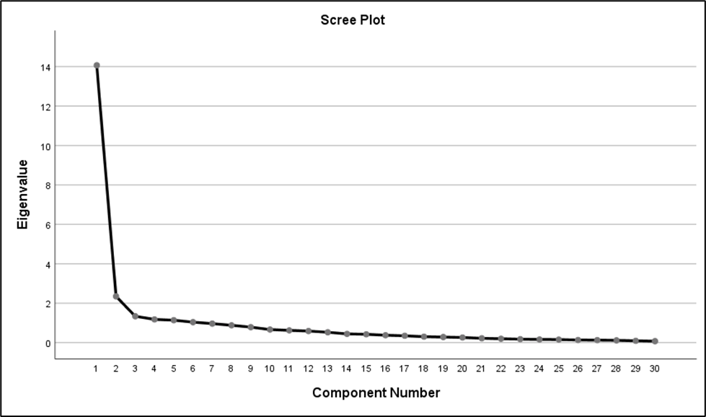

**Rotated Component Matrix**

Presented in Table 2 are the community involvement and well-being as a factor. The loading of 0.823 for item 4 indicated that the coastal road developments in my area are socially acceptable because we are given the opportunity to take part in the decision-making process of the developments. Item 2 indicated that the coastal road developments in my area are socially acceptable because we are well informed by the government of the possible risks generated by the developments with a factor loading of 0.746. Item 1 emphasized that the coastal road developments in my area are socially acceptable because the government adequately compensates the affected people with a factor loading of 0.739. Item 6 indicated that the coastal road developments in my area are socially acceptable because the affected people are given appropriate resettlement with a factor loading of 0.735. Item 3 indicated that the coastal road developments in my area are socially acceptable because the government has informed us of the developments' positive and negative economic impacts, with a factor loading of 0.685. Item 18 indicated that the coastal road developments in my area are socially acceptable because they improve our living standards with a factor loading of 0.592. Item 13 indicated that the coastal road developments in my area are socially acceptable because issues and concerns brought up during the process are highly taken seriously by the developers, with a factor loading of 0.575. Item 9 indicated that the coastal road developments in my area are socially acceptable because people in the communities are highly represented in the decision-making process of the developments, with a factor loading of 0. 537. The identified factor supported Brunson and Kruger's (1996) study, which indicated a growing recognition of the importance and value of public participation throughout the planning and decision-making process, from the initial thought about an activity to its implementation. Furthermore, giving the public a meaningful involvement in decision-making is a significant aspect of whether people can live with a project or not and is part of the social learning process, which also includes adaptive management.

***Table 2: Rotated Component Matrix with Grouped Attributes Related to Community Involvement and Well-Being dimension of social acceptability of a coastal road development.***

| Factor | Attributes | Loadings |
| --- | --- | --- |
| **Community Involvement and well-being** | Item 4 – The coastal road developments in my area are socially acceptable because we are given the opportunity to take part in the decision-making process of the developments. | 0.823 |
| Item 2 – The coastal road developments in my area are socially acceptable because we are well informed by the government of the possible risks generated by the developments. | 0.746 |
| Item 1 – The coastal road developments in my area are socially acceptable because the government adequately compensates the affected people. | 0.739 |
| Item 6 – The coastal road developments in my area are socially acceptable because the affected people are given appropriate resettlement. | 0.735 |
| Item 3 – The coastal road developments in my area are socially acceptable because we are well informed by the government of the positive and negative economic impacts of the developments. | 0.685 |
| Item 18 – The coastal road developments in my area are socially acceptable because they improve our living standards. | 0.592 |
| Item 13 – The coastal road developments in my area are socially acceptable because issues and concerns brought up during the process are highly taken seriously by the developers. | 0.575 |
| Item 9 – The coastal road developments in my area are socially acceptable because people in the communities are highly represented in the decision-making process of the developments | 0.537 |

Presented in Table 3 are sustainable development and community harmony as a factor. The loading of 0.666 for item 28 indicated that the coastal road developments in my area are socially acceptable because they give additional income to our local government. Item 24 indicated that the coastal road developments in my area are socially acceptable because the government provided an avenue for discussions between local key players and developers, with a factor loading of 0.637. Item 23 emphasized the coastal road developments in my area are socially acceptable because the developers can accomplish the project efficiently with a factor loading of 0.589. Item 19 indicated that the coastal road developments in my area are socially acceptable because they lessen coastal encroachment, with a factor loading of 0.587. Item 16 indicated the coastal road developments in my area are socially acceptable because they lessen coastal pollution with a factor loading of 0.579. Item 17 indicated that the coastal road developments in my area are socially acceptable because the developers consider our cultural, demographic, and historical background, with a factor loading of 0.544. According to Brunson and Kruger (1996), how management strategies affect specific areas or community usage significantly impacts public approval. As a result, a greater understanding of various contextual elements, such as the uncertainty and risk of various choices, as well as how the public reacts to them, is required.

***Table 3: Rotated Component Matrix with Grouped Attributes Related to Sustainable Development and Community Harmony Dimension of Social Acceptability of a Coastal Road Development***

| Factor | Attributes | Loadings |
| --- | --- | --- |
| Sustainable development and community harmony | Item 28 – The coastal road developments in my area are socially acceptable because they give additional income to our local government. | 0.666 |
| Item 24 – The coastal road developments in my area are socially acceptable because the government provided an avenue for discussions between local key players and developers. | 0.637 |
| Item 23 – The coastal road developments in my area are socially acceptable because the developers can accomplish the project efficiently. | 0.589 |
| Item 19 – The coastal road developments in my area are socially acceptable because they lessen coastal encroachment. | 0.587 |
| Item 16 – The coastal road developments in my area are socially acceptable because they lessen coastal pollution. | 0.579 |
| Item 17 – The coastal road developments in my area are socially acceptable because the developers consider our cultural, demographic, and historical background. | 0.544 |

Presented in Table 4 are sustainable development and community harmony as a factor. The loading of 0.817 for item 30 indicated that the coastal road developments in my area are socially acceptable because they do not cause harm to our health. Item 29 indicated that the coastal road developments in my area are socially acceptable because they give us happiness by allowing us to see new infrastructure in our city with a factor loading of 0.646. Item 25 emphasized that coastal road developments in my area are socially acceptable because they provide green spaces, bike lanes, and jogging areas for recreation and promotion of healthy living with a factor loading of 0.576. Item 26 indicated that the coastal road developments in my area are socially acceptable because the developers and the government tapped local experts who are knowledgeable of the current situation in the area with a factor loading of 0.532. Brunson and Kruger (1996) emphasized the necessity for greater scenic management to minimize the negative aesthetic impacts of activities despite the fact that most early social acceptability research focused on aesthetics and visual quality.

***Table 4: rotated component matrix with grouped attributes related to health and recreational impact dimension of social acceptability of a coastal road development***

| Factor | Attributes | Loadings |
| --- | --- | --- |
| Health and recreational impact | Item 30 – The coastal road developments in my area are socially acceptable because they do not cause harm to our health. | 0.817 |
| Item 29 – The coastal road developments in my area are socially acceptable because they give us happiness through seeing new infrastructure in our city. | 0.646 |
| Item 25 – The coastal road developments in my area are socially acceptable because they provide green spaces, bike lanes and jogging areas for recreation and promotion of healthy living. | 0.576 |
| Item 26 – The coastal road developments in my area are socially acceptable because the developers and the government tapped local experts who are knowledgeable of the current situation in the area. | 0.532 |

Presented in Table 5 are trustworthiness and community benefits as factors. The loading of 0.740 for item 10 indicated the coastal road developments in my area are socially acceptable because the developers are trustworthy and reliable. Item 5 indicated that the coastal road developments in my area are socially acceptable because people in the government are well-trusted, with a factor loading of 0.591. Item 20 emphasized that the coastal road developments in my area are socially acceptable because they do not harm our coastal environment, with a factor loading of 0.577. Item 8 indicated that the coastal road developments in my area are socially acceptable because they generate livelihoods for our communities, with a factor loading of 0.576. Brunson et al. (1996) contend that no matter how good a strategy is, only something is validated if the people involved trust one another. They said that if the management organization is viewed as weak and ineffective, little satisfaction will be attained, and citizens will continue to look for other solutions to their unhappiness. This frequently undermines the joint action's goal and widens the public and agency chasm.

***Table 5: rotated component matrix with grouped attributes related to health and recreational impact dimension of social acceptability of a coastal road development***

| Factor | Attributes | Loadings |
| --- | --- | --- |
| Trustworthiness and community benefits | Item 10 – The coastal road developments in my area are socially acceptable because the developers are trustworthy and reliable. | 0.740 |
| Item 5 – The coastal road developments in my area are socially acceptable because people in the government are well- trusted. | 0.591 |
| Item 20 – The coastal road developments in my area are socially acceptable because they do not harm our coastal environment. | 0.577 |
| Item 8 – The coastal road developments in my area are socially acceptable because they generate livelihoods for our communities. | 0.576 |

**STUDY FRAMEWORK**

Presented in Figure 2 is the framework based on the study's findings. The identified factors in the social acceptability of a coastal road development are Community involvement and well-being, sustainable development and community harmony, health and recreational impact, and trustworthiness and community benefits.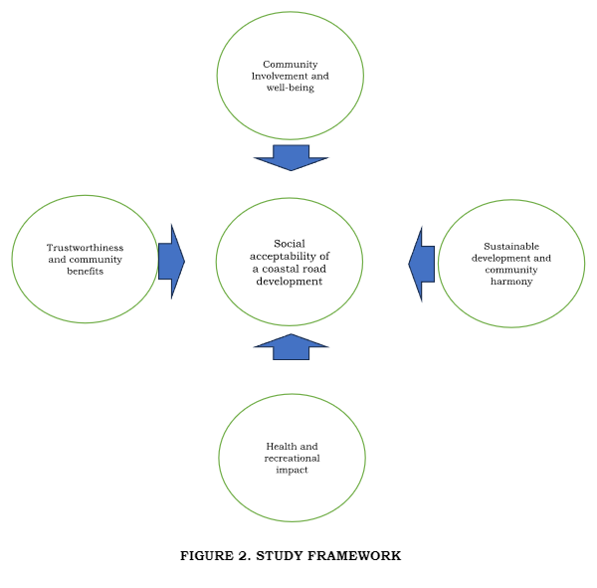

**CONCLUSION**

Based on the study's findings, four dimensions of the social acceptability of coastal road development were identified using exploratory factor analysis. These factors included community involvement and well-being, sustainable development and harmony, health and recreational impact, trustworthiness, and community benefits. This implies that the factors mentioned above could help, on a perceptual level, the community's satisfaction with the social acceptability of coastal road development. This might be achieved by considering these factors in governments' and the private sectors' existing coastal road implementation processes.

**RECOMMENDATIONS**

1. To come up with a socially accepted coastal road development approach for future coastal road development projects, the following recommendations were drawn for the project implementers:

* Community involvement and well-being in the pre-implementation or consultation phase of coastal road development projects should be considered, such as providing adequate avenues of discussion on hearing and addressing the needs of the affected communities. Another is to hear the demands of the communities and enlighten them on the project's benefits, highlighting its more significant positive than its negative impacts.
* To integrate sustainable development in the project designs and a project that considers the value of community harmony encompassing economic, cultural, and environmental considerations relative to the areas of the project concerned;
* To anticipate the adverse health effects of the project on the community and minimize them as much as possible, and to provide not just purely road infrastructure but spaces for the people to pursue health and recreation activities, improving the psycho-emotional well-being of the community.
* To maintain an attitude of trustworthiness and reliability by being transparent to the community about the project's processes and decisions that put into premium the benefits they could attain from the project, specifically in the continued protection of the coastal resources, notwithstanding the built-up structures developed to sustain and generate more livelihoods.

2. As to the validity of the observed items or variables, it is recommended that the items undergo further content validity and confirmatory tests to better enhance their reliability as a measurement of the level of social acceptability.

**REFERENCES**

Areia, N. P., Costa, P., & Tavares, A. O. (2022). Social engagement in coastal adaptation processes: Development and validation of the CoastADAPT scale. *Environmental Science & Policy*, *133*, 107–114. <https://www.sciencedirect.com/science/article/pii/S1462901122000983>

Bax, N., Novaglio, C., Maxwell, K. H., Meyers, K., McCann, J., Jennings, S., Frusher, S., Fulton, E. A., Nursey‐Bray, M., Fischer, M., Anderson, K. L., Layton, C., Emad, G. R., Alexander, K., Rousseau, Y., Lunn, Z., & Carter, C. (2021). Ocean resource use: building the coastal blue economy. *Reviews in Fish Biology and Fisheries*, *32*(1), 189–207. https://link.springer.com/article/10.1007/s11160-021-09636-0

Bax, V., Van De Lageweg, W. I., Terpstra, T., Buijs, J., De Reus, K., De Groot, F., Van Schaik, R., Habte, M., Schram, J. B., & Hoogenboom, T. (2023). The impact of coastal realignment on the availability of ecosystem services: gains, losses and trade-offs from a local community perspective. *Journal of Environmental Management*, *345*, 118675. https://www.sciencedirect.com/science/article/pii/S0301479723014639

Brunson, M., & Kruger, L. (1996, August). Defining Social Acceptability in Ecosystem Management, a Workshop Proceedings: Kelso, Washington, June 23-25, 1992 - Google Play.<https://play.google.com/books/reader?id=ujG91C9m_KgC&pg=GBS.PP6>

Evans, K. S., Noblet, C. L., Fox, E., Bell, K. P., & Kaminski, A. (2017). Public acceptance of coastal zone management efforts: The role of citizen preferences in the allocation of funds. Agricultural and Resource Economics Review, 46(2), 268–295.<https://www.cambridge.org/core/services/aop-cambridge-core/content/view/53FAB35E027D2C4F51C31C1A574DF345/S1068280517000090a.pdf/public_acceptance_of_coastal_zone_management_efforts_the_role_of_citizen_preferences_in_the_allocation_of_funds.pdf>

Fein, E. C. (2022, June 16). *Section 8.2: EFA versus CFA*. Pressbooks.<https://usq.pressbooks.pub/statisticsforresearchstudents/chapter/efa-versus-cfa/#:~:text=Sample%20size%20is%20very%20important,participants%20(Hatcher%2C%201994)>.

Floerl, O., Atalah, J., Bugnot, A. B., Chandler, M., Dafforn, K. A., Floerl, L., Zaiko, A., & Major, R. (2021). A global model to forecast coastal hardening and mitigate associated socioecological risks. *Nature Sustainability*, *4*(12), 1060–1067. https://www.nature.com/articles/s41893-021-00780-w

Goldblatt Partners LLP. (2020, October 23). *What is social acceptability and why does it matter?*<https://goldblattpartners.com/experience/publications/post/what-is-social-acceptability-and-why-does-it-matter/>

Hooper, T., Hattam, C., Edwards-Jones, A., & Beaumont, N. (2020). Public perceptions of tidal energy: Can you predict social acceptability across coastal communities in England? Marine Policy, 119, 104057. https://plymsea.ac.uk/id/eprint/8978/1/post-print.pdf

*News*. (2023a, July 1). PIA.<https://pia.gov.ph/news/2023/07/01/davao-city-coastal-road-to-act-as-a-storm-surge-barrier-promenade>

*News*. (2023b, July 6). PIA.<https://pia.gov.ph/news/2023/07/06/former-presidents-role-cited-in-realizing-davao-citys-coastal-road#:~:text=The%20Davao%20City%20Coastal%20Road%20is%20a%20bypass%20road%20network,to%20and%20from%20the%20city>.

Maghsood, F. F., Moradi, H., Berndtsson, R., Panahi, M., Daneshi, A., Hashemi, H., & Bavani, A. M. (2019). Social Acceptability of Flood Management Strategies under Climate Change Using Contingent Valuation Method (CVM). Sustainability, 11(18), 5053.<https://www.mdpi.com/2071-1050/11/18/5053>

Pana, M. a. S. (2016). Davao City Coastal Zone management Situation and recommendations. *www.academia.edu*.<https://www.academia.edu/20888210/Davao_City_Coastal_Zone_Management_Situation_and_Recommendations>

Reimann, L., Vafeidis, A. T., & Honsel, L. E. (2023). Population development as a driver of coastal risk: Current trends and future pathways. *Cambridge Prisms Coastal Futures*, *1*.<https://www.cambridge.org/core/services/aop-cambridge-core/content/view/8261D3B34F6114EA0999FAA597D5F2E2/S2754720523000033a.pdf/population-development-as-a-driver-of-coastal-risk-current-trends-and-future-pathways.pdf>

Shindler , Bruce A .; Brunson , Mark ; Stankey , George H. 2002. Social acceptability of forest conditions and management practices : a problem analysis . Gen. Tech . Rep . PNW - GTR - 537 . Portland , OR : U.S. Department of Agriculture , Forest Service , Pacific Northwest Research Station . 68 p .

*Social acceptability*. (n.d.). Gouvernement Du Québec.<https://www.quebec.ca/en/government/policies-orientations/social-acceptability#:~:text=Social%20acceptability%20is%20the%20outcome,%3A%20local%2C%20regional%20or%20national>.

Torrentira, M. (2020). Online data collection as adaptation in conducting quantitative and qualitative research during the COVID-19 pandemic. European Journal of Education Studies, 7(11). DOI:<http://dx.doi.org/10.46827/ejes.v7i11.3336>

Voyer, M., Gollan, N., Barclay, K., & Gladstone, W. E. (2015). ‘It׳s part of me’; understanding the values, images and principles of coastal users and their influence on the social acceptability of MPAs. Marine Policy, 52, 93–102. https://www.sciencedirect.com/science/article/abs/pii/S0308597X14002899

Watkins, M. W. (2018). Exploratory Factor Analysis: A Guide to Best practice. *Journal of Black Psychology*, *44*(3), 219–246. https://psycnet.apa.org/record/2018-23443-002