**E-COMMERCE WEB APPLICATION**

**R. SARAVANAN1, T. SARAVANAN2**

1Assistant Professor, Department of CSA, SCSVMV [Deemed to be University], Enathur, Kanchipuram, Tamilnadu, India.

2PG Student, Department of CSA, SCSVMV [Deemed to be University], Enathur, Kanchipuram, Tamilnadu,

India.

**ABSTRACT**

This paper presents the development of an e-commerce web application using the MERN stack, which consists of MongoDB, Express.js, React, and Node.js. The application aims to deliver a seamless online shopping experience by leveraging the full-stack JavaScript framework. Key features include user authentication, product catalog management, shopping cart functionality, and secure payment processing. The utilization of MongoDB ensures efficient data storage and retrieval, while Express.js and Node.js facilitate robust server-side operations. React enhances the user interface with dynamic and responsive components. The integration of these technologies results in a scalable, high-performance application that meets modern e-commerce requirements and provides a solid foundation for future enhancements.

**Keywords:** E-commerce, MERN Stack, Framework, Library, React.js, Node.js, Express.js, MongoDB.

**1.** **INTRODUCTION**

E-commerce, or simply electronic commerce, is the term used to describe the buying and selling of products and services via the Internet. E-commerce is a massive industry that has grown dramatically in recent years, providing more benefits and conveniences than offline businesses. The fashion of interaction between businesses and customers has also changed drastically because of the internet boom and rapid innovations and development of the logistics industry, and E-commerce has even made it possible for small businesses to commerce with customers globally. Recognizing this need, we made the decision to create an E commerce web application as our project. This project is implemented using the MERN Stack. MERN Stack is an open-source JavaScript-based stack that is used for building dynamic web applications more quickly and easily. It is a combination of modern technologies for building high-end online apps. MERN Stack is a package of MongoDB, Express, React and Node.

**2.PROBLEM STATEMENT**

The purpose of this project is to makes a web application which will be easier to find interesting clothes and easier to sell goods. This E-commerce web application admin can add products, which will by attracting customers. Customers also can easily search for their favorite goods. They can also buy them easily by just adding to the cart and they can decrease by clicking on the "x" sign. After adding they can check the total amount of the thing which have been added to the cart. A successful payment gateway way enabled so payment can be done by debit card, credit card, and net banking.

**3. E-COMMERCE**

E-commerce, also known as E-comm, EC for short, is a concept concerning transactions, buying and selling of goods and services via the internet. E-commerce first surfaced in the 1960s. E-commerce gained popularity after the introduction of devices like laptops and mobile phones, and social media progressively ensured the strength and expansion of web-based apps. Launchers encourage the quick growth of commerce (especially online commerce). The internet is what drives e-commerce. Customers use their own devices to access a website or mobile app to browse the products and place orders for products or services.

Types of E-commerce:

1) B2B (Business to Business): Business-to-business electronic commerce, or B2B, refers to the online buying and selling of goods and services between corporations. B2B commerce is different from B2C commerce, which is business-to-consumer online sales of products or services to consumers.

2) B2C (Business to Consumer): Business-to-consumer (B2C) e-commerce also known as retail e commerce, refers to the business model that involves the act of selling products and services directly to the consumers. Most of the enterprises that conduct business directly with consumers are referred to as B2C companies.

3) C2C (Consumer-to-Consumer): This is a reference to an interpersonal commercial transaction. Without any use of middlemen, individuals can sell goods, supplies, and services through the marketplaces that are specifically built for that purpose.

4) C2B (Consumer-to-Business): An exact polar opposite of a C2B model is a B2C model. In contrast to the B2C model, which is handled by a business on behalf of the customer, the C2B model allows end users to offer their products and services to businesses. The approach is regularly employed in crowdsourcing based projects, the kinds of which frequently entail the production of logos, the sale of royalty-free photos, media, design elements, etc.

**4. METHODOLOGY USED**

A) MERN STACK: The MERN stack is a collection of four different technologies that work together to create dynamic web applications and websites. We have used MERN Stack as our main full-stack technology in the development of the project application.

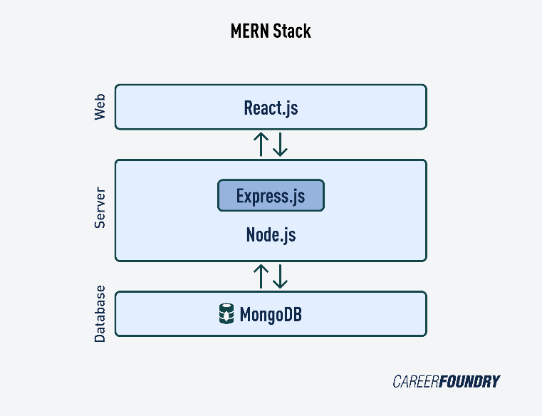

**Figure 1:** MERN stack methodology

The following are the components of the MERN stack:

1. MONGODB: The MERN stack utilizes the database known as MongoDB. It is a NoSQL document-oriented database with a flexible schema and a query language based on JSON. There is no prescribed schema that must be complied with when storing an object in a MongoDB database. It's not necessary for every document in a collection to have the same set of fields. As a result, you don't need to add or rename columns in the schema, particularly for the early phases of development. MongoDB is a document-oriented database. A document or object is a unit of storage (which is comparable to a row), while many documents are stored in collections (which is comparable to a table). Each document in a collection has a special identification that can be used to access it.
2. EXPRESS.JS: Express.js is a framework that's built in conjunction with Nodejs. Express is an open-source server format that is created altogether in JavaScript. It has great features for building web-based applications and mobile applications. Additionally, Express.js supports HTTP and middleware methods, giving the API an incredible amount of power and making it simple to use. A framework based on Node.js is Express.js. Instead of slowing down NodeJS, Express implements extra features that developers can use and have a better development environment. Importantly, the well-known frameworks of NodeJS like Sails.js and MEAN include Express.js as a core component.
3. REACT.JS: ReactJS is an open-source client-side JavaScript library that is declarative and flexible in nature and is used for creating reusable UI components. It is a component-based front-end library that mainly handles the application's view layer. Facebook created it and now maintains it with a group of developers and companies. Each React web application is made up of reusable components that make up various user interface elements.
4. NODE.JS: Node.js open-source cross-platform server environment. It is a JavaScript runtime environment that is used for carrying out and implementing scalable JavaScript applications that are being used for building networking and server-side JavaScript applications. It is one of the most powerful cross platform runtime environments that helps developers to build scalable web servers and web clients. NodeJS is a runtime environment developed on Google Chrome’s V8 engine for creating fast and scalable network web-based applications, and because of it, its execution time is very quick, and it runs very swiftly.

**B) ARCHITECTURE DIAGRAM**

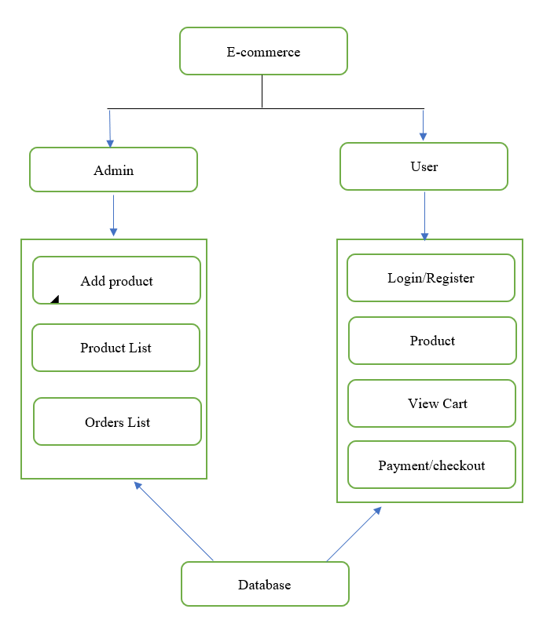

**Figure 2:** Architecture diagram

**5. ADVANTAGES**

1)Market at the global scale with a huge customer base.

2) Saves customer time.

3) Easy to maintain and scale up.

4) A wide variety of products.

5) Accessible anywhere at any time.

6) Precise and targeted marketing.

**6. RESULTS**

**1)User**

A) Home page

The project Homepage consists of the products popular in women and new collections which are newly added to the database by the admin. User can switch to the preferred category by using navbar section.

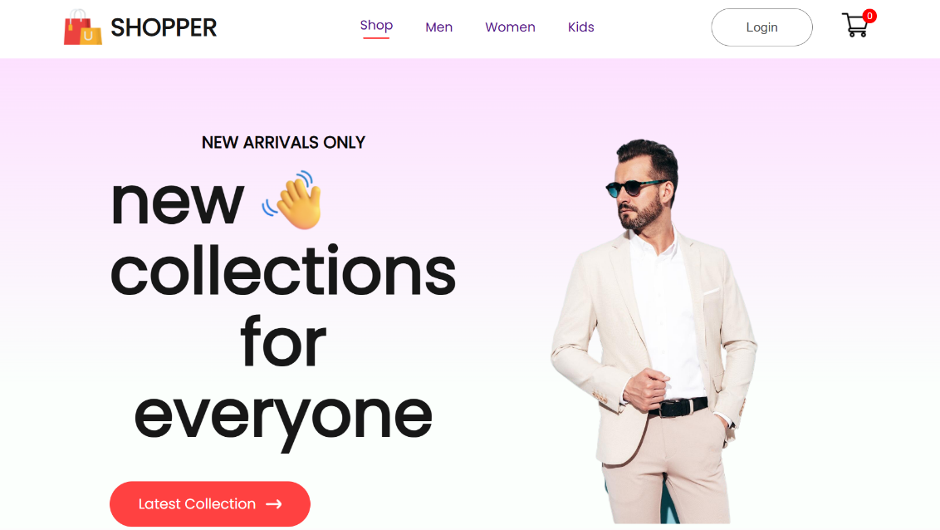

**Figure 3:** Home page

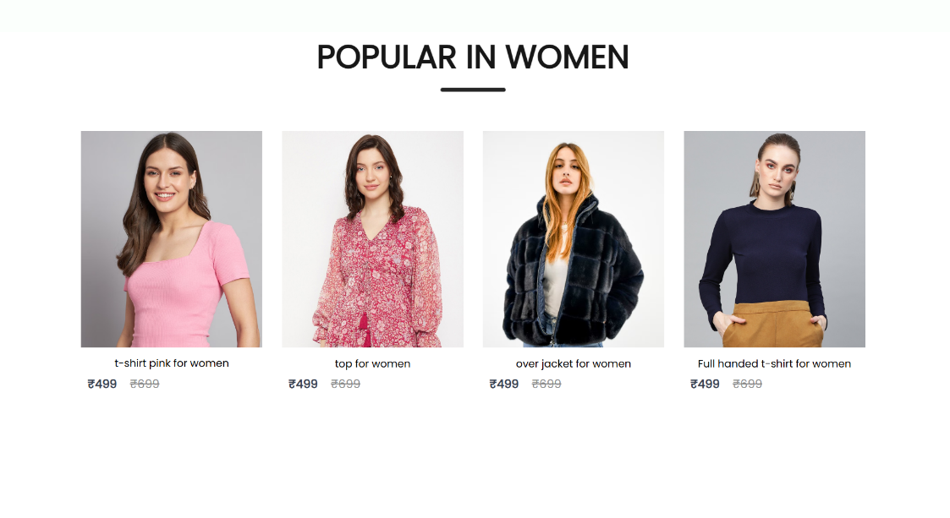

**Figure 4:** Popular in women products

B) Signup page

The project signup page is where users can sign up and create their account in web application.

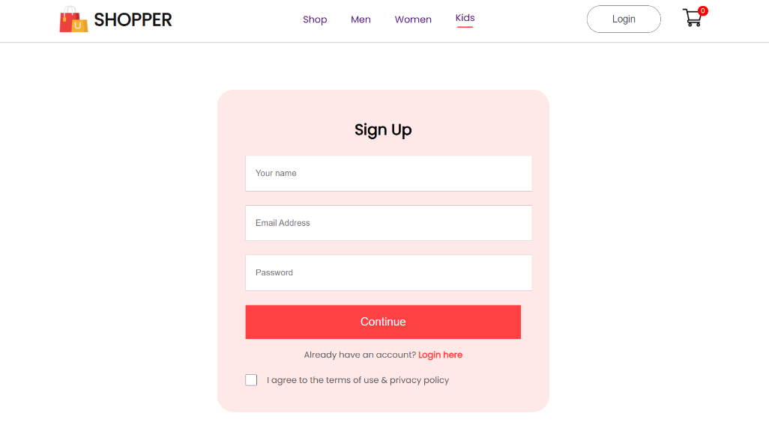

**Figure 5:** Sign up page

C) Cart Page

In this page user can view the items in the cart and they can proceed to payment and checkout.

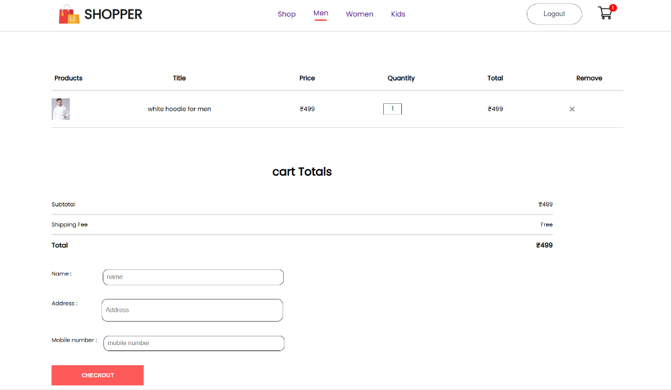

**Figure 6:** Cart page

**2)Admin**

A) Add product page

In this page, Admin can add a new product in the database.

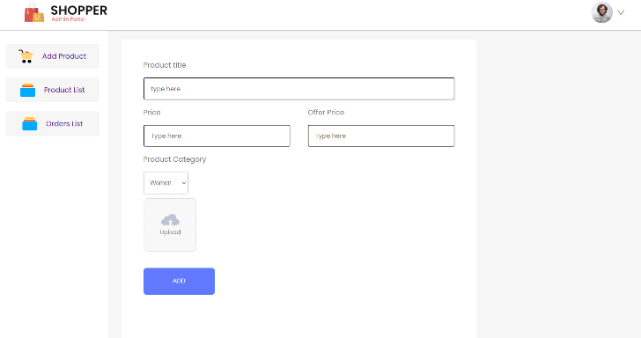

**Figure 7: Add** product page

B) Product List

In this page, Admin can able to view all products available in the database.

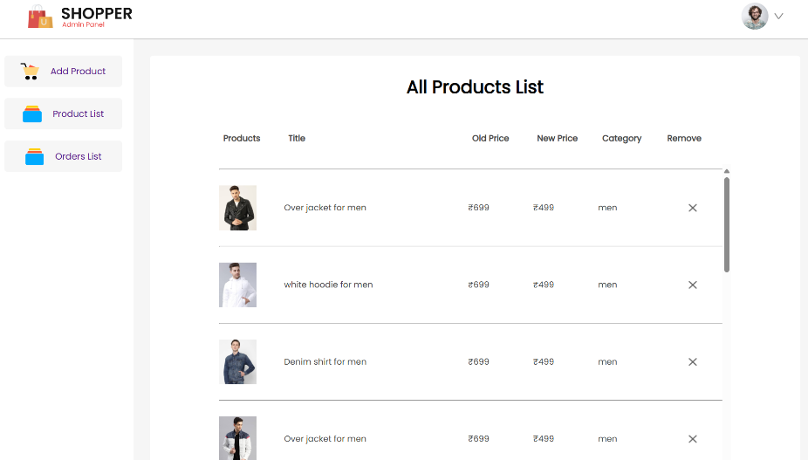

**Figure 8:** All product list

C) Order List

In this page, Admin can view all the placed orders.

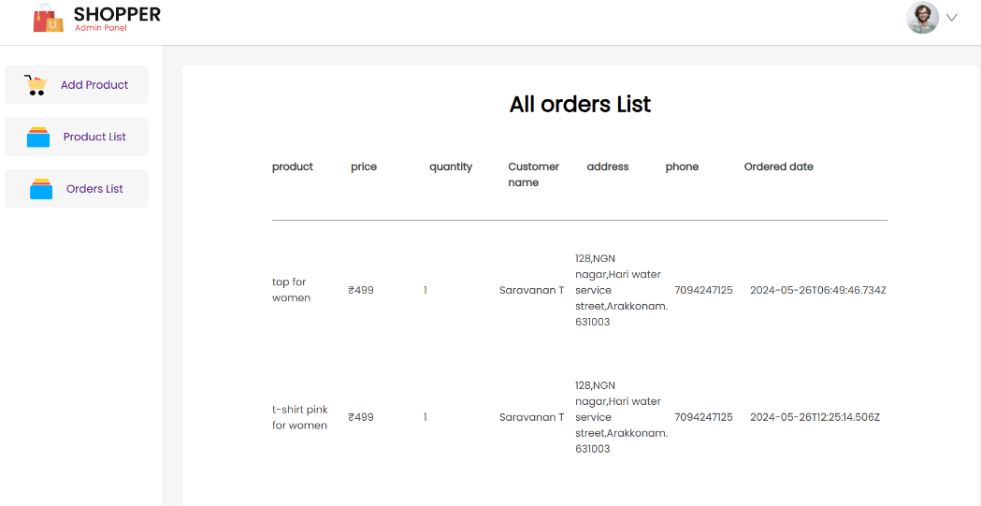

**Figure 9:** All orders list

**7. CONCLUSION**

In conclusion, the development and deployment of our e-commerce web application mark a significant milestone in our journey toward enhancing the digital shopping experience. By integrating user-friendly interfaces, robust security measures, and efficient backend processes, we have created a platform that not only meets but exceeds user expectations. This project exemplifies our dedication to leveraging technology to provide seamless, secure, and enjoyable shopping experiences for our customers.

**REFERENCES**

1. Nagothu Diwakar Naidu., Pentapati Adarsh., Sabharinadh Reddy., Gumpula Raju., Uppu Sai Kiran & Vikash Sharma. E-Commerce web Application by using MERN Technology. International Journal for Modern Trends in Science and Technology 7, 1–5 (2021).
2. Mai, N. (2020). E-commerce Application using MERN stack.
3. King,D.N.,&D.N.(2004).Introduction to e-commerce.Prentice Hall.
4. Hoque, S. (2020). Full-Stack React Projects: Learn MERN stack development by building modern web apps using MongoDB, Express, React, and Node. js. Packt Publishing Ltd.