**FORMULATION AND EVALUTION OF HERBAL HAND WASH BY USING NATURAL INGREDIENTS BY SIMPLE METHOD**

**Aniket G. Karodade1, Sunil S. Bhagat2, Dr. Swati P. Deshmukh3**

1Student, Shraddha Institute of Pharmacy, Kondala Zambre, Washim-444505

2Assistant Professor, Department of Industrial Pharmacy, Shraddha Institute of Pharmacy, Washim-444505

3Principal, Shraddha Institute of Pharmacy, Department of Pharmacology, Kondala Zambre, Washim-444505

**Address of Correspondence,**

Aniket Ganesh Karodade,

Shraddha Institute of Pharmacy,

Kondala Zambre, Washim - 444505.

Mob. No.: +919021248803

Email Id: [aniketkarodade123@gmail.com](mailto:aniketkarodade123@gmail.com)

**ABSTRACT:**

The primary objective of this study is to develop and assess a poly-herbal hand wash formulation incorporating aloe vera and lemon juice. The aim is to create a hand wash product with minimal side effects while ensuring effective hand cleansing. Given that hands are primary sites for microbial infections, particularly in children and employees within pharmaceutical industries, the importance of hand hygiene cannot be overstated. Therefore, the formulation of an efficient hand wash solution becomes imperative.The formulated hand wash was designed to meet stringent criteria, focusing on both safety and efficacy. By utilizing natural ingredients such as aloe vera and lemon juice, known for their antimicrobial and cleansing properties, the formulation aims to provide thorough cleaning while minimizing the risk of adverse effects. The inclusion of these herbal extracts not only enhances the cleansing action but also offers potential benefits for skin health.The evaluation of the prepared hand wash involved various parameters to ensure its quality and effectiveness. These parameters include color, odor, pH level, viscosity, and stability. By assessing these factors, the researchers aimed to determine the overall suitability and performance of the hand wash product. Favorable results in these parameters indicate that the formulated hand wash meets the desired standards for use as an antiseptic hand wash solution.In conclusion, the development and evaluation of the poly-herbal hand wash formulation represent a significant step towards promoting hand hygiene and reducing the risk of microbial infections. By leveraging the benefits of natural ingredients and thorough evaluation, this hand wash offers a safe and effective solution for maintaining hand cleanliness in both domestic and industrial settings.

**KEYWORDS:** - herbal hand wash, tulsi, vitamin c, Aloe Vera, citrus Lemon, essential oil.

**INTRODUCTION:**

Every year, approximately 525,000 children succumb to diarrheal diseases, primarily due to inadequate hand hygiene practices. This alarming statistic underscores the critical importance of maintaining proper hygiene to prevent the spread of diseases. Establishing simple yet healthy habits can save countless lives, with hand-washing playing a pivotal role in maintaining good health. Failure to wash hands increases the risk of bacterial or viral infections, especially when individuals inadvertently touch their eyes, mouth, or consume food with unwashed hands. The ingestion of germs from unwashed hands can lead to severe infections, highlighting the direct correlation between hand hygiene and overall health.

Hand hygiene entails the practice of washing hands with water and soap, a simple yet powerful preventive measure against various infections, including influenza and COVID-19. The World Health Organization (WHO) recommends washing hands for at least 20 seconds before and after specific activities to effectively mitigate the spread of infections. Amidst the proliferation of chemical-based treatments, herbal medicine, also known as botanical or phytomedicine offers a time-tested alternative rooted in Ayurveda, an ancient Indian tradition.

Ayurvedic herbs, derived from plant roots, seeds, flowers, bark, and leaves, have been utilized for thousands of years, boasting a legacy of safety and efficacy. In contrast to synthetic chemicals, herbal medicines harness the healing properties of nature without causing harm. The popularity of herbal products is on the rise, with a significant percentage of adults in both the United States and India opting for herbal remedies.

Recognizing the growing demand for natural solutions, we have embarked on the development of an herbal hand wash for our school project. Our herbal hand wash is crafted with pure, hygienic, and plant-based ingredients, ensuring safety and efficacy while upholding the principles of Ayurveda. By leveraging the wealth of botanical knowledge accumulated over centuries, we aim to offer a holistic approach to hand hygiene, promoting health and well-being without compromising on safety.

The herbal medicine is also known as botanical treatment or phyto-Medicine. Herbal medication refers to the uses of any plant seeds, root, leaves, bark, flower And aerial part for medicinal purpose. Herbal medicine has been the treatment and care of numerous diseases. Skin being the most exposed part of our body requires protection from Skin pathogen. To defend the skin from harmful micro-organism to avoid spreading Disease. Hand washing is extremely significant precautions. Hand hygiene is the single most important simplest and least expensive mean of preventing nosocomial Infection. Hand washing is main purpose of cleaning hands with removing Soil, dirt, pathogenic microorganisms and avoid transmitting of transient microorganisms.

Hygiene is basically defined as the branch of science which is involved in knowledge and Practice related to promotion of health. The concept highlights the need of maintaining Hygiene in prevention of disease. Spread of infection (bacterial or viral) can be prevented Hygiene practices. An herbal drug treatment gives healthy life. It was general used to fournish first line and common health provider. Since ancient time in India herbal medicine has been the basis of treatment and cure for various diseases. Herbal medicine having various therapeutic uses like healing, wound, treating inflammation due to infection, skin leprosy, diarrhea, scabies venereal disease like, snake bite and ulcer. Plant have Provided good source of antimicrobial activity and plant extract have potential as antimicrobial compound against several pathogenic microorganisms which cause Infections disease and resistance toward synthetic drug Conventional dosage forms are pioneer of drug administration systems. The most widely used and accepted is the oral route of drug administrations. The oral dosage forms are widely used for ease of self-administration and low cost as compared to other dosage forms.

It is however associated with some drawbacks such as dysphasia (difficulty in swallowing), low bioavailability and delayed onset of action. In order to overcome these issues researchers have long explored the “oral cavity” to harness its drawback to enhance the drug’s permeability as well as bio avail-ability. The “oral cavity” has a good permeability because of mucosal lining being relatively less keratinized in the buckle mucosa. Drug absorbed via “oral cavity” directly enters into systemic circulation by a jugular vein ensuring, a rapid onset of action, avoidance of first pass metabolism, and drug degradation in gastric region and enzymatic hydrolysis in intestine. Keeping in mind the advantages of the “oral cavity”, an Oral Dispersible Tablet, commonly known as the Fast Dissolving Tablets are a widely accepted formulations. According to European pharmacopoeia “ODT (Oral Dispersible Tablet) should disperse or disintegrate in less than 3 minute when placed on tongue. Fast dissolving drug delivery system (FDDDS) is a newer concept which combines the advantages of both liquid and solid formulations and at the same time, offer advantages over the traditional dosage forms.

**Advantages of herbal cosmetic:**

Herbal cosmetic have been using for beauty from the ancient times.it is considered best for the skin and hair care because of their lack of side effects. It is gaining the popular day by day in the world. Following are the some advantages of using Natural cosmetics.

* **Safe to use:** Compared to the beauty products Natural cosmetic are safe to use.yhey are hypoallergenic, and tested and proven by dermatologist to be safe to use anytime.
* **No side effects:** The synthetic beauty product cab irritates skin and cause pimples they might block skin pores and make skin dry or oily. The natural ingredients are used assure to no side effects.
* **Animal testing not required:** Some cosmetic are initially tested on animal to ensure that they are safe and effective to use for human. However, natural cosmetic need not be tested on animal. These natural formulation are tested by experts in laboratories using are equipment with no animal involved.
* **Natural products:** The name itself suggests that herbal cosmetic are natural and free from synthetic chemicals, which otherwise may prove to be toxic to the skin. Instead of traditional synthetic products, different plants extract are used in these products. Egg. Aloe-Vera gel and coconut oil.
* **Inexpensive:** Natural cosmetic are not that expensive. In fact, some of these products are more affordable than synthetic ones. An estimates of demonstrated about 80% of world population depends upon natural products for their health care.
* **Compatible with skin type:** Natural products are suitable for all skin type, whether it is dark or fair .natural cosmetic like foundation, eye shadow and lipstick can be safely used irrespective of the skin tone.

**Advantages of Herbal Hand wash:-**

* No side effects.
* Bacteria on our hands can be minimized.
* It also helps to clear antiseptic a fungal problem faced by the skin.
* It also helps to remove dirt and oil effectively from the skin.
* Easier access compared to using soap and water.
* The easiest way to get rid of microorganism.
* Hand wash prevent germs from entering into our body.

**Drug/ plant profile**

**Tulsi (*Ocimum sanctum*)**

**Scientific classification of tulsi:**

1. Kingdom : plantae
2. Division : magnoliophyta
3. Class : Magnoliopsida
4. Order : Lameness
5. Genus: : Ocimum
6. Species : O.tonuiflorum
7. Bionomical name : ocimum tenuifloram/Ocimum sanctum
8. Nepali name : Tulsi

*Ocimum sanctum* commonly known as holy basil or Tulsi. Tulsi consist of fresh and dried leaves of *ocimum sanctum* belonging to family Lamiaceae. Tulsi is an aromatic perennial plant.tulsi known for its detoxifying purifying and antimicrobial properties. Tulsi helps to protect your hands by killing 99.99%of germs. Tulsi now days cultivated commercially for its volatile oil.it is much branched small herb 30 to 75cm in height. All parts of tulsi are used in medicine especially fresh and dried leaves.leaves is ablong acute with entire sterolate margins pubscent on both sides and minutely gland dotted. The leaves are green in colour with aromatic flavors and slightly compressed. Seeds are reddish black and subglobose. The leaf is dorsiventral stomach are of bicyclic type. Particularly abundant on lower surface.

**Chemical constituents:** It contains approximately 70%Eugenia, carvacrol 3% and Eugene methyl ether. It also contains caryophyllin, seeds contain fixed oil with good drying properties. The plant also contain alkaloids, glycosides, sapping, tannins an appreciable amount of vitamin c and traces of maleic and Tartaric acids. the fresh leaves,it’s juice and volatile oil are used for various purposes.

**Uses of Tulsi:** The leaves are used as stimulants, aromatic, spasmolytic, diaphoretic The juice is used as an antiperiodic and act as constituents of several preparation for skin disease and also to cure earache.it acts as a natural Immunity booster, it also acts as antifungal, antiviral agent.

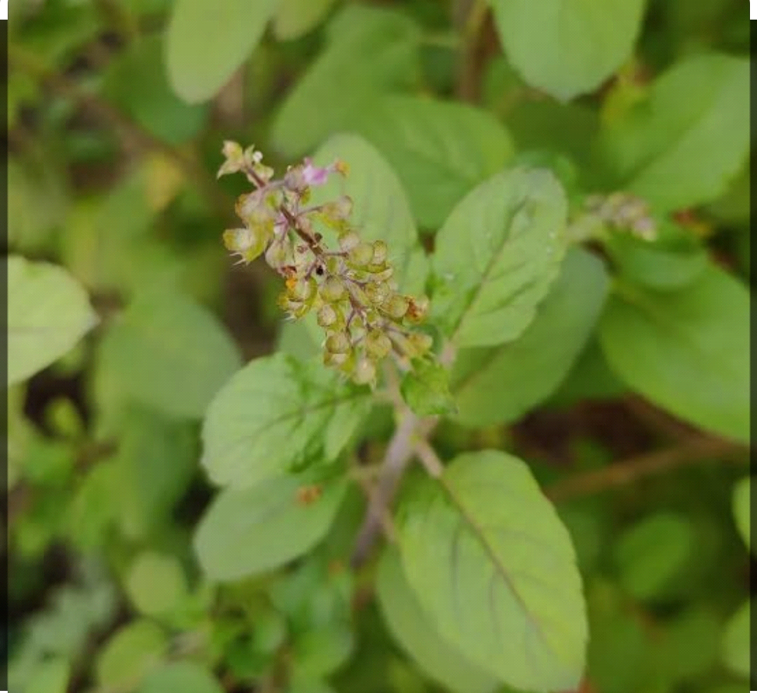

**Fig. 1: Tulsi**

**Aloe Vera:**

**Scientific classification of aloe-vera:-**

1. Kingdom : plantae
2. Order : Aspargels
3. Family : Xanthorrhoeaceae
4. Genus : Aloe
5. Species : A.Vera
6. Bionomical name : Aloe vera

Aloevera is a succulent plant Species that probably originated in northern Africa. The species does not have any naturally occurring population, although closely related Aloe does not occur in northern Africa.The Species is frequently cited as being used in herbal medicine since the beginning of the first century. Extract from the Aloe vera widely used in cosmetic and alternative medicine industries, being marketed as variously having regenerating, healing or smoothing properties.

Aloe is the dried juice collected by incision from the basis of the leaves of various Species of aloe. Aloe Perry Baker, aloevera linn,or Aloe barbandesis belonging to family liliaceae,Aloe perry Baker is found in socotra and zanzibar Islands and in their neighbouring areas and so the obtain from these Species is known as soothing and zanzibar. Aloevera linn also known as vulgaris or Aloe barbendesis. Aloe is an perennial growing to 0.8by 1ml ata slow rate. The plant prefers light (sandy)and medium soil. Can grow nutritionally poor soil. The plant prefers acid basic and neutral soil. It cannot grow in shade it requires dry or moist soil and can tolerate drought. They are xenophobic plant .it can be propagated by seed. Seeds are shown in the spring in warm green house.

**Chemical constituents:** The most important constituents of aloevera are three isomers of Aloins ,barbaloins and isobarbaloins which constitute so called crystalline along.present in drug at from 10-30% other constituents are amorphous aloin,resin,eroding and Aloe emodin. Barbaloins is present in all the varieties.it is slightly yellow colour,bitter water soluble isobarbaloin is a crystalline substance present in curaco Aloe and in trace amounts in cape Aloe and in absent in socotrine and zanzibar Aloe.The chief constituents of socotrine Aloe and zanzibar Aloe is barbaloin.

Aloevera has been Recommended for skin care in number of ways:-

1. Relieves the burned skin caused by skin.
2. Smooth and glowing skin can be achieved with the help of Aloe.
3. It is an outstanding skin moisturizer.
4. Helps in restoring skin natural beauty.it provide oxygen to the cells which strengthen the skin tissues and help to keep the skin healthy.
5. It is beneficial for dry skin when the aim is get normal, Smooth and shiny skin with the oil extract of the plant.
6. Aloe Vera extracts have antibacterial and antifungal activities, which may help in the treatment of minor skin infections.
7. It is helpful in the curing blister, insects bites and any allergic reactions, eczema, burns, inflammation, wounds, psoriasis.

A large number of aloe Vera based cosmetics products are available commercial that claim for natural skin care based on the healing and soothing properties of aloe Vera and also are useful for natural skin care based on the healing and soothing properties of aloe Vera and also used for eczema, psoriasis, dermatitis, acne and pigmentation. Aloe Vera is a rich source of antioxidants and vitamins that helps to protect skin.

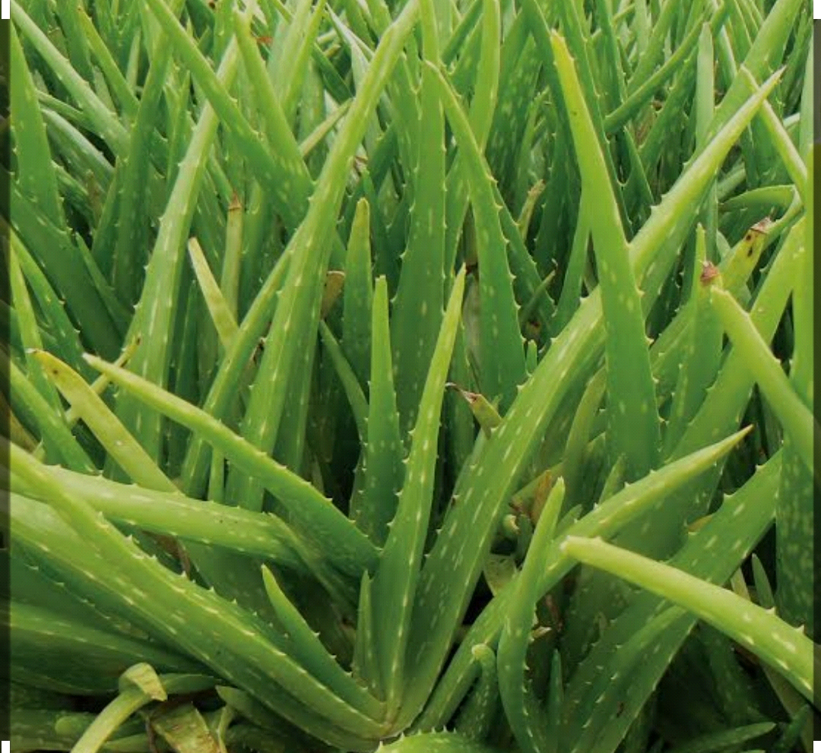

**Fig. 2: Aloe Vera**

**Citrus Lemon:**

**Scientific classification of Citrus lemon:**

1. Kingdom : plantae
2. Family : Rutaceae
3. Order : sapindales
4. Genus : citrus
5. Species: citrus. lemon

The Limon citrus Limon is a species of small evergreen tree in the flowering plant Family Rutaceae native to South Asia, primarily eastern India.

The tree ellipsoidal yellow fruit is used for colinary and non-culinary purposes throughout the world primarily for its juice, which has both colinary and cleaning uses. The pulp and hind are also used in cooking and baking. The juice of the lemon is about 5% to 6%.citric acid with a pH of around 2.2 giving it a sour taste. The distinctive sour taste of lemon juice makes it a key ingredient in drink and foods such as lemon meringue pie.

It is obtained from the ripe or nearly ripe fruit of citrus Limon belonging to the family rutaceae. The main raw material of citrus Limon is the fruit particularly essential oil and juice is obtained from it . Citrus Limon fruit juice has traditionally been used as a remedy for survey before the discovery of vitamin c.

**Characteristics:** Citrus Limon is a tree reaching 2.5-3 m in height. It has evergreen lanceolate leaves. Bisexual flower are white with purple color at the axils. The fruit is elongated oral, pointed green berry that turns yellow during ripening. Inside the berry is filled with a juicy pulp divided into segment.

**Chemical constituents:** The chemical constituents of citrus fruit is well known. It has nat only determined for the whole fruit but also separately from the whole fruit but also separately from the pericarp, juice and essential oils

**Uses of citrus Lemon:-** The antioxidants activities of flavonoids from citrus Limon-heseperidin and hesepertin was not only limited to their radical scavenging activity but also arguments the antioxidants cellular defence .Limon fruit have shown inhibitory activity against the gram positive bacteria entrrococus feacalis and bacillus substitute and gram negative shigel lasonnei. The oil used in pharmacy and cosmetic formulation as flavour or aroma Corrigan as well as natural preservative, due to its confirmed antibacterial and fungistatic effects.

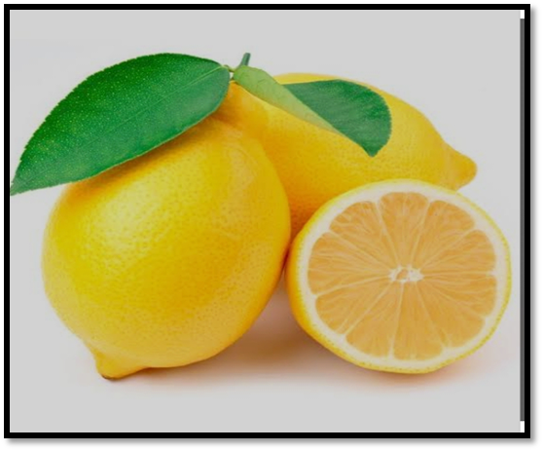

**Fig. 3: Citrus Limon**

**Sapindus Mukorosis:**

Sapindus mukorosis commonly known as Indian soapberry, washout, or Rita.it is a species of tree in the family sapndaceae.it is a deciduous tree that grows in the lower foothills and mid hills of the Himalayas at altitude of up to 1200 meters. Sapindus is a Genus of about five to twelve species of shrubs and small trees in the lychee family, sapindaceae,

negative to warm temperatures to tropical region of the world. The Genus includes both deciduous and evergreen species. Member of the Genus are commonly known as soapberries or soap nuts because the fruit pulp is used to make soap.The generic name is derived from the Latin words, soap meaning soap and indicus meaning of India .

**Scientific classification:**

1. Kingdom : plantae
2. Class : Angiosperms
3. Order : sapindales
4. Family : sapindaceae
5. Subfamily : sapindoideae
6. Genus : sapindus

**Uses:** The drapes (soapnuts)contains saponins,which have surfactants properties, having been used for washing by ancient Asian and American people. A number of others uses for sapindus have also been reported such as making arrows from the wood and decorative objects from the seeds.leaf and fruit extract of sapindus have historically been used in folk remedies to treat various conditions.

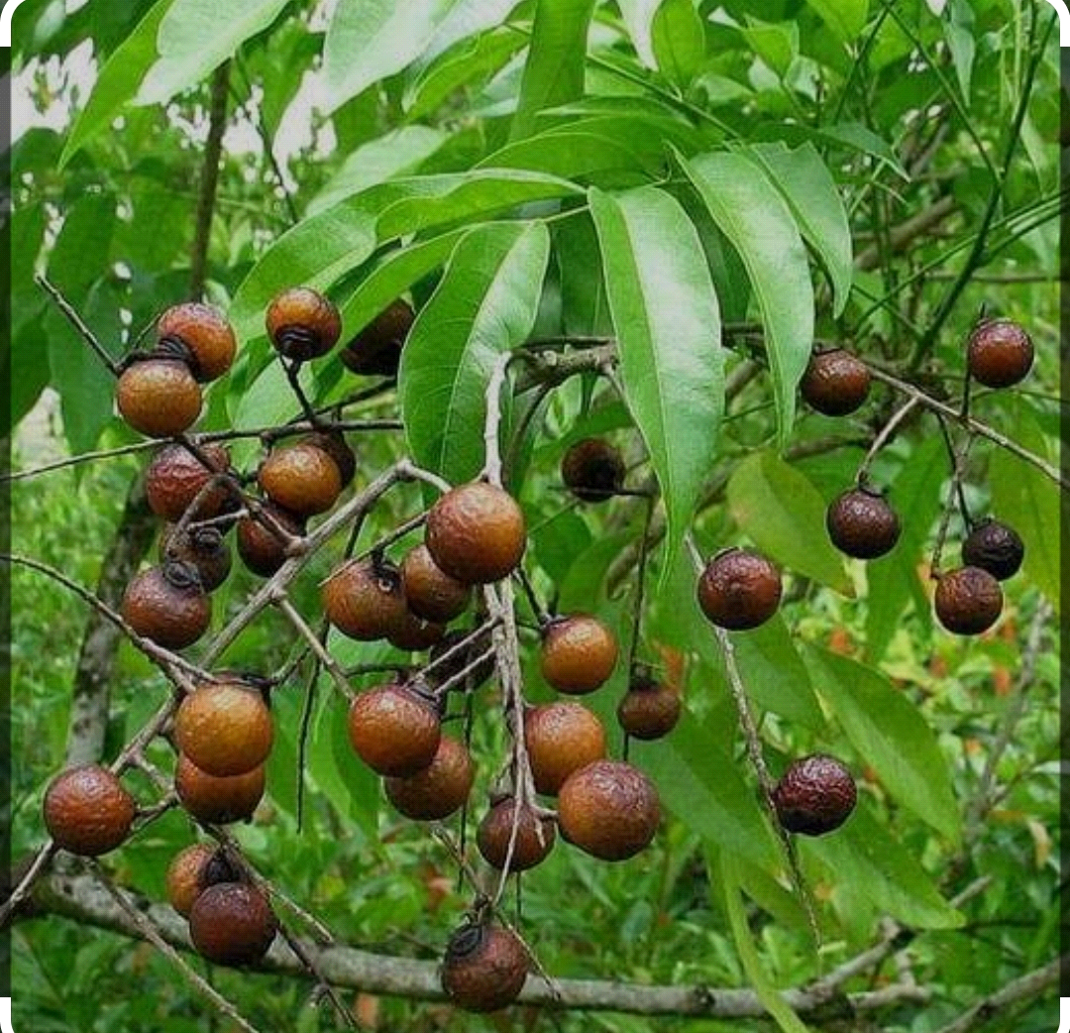

**Fig. 4: Sapindus Mukorosis**

**Eucalyptus oil:**

Eucalyptus oil is the essential oil obtained from by the distillation of fresh leaves of Eucalyptus globular and other species of like eucalyptus Smith belonging to the family myrtaceae. Eucalyptus globular has been used since a long time for intermittent fever. The leaves and their preparation have been successfully used as tonic, stimulant, stomach in dyspepsia in typhoid, fever in asthma, in whooping cough etc. More recently it has been recommended as a diuretic in the treatment of dropsy.

**Characteristics:** Eucalyptus is a tall evergreen tree the trunk, which grows to 300 feet high or more is covered with peeling papery bark. The leaves on the young plant. Up to five years old are opposite, sensible, soft, oblong, pointed and blue color. The mature leaves are alternate, petioled, leathery, and shaped like a scimitar, the flowers are solitary and white without any petal. Eucalyptus oil is colorless or straw colored fluid, with characteristics odour and taste soluble in its own weight of alcohol.

According to British pharmacopeia Eucalyptus oil should contain not less than 55%by volume of eucalyptus,have specific gravity 0.910 to 0.930. Eucalyptus leaf is isobilateral stomach are of anomocytic type and shrunken on both surface.epidermal cell are three to four layer of elongated palisade cells below each epidermis between these palisade region,two or three layer of spongy parnchyma occurs and some of its cells contain cluster and prismatic calcium oxalate crystal.

**Chemical constituents:** Eucalyptus oil contains volatile oil of which 78-85% is 1-8 cineole also known as eukalyptol. The other constituents present are p-cymene, alpha pinene, small quantity of sesquiterpenes like,lemon, aromadendrene, aldehyde, ketone and alcohols .it also has polypenolic acids like ferulic acids, caffeic acids ,gallic acids, flavonoids such as eucalyptus, hyperopia and rutine.

**Uses:** The oil is used as stimulants, antiseptic, flavoring agent, aromatic deodorant and antispasmodic. It also used in the treatment of lung disease, sore throat, cold as a vapor bath for asthma and various respiratory ailments and in bronchitis. A 50% ehanolic extract of eucalyptus globular leaves yielded eight phloroglucinol sesquiterpenes couple constituents, including three novel compounds named macrocarpals.

It has decided disinfectant action destroying the lower form of life .Eucalyptus oil also used in air fresheners. Most of the Eucalyptus oil are in aroma lamp. Electric room diffuser and spray mist.to make simple mist spray dilute 50-100 drop or 50 of essentials oils in 4 fluid (120ml) of pure water spray to refresh and cleanse the air, phloroglucinol monoterpine derivative, eugobal was obtained from the leaves of Eucalyptusgrandis as an active constituents inhibited the promotion stages on two stages carcinogenesis induced by both TPA type and non TPA promoter and inhibited the pulmonary tumorigenesis induced by 4NQO and glycerol. Therefore Eucalyptus globuls might be valuable as chemoprotective agent in chemical carcinogenesis eucaluptus globulus leaves were found to be potent against cute quinquefascatus and culxetrianiorhynchus. Terpinol,volatile terpenol alcohol of low toxicity, widely used in perfume industry. It is important constituents of essentials oil of many plants with widespread applications in folk medicine and aromatherapy.

**MATERIAL & METHODS:**

**Materials:**

The formulation comprises various materials, each serving a specific function to create an effective herbal hand wash. Tulsi extract is incorporated as an antimicrobial agent, providing protection against harmful microorganisms. Citrus lemon, or lemon juice, acts as an antiseptic, further enhancing the hand wash's germ-fighting properties. Aloe vera gel is included for its healing properties, soothing and nourishing the skin. Sapindus mukorosis serves as a foaming agent, facilitating lathering and cleansing. Eucalyptus oil not only contributes to foaming but also imparts a cooling sensation, refreshing the hands during use. Glycerin is added as a moisturizing agent, preventing dryness and maintaining skin hydration. Methyl-paraben serves as a preservative, extending the shelf life of the hand wash. Finally, water is included as the solvent, providing the necessary fluidity and consistency to the formulation. Together, these materials synergistically combine to create a herbal hand wash that effectively cleanses, protects, and nourishes the hands while maintaining optimal hygiene.

**Methods**

The extraction method for Tulsi involves the following steps:

**Preparation of Tulsi Leaves:**

Tulsi leaves are carefully separated from the plant and washed thoroughly with water to remove any dirt or impurities. After washing, the leaves are dried properly and then separated for further processing.

**Preparation of Methanolic Extract:**

A methanolic extract is prepared from the dried Tulsi leaves. Approximately 20 grams of finely powdered Tulsi leaves are mixed with 80 ml of methanol in a container. The mixture is allowed to macerate for a period of 4 to 6 days, during which the bioactive compounds from the Tulsi leaves are extracted into the methanol. After maceration, the alcoholic decoction is filtered to remove any solid particles, resulting in a clear filtrate containing the methanolic extract of Tulsi.

**Method for formulation of herbal hand wash:**

The process for preparing the herbal hand wash using Tulsi extract is outlined as follows:

* The methanolic extract of Tulsi leaves is combined with 4 ml of Citrus Limon juice in 20 ml of water. This initial mixture sets the foundation for the herbal hand wash.
* Aloe Vera juice is added twice to the mixture to enhance its healing properties. Additionally, the extract of Sapindus Mukorosis is introduced to provide sufficient foaming capacity, ensuring effective cleansing.
* The desired quantity of glycerine is then added to the mixture, followed by the incorporation of eucalyptus oil. These ingredients contribute to moisturizing the skin and imparting a refreshing scent, respectively. Moderate stirring ensures uniform distribution.
* To prolong the shelf-life and prevent microbial growth, a sufficient quantity of preservative is added to the mixture, ensuring the longevity and safety of the hand wash.
* A small amount of food-grade coloring agent is added to impart an appealing color to the hand wash, enhancing its aesthetic appeal.
* The solution is thoroughly mixed to achieve homogeneity under room temperature conditions. Once homogenized, the herbal hand wash is ready for further screening of its activity, ensuring its effectiveness in promoting hand hygiene and overall well-being.

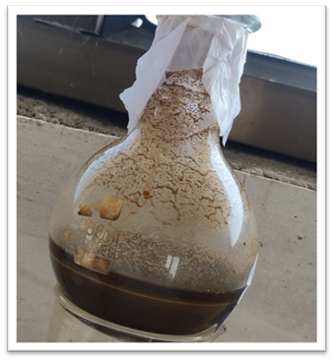

**Fig. 5: Extraction of Tulsi**

**Table 1: Formulation table of herbal hand wash**

|  |  |  |
| --- | --- | --- |
| **Ingredient** | **Quantity** | **Action** |
| Tulsi extract | 8ml | Antimicrobial agent |
| Citrus limon/juice | 4ml | Antiseptic |
| Aloe-vera gel | 6ml | Healing agent |
| Sapindus mukorosis | 7ml | Foaming agent |
| Eucalyptus oil | 0.5ml | Cooling agent |
| Glycerin | 12ml | Moisturizing agent |
| Methylparaban | 0.3ml | Preservative |
| Up to 60ml | Up to 60ml | **-** |

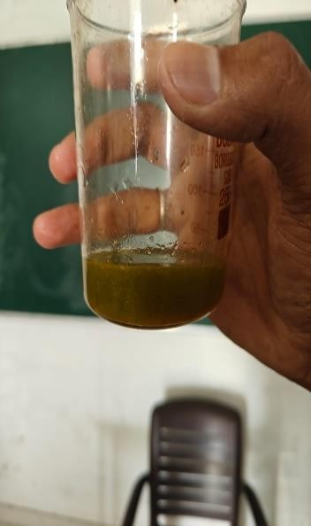**Fig. 6: Final Formulation Hand Wash**

**EVALUATION PARAMETER OF HERBAL HAND WASH**

The evaluation of the prepared formulation of herbal hand wash was conducted based on the following assessment criteria:

**Organoleptic Assessment:**

This involved evaluating the texture, color, and appearance of the hand wash. Visual and tactile perceptions were utilized to assess the color and texture, ensuring that the hand wash met the desired sensory qualities.

**Appearance:**

The homogeneity and grittiness of the hand wash were evaluated visually. A small amount of hand wash was taken on the fingertips and rubbed between two fingertips to check for any grittiness, ensuring a smooth and uniform texture.

**pH Measurement:**

The pH of the herbal hand wash sample was determined by dissolving 1 ml of the sample in 100 ml of distilled water. A standardized digital pH meter was then used to measure the pH of the resulting solution, ensuring that it fell within the desired pH range for effective cleansing and skin compatibility.

**Foam Test:**

The foam volume produced by the herbal hand wash was assessed using a 100 ml measuring cylinder. A 25 ml sample of the hand wash was agitated ten times, and the foam volume was measured at one-minute intervals for a total of ten minutes, providing insights into the hand wash's foaming capacity and stability.

**Detergency Power Test:**

The detergency power of the hand wash was evaluated by determining its ability to remove grease. A beaker containing 200 ml of water and 1 g of hand wash sample was filled with 5 g of wool, which was then placed in grease and agitated for four minutes. The sample was then removed from the solution, dried, and weighed. The percentage of detergency power was calculated using a formula to quantify the hand wash's effectiveness in removing grease and dirt.

**Foam Height:**

To measure the foam height, 1 gram of the sample hand wash was dispersed in 50 ml of distilled water. The dispersion was then transferred to a 500 ml measuring cylinder and the volume was adjusted to 100 ml with water. After 25 strokes, the mixture was set aside and the foam height above the aqueous volume was observed and noted.

**Stability Test:**

Stability studies for the hand wash formulation were conducted by storing it under various temperature conditions for duration of 7 days.

**Spreadability Test:**

To assess spreadability, a sample of 0.5 grams from each formulation was placed between two slides and allowed to settle for approximately 5 minutes until no further spreading was anticipated. The diameters of the spread circles were then measured in centimeters, serving as comparative values for spreadability evaluation.

**Viscosity Measurement:**

Viscosity of the hand wash was determined using a viscometer. A measured quantity of the herbal hand wash was poured into a beaker, and the tip of the viscometer was immersed into the hand wash for viscosity assessment.

These evaluation tests collectively ensured that the prepared formulation of herbal hand wash met the necessary quality standards in terms of sensory attributes, pH balance, foaming capacity, and cleansing efficacy, thereby confirming its suitability for effective hand hygiene.

**RESULTS & DISCUSSION**

**Organoleptic Assessment of herbal hand wash:**

The organoleptic assessment of the herbal hand wash revealed distinctive characteristics. Its color appeared as a rich Brown Yellow hue, indicative of its natural ingredients. The texture was observed to be smooth, enhancing the overall user experience. Furthermore, the hand wash emitted an aromatic odor, suggesting the presence of botanical extracts. These sensory attributes collectively contribute to a pleasant and inviting hand washing experience, aligning with the natural essence of the herbal formulation.

**pH Measurement:**

The formulation's pH was determined using a digital pH meter, resulting in a pH value of 5.7.

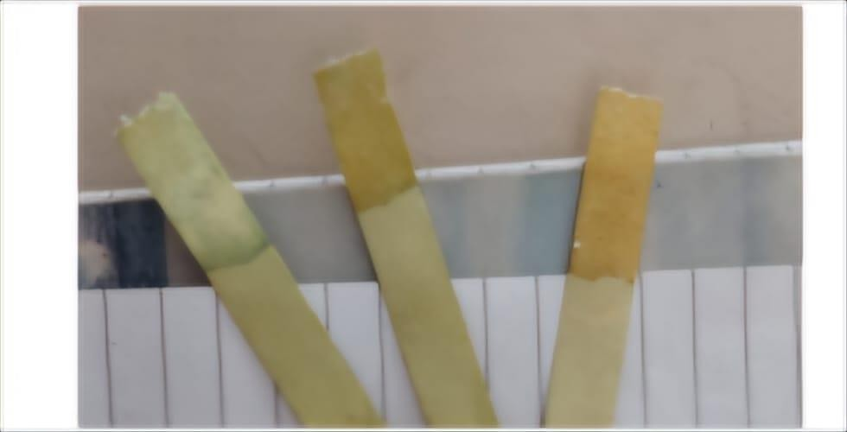

**Fig. 7: pH Measurement**

The evaluation results of the herbal hand wash formulation indicate promising characteristics across various parameters. Firstly, the pH level was measured at 5.7, suggesting a mildly acidic composition suitable for skin compatibility. The color of the hand wash appeared as a brown yellow, visually appealing and indicative of its natural ingredients.

Additionally, the hand wash emitted a pleasant odor, enhancing the overall user experience. Stability testing revealed that the formulation remained stable under storage conditions, ensuring its longevity and usability over time. In terms of foaming height, the hand wash exhibited a foam height of 3.5 cm, indicating sufficient foaming capacity for effective cleansing. The viscosity of the hand wash was measured at 63 centipoise (cp), indicating a moderate thickness that facilitates easy application and rinsing. Furthermore, the consistency of the hand wash was observed to be liquid, providing smooth dispensing and coverage during use. These evaluation parameters collectively affirm the quality and efficacy of the herbal hand wash formulation, promising a refreshing and effective cleansing experience for users.

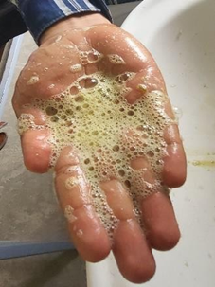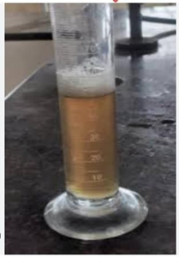

**Fig. 8: Foam test**

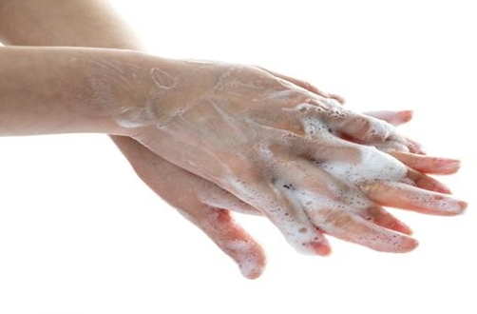

**Fig. 9: Cleaning test**

**ACKNOWLEDGMENT:**

Author take it as a privilege to sincerely express my gratitude to Dr. Swati Deshmukh, Principle Shraddha Institute of Pharmacy, Kondala Zambre, Washim, for providing project amenities and permission to carry out this work. This author is also thankful to respected Mr. Sunil S. Bhagat for his valuable guidance, support and encouragement.

**CONFLICT OF INTEREST:**

We declare that we have no conflict of interest.

**CONCLUSION:**

Hands serve as the primary medium for transmitting diseases related to the skin, respiratory system, and gastrointestinal tract. The use of bar soap, while traditional, presents challenges as it can become contaminated with various disease-causing germs over time, potentially facilitating the spread of infections. In contrast, liquid hand washes have become increasingly popular in today's modern world due to their convenience and hygiene benefits. Liquid hand washes offer the advantage of maintaining cleanliness as the soap remains untouched, minimizing the risk of contamination. With a new pump dispensed for each use, liquid hand washes are considered uncontaminated and more hygienic. The market is flooded with a variety of hand wash products, each claiming to effectively eliminate harmful germs within a short period. However, to ascertain the efficacy of these hand washes, it is imperative to conduct efficiency tests to evaluate their ability to kill germs at a significant rate within a minimal timeframe. By assessing the efficiency of hand wash products, consumers can make informed choices about maintaining proper hand hygiene and preventing the spread of infections.

**REFERENCES:**

1. Warrier, P K (1995). Indian Medicinal plants. Orient Longman. Pg. 168.
2. Ocimum tenuiflorum (holy basil) CABI invasive Species compendium. 23 August 2014.
3. Holy basil drugs.com. 1 February 2022.
4. Ocimum tenuiflorum L. Kew, royal botanic gardens.
5. Textbook of Phytomedicine and phytochemistry, Biren shah and A.K. Seth, pg. No, 238-239.
6. C. K. Kokate, A.P. Purohit, S. B. Gokhale Pharmacognosy book by Nirali Prakashan. Pg. no. 44.8 forty second edition.
7. Pritam v. Chindarkar formulation and evaluation of herbal hand wash.
8. Marvin. S. Balsam and Edward Sagarin: Cosmetics science and technology,) 2ndedition, page no. 179-152.
9. Flowers extract Rasool Bazigha Kadhim et.al, JRAP 2011-12.
10. Mr. Bhise Akash Bhagwan, Formulation and Evaluation of herbal hand wash by using natural ingredient by simple method, IGCRT, (12),2021-page no. B629.
11. Mr. Bhise Akash Bhagwan, Formulation and Evaluation of herbal hand wash by using natural ingredient by simple method, IGCRT, (12),2021-page no. B637.
12. Priyanka V. Bagdeetal, Formulation and evaluation if gel based herbal hand wash usingextracts of argemone Mexicana, Int. Journal of pharmaceutical science and medicine (IJPSM), 6(6), 2021, page no.31.
13. Megha Bahuguna, etal, formulation and evaluation of hand wash, world journal of pharmaceutical research (WJPR), 5(7), 2016, page no. 1567.
14. Niraj Terkar, etal, formulation and evaluation of polyherbal hand wash (gel), IJSR, 10(8), 2021, page no. 1216.
15. P.A. Jumma, hand hygiene simple and complex International Journal of Infectious Disease,9,2005-page no.4.
16. Rakesh Kumar Joshi, Phytoconstituents, traditional medicinal and bioactive uses of tulsi.
17. Priyanka Sharma, etal, A review on pharmacological properties of aloe vera, International Journal of Phytomedicine and life science 1(1), 2020, page no. 38.
18. Shakib Uzzaman pharmacological activities of neem (Azadirchita indica): A review International Journal of Phytomedicine.
19. Rohit Jaysingh Bhor, etal. Formulation and evaluation by phytochemical analysis of herbal hand wash AJPER, 7(1), 2018, page no. (111-121).
20. www.Google.com
21. A review, research Journal of pharmacy and technology, 2013; 6(5): 496-505 and functional food.
22. www.wikipedia.org
23. Brewer M. Natural antibacterial, antifungal sources, compounds, mechanism of action, and potential application.
24. India wins landmark patent battle BBC news. 9 March 2005.
25. Neem cake Fertilizer, uses, application, benefits Agri farming www.agrifarming.in. 9 August 2020.